Annex B:
What are the outcomes of RD&D programmes?

The significant role of technological change in almost all human and economic activity highlights the relevance of RD&D. But relating the outcomes of a specific RD&D programme and desired societal results, such as GHG emission reductions, is difficult because a successful product may embody many technologies. A new wind turbine design, for example, may incorporate new blade designs that have relied on cutting-edge aerodynamic modelling, new materials for lighter and stiffer blades, improved gearboxes and electronics for helping translating the rotational energy of the wind turbine into electricity. The outcomes of some RD&D programmes may not yield direct real-world applications. And shifts in economic activity and other factors may confound the analysis of RD&D programme outcomes.
Still, it is possible to observe and assess the outcomes of RD&D programmes. Patent data provide one measure of RD&D outcomes. Evaluations of specific RD&D programmes document the results achieved. And economic analyses estimate the economic and broader social benefits of RD&D programmes.

B.1 Patent Data
Patents are often used as a measure of innovation since they represent a central product of R&D; successful R&D and an expectation of commercial potential lead to patent applications. The main advantage of using patents to measure technology development is that they are available at a highly technologically disaggregated level. But the limitations of patent should also be noted, especially for the assessment of the real-world impacts of R&D. Patent classes may not match specific technologies or products well. Differences in the propensity to patent need to be taken into account when comparing patent counts across countries, sectors and time. Finally, the patented technology may not be used in a commercial product.

A separate patent must be filed in each patenting jurisdiction (country or group of countries). That is costly. As a result most patents are registered only in a single jurisdiction, often the largest potential market rather than the home of the inventor, and few patents are filed in more than five jurisdictions. In the United States, with lots of RD&D activity and a large market, resident patents account for 50% to 55% of all patents. For Canada, Portugal and Spain resident patents are only 3% to 5% of the total. In contrast, due to their small markets fewer non-residents file patents in Latin America and Caribbean countries, so resident patents represent 16% to 20% of all patents.

Patent applications relating to low-carbon technologies have increased enormously over the past decade. The rate of increase of patent applications for biofuels, solar PV, and wind is far higher than that of overall patents during the past decade as shown in Figure B.1. The figure shown a slight rise in the rate of patenting for these technologies in the late 1990s and then a sharper rise beginning in the middle of the last decade. The rise in patent applications is significantly greater than the rise in the public R&D expenditures for these technologies (see section 3). This could be due to a number of reasons such as a rise in private R&D and a greater propensity to patent with the expectation of growth in the markets of these technologies.

Figure B.1: Global patent family filing trends for selected climate mitigation technologies, 1975-2011
(Number of global patent filings are on the right-hand axis)
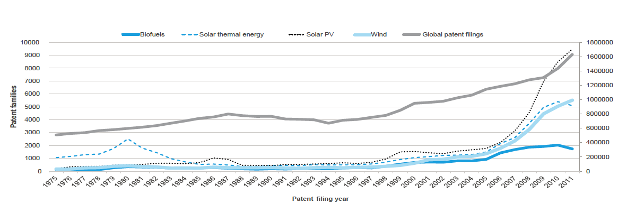

In the case of agriculture and foodstuffs, the number of patent applications under the Patent Cooperation Treaty dropped from about 3% to 2.4% of the global total between 1990 and 2010, but since the overall number of patents applied for over this time increased almost eight-fold, there was a remarkable rise in the number of patents filed in this area. In 2010, almost 4000 agriculture and foodtsuff-related patent applications were filed.

An estimated 28,000 water conservation patents were filed worldwide between 1990 and 2010 with more inventive activity focused on the supply side than the demand side (see Figure B.2). There is no correlation between the water vulnerability of a region and its water innovation. In fact, around 70-80% of water inventions globally take place in geographies without low or moderate water shortage risk. This suggests that efficiency of water services has been less of a focus for RD&D programmes.

Figure B.2 Trends in invention in water technologies (normalized to equal 1 in 1990)
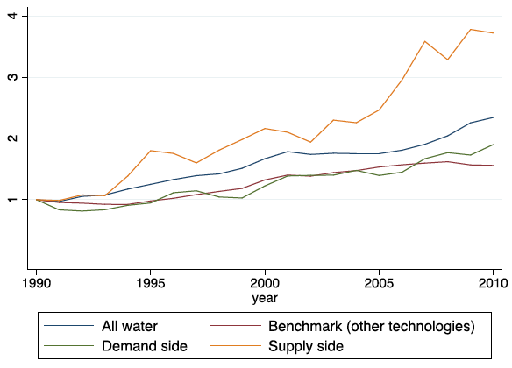
B.2 Other outcomes
Many efforts have been made to understand the real-world outcomes of specific R&D programmes, including attempts to explore causal linkages between R&D activities and outcomes. A set of third-party evaluations of a portion of the energy efficiency and renewable energy (EERE) portfolio of the US Department of Energy (DOE) provides results for a number of climate technologies.

Patents that emerged directly from DOE’s R&D programmes for solar PV, wind, geothermal, and advance combustion in vehicles were analyzed. In all cases, there was significant and influential intellectual and inventive output from these programmes that subsequently contributed to other research in the field as well as many of the key technologies in the domain. For example, in the case of windpower, DOE-funded R&D led to intellectual property in areas as diverse as variable speed wind turbines, airfoils for blades, retractable rotor blades, doubly fed generator variable speed generation control systems, rotor control systems and active pitch controls. Research funded under these programmes was also found to have spillovers in industries beyond renewable energy.

DOE-funded collaborative R&D also was found to help build professional networks among researchers and organizations that advanced the industry. These R&D programmes helped train scientists and technologists who then contributed to R&D programmes in various academic and commercial organizations as well as a range of other activities that support the broader innovation and deployment ecosystem. Since successful technology deployment requires a number of actors, strengthening the ecosystem for a particular technology is an important outcome of R&D efforts.

B.3 Economic and social benefits of RD&D
Assessing the financial and social returns from RD&D is not easy given the nature of the R&D process and the difficulty of linking cause-and-effect. Many streams of R&D (and other forms of knowledge) may contribute to the development of a product. Thus, attempts to estimate returns from R&D often are carried out on a programmatic basis.

Third-party evaluations of a portion of the US DOE’s EERE R&D portfolio (amounting to one-third of the funding from 1976 to 2012) indicated that the USD 12 billion funding (2013 constant dollars) led to estimated net economic benefits of more than USD 230 billion. Thus, the average annual rate of return on this R&D spending was estimated to be more than 20% and the benefit-to-cost ratio was estimated at 7:1 (at a 7% discount rate).

A recent major meta-study of attempts to evaluate the returns to agriculture R&D found a wide distribution of internal rates of return and benefit cost ratios, with median values of 42.6% and 10.6, respectively. Although the authors contend that these figures need to be revised downwards substantially, they suggest that even after their revisions, the “rates of return [from] public agricultural R&D are more modest but still substantial enough to question the current scaling back of public agricultural R&D spending in many countries.” Another review found that of all the public investments that could be made to improve the performance of the agricultural sector, “R&D investments often have the single largest effect on sectoral growth—even more so when considering long-run effects.”

Assessments of CGIAR R&D programmes indicate that for every USD 1 of R&D spending, additional food worth over USD 9 worth is produced in developing countries. CGIAR’s own analysis shows that its expenditures on crop improvement research lead to extraordinarily high rates of return: 39% in Latin America and more than 100% in Asia and in the Middle East and North Africa. The overall economic benefit of CGIAR research is estimated to be greater than USD 120 billion.

The economic estimates conceal the diverse social benefits of RD&D programmes. For example, implementation of a climate-smart agroforestry practice developed by CGIAR R&D more than tripled farmers' maize yields, increased incomes and rainwater-use efficiency by up to 3.8 times; stored as much as 4 tons of carbon and avoided 3.5 tonnes CO₂-equivalent per hectare per year. In another programme, improved varieties of cassava engineered to withstand drought, heat and other effects of climate change, led to benefits worth almost USD 12 billion over the last 20 years in Southeast Asia.

B.4 Summary
Measuring the outcomes of RD&D is difficult. The results of RD&D efforts are uncertain. Results achieved may not find real-world applications. The impacts of real-world applications may be very diverse and likely will vary over time. Establishing clear causality that links economic and social benefits to specific RD&D expenditures is much more difficult still. Despite the difficulties, attempts are made to document and assess the outcomes of R&D programmes.

Data on patent applications, although they have limitations, are a measure of the immediate output of R&D activity with expected commercial potential. The rate of increase of patent applications for biofuels, solar PV, and wind is far higher than that of overall patents during the past decade and significantly greater than the growth in public R&D expenditures for these technologies. This could be due to a number of reasons such as a rise in private R&D and a greater propensity to patent with the expectation of growth in the markets of these technologies. Patent applications for agriculture and foodstuffs and water supply increased rapidly between 1990 and 2010.

Evaluations of specific R&D programmes often span decades of funding, to allow the impacts of the research activity to unfold. Outcomes such as patents and knowledge may contribute to the intended goal of improving climate technology or they may benefit other technologies. And research focused on other goals may improve climate technology. R&D also helps to build professional networks among researchers and organizations that advance the industry. But all of those developments take time.

Economic analyses estimate the economic and broader social benefits of R&D programmes. Results for renewable energy, energy efficiency and agriculture R&D programmes often show returns in excess of 20% for research expenditures. The economic returns may not capture other benefits such as increased food production, reduced GHG emissions, lower water use and higher incomes. Because the benefits take time to materialize, the results are sensitive to the period analysed.

Increasing public R&D budgets for climate technologies can be difficult to justify. The results of R&D programmes are uncertain. It takes time for an R&D programme to yield results and even longer for it to have a real-world impact. Due to these factors, public R&D budgets are easy to cut when faced with budget pressures, and difficult to increase given competing demands with more immediate and more certain impacts.

See, for example, Garrone, P. and Grilli, L., 2010. Is there a relationship between public expenditures in energy R&D and carbon emissions per GDP? An empirical investigation. Energy Policy, 38(10): 5600-5613.
This section draws extensively from Dechezleprêtre, Antoine, Ralf Martin and Samuela Bassi, 2016. Climate change policy, innovation and growth, Grantham Research Institute on Climate Change and the Environment and Global Green Growth Institute. Retrieved from http://www.lse.ac.uk/GranthamInstitute/publication/climate-change-policy-innovation-and-growth/ December 15, 2016.
For a detailed discussion see Dechezleprêtre, A., Glachant, M., Haščič, I., Johnstone, N., & Ménière, Y. (2011). Invention and transfer of climate change mitigation technologies: A global analysis. Review of Environmental Economics and Policy, 5, 109–130. doi:10.1093/reep/req023
The Network for Science and Technology Indicators –Ibero-American and Inter-American– (RICYT). Data available at http://www.ricyt.org/indicators Retrieved November 16, 2016. Although data are available from 1990, the ranges reported are for the period from 2000 due to incomplete coverage for earlier years.
UNEP, EPO and ICTSD., 2010. Patents and clean energy: bridging the gap between evidence and policy; Helm, S., Tannock, Q., and Iliev, I., 2014. Renewable energy technology: evolution and policy implications – evidence from patent literature, WIPO.
In principle the patent data could identify the public and private patents by organization but that information is not provided in the studies.
Helm, S., Tannock, Q., & Iliev, I. 2014. Renewable energy technology: Evolution and policy implications – evidence from patent literature (Global Challenges Report). Geneva: WIPO.
The Patent Cooperation Treaty (PCT) is an international treaty that provides a unified procedure for filing patent applications in the states that are signatories to this treaty.
Lippoldt, D. (2015), “Innovation and the Experience with Agricultural Patents Since 1990: Food for Thought”, OECD Food, Agriculture and Fisheries Papers, No. 73, OECD, Paris
Dechezleprêtre, A., Haščič, I, and Johnstone, N. 2014. Invention and International Diffusion of Water Conservation and Availability Technologies: Evidence from Patent Data, OECD Environment Working Papers No. 82 ; Paris: OECD.
Dechezleprêtre, A., Haščič, I, and Johnstone, N. 2014. Invention and International Diffusion of Water Conservation and Availability Technologies: Evidence from Patent Data, OECD Environment Working Papers No. 82; Paris: OECD.
Ruegg, R and Thomas, P, 2011, Linkages from DOE’s Solar Photovoltaic R&D to Commercial Renewable Power from Solar Energy, Office of Energy Efficiency and Renewable Energy, DOE: Washington DC.
Ruegg, R and Thomas, P, 2009. Linkages from DOE’s Wind Power R&D to Commercial Renewable Power Generation, Office of Energy Efficiency and Renewable Energy, DOE: Washington DC.
Ruegg, R and Thomas, P, 2011. Linkages from DOE’s Geothermal R&D to Commercial Power Generation, Office of Energy Efficiency and Renewable Energy, DOE: Washington DC.
Ruegg, R and Thomas, P, 2011. Linkages from DOE’s Vehicle Technologies R&D in Advanced Combustion to More Efficient, Cleaner-Burning Engines, Office of Energy Efficiency and Renewable Energy, DOE: Washington DC.
Dowd, J., 2016. “Aggregate Return on Investment for R&D Investments in the U.S. DOE Office of Energy Efficiency and Renewable Energy,” US DOE. https://energy.gov/sites/prod/files/2016/10/f33/Aggregate%20ROI%20impact%20for%20EERE%20RD%20-%2010-5-16.pdf
Pardey, P.G., Andrade, R.S., Hurley, T.M., Rao, X. and Liebenberg, F.G., 2016. Returns to food and agricultural R&D investments in Sub-Saharan Africa, 1975–2014. Food Policy, 65, pp.1-8. Hurley, T.M., Pardey, P.G., Rao, X. and Andrade, R.S., 2016. Returns to Food and Agricultural R&D Investments Worldwide, 1958-2015 (No. 249356). University of Minnesota, International Science and Technology Practice and Policy.
Mogues, T., Yu, B., Fan, S. and McBride, L., 2012. The impacts of public investment in and for agriculture. ESA Working paper No. 12-07, FAO: Rome.
CGIAR, 2012. The CGIAR Fund: Securing Investments for a Food-secure Future.
CGIAR, 2014. CGIAR: A Global Research Partnership for a Food Secure Future.
CGIAR, 2012. The CGIAR Fund: Securing Investments for a Food-secure Future.
CGIAR, 2012. The CGIAR Fund: Securing Investments for a Food-secure Future.

