Annex C

Illustrative set of collaborative RD&D options to meet developing country needs[1]

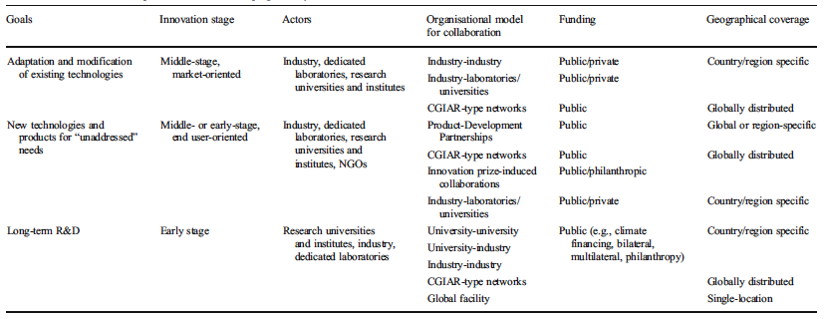

1. Report on options to facilitate collaborative technology research and development, FCCC/SBSTA/2010/INF.11; Ockwell, D., Sagar, A. and de Coninck, H., 2015. Collaborative research and development (R&D) for climate technology transfer and uptake in developing countries: towards a needs driven approach. Climatic Change, 131(3): 401-415.