**Concept Note: Regional Exchange Dialogue on Accelerating support for Formulation and Implementation of National Adaptation Plans in the East and Southern African Region.**

**Dates: June 04th June 2025**

**Virtual: Microsoft Teams**

**Biography for Presenters**

**Mr. Muhammad Semambo**: **Assistant Commissioner - Climate Change Office**r in the Ministry of Water and Environment. His areas of expertise include climate change adaptation with specialty in monitoring and evaluation of climate change adaptation strategies.

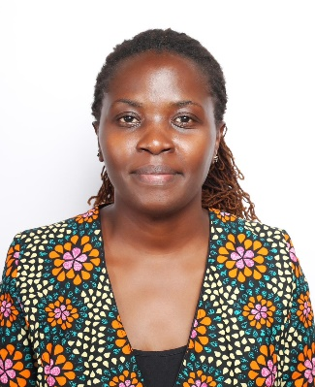**Faith Agnes Ondeng** is a **Knowledge Management Technical Officer at Kenya’s Climate Change Directorate (CCD), Ministry of Environment, Climate Change and Forestry,** where she is embedded through the NDC Partnership.

In this role, Faith has been instrumental in capturing, documenting, and disseminating Kenya’s innovative approaches to climate adaptation, including devolved climate finance systems, county (subnational)- based adaptation strategies, and best practices, contributing to national knowledge platforms on climate adaptation. Her expertise spans climate change adaptation strategies, institutional knowledge systems, and stakeholder engagement across government and civil society organizations, particularly in Kenya and broader East African region.

**Biography for Speakers:**

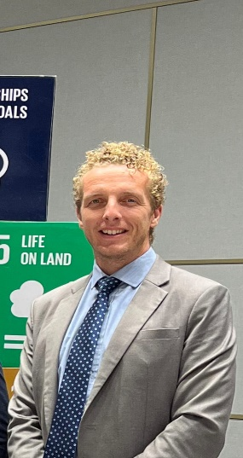**Liam Fee**

**Adaptation Planning Specialist, UNDP**.

Liam Fee is an Adaptation Planning Specialist at UNDP’s Climate Hub. He supports UNDP’s portfolio of National Adaptation Planning support projects, both under design and implementation. He also supports UNDP’s efforts to ensure greater alignment between NDCs and NAPs and spearheads the agency’s engagement with the Adaptation Research Alliance. Liam has worked on adaptation, climate finance and natural resources management for over 15 years in a variety of positions in Europe, Asia, and Africa. Liam is an economist by training.

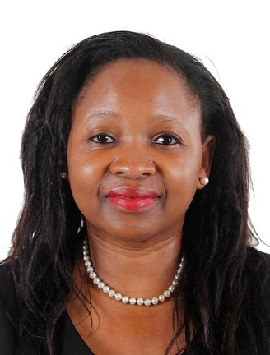 **Chihenyo Kangara, Regional Manager for Africa Desk, Division of Country Programming, GCF.**

Chihenyo Kangara serves as the Regional Manager for the Africa Desk at the Green Climate Fund (GCF).

In her role, Ms. Kangara guides the GCF in delivering ambitious, country-driven programs across the continent. She drives engagement with various stakeholders, supports direct access entities, and collaborates with delivery partners to identify, develop, and implement transformational projects and programs. Her efforts ensure alignment among programming partners to effectively channel resources from the GCF. Additionally, Ms. Kangara leverages GCF’s support programs to enhance the capacity of countries, enabling them to originate and implement a diverse portfolio of investments that align with both national strategic goals and the objectives of the GCF. Her leadership and expertise are vital in advancing sustainable development and climate resilience in the region.

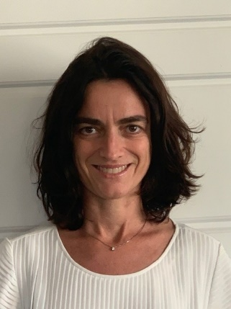**Silvia Mancini – Adaptation Fund/ Countries and Partnerships Team Lead- Senior Program Officer.**

Silvia Mancini is the Senior Program Officer and Lead of the Countries and Partnerships Unit at the Adaptation Fund. She focuses on accreditation, readiness, resource mobilization, and the management of emerging partnerships. Silvia brings a wealth of international experience in Public Financial Management. She has worked with the International Fund for Agricultural Development (IFAD), Moody’s Investor Service, and various commercial banks.

Silvia holds a Master of Arts in Economic Sciences in Public Policy Management from SOAS, University of London, a master’s in European economics and public Affairs from University College Dublin, and a degree in Political Science from Università degli Studi di Teramo. From 2012 to 2014, she served as IFAD’s Regional Financial Officer in Nairobi. Prior to her role at the Adaptation Fund Board Secretariat, she led a unit focused on the fiduciary aspects of IFAD’s grant portfolio at the Rome headquarters.