

REPUBLIC OF SERBIA
Ministry of Environmental Protection
Environmental Protection Agency

National Greenhouse Gas Inventory document of Serbia 2024

Belgrade, December 2024

Preface
Serbian Environmental Protection Agency (SEPA) is responsible for the overall coordination of activities necessary for the development of emission inventories as well as with preparing national inventory of anthropogenic emissions by sources and removals by sinks of greenhouse gases for the purposes of reporting to the United Nations Framework Convention on Climate Change (UNFCCC), in accordance with the Serbian legislation.
In line with Articles 4 and 12 of the United Nations Framework Convention on Climate Change (UNFCCC) and Article 13 of the Paris Agreement, all Parties are required to submit national inventories of greenhouse gas emissions and removals. In this respect, national inventory of anthropogenic emissions by sources and removals by sinks of greenhouse gases of the Republic of Serbia is outlined in this National Inventory Document, prepared in accordance with the Modalities, Procedures, and Guidelines for the Transparency Framework for Action and Support, as referred to in Article 13 of the Paris Agreement (Decision 18/CMA.1 Annex).

National Inventory Document presents Serbia’s national inventory arrangements, the estimation methods of greenhouse gas emissions and removals from sources and sinks, and the trends in emissions and removals for greenhouse gases (carbon dioxide [CO₂], methane [CH₄], nitrous oxide [N₂O], hydrofluorocarbons [HFCs], perfluorocarbons [PFCs], sulphur hexafluoride [SF₆], nitrogen trifluoride [NF₃]). Methodological details of the LULUCF sector not accounting in the Nationally Determined Contribution (NDC) is presented as well, as other relevant additional information.

The structure of this document is prepared in line with the structure specified in the Outline of the National Inventory Document, Pursuant to the Modalities, Procedures and Guidelines for the Transparency Framework for Action and Support Referred to in Article 13 of the Paris Agreement (Decision 5/CMA.3 Annex).

The Executive Summary focuses on the latest trends in emissions and removals of greenhouse gases in the Republic of Serbia. Chapter 1 presents background information on the greenhouse gas inventory, national inventory arrangements, the inventory preparation process, methodologies and data sources used, key category analysis, and results of uncertainty assessment. Chapter 2 describes the latest information on trends in emissions and removals of greenhouse gases in Serbia. Chapters 3 to 7 provide the details of estimation methods for the sources and sinks described in the 2006 IPCC Guidelines. Chapter 8 provides the explanations on improvements and recalculations (data revision, addition of new categories, etc.) made since the previous submission. Annexes offer information to assist further understanding of Serbia’s inventory and other additional information.
First National Inventory Document (NID) of the Republic of Serbia under the UNFCCC was prepared under the GEF funded project “Development of the First Biennial Transparency Report and the combined Fourth National Communication and Second Biennial Transparency Report of Serbia under the UNFCCC” and with the support of CITEPA.
December, 2024
Ministry of Environment Protection of the Republic of Serbia

Republic of Serbia
Ministry of the Environmental Protection
Serbian Environment Protection Agency

Phone: +381 (0)11 6356788
E-Mail: office @sepa.gov.rs
Adresse: Agencija za zaštitu životne sredina, Žabljačka 10a, 11160 Belgrade
Internet: www.sepa.gov.rs

Contact person:

Ivana Dukić
Phone: +381 (0)11 6356793
E-Mail: ivana.dukic@sepa.gov.rs

Table of Content

EXECUTIVE SUMMARY 19
Chapter 1: Introduction 23
1.1 Background information on GHG inventories and climate change 23
1.2 A description of the national circumstances and institutional arrangements 25
1.2.1 National entity or national focal point 25
1.2.2 Inventory preparation process 27
1.2.3 Archiving information 31
1.2.4 Processes for official consideration and approval of inventory 31
1.3 Brief general description of methodologies (including tiers used) and data sources used 32
1.4 Brief description of key categories 35
1.5 Brief general description of QA/QC plan and implementation 40
1.6 General uncertainty evaluation 41
1.7 General assessment of completeness (MPGs para 30) 42
1.7.1 Information on completeness (MPGs para. 30) 42
1.7.2 Description of insignificant categories (MPGs para. 32) 42
1.7.3 Total aggregate emissions considered insignificant (MPGs para. 32) 43
1.8 Metrics (MPGs para. 37) 43
1.9 Summary of any flexibility applied (MPGs paras. 4-6) 44
Chapter 2: Trends in greenhouse gas emissions 45
2.1 Description of emission and removal trends for aggregated GHG emissions and removals 45
2.2 Description of emission and removal trends by sector and by gas 47
Chapter 3: Energy (CRT sector 1) 55
3.1 Overview of sector 55
3.2 Fuel combustion (CRT 1.A) 57
3.2.1 Comparison of the sectoral approach with the reference approach (RA vs. SA) 57
3.2.2 International bunker fuels 60
3.2.3 Feedstocks and non-energy use of fuels 61
3.2.4 General characteristics for fuel combustion (CRT 1A) 62
3.2.5 Energy industries (CRT 1A1) 65
3.2.6 Manufacturing industry and construction (CRT 1A2) 72
3.2.7 Transport (CRT 1A3) 77
3.2.7.1 Road transportation (CRT 1A3b) 78
3.2.7.1.1 Category description 78
3.2.7.1.2 Methodological issues 79
3.2.7.2 Railways (CRT 1A3c) 79
3.2.7.2.1 Category description 79
3.2.7.2.2 Methodological issues 80
3.2.7.3 Domestic navigation (CRT 1A3d) 81
3.2.7.3.1 Category description 81
3.2.7.3.2 Methodological issues 81
3.2.8 Other sectors (CRT 1A4) 82
3.2.8.1.1 Category description 85
3.2.8.1.2 Methodological issues 85
3.2.8.2.1 Category description 86
3.2.8.2.2 Methodological issues 87
3.2.8.3.1 Category description 87
3.2.8.3.2 Methodological issues 88
3.3 Fugitive emissions from solid fuels and oil and natural gas and other emissions from energy production (CRT 1.B) 89
3.3.1 Category description 89
3.3.2 Methodological issues 97
3.3.3 Uncertainties and time-series consistency 98
3.3.4 Category-specific QA/QC and verification 99
3.3.5 Category-specific recalculations 99
3.3.6 Category-specific planned improvements 99
Chapter 4: Industrial processes and product use (CRT sector 2) 100
4.1 Overview of sector 100
4.2 Mineral industry (CRT 2A) 102
4.2.1 Cement production (CRT 2A1) 103
4.2.2 Lime production (CRT 2A2) 104
4.2.3 Glass production (CRT 2A3) 104
4.2.4 Other use of carbonates (CRT 2A4) 105
4.2.5 Uncertainties and time-series consistency 107
4.2.6 Category-specific QA/QC and verification 107
4.2.7 Category-specific recalculations 107
4.2.8 Category-specific planned improvements 108
4.3 Chemical industry (CRT 2B) 108
4.3.1 Ammonia production (CRT 2B1) 109
4.3.2 Nitric acid production (CRT 2B2) 110
4.3.3 Petrochemical and carbon black production (CRT 2B8) 111
4.3.4 Other (2B10) 113
4.3.5 Uncertainties and time-series consistency 114
4.3.6 Category-specific QA/QC and verification 114
4.3.7 Category-specific recalculations 115
4.3.8 Category-specific planned improvements 115
4.4 Metal industry (CRT 2C) 115
4.4.1 Iron and steel (CRT 2C1) 116
4.4.2 Magnesium production (CRT 2C4) 119
4.5 Lead production (CRT 2C5) 120
4.6 Zinc production (CRT 2C6) 120
4.6.2 Uncertainties and time-series consistency 121
4.6.3 Category-specific QA/QC and verification 122
4.6.4 Category-specific recalculations 122
4.6.5 Category-specific planned improvements 122
4.7 Non-energy products from fuels and solvent use (CRT 2D) 122
4.7.1 Lubricant use (CRT 2D1) 123
4.7.2 Paraffin wax use (CRT 2D2) 124
4.7.3 Solvent use (CRT 2D3) 124
4.7.4 Uncertainties and time-series consistency 125
4.7.5 Category-specific QA/QC and verification 125
4.7.6 Category-specific recalculations 126
4.7.7 Category-specific planned improvements 126
4.8 Product uses as substitutes for ODS (CRT 2F) 126
4.8.1 Refrigeration and air-conditioning (CRT 2F1) 127
4.8.2 Foam blowing agents (CRT 2F2) 130
4.8.3 Fire protection (2F3) 130
4.8.4 Aerosols (2F4) 130
4.8.5 Uncertainties and time-series consistency 131
4.8.6 Category-specific QA/QC and verification 132
4.8.7 Category-specific recalculations 132
4.8.8 Category-specific planned improvements 132
4.9 Other product manufacture and use (CRT 2G) 132
4.9.1 Electrical equipment (CRT 2G1) 133
Chapter 5: Agriculture (CRT sector 3) 135
5.1 Overview of sector 135
5.2 Enteric fermentation (CRT 3A) 137
5.2.1 Cattle (CRT 3A1) 138
5.2.2 Sheep (CRT 3A2) 140
5.2.3 Swine (3A3) 141
5.2.4 Other livestock (3A4) 141
5.2.5 Uncertainties and time-series consistency 143
5.2.6 Category-specific QA/QC and verification 143
5.2.7 Category-specific recalculations 143
5.2.8 Category-specific planned improvements 143
5.3 Manure management (CRT 3B) 143
5.3.1 CH₄ emissions from Manure management (CRT 3B1) 145
5.3.2 N₂O emissions from manure management (CRT 3B2) 151
5.3.3 Uncertainties and time-series consistency 155
5.3.4 Category-specific QA/QC and verification 156
5.3.5 Category-specific recalculations 156
5.3.6 Category-specific planned improvements 156
5.4 Agricultural soils (CRT 3D) 156
5.4.1 Direct N₂O emissions from managed soils (CRT 3D1) 158
5.4.2 Indirect N₂O emissions from managed soils (CRT 3D2) 161
5.4.3 Uncertainties and time-series consistency 162
5.4.4 Category-specific QA/QC and verification 162
5.4.5 Category-specific recalculations 163
5.4.6 Category-specific planned improvements 163
5.5 Field burning of agricultural residues (CRF 3F) 163
5.5.1 Cereals (CRF 3F1) 163
5.5.2 Uncertainties and time-series consistency 165
5.5.3 Category-specific QA/QC and verification 165
5.5.4 Category-specific recalculations 165
5.5.5 Category-specific planned improvements 165
5.6 Urea application (CRF 3H) 166
5.6.1 Category description 166
5.6.2 Methodological issues 166
5.6.3 Uncertainties and time-series consistency 167
5.6.4 Category-specific QA/QC and verification 167
5.6.5 Category-specific recalculations 167
5.6.6 Category-specific planned improvements 167
Chapter 6: Land Use, Land-Use Change and Forestry (CRT sector 4) 168
6.1 Overview of sector 168
6.2 Land-use definitions and the classification systems used and their correspondence to the land use, land-use change and forestry categories (e.g. land use and land-use change matrix) 170
6.3 Information on approaches used for representing land areas and on land-use database used for the inventory preparation 170
6.4 Common elements to all land uses (CRT 4) 173
6.4.1 Carbon stock changes 173
6.4.2 Direct N₂O Emissions from N Inputs to Managed Soils 174
6.4.3 Emissions and removals from drainage and rewetting and other management of organic and mineral soils 174
6.4.4 Direct N₂O Emissions from N Mineralization/Immobilization 174
6.4.5 Indirect N₂O Emissions from Managed Soils 175
6.4.6 Biomass Burning 175
6.5 Forestlands (CRT 4A) 176
6.5.1 Description 176
6.5.2 Methodological issues 178
6.5.3 Uncertainties and time-series consistency 181
6.5.4 Category-specific QA/QC and verification 182
6.5.5 Category-specific recalculations 182
6.5.6 Category-specific planned improvements 182
6.6 Croplands (CRT 4B) 182
6.6.1 Description 182
6.6.2 Methodological issues 183
6.6.3 Uncertainties and time-series consistency 185
6.6.4 Category-specific QA/QC and verification 185
6.6.5 Category-specific recalculations 185
6.6.6 Category-specific planned improvements 185
6.7 Grasslands (CRT 4C) 185
6.7.1 Description 185
6.7.2 Methodological issues 187
6.7.3 Uncertainties and time-series consistency 189
6.7.4 Category-specific QA/QC and verification 189
6.7.5 Category-specific recalculations 189
6.7.6 Category-specific planned improvements 189
6.8 Wetlands (CRT 4D) 189
6.8.1 Description 189
6.8.2 Methodological issues 190
6.8.3 Uncertainties and time-series consistency 192
6.8.4 Category-specific QA/QC and verification 192
6.8.5 Category-specific recalculations 192
6.8.6 Category-specific planned improvements 192
6.9 Settlements (CRT 4E) 192
6.9.1 Description 192
6.9.2 Methodological issues 194
6.9.3 Uncertainties and time-series consistency 195
6.9.4 Category-specific QA/QC and verification 195
6.9.5 Category-specific recalculations 195
6.9.6 Category-specific planned improvements 195
6.10 Other lands (CRT 4F) 196
6.10.1 Description 196
6.10.2 Methodological issues 197
6.10.3 Uncertainties and time-series consistency 198
6.10.4 Category-specific QA/QC and verification 198
6.10.5 Category-specific recalculations 198
6.10.6 Category-specific planned improvements 198
6.11 Harvested wood products (CRT 4G) 199
6.11.1 Description 199
6.11.2 Methodological issues 200
6.11.3 Uncertainties and time-series consistency 200
6.11.4 Category-specific QA/QC and verification 200
6.11.5 Category-specific recalculations 200
6.11.6 Category-specific planned improvements 200
Chapter 7: Waste (CRT sector 5) 201
7.1 Overview of sector 201
7.2 Managed waste disposal sites (CRFT 5A1) 202
7.2.1 Category description 202
7.2.2 Methodological issues 203
7.2.3 Uncertainties and time-series consistency 209
7.2.4 Category-specific QA/QC and verification 209
7.2.5 Category-specific recalculations 209
7.2.6 Category-specific planned improvements 209
7.3 Wastewater treatment and discharge (CRT 5D) 210
7.3.1 Category description 210
7.3.2 Methodological issues 211
7.3.3 Uncertainties and time-series consistency 219
7.3.4 Category-specific QA/QC and verification 219
7.3.5 Category-specific recalculations 219
7.3.6 Category-specific planned improvements 219
Chapter 8: Other 220
Chapter 9: Indirect CO₂ and N₂O emissions 221
9.1. Description of sources of indirect emissions in GHG inventory 221
9.2. Methodological issues 221
9.3. Uncertainties and time-series consistency 221
9.4. Category-specific QA/QC and verification 221
9.5 Category-specific recalculations 221
9.6. Category-specific planned improvements 221
Chapter 10: Recalculations and improvements 222
10.1. Explanations and justifications for recalculations, including in response to the review process 222
10.2. Implications for emission and removal levels 222
10.3. Implications for emission and removal trends, including time-series consistency 222
10.4. Areas of improvement and/or capacity building in response to the review process 222
Annex 1: Key categories from CRT Reporter 223
Annex 2: Assessment of uncertainty 224
Annex 3: Detailed description of the reference approach (including inputs to the reference approach such as the national energy balance) and the results of the comparison of national estimates of emissions with those obtained using the reference approach 230
Annex 4: QA/QC procedures. 231
Annex 5: Any additional information, as applicable, including detailed methodological descriptions of source or sink categories and the national emission balance 236
References 237

List of figures
Figure 1: General process diagram for the preparation of the national emission inventory, with QA/QC procedures 28
Figure 2: Total GHG emissions, including LULUCF, in the Republic of Serbia (in kt CO₂e), with CRT main sector contributions, over the period 1990-2022 46
Figure 3: Contributions of each gas on the Republic of Serbia aggregated GHG emissions, excluding LULUCF, in 1990 and 2022 46
Figure 4: Total aggregated fuel consumptions in the Republic of Serbia, for the period 1990-2022, per fuel type (in PJ) 56
Figure 5: GHG emission trends for the Energy sector (CRT 1), per main subsector (in kt CO₂e) 56
Figure 6 : Fuel consumptions in Public electricity and heat production (CRT 1A1a), for the period 1990-2022 (in TJ) 66
Figure 7: GHG emissions for Public Electricity and Heat production (CRT 1A) for the period 1990-2022 (in kt CO₂e) 66
Figure 8: Evolution of the amounts of crude oil treated in petroleum refining for the period 1990-2022 68
Figure 9: GHG emissions for the petroleum refining (CRT 1A1b), for the period 1990-2022 (in kt CO₂e) 68
Figure 10: GHG emissions for the Manufacture of solid fuels (CRT 1A1c), for the period 1990-2022 (in kt CO₂e) 70
Figure 11: Fuel consumptions in the Manufacturing industries and Construction (CRT 1A2), per fuel type, for the period 1990-2022 (in TJ) 73
Figure 12: Fuel consumptions in the Manufacturing industries and Construction (CRT 1A2), per subsector, for the period 1990-2022 (in TJ) 74
Figure 13: GHG emissions in the Manufacturing industry and construction (CRT 1A2), for the period 1990-2022 (in kt CO₂e) 74
Figure 14: Fuel consumptions in the Transport sector (CRT 1A3), per fuel type, for the period 1990-2022 (in TJ) 77
Figure 15 : GHG emissions for road transportation (CRT 1A3b), for the period 1990-2022 (in kt CO₂e) 79
Figure 16 : GHG emissions for railways (CRT 1A3c), for the period 1990-2022 (in kt CO2e) 80
Figure 17 : GHG emissions for domestic navigation (CRT 1A3d), for the period 1990-2022 (in kt CO₂e) 81
Figure 18: Fuel consumptions in the Other sectors (CRT 1A4), per fuel type, for the period 1990-2022 (in TJ) 83
Figure 19: Fuel consumptions in the Other sectors (CRT 1A4), per subsector, for the period 1990-2022 (in TJ) 83
Figure 20: GHG emissions for Other sectors (CRT 1A4), for the period 1990-2022 (in kt CO₂e) 84
Figure 21: GHG emissions for commercial and institutional (CRT 1A4a), for the period 1990-2022 (in kt CO₂e) 85
Figure 22 : GHG emissions for residential (CRT 1A4b) activities, for the period 1990-2022 (in kt CO₂e) 86
Figure 23 : GHG emissions for agriculture/forestry/fishing activities - stationary combustion (CRT 1A4ci), for the period 1990-2022 (in kt CO₂e) 87
Figure 24 : GHG emissions for agriculture/forestry/fishing activities – mobile combustion (CRT 1A4cii), for the period 1990-2022 (in kt CO₂e) 88
Figure 25: Evolution of the solid fuel production in Serbia, distinguished with underground and surface mining, for the period 1990-2022 (in kt) 90
Figure 26: Evolution of the amounts of crude oil produced and transported, for the period 1990-2022 (in 000 m³) 91
Figure 27: Evolution of the amounts of gas produced, transported and distributed, for the period 1990-2022 (in Mio m³) 91
Figure 28 : GHG emissions from mining in underground mines – COAL (CRT 1B1ai1) (kt CO₂e) 92
Figure 29 : GHG emissions from post-mining in underground mines - COAL (CRT 1B1ai2) (kt CO₂e) 93
Figure 30 : GHG emissions from abandoned underground mines - COAL (CRT 1B1ai3) (kt CO₂e) 93
Figure 31 : GHG emissions from mining in surface mines - COAL (CRT 1B1aii1) (kt CO₂e) 93
Figure 32 : GHG emissions from post-mining in surface mines - COAL (CRT 1B1aii2) (kt CO₂e) 94
Figure 33 : GHG emissions from production and upgrading of OIL (CRT 1B2aii) (kt CO₂e) 94
Figure 34 : GHG emissions from transport of OIL (CRT 1B2aiii) (kt CO₂e) 94
Figure 35 : GHG emissions from production of NATURAL GAS (CRT 1B2bii) (kt CO₂e) 95
Figure 36 : GHG emissions from processing of NATURAL GAS (CRT 1B2biii) (kt CO₂e) 95
Figure 37 : GHG emissions from transmission and storage of NATURAL GAS (CRT 1B2biv) (kt CO₂e) 95
Figure 38 : GHG emissions from distribution of NATURAL GAS (CRT 1B2bv) (kt CO₂e) 96
Figure 39 : GHG emissions from venting in OIL systems (CRT 1B2ci1) (kt CO₂e) 96
Figure 40 : GHG emissions from venting in NATURAL GAS systems (CRT 1B2ci2) (kt CO₂e) 96
Figure 41 : GHG emissions from flaring in OIL systems (CRT 1B2cii1) (kt CO₂e) 97
Figure 42 : GHG emissions from flaring in NATURAL GAS systems (CRT 1B2cii2) (kt CO₂e) 97
Figure 43: GHG emissions trends for industrial processes and product use (CRT 2), for the period 1990-2022, per subcategory (in kt CO₂e) 100
Figure 44: GHG emissions trends for the mineral industries (CRT 2A), for the period 1990-2022, per subcategory (in kt CO₂e) 102
Figure 45: GHG emission distribution for mineral industries (CRT 2A), for the years 1990 and 2022, per subcategory (in %) 103
Figure 46: GHG emissions for the cement production (kt GHG) 103
Figure 47: CO₂ emissions for the lime production (kt CO₂e) 104
Figure 48: CO₂ emissions for Glass production (kt CO₂e) 105
Figure 49: GHG emissions for the ceramics production (kt CO₂e) 106
Figure 50: GHG emissions for the other use of soda ash (kt CO₂e) 107
Figure 51: GHG emissions trends for the chemical industries (CRT 2B), for the period 1990-2022, per subcategory (in kt CO₂e) 108
Figure 52: GHG emission distribution for chemical industries (CRT 2B), for the years 1990 and 2022, per subcategory (in %) 109
Figure 53 : GHG emissions for ammonia production (CRT 2B1), for the period 1990-2022 (in kt CO₂e) 109
Figure 54 : GHG emissions for nitric acid production (CRT 2B2), for the period 1990-2022 (in kt CO₂e) 110
Figure 55 : GHG emissions for methanol production (CRT 2B8a), for the period 1990-2022 (in kt CO₂e) 111
Figure 56 : GHG emissions for ethylene production (CRT 2B8b), for the period 1990-2022 (in kt CO₂e) 112
Figure 57 : GHG emissions for ethylene dichloride and vinyl chloride monomer production (kt CO₂e) 113
Figure 58 : GHG emissions for other chemical production (CRT 2B10) for the period 1990-2022 (in kt CO₂e) 113
Figure 59: GHG emissions trends for the metal industries (CRT 2C), for the period 1990-2022, per subcategory (in kt CO₂e) 116
Figure 60: GHG emission distribution for metal industries (CRT 2C), for the years 1990 and 2022, per subcategory (in %) 116
Figure 61: Overview of the integrated steel production 117
Figure 62: GHG emissions for steel production, for the period 1990-2022 (in kt CO₂e) 117
Figure 63: GHG emissions for sinter production, for the period 1990-2022 (in kt CO₂e) 118
Figure 64: GHG emissions for pellet production, for the period 1990-2022 (in kt CO₂e) 118
Figure 65 : GHG emissions for magnesium production, for the period 1990-2022 (in kt CO₂e) 119
Figure 66 : GHG emissions for lead production, for the period 1990-2022 (in kt CO₂e) 120
Figure 67 : GHG emissions for zinc production, for the period 1990-2022 (in kt CO₂e) 121
Figure 68: GHG emissions trends for the non-energy product uses (CRT 2D), for the period 1990-2022, per subcategory (in kt CO₂e) 123
Figure 69: CO₂ emissions for lubricant use, for the period 1990-2022 (in kt CO₂e) 123
Figure 70: CO₂ emissions for paraffin wax use, for the period 1990-2022 (in kt CO₂e) 124
Figure 71: CO₂ emissions for solvent use, for the period 1990-2022 (in kt CO₂e) 125
Figure 72: GHG emissions trends for the product uses as substitutes for ODS (CRT 2F), for the period 1990-2022, per subcategory (in kt CO₂e) 127
Figure 73: GHG emissions for domestic refrigeration, for the period 1990-2022 (in kt CO₂e) 128
Figure 74: GHG emissions for mobile air-conditioning, for the period 1990-2022 (in kt CO₂e) 128
Figure 75: GHG emissions for commercial refrigeration, industrial refrigeration and stationary air-conditioning, for the period 1990-2022 (in kt CO₂e) 128
Figure 76: GHG emissions for pharmaceutical aerosols, for the period 1990-2022 (in kt CO₂e) 131
Figure 77: GHG emissions for electrical equipment, for the period 1990-2022 (in kt CO₂e) 133
Figure 78: GHG emission trends for agriculture (CRT 3), for the period 1990-2022, per subcategory (in kt CO₂e) 136
Figure 79: GHG emission trends for the enteric fermentation (CRT 3A), for the period 1990-2022, per subcategory (in kt CO₂e) 137
Figure 80: GHG emission distribution for enteric fermentation (CRT 3A), for the period 1990-2022, per subcategory (in %) 138
Figure 81 : Livestock evolution for cattle, in number of heads, for the period 1990-2022 138
Figure 82 : GHG emissions for enteric fermentation of dairy cattle (CRT 3A1a) (kt CO₂e) 139
Figure 83 : GHG emissions for enteric fermentation of non-dairy cattle (CRT 3A1b) (kt CO₂e) 139
Figure 84 : Livestock evolution for sheep, in number of heads, for the period 1990-2022 140
Figure 85 : GHG emissions for enteric fermentation of sheep (CRT 3A2) (kt CO₂e) 140
Figure 86 : GHG emissions for enteric fermentation of swine (CRT 3A3) (kt CO₂e) 141
Figure 87 : Livestock evolution for other livestock, in number of heads, for the period 1990-2022 142
Figure 88 : GHG emissions for enteric fermentation of other livestock (CRT 3A4) (kt CO₂e) 142
Figure 89: GHG emission trends for manure management (CRT 3B), for the period 1990-2022, per subcategory (in kt CO₂e) 144
Figure 90: GHG emission distribution for manure management (CRT 3B), for the period 1990-2022, per subcategory (in %) 145
Figure 91 : Livestock evolution for poultry, in number of heads, for the period 1990-2022, per different animal species 146
Figure 92 : CH₄ emissions for manure management of dairy cattle (CRT 3B11a) (kt CO₂e) 146
Figure 93 : CH₄ emissions for manure management of non-dairy cattle (CRT 3B11b) (kt CO₂e) 146
Figure 94 : CH₄ emissions for manure management of sheep (CRT 3B12) (kt CO₂e) 147
Figure 95 : CH4 emissions for manure management of swine (CRT 3B13) (kt CO₂e) 147
Figure 96 : CH4 emissions for manure management of other livestock (CRT 3B14) (kt CO₂e) 147
Figure 97 : Evolution of the average annual temperature, in the Republic of Serbia, for the period 1990-2022 (in °C) 148
Figure 98 : N₂O emissions for manure management of dairy cattle (CRT 3B21a) (kt CO₂e) 152
Figure 99 : N₂O emissions for manure management of non-dairy cattle (CRT 3B21b) (kt CO₂e) 152
Figure 100 : N₂O emissions for manure management of sheep (CRT 3B22) (kt CO₂e) 152
Figure 101 : N₂O emissions for manure management of swine (CRT 3B23) (kt CO₂e) 152
Figure 102 : N₂O emissions for manure management of other livestocks (CRT 3B24) (kt CO₂e) 153
Figure 103 : Indirect N₂O emissions from volatilisation and leaching in manure management (CRT 3B25) (kt CO₂e) 153
Figure 104: GHG emission trends for agricultural soils (CRT 3D), for the period 1990-2022, per subcategory (in kt CO₂e) 157
Figure 105: GHG emission distribution for agricultural soils (CRT 3D), for the period 1990-2022, per subcategory (in %) 157
Figure 106 : N₂O emissions from inorganic N fertilisers (CRT 3D1.1) (kt CO₂e) 159
Figure 107 : N₂O emissions from organic N fertilisers (CRT 3D1.2.a) (kt CO₂e) 159
Figure 108 : N₂O emissions from urine and dung deposited by grazing animals (CRT 3D1.3) (kt CO₂e) 159
Figure 109 : N₂O emissions from crop residues (CRT 3D1.4) (kt CO₂e) 159
Figure 110 : N₂O emissions from cultivation of organic soils (CRT 3D1.6) (kt CO₂e) 160
Figure 111 : Indirect N2O emissions from atmospheric deposition (CRT 3D2.1) (kt CO2e) 161
Figure 112 : Indirect N2O emissions from nitrogen leaching and run-off (CRT 3D2.2) (kt CO₂e) 161
Figure 113 : GHG emissions from field burning of wheat (CRT 3F1.1) (kt CO₂e) 164
Figure 114 : GHG emissions from field burning of maize (CRT 3F1.3) (kt CO2e) 164
Figure 115: GHG emission distribution for field burning of agriculture residues (CRT 3F), for the period 1990-2022, per subcategory (in %) 164
Figure 116 : GHG emissions from urea application (CRT 3H) (kt CO₂e) 166
Figure 117: GHG emission distribution for LULUCF (CRT 4), for the period 1990-2022, per subsector (in %) 169
Figure 118: GHG emissions trends for LULUCF (CRT 4), for the period 1990-2022, per subcategory (in kt CO₂e) 169
Figure 119: Evolution of the and use areas in the Republic of Serbia since 1990 172
Figure 120: GHG emissions from Forest land remaining forest land (CRT 4.A.1) (kt CO_{2e}) 176
Figure 121: GHG emissions from cropland converted to forest land (CRT 4.A.2.1) (kt CO_{2e}) 177
Figure 122: GHG emissions from grassland converted to forest land (CRT 4.A.2.2) (kt CO_{2e}) 177
Figure 123: GHG emissions from wetlands converted to forest land (CRT 4.A.2.3) (kt CO_{2e}) 177
Figure 124: GHG emissions from settlements converted to forest land (CRT 4.A.2.4) (kt CO2e) 177
Figure 125: GHG emissions from other land converted to forest land (CRT 4.A.2.5) (kt CO_{2e}) 178
Figure 126: GHG emissions from forest land converted to cropland (CRT 4.B.2.1) (kt CO_{2e}) 182
Figure 127: GHG emissions from grassland converted to cropland (CRT 4.B.2.2) (kt CO_{2e}) 182
Figure 128: GHG emissions from wetlands converted to cropland (CRT 4.B.2.3) (kt CO_{2e}) 183
Figure 129: GHG emissions from settlements converted to cropland (CRT 4.B.2.4) (kt CO_{2e}) 183
Figure 130: Direct N₂O emissions from N mineralization/immobilization in cropland (CRT 4.B.2) (kt CO_{2e}) 183
Figure 131: GHG emissions from wildfires (CRT 4.C.1) (kt CO_{2e}) 186
Figure 132: GHG emissions from forest land converted to grassland (CRT 4.C.2.1) (kt CO_{2e}) 186
Figure 133: GHG emissions from cropland converted to grassland (CRT 4.C.2.2) (kt CO_{2e}) 186
Figure 134: GHG emissions from wetlands converted to grassland (CRT 4.C.2.3) (kt CO_{2e}) 186
Figure 135: GHG emissions from settlements converted to grassland (CRT 4.C.2.4) (kt CO_{2e}) 187
Figure 136: GHG emissions from other land converted to grassland (CRT 4.C.2.5) (kt CO_{2e}) 187
Figure 137: Direct N2O emissions from N mineralization/immobilization in grassland (CRT 4.C.2) (kt CO_{2e}) 187
Figure 138: GHG emissions from land converted to other wetlands (CRT 4.D.2.3) (kt CO_{2e}) 190
Figure 139: Direct N₂O emissions from N mineralization/immobilization in wetlands (CRT 4.D.2) (kt CO_{2e}) 190
Figure 140: GHG emissions from forest land converted to settlements (CRT 4.E.2.1) (kt CO_{2e}) 193
Figure 141: GHG emissions from cropland converted to settlements (CRT 4.E.2.2) (kt CO_{2e}) 193
Figure 142: GHG emissions from grassland converted to settlements (CRT 4.E.2.3) (kt CO_{2e}) 193
Figure 143: Direct N₂O emissions from N mineralization/immobilization in settlements (CRT 4.E.2) (kt CO_{2e}) 193
Figure 144: GHG emissions from forest land converted to other land (CRT 4.F.2.1) (kt CO_{2e}) 196
Figure 145: GHG emissions from grassland converted to other land (CRT 4.F.2.3) (kt CO_{2e}) 196
Figure 146: Direct N2O emissions from N mineralization/immobilization in other lands (CRT 4.F.2) (kt CO2e) 196
Figure 147: Carbon mass produced from domestic harvested wood products (CRT 4G), per product type (in t C) 199
Figure 148: GHG emissions from harvested wood products (CRT 4G) (kt CO_{2e}) 199
Figure 149: GHG emission trends for waste (CRT 5), for the period 1990-2022 (in kt CO₂e) 201
Figure 150: GHG emission distribution for waste sector (CRT 5), for the period 1990-2022, per subcategory (in %) 202
Figure 151: GHG emissions for managed waste disposal sites (kt CO₂e) 203
Figure 152: GHG emissions for domestic wastewater treatment and discharge (CRT 5.D.1) (kt CO₂e) 211
Figure 153: GHG emissions for industrial wastewater treatment and discharge (CRT 5.D.2) (kt CO₂e) 211
Figure 154: Evolution of the COD for industrial wastewater, depending on the product type (CRT 5.D.2) (in t) 211
Figure 155: Serbia’s treatment systems and pathways for domestic wastewater 212

List of Tables
Table 1: Synthetic description of the input and output elements for each activity emission inventories 26
Table 2: Methodology employed by CRT for emission estimate and emission factors used (1/2) 32
Table 3: Methodology employed by CRT for emission estimate and emission factors used (2/2) 33
Table 4: Key Category Analysis for the 2022 based on level of emissions (including LULUCF) 36
Table 5: Key Category Analysis for the 2022 year based on level of emissions (excluding LULUCF) 37
Table 6: Key Category Analysis based on trend in emissions (from base year 1990 to 2022, including LULUCF) 38
Table 7: Key Category Analysis based on trend in emissions (from base year 1990 to 2022, excluding LULUCF) 39
Table 8: Total GHG emissions in the Republic of Serbia for the period 1990-2022 (in kt CO₂e) 44
Table 9: Total GHG emissions per GDP (kg CO₂e/$) and per capita (t CO₂e/inhabitant), in the Republic of Serbia, for the period 1990-2022 45
Table 10: GHG emissions in the Republic of Serbia, per substance and per main CRT category, between 1990 and 2022 46
Table 11: Mass emissions of the different fluorinated gases in the Republic of Serbia, for the period 1990-2022 48
Table 12: Aggregated GHG emissions (in kt CO₂e) in the Republic of Serbia, for each CRT category, between 1990 and 2022 49
Table 13: Overall comparison of the CO₂ emissions from the reference and sectoral approaches for the Republic of Serbia, for the period 1990-2022 57
Table 14: Differences between sectoral and reference approaches (in %) in terms of fuel consumptions and CO₂ emissions, for all different fuel categories, for the Republic of Serbia, for the period 1990-2022 59
Table 15: Conversions of different energy units into Joules 61
Table 16: Net calorific values (NCVs) ranges used in the Serbian inventory (source: national energy balances) 61
Table 17: Net calorific values (NCVs) ranges used in the Serbian inventory 62
Table 18: Country-specific CO₂ emission factor used in the Serbian inventory for lignite burned in TPPs 63
Table 18: Main public electricity and heat production units with installed capacity and main fuel used 64
Table 19: Key categories in level and trend for the Manufacturing industries and construction, in 2022, excluding LULUCF 74
Table 20: Key categories in level and trend for the Residential combustion, in 2022, excluding LULUCF 85
Table 21: Key categories in level and trend for the Fugitive sector (CRT 1B), in 2022, excluding LULUCF 91
Table 22: Fraction of livestock category’s manure handled by each manure management system (in %), from 2019 IPCC Guidelines, used in Serbian inventory 147
Table 23: Methane conversion factors per manure management system (in %), depending on the average annual temperature, from 2006 IPCC Guidelines, used in Serbian inventory 148
Table 24: Daily volatile solid excreted VS, for each livestock category (in kg dry matter/animal/day), from 2006 IPCC Guidelines, used in Serbian inventory 148
Table 25: Maximum methane producing capacities for manure produced by each livestock category (“Bo values”) (in m³ CH₄/kg of VS excreted), from 2006 IPCC Guidelines, used in Serbian inventory 149
Table 26: Manure management CH₄ EF (in kg/head), per livestock category, for the period 1990-2015, every 5 years 149
Table 27: Manure management CH₄ EF (in kg/head), per livestock category, for the period 2016-2022 150
Table 28: Typical animal mass per livestock category (in kg/animal), from 2019 IPCC Guidelines, used in Serbian inventory 153
Table 29: Daily N excretion rate per animal (in kg N/t animal/day), from 2019 IPCC Guidelines, used in Serbian inventory 153
Table 30: N₂O EF per manure management system (in kg N₂O-N/kg Nex) from 2019 IPCC Guidelines, used in Serbian inventory 153
Table 31: N₂O Emission factor for direct emissions from manure management (CRT 3B2) used in Serbian inventory 154
Table 32: Activity data for direct N₂O emissions from agricultural soils (3D1), for the period 1990-2010, every 5 years 157
Table 33: Activity data for direct N₂O emissions from agricultural soils (3D1), for 2015 and 2019-2022 157
Table 34: N₂O emission factors for agricultural soils (3D1), per management system, from 2019 IPCC Guidelines and 2013 Wetland supplement, used in Serbian inventory 159
Table 35: N₂O emission factors for indirect emissions from agricultural soils (CRT 3D1) from 2019 IPCC Guidelines, used in Serbian inventory 161
Table 36: N₂O emission factors for field burning of agricultural residues (CRT 3F), from 2006 IPCC Guidelines, used in Serbian inventory 164
Table 37: Table of correspondence between CLC and IPCC classes 169
Table 38: Annual land use changes for the period 1990-2000 (ha/year) 170
Table 39: Annual land use changes for the period 2000-2006 (ha/year) 170
Table 40: Annual land use changes for the period 2006-2012 (ha/year) 170
Table 41: Example of annual matrix for the year 2022 (ha) 171
Table 42: Example of 20-year matrix for the year 2022 (ha) 171
Table 43: Default carbon stocks from 2006 IPCC guidelines 172
Table 43: Carbon stock parameters used in the Serbian emission inventory, per type of land (in t C/ha) 173
Table 44: Default parameters for emission estimation, for harvested wood products (CRT 4G), used in Serbian inventory 199
Table 45: MSW generation rate, for the period 1990-2022, used in the Serbian inventory (in kg/inhabitant/year) 203
Table 46: Fraction of generated MSW going to landfills, for the period 1990-2022, used in the Serbian inventory (in %) 204
Table 47: Evolution of the amount of MSW disposed in landfills, for the period 1990-2022, in the Republic of Serbia (in kt) 204
Table 48: Municipal solid waste composition used in the Serbian inventory, per waste category (in %) 205
Table 49: Industrial waste generation and destination, for the period 1990-2022, used in the Serbian inventory 205
Table 50: Repartition between management practices, used in the Serbian inventory 206
Table 51: Degradable Organic Content (DOC), used in the Serbian inventory, per waste type 206
Table 52: Dissimilated degradable organic content (DOC_{f}), used in the Serbian inventory 207
Table 53: Methane generation rate constant (k), used in the Serbian inventory, per waste type (in years⁻¹) 207
Table 54: Methane correction factor (MCF) , used in the Serbian inventory, per waste management type 207
Table 55: Oxidation factor (F), used in the Serbian inventory, for the period 1990-2022 208
Table 56: Evolution of Serbian population (P), in millions of inhabitants, for the period 1990-2022 211
Table 57: Degree of utilisation of treatment/discharge pathway or system (Ti,j), used in Serbian inventory 212
Table 58: Correction factor for additional Industrial BOD (I), per treatment/discharge system 212
Table 59: Methane correction factor per treatment systems and discharge pathways (MCF) 213
Table 60: Protein consumption per capita (Protein) 213
Table 61: Fraction of Nitrogen in protein (Fnpr), Factor for non-consumed protein (Fnon-con) and factor for industrial and commercial co-discharged (Find-com) 214
Table 62: Nitrogen removed with sludge (N_{sludge}) (in kg N/year) 214
Table 63: Total industrial productions (Pi) used in the CRT 5D2, for the period 1990-2022, in the Republic of Serbia (in kt) 215
Table 64: Chemical Oxygen Demand (COD_{i}) and Wastewater generated (W_{i}), per product type 216
Table 65: Correction factor used for additional industrial BOD, per treatment/discharge system 217
Table 66: Key Source Categories for the latest reported year (including and excluding LULUCF) – CRT Reporter 222
Table 67: Key Source Categories for the base year (including and excluding LULUCF) – CRT Reporter 222
Table 68: Uncertainty estimates excluding LULUCF, base year to the latest reported year 223
Table 69: Uncertainty estimates including LULUCF, base year to the latest reported year 225
Table 70: Uncertainty estimates for the base year (including and excluding LULUCF) 227

EXECUTIVE SUMMARY

ES.1. Background information

This national inventory report provides emission data and the associated estimation methodologies for the Republic of Serbia for the period 1990-2022, for all substances which contribute to enhancing the greenhouse effect, required under the United Nations Framework Convention on Climate Change (UNFCCC).

This 2024 inventory reporting represents the first reporting obligation under the Paris Agreement. The substances covered are the direct greenhouse gases (GHG): carbon dioxide (CO₂), methane (CH₄), nitrous oxide (N₂O), the two species of halogenous substances, hydrofluorocarbons (HFCs) and perfluorocarbons (PFCs), sulphur hexafluoride (SF₆) and nitrogen trifluoride (NF₃). Indirect GHG are also to be reported under the Paris Agreement and comprise the following substances: sulphur dioxide (SO₂), nitrogen oxides (NO_{x}), non-methane volatile organic compounds (NMVOCs), and carbon monoxide (CO).

Compared with the latest GHG inventory reported in the National Communication from April 2024, for the period 1990-2021, the estimates have been revised and corrected to consider updated statistics, improved knowledge, possible changes in methodology and specifications contained in the guidelines (FCCC/CP/2013/10), as defined by the UNFCCC.
Although continuous progress is realized in terms of coverage of emission sources and the quality of estimates, non-negligible uncertainties remain concerning emissions. This should be borne in mind when using the data in this report. A table presenting uncertainties for each subsector and substance has been included in the report.
Future reviews and updates of these data are likely, in order to take into account, the need to estimate key categories using higher tier methods using more detailed activity data and emissions factors, reflect changes in the methodologies, and the ongoing work at international level on improving methods for GHG emission estimates and its reporting.

ES.2. Summary of trends related to national emissions and removals

The emissions of GHG, which contribute directly to the greenhouse effect, expressed in CO₂ equivalent, amount a total of 62.8 Mt CO₂e in the Republic of Serbia in 2022, excluding LULUCF (land use, land-use change and forestry) contribution, which corresponds to a decrease of 23.3% compared with the emission levels of 1990. Since 2009 and the global economic downturn, the national emissions of the Republic of Serbia, excluding LULUCF, have been rather stable, except for 2014 where significant floods occurred, disrupting the mining activity over the territory of Serbia.
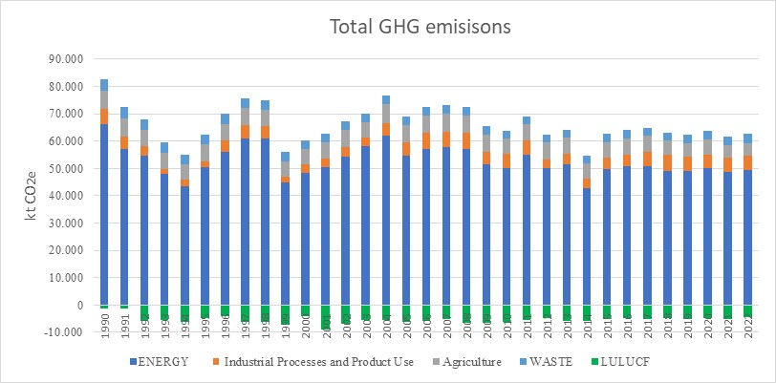
The national GHG emissions of the Republic of Serbia including the LULUCF contribution amount 58.2 Mt CO₂e in 2022, and decreased of 27.6% compared with 1990, and follow a similar trend to the emissions including the LULUCF contribution. This overall trend does not enable to observe the different trends depending on the GHG considered. Without considering LULUCF, the national CO₂ emissions decreased by 23% in 2022, compared with 1990, whereas CH₄ and N₂O decreased by 29% and 12%, respectively, over that same period.

In 2022, the contributions of the different GHG to the national emissions excluding LULUCF are rather similar to the ones observed in 1990, with CO₂ the most predominant substance with 82,2%, followed by CH₄ (13,9%) and N₂O (3.5%), whereas the other substances contribute more negligibly with 0.1% for SF₆ and 0.3% for HFCs. Nevertheless, it is important to notice the increasingly HFC emissions, related to the use of refrigerants, which were not occurring in 1990.
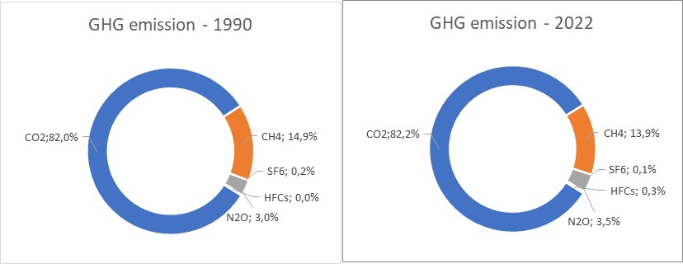

ES.3. Overview of source and sink category emission estimates and trends

The energy sector is the predominant source of GHG emissions in 2022 (as well as over the whole period), in the Republic of Serbia, contributing to 78.8% of the national GHG emissions without considering LULUCF contribution. The industrial process and product use, agriculture and waste sectors respectively contribute to 8.2%, 7.8% and 5.1% of the national GHG emissions excluding LULUCF, for the year 2022. Since 1990, all contributions have been varying but are rather stable in 2022, compared with 1990. Meanwhile the relative contribution of the energy sector (CRT 1) has slightly decreased, which was of 80.2% in 1990, while the industrial processes and product use (CRT 2) increased from 6.7%, to 8.2%, over the same period.
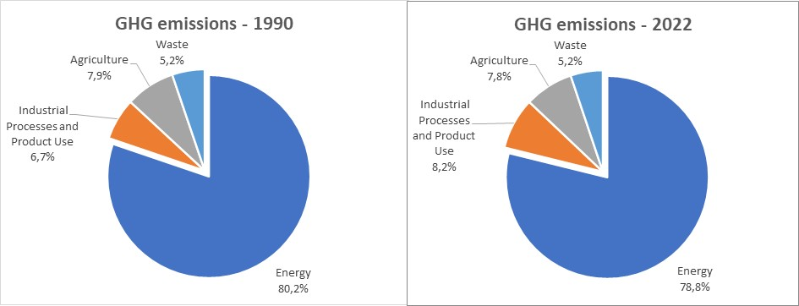
Key trends between 1990 and 2022 include:
- a significant decrease in the fugitive GHG emissions of oil and natural gas systems (CRT 1B2, -62%), in particular due to the downfall of flaring in refineries,
- a considerable decrease of CO₂ and N₂O emissions of the chemical industry (CRT 2B, -78% in CO₂e), in particular following the shutdown of ammonia and nitric acid plants, compensated by the increase in CO₂ emissions from iron and steel production (CRT 2C1, +81%),
- the important increase in CO₂ emissions from the use of urea in agriculture (CRT 3H, +574%), accompanied with the significant increase in direct N₂O emissions related to application of inorganic fertilizers (CRT 3.D.a.1, +598%), but which do not compensate in CO₂e the decrease in CH₄ emissions of the enteric fermentation (CRT 3A, -44%) for the global agriculture sector (-24% in CO₂e),
- the large increase of the negative emissions of CO₂ of the LULUCF sector, which more-than-tripled between 1990 and 2022 (+222%), mostly due to the growing forest (CRT 4A, +133%).
In 2022, the CO₂ balance for LULUCF is a net removal which represents more than 7% of the total GHG emissions without LULUCF contribution, expressed as CO₂ equivalent (i.e., 4.5 Mt CO₂e).

ES.4. Other information - indirect GHGs

For the indirect emissions the SEPA is using inventory system for Air Pollutants established and maintained under the Convention on Long Range transboundary pollution. This system is sharing activity data with GHG Inventory system where applicable and building on EMEP methodology and emission factors.
Between 1990 and 2022, there was a downward trend in mass emissions of the three gases which indirectly contribute to the greenhouse effect: 70.2% for sulphur dioxide, 43.9% for carbon monoxide and 46.5% for non-methane volatile organic compounds, while emissions of nitrogen oxides increased for 1%.

The emissions of NOx increased mostly due to the growth in the road transport emissions, which have gone up by 54% over the timeseries and now contribute to 41% of the national emissions. The SO₂ emissions have fallen mostly due to the decline in the solid fuel consumption for the public heat and electricity production (CRT 1A1a), as well as due to national regulations, which have reduced its emissions by 33% meanwhile it represented more than 90% of the national emissions in 1990. The NMVOC emissions, which are more evenly distributed among subsectors, have been reduced due to the drop in the evaporative exhaust from road vehicles, the decline in the coal mining, the fall in the livestock of cattle, and the decrease in the Serbian population which has a direct impact on solvent consumption. Finally, the CO emissions have principally decreased due to the improvement of the exhaust emission levels from road vehicle, whereas an increase is observed in some industrial sectors due to increasing productions.

ES.6. Key category analysis

According to the Good Practice Guidance and Uncertainty Management in National Greenhouse Gas Inventories, key categories are those which represent 95% (Tier 1) or 90% (Tier 2) of the total annual emissions in the last reported year or belonging to the total trend, when ranked from contributing the largest to smallest share in annual total and in the trend.
In 2022, in terms of emission levels, the principal key categories in the Republic of Serbia are the public electricity and heat production by solid fuels (CRT1A1a-CO₂: rank 1, 45.5% contribution), the liquid fuel combustion in road transport (CRT 1A3b-CO₂: rank 2, 12.7%), the iron and steel processes (CRT 2C1-CO₂: rank 3, 4.2%), the solid waste disposal (CRT 5A1-CH₄: rank 4, 3.9%) and the public electricity and heat production with burning of gaseous fuels (CRT 1A1a-CO₂: rank 5, 3.9%). They represent more than 70% of the whole national GHG emission totals, excluding LULUCF. In overall, 40 emission sources constitute the key categories in emission levels in 2022 in the Republic of Serbia, excluding LULUCF.
While considering the LULUCF emissions, the main key categories are relatively the same, but the CO₂ emissions related to the forest land remaining forest land (CRT 4A1) comes in 3rd position with a contribution of 6.7%. Only three LULUCF subcategories are in the emission level key categories analysis while considering LULUCF contribution, and the total number of key categories increases up to 46 emission sources in 2022.
In terms of emission trend, in 2022, the similar emission sources are responsible for the major changes but in a different order, excluding LULUCF: CO₂ from road transport with liquid fuels (rank 1, 16.6%), due to its large increase, CO₂ from public electricity and heat production burning solid fuels (rank 2, 5.9%) and gaseous fuels (rank 3, 5.6%), CO₂ from iron and steel processes (rank 4, 5.1%), and finally the burning of solid fuels in residential sector (CRT 1A4b: rank 5, 4.6%). These five main key categories contribute only to 38% of the total trend contribution. Hence, a total of 59 emission sources constitutes the key categories in trend in 2022, in the Republic of Serbia, excluding LULUCF.
Considering the LULUCF contribution, the five main key categories in terms of trend assessment are relatively the same, except with the forest land remaining forest land which comes in 2nd position with a contribution of 8.2% in 2022. 11 emission sources from LULUCF represent key categories in trend assessment in 2022. In total, considering the LULUCF emissions, a total of 70 emission sources constitutes the key categories in trend assessment in 2022, in the Republic of Serbia.

ES.6. Improvements introduced

Since the latest inventory submission, various improvements have been implemented in terms of GHG emission inventory exhaustivity, completeness, accuracy and coherence, as well as on the transparency in terms of reporting. Among them, remarkable improvements which could be mentioned:

- The executive summary and Chapter 2 about trends have been added into the NID,
- The reference approach has been further developed and reported in the NID,
- The subsector chapters have been completed with further analysis of activity data and reporting of methodologies,
Some timeseries about the emission calculation have been completed, such as for the CRT 1A4ci (2005-2006) and 1A4cii (1990-2006),

Chapter 1: Introduction

Background information on GHG inventories and climate change

General framework

The United Nations Framework Convention on Climate Change (hereinafter: the Convention – UNFCCC) was adopted and signed at the Earth Summit in Rio de Janeiro, Brazil, in June 1992. The Convention entered into force in March 1994. The Kyoto Protocol (hereinafter: the Protocol) to the Convention, was adopted at the third session of the Conference of the Parties, held in December 1997 in Kyoto, Japan.

The Republic of Serbia has been part of the United Nations Framework Convention on Climate Change (UNFCCC) (Convention) since 2001 and the Kyoto Protocol (hereinafter: Protocol) since 2008 as a developing country (non-Annex I country). The Ministry of Environmental Protection (MEP) is the National Focal Point for the implementation of the Convention and the Protocol. The Republic of Serbia, as a non–Annex I state member of the Convention, in line with its capabilities and principles of sustainable development, endeavors to contribute to the fulfilment of the primary goals of the Convention.

The Republic of Serbia harmonized national legislation with the EU legislation framework in the field of climate change and is continuing with the process of further alignment. This process will also contribute to the improvement of fulfilling the obligations of the Republic of Serbia under the UNFCCC and Paris Agreement, aiming at increasing its capacity to be able to fulfil the Annex I Party reporting requirements. As a result of this process, institutional and legislative structure for monitoring, reporting and verification of GHG emissions from stationary installations – as a prerequisite for EU Emission Trading System, as well as information relevant to climate change was established. Within this structure Serbian Environmental Protection Agency took an important role of technical assessment of Monitoring Plans from stationary installations.
The Republic of Serbia has updated National Determined Contribution (NDC), in accordance with the Articles 3 and 4 of the Paris Agreement and paragraphs 22 and 24 of Decision 1 CP/21. This led to increasing its ambition to the GHG emission reduction by 13.2% compared to 2010 level (i.e. 33.3% compared to 1990) by 2030.

National GHG inventories

In the framework of the Convention, the annual greenhouse gases (hereinafter: GHG) inventory should be transparent, consistent, comparable, complete and accurate.

- Transparency means that the data sources, assumptions and methodologies used for an inventory should be clearly explained, in order to facilitate the replication and assessment of the inventory by users of the reported information. The transparency of inventories is fundamental to the success of the process for the communication and consideration of the information. The use of the common reporting format (CRT) tables and the preparation of a structured national inventory report (NID) contribute to the transparency of the information and facilitate national and international reviews;

- Consistency means that an annual GHG inventory should be internally consistent for all reported years in all its elements across sectors, categories and gases. An inventory is consistent if the same methodologies are used for the base and all subsequent years and if consistent data sets are used to estimate emissions or removals from sources or sinks. An inventory using different methodologies for different years can be considered to be consistent if it has been recalculated in a transparent manner, in accordance with the 2006 IPCC Guidelines for National Greenhouse Gas Inventories (hereinafter referred to as the 2006 IPCC Guidelines);

- Comparability means that estimates of emissions and removals reported by Annex I Parties in their inventories should be comparable among Annex I Parties. For that purpose, Annex I Parties should use the methodologies and formats agreed by the COP for making estimations and reporting their inventories. The allocation of different source/sink categories should follow the CRT tables provided in annex II to decision 24/CP.19 at the level of the summary and sectoral tables;

- Completeness means that an annual GHG inventory covers at least all sources and sinks, as well as all gases, for which methodologies are provided in the 2006 IPCC Guidelines or for which supplementary methodologies have been agreed by the COP. Completeness also means the full geographical coverage of the sources and sinks of an Annex I Party;

- Accuracy means that emission and removal estimates should be accurate in the sense that they are systematically neither over nor under true emissions or removals, as far as can be judged, and that uncertainties are reduced as far as practicable. Appropriate methodologies should be used, in accordance with the 2006 IPCC Guidelines, to promote accuracy in inventories.

Under the Convention, the annual GHG emission inventory covers:

- The period 1990-202022. The year 1990 should be the base year for the estimation and reporting of inventories.
- Seven direct GHG: carbon dioxide (CO₂), methane (CH₄), nitrous oxide (N₂O), halogenated carbons (HFC, PFC), sulfur hexafluoride (SF₆), nitrogen fluoride (NF₃).
- Four indirect GHG: Sulphur dioxide (SO₂), carbon monoxide (CO), non-methane volatile organic compounds (NMVOC), oxides of nitrogen (NO_{x}).
- Five main activity sectors: Energy, Industrial Processes and Product Use, Agriculture, Land Use, Land-Use Change and Forestry, and Waste.

The Republic of Serbia has examined whether there are activities which would result in emissions of trinitrogenfluoride (NF₃) and perfluorocarbons (PFCs), and our assessment is that there are no emissions of these two substances on the territory for the covered period.

Global warming potentials (GWP)

In order to assess the relative impact of each GHG on climate change, the global warming potential (GWP) has been defined. It corresponds to the radiative effect that one GHG can exert over a period of a hundred years, in comparison with CO₂ for which the GWP is determined as 1. The GWP applied are the values provided by the UNFCCC, which currently corresponds to the values from the 2019 IPCC 5th Assessment Report (AR5), which are as follows:

GWP CO₂ | GWP CH₄ | GWP N₂0 | GWP SF₆ | GWP NF₃
1 | 28 | 265 | 23 500 | 16 100

GWP
HFC-125 | HFC-134a | HFC-143a | HFC-152a | HFC-227ea | HFC-365mfc | HFC-23 | HFC-4310mee | HFC-32 | HFC-245fa
3 170 | 1 300 | 4 800 | 138 | 3 350 | 804 | 12 400 | 1 650 | 677 | 858

GWP
PFC-14 | PFC-116 | C₃F₈ | c-C₄F₈ | C₄F₁₀ | C₅F₁₂ | C₆F₁₄ | C₁₀F₁₈*
6 630 | 11 100 | 8 900 | 9 540 | 9 200 | 8 550 | 7 910 | 7 190
* the GWP for C₁₀F₁₈ is taken as 7 190, but is indicated as “> 7 190” in the IPCC AR5)

The four other substances which have an indirect impact on the greenhouse effect as primary substances acting on the formation of secondary pollutants such as ozone (O₃) or aerosols are:

- CO, which can get oxidized in the atmosphere into CO₂,
- NMVOC and NO_{x} (expressed in equivalent NO₂), which can interact in complex chemical reactions into the atmosphere to form ozone, which contributes to the greenhouse effect,
- SO_{x} (expressed in equivalent SO₂), which have an indirect cooling action on the climate through the contribution to aerosol formation with a relatively high albedo.

Changes in the national inventory arrangements since the previous annual GHG

This National Inventory Document under the BTR1 report is the first one reported in the format as requested by Decision 18.CMA.1 in format detailed by the Decision 5/CMA.3. In addition to the preparation of the National Inventory Report Serbia adjusted its GHG inventory compilation structure in order to be ready to upload the CRT Tables for the whole timeseries between 1990.2022.

A description of the national circumstances and institutional arrangements

National entity or national focal point
Legal framework
The current Serbian legal framework contains different laws and legal texts which can be useful for the preparation of the national GHG inventory (not exhaustive):
- Law on climate change (OJ No 26/21)
This Law regulates the system for the limitation of greenhouse gas emissions (hereinafter: GHG) and for adaptation to changed climatic conditions, monitoring and reporting on the low-carbon development strategy and its improvement, the program of adaptation to changed climatic conditions, the adoption of the low-carbon development strategy and the program of adaptation to changed climatic conditions, the issuance of permits for GHG emissions to the operator of the installations, Issuance of approvals for the aircraft operator's monitoring plan, monitoring, reporting, verification and accreditation of verifiers, administrative fees, oversight and other issues relevant to the limitation of GHG emissions and adaptation to changed climatic conditions.
Chapter V the law defines National GHG inventory system for monitoring and reporting national GHG emissions in Serbia and establishes a comprehensive framework for managing and reporting greenhouse gas emissions.
National Entity
Article 58 of the Law on Climate Change mandate Environmental Protection Agency as national entity for to establishes and maintains a GHG Inventory system and prepares a relevant GHG Inventory Reports.
ENVIRONMENTAL PROTECTION AGENCY
Žabljačka 10a, 11160 Belgrade, Republic of Serbia
+381(0)11 6356788
+381(0)11 6356793
office@sepa.gov.rs
https://sepa.gov.rs/

In addition to the Law on climate change Serbia developed relevant sub- laws for implementation of the provisions of the Law such as:
- Rulebook on the contents of the national GHG inventory and national report on GHG inventory (OJ No 55/23)
- Regulation on types of data, bodies and organizations and other natural and legal persons submitting data for the creation of the national GHG inventory (OJ No 43/23)
- Rulebook on monitoring and reporting of GHG (OJ No 118/23)
Those sub-laws are complemented by additional legal framework established in the context of the Law on Air Protection such as:
- Ordinance on the methodology for the development of national and local register of pollution sources and on the methodology and deadlines for data collection (OJ No 91/10, 10/13)
- Regulation on fluorinated greenhouse gases management, as well as on conditions for license issuance to import and export of such gases (OJ No 120/13),
Institutional and procedural arrangements
In terms of organizational arrangements, a centralized model has been applied in the Republic of Serbia. From an institutional point of view, the Ministry of Environmental Protection (MEP) is the National Focal Point for the UNFCCC Convention.
As the UNFCCC National Focal Point and responsible of the National GHG Inventory, the MEP /Sector for International Cooperation, Projects and Climate Change proceeds at the relevant frequency to:
- the official approval of the national emission inventory and the national inventory report prepared by the Inventory Agency;
- the official communications and reporting of the national inventory to the UNFCCC.
The inventory preparation is under the responsibility of Serbian Environment Protection Agency (SEPA). SEPA undertakes all activities such as data collection and preparation of emission reporting, according to CRT nomenclature, and the national GHG inventory report. All data which are necessary for the preparation of these products are collected by SEPA.
Law on Climate change mandates SEPA to conclude an agreement with the institutions and organizations responsible for the management or management of information systems and databases containing the data necessary for the preparation of the GHG Inventory, which shall determine the obligations of these institutions and organizations, in particular the data, deadlines, form and manner of their submission to the Agency.
The institutions and scope of data are to be reported are in detail defined by the Regulation on types of data, institutions and organizations and other natural and legal persons submitting data for the creation of the national GHG inventory (OJ No 43/23).
In addition, the Law requires from SEPA to develop and implement the Quality Assurance and Data Quality Control (QA/QC) Plan for the purpose of developing and improving the quality of the GHG Inventory. Furthermore, the law requires that the Agency coordinate activities with the authorities and organizations in order to ensure the quality and ensure data quality control in accordance with the plan.
In addition, the laws also requires that the bodies and organizations act in accordance with the procedures referred to in the plan and shall inform the Agency of all implemented and planned changes, accompanied by an explanation.

Inventory preparation process
Process of inventory preparation involves several steps starting with activity data collection and followed by emission estimations and recalculations, compilation of inventory including the NID and the CRT and, in parallel, implementation of general and source-category specific quality control procedures.
Process of preparation of the GHG inventory represents significant works because it includes many of national institutions and experts, and it requires different databases and/or data sets.
A synthetic description of the input elements, output elements for each activity of emission inventories is presented in the table below.
Table 1: Synthetic description of the input and output elements for each activity emission inventories

Figure 1: General process diagram for the preparation of the national emission inventory, with QA/QC procedures
For details on QA/QC procedures, see annex 4.
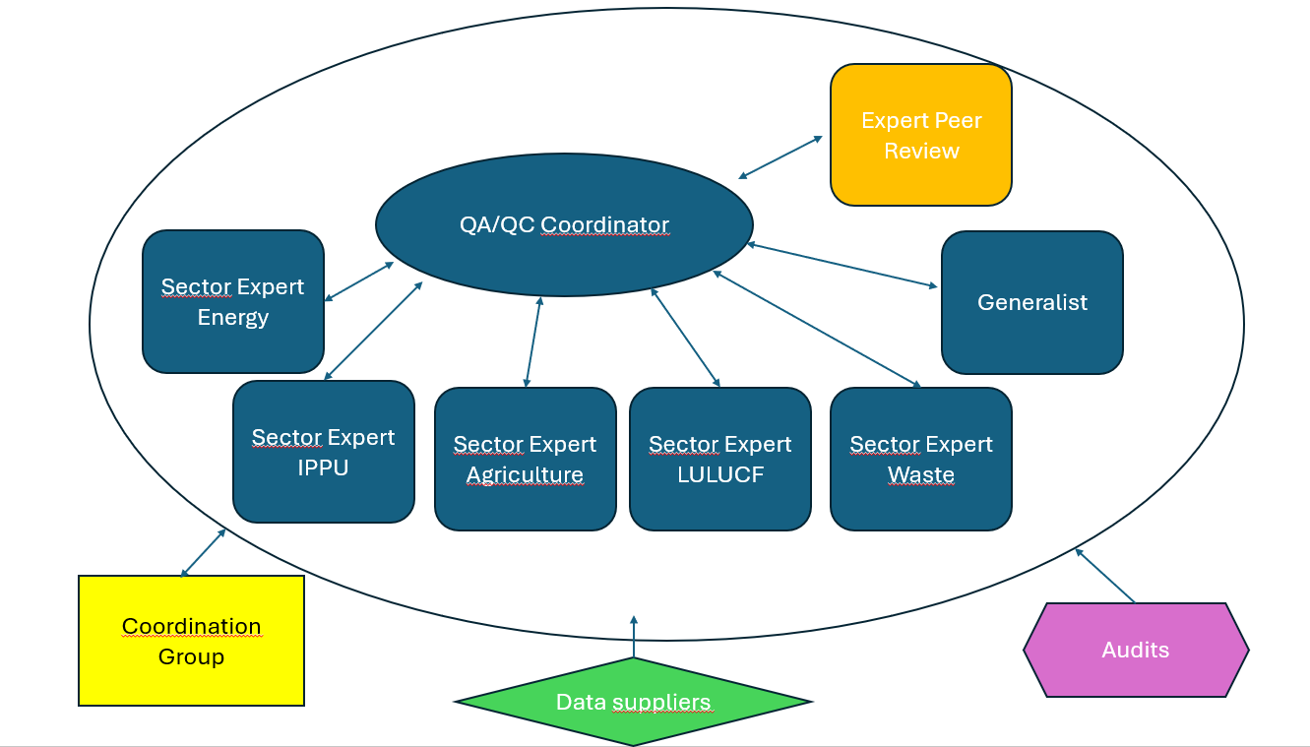

With the aim of ensuring the sustainability of the process, the data bases produced during the process of preparation of the GHG inventory are located in the Environmental Protection Agency of the Republic of Serbia.
Activity data collection is under responsibility of SEPA, which represents a hub between governmental and public institutions responsible for providing activity data and Authorised Institution responsible for inventory preparation.
For this submission, some confidential data are used and cannot be reported. This concerns mostly industrial sectors where only one plant constitutes the whole subsector. CRT sectors where confidential data are used are the CRT categories 2B1 (ammonia), 2B2 (nitric acid), 2C1 (iron and steel) and 2C4 (magnesium).
The scope and due dates for delivering activity data to SEPA are defined within the national inventory system.
Planning
A detailed and operational inventory planning is prepared by the Inventory Manager for the internal coordination of the works within the SEPA. In the framework of the preparation of the national emission inventory, the inventory manager prepares an internal schedule for the inventory team to follow the UNFCCC reporting deadlines.
Management
The following schema presents the emission inventory management system in the Republic of Serbia.

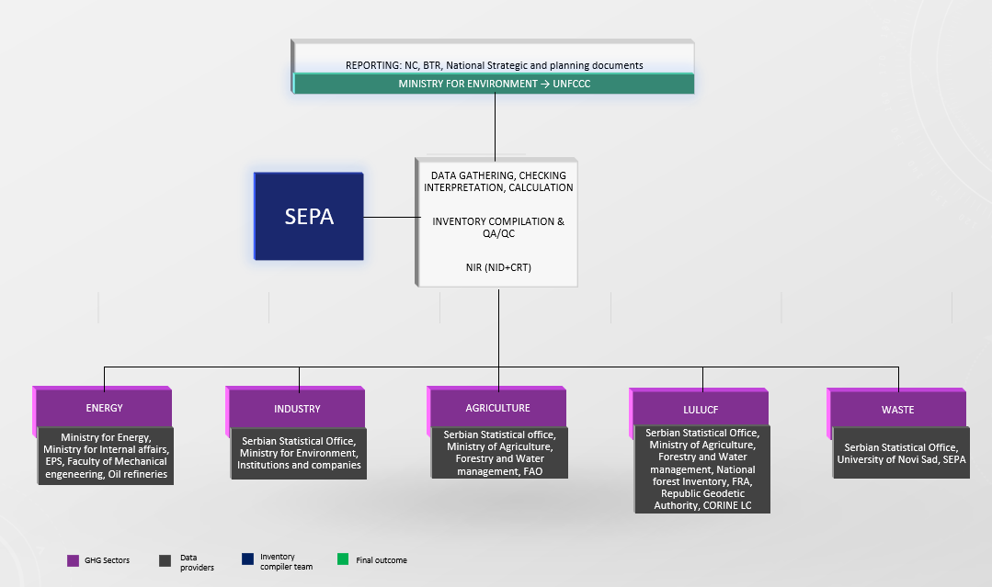

Preparation
The elaboration of the national inventory is realized by sectoral experts in SEPA.
The process of Greenhouse Gas (GHG) inventory preparation involves several stages to ensure accurate reporting of a country's emissions. Serbia’s GHG inventory is compiled annually to ensure proper tracking of its NDC target and is biennially submitted to the UNFCCC. The preparation process can be broken down into the following key steps taking into account the regulatory framework is in place:

1. Identification of Emission Sources
SEPA experts identifies all relevant sectors contributing to GHG emissions, which include:
- Energy ( e.g. fossil fuel combustion, electricity generation, etc…)
- Industrial Processes (e.g. cement production, iron and steel production, F gasses consumption, etc…)
- Agriculture (e.g. livestock emissions, fertilizer use, etc…)
- Land-Use and Forestry (e.g. change in land uses, forest gains and losses, etc…)
- Waste (e.g. solid waste disposal, wastewater treatment, etc…)
It Has to be noted that the pool of available data is improving because of adoption and implementation of relevant MRV related legislation. In year 2025 Republic of Serbia is expecting to start using the information from the verified emission reports installations are preparing in accordance with the approved monitoring plans, as additional source of information for preparation of the GHG estimates from Energy industries, Manufacturing industries and for preparation of the emission estimates from selected industrial process falling under the scope of the Regulation on types of activities and greenhouse gases "Official Gazette of RS", No 13 of 4 February 2022.

2. Data Collection
The core of GHG inventory preparation is the collection of activity data, such as fuel consumption, industrial output, or agricultural practices. This data can are sourced from various sources, including government reports, industry statistics, or specialized surveys. Law on Climate change is mandating SEPA to request from institutions and organisations any data it might need annually for the compilation of GHG Inventory.

3. Application of appropriate IPCC methodology
The IPCC Guidelines provide the international standard for calculating GHG emissions. Serbia uses either:
- Tier 1 methods, which are simple and rely on default emission factors.
- Tier 2 or 3 methods, which involve more detailed calculations using country-specific data or direct measurements.
4. Emission Factors
Selections of appropriate emissions factors is driven by the IPCC decision trees applicable for every category. Serbia in many sectors still rely on default values as contained in the 2006 IPCC Gudelines for preparation of GHG Inventory ( where appropriate SEPA uses 2019 Refinement of the IPCC guidelines) or develop country-specific emission factors that reflect local conditions for most significant fuels such as domestic lignite.

5. Compilation and QA/QC
After calculating emissions from each sector, the data is compiled into a national GHG inventory. This process includes quality assurance/quality control (QA/QC) measures to check for errors, inconsistencies, or gaps in the data. External reviews or independent audits might be conducted as part of this process.

6. Uncertainty and key source analysis
Since all inventories are based on estimates, SEPA experts assess the uncertainty of their data and methods. Uncertainty analysis helps in identifying the most uncertain areas of the inventory, guiding improvements for future submissions. Alongside with uncertainty analysis SEPa experts performs the key source assessment and check if emissions from specific gas and category fall under or falls out of the 95% of most significant lever/trend categories.

7. Approval and reporting
Once the inventory is complete, SEPA must submit to MEP for consideration and approval. Report it using a standardized format, while numerical information is submitted via ETF Reporting tool which is ensuring transparency and comparability of emissions data between countries. The NID is submitted through conventional UNFCCC submission channels as annex to the BTR.

8. Continuous Improvement
Serbia is committed to continuously improve their GHG inventories by refining their data collection, methods, and reporting procedures. This iterative process where the UNFCCC review process play an important role is supported by Serbia’s international collaboration, capacity-building initiatives, and significant technical support pipelines Serbia can use as EU candidate country.

Archiving information
The reporting guidelines in decision 24/CP.19 identify what a Party should archive:
- Disaggregated emission factors and activity data,
- Documentation of data collection, assumption, and aggregation,
- Internal documentation on QA/QC procedures,
- External and internal reviews,
- Documentation on annual key sources,
- Planned inventory improvements.
In order to ensure transparency about the emission calculation and the archiving of data, the inventory team annually prepares and updates emission inventory Excel sheets, which contain several information about the process of emission estimation. In each file, divided by CRT category, all details can be found on the person and organization responsible, the major changes throughout different reporting, the references used for activity data and the applied emission factors, the methodologies of calculation applied, eventual data gaps, suggestions for future improvement and other relevant bibliographic references. The information provided in these files is available for each source category and for the entire time-series. All files and data related to these emission inventory sheets are archived by SEPA for each submission. That includes achieving all emission factors and activity data along with all relevant references, which are clearly numbered in every calculation sheet. References itself are contained in every category folder under subfolder “References”. Calculation files also include the segment dedicated to QC activities with information on who and when performed those activities and what is the outcome and if appropriate what kind of corrective actions are needed. Where appropriate all assumptions are documented and archived together with calculation files. The results of the External and internal reviews are also archived. It has to be noted that Serbia benefited from the QA activities performed by the UNFCCC and prepared a separate document on the necessary improvements and its priority levels. Special attention and priority is given to improvements affecting accuracy and completeness of emission estimates since these principles affect the processes related to future target setting the most.

Processes for official consideration and approval of inventory
During the preparation of the inventory, several checks are performed by sector experts from SEPA to avoid miscalculations, and in order to ensure completeness, consistency and comparability of the emission inventory. In addition, methodological changes and recalculations, as well as uncertainties on activity data, emission factors and emission estimates are analysed during the NIR preparation. All details on these issues are elaborated in the NIR for each sector, subsector and corresponding CRT.

Before SEPA submits the NIR to MEP, QA/QC manager carried out an audit which covers selected IPCC source categories, as outlined in the QA/QC plan, with purpose to check which quality control elements, both general (Tier 1) and specific (Tier 2), as defined in the IPCC Good Practice Guidance, are already implemented by sector experts and which improvements and corrective actions should be carried out in the future submissions. CRT tables for each sector are reviewed in accordance with the Quality Management Standard (ISO 9001) and Environmental Management Standard (ISO 14001) implemented within the Authorized institution. Audit results are registered in control lists as well as performed correction activities.
In addition, the coordination group of national inventories is also part of the approval process, as mentioned in the Chapter 1.5 on QA/QC. Thus, its members provide their opinion on certain parts of the Inventory within the frame of their speciality and approve the methodological changes implemented.

Finally, the Ministry of Environmental Protection, as UNFCCC focal point, approves the inventory before official submission to the UNFCCC. As a basis for approving the inventory, the MEP will assess the completion of the GHG Inventory and the NID.

Brief general description of methodologies (including tiers used) and data sources used

Methodology
The GHG inventory for the Republic of Serbia was prepared according to the 2006 IPCC Guidelines for National Greenhouse Gas Inventories, as well as the 2019 IPCC refinement for some emission sources, for emission estimations of greenhouse gases which result from anthropogenic activities: CO₂, CH₄, N₂O, HFCs, PFCs, SF₆ and NF₃. For some subsectors, the IPCC 2019 refinements have been implemented but this is not the case for all subsectors concerned yet. The emission calculations are developed for each emission source according to the CRT nomenclature.
The emissions for one specific activity data are estimated through the generic formula and following mechanism:
$$E_{s,a,t}=A_{a,t}×{EF}_{s,a}$$ | (1)
with E: emission related to the substance "s" and the activity "a" during the time period "t",
A: activity data related to activity "a" during the time period "t",
EF: emission factor related to substance "s" to the activity "a".
The associated emissions from one subsector are equal to the sum of the different emissions for the activities included in the subsector.
The major part of the methodologies applied to estimate emissions is Tier 1 and relates to the multiplication of activity data (e.g. fuel consumption, manufactured product production, etc.) with default emission factors from the IPCC Guidelines. In some cases, a Tier 2 methodology is applied when already possible for this inventory according to IPCC 2006 (e.g. lignite combustion in thermal power plants, product use as ODS substitutes, manure management).
Under the framework of the Tier 1 Method, the internationally recommended values for emission factors for all fossil fuels (solid, liquid and gaseous) and biomass were used, except for open pit mined lignite used in thermal power plants where a national emission factor is applied. The lignite produced and used in the Republic of Serbia, due to its characteristics, has a significantly lower net calorific value and a higher emission factor value than the default IPCC values. In addition, the net calorific values used in the Serbian inventory are country-specific values taken from the national energy balances.
The methodologies applied into the GHG emission inventory are summarized in the following Table 2 and Table 3.
Table 2: Methodology employed by CRT for emission estimate and emission factors used (1/2)
Table 3: Methodology employed by CRT for emission estimate and emission factors used (2/2)

Data sources
In the framework of the preparation of the emission inventory, a large amount of data must be collected. Data sources can be:
- Activity data and associated characteristic values (such as fuel consumption, raw material consumption, net calorific value, production, etc.)
  - Examples of sources: international statistics, national statistics, local statistics, governmental agencies, professional bodies, reporting data from individual plants, possible default parameters available in models.
- Emission factors and associated variables (such as emission factor, oxidation factor, conversion factor, carbon content, biomass content, sulphur content, etc.)
  - Examples of sources: international guidebooks, international web databases, sectoral documents, scientific articles, expert judgments, data within calculations tools / models.
A data source has to be available for all reported years (as far as possible, else estimation/extrapolation procedures are needed cf. IPCC 2006), available at a reasonable cost, traceable, transparent, reliable, registered and archived. In addition, to apply higher Tier methods, activity data with higher degree of precision are necessary, which can be hard to collect.
The primary sources of the activity data for the GHG inventory were provided by the Statistical Office of the Republic of Serbia (e.g. statistical yearbook, energy balance). In addition, for CRT subcategories 2C1, 2C4 and 2G1, data about activity data and emissions are directly obtained from facilities (bottom-up approach).

Emission factors applied are mostly default values provided in 2006 IPCC Guidelines.

Brief description of key categories
According to IPCC recommendations, a key category analysis (KCA) is developed in this chapter, based on the contribution of GHG emissions (expressed in CO₂e) for each CRT category and direct GHG. In addition, for combustion activities (i.e., CRT 1A), the key categories are determined per type of fuel. Key categories are defined as the sources of emissions which have a significant influence on the inventory as a whole, in terms of absolute level of emissions, uncertainty or trend. In Approach 1, key categories are identified using a pre-determined cumulative emissions threshold.

The following tables summarize the key source categories, for the latest inventory year (2022), and the base year (1990), derived from the IPCC Approach 1 key category analyses (KCA). Results are presented for the analysis with and without LULUCF contribution.

Approach Tier 1

According to the 2006 IPCC Guidelines for the Tier 1 approach, key categories are those contributing in the accumulative 95% of the total emissions in level or in trend analysis, when ranking from the largest to smallest contributions in level and in trend.
Tier 1 analyses were performed at a detailed level of IPCC source categories and each greenhouse gas from each source category was considered separately with respect to its total CO₂e emissions.

The results from the key category analyses of the CRT reporter are presented in Annex 1. The Republic of Serbia has carried out a key-category analysis on a more-detailed category level than the one recommended, which is presented in the following tables. Excluding LULUCF contribution, the Tier 1 analysis identified 40 key categories on level of emissions, for the year 2022, and 59 key categories on trend between 1990 and 2022.

A comparison of the key-category analysis carried out within the CRT Reporter and Serbia's key-category analysis has found that the two analyses differ because of different choices of definition of category levels for the KCA. Indeed, differences of approach are apparent; for example, Serbia divides agricultural or F-gases sectors into sub-categories (e.g. 3.D.1.2.a and 3.D.1.4 in Serbia‘s approach vs 3D1 within the CRT Reporter approach, or 2.F.1.f for stationary air conditioning in Serbia‘s approach vs 2F1 with CRT Reporter approach, etc.). The resulting numbers of key categories are consequently quite different between these two approaches.

In 2022, the first key category is the CO₂ emissions from the combustion of solid fuels in public electricity and heat production (CRT 1A1a) with almost half of the total emissions in the Republic of Serbia (45.5%, excluding LULUCF). The emissions of CO₂ in the road transport sector (CRT 1A3b) are the second highest contribution to the national GHG totals with 12.7% of the total emissions. Then, the emissions of CO₂ from iron and steel production (CRT 2C1a) constitute the third key category with 4.2% of the total emissions. Methane emissions from managed waste disposal (CRT 5A1) is the fourth highest contribution over the territory in 2022 with 3.9%, followed by CO₂ emissions from gaseous fuel combustion in public electricity and heat production (CRT 1A1a) with 3.9% as well.
Among the 40 key categories (95% of total emissions), CO₂ represents 80.7% of total GHG emissions excluding LULUCF.

In terms of trend of emissions between 1990 and 2022, excluding LULUCF contribution, similar emission sources as in the level assessment analysis constitute the principal key categories. The CO₂ emissions from road transport (CRT 1A3b) is the first key category with 16.6%, due to the large increase in emissions and its significant level contribution. Then, the public electricity and heat production (CRT 1A1a) follows in second and third positions, with the CO₂ emissions related to the combustion of solid and gaseous fuels, respectively. Nevertheless, contrary to the key category in level in 2022, 9 key categories in trend assessment are necessary to represent more than 50% of the national contribution, meanwhile only 2 would contribute to 58% in level assessment.

Considering LULUCF emission sources and removals in absolute values, 46 key categories represent 95% of the national GHG emissions in level in 2022 whereas there are 70 key categories in trend assessment between 1990 and 2022. Three LULUCF sectors are among the key categories while considering LULUCF contribution, and the most predominant is the forest land remaining forest land (CRT 4A1), which is a sink, and is the third key category in level assessment with LULUCF in 2022 with a contribution of 6.7%. The other two subsectors which are key categories are the harvested wood products (CRT 4G) and the forest land converted to settlements (CRT 4E21), but with less significant contributions, at the 30th and 46th positions.

Approach Tier 2

For the next submission, implementation of the key category analysis on the basis of Tier 2 approach could be carried out. Such Tier 2 approach will be mixed with KCA Tier 1 and uncertainties.

Table 4: Key Category Analysis for the 2022 based on level of emissions (including LULUCF)

Table 5: Key Category Analysis for the 2022 year based on level of emissions (excluding LULUCF)

Table 6: Key Category Analysis based on trend in emissions (from base year 1990 to 2022, including LULUCF)

Table 7: Key Category Analysis based on trend in emissions (from base year 1990 to 2022, excluding LULUCF)

Brief general description of QA/QC plan and implementation
The development of an emission inventory is a complex task in the light of:
- The large number of data to manipulate,
- The great diversity of quantitative and qualitative sources of information,
- Methodologies to be implemented to best quantify each activity,
- The need to provide information as relevant and accurate as possible while respecting the constraints of resources and deadlines,
- Ensuring respect of the fundamental qualities of inventories (TACCC principle: Transparency, Accuracy, Consistency, Comparability, Completeness).
A quality control and quality assurance system is essential to achieve these tasks.

QA/QC procedures have been defined by listing a set of tasks to be carried out depending on the function of the inventory actor (see Annex 4) and the type of QA/QC activities. Nevertheless, it has to be mentioned that the Serbian Inventory system is under construction to fully answer EU and UNFCCC Annex I requirements in that field. Thus, all tasks listed for the QA/QC activities are not yet carried out. They can be applied, partially applied or not applied.

In Annex 4, QA/QC procedures are positioned along with the inventory process. The QA/QC activities concerned different steps of the inventory and different actors:

QA/QC Activities | Actors / Function
Q1: coordination and planning | (1) sectoral expert
Q2: data sources | (2) inventory manager
Q3: emissions calculations | (3) coordination group of national inventories
Q4/Q5: data reporting | (4) ETS expert
Q6/Q7: National Inventory Report | (5) Inventory manager or sectoral experts
Q8/Q9/Q10: Proxy GHG inventories (X-1) | (6) CRT reporter expert
 | (7) Ministry in charge of Environment
 | (8) NID expert
 | (9) Proxy expert

General uncertainty evaluation
The 2006 IPCC Guidelines characterize determination of uncertainties as a key element of any complete inventory. As a result of the need to continually improve the inventories, the uncertainty analysis plays an important role. The uncertainty analysis is used primarily to define priorities for improving the precision of emission inventories, as well as for selecting methods and carrying out recalculations for inventories.

Uncertainties are quantified for emission factors and activity data, then combined uncertainties for emission estimations are estimated according to IPCC guidelines.

In general, two methods for determining uncertainties are distinguished. The Tier 1 method combines, in a simple way, the uncertainties in activity data and emission factors, for each category and greenhouse gas, and then aggregates these uncertainties, for all categories and greenhouse gases, to obtain the total uncertainty for the GHG emission inventory. The Tier 2 method for uncertainties determination and aggregation is based on Monte Carlo simulation processes considering the distribution functions for the different parameters and variables of emissions calculations.

In the present NID, Serbia reports uncertainties that have been calculated pursuant to the Tier 1 method. The uncertainties for the activity data and emission factors used were taken from expert judgments and literature.

The results from the uncertainties are summarized in Annex 2.

The total national emissions of GHG, including LULUCF, in 2022 are estimated with an uncertainty of 8.4%. In 2022, the sector contributing the most to the overall inventory uncertainty including LULUCF is the CH₄ emissions of the solid waste disposal (CRT 5A) with a combined uncertainty of 7.4% of the national total. The major emission source of the inventory, the CO₂ emissions from the solid fuel combustion of public electricity and heat production (CRT 1A1a), has a combined uncertainty of 1.5% in the national GHG total. Another significant contributor to the overall emission inventory uncertainty in 2022 is the methane emissions of the enteric fermentation (CRT 3A) with an uncertainty of 1.7%. The uncertainty associated with the GHG emissions in the Republic of Serbia excluding the LULUCF contribution is of 7.6% in 2022, implying the national total is of 62.6 +/- 4.8 Mt CO₂e.

For the reference year (1990), the total uncertainty level was 7.6% including LULUCF and 8.8% excluding LULUCF contribution. As for the latest inventory year, the biggest contributor to the overall uncertainty, including LULUCF contribution, is the solid waste disposal (CH₄, CRT 5A) with 6.7%, followed by the enteric fermentation (CH₄, CRT 3A) with 2.3% and by the solid fuel combustion in public electricity and heat production (CO₂, CRT 1A1a) with 1.3%, including LULUCF.

In terms of trend of emissions between 1990 and 2022, the uncertainty for the national GHG emissions is 1.7% including LULUCF contribution, and 1.3% without it, and the CO₂ from the metal industry (CRT 2C) and from the burning of liquid fuels in transport (1A3) are the main contributors, with respectively 0.6% and 0.8%, due to their significant increase in emissions over the timeseries.

When considering the LULUCF sectors, the most predominant one in terms of uncertainty level is the Forest lands (4A), both in terms of emission levels (1.8% in 2022) than in emission trend (0.9%). The other significant category among LULUCF is the harvested wood products (4G) with uncertainty contributions of 0.4% in emission level and 0.3% in emission trend, due to its important growth over the timeseries.

General assessment of completeness (MPGs para 30)

Information on completeness (MPGs para. 30)
Temporal coverage

The emission inventories reported in the UNFCCC framework in the present document cover the period 1990-2022, with a timestep of one year. The base year for all gases and categories is 2010. Since the NDC target is expressed, both compared to 2010 and 1990, the same approach also applies to 1990.

Geographical scope

Administratively and territorially the Republic of Serbia is divided into provinces, regions and administrative districts. It consists of two autonomous provinces: the Autonomous Province of Vojvodina (21,614 km²), in the north, and the Autonomous Province of Kosovo and Metohija (10,910 km²) in the south. According to the international standard NUTS (Nomenclature of Territorial Units for Statistics), Serbia is divided into two parts – the North (Vojvodina and Belgrade) and the South (the rest of the country). The country is further divided into five statistical regions: Vojvodina, Belgrade, Šumadija and Western Serbia, Southern and Eastern Serbia, and Kosovo and Metohija. The territory of the Republic of Serbia includes 30 administrative districts, 24 cities, 28 city municipalities and 150 municipalities. The city of Belgrade, as the capital, has a special status as regulated by law and the statute of the capital city of Belgrade. The Republic of Serbia has 6,158 settlements, of which 193 are urban settlements.

Categories included elsewhere (IE)

Several emission sources are included within the emission estimations of other categories by lack of detail to separate the activity data between
- CRT 1A3a – Domestic aviation (included in international aviation 1D1a)
- CRT 1A4aii – Mobile combustion in commercial/institutional activities (included in 1A4ai)
- CRT 1A4bii – Mobile combustion in residential activities (included in 1A4bi)
- CRT 1A4ciii – Fishing (included in 1A4ci and 1A4cii)
- CRT 4D2.2 – Lands converted to Wetlands

Description of insignificant categories (MPGs para. 32)
The revised UNFCCC Reporting Guidelines on Annual Inventories as adopted by the COP by its Decision 24/CP.19 specifies that a Party may consider that a disproportionate amount of effort would be required to collect data for a gas from a specific category that would be insignificant in terms of the overall level and trend in national emissions and in such cases use the notation key NE. The Party should in the NID provide justifications for exclusion in terms of the likely level of emissions. An emission should only be considered insignificant if the likely level of emissions is below 0.05% of the national total GHG emissions (specified in a footnote to total GHG emissions without LULUCF for the latest reported inventory year) and does not exceed 500 kt CO2 equivalents. The total national aggregate of estimated emissions for all gases and categories considered insignificant shall remain below 0.1% of the national total GHG emissions.
According to paragraph 32 of the Decision 18/CMA.1 Parties should use approximated activity data and default IPCC emission factors to derive a likely level of emissions for the respective category. Those developing country Parties that need flexibility in the light of their capacities with respect to this provision have the flexibility to instead consider emissions insignificant if the likely level of emissions is below 0.1 per cent of the national total GHG emissions, excluding LULUCF, or 1,000 kt CO2 eq, whichever is lower. The total national aggregate of estimated emissions for all gases from categories considered insignificant, in this case, shall remain below 0.2 per cent of the national total GHG emissions, excluding LULUCF.

In the scope of this submission, several activities remained not estimated (NE) for the Republic of Serbia:
- CRT 2F2 – Foam blowing agents: lack of data. Questionnaires were sent to companies and will hopefully be available for next submission.
- CRT 2F3 – Fire protection: lack of data. Questionnaires were sent to companies and will hopefully be available for next submission.
- CRT 3G – Liming: Statistical data on liming activities are not available.
- CRT 5C2 – Open burning of waste: no activity data available.

Please note that emissions from categories where methodology for GHG estimates are not available in the 2006 IPCC guidelines are not listed.

Demonstration of significance

It has to be noted that in the evaluation process it was assessed based on the existing reports from developed countries ( Slovenia 2023 CRF Tables) taking into account the number of inhabitants ( approximately 3.5 times more than in Slovenia) that bot CRT 2F2 and CFR 2F3 are below the materiality threshold (5kt CO_{2e} or 0,008% of national GHG emissions), however the questionnaires were submitted to relevant companies and more detailed.
Regarding the Liming the activity data is not available, while the views of the experts whether the liming is even occurring in Serbia are diverge. However, using the same approach, due to geographical circumstances of the agriculture land the comparison was made with Croatia. Since Serbia has 2,1 times more agriculture land the approximated CO2 emissions from liming would account to 39ktCO_{2e} or 0,063% of national GHG emissions which is slightly above the threshold not considering the flexibility available to Serbia as developing country. Due to lack of capacity and available time for the preparation of the BTR1, Serbia will for its subsequent submission investigate further the activity data needed for estimating GHG emissions from liming.

Open burning of waste is potentially occurring in some isolated rural areas where municipal solid waste management system and landfill capacities are not catching up with the spatial development plans. Assuming that from an average composition of municipal solid waste 70% of the plastic is recovered (due to commercial value) and that up to 1% of the municipal solid waste is openly burned, the estimate GHG emissions for open burning would account to 84ktCO_{2e} or 0,13% of national GHG emissions

Total aggregate emissions considered insignificant (MPGs para. 32)
The total aggregate emissions considered insignificant in this NID amount to 128 kt CO₂ equivalent, representing 0.21% of total emissions not including LULUCF. This percentage exceeds the threshold established by Decision 18/CMA.1. Consequently, Serbia will, subject to the availability of resources, enhance its efforts to estimate GHG emissions mainly from categories 5.C.2 (Open Burning of Municipal Waste) and 3.G (Liming).

Metrics (MPGs para. 37)
In accordance with decisions 6/CP.27, the emissions and removals of all GHG are expressed in CO₂ equivalent. Since the GHG have different irradiation properties, hence different contribution to the greenhouse effect, it is necessary to multiply the emission of every gas with proper Global Warming Potential (GWP), excluding the value for fossil methane, over a 100-year time horizon as listed in table 8.A.1 of the contribution of Working Group I to the Fifth Assessment Report (AR5) of the Intergovernmental Panel on Climate Change (IPCC).

Summary of any flexibility applied (MPGs paras. 4-6)

GHG Inventory related Flexibilities as contained in the MPG (Decision 18/CMA.1):

Para 25 – Flexibility concerning Key Source analysis – NOT USED
Para 29 – Flexibility to provide qualitative discussion on uncertainty – NOT USED
Para 32 – Flexibility regarding the significance levels - NOT USED
Para 34 – Flexibility regarding the elaboration of the QA/QC plan – NOT USED
Para 35 – Flexibility regarding the requirement for Parties to implement and provide information on general QA/QC plan - NOT USED
Para 48 – Flexibility regarding reporting emissions from F gases – NOT USED
Para 57 – Flexibility regarding reporting time-series – NOT USED

It has to be noted that in accordance with the IPCC guidelines Parties need to use higher Tiers for all Key source categories or provide an explanation why they are not in capacity to do so. Serbia would like to note that for all key source categories where Tier 1 is used the main constrain it lack human capacity and other resources to moving to higher Tiers since in the main focus of the past years was on establishing the sustainable GHG Inventory system allowing for yearly preparation of GHG emission estimates, tracking the implementation of the NDC and are reporting to the UNFCCC.

Chapter 2: Trends in greenhouse gas emissions

Description of emission and removal trends for aggregated GHG emissions and removals
The observed trend for the aggregated GHG emissions in the Republic of Serbia is a reduction of 24.3%, excluding the LULUCF contribution, between 1990 and 2022. Considering the contribution of the LULUCF sector, the total national GHG emissions, expressed in CO₂e, decreased by 28.6% over the same period. This overall decrease is the result of the respective reductions in the emissions of all substances compared with 1990, excepted for HFC emissions which were not occurring by the time. The observed trend of emissions is also the result of the changes in the climate severity depending on the years, as well as the economic and conjunctural situations. After the collapse of Socialistic Federal Republic of Yugoslavia (SFRJ) in 1991, The Federal Republic of Yugoslavia (FRJ), of which the Republic of Serbia was part of, between 1992 and 1995, the experienced a long period of hyperinflation and was affected by the war in the Balkan, resulting in a drastic deterioration of the economy, and consequently of the GHG emissions. Moreover, another event which led to a change in the GHG emission trend was the NATO bombing in 1999. After the slow recovery at the beginning of the millennia, the year 2009 was marked by a global economic downturn. In addition, some extensive floodings occurred in 2014, leading to a least exploitation of surface coal mines, which can be observed in the drop in emissions for these two years. During the year 2020, the global pandemic related to COVID virus is observed to have a relatively moderate impact on the Serbian GHG emissions.
The following table and graph present the evolution of the national GHG emissions for the Republic of Serbia, per CRT sector, between 1990 and 2022.
Table 8: Total GHG emissions in the Republic of Serbia for the period 1990-2022 (in kt CO₂e)
Per capita GHG emissions (excluding LULUCF) increased by 8% between 1990 and 2022, rising from 8.5 to 9.2 kg CO₂e per inhabitant. This increase reflects a faster population decline (-30%) compared to the reduction in GHG emissions (excluding LULUCF) of -24%. When considering the LULUCF contribution, per capita emissions remained nearly stable over the same period.
From an economic perspective, GHG emissions per unit of GDP decreased significantly by 52% over the entire time series (excluding LULUCF), driven by a 57% increase in GDP alongside a decline in overall GHG emissions

Table 9: Total GHG emissions per GDP (kg CO₂e/$) and per capita (t CO₂e/inhabitant), in the Republic of Serbia, for the period 1990-2022

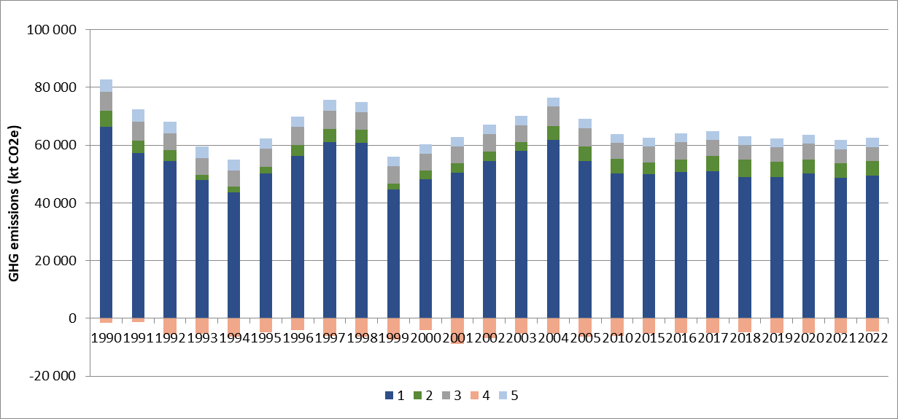
Figure 2: Total GHG emissions, including LULUCF, in the Republic of Serbia (in kt CO₂e), with CRT main sector contributions, over the period 1990-2022

The relative contributions of each GHG on the national aggregated GHG emissions, excluding LULUCF, between 1990 and 2022, evolve as follows:

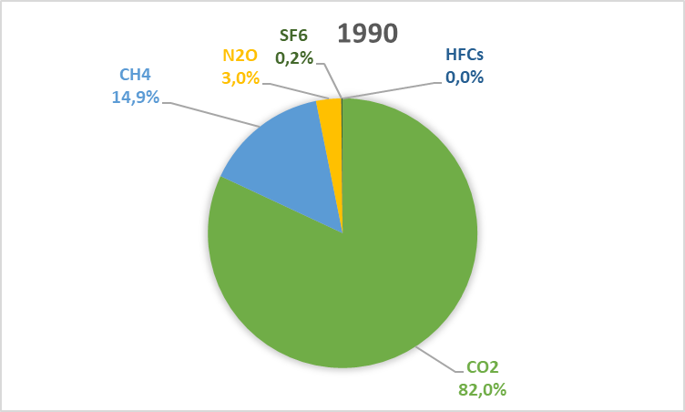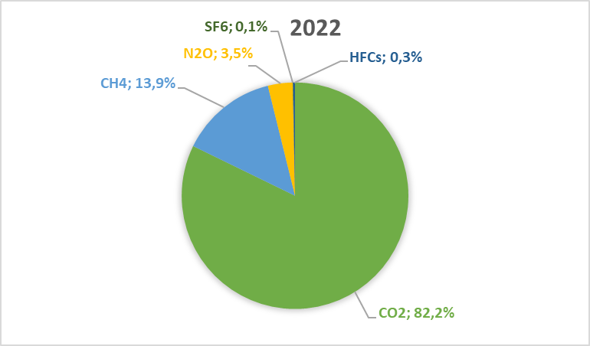
Figure 3: Contributions of each gas on the Republic of Serbia aggregated GHG emissions, excluding LULUCF, in 1990 and 2022
Despite some inter-annual variations, for the years 1990 and 2022, the relative contribution of the CO₂ to the total GHG emissions excluding LULUCF is quite stable at 82%. However, over the whole period, the CO₂ contribution varies between 77% and 83%, and has a mean value of 81%. The CH₄ and N₂O emission contributions are also rather stable between 1990 and 2022, with a slightly decreasing contribution for CH₄ (from 14.9% to 13.9%) whereas N₂O increases slightly in consequence (from 3.0% to 3.5%). Meanwhile SF₆ emissions are less prominent in the national GHG emissions, without LULUCF contribution, going from 0.2% in 1990 to 0.1% in 2022, HFC emissions, which were not occurring in 1990, increased their contribution in 2022 at 0.3%.

Description of emission and removal trends by sector and by gas
Table 10 presents the national GHG emission and removal trends for each gas, in the Republic of Serbia, for the period 1990-2022.
Table 10: GHG emissions in the Republic of Serbia, per substance and per main CRT category, between 1990 and 2022
CO₂
The national CO₂ emissions from the Republic of Serbia, excluding LULUCF contribution, decreased by 24.1% over the period 1990-2022. This reduction goes up to 29.3% when LULUCF contribution is included. CO₂ emissions are mainly related to fossil fuel combustion activities (CRT 1A) and, in 2022, around 91% of the national emissions without LULUCF are originated from fuel combustion. In 2022, the energy industries (CRT 1A1) contribute to 62% of the national CO₂ emissions excluding LULUCF, meanwhile the transport (CRT 1A3) contribution is of 16%, the one of the manufacturing industries is of 7% and the residential-tertiary-agriculture subsector contributes to 5%. The sector of industry processes is the other main contributor about 10% in 2022, and the metal industry (CRT 2C) is the predominant emission source of this sector with 6% of the national emissions without considering LULUCF in 2022.
Most of the biggest CO₂ emission sources follow a downward trend between 1990 and 2022, except for the transport (+79%) and the metal industry (+73%). The CO₂ emission reductions observed between 1990 and 2022 contributing the most to the overall reduction are for the sectors of the energy industries (CRT 1A1, -25%), the manufacturing industries (CRT 1A2, -54%), the other sector (CRT 1A4, -59%), the fugitive emissions of the oil and natural gas (CRT 1B2, - 98%) and the mineral industry (CRT 2A, -24%). Since the year 2009, the national CO₂ emissions are rather stable, except for some years where the emission levels were either particularly high, such as in 2011, or very low, such as in 2014. The national emissions between 1990 and 2002 undergo several significant interannual variations due to the war context around the Balkan and ex-Yugoslavia regions.

CO₂ emissions from the residential-tertiary sector (CRF 1A4) and the production of heat and electricity (CRF 1A1a) are heavily influenced by climatic conditions. Notably, in recent years, 2011 experienced a particularly cold winter, while 2014 was relatively warm. Conversely, during extremely hot summers with heatwaves, CO₂ emissions from electricity production tend to increase due to higher demand for air conditioning.

Additionally, overall CO₂ emissions are significantly affected by electricity imports and exports, although the balance has remained relatively stable in the Republic of Serbia.

Other structural parameters can also influence the interannual CO₂ emission variations: the economic context such as the global economic downturn in 2009, energy crisis in 2022 on natural gas supply following the Ukrainian and Russian conflict, or other conditions such as the sanitary crisis related to the Covid virus or the impact of policies and measures implemented by governments and administrations.

The national CO₂ emissions including the LULUCF contribution decreased by 29% between 1990 and 2022, which is higher than the observed reduction without LULUCF. In the Republic of Serbia, the net balance of the LULUCF sector is a net removal, which means that the CO₂ absorptions (tree growth, reforestation) overcompensate the CO₂ emissions (e.g., tree mortality, deforestation, artificialisation) and, in addition, an increasing net removal from this sector is observed. Indeed, for the period 1990-2022 the net CO₂ removals increased by 215%, mostly due to the forest lands (CRT 4A) which contribute to 88% of the emissions and removals in 2022 and increased by 132% over the same period. This is partly due to the fact that heavy commercial logging and industrial technical wood use for the pulp and paper industry were very present in the country in 1990 which later collapsed and never recover. Although there has been a huge increase of the net removal of this subcategory over the whole period, the sink decreased significantly since 2007 (-31%) due to the increased use of biomass as a fuel and natural disturbances. Among the other categories, the grassland category (CRT 4C) reduced its CO₂ emissions by almost 100%, whereas the net removals from harvested wood products (CRT 4G) increased by 391%, between 1990 and 2022.

CH₄
The national CH₄ emissions from the Republic of Serbia, decreased by 29% for the period 1990-2022, with or without considering the LULUCF contribution. Different emission sources contribute significantly to the national CH₄ emissions. In 1990, the predominant source is the agriculture sector (CRT 3), which represented 41% of the Republic of Serbia methane emissions and, in 2022, had a contribution of 33%. The other major emission source is the waste sector (CRT 5), which contributed to 34% in 1990 and increased its share up to 36% in 2022. The CH₄ emissions of these two sectors decreased considerably for the period 1990-2022, with a faster rate for agriculture (-43%) than for the waste (-25%). In addition, the fugitive emissions (CRT 1B) are also a significant contributor to the national emissions excluding LULUCF with 31% in 2022, despite having reduced their emissions by 19% for the period 1990-2022. The fall in the fugitive CH₄ emissions of this sector is related to the drops in coal and oil productions, respectively of 19% and 25% between 1990 and 2022. The reduction in the emissions of the agriculture is mainly related to the decrease in the livestock, which impact enteric fermentation (CRT 3A, - 44%), the main emission source, and manure management (CRT 3B, -38%). For the waste sector, the drop in the solid waste disposal (CRT 5A, -20%), due to smaller amounts being disposed, and the wastewater treatment (CRT 5D, -37%), due to a decreasing population, can explain the observed trends. For the waste sector, the solid waste disposal is the main source of methane emissions with a contribution of 77% to the sector total in 2022.
Contrarily to the CO₂ emissions, the fuel combustion activities (CRT 1A) represent a rather smaller share of the national totals for CH₄ with only 7% in 2022. However, the contribution of the sector was less significant in 1990 (4%), as the emissions of this sector can be observed to increase from 20% over the period 1990-2022. This is mainly due to the residential-tertiary sector (CRT 1A4, +20%), related to an increase in the residential wood consumptions.

N₂O
The national N₂O emissions have been reduced by 12% in the Republic of Serbia, for the period 1990-2022, with or without considering the LULUCF contribution. The agriculture sector is the most predominant N₂O emission sources on the territory, with more than 82% of the national emissions in 2022. Actually, the emissions of this sector are observed to have increased over the period 1990-2022, by 19%, and its contribution was of 61% in 1990. The growing share of this sector is only due to the increase in the emissions of the agricultural soils (CRT 3D, +71%); in particular, the increase in inorganic N-fertiliser application (CRT 3Da1, +598% in emissions), partly in substitution of the organic N-fertilisers, and, to another extent, to the growth in the indirect N₂O from managed soils (CRT 3Db, +56%). This trend is also the consequence of a lack of consistency in the activity data, which are better managed by the SORS from 2013 onwards. In contrast, the N₂O emissions related to manure management, which contributed to 43% of the emissions of the agricultural sector in 1990 and 26% of the national emissions without LULUCF, have decreased by 47% due to the decrease in the livestock category.
In addition, the fuel combustion activities (CRT 1A) also contribute in a non-negligible way with 15% of the Republic of Serbia emissions in 2022. The N₂O emissions of this sector are rather stable over time and slightly increased by 11% between 1990 and 2022, mostly due to the growth in road transport. In addition, its contribution to the national total was rather similar in 1990 with 12%, and the shares between the subsectors are rather equal in 2022: the energy industries (CRT 1A1, 5%), the transport (CRT 1A3, 5%) and the other sectors (CRT 1A4, 4%). The chemical industry (CRT 2B) was also an important contributor the national N₂O emissions in 1990 with 23% of the share but has suppressed its emissions due to the discontinuation of the acid nitric production in 2019, contributing significantly to the overall national emission reduction. Finally, the N₂O emissions of the wastewater treatment have been reduced by 32% over the period 1990-2022, and now contributes to 4% to the national emissions.

SF₆
The national SF₆ emissions from the Republic of Serbia have been reduced by 62% for the period 1990-2022. The industrial processes (CRT 2) are the only emitting sector of SF₆ over the territory. Among it, the metal industry with the production of magnesium was for long the only SF₆ emission source but, since 2000, emissions from the use of SF₆ in electrical equipment for insulation (CRT 2G1) have arisen. In 2022, the magnesium production represents 83% of the national SF₆ emissions. This subsector has decreased its emissions by 69% between 1990 and 2022, explaining most of the observed downward trend, due to the drop in the production of magnesium.

HFCs
The national HFC emissions in the Republic of Serbia occurred from 1997, and in 2022 contribute to 0.3% of the national GHG emissions excluding LULUCF contribution. Several HFC can be emitted and the evolution of the mass emissions depending on the HFC are presented in Table 11. The national trend in HFC emissions, expressed in CO₂ equivalent, showed a consistent increase until 2014, when emissions peaked. Since then, emissions have steadily declined, with an average annual decrease of 12% between 2014 and 2022. This reduction is largely attributed to the implementation of regulations governing the use of refrigerants, such as the Regulation on the Treatment of Fluorinated Gases with a Greenhouse Effect and the conditions for issuing permits for their import and export (Official Gazette No. 120/13).
Table 11: Mass emissions of the different fluorinated gases in the Republic of Serbia, for the period 1990-2022
Table 12 presents the evolution of the aggregated GHG emissions for each CRT category, with more details than before, in the Republic of Serbia, for the period 1990-2022.
Table 12: Aggregated GHG emissions (in kt CO₂e) in the Republic of Serbia, for each CRT category, between 1990 and 2022

Energy (CRT 1)
The energy sector represents 79% of the national GHG emissions, in CO₂ equivalent, excluding LULUCF contribution, in the Republic of Serbia, in 2022. Its contribution was slightly more important in 1990 with 80% of the national totals, but is rather stable and has a mean value over the period 1990-2022 of 80%. This is mainly due to the energy industries (CRT 1A1), which is the major emitting source contributing up to 52% of the national GHG emissions without LULUCF in 2022, in particular due to the production of electricity (CRT 1A1a). The main substance emitted by this sector is the CO₂, which represents 94% of the sector GHG emissions. Only CO₂ emissions from fuel combustion activities (CRT 1A1), excluding CO₂ from biomass combustion, represent more than 90% of the national CO₂ emissions and 74% of the national GHG emissions, without LULUCF contribution.
The energy sector is also responsible for 31% of the CH₄ national emissions excluding LULUCF in 2022, mostly related to fugitive emissions from coal, oil and natural gas production, as the CRT 1B has a share of 24% of the national totals in 2022. The other main methane emission source in the energy industries is the wood combustion in residential appliances (CRT 1A4, 6% of the national total in 2022). Finally, about its contribution to other direct GHG, the energy sector represents 15% of the N₂O emissions in the Republic of Serbia, excluding LULUCF contribution, related to the fuel combustion.
The energy sector is also a large predominant emission source in terms of indirect GHG emissions (including LULUCF) with 99%, 96% and 97% of the national emissions of SO₂, NO_{x} and CO in 2022. It also contributes to NMVOC emissions over the territory but to a lesser extent with 41% in 2022.
In 2022, for CO₂ emissions, the main contributing source is the energy industries (CRT 1A1) with a share of 62% of the national CO₂ emissions excluding LULUCF, mainly due to electricity and heat production, followed by the transport sector (CRT 1A3) with 16%, mostly related to road transport, the manufacturing industries (CRT 1A2) with 7% and the other sectors (CRT 1A4) with 5%. The total sectoral CO₂ emissions decrease by 25% for the period 1990-2022, thanks to the contribution of all sectors except transport which has increased its emissions by 79% due to the traffic growth. The other sectors all contributed to the observed emission reduction, in particular the highest influence is from the energy industries with a 25% decrease, mostly thanks to the drop of 25% in the fuel consumption of the production of heat and electricity (CRT 1A1a) over the period 1990-2022, with the coal consumption which decreased by 31%, substituting partially by natural gas which doubled, but also by increasing renewable energies and issues with lignite mining in most recent years. The CO₂ emissions of the other subsectors all decrease significantly as well, with -54% for the manufacturing industries (CRT 1A2) and -59% for the other sectors (CRT 1A4), related to fossil fuel consumption reductions and the partial substitutions with the development of biomass. Finally, the fugitive CO₂ emissions, mainly related to flaring in oil refining, have also decreased by 98% over the period 1990-2022, whereas it had a share of 3% of the CO₂ emissions of the energy in 1990.
The emissions of the energy industries, in particular of the power plants for electricity production, and of the residential sector, can vary quite significantly depending on the climate severity (for winters, mostly, with heating, but also, to another extent, for summers with air conditioning) and the eventual imports and exports of electricity. Over the most recent years, the year 2011 and 2014 are good examples of extreme climate conditions either leading to a peak of CO₂ emissions such as in 2011, or to a significant drop in emissions as in 2014 which was also affected by flooding of some surface lignite mines.
The methane emissions of the energy sector also decrease by 13% between 1990 and 2022, mostly due to the drop in coal and oil productions with -19% for the fugitive methane production (CRT 1B) over this period, meanwhile the emissions related to fuel combustion (CRT 1A) increased by 19%, related to the increase in the use of biomass, in particular in small residential appliances. The energy emissions of N₂O, mainly related to fuel combustion in 2022, increased by 9% during the period 1990-2022, which is mostly due to the road transport growth (CRT 1A3, +85% for N₂O).
In terms of SO₂, the emissions are mostly the responsibility of the Public Electricity and Heat production (1A1a), which contributes to 92% to the CRT 1 emissions in 2022. The main reason for the SO₂ emissions the solid fuel combustion. This emission source is also the responsible to a significant part of the NOx emissions of the Energy sector (38% in 2022), alongside with the road transport (CRT 1A3b) which is the most predominant source with 43% of the sector emissions. The emissions of NMVOC from the Energy sector are mainly due to coal mining and handling (1B1a) with 31% in 2022, as well as the residential heating (1A4bi), in particular due to biomass and solid fuel combustion, with 42%. The latter contributes also significantly to the CO emissions from the CRT 1, with a share of 75% in 2022, the rest being mostly related to road transport (13%) and to other stationary combustion.
Most of the emissions of indirect GHG from the Energy sector have been reduced significantly over the timeseries, with -34% for SO₂, -24% for NMVOC and -31% for CO. The emissions of NOx are rather stable (-1% between 1990 and 2022) due to the road traffic growth which compensate the emission reduction achieved by the implementation of regulations and the change in the energy mix. For the other substances, these two factors are the main reasons for the fall in emissions.

Industrial Processes and Product Use (CRT 2)
The sector of industrial processes and product use represents 8% of the national GHG emissions, excluding LULUCF contribution, in the Republic of Serbia, in 2022. It has a slightly growing contribution since 1990 where its share was less than 7%, although its GHG emissions have been reduced by 7% in between. In 2022, the main contributing source is the metal industry (CRT 2C), with 5% of the national GHG emissions excluding LULUCF, followed by the mineral industry (CRT 2A) with 2.4%. The main substance emitting by this sector is the CO₂, which represents almost 96% of the total sectoral GHG emissions in 2022. The industrial processes are the second biggest emission source of CO₂ in the Republic of Serbia, preceding by the energy sector, with more than 9% of the national emissions in 2022, excluding LULUCF contribution.
The industrial processes and product use sector is the only emission source of SF₆ and HFCs in the Republic of Serbia. On the opposite, in 2022, its contribution to the national emissions of CH₄ is relatively marginal with 0.1%, and there is no N₂O emission related to this category. In 1990, the CRT category was a relatively high N₂O emitter due to the chemical industry (CRT 2B), and contributed to 23% of the national emissions without LULUCF, but since 2019, the acid nitric production (CRT 2B2), the only emission source, has ceased.
The industry sector is a marginal contributor to the emissions of NO_{x} and SO₂ with about 0.4% and 0.3% in 2022. Its contribution to the national emissions of CO is also rather small with 3% in 2022. However, it has a non-negligible share in the NMVOC emissions over the territory with 18% in 2022, due principally to the emissions from solvent use (CRT 2D3) and from food and beverage industry (CRT 2H2).
In 2022, the most predominant source of CO₂ emissions for the CRT 2 is the metal industry (CRT 2C), which contributes to 6% to the national CO₂ emissions excluding LULUCF, principally due to the iron and steel industry (CRT 2C1). The metal industry was less important in 1990 as its CO₂ emissions increased by 73% over the period 1990-2022. The most important CO₂ emission source, which is now the second highest, was the mineral industry (CRT 2A), which now has a share of 3% of the national emissions in 2022 and underwent a reduction of 24% between 1990 and 2022. The cement industry (CRT 2A1) is the most predominant source with 85% of the emissions of this CRT category, followed by the lime industry (CRT 2A2) and the use of carbonates in other industries (CRT 2A4a). The emission reduction observed for the mineral industry for the period 1990-2022 is mainly due to the decrease observed in the lime industry (-67%). The other emissions sources, the chemical industry (CRT 2B) and the non-energy products from fuels and solvent use (CRT 2D) have both reduced their contributions to the sectoral CO₂ emissions with reductions of 63% and 64%, respectively. In overall, the CO₂ emissions of the whole CRT 2 category have gone up by 2.5% between 1990 and 2022.
As already mentioned before, the N₂O emissions of the industry processes, which represented 10% of the sectoral GHG emissions in 1990, have been suppressed following the stop of the acid nitric production in 2019. The SF₆ emissions, which originate from the magnesium production (CRT 2C4) and the use in electrical equipment (CRT 2G1), have been reduced by 62% over the period 1990-2022. This is mainly related to the drop in the magnesium production which is of 69% for the whole period. Finally, the HFC emissions, which were not occurring in 1990, appeared in 1997 with the use of refrigerants and now represent 0.3% of the national GHG emissions excluding LULUCF.
In terms of indirect GHG, the analysis focuses only on NMVOC, which are rather significant in the Industry sector (CRT 2), the other substances being rather negligible. For NMVOC, the emissions from the CRT 2 are mostly the responsibility of the domestic solvent use (CRT 2D3a) with 33%, the food and beverage industry (CRT 2H2) with 26%, the use of solvent in printing (2D3h) with 18% and the other solvent use (2D3i) with 11%. The NMVOC emissions from the Manufacturing Industry sector have been reduced by 37% between 1990 and 2022, mostly due to the drop in the population, in the production of food and beverages, as well as due to national regulation on solvent contents.

Agriculture (CRT 3)
The agriculture sector is the major source of N₂O emissions in the Republic of Serbia in 2022, with a share of 82% of the national emissions excluding LULUCF. In addition, it also contributes significantly to the CH₄ emissions with 33% of the national emissions without LULUCF in 2022. However, the agriculture sector has relatively marginal CO₂ emissions in the national totals with a total share of 0.4% in 2022 and does not contribute to the emissions of other direct GHG. In overall, the contribution of the CRT 3 to the national GHG emissions excluding LULUCF is of 8% in 2022, making it the third most predominant sector. Its contribution is rather stable over time as it was of 8% as well in 1990 and has a mean contribution value of 9% over the whole period. In 2022, the main emitted substance of the agriculture sector is CH₄, which represents 59% of the sectoral GHG emissions, followed by N₂O with a share of 37% and CO₂ with a share of 4%.
Enteric fermentation (CRT 3A) is the main CH₄ emission source and contributes to 26% of the national emissions of this substance, without considering LULUCF. The methane emissions of this subsector have decreased by 44% between 1990 and 2022, mostly due to the downfall in the livestock, in particular cattle and sheep. Another important methane emission source from agriculture which has been impacted by the decrease in the livestock is the manure management (CRT 3B), which decreased its emissions by 38% for the period 1990-2022, but still represent 6% of the national totals. The final emission source contributing to the agricultural methane emissions is field burning (CRT 3F), with a rather small but stable contribution.
The emissions of N₂O in the agriculture are mostly related to the agricultural soils (CRT 3D) which contribute up to 65% to the national emissions excluding LULUCF. This subsector has increased considerably its emissions, by 71% between 1990 and 2022, due to the growth of the application of inorganic N-fertilisers (CRT 3Da1, +598%), partly in substitution of manure application (CRT 3Da2a, -42%). The indirect N₂O emissions of the agriculture soils (CRT 3Db) have been impacted by this growth and thus increased by 56% over the period 1990-2022. The other significant emission source is the manure management (CRT 3B), which contribute to almost 16% of the national N₂O emissions, without LULUCF, in 2022. This CRT category had a higher share of emissions in 1990 with 26%, but underwent a considerable emission reduction of 47% for the period 1990-2022, due to the decline in the populations of livestock, and in particular cattle, pigs and poultry. As a result of these different variations, the agricultural N₂O emissions have increased by 19% between 1990 and 2022.
Finally, the CO₂ emissions of the agriculture sector are related only to the urea application (CRT 3H) as the emissions and removals from agricultural soils are considered in CRT 4. For the CRT 3H, its emissions increased by 574% for the period 1990-2022, but are still rather marginal compared with the national totals with a contribution of 0.4% to the national totals excluding LULUCF.
In overall, the GHG emissions of the agriculture sector (CRT 3) decreased by 25% for the period 1990-2022.
The agriculture sector is a negligible emission source for the indirect GHG emissions of SO₂ and CO, as it is only related to field burning of agricultural residues (CRT 3F). However, it has a rather important contribution to the national emissions of NMVOC with 14% in 2022, due mostly to the manure management (CRT 3B). Finally, its contribution to the NOx emissions, mostly due to the use of inorganic N-fertilisers (CRT 3D1a), which represents 95% of the emissions from this sector, is rather small with 3.5% in 2022. The emissions of NOx have drastically increased for the period 1990-2022, by 433%, in relation with the increasing use of inorganic N-fertilisers. The emissions of NMVOC of the sector are more evenly spread out, with the most emitting sources being the manure management for cattle livestock (3B1) with 55%, the cultivated crops (3D5) with 16%, the manure management from poultry (3B4g) with 14% and from swine (3B3) with 11%.

LULUCF (CRT 4)
The land use, land-use change and forestry sector is a sink of GHG in the Republic of Serbia, over the whole period 1990-2022, in particular thanks to the growth of the forest lands (CRT 4A), mainly, and the harvested wood products (CRT 4G). The CO₂ represents almost 100% of the sectoral GHG emissions of this sector, making CH₄ and N₂O contributions almost negligible.
Forest land (CRT 4) is the most predominant emission source with more than 88% of the CO₂ emissions of this sector, and represents a net removal of 4.7 Mt CO₂ in 2022. The net removal of this subsector has increased by 132% within the period 1990-2022, and now enables to compensate about 9% of the national CO₂ emissions excluding LULUCF. This is in particular due to the CRT 4A, where a large commercial logging and industrial technical wood use for the pulp and paper industry were very present in 1990, and decreased significantly over time. However, since 2007, the increasing trend of the sink observed for the CRT 4A has changed, due to the increasing use of wood as a fuel and, to another extent, the more frequent natural disasters (e.g., woodfires, breakages due to strong winds, damages caused by insects and diseases, etc.).
The land-use changes correspond either to a storage of CO₂ (e.g., through conversion of cropland or grassland in forest land) or to an emission of CO₂ (e.g., through deforestation). The emissions or removals for the subsectors cropland (CRT 4B) and grassland (CRT 4C) vary significantly for the period 1990-2022. In overall, the land-use changes for CRT 4B to 4F decrease their CO₂ emissions over the timeseries by 42%, contributing to the observed increase of the sink for the whole sector. For the CRT 4C, the observed reduction in emissions is due to a significantly reduced grassland area, which was easily affected by fires, as well as to land use changes. Finally, the harvested wood product category (CRT 4G) has also participated in the growth of the net removal of CO₂ as it increased its by 391% due to the increase in the wood products such as industrial roundwood, sawnwood, wood panels and paperboards.
The emissions of CH₄ and N₂O for LULUCF also decline between 1990 and 2022, in the Republic of Serbia, with respective reductions of 57% and 39%.

Waste (CRT 5)
The waste sector is a significant emission source of CH₄ emissions in the Republic of Serbia, with a contribution of 36% to the national emissions excluding LULUCF, in 2022. Its share in the national emissions is rather stable and was of 34% in 1990, although an overall emission reduction of 25% is observed between 1990 and 2022. The emissions sources contributing to the methane emissions are the solid waste disposal (CRT 5A), with a share of 30% of the national CH₄ emissions excluding LULUCF in 2022, and, to another extent, the wastewater treatment (CRT 5D) with 9% of the national totals. For the period 1990-2022, both subsectors decreased their methane emissions, by 20% for the CRT 5A, due to the drop in solid waste amounts being disposed, and for the CRT 5D by 37%, due to a downfall in the population.
The waste sector also contributes, to a lesser extent, to N₂O emissions with 4% of the national emissions, without LULUCF, in the Republic of Serbia in 2022. The emissions of this substance are only related to wastewater treatment (CRT 5D), and an emission reduction of 32% is observed over the timeseries, corresponding to a decline in the Serbian population. However, the waste sector does not contribute to the emissions of other direct GHG over the timeseries.
The methane emissions of the waste sector represent 94% of the total sectoral GHG emissions in 2022, explaining the fact that the overall trend of the sector (-25% in GHG emissions between 1990 and 2022) corresponds to the CH₄ emission reduction observed. In overall, the waste sector contributes to 5% of the national GHG emissions from the Republic of Serbia, in 2022, and has a rather stable contribution between 1990 and 2022.
In terms of indirect GHG emissions, the waste sector is a negligible emission source and contributes to less than 0.01% of the different concerned substances, in 2022, in the Republic of Serbia.

Chapter 3: Energy (CRT sector 1)

Overview of sector
The CRT 1 category covers the following sectors:
- Energy industries (1A1), including the thermal power plants, the district heating, the oil refineries and the production of solid and gaseous fuels such as coke ovens,
- Manufacturing industry (1A2),
- Transports (1A3),
- Other sectors (1A4), including residential heating, as well as the tertiary and agriculture/forestry/fishing subsectors,
- Non-Specified (1A5),
- Fugitive emissions from solid fuels (1B1),
- Fugitive emissions from oil and natural gas (1B2).
The CO₂ transport and storage (1C) does not occur in Serbia.
The main reference for the Energy sector is the energy balance, developed and updated each year by the Ministry of mining and energy in the format of the IEA questionnaires. The energy flows presented in it are not corrected upon the yearly climate. The same methodology is applied to the energy balance for the whole period from 1990 to 2022. It has to be noted that the complete data for the Autonomous Province of Kosovo are not available after 2000.
Energy consumption data from energy balance can be completed with other more-detailed data or bottom-up data when available, but then a balance on the overall consumptions from the energy balance is operated so that this is the main reference for Energy sector.
In the following Figure 4, the total fuel consumptions in the Republic of Serbia, for the whole timeseries, are displayed. This includes all fuel consumptions over the territory, for each year, considering the production, the imports and exports, and the stock variations. Hence, all energy and non-energy fuel consumptions are considered in this analysis. Overall, a reduction of 24% is observed over the period for the total fuel consumptions in the Republic of Serbia. All fossil fuels contributed to that reduction, meanwhile the biomass consumption increased by 41%, and represents 11% of the total fuel consumption in 2022, whereas it contributed to 6% in 1990. The solid fuel consumption, which was the biggest contributor to the total fuel consumption in 1990 with 53%, has overgone the highest decrease with 31%, and now represents 45% of the total share. The liquid fuel and natural gas consumptions have respectively been reduced by 18% and 11% between 1990 and 2022, and their respective share in the total fuel consumptions remained constant for the same period. Since 2006, the apparition of other solid fossil fuel consumption is to be noted but remains negligible overall.
Over the period 1990-2022, the total fuel consumption has undergone significant variations. Between, 1992 and 1994, the Federal Republic of Yugoslavia experienced a long, intense period of hyperinflation, which resulted in a drastic deterioration of the economy, explaining the observed downward trend in the fuel consumptions. Following that event, the fuel consumption progressively increased, without reaching the pre-crisis levels, before drastically plunging in 1999 following the NATO bombing. Afterwards, all fuel consumptions increased progressively until 2004, when the solid fuel consumption significantly decreased in 2005. For the period 2006-2022, an overall decreasing trend is observed, punctuated by some variations following events such as the economic crisis in 2009, the large floods in 2014 which hindered the extraction of solid fossil fuels, the sanitary crisis in 2020, but also the variations of the severity of winters which can influence significantly the fuel consumptions in residential heating and electricity production.

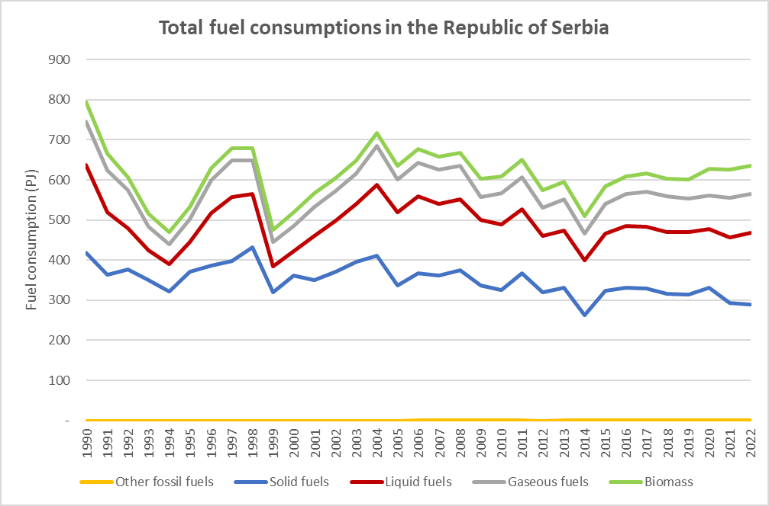
Figure 4: Total aggregated fuel consumptions in the Republic of Serbia, for the period 1990-2022, per fuel type (in PJ)

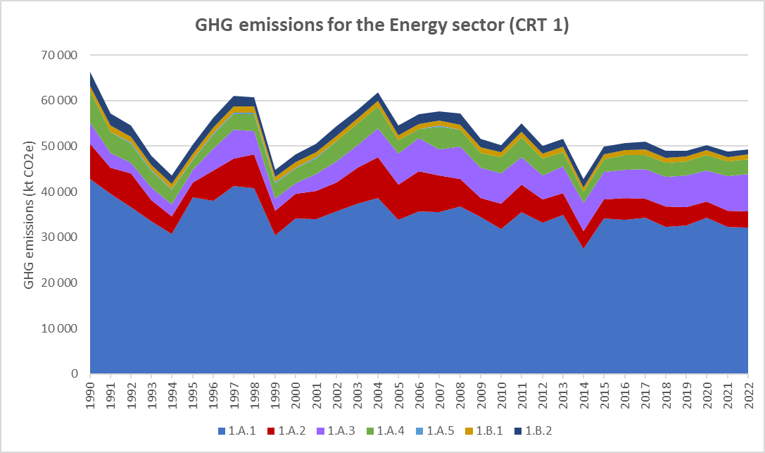
Figure 5: GHG emission trends for the Energy sector (CRT 1), per main subsector (in kt CO₂e)

The total annual emissions of GHGs from the Energy sector, expressed in CO₂e, for the period 1990–2022, are presented above.

In 2022, GHG emissions from CRT 1 are equal to 49.3Mt CO₂e, compared to 66.3 Mt CO₂e in 1990, which implies a reduction of 26%. The GHG emissions of the sector contributed to 80% of The Republic of Serbia total GHG emissions (without LULUCF) in 1990, and its share is rather stable and now represents 79% of total emissions in 2022. The GHG emissions vary significantly during the studied period, rather similarly to the total fuel consumption as described previously. All subsectors contributed to the overall observed GHG emission reduction, except the transport sector (CRT 1A3) which has known an emission increase of 79%. The Energy industries sector (CRT 1A1), which contributed to 52% of the Energy sector GHG emissions in 1990, have reduced its emissions by 25% over the period 1990-2022.

Fuel combustion (CRT 1.A)

Comparison of the sectoral approach with the reference approach (RA vs. SA)
The reference approach is recommended by the IPCC. This consists of the comparison of the fuel consumptions of the Energy sector (CRT 1A) from the energy balances, based on the production, imports, exports and stock changes (reference approach), with the fuel consumptions used in the emission inventory (sectoral approach). The CO₂ emissions associated with these two approaches are also compared. The results from the comparison of both approaches are reported in the CRT tables, and a brief analysis of the main observations is presented hereafter.
Table 13: Overall comparison of the CO₂ emissions from the reference and sectoral approaches for the Republic of Serbia, for the period 1990-2022

In overall (all fuel considered), for the period 1990-2022, the differences between the two approaches are of 2.6%. It can be observed that the differences are always negative, meaning that the CO₂ emissions related to the fuel consumptions from the reference approach are smaller than the ones from the sectoral approach. The observed gaps are pretty reasonable compared to IPCC recommendations of 5%. In the following paragraphs, additional details and explanations are given by fuel categories:
- Liquid fuels: the differences between energy consumptions and CO₂ emissions are rather proportional and, there are some years where they are not negligible. For the period 1990-2000 (in particular in 1999), the largest differences can be explained by the statistical differences. For the period 2013-2015, the high discrepancies observed are related to the increases in non-energy uses of naphtha and refinery feedstocks, which are not compensated (e.g., by an increase of crude oil consumption), therefore making the reference approach consumptions way lower than the sectoral ones. It has to be noted that ‘refinery feedstocks’ reported as refinery intakes in the IEA questionnaires have been considered in the RA as non-energy products to be consistent with the SA.

- Solid fuels: a mean discrepancy of 2.8% is observed for the energy consumptions of the two approaches. Considering the CO₂ emissions, the mean difference for the whole period is -2.5%.
In the sectoral approach, the emissions from the Iron and Steel sector (CRT 2C1) are based on a Tier 1 methodology which does not enable the inventory team to estimate fuel quantities used for non-energy purposes. Even if such non-energy quantities are estimated in the IEA questionnaires and reported in the reference approach, a bias could remain due to the use of the Tier 1 methodology.

- Gaseous fuels: the average differences observed on the apparent consumption and the CO₂ emissions are rather acceptable with 2.6% for both.
In the reference approach, non-energy uses of natural gas are consistent with the sectoral approach. Non-energy uses have been only identified for ammonia (CRT 2B1) and methanol (CRT 2B8) productions. The largest discrepancy observed in 2013 is due to a mistake in the energy balance treatment which will be corrected for the next submission.

Table 14: Differences between sectoral and reference approaches (in %) in terms of fuel consumptions and CO₂ emissions, for all different fuel categories, for the Republic of Serbia, for the period 1990-2022

International bunker fuels
In the GHG inventory, emissions reported on international bunkers concern emissions relating to international civil aviation and international maritime traffic based on fuel sales in Serbia.

International aviation bunkers

International aviation bunkers concern fuel consumptions of international flights refueling in Serbia.
There are few airports in Serbia and the two largest (Nikola Tesla in Belgrade and Konstantin Veliki in Niš) which are serving international flights. Thus, for this submission, all civil aviation is considered as international and is reported as a memo item.

International marine bunkers

Regarding international maritime traffic (between a Serbian port and a foreign port), this activity is considered as not occurring in Serbia since the country has no direct access to the sea and fluvial traffic is only considered domestic.
However, when looking at the IEA questionnaires/energy balance for the recent years, there are consumptions of gas/diesel oil for international bunkers. This needs to be investigated in order to understand if international fluvial traffic has to be excluded from the national total of the inventory.

Feedstocks and non-energy use of fuels
Fossil fuels can be consumed for different uses such as combustion for energy needs or as raw material, intermediate or reducing agent (non-energy uses).

As defined in Box 1.1 of the Introductory Volume for Industrial Processes in 2006 IPCC Guidelines, Fuel Combustion is defined as the intentional oxidation of materials within an apparatus that is designed to provide heat or mechanical work to a process, or for use away from the apparatus.
During operations, emissions may occur both at the combustion stage and as an industrial process. However, it is not always possible, partly for practical reasons, to report these two types of emissions separately.

In the 2006 IPCC Guidelines, the following rule is formulated:

Combustion emissions from fuels obtained directly or indirectly from the feedstock for an IPPU process will normally be allocated to the part of the source category in which the process occurs. These source categories are normally 2B and 2C. However, if the derived fuels are transferred for combustion in another source category, the emissions should be reported in the appropriate part of Energy Sector source categories (normally 1A1 or 1A2).

In the Serbian inventory, this rule of the guidelines is followed and for each fuel, the distinctions are as follows (see CRT tables "Table 1.A (d) Sectoral background data for energy - Feedstocks, reductants and other non-energy use of fuels for more details):
- Solid fuels: in iron and steel production, energy and non-energy use of solid fuels (coal, coking coal and derivate fuels) are considered CRT 2C1. Indeed, blast furnace gas is considered entirely combusted within the Iron and Steel industry and thus the associated emissions are reported in this IPPU subcategory.
- Liquid fuels:
- Non-energy petroleum products are mainly consumed at petrochemical sites. This is the case of naphtha used for chemical production in steam crackers, some of which is self-consumed (oil and gas from raw materials) for energy purposes. The associated emissions are reported in CRT 2B8.
- Emissions related to the combustion of lubricants for 2-stroke are not considered yet in the energy category of the Serbian inventory. Thus, emissions related to the use of lubricants are all reported in CRT category 2D1.
- Gaseous fuels: The main non-energy use of natural gas in Serbia is for ammonia production. The associated CO₂ emissions are accounted for in the CRT 2B1 category.

General characteristics for fuel combustion (CRT 1A)
A – Introduction
The term “fuel” is used in this report to define all type of product which is used in a combustion installation (fossil fuels, biomass, other products) in order to produce heat or electricity. In order to estimate GHG emissions related to fuel combustion, their different features such as chemical composition, calorific value, carbon content, etc. need to be known. The characteristics vary from one fuel to another, but also for similar fuel type depending on its origin and eventual regulations applying to it.
B – Calorific value
The calorific value is used to convert the amounts of fuel in mass or volume into energy unit. Among the most encountered energy units are:
Table 15: Conversions of different energy units into Joules
Unit | Symbole | Equivalence in Joules | Other multiples used
tonne oil equivalent | toe | 41.868 GJ | ktoe, Mtoe
Watt hour NCV | Wh | 3,600 J | kWh, MWh, GWh, TWh
Joule | J | 1 J | MJ, GJ, TJ
Thermie | th | 4,18 MJ | kth
Calorie | cal | 4,18 J | kcal
k (kilo) = 10³ M (Mega) = 10⁶ G (Giga) = 10⁹ T (Tera) = 10¹²
In the emission inventory for the Republic of Serbia, for all fuels, the net calorific values given by the energy balances are used, can vary depending on the year, its origin (produced or imported) and the use, in the following ranges:
Table 16: Net calorific values (NCVs) ranges used in the Serbian inventory (source: national energy balances)
Fuel | NCV (GJ/t)
Anthracite | 21.2-26.5
Other bituminous coal | 22.0-28.7
Sub-bituminous coal | 16.1-23.6
Lignite | 7.1-17.0
Brown coal briquettes (BKB) | 15.7-20.0
Coke/Oven Coke | 24.1-30.1
Coal tar | 37.8-41.3
Crude oil | 42.7-44.2
Natural gas liquids | 45.2-46.0
Gasoline | 44.0-44.8
Jet kerosene | 43.0-44.6
Other kerosene | 42.5-43.8
Gas/Diesel oil | 42.6-44.0
Residual fuel oil | 40.0-41.6
Liquefied petroleum gas (LPG) | 46.0-47.3
Naphtha | 44.0-45.0
Bitumen | 40.2
Lubricants | 40.2-42.0
Petroleum coke | 17.4-38.0
Refinery feedstocks | 40.2-43.9
White spirit | 40.2-43.6
Paraffin wax | 40.0-40.4
Other oil products | 40.0-40.4
Natural gas | 33.3-33.9
Solid Biomass | 16-19

C – Emission factors
In the Serbian emission inventory, all GHG emissions related to fuel combustion are estimated based on the application of emission factors to the sectoral consumptions given by the energy balances. Emission calculations based on mass balances or direct measurements are not considered. In addition, only top-down approaches are used for the fuel combustion emission estimations and no reported emission data are considered.
For CO₂ emission calculations, only the carbon content for lignite used in thermal power plants (TPP) since 2008 is based on measurements of NCV and carbon content by JP-EPS laboratories which are now also accredited in accordance with ISO 17025 for reference methods needed to determine CO₂ Emission factors in accordance with rules applicable for installations included in the EU-ETS. A clear correlation between the NCV and EF has been determined for the lignite consistent with the correlations determined by Slovenia and Greece for preparation of their national CO₂ emission factors since they are exploiting same Pliocene lignite deposits in the region. Since the quality of lignite is since 1990 slowly deteriorating the CO₂ EF is gradually increasing. Due to implementation of national MRV regulatory framework it is expected that starting from 2025-2006 plant specific (Tier 3) CO₂ emission factors will be available to the GHG inventory team.
For other categories , the default Tier 1 emission factors from IPCC 2006 guidelines are used. In overall, the CO₂ emission factors are as follows:
Table 17: Net calorific values (NCVs) ranges used in the Serbian inventory
Fuel | Carbon content  (t C/TJ) | CO₂ EF  (kg/GJ)
Anthracite | 26.8 | 98.3
Other bituminous coal | 25.8 | 94.6
Sub-bituminous coal | 26.2 | 96.1
Lignite in TPP | 29.0-30.4 | 106.4-111.3
Lignite for other uses | 27.5 | 101.0
Brown coal briquettes (BKB) | 26.6 | 97.5
Coke/Oven Coke | 29.2 | 107.0
Coal tar | 22.0 | 80.7
Crude oil | 20.0 | 73.3
Natural gas liquids | 17.5 | 64.2
Gasoline | 18.9 | 69.3
Jet kerosene | 19.5 | 71.5
Other kerosene | 19.6 | 71.9
Gas/Diesel oil | 20.2 | 74.1
Residual fuel oil | 21.1 | 77.4
Liquefied petroleum gas (LPG) | 17.2 | 63.1
Naphtha | 20.0 | 73.3
Bitumen | 22.0 | 80.7
Lubricants | 20.0 | 73.3
Petroleum coke | 26.6 | 97.5
Refinery feedstocks | 20.0 | 73.3
White spirit | 20.0 | 73.3
Paraffin wax | 20.0 | 73.3
Other oil products | 20.0 | 73.3
Natural gas | 15.3 | 56.1
Solid biomass | 30.5 | 112.0
Industrial waste | 39.0 | 143.0

For lignite used in thermal power plants, the CO₂ emission factor evolves as follows:
Table 18: Country-specific CO₂ emission factor used in the Serbian inventory for lignite burned in TPPs
EF CO₂
(kg/GJ)
1990 | 106.95
1991 | 106.95
1992 | 106.95
1993 | 106.95
1994 | 106.95
1995 | 106.95
1996 | 106.95
1997 | 106.95
1998 | 106.95
1999 | 106.95
2000 | 106.95
2001 | 106.95
2002 | 106.95
2003 | 106.95
2004 | 106.95
2005 | 106.95
2006 | 106.95
2007 | 106.95
2008 | 106.95
2009 | 108.99
2010 | 109.81
2011 | 109.71
2012 | 109.53
2013 | 109.37
2014 | 108.93
2015 | 110.40
2016 | 110.40
2017 | 110.40
2018 | 110.40
2019 | 111.49
2020 | 111.49
2021 | 111.49
2022 | 111.49

Energy industries (CRT 1A1)
In the Republic of Serbia, the energy industries sector covers:
- the production of public electricity and heat (CRT 1A1a),
- the petroleum refining (CRT 1A1b),
- the manufacture of solid fuels (CRT 1A1ci).
In 2022, the energy industries (CRT 1A1) contribute to 51% of the total GHG emissions without LULUCF, and it contributes to 65% of the Energy category (CRT 1) in Serbia.

Public electricity and heat production (CRT 1A1a)

Category description
This sector consists of electric power system, and a decentralized municipal district for heating.

Electricity production is based on the combustion of low-quality domestic lignite in existing power plants and the use of hydropower potential in the existing impoundment and reservoir-pumped hydro power plants. In 1990, Serbia was equipped with modern and up–to–date electricity production system comprising six coal–burning thermal power plants (TPP) having 25 production units and three liquid fuel and gas burning combined heat and power (CHP) plants having 6 production units.
Table 18: Main public electricity and heat production units with installed capacity and main fuel used
Installation | Installed capacity (MWe) | Main fuel
TE Nikola Tesla A | 1650 | Lignite
TE Nikola Tesla B | 1240 | Lignite
TE Kolubara | 271 | Lignite
TE Morava | 125 | Coal mix of differnet domestic coal
TE Kostolac A | 281 | Lignite
TE Kostolac B | 640 | Lignite
TE-TO Novi Sad | 208 | Natural gas, Fuel oil
TE-TO Zrenjanin | 110 | Natural gas, Fuel oil
TE-TO S. Mitrovica | 14 | Biomass, natural gas, fuel Oil
TE-TO Pančevo | 208 | Natural Gas

The total consumption of all distribution companies and consumers in the electricity market and the consumption of electricity production is high. High consumption is greatly affected by the use of electricity for household heating and the low-energy efficiency of buildings (mainly built in the 1970s and 1980s).

The evolution of fuel consumption in the public heat and electricity production sector are presented in the following Figure 6. Overall fuel consumption decreased by 25% between 1990 and 2022. Solid fuels, and in particular lignite is the fuel contributing to the highest share of the fuel consumption over the whole studied period, with 91% of the share in 1990 and 84% in 2022. Liquid fuel consumptions also significantly decreased between 1990 and 2022 and have been substituted by the increasing use of natural gas, which more than doubled for the same period, and also biomass which have slightly developed since 2007 but stays relatively marginal in the overall share in 2022.
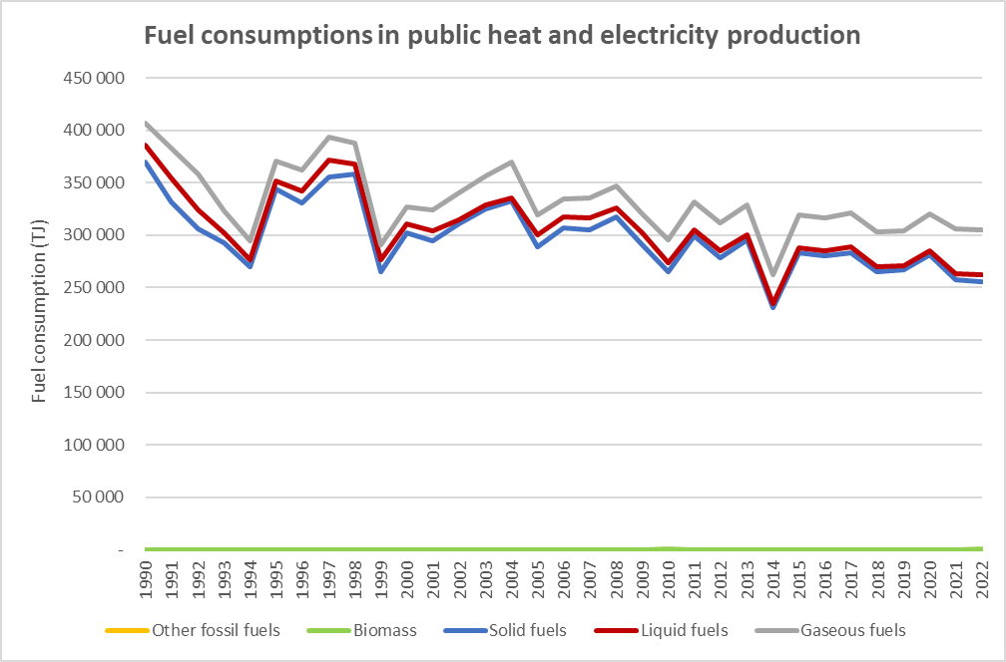
Figure 6 : Fuel consumptions in Public electricity and heat production (CRT 1A1a), for the period 1990-2022 (in TJ)
The GHG emissions, which are mainly related to CO₂, evolve as follows:
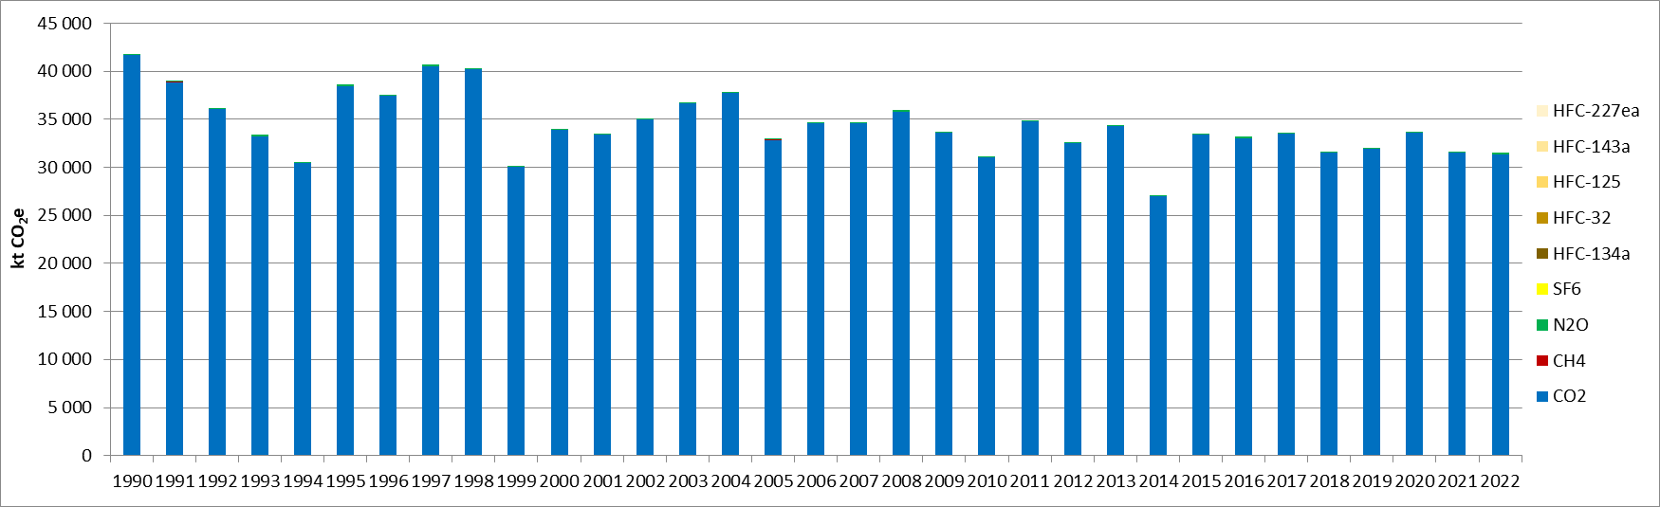
Figure 7: GHG emissions for Public Electricity and Heat production (CRT 1A) for the period 1990-2022 (in kt CO₂e)
In general, GHG emissions from the public electricity and heat production evolved as the general trend described for the Energy sector in Chapter 3.1. First, the sector emissions declined from 1990 to 1994 due to the decrease in industrial activities, caused by the war in the Balkan and economic crisis related to the hyperinflation which occurred in the Republic of Serbia. Then, after increasing back to the pre-crisis level, they plunged in 1999 following the NATO bombing. Since 2004, emissions fluctuate with the climate conditions, the economic crisis and other external phenomena such as the floodings in 2014, but a general slightly declining trend can be observed. In overall, a reduction of 25% can be observed for the period 1990-2022, mostly related to the fuel consumption evolution, as the GHG implied emission factor is rather stable around 105 kg/GJ.

In contrast to other industrial sectors in the Republic of Serbia, energy sector has not exhibited a drastic decline in production when compared to production levels achieved during the 90’s of the last century. Reduced industrial production, lack of imported fuels and very low electricity price (determined by the government), have led to a change in the electricity consumption structure. General electricity consumption in households and public and commercial sectors has increased significantly at the expense of industrial sector electricity consumption.
In 2022, the category Public electricity and heat production is a key category for CO₂ emissions in Serbia, without considering LULUCF, for the combustion of liquid, solid, and gaseous fuels.

Consumption of liquid fuels in the Public electricity and heat production
The CO₂ emissions related to the combustion of liquid fuels in the Public electricity and heat production contribute to 0.8% in terms of emissions level (rank 19) and 1.4% in terms of emissions trend (rank 20), without considering LULUCF.

Consumption of solid fuels in the Public electricity and heat production
The CO₂ emissions related to the combustion of solid fuels in the Public electricity and heat production contribute to 45.5% in terms of emissions level (rank 1) and 5.9% in terms of emissions trend (rank 2) , without considering LULUCF.

Consumption of gaseous fuels in the Public electricity and heat production
The CO₂ emissions related to the combustion of gaseous fuels in the Public electricity and heat production contribute to 3.9% in terms of emissions level (rank 5) and 5.6% in terms of emissions trend (rank 3), without considering LULUCF.

Methodological issues
According to the CRT Tables nomenclature, GHG emissions related to the Public electricity and heat production are reported by fuels:
- Liquid fuels,
- Solid fuels,
- Gaseous fuels,
- Other fossil fuels,
- Peat,
- Biomass.
It has to be noted that biomass consumption has to be reported in the 1A1a sector, but the associated CO₂ emissions are excluded from the national total GHG emissions (they are reported under the “Memo items”).

The Tier 1 method from the 2006 IPCC Guidelines is used to calculate the GHG emissions [E1], except for CO₂ related to lignite burning where a Tier 2 method is used.
Fuel consumptions for thermal power generation are provided in the energy balance of Serbia [E2].
Default Tier 1 emissions factors (CO₂, CH₄, N₂O) are used to calculate all GHG emissions, except for the CO₂ emissions related to the burning of lignite where country-specific carbon contents (i.e., Tier 2) derived from national measurements are used, as presented in the chapter 3.2.4. Default values for non-CO₂ emission factors are sourced from the 2006 IPCC Guidelines [E3]. It has to be noted that emissions related to heat and electricity auto-production in industrial plants are estimated in the sector CRT 1A2-Manufacturing industry sector, according to the IPCC 2006 guidelines.

Petroleum refining (CRT 1A1b)

Category description
In the Republic of Serbia, two oil refineries are located in Pančevo and Novi Sad. These refineries utilize residual fuel oil, natural gas, LPG, and refinery gas, resulting in CO₂, CH₄, and N₂O emissions from fuel combustion. However, since 2019, the Novi Sad refinery has been repurposed as a tank farm.The evolution of crude oil treated in oil refineries for the period 1990-2022 is as follows:
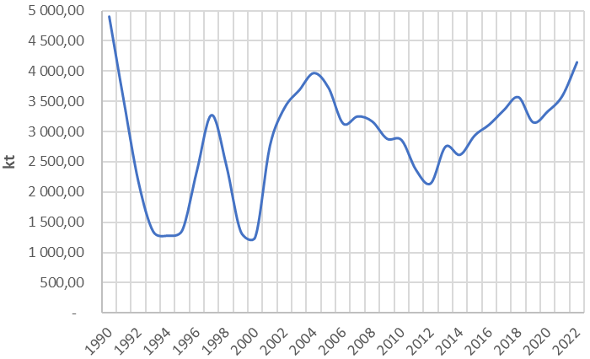
Figure 8: Evolution of the amounts of crude oil treated in petroleum refining for the period 1990-2022

For the period 1990-2022, the amounts of crude oil refined have varied significantly, rather similarly to the trend observed for the overall energy consumptions of the country for the period 1990-2014 (cf. chapter 3.1). Between 2014 and 2022, a large increase of 59% in the sector activity has been observed, meanwhile the fuel consumptions have increased by 40% over the same period.
The following graph presents the evolution of the GHG emissions for the petroleum refining sector:
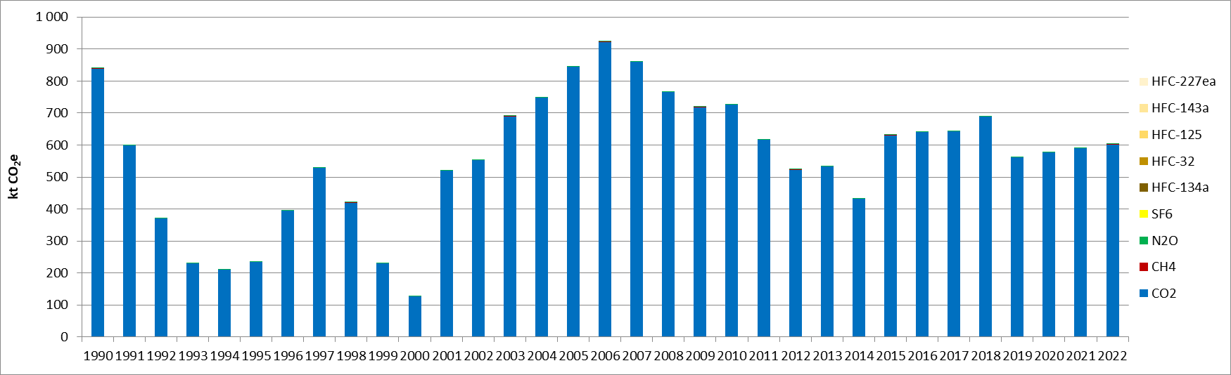
Figure 9: GHG emissions for the petroleum refining (CRT 1A1b), for the period 1990-2022 (in kt CO₂e)

The GHG emissions from the Petroleum refining follows roughly the trend of the amount of crude oil treated over the whole timeseries. In the end of the period, the GHG emissions underwent a least increase as the fuel consumptions did not increase as much as the amount of crude oil refined, as well as due to the progressive withdrawal of the use of heavy fuel oil, substituted partly by other fuels with a smaller carbon content such as natural gas and LPG.

In 2022, the category Petroleum refining is a key category for CO₂ emissions in Serbia, for the consumption of liquid and gaseous fuels, both in level and trend of emissions.

Consumption of liquid fuels in the Petroleum refining
The CO₂ emissions related to the consumption of liquid fuels in the Petroleum refining contribute to 0.5% in terms of emissions level (rank 23) and 1.0% in terms of emissions trend (rank 24), without considering LULUCF.

Consumption of gaseous fuels in the Petroleum refining
The CO₂ emissions related to the consumption of gaseous fuels in the Petroleum refining contributes to 0.5% in terms of emissions level (rank 22) and 0.8% in terms of emissions trend (rank 28), without considering LULUCF.

Methodological issues
According to the CRT Tables nomenclature, GHG emissions related to the Petroleum refining are reported by fuels:
- Liquid fuels,
- Solid fuels,
- Gaseous fuels,
- Other fossil fuels,
- Peat,
- Biomass.
The Tier 1 method from the 2006 IPCC Guidelines is used to calculate the GHG emissions [E1].
Fuel consumptions for refineries are taken directly from the refineries data from 2000 to 2022 [E4]. For the years 1990 to 1999, some extrapolations are developed based on the total amount of crude oil refined.
Default emissions factors (CO₂, CH₄, N₂O) are used to calculate emissions, and the applied CO₂ EF are presented in Chapter 3.2.4. Default values are sourced from the 2006 IPCC Guidelines [E3].

Manufacture of solid fuels and other energy industries (CRT 1A1c)

Category description (e.g. characteristics of sources)
According to the CRT Tables nomenclature, GHG emissions related to the Manufacture of Solid fuels are reported by fuels:
- Diesel oil,
- Fuel oil,
- Sub-bituminous coal,
- Biomass.
The consumption of other bituminous coal and lignite coke from Energy Balance, for coke manufacture, are not calculated in this category, since those amounts are already included in IPPU Tier Emission Factor for Steel Production. Also, emissions related to lignite production are included in fugitive emissions from coal handling (CRT 1B1b).
Except for the year 1990, only biomass is consumed for this sector, in the period 2011-2022. The GHG emissions for the manufacture of solid fuels and other energy industries evolve as follows:
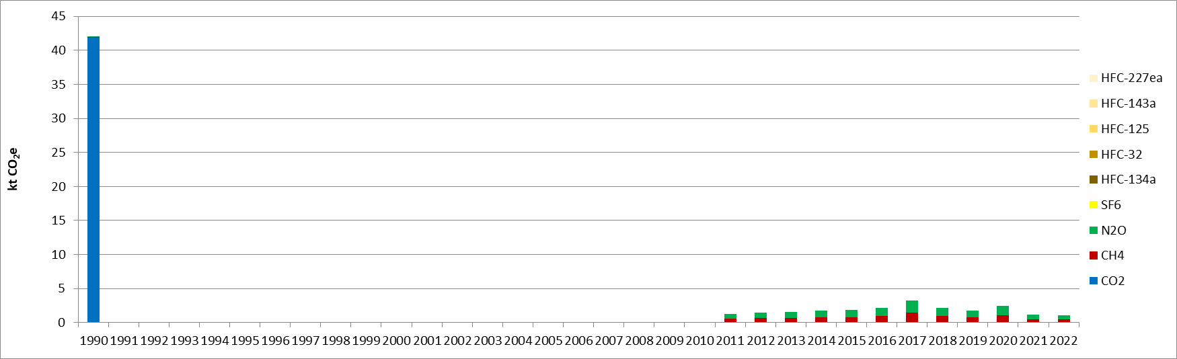
Figure 10: GHG emissions for the Manufacture of solid fuels (CRT 1A1c), for the period 1990-2022 (in kt CO₂e)

The GHG emissions trend evolves as the fuel consumptions given in the energy balance, with some fossil fuels used in 1990 only, and then biomass consumed from 2011 onwards, explaining why only CH₄ and N₂O emissions are reported for this period.
The manufacture of solid fuels and other energy industries (CRF 1A1c) is not considered a key category in 2022 in terms of either emission levels or trends, excluding LULUCF. Despite the relatively low emission levels, inconsistencies were identified in the time series for energy industries. Additional efforts will be dedicated to investigating the cause of these inconsistencies, and, if necessary, the time series will be adjusted to ensure accuracy and consistency.

Methodological issues
The Tier 1 method from the 2006 IPCC Guidelines is used to calculate GHG emissions [E1].
The consumption of fuels is sourced from the Serbian energy balance for the whole timeseries [E2].
The emission factors are sourced from the 2006 IPCC Guidelines [E3], and the applied CO₂ EF are presented in Chapter 3.2.4.

Uncertainties and time-series consistency

CO₂
In 2022, the uncertainty estimate associated with activity data for the 1A1-Energy industry category is 1%, based on 2006 IPCC Guidelines [E5].

Uncertainty estimate associated with CO₂ default emission factor for 1A1 category is 7%, accordingly to values reported in 1996 IPCC Guidelines [E6].

Combined uncertainty for CO₂ emissions is 1.6% in 2022, excluding LULUCF, in the total national terms of level of emissions.

CH₄
In 2016, the uncertainty estimate associated with activity data for the 1A1-Energy industry category is 1%, based on 2006 IPCC Guidelines [E5].

Uncertainty estimate associated with CH₄ default emission factor for 1A1 category is 100%, accordingly to values reported in 2006 IPCC Guidelines [E7].

Combined uncertainty for CH₄ emissions is 0.02% in 2022, excluding LULUCF, in the total national terms of level of emissions.

N₂O
In 2016, the uncertainty estimate associated with activity data for the 1A1-Energy industry category is 1%, based on 2006 IPCC Guidelines [E5].

Uncertainty estimate associated with N₂O default emission factor for 1A1 category is 100%, based on a conservative assumption.

Combined uncertainty for N₂O emissions is 0.2% in 2022, excluding LULUCF, in the total national terms of level of emissions.

Category-specific QA/QC and verification
During the preparation of the inventory submission, activities related to quality control were mainly focused on proper use of notation keys in the CRT tables according to QA/QC plan.

Category-specific recalculations
The current report is the first National Inventory Document for Serbia. Consequently, there is no recalculation. Possible recalculation will occur and be estimated in the next submission if necessary.

Category-specific planned improvements
For the manufacture of solid fuels, the completeness of the activity data set has to be improved.
In addition, for sectors where reporting data are available, the data used in the inventory will be compared with the reports from operators for QA/QC.

Manufacturing industry and construction (CRT 1A2)

Category description
Manufacturing Industries and Construction include emissions from fuel combustion in different industries, such as iron and steel industry, industries of non-ferrous metals, chemicals, pulp and paper, food processing, beverages and tobacco, non-mineral industry:
- Iron and steel (CRT 1A2a),
- Non-ferrous metals (CRT 1A2b),
- Chemicals (CRT 1A2c),
- Pulp, paper and print (CRT 1A2d),
- Food processing, beverages and tobacco (CRT 1A2e),
- Non-metallic minerals (CRT 1A2f)
- Manufacturing of Machinery (CRT 1A2gi)
- Transport equipment (CRT 1A2gii)
- Mining (excluding fuels) and Quarrying (CRT 1A2giiI)
- Wood and wood products (CRT 1A2giv)
- Construction (CRT 1A2gv)
- Textile and Leather (CRT 1A2gvi)
- Off road vehicles and other machinery (CRT 1A2gvii)
- Other (CRT 1A2gviii).
In addition, the fuel consumptions related to the auto-production of heat and electricity in manufacturing industries are also estimated in this sector, according to the 2006 IPCC guidelines, and included in the CRT 1A2gviii
According to the CRT Tables nomenclature, GHG emissions related to the Manufacturing industry are reported by consumption of the following fuel categories:
- Liquid fuels,
- Solid fuels,
- Gaseous fuels,
- Other fossil fuels,
- Peat,
- Biomass.
It has to be noted that biomass consumption has to be reported in the 1A2 sector, but the CO₂ related emissions are excluded from the national total GHG emissions (they are reported under the “Memo items”).

In 2022, the manufacturing industries (CRT 1A2) contributes to 6% of the total GHG emissions without considering LULUCF, and it contributes to 7% of the Energy category (CRT 1) in Serbia.
The evolution of the fuel consumptions in the sector of the manufacturing industries and construction, per fuel category and per subsector, are presented in the following graphs. It can be observed that some significant variations occur over the timeseries, according to generic comments which have been developed in the Chapter 3.1. To summarize, there have been some drastic changes following the hyperinflation period, which can be observed until 1995 for the industry, the NATO bombing in 1999, the global economic crisis of 2009, and the floodings in 2014. Since 2016, a progressive declining trend can be observed, and there has been an overall reduction of the fuel consumptions of 17% in 2022. In overall, the fuel consumptions of the industry have decreased by 47% between 1990 and 2022, and all the different fuel have contributed to this reduction, except biomass and the other fuels which were not occurring in 1990.
Comparing the different fuel types, for the period 1990-2022, the combustion of liquid fuels, which was predominant in 1990 and represented almost half the overall consumption, have decreased a faster rate than the other fuels, and contribute to 30% of the total consumption in 2022. A similar observation, to a lesser extent and overall contribution, can be drawn for the solid fuels. Liquid and solid fuels have been mainly substituted by the development of biomass, which was not occurring in 1990 and now contributes to 12% of the total consumption, and gaseous fuels which have seen their share increased from 38% to 47% over the whole timeseries.
In terms of subsectors, the major contributors to the total industry fuel consumptions are the non-metallic minerals (CRT 1A2f), the other industries (including auto-producers) (CRT 1A2viii), the food and beverages (CRT 1A2e), the chemicals (CRT 1A2c) and the iron and steel (CRT 1A2a). All these subsectors have decreased their fuel consumptions between 1990 and 2022, by 44% to 58%, except for the non-metallic mineral industries which increased theirs by 26%. Among the other significant changes can be noted the increasing fuel consumptions of the mining and quarrying industries (CRT 1A2i), which are 144% higher in 2022 than in 1990.
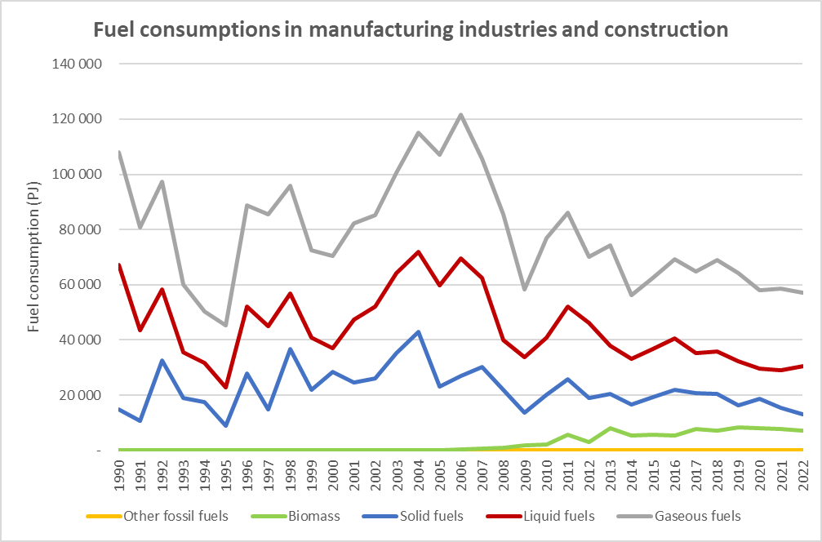
Figure 11: Fuel consumptions in the Manufacturing industries and Construction (CRT 1A2), per fuel type, for the period 1990-2022 (in TJ)
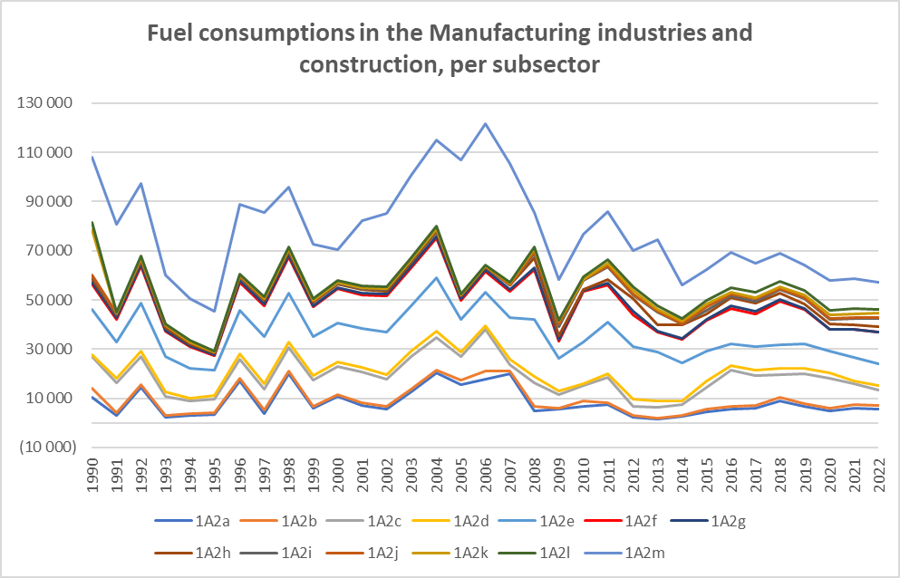
Figure 12: Fuel consumptions in the Manufacturing industries and Construction (CRT 1A2), per subsector, for the period 1990-2022 (in TJ)
The following graph presents the trend evolution of the GHG emissions of the CRT 1A2, between 1990 and 2022:
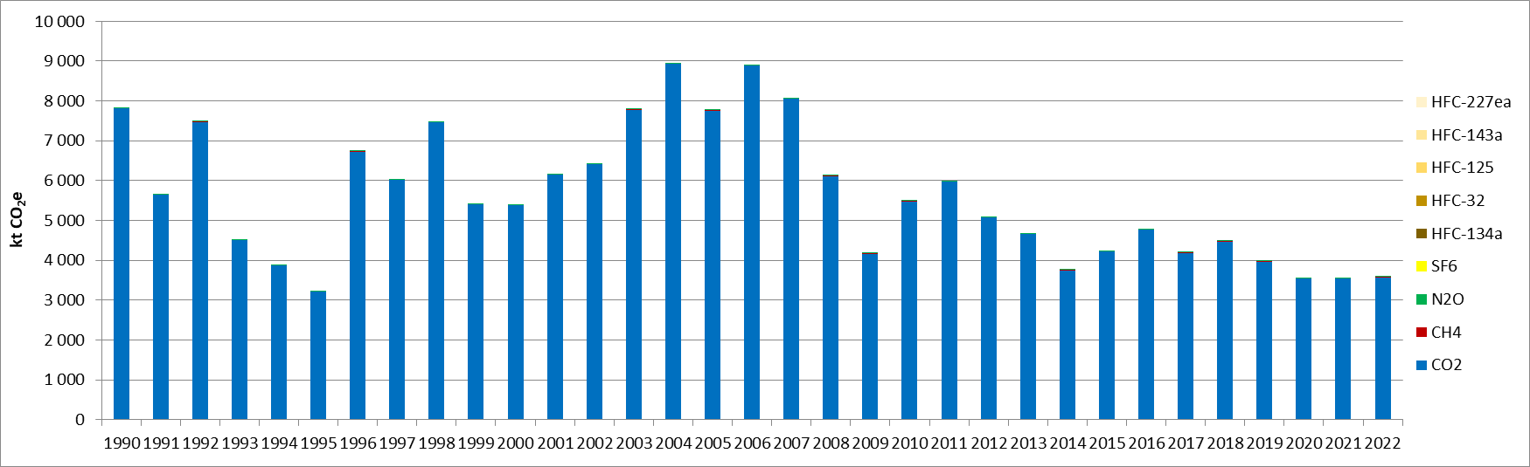
Figure 13: GHG emissions in the Manufacturing industry and construction (CRT 1A2), for the period 1990-2022 (in kt CO₂e)

As for the other subsectors from the Energy, most of the GHG emissions are related to CO₂ emissions.

The overall GHG emissions of the CRT 1A2 follow the trend of the fossil fuel consumptions, and have decreased by 54% between 1990 and 2022. The GHG emissions have decreased at a faster rate than the fuel consumptions of the sector, due to changes in the energy mix with substitution of fuels with relatively high carbon contents such as coal and residual fuel oil, with fuels with a lesser impact such as natural gas, and obviously biomass (as the CO₂ is not included in the total). As a consequence, the GHG implied emission factor have been reduced from 73 to 63 kg/GJ for the timeseries, meaning a 13% reduction.

In 2022, the different categories constituting the sector CRT 1A2 are key categories for CO₂ emissions in Serbia, for the combustion of liquid, solid, and gaseous fuels, both in terms of levels and trends of emissions, and are as follows:

Table 19: Key categories in level and trend for the Manufacturing industries and construction, in 2022, excluding LULUCF
CRT category/fuel/substance | Key category in level rank  (% of contribution) | Key category in trend rank  (% of contribution)
1.A.2.g.viii Other industries/gaseous fuels/CO₂ | 9 (1.2%) | 11 (2.3%)
1.A.2.f Non-metallic minerals/liquid fuels/CO₂ | 11 (1.2%) | 13 (2.2%)
1.A.2.g.viii Other industries/solid fuels/CO₂ | 20 (0.7%) | 31 (0.7%)
1.A.2.a Iron and steel/liquid fuels/CO₂ | 25 (0.5%)
1.A.2.f Non-metallic minerals/solid fuels/CO₂ | 31 (0.3%) | 33 (0.7%)
1.A.2.i Mining and quarrying/liquid fuels/CO₂ | 33 (0.3%) | 39 (0.5%)
1.A.2.e Food and beverages/gaseous fuels/CO₂ | 34 (0.3%) | 41 (0.5%)
1.A.2.g.viii Other industries/liquid fuels/CO₂ | 35 (0.3%) | 8 (3.5%)
1.A.2.f Non-metallic minerals/gaseous fuels/CO₂ | 39 (0.2%) | 36 (0.6%)
1.A.2.g.v Construction/liquid fuels/CO₂ | 40 (0.2%) | 21 (1.1%)
1.A.2.e Food and beverages/liquid fuels/CO₂ |  | 15 (1.8%)
1.A.2.e Food and beverages/solid fuels/CO₂ |  | 16 (1.8%)
1.A.2.c Chemicals/gaseous fuels/CO₂ |  | 17 (1.6%)
1.A.2.g.v Construction/gaseous fuels/CO₂ |  | 19 (1.6%)
1.A.2.a Iron and steel/liquid fuels/CO₂ |  | 35 (0.6%)
1.A.2.b Non-ferrous metals/solid fuels/CO₂ |  | 40 (0.5%)
1.A.2.g.v Construction/solid fuels/CO₂ |  | 43 (0.4%)
1.A.2.g.vi Textiles and leather/liquid fuels/CO₂ |  | 47 (0.4%)
1.A.2.b Non-ferrous metals/liquid fuels/CO₂ |  | 48 (0.4%)
1.A.2.c Chemicals/liquid fuels/CO₂ |  | 50 (0.3%)
1.A.2.d Pulp, paper and print/gaseous fuels/CO₂ |  | 53 (0.3%)
1.A.2.b Non-ferrous metals/gaseous fuels/CO₂ |  | 57 (0.2%)

Methodological issues
The Tier 1 method from the 2006 IPCC Guidelines is used to calculate the GHG emissions [E1].
The activity data are the consumptions of fuels, which are sourced from the national energy balance [E2]. It has to be noticed that the non-energy use fuel consumptions are not reported in the 1A2 sector, but in the CRT 2-Industrial processes sector.
Default emissions factors (CO₂, CH₄, N₂O) are used to calculate emissions. Default values are sourced from the 2006 IPCC Guidelines [E3], and the applied CO₂ EF are presented in Chapter 3.2.4.

Uncertainties and time-series consistency
CO₂
In 2022, the uncertainty estimate associated with activity data for category 1A2-Manufacturing industry is 2%, based on 2006 IPCC Guidelines [E5].

Uncertainty estimate associated with CO₂ default emission factor for category 1A2-Manufacturing industry is 7%, accordingly to values reported in 1996 IPCC Guidelines [E6].

Combined uncertainty for CO₂ emissions is 0.5% in the total national levels of emission in 2022, excluding LULUCF contribution.

CH₄
In 2022, the uncertainty estimate associated with activity data for category 1A2-Manufacturing industry is 2%, based on 2006 IPCC Guidelines [E5].

Uncertainty estimate associated with CH₄ default emission factor for category 1A2-Manufacturing industry is 100%, accordingly to values reported in 2006 IPCC Guidelines [E7].
Combined uncertainty for CH₄ emissions is 0.006% in the total national levels of emission in 2022, excluding LULUCF contribution.
N₂O
In 2022, the uncertainty estimate associated with activity data for category 1A2-Manufacturing industry is 2%, based on 2006 IPCC Guidelines [E5].

Uncertainty estimate associated with N₂O default emission factor for category 1A2-Manufacturing industry is 100%, accordingly to a conservative assumption.
Combined uncertainty for N₂O emissions is 0.01% in the total national levels of emission in 2022, excluding LULUCF contribution.

Category-specific QA/QC and verification
During the preparation of the inventory submission activities related to quality control were mainly focused on proper use of notation keys in the CRT tables according to QA/QC plan.

Category-specific recalculations
The current report is the first National Inventory Document for Serbia. Consequently, there is no recalculation. Possible recalculation will occur and be estimated in the next submission if necessary.

Category-specific planned improvements
To enhance the completeness of activity data for the autoproducers of electricity and heat in manufacturing industries, discussions will be initiated with experts from the Ministry of Mining and Energy, who are responsible for compiling energy balances.

Transport (CRT 1A3)
This category covers the emission from combustion and evaporation of fuel for all transport activities. This sector includes the emission from:
- Air transport (CRT 1A3a),
- Road transport (CRT 1A3b),
- Rail transport (CRT 1A3c),
- Marine transport (CRT 1A3d).
There is no domestic aviation (CRT 1A3a) fuel consumptions reported in the Republic of Serbia. For aviation, only internationals bunker emissions are estimated and excluded from the national total emission (memo items). On the opposite, because there is no direct access to the sea in the Republic of Serbia, all fuel consumptions related to water-borne transport are included in the domestic transport (CRT 1A3d).
In 2022, the transport sector (CRT 1A3) contributes to 13% of the total GHG emissions with LULUCF, and it contributes to 17% of the Energy category (CRT 1) in the Republic of Serbia.
The fuel consumptions for the transport sector (CRT 1A3) are presented in the following graph. The trend is observed to be quite fluctuating with low levels observed in 1992-1995 and 1999-2000 due to the hyperinflation crisis and the NATO bombing, respectively. Since then, the transport sector activity has been in a relatively progressive increase, in particular since 2012. The fuel consumptions for the transport sector are almost only related to liquid fuel consumptions, except a relatively marginal consumption of solid fuels for railway transport until 2009, and the more recent development of liquefied natural gas for road transport from 2008, which remains overall marginal. In overall, almost only road transport contributes to the total fuel consumptions of the transport sector, with more than 99-100% of the share for the whole period.
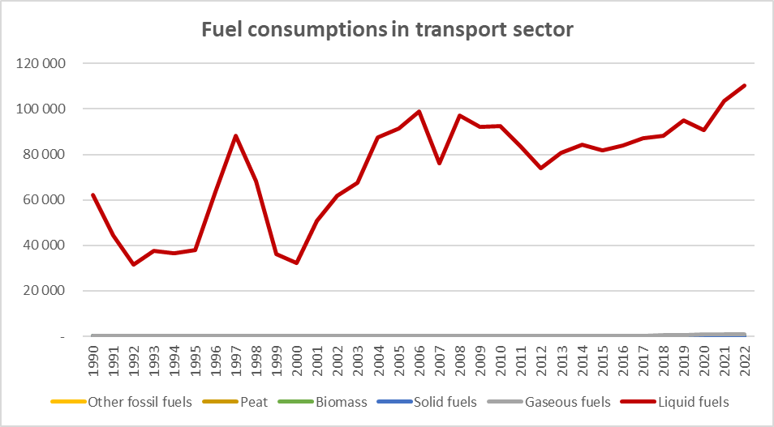
Figure 14: Fuel consumptions in the Transport sector (CRT 1A3), per fuel type, for the period 1990-2022 (in TJ)

Road transportation (CRT 1A3b)

Category description
This category refers to GHG emissions due to road transport. Road transport includes all types of passenger cars, light-duty vehicles, heavy-duty vehicles, buses, mopeds and motorcycles. These mobile sources use different types of liquid and gaseous fuels, mostly gasoline and diesel oil, and emit significant amounts of greenhouse gases and air pollutants.
Road transport represents the most developed mode of transportation in the Republic of Serbia. Road network in Serbia today, although relatively well developed (total length of roads reaches about 45,419 km). Lack of financial resources starting from 1990 onwards, as well as utilization of all available funds for maintenance and repair of infrastructure damaged during the 1999 bombardment, represent the main reasons for the situation encountered today. Current condition of road network directly affects the safety of road transport, low level of transportation services provided through the existent and perspective road network, as well as high exploitation costs.
In addition, the old age of vehicle fleet represents a key problem with respect to energy efficiency, environmental protection as well as transportation safety. In the period 1990 – 1999, the average annual increase in the number of vehicles was about 7%. However, much of the increase was due to importation of used vehicles from the western countries, which had largely influenced the average age of vehicle fleet.
The period from 1990 to 2000 was marked by the import of low-rank fuels, in addition to domestic production. During this time, the use of diesel fuel increased significantly. These factors contributed to a rise in pollutant emissions at the national level, despite a recorded decline in the transport sector's contribution to the national economy during the same period. After 2000 the road transport sector was rapidly developing. Number of cars are significantly increasing, reflecting the stronger purchase power of households and growth of the industrial activities and services.
In 2022, the road transport sector is a key category for CO₂ emissions in the Republic of Serbia, both in terms of level and trend of emissions. The CO₂ emissions from the liquid fuel combustion in this sector contribute to 12.7% in terms of emissions level (rank 2) and 16.6% in terms of emissions trend (rank 1). The N₂O emissions of liquid fuel combustion in road transport are also a key category in terms of emission trend with a contribution of 0.2% (rank 59).
The following Figure 15 presents the trend of the GHG emissions of road transportation in the Republic of Serbia over the whole timeseries. In overall, between 1990 and 2022, the GHG emissions of the road transport sector increased by 78%. From 2004, after having recovered from the NATO bombing, to 2018, the GHG emissions have been rather stable although varying for some specific years. Since 2019, except in 2020 with the COVID crisis, an increasing trend in the GHG emissions is observed. The GHG emissions have increased slightly less than the fuel consumptions as, since 2008, the introduction of LPG and LNG, enables to decrease a little the implied emission factor of the overall mix. In 2022, LPG consumption represents about 4% of the total consumption whereas LNG contributes to around 1%.
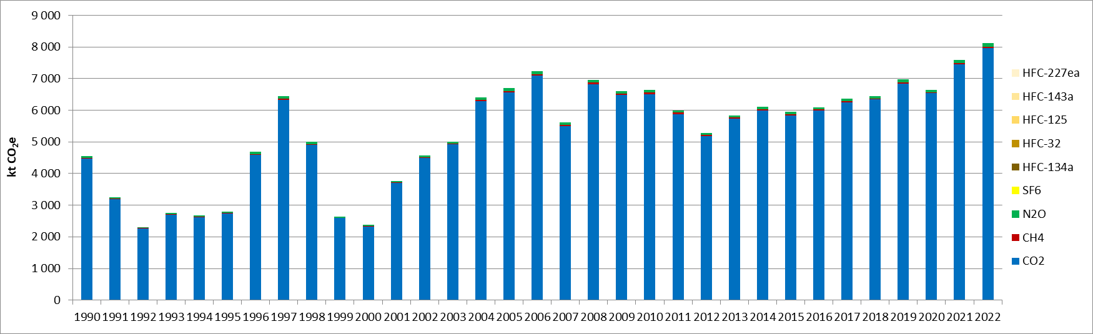
Figure 15 : GHG emissions for road transportation (CRT 1A3b), for the period 1990-2022 (in kt CO₂e)

Methodological issues
Emissions of GHG from liquid and gaseous fuels are calculated on the basis of the fuel consumptions using Tier 1 (top-down) approach, which is in accordance with the 2006 IPCC Guidelines.

Activity data used are the fuel consumption by type of fuel (diesel, gasoline, LPG and LNG). Amounts of all types of liquid and gaseous fuels consumed for the whole timeseries were extracted from national energy balance [E2], as well as the NCV [E10], which are summarized in Chapter 3.2.4.

Emissions factors used for calculating CO₂ emissions from liquid and gaseous fuels are sourced from 2006 IPCC guidelines [E8], and are presented in Chapter 3.2.4.
Emissions factors used for calculating CH₄ and N₂O emissions from liquid and gaseous fuels also are sourced from 2006 IPCC guidelines [E9].

Railways (CRT 1A3c)

Category description
This category refers to GHG emissions due to rail transport.
In 2022, this category is not a key category in terms of emissions level nor in terms of emissions trend for GHG emissions in Serbia.
The dissagregation of fuel consumption for railways is having in energy balance of Serbia a consistent datasets since only since 2008. Due lack of available resources and time available for preparation of this report, the issue of timeseries consistency have not yet been resolved since the period 1990-2008 is not a key priority for the energy statistics. Therefore, the GHG inventory team will for one the subsequent submissions for the period 1990-2007 use extrapolation or will if appropriate estimate emissions using drivers such as tkm or pkm. It is assumed that for the period 1990-2007 the diesel used for railways is allocated under the road transport.

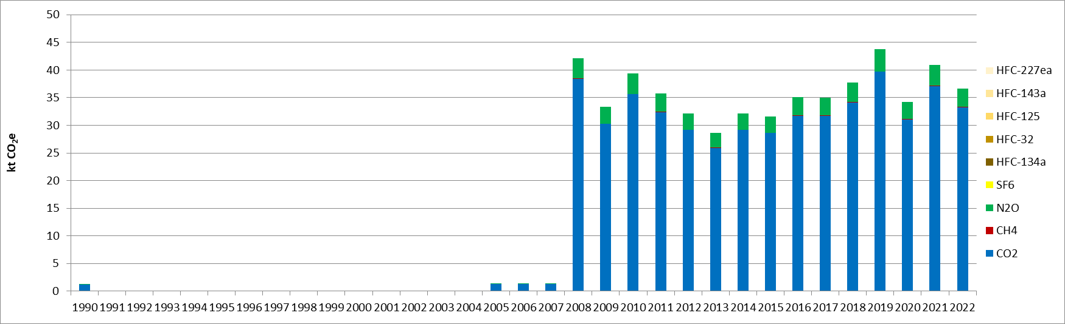
Figure 16 : GHG emissions for railways (CRT 1A3c), for the period 1990-2022 (in kt CO2e)

Since 1990, investments in rail transport and its infrastructure have been relatively insignificant, resulting in this mode of transportation struggling to compete with road freight and passenger transport. Consequently, the share of rail transport has steadily declined from 1990 onwards
Until 2005, intermodal transport in the Republic of Serbia was represented in overall transport with approximately only 0.5 % Development of intermodal transport in the Republic of Serbia, as transport of the wider public interest, environmentally acceptable, economically justified and safe, requires support from the government.
In recent years, changes in state policy have contributed to the development of this subsector. As a result, intermodal transport, which emphasizes ecological principles, has gained prominence. This approach has driven its intensified development in most European countries.

Methodological issues
Emissions of GHG from liquid and solid fuels are calculated on the basis of the fuel consumption using Tier 1 (top-down) approach, which is in accordance with the 2006 IPCC Guidelines [E10].
Activity data used are the fuel consumptions by type of fuel. Amounts of all types of fuels consumed (brown coal briquettes and diesel) for the whole timeseries were taken from national energy balance [E2], as well as NCV values, which are presented in Chapter 3.2.4.
Emissions factors used for calculating CO₂, CH₄ and N₂O emissions from fuels are sourced from 2006 IPCC guidelines [E3]. CO₂ emission factors applied are given in Chapter 3.2.4.

Domestic navigation (CRT 1A3d)

Category description
This category refers to GHG emissions due to domestic navigation.
River transport in Serbia is only modestly utilized, mainly due to poor condition of related infrastructure resulting from improper maintenance of waterways and auxiliary infrastructure during the 90’s of the last century.
Total length of waterways in the Republic of Serbia, measured at the mean river water levels, equals approximately to 1,680 km. The federal waterways are mainly constituted of the navigable river streams of the Danube, Sava and Tisa river (960 km in total), as well as a network of navigable canals of the hydro–engineering system mainly used for flood control Danube–Tisa–Danube (600 km in total).
With respect to the annual volume of river transport and available capacity, the most important river ports are the port of Belgrade, Novi Sad, Pančevo, Smederevo and Prahovo. Most of the river ports are either directly connected or are close to the main railways and roads, which represent a strategic and logistic advantage not sufficiently exploited over the last twenty years. The said is clearly demonstrated in the fact that total traffic that came in Serbian river ports in 2000 equaled about 40% of the traffic achieved in 1989. Such a significant decrease was primarily a result of reduced national river transport caused by negative trends in the country’s economy.
In 2022, the category domestic navigation is not a key category in terms of emission levels nor in terms of emission trend for GHG emissions in the Republic of Serbia. Regarding the timeseries consistency we are facing similar issue as identified in the railways, however similarly the diesel consumption for domestic navigation is likely allocated under road transport.
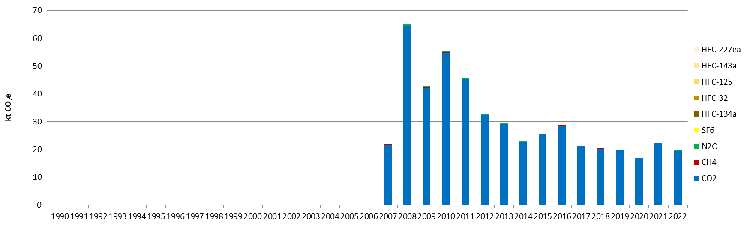
Figure 17 : GHG emissions for domestic navigation (CRT 1A3d), for the period 1990-2022 (in kt CO₂e)
Due to time constraints and availability of resources the issue of timeseries consistency was not during the preparation of this report and is expected to be addressed during the preparation of the next NID.

Methodological issues
Emissions of GHG from liquid fuels are calculated on the basis of the fuel consumption using Tier 1 (top-down) approach which is in accordance with the 2006 IPCC Guidelines [10].
Activity data used are fuel consumptions, by type of fuel. Amounts of all types of fuels consumed for the whole timeseries were given in the national energy balance [E2], as well as NCV values, which are presented in Chapter 3.2.4.
Emissions factors used for calculating CO₂, CH₄ and N₂O emissions from fuels are taken from 2006 IPCC guidelines [E11]. CO₂ emission factors applied are given in Chapter 3.2.4.

Uncertainties and time-series consistency
CO₂, CH₄, N₂O
Uncertainty estimate associated with activity data for CRT 1A3 amounts to 5%, according to values available in 2006 IPCC Guidelines.
Uncertainty estimate associated with default emission factor for CO₂ amounts to 5%, according to values available in 2006 IPCC Guidelines. For CH₄ and N₂O, the uncertainties on Tier 1 emission factors are about 200% according to 2006 IPCC Guidelines.
Combined uncertainty for CO₂ emissions is 0.9% in the total national levels of emission in 2022, excluding LULUCF contribution. Combined uncertainties for CH₄ and N₂O emissions are 0.12% and 0.35%, respectively, in the total national levels of emission in 2022, excluding LULUCF contribution.

Category-specific QA/QC and verification
During the preparation of the inventory submission activities related to quality control were mainly focused on proper use of notation keys in the CRT tables according to QA/QC plan.

Category-specific recalculations
The current report is the first National Inventory Document for Serbia. Consequently, there is no recalculation. Possible recalculation will occur and be estimated in the next submission if necessary.

Category-specific planned improvements
One important planned improvement is to improve the timeseries consistency and completeness for the collected data from the energy balance for the sectors of railways (1A3c) and domestic navigation (1A3d).
Another further improvement will be to move to tier 2 methodologies for road transport, which is the second most emitting sector in 2022.

Other sectors (CRT 1A4)
This category covers the emission from combustion of fuel for other activities. This sector includes the emissions from:
- Commercial and institutional activities (CRT 1A4a),
- Residential (CRT 1A4b),
- Agriculture, forestry and fishing (CRT 1A4c).
In 2022, the other sectors (CRT 1A4) contribute to 5.3% of the total GHG emissions without considering LULUCF, and to 7% of the Energy category (CRT 1) in the Republic of Serbia.
The following Figure 18 and Figure 19 present the fuel consumptions in the other sectors over the whole studied period, per fuel type and per subsector. The overall fuel consumption decreased by 26% between 1990 and 2022, meanwhile the fossil fuel consumption has been reduced by 54% over the same period. All fossil fuels (liquid, gaseous and solid) contributed to that reduction, with the solid fuels contributing the most to that overall reduction with a drop of 76% for the period 1990-2022. In the latest year, they only represent 6.6% of the total fuel consumption (including biomass), whereas their share was of more than 20% in 1990. On the opposite, biomass consumption, which is mainly consumed in the residential sector, is rather stable over the timeseries, until 2020 where an important increase is observed, until reaching a plateau again. The biomass consumption for other sectors is 24% higher in 2022 than it was in 1990.
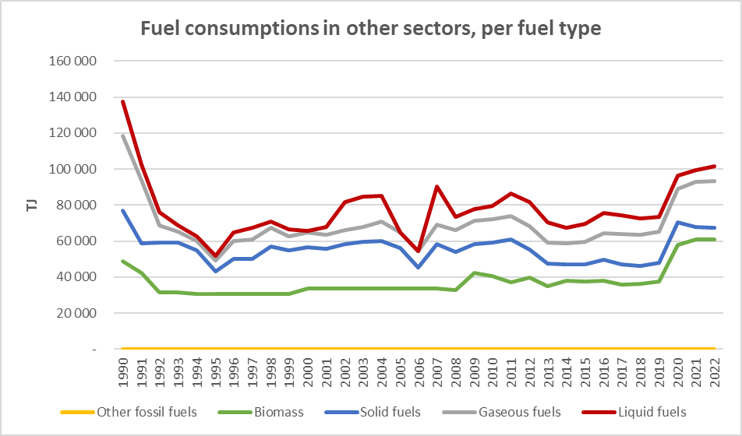
Figure 18: Fuel consumptions in the Other sectors (CRT 1A4), per fuel type, for the period 1990-2022 (in TJ)
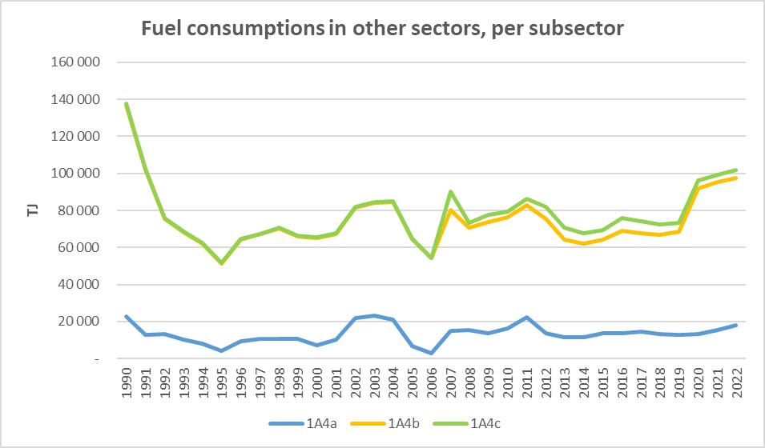
Figure 19: Fuel consumptions in the Other sectors (CRT 1A4), per subsector, for the period 1990-2022 (in TJ)
With regards to subsectors, residential combustion is the main responsible for the fuel consumptions of the other sectors, with a slightly decreasing contribution from 83% in 1990 to 78% in 2022. The tertiary subsector is the second contributor to the other sector total fuel consumptions with a share of about 17% in 1990 and 18% in 2022. The latest subsector, agriculture, forestry and fishing, has increased its fuel consumption by 456% over the period 1990-2022. This is mainly due to the fact there are discrepancies in the timeseries of the energy balances (only diesel for tractors from 2007). Since this increase is likely due to issues with the quality of statistical data and use of methodological approaches the issues and potential resolutions will be discussed with the energy balance compilers during the preparation of the next BTR report. Same applies for the recalculation of the biomass consumption in the Other sector conducted be the energy balance compilers which was not recalculated for the period before 2020.
The overall GHG emissions from the Other sectors evolve as presented in the following Figure 20. It can be observed that the GHG emissions follow the trend of the total fuel consumptions, as the biomass consumption is rather stable over time, and the associated CO₂ emissions are not included in the totals for reminder, except for the period 2020-2022 where there is a significant increase in biomass consumption. In overall, the GHG emissions have been reduced by 53% between 1990 and 2022, mainly due to CO₂ emissions but also CH₄ emissions. The GHG emissions have been reduced at a faster rate than the fuel consumptions, and the GHG implied emission factor went from 52 to 33 kg/GJ (36% reduction) for the whole sector, due to the increased use in biomass meanwhile high carbon content fuel such as lignite, brown coal briquettes and residual fuel oil have been progressively substituted.
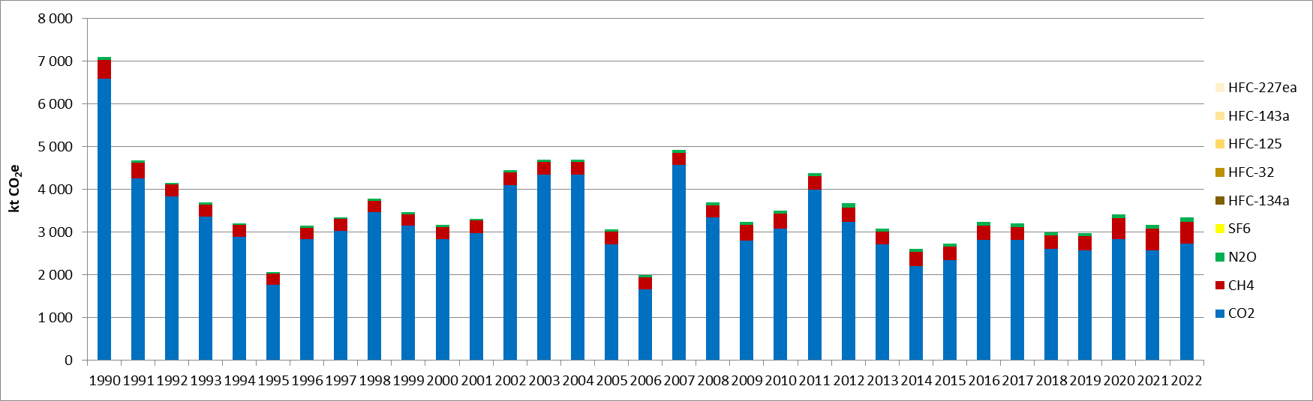
Figure 20: GHG emissions for Other sectors (CRT 1A4), for the period 1990-2022 (in kt CO₂e)

Commercial/institutional (CRT 1A4a)

Category description
This category refers to GHG emissions due to the combustion of fuels in commercial and institutional equipment (stationary and mobile). These sources use different types of fuels and emit significant amounts of greenhouse gases and air pollutants.
In 2022, the category commercial/institutional is a key category for CO₂ emissions in the Republic of Serbia, both in emission levels and trends. In terms of emission level, this sector contributes to 1.1% with the gaseous fuel combustion (rank 14) and of 0.4% with liquid fuel combustion (rank 28).In terms of emissions trend, the CO₂ emissions are key categories for the combustion of liquid fuels with a contribution of 3.0% (rank 9), gaseous fuels with a contribution of 2.5% (rank 10), and solid fuels with a contribution of 0.7% (rank 30).
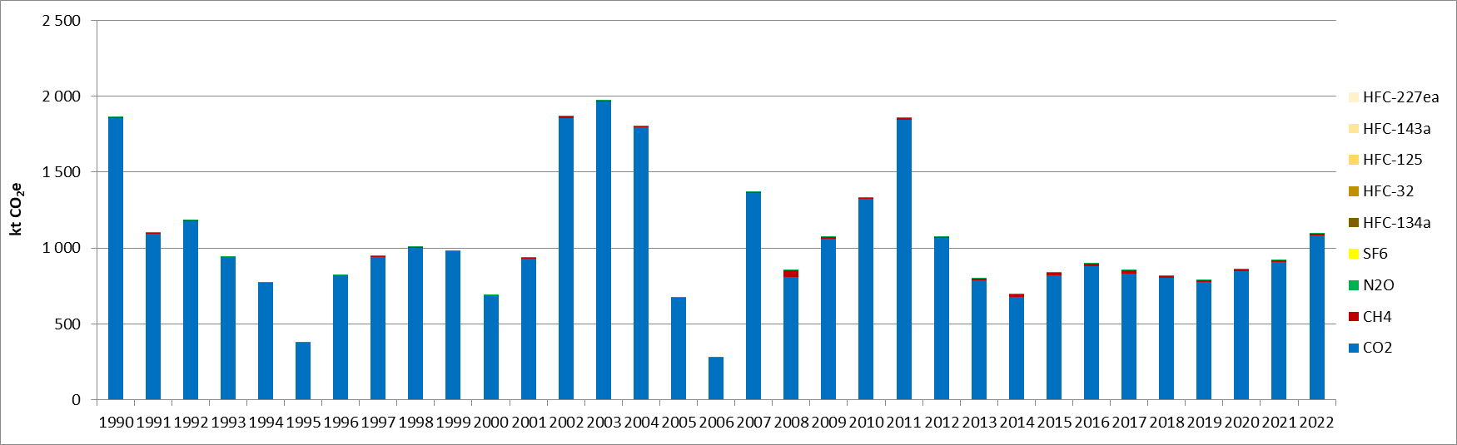
Figure 21: GHG emissions for commercial and institutional (CRT 1A4a), for the period 1990-2022 (in kt CO₂e)

Fuel consumptions for mobile and stationary equipment are considered in this category. However, it is not possible to split the consumptions between the two types of equipment, hence all consumptions are considered in stationary equipment.
In 2022, this sector mainly consumes natural gas (67%), heavy fuel oil (13%), lignite (7%), solid biofuels (5%) and LPG (3%). In 1990, only residual fuel oil (76%), lignite (18%) and LPG (6%) were consumed, hence the energy mix has significantly changed over the timeseries. Due to the development of natural gas and, to another extent, biomass, substituting higher carbon content fuels such as lignite and fuel oil, the GHG implied emission factor of the tertiary sector has been reduced significantly, from 82 to 61 kg/GJ.

Methodological issues
Emissions of GHG from fuels are calculated on the basis of the fuel consumption using Tier 1 (top-down) approach, which is in line with the 2006 IPCC Guidelines [E10].
Activity data used are fuel consumptions by type of fuel. Amounts of all types of fuels consumed for the whole timeseries are extracted from the national energy balance [E2], as well as NCV values, which are given in Chapter 3.2.4.
Emissions factors used for calculating CO₂, CH₄ and N₂O emissions from fuels are sourced from 2006 IPCC guidelines [E3]. CO₂ emission factors applied are given in Chapter 3.2.4.

Residential (1A4b)

Category description
This category refers to GHG emissions due to the combustion of fuels in residential equipment (stationary and mobile). These sources use different types of fuels and emit significant amounts of greenhouse gases and air pollutants.
In 2022, the category residential is a key category for CO₂ and CH₄ emissions in the Republic of Serbia, both in terms of emission level and trend. Here is a summary of the categories which are considered as key categories for this subsector:
Table 20: Key categories in level and trend for the Residential combustion, in 2022, excluding LULUCF
CRT category/fuel/substance | Key category in level rank  (% of contribution) | Key category in trend rank  (% of contribution)
1.A.4.b Residential combustion/gaseous fuels/CO₂ | 12 (1.1%) | 7 (3.9%)
1.A.4.b Residential combustion/solid fuels/CO₂ | 17 (0.9%) | 5 (4.6%)
1.A.4.b Residential combustion/biomass/CH₄ | 18 (0.8%) | 34 (0.7%)
1.A.4.b Residential combustion/liquid fuels/CO₂ |  | 49 (0.3%)

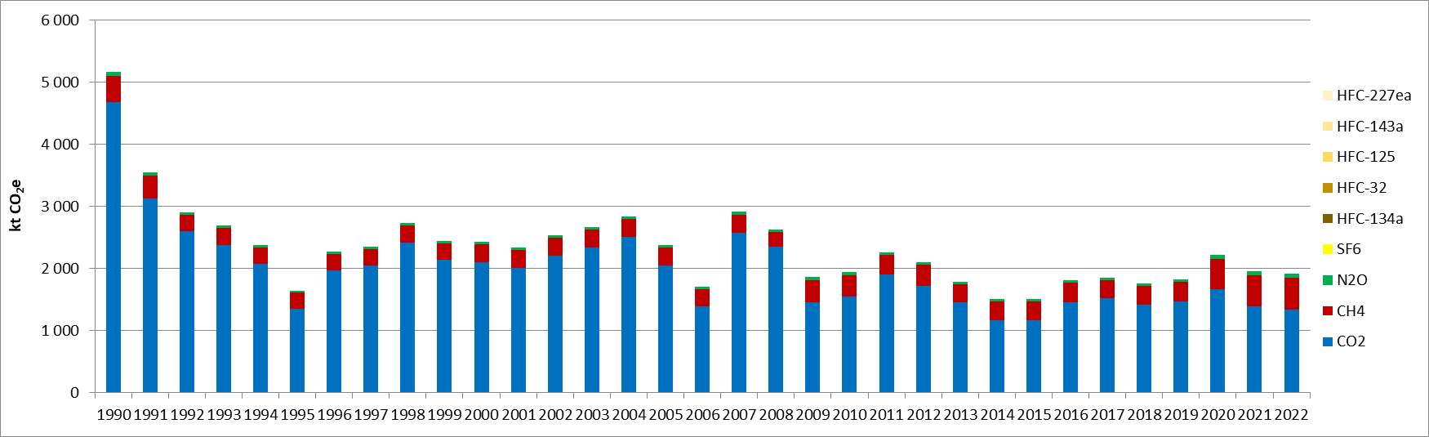
Figure 22 : GHG emissions for residential (CRT 1A4b) activities, for the period 1990-2022 (in kt CO₂e)

The activity data is sourced directly from the national energy balance. The energy mix for this subsector includes sub-bituminous coal, lignite, brown coal briquettes, natural gas, biomass, LPG, and diesel oil. Over the entire study period, fuel consumption in this subsector decreased by 30%. However, it remained relatively stable between 1992 and 2019 before experiencing a significant increase in recent years, with consumption rising by 42% from 2019 to 2022. This growth is primarily driven by a substantial increase in biomass consumption (+64%) which was not recalculated for the period 1990-2019 and, to a lesser extent, by an increase in natural gas consumption (+48%).

In terms of GHG emissions, the trend of evolution follows mostly the fossil fuel consumption of the subsector (depicted by the CO₂ emissions in blue in the above figure). Therefore, there is a decorrelation between the total fuel consumption and the GHG emissions, although methane emissions related to biomass combustion in small equipment are not negligible. This can be observed in the evolution of the GHG implied emission factor of the residential combustion which evolves from 45 kg/GJ in 1990 to 24 kg/GJ in 2022. The significant reduction is also the result from the drop in solid fuel consumption in this sector (-77%) for the studied period.

Fuel consumptions for both mobile and stationary combustion equipment are considered in this category. However, it is currently not possible to split the consumption between the two types and therefore all the consumptions are considered in stationary equipment.
In 2022, the energy mix of the subsector is as follows: solid biomass (75%), natural gas (16%), lignite (4%), brown coal briquettes (3%) and LPG (2%).

Methodological issues
Emissions of GHG from fuels are calculated on the basis of the fuel consumption using Tier 1 (top-down) approach, which is in line with the 2006 IPCC Guidelines [E10].
Activity data used are fuel consumptions by type of fuel. Amounts of all types of fuels consumed for the whole timeseries are given in the national energy balance [E2], as well as NCV values, which are given in Chapter 3.2.4.
Emissions factors used for calculating CO₂, CH₄ and N₂O emissions from fuels are sourced from 2006 IPCC guidelines [E3]. CO₂ emission factors applied are given in Chapter 3.2.4.

Agriculture/forestry/fishing (CRT 1A4c)

Category description
This category refers to GHG emissions due to the combustion of fuels in the sector of agriculture/forestry/fishing. This main category is split in two sub-sectors: stationary equipment (CRT 1.A.4.c.i) and off-road vehicles & other machineries (CRT 1.A.4.c.ii). These sources use different types of fuels and emit significant amounts of greenhouse gases and air pollutants.
The subcategory of off-road vehicles and other machinery is a key category in 2022 for CO₂ emissions of liquid fuels, both in terms of emission levels and trend. It contributes to 0.4% in terms of CO₂ emissions level (rank 29) and 039% in terms of emission trend (rank 26).
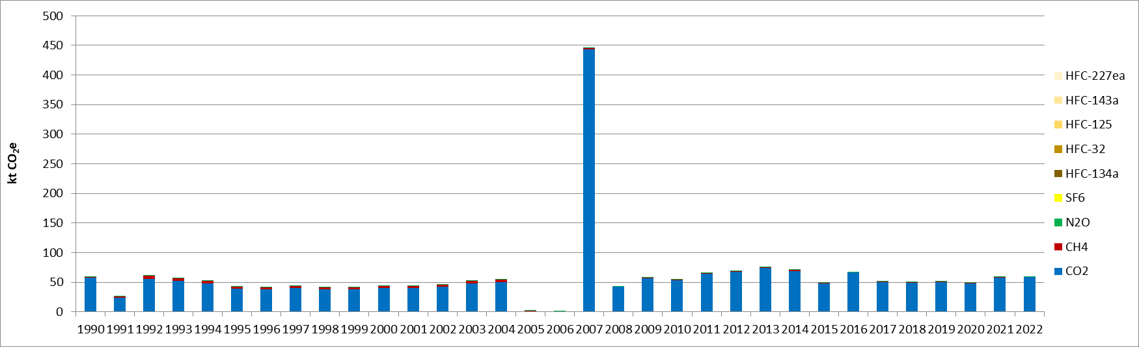
Figure 23 : GHG emissions for agriculture/forestry/fishing activities - stationary combustion (CRT 1A4ci), for the period 1990-2022 (in kt CO₂e)

As shown on Figure 23 the timeseries for stationary combustion is having significant consistency issue in the period 2005-2007 with potential data error in 2007 which will be investigated and addressed during the preparation of the subsequent NID.
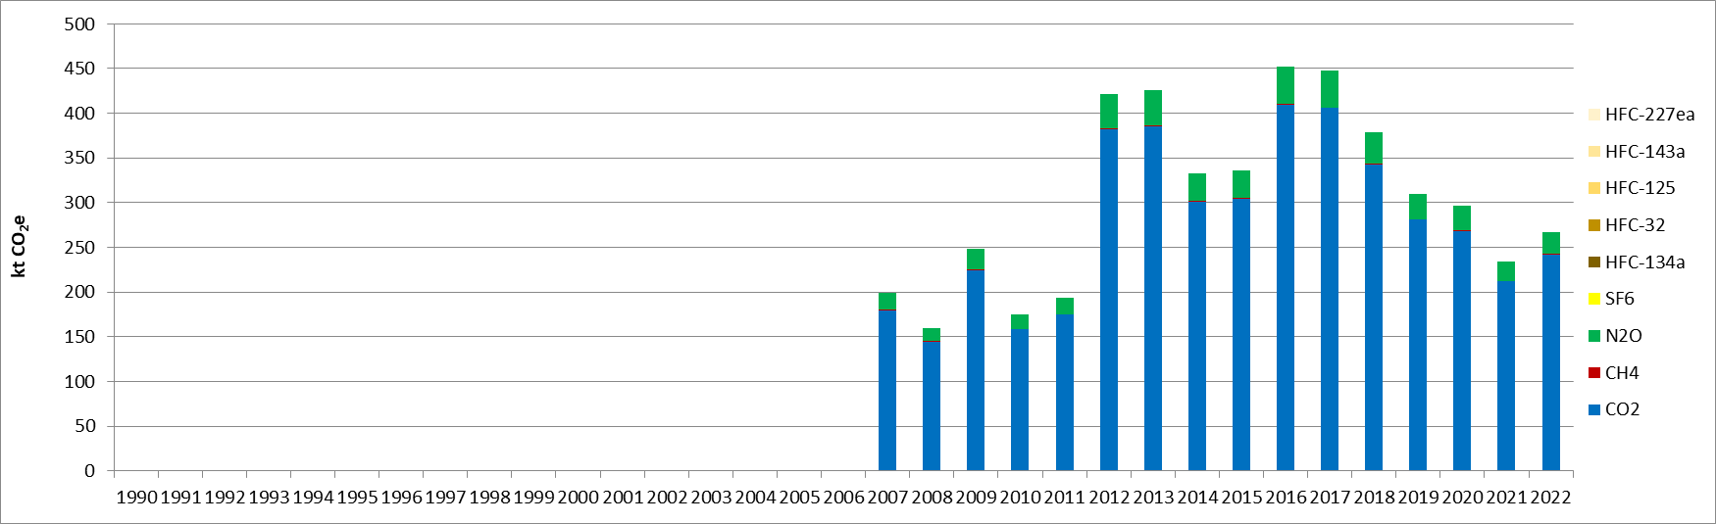
Figure 24 : GHG emissions for agriculture/forestry/fishing activities – mobile combustion (CRT 1A4cii), for the period 1990-2022 (in kt CO₂e)

The activity data is sourced directly from the national energy balance. As it can be observed in the two graphs, the time-series is not consistent because methodological choices and information have changed through the time-series. From 1990 to 2006, fuel consumptions for off-road were considered in another category before additional information was made available and enable the split for consumption between stationery and off-road.

In 2022, the stationary subsector mainly consumes natural gas (77%), solid biomass (8%) and LPG (16%), whereas only diesel oil is considered for the off-road subsector.

Methodological issues
Emissions of GHG from fuels are calculated on the basis of the fuel consumption using Tier 1 (top-down) approach, which is in line with the 2006 IPCC Guidelines [E10].
Activity data used are fuel consumptions by type of fuel. Amounts of all types of fuels consumed for the whole timeseries are taken from the national energy balance [E2], as well as NCV values, which are given in Chapter 3.2.4.
Emissions factors used for calculating CO₂, CH₄ and N₂O emissions from fuels are sourced from 2006 IPCC guidelines [E3]. CO₂ emission factors applied are given in Chapter 3.2.4.

Uncertainties and time-series consistency
Activity data
In 2022, the uncertainty estimate associated with activity data for category 1A4-Other sectors is 10%, based on 2006 IPCC Guidelines [E5].

CO₂
Uncertainty estimate associated with CO₂ default emission factor for category 1A4-Other sectors is 7%, accordingly to values reported in 1996 IPCC Guidelines [E6].

Combined uncertainty for CO₂ emissions is 0.5% in the total national levels of emission in 2022, excluding LULUCF contribution.

CH₄
Uncertainty estimate associated with CH₄ default emission factor for category 1A4-Other sectors is 100%, accordingly to values reported in 2006 IPCC Guidelines [E7].
Combined uncertainty for CH₄ emissions is 0.8% in the total national levels of emission in 2022, excluding LULUCF contribution.
N₂O
Uncertainty estimate associated with N₂O default emission factor for category 1A4-Other sectors is 100%, accordingly to a conservative assumption.
Combined uncertainty for N₂O emissions is 0.15% in the total national levels of emission in 2022, excluding LULUCF contribution.

Category-specific QA/QC and verification
During the preparation of the inventory submission activities related to quality control were mainly focused on proper use of notation keys in the CRT tables according to QA/QC plan.

Category-specific recalculations
The current report is the first National Inventory Document for Serbia. Consequently, there is no recalculation. Possible recalculation will occur and be estimated in the next submission if necessary.

Category-specific planned improvements
The completeness and consistency of the energy consumptions from the energy balance could be improved, in particular for the agriculture/forestry (1A4c) sector. To do so, discussions with experts from the Ministry of Mining and Energy, which develop energy balances, need to be engaged.

Fugitive emissions from solid fuels and oil and natural gas and other emissions from energy production (CRT 1.B)

Category description
Intentional or unintentional release of greenhouse gases may occur during the extraction, processing and delivery of fossil fuels to the point of final use. These are known as fugitive emissions.
In the Republic of Serbia, there are fugitive emissions associated with:
- Coal mining and handling: mining activities in underground and surface mines, post-mining emissions and emissions from abandoned underground mines,
- Oil systems: production and upgrading of oil, transport of oil, venting and flaring,
- Natural gas systems: production of natural gas, processing of natural gas, transmission and storage of natural gas, distribution of natural gas, venting and flaring.
The following graphs present the evolution of the main activities of the different subsectors of the fugitive emissions:
- Solid fuels (CRT 1B1): amounts of solid fuels produced in underground and surface mines;
- Liquid fuels (CRT 1B2a): amounts of crude oil produced and transported;
- Gaseous fuels (CRT 1B2b): amounts of gas produced, transported (high-pressure pipeline system) and distributed (low-pressure pipeline system).
In the following Figure 25, Figure 26 and Figure 27, the evolution of the activity data relevant for fugitive emissions are presented independently.
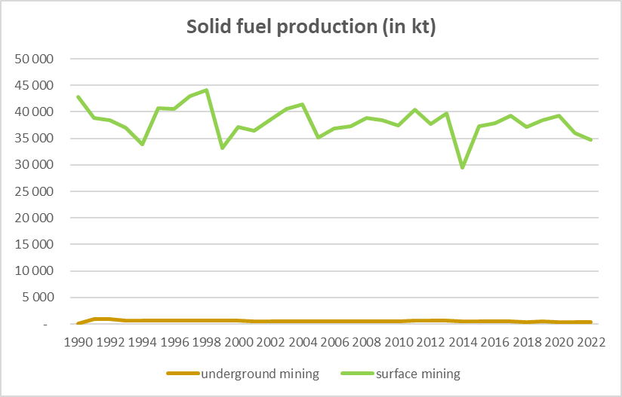
Figure 25: Evolution of the solid fuel production in Serbia, distinguished with underground and surface mining, for the period 1990-2022 (in kt)

For the mining of solid fuels, it can be observed that most of the production occurs in surface mines. The overall production has been reduced by 18% between 1990 and 2022. The evolution of the trend corresponds with the various events evoked in Chapter 3.1, with a first decline observed during the hyperinflation period (1992-1994), followed by a drastic drop during the NATO bombing in (1999), and then during the floodings in 2014. In the most recent years, a small reduction can be observed (-11% between 2020 and 2022), related to the coal production bottlenecks and therefore to the smaller use of this fuel in the electricity production, but also industrial, commercial and residential combustions. However, a rather large amount is still produced as it is the main fuel used for electricity production.
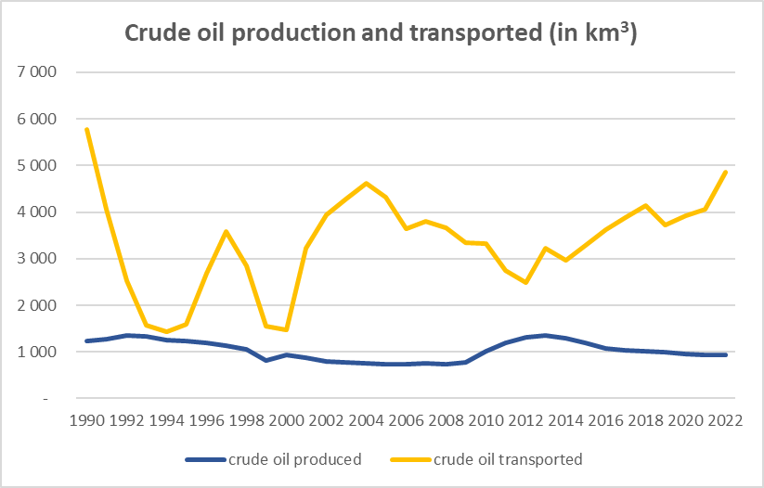
Figure 26: Evolution of the amounts of crude oil produced and transported, for the period 1990-2022 (in 000 m³)

The amount of crude oil produced in the Republic of Serbia is rather stable for the period 1990-2022. A sudden reduction can be observed in 1999 during the NATO bombing. Then, a significant increase has been observed from 2010 to 2012, following the global economic crisis of 2009. Since 2013, a slow but progressive declining trend can be observed, the crude oil production has dropped by 31%.
The trend of the amounts of crude oil transported in the Republic of Serbia is much more instable and follows the evolution of the amount of crude oil used for refining, as presented in Chapter 3.2.5.2.1.
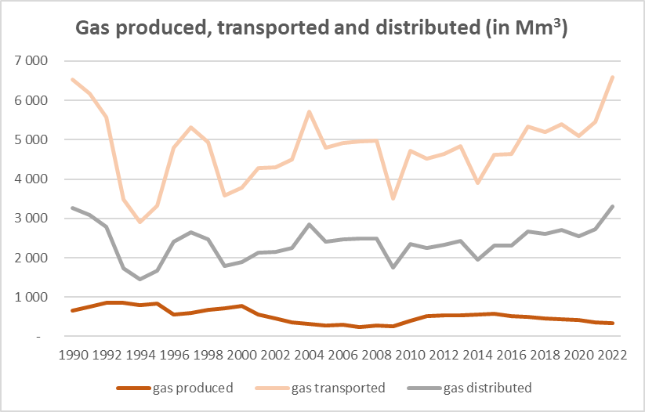
Figure 27: Evolution of the amounts of gas produced, transported and distributed, for the period 1990-2022 (in Mio m³)
The evolution of the trends of gas transported and distributed are rather similar and show a relative progressive increase in the most recent years. This is coherent with the evolution of the fuel consumptions observed for the latest years, in particular in the electricity production and residential heating. The trendline for the period 1990-2014 follows the list of events described in Chapter 3.1 and the other subchapters.
The amounts of gas produced on the Serbian territory are rather small compared with the amounts of gas transported, and represents 10% in 1990 and 5% in 2022. Despite the increasing amounts of gas transported and distributed (hence, consumed), the amounts of gas produced are in a progressive decline since 2015 (-43% in 2022).
In 2022, the different categories from the Fugitive sector which are key categories in the Republic of Serbia, either in terms of levels or trend of emissions, are as follows:
Table 21: Key categories in level and trend for the Fugitive sector (CRT 1B), in 2022, excluding LULUCF
CRT category/fuel/substance | Key category in level rank  (% of contribution) | Key category in trend rank  (% of contribution)
1.B.1 Fugitive emissions from solid fuels/CH₄ | 7 (1.6%) | 37 (0.6%)
1.B.2.a.2 Fugitive emissions from Oil systems /Production and upgrading/CH₄ | 10 (1.2%)
1.B.2.b.5 Fugitive emissions from Natural gas /Distribution/CH₄ | 36 (0.3%)
1.B.2.c.2.i Fugitive emissions from Oil systems /Flaring/CO₂ |  | 6 (4.1%)

The following graphs present the evolution of GHG emissions for the different subcategories from the Fugitive sector.

In the two following Figures, related to the mining and post-mining activities in underground mines, only methane emissions are estimated, and the trend follows exactly the evolution of the amount of solid fuel mined from underground mines, as presented previously, as a constant emission factor is applied. The emissions are very low in 1990, and very high in 1991-1992, but since 1993 are rather stable, although an overall declining trend can be observed. For the period 1993-2022, the amounts of solid fuel mined, and hence the associated methane emissions, have been reduced by 49%.
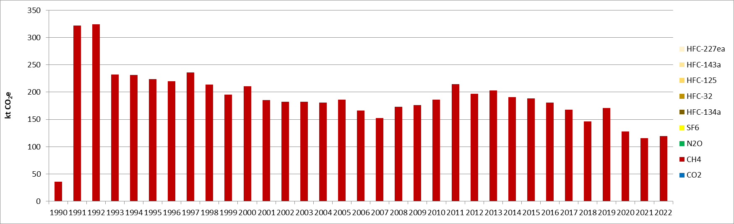
Figure 28 : GHG emissions from mining in underground mines – COAL (CRT 1B1ai1) (kt CO₂e)

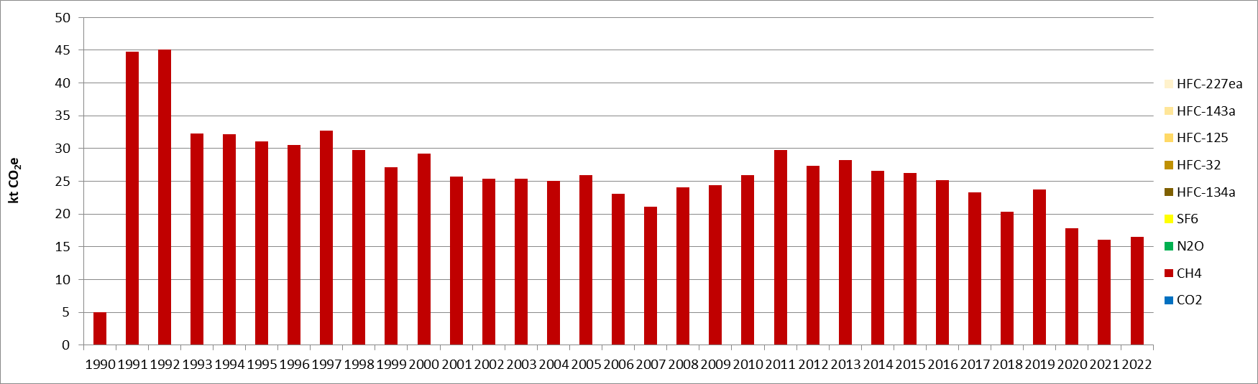
Figure 29 : GHG emissions from post-mining in underground mines - COAL (CRT 1B1ai2) (kt CO₂e)
The emissions related to the abandoned underground mines are almost negligible. The increase in 2001 is related to the fact that two additional mines were abandoned this year, making the total number to 3.
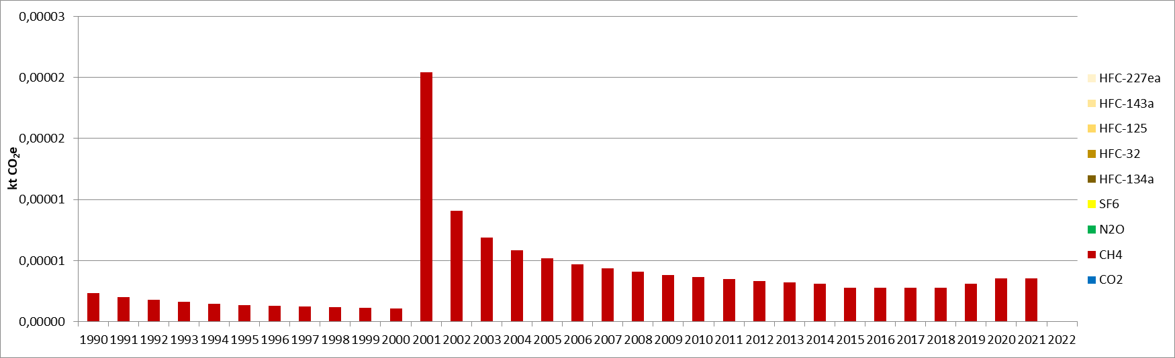
Figure 30 : GHG emissions from abandoned underground mines - COAL (CRT 1B1ai3) (kt CO₂e)
The GHG emissions from mining and post-mining in surface mines are directly proportional to the evolution of the amounts of coal mined as a constant EF is applied for this subsector. Therefore, the trend evolves accordingly to the description of the activity data given above for Figure 25. The methane emissions have been reduced by 19% for the period 1990-2022.
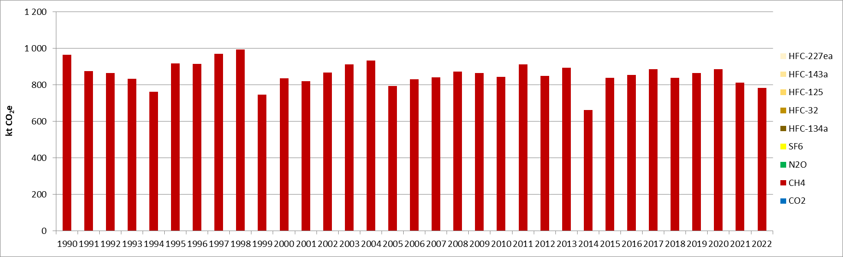
Figure 31 : GHG emissions from mining in surface mines - COAL (CRT 1B1aii1) (kt CO₂e)

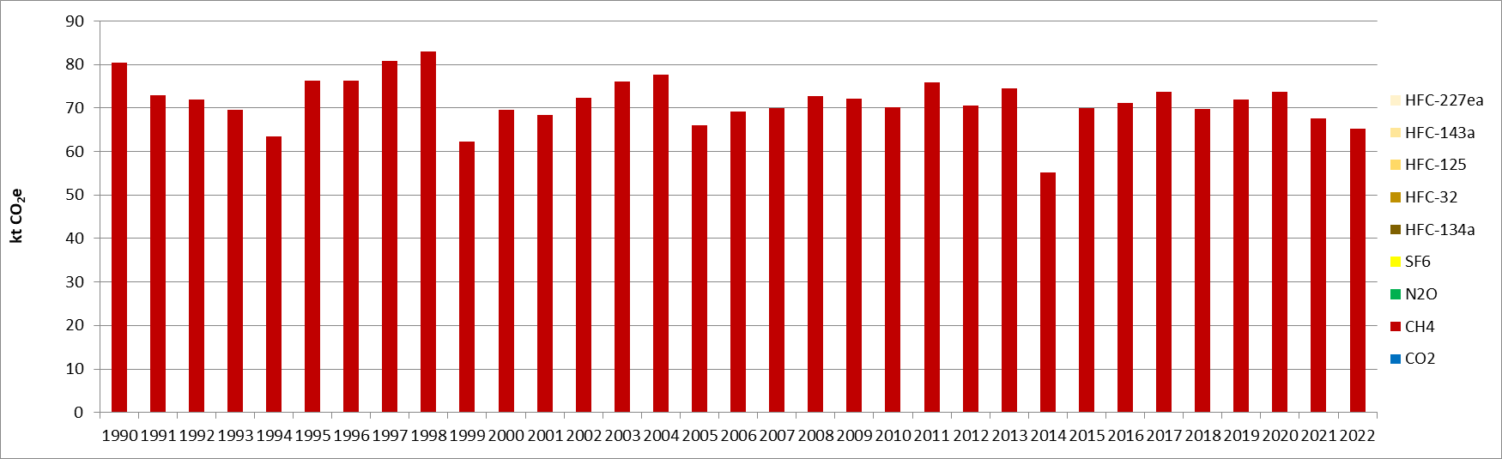
Figure 32 : GHG emissions from post-mining in surface mines - COAL (CRT 1B1aii2) (kt CO₂e)

The following graph presents the evolution of GHG emissions for the production and upgrading of crude oil, which is directly proportional to the crude oil production presented in Figure 26. For the whole timeseries, the methane emissions have been decreased by 25%.
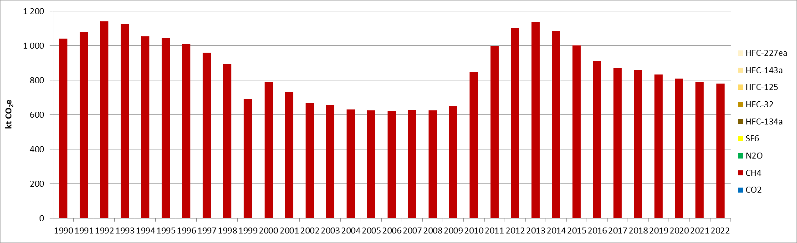
Figure 33 : GHG emissions from production and upgrading of OIL (CRT 1B2aii) (kt CO₂e)

The graph hereafter represents the GHG emissions trend related to the transport of crude oil, which evolve proportionally to the amounts of crude oil transported as presented in Figure 26. The evolution until 2005 is rather similar to other trends observed in the Energy sector, with declines during the hyperinflation period (1992-1994) and the NATO bombing in 1999, followed by recovery periods where similar levels to the pre-crisis period occur. In addition, for the transport of oil, the amounts of crude oil transported follows the amounts of intake into oil refineries as presented in Figure 8. For the period 2005-2022, it can be seen there is first a progressive decline until 2012, with a reduction of 42% between 2005 and 2012. Then, it is follows by an increasing trend of the amount of oil transported from 2012 to 2022, where it almost doubled in that period, although there are some inflecion points in 2014 during the floodings as well as in 2019. The level reached in 2022 is the second highest observed in the timeseries after the year 1990, in accordance with the recent further development of the oil refining activity.
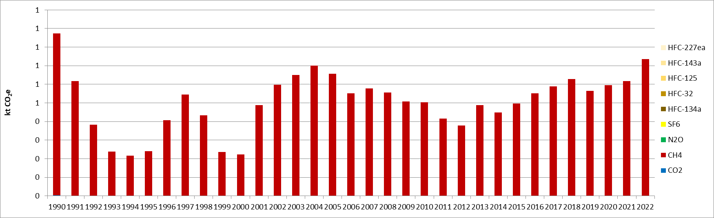
Figure 34 : GHG emissions from transport of OIL (CRT 1B2aiii) (kt CO₂e)

The two following graphs present the fugitive GHG emissions related to the production and processing of gas, which follow the evolution of the amounts of gas produced over the territory as presented in Figure 35. In the most recent years, a decline is observed, and the activity (hence the GHG emissions) are almost half the levels they were in 1990.
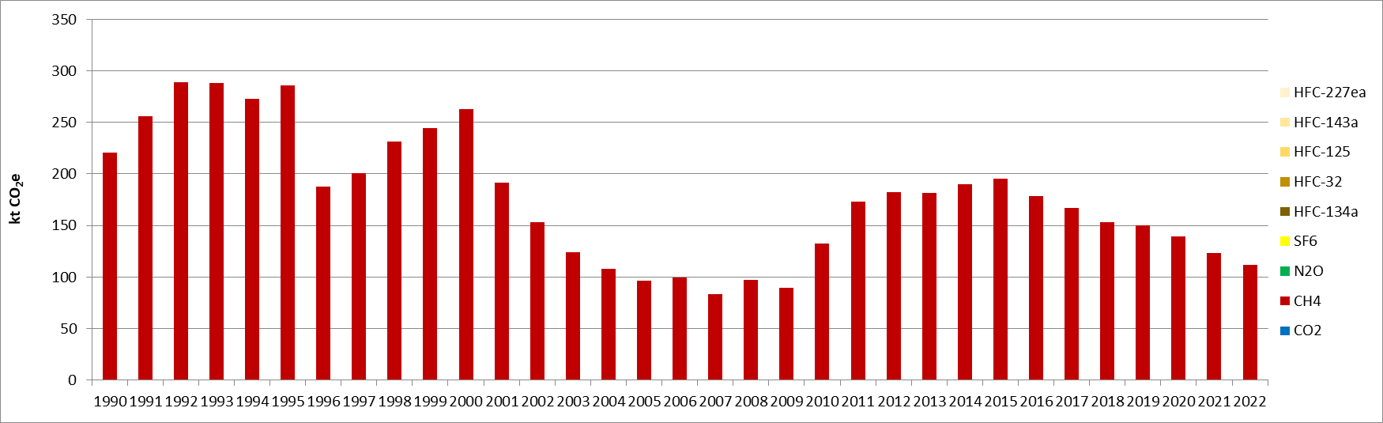
Figure 35 : GHG emissions from production of NATURAL GAS (CRT 1B2bii) (kt CO₂e)

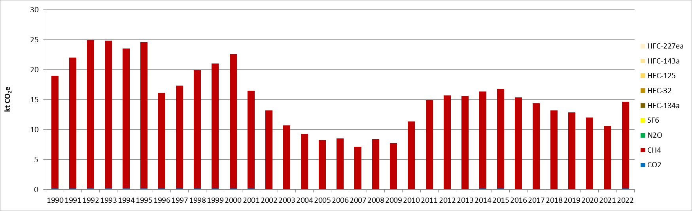
Figure 36 : GHG emissions from processing of NATURAL GAS (CRT 1B2biii) (kt CO₂e)

The two following graphs present the trend of the GHG emissions of the transmission and storage and the distribution of natural gas. They evolve respectively according to the amounts of gas transported and distributed, which have similar trends as presented in Figure 27. Contrary to the production of gas, the activity (i.e., the consumption of gas) has been intensifying, in correlation with the most recent development of natural gas in electricity production and residential combustion, in the light of the will to substitute partly and progressively solid fuels.
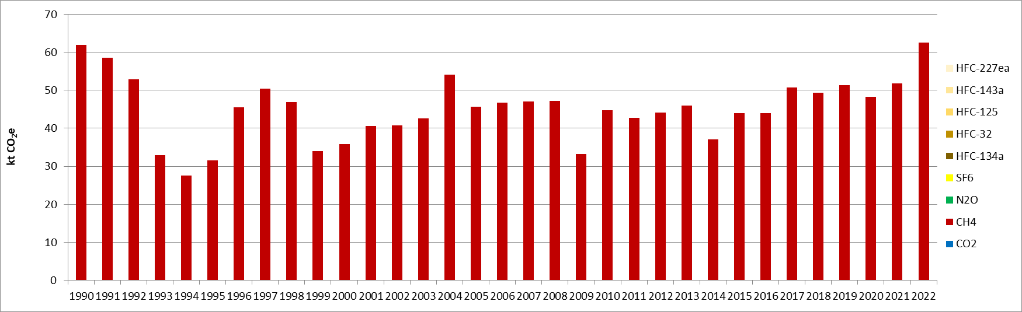
Figure 37 : GHG emissions from transmission and storage of NATURAL GAS (CRT 1B2biv) (kt CO₂e)

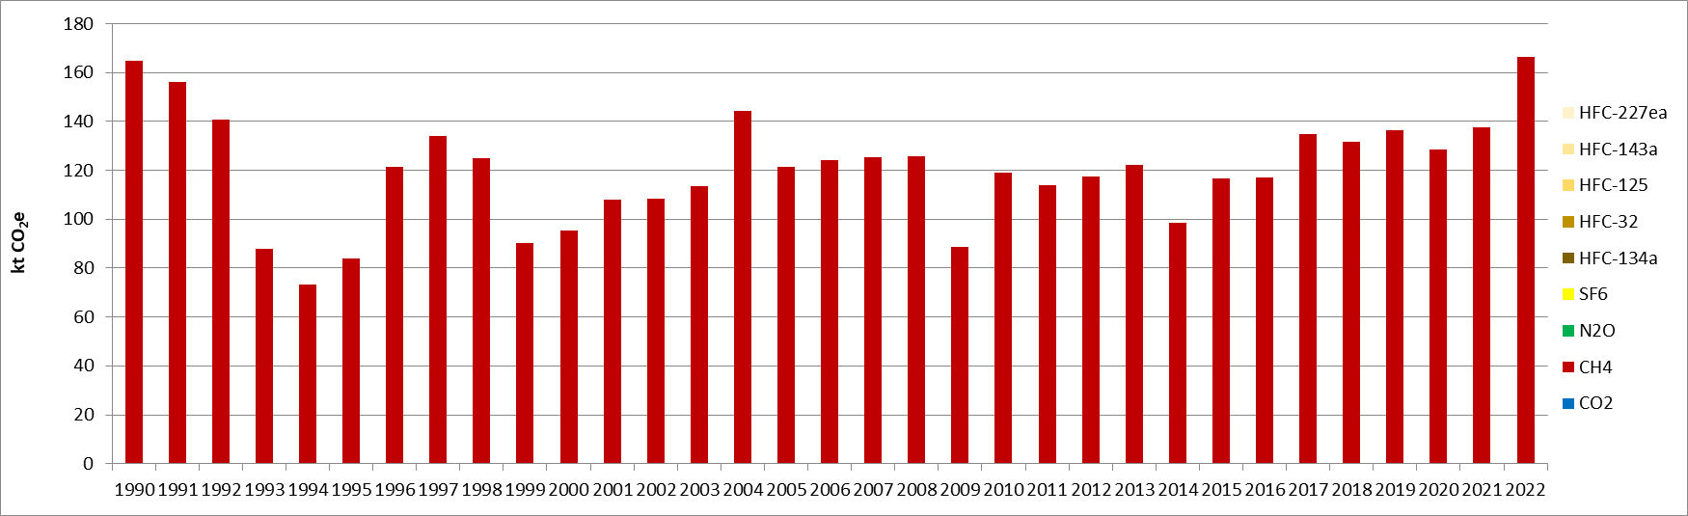
Figure 38 : GHG emissions from distribution of NATURAL GAS (CRT 1B2bv) (kt CO₂e)
The following graph presents the GHG emissions related to the venting in oil systems, which are rather negligible, and follow the production of crude oil, as presented in Figure 26.
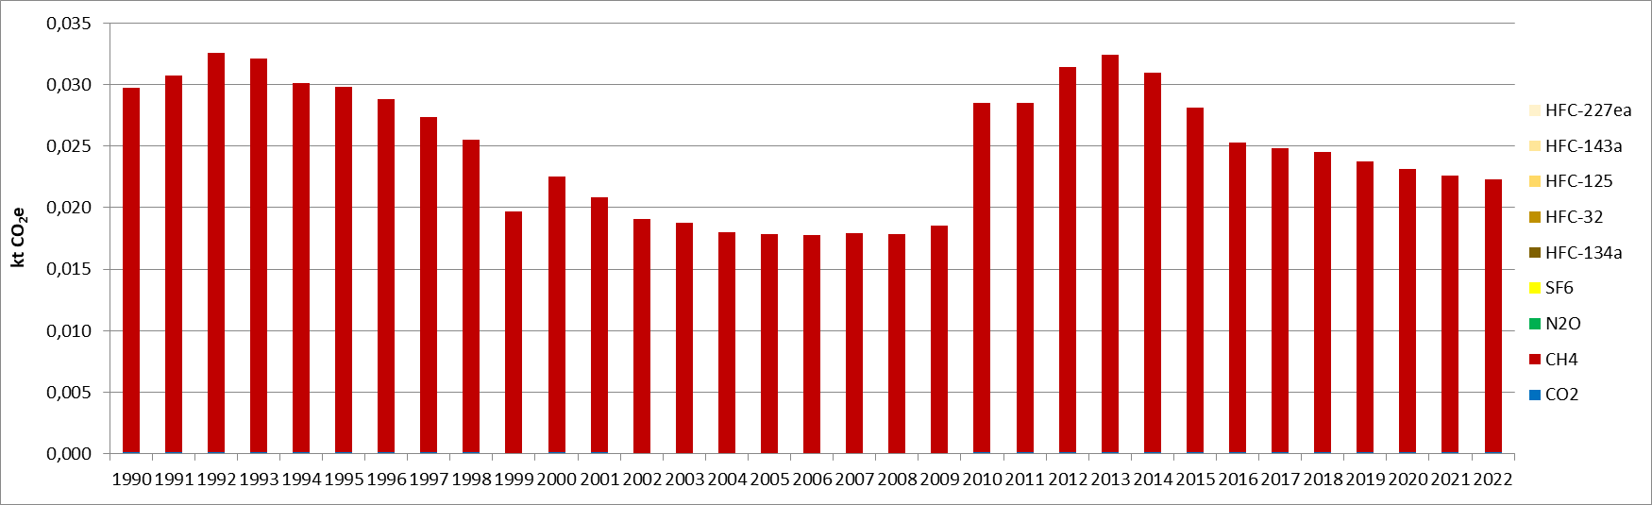
Figure 39 : GHG emissions from venting in OIL systems (CRT 1B2ci1) (kt CO₂e)
The next graph depicts the trend of the GHG emissions from venting in natural gas production to distribution system, which are proportional to the amounts of gas produced, as presented in Figure 27.
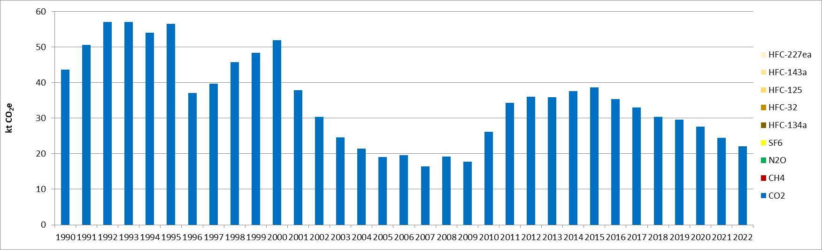
Figure 40 : GHG emissions from venting in NATURAL GAS systems (CRT 1B2ci2) (kt CO₂e)
The following graph presents the GHG emission evolution associated with the flaring in oil systems, which evolve according to the amounts of gas flared in oil refineries. Until 2005, the GHG emissions evolve in a similar way as the amounts of crude oil treated in refineries, as presented in Figure 8.
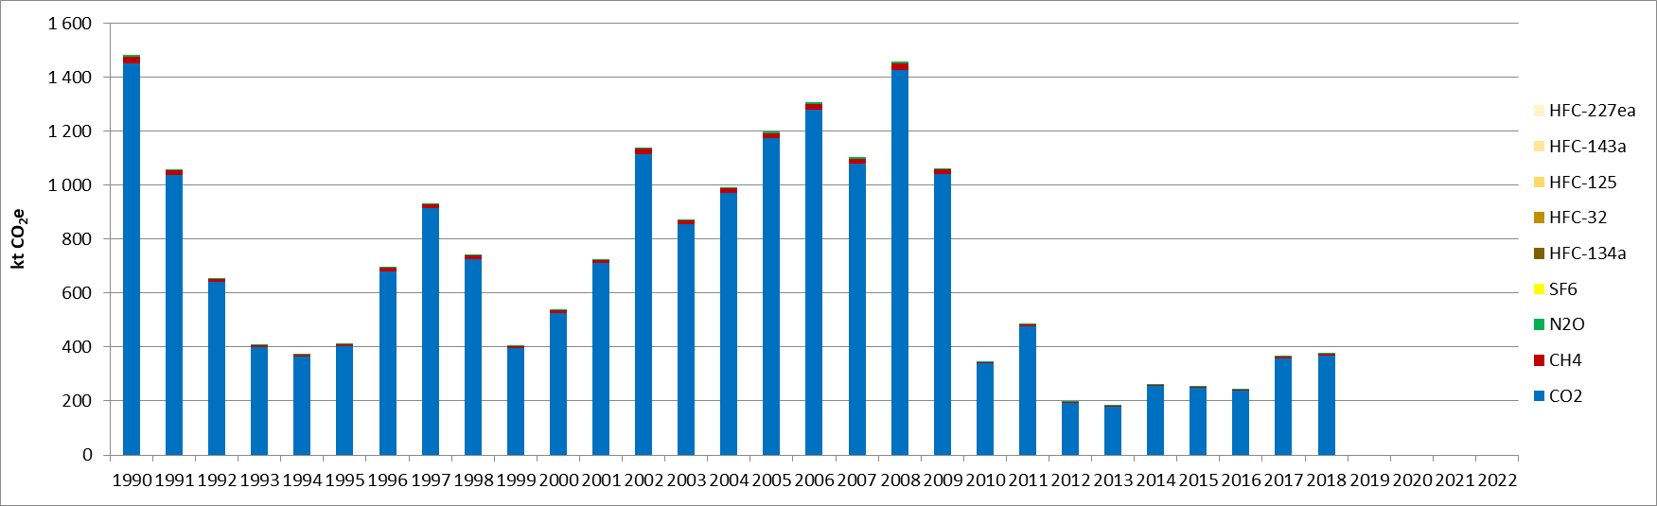
Figure 41 : GHG emissions from flaring in OIL systems (CRT 1B2cii1) (kt CO₂e)

Finally, the last graph describes the trend of the GHG emissions from flaring in natural gas production to distribution system, which evolve according to the amounts of gas produced, as presented in Figure 27. Since 2008, where the level was equal to the level of 1990, a rapid decline has been observed until 2010, where it became rather stable and to lower emission levels than what could be observed over the whole timeseries. Since 2019, the oil refinery of Novi Sad became Tank farm Novi Sad and no more flaring occurs.
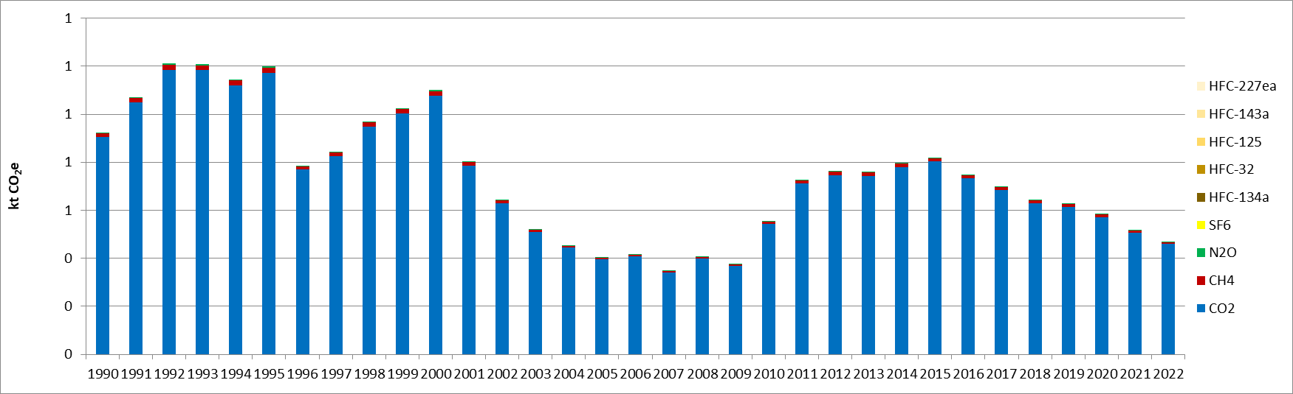
Figure 42 : GHG emissions from flaring in NATURAL GAS systems (CRT 1B2cii2) (kt CO₂e)

Methodological issues
Emissions of GHG for fugitive emissions are calculated on the basis of the 2006 IPCC Guidelines [E12].
Activity data used is different regarding the sub-categories and are summarized in the following table:
CRT code | Activity data considered | Reference
1.B.1.a.i.1 – Mining in underground mines | Underground production of lignite | Serbian Energy Balance of Coal (1990-2022)
1.B.1.a.i.2 – Post-mining in underground mines | Underground production of lignite | Serbian Energy Balance of Coal (1990-2022)
1.B.1.a.i.3 – Abandoned underground mines | Number of abandoned underground mines | Mine Kovin, mine Resavica
1.B.1.a.ii.1 – Mining in surface mines | Surface production of lignite | Serbian Energy Balance of Coal (1990-2022)
1.B.1.a.ii.2 – Post-mining in surface mines | Surface production of lignite | Serbian Energy Balance of Coal (1990-2022)
1.B.2.a.ii – Production and upgrading of oil | Production of Crude Oil / density (860 kg/m³) | Serbian Energy Balance of Oil (1990-2022)
1.B.2.a.iii – Transport of oil | Production and import of Crude Oil / density (860 kg/m³) | Serbian Energy Balance of Oil (1990-2022)
1.B.2.b.ii – Production of natural gas | Production of Natural gas | Serbian Energy Balance of Natural gas (1990-2022)
1.B.2.b.iii – Processing of natural gas | Production of Natural gas | Serbian Energy Balance of Natural gas (1990-2022)
1.B.2.b.iv – Transmission and storage of natural gas | Production and import of Natural gas | Serbian Energy Balance of Natural gas (1990-2022)
1.B.2.b.v – Distribution of natural gas | Production, import and export of Natural gas | Serbian Energy Balance of Natural gas (1990-2022)
1.B.2.c.i.1 – Venting in oil systems | Production of Crude Oil / density (860 kg/m³) | Serbian Energy Balance of Oil (1990-2022)
1.B.2.c.i.2 – Venting in natural gas systems | Production of Natural gas | Serbian Energy Balance of Natural gas (1990-2022)
1.B.2.c.ii.1 – Flaring in oil systems | Volume of gas flared, Crude oil (Refinery intake) | Serbian oil industry, Serbian Energy Balance of Oil (1990-1999)
1.B.2.c.ii.2 – Flaring in natural gas systems | Production of Natural gas | Serbian Energy Balance of Natural gas (1990-2022)

Emissions factors used for calculating CO₂, CH₄ and N₂O emissions from fuels are sourced from 2006 IPCC guidelines [E12].

Uncertainties and time-series consistency
1B1-Solid fuels fugitives
Activity data
In 2022, the uncertainty estimate associated with activity data for category 1B1-Solid fuels fugitives is 5%, based on expert judgement.

CH₄
Uncertainty estimate associated with CH₄ default emission factor for category 1B1-Solid fuels fugitives is 20%, based on expert judgement.
Combined uncertainty for CH₄ emissions is 0.3% in the total national levels of emission in 2022, excluding LULUCF contribution.

1B2-Oil and natural gas fugitives
Activity data
In 2022, the uncertainty estimate associated with activity data for category 1B2-Oil and Natural gas fugitives is 10%, based on 2006 IPCC Guidelines [E5].

CO₂
Uncertainty estimate associated with CO₂ default emission factor for category 1B2-Oil and Natural gas fugitives is 2%, based on expert judgement.

Combined uncertainties for CO₂ emissions are 0.0003% for 1B2a and 0.004% for 1B2b, in the total national levels of emission in 2022, excluding LULUCF contribution.

CH₄
Uncertainty estimate associated with CH₄ default emission factor for category 1B2-Oil and Natural gas fugitives is 100%, accordingly to values reported in 2006 IPCC Guidelines [E7].
Combined uncertainties for CH₄ emissions are 1.25% for 1B2a and 0.57% for 1B2b in the total national levels of emission in 2022, excluding LULUCF contribution.
N₂O
Uncertainty estimate associated with N₂O default emission factor for category 1B2-Oil and Natural gas fugitives is 100%, accordingly to a conservative assumption.
Combined uncertainties for N₂O emissions are null for 1B2a and 1B2b, as the emissions in 2022 are null, in the total national levels of emission, excluding LULUCF contribution.

Category-specific QA/QC and verification
During the preparation of the inventory submission activities related to quality control were mainly focused on proper use of notation keys in the CRT tables according to QA/QC plan.

Category-specific recalculations
The current report is the first National Inventory Document for Serbia. Consequently, there is no recalculation. Possible recalculation will occur and be estimated in the next submission if necessary.

Category-specific planned improvements
One of the main improvements to be considered in the future submissions is to use the 2019 IPCC Refinement with the most recent methodologies for the Fugitive sector.
In addition, another improvement will be to collect data for gas flared and vented from operators in different steps of the fuel production (oil refineries, oil and gas extraction fields, coal fields, etc.).

Chapter 4: Industrial processes and product use (CRT sector 2)

Overview of sector
This CRT 2 category covers all the industrial activities where the industrial process can imply GHG emissions which do not result from the combustion of fuels, as well as the use of industrial products such as lubricants, fluorinated gases and others. In overall, in the Republic of Serbia, the following sectors are covered:
- Mineral industry (2A), including cement, lime and glass productions, as well as other use of carbonates,
- Chemical industry (2B), about ammonia, nitric acid, petrochemical and other chemical productions,
- Metal industry (2C), including iron and steel, lead, magnesium and zinc productions,
- Non-energy products from fuels and solvent use (2D), related to lubricant, paraffin and solvent uses,
- Product uses as substitutes for ODS (2F),
- Other Product Manufacture and Use (2G)
The Electronics industry (2E) does not occur in Serbia.
In 1990, excluding the LULUCF contribution, the CRT 2 sector contributed to the national total emissions by: 7.1% for CO₂, 0.2% for CH₄, 22.6% for N₂O, 100% for SF₆, and hence in total to 6.7% in terms of GHG emissions. In 2022, the same contributions evolved as follows: 9.6% for CO₂, 0.1% for CH₄, 0.0% for N₂O, 100% for SF₆, 100% for HFCs, and hence in total to 8.2% in terms of GHG emissions.
The following graph presents the GHG emission evolution for the industrial processes and product uses in the Republic of Serbia, for the period 1990-2022, per subcategory.
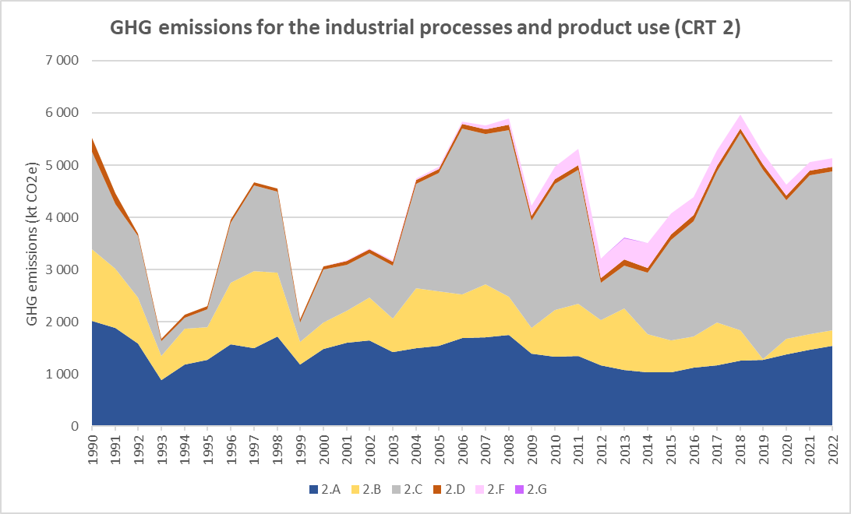
Figure 43: GHG emissions trends for industrial processes and product use (CRT 2), for the period 1990-2022, per subcategory (in kt CO₂e)

GHG emissions fluctuate during the studied period as follows:
- CO₂ emissions from industrial processes declined from 1990 to 1994 due to the decrease in industrial activities caused by the collapse of Yugoslavia and war in the Balkan,
- During the period 1995 – 1998, the industrial emissions progressively recovered and increased to emission levels almost to similar ones to 1990, before drastically plunging in 1999 during the NATO bombing,
- From 2000 to 2002, the GHG emissions related to the industrial activities recovered from the previous sudden decline, before stagnating between 2003 and 2008, except for the metal industry which has known a significant increase of +211% in GHG emissions between 2003 and 2006, due to the increase in pig iron and steel productions, but also to the new development of sinter and pellet installation facilities,
- In 2009, emissions sharply decreased due to diminution of economic activity caused by the global economic crisis,
- From 2010 to 2011, the economy of the Republic of Serbia began to recover from the impact of the global crisis, before drastically reducing in 2012 mostly related to the iron and steel industry,

- For the period 2012-2018, the GHG emissions of the sector increased progressively and significantly, due to all principal activities but in particular the iron and steel production, before slightly decreasing in 2019 due to the stop of the activities of ammonia (CRT 2B1) and nitric acid (CRT 2B2) productions,

- In 2020, due to the sanitary crisis related to COVID, the industrial GHG emissions slightly reduced, in particular due to the iron and steel production, before increasing back in 2021 to pre-crisis levels.

In overall, the GHG emissions of the industrial processes and product uses have been reduced by 7% between 1990 and 2022, but with different relative variations depending on the subsectors. Among the principal sector-specific changes which can be highlighted, there are:

- The development of the use of fluorinated gases (CRT 2F) which started in 1997, rather slow until 2007, before accelerating up to 2014 (+542% from 2007 to 2014). Afterwards, a slow and progressive decline can be observed, mainly due to regulations promoting the use of less emitting substances, which enabled to reduce the GHG emissions of this subsector by 66% from 2014 to 2022;

- The overall increasing development of iron and steel productions, and the launch of the production of sinters and pellets starting from 2003;

- The stop of the production of some chemical products, in particular ammonia and nitric acid in 2019, but also, to a lesser extent, of methanol in 2012 and vinyl chloride monomer (VCM) in 2000. This enabled the chemical industry to reduce its GHG emissions by 78% between 1990 and 2022, and the overall industry sector to no longer be an emitter of N₂O whereas it contributed to 23% to the national totals in 1990;

- The use of SF₆ in electrical equipment starting in 2000, which increased progressively until 2022, but remains marginal in the total GHG emissions of the CRT 2.

Mineral industry (CRT 2A)
In the Republic of Serbia, the Mineral industry covers:
- The production of cement (2A1),
- The production of lime (2A2),
- The production of glass (2A3),
- The other use of carbonates (2A4).
In the Republic of Serbia, mineral productions used to be strong because of a significant production capacity and a significant consumption and demand in the country (primarily by the construction industry). After the decline in productions in the nineties, following the hyperinflation and NATO bombing, the mineral productions recovered since 2008. Then, the economic crisis in 2009 implied a sudden production decrease. The mineral productions, in particular the production of cement, kept decreasing until 2013, before progressively increasing since then, to emission levels lower than 2008 though. The observed GHG emission reduction for the period 1990-2022 for the CRT 2A is of 24%.
The GHG emissions from the mineral industries are almost only CO₂ and are dominated by the subsector of the cement production (CRT 2A1), which represented 66% of the sector emissions in 1990 and contributes to 84% in 2022. The other dominant subsector is the lime production (CRT 2A2), which decreased significantly its contributions from 25% to 11% for the same period, and the ceramic industry (CRT 2A4a) with 5% in 2022.
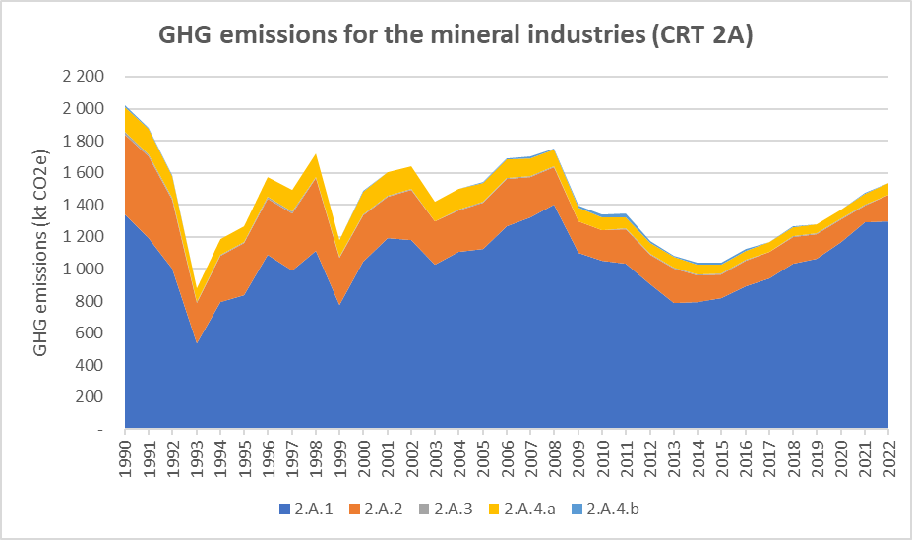
Figure 44: GHG emissions trends for the mineral industries (CRT 2A), for the period 1990-2022, per subcategory (in kt CO₂e)

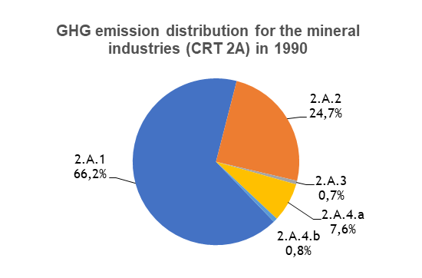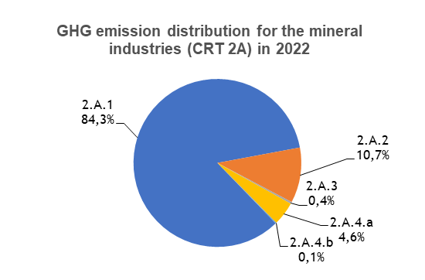
Figure 45: GHG emission distribution for mineral industries (CRT 2A), for the years 1990 and 2022, per subcategory (in %)

The Mineral industry (CRT 2A) contributes to 2.5% of the total GHG emissions excluding LULUCF, and it contributes to 30% of the Industrial processes (CRT 2) sector in the Republic of Serbia in 2022.

Cement production (CRT 2A1)

Category description
Only Portland cement is produced in Serbia. CO₂ emissions are due to the use of carbonated raw materials in the production process. CH₄ and N₂O emissions are not expected for this process.

In 2022, cement production was the highest individual contributor of the mineral industry with a share of 84%.

In 2022, the category Cement production is a key category for CO₂ emissions in the Republic of Serbia, both in emission levels and trend. This sector contributes to 2.1% in terms of emissions level (rank 6) and to 1.0% in terms of emissions trend (rank 22), excluding LULUCF.
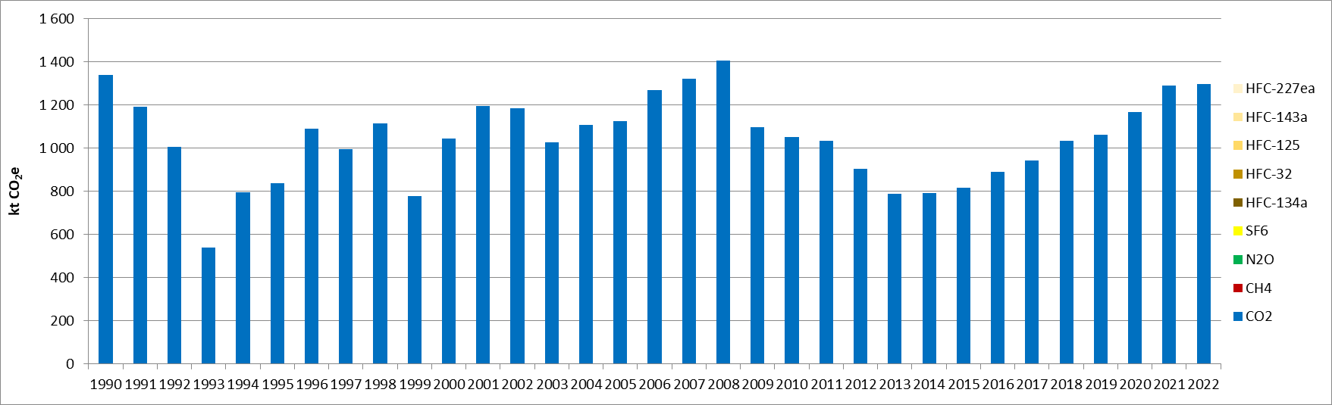
Figure 46: GHG emissions for the cement production (kt GHG)

CO₂ emissions from cement production declined from 1990 to 1993 due to the decrease in industrial activities, caused by the collapse of Yugoslavia and the hyperinflation. In 1999, the emissions dropped due to the NATO bombing.

The trend of the sectoral GHG emissions for the 2009-2013 period is a consequence of the global economic crisis due to which halted economic recovery and the upward trend of Serbia’s GDP (gross domestic product). A key cause for the significant decrease in emissions in the 2010-2013 period is the lower market demand for Portland cement. Since 2014, a progressive increase is observed, and the emissions of this subsector almost reached the levels of the pre-crisis and 1990.

Methodological issues
The Tier 1 method from the 2006 IPCC Guidelines is used to calculate the CO₂ emissions [I1].
The CO₂ emissions are based on the Portland cement production (provided in the yearly Statistical Industry bulletins of Serbia) [I2], and the 2006 IPCC Guidelines CO₂ default emission factor for clinker (0.52 t CO₂/t clinker) [I3].

Lime production (CRT 2A2)

Category description
In the Republic of Serbia, high-calcium lime (Quicklime) is produced. CO₂ emissions are due to the use of carbonated raw materials in the production process. CH₄ and N₂O emissions are not expected for this process.
In 2022, the category Lime production is a key category for CO₂ emissions both in terms of emissions level and trend. This sector contributes to 0.3% in terms of emission levels (rank 37), and to 0.8% in terms of emissions trend (rank 29), excluding LULUCF.
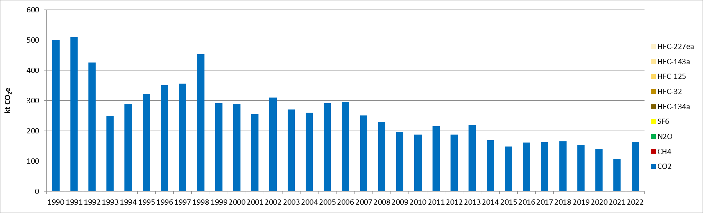
Figure 47: CO₂ emissions for the lime production (kt CO₂e)

CO₂ emissions from lime production declined from 1990 to 1993 due to the decrease in industrial activities, caused by the collapse of Yugoslavia and the hyperinflation. After recovering to pre-crisis level until 1998, the NATO bombing impacted the GHG emissions from the lime production to a large decrease. Then, the GHG emissions were rather stable since 2006, before undergoing a slow but progressive decline until 2021. In 2022, the emissions increased by +53% compared with 2021.

Methodological issues
The Tier 1 method from the 2006 IPCC Guidelines is used to calculate the CO₂ emissions (equation 2.4 of the 2006 IPCC Guidelines [I4]).
The national lime production is sourced from the yearly Statistical books of Serbia [I2].
Stoichiometric ratio between CaO and CO₂ for the high calcium lime is used to calculate the CO₂ emissions. It comes from the 2006 IPCC Guidelines [I5]. The value (0.785 t CO₂/t CaO) is considered constant over the entire time-series.

Glass production (CRT 2A3)

Category description
CO₂ emissions are due to the use of carbonated raw materials in the production process. CH₄ and N₂O emissions are not expected for this process.

In 2022, the category Glass production is not a key category in terms of emissions level nor in terms of emissions trend.
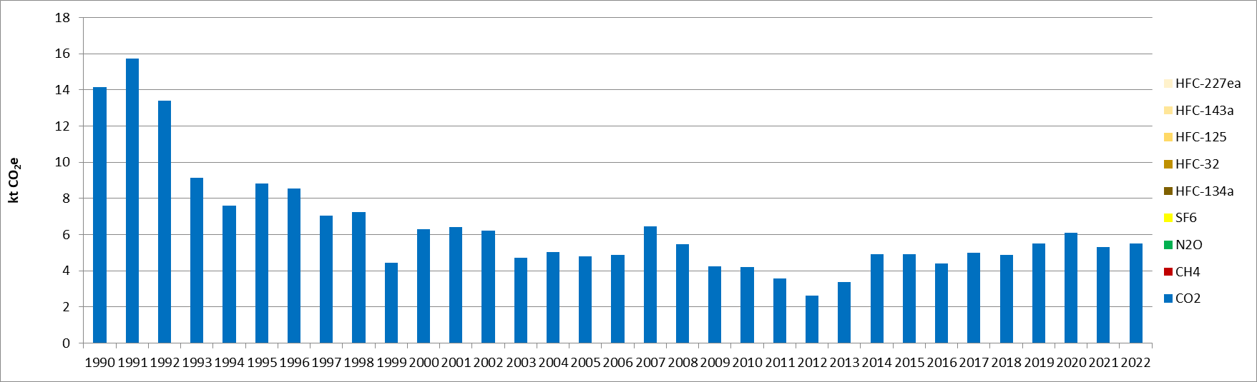
Figure 48: CO₂ emissions for Glass production (kt CO₂e)

CO₂ emissions from glass production declined from 1990 to 1993 due to the decrease in industrial activities, caused by the collapse of Yugoslavia and the hyperinflation. Since then, the emissions are rather stable and evolve based on the main events occurring in Serbia, such as the NATO bombing in 1999, the global economic crisis in 2009, which had an impact until 2013.

Methodological issues
The Tier 1 method from the 2006 IPCC Guidelines is used to calculate the CO₂ emissions (equation 2.10 of the 2006 IPCC Guidelines [I6]).
The national glass production comes from the yearly Statistical books of Serbia [I2].
A cullet ratio is needed to calculate CO₂ emissions. A default cullet ratio is used and comes from the 2006 IPCC Guidelines [I1] (50%). It is considered constant for the entire time-series.
A default CO₂ emission factor is used and comes from in the 2006 IPCC Guidelines [I6] (0,2 t CO₂/t glass produced). It is considered constant for the entire time-series.

Other use of carbonates (CRT 2A4)
In the Republic of Serbia, the CRT 2A4 sector covers two sub-sectors:
- Ceramics production, including tiles and bricks (CRT 2A4a),
- Other use of soda ash (CRT 2A4b).

Ceramics production (CRT 2A4a)

Category description
CO₂ emissions are due to the use of carbonated raw materials (such as dolomite (CaMg(CO₃)₂, and limestone (CaCO₃)) in the production process. CH₄ and N₂O emissions are not expected for this process.

In 2022, the category Ceramics production is neither a key category in terms of emissions level nor in emission trend.
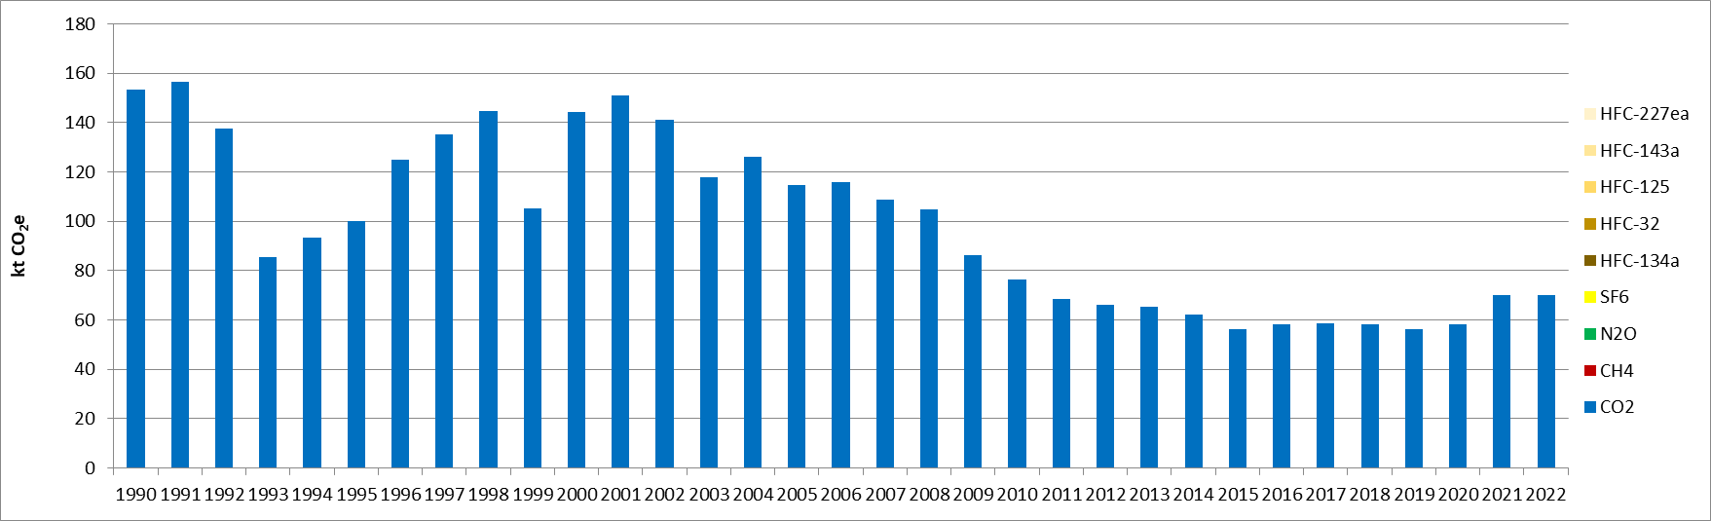
Figure 49: GHG emissions for the ceramics production (kt CO₂e)

CO₂ emissions from ceramics production declined from 1990 to 1993 due to the decrease in industrial activities, caused by the collapse of Yugoslavia and the hyperinflation. After the recovery since 1998, the emissions dropped in 1999 due to the NATO bombing. The trend of the sectoral GHG emissions for the 2009-2013 period is a consequence of the global economic crisis due to which halted economic recovery and the upward trend of Serbia’s GDP (gross domestic product). Between 2013 and 2020, the emissions were rather stable, before slightly increasing in 2021 and 2022 due to the increase in the use of carbonates.

Methodological issues
The Tier 1 method from the 2006 IPCC Guidelines is used to calculate the CO₂ emissions (equation 2.15 of the 2006 IPCC Guidelines [I7]).
The activity data are the national consumptions of limestone and dolomite in the ceramics, bricks and tiles sector, excluding the carbonates consumed elsewhere (e.g. in the glass production). The national consumptions of limestone and dolomite are sourced from the yearly Statistical books of Serbia [I2].
Default CO₂ emission factors for each carbonate are used. They come from the 2006 IPCC Guidelines [I8] (0.47732 t CO₂/t dolomite; 0.043971 t CO₂/t limestone), and they are considered constant over the entire time-series.

Other use of soda ash (CRT 2A4b)

Category description
CO₂ emissions are due to the use of soda ash (Na₂CO₃) in the production process. CH₄ and N₂O emissions are not expected for this process.

In 2022, the category Other use of soda ash is neither a key category in terms of emissions level nor in terms of emissions trend.
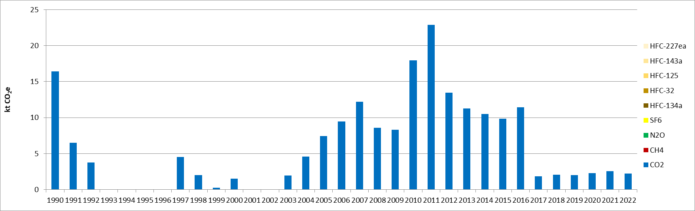
Figure 50: GHG emissions for the other use of soda ash (kt CO₂e)

CO₂ emissions vary significantly and the timeseries is not complete as the soda ash consumptions in other mineral industries are calculated as the balance with the overall consumption and the ones from other subsectors.

Methodological issues

The Tier 1 method from the 2006 IPCC Guidelines is used to calculate the CO₂ emissions (equation 2.15 of the 2006 IPCC Guidelines [I7]).
The activity data are the national consumptions of soda ash. It is sourced from the Statistical Office data [I2].
Default CO₂ emission factor for soda ash is used. It is sourced from the 2006 IPCC Guidelines [I8] (0.41492 t CO₂/t soda ash), and it is considered constant over the entire time-series.

Uncertainties and time-series consistency
In 2022, the uncertainty estimate associated with activity data for category 2A-Mineral industry is 2%, based on 2006 IPCC Guidelines.

Uncertainty estimate associated with CO₂ default emission factor for category 2A-Mineral industry is 2%, accordingly to values reported in 2006 IPCC Guidelines.

Combined uncertainty for CO₂ emissions is 0.1% in the total national levels of emission in 2022, excluding LULUCF contribution.

Category-specific QA/QC and verification
During the preparation of the inventory submission, activities related to quality control were mainly focused on completeness and consistency of emission estimates, and on proper use of notation keys in the CRT tables.

Category-specific recalculations
The current report is the first National Inventory Document for Serbia. Consequently, there is no recalculation. Possible recalculation will be occurred and estimated in the next submission if necessary.

Category-specific planned improvements
For the mineral industry, especially for the soda ash consumption, the completeness of the activity data set has to be improved.

Chemical industry (CRT 2B)
In 2022, the chemical industry represents 6% of the Industrial Processes and Product Use GHG emissions and 0.5% of the national GHG emissions excluding LULUCF. During the timeseries, the main chemical activities occurring in Serbia are the productions of ammonia, nitric acid, petrochemicals and other chemicals.
In the Republic of Serbia, chemical productions used to be rather significant and represented 25% of the IPPU GHG emissions in 1990, because of significant productions of ammonia, nitric acid and ethylene. The productions declined in the nineties, after the economic downturn and period of hyperinflation (1990-1994) and the NATO bombing. Then, the economic crisis in 2009 implied a sudden production decrease. Finally, after several variations in the trend of emissions, the GHG emissions dropped drastically in 2019 following the stop of the ammonia and nitric acid productions, before being rather stable from 2020 onwards. The observed GHG emissions for the CRT 2B in 2022 are 78% lower than in 1990.
The emission distribution between the different GHG for the chemical industries evolved significantly during the timeseries and almost only CO₂ contributes to the total in 2022 (96%), the rest being CH₄, whereas N₂O was representing 41% of the sector totals in 1990. This is due to the drop in the production of nitric acid.
In 1990, the sector GHG emissions were dominated by the subsector of the nitric acid production (CRT 2B2), which represented 41% of the sector emissions. The other dominant subsectors in 1990 are the ammonia production (CRT 2B1), which had a contribution of 24%, and the ethylene production (CRT 2B8b), with 27% in 1990. The other subsectors represented between 2% and 3% in 1990. In 2022, after the stop of the activities of ammonia, nitric acid, methanol vinyl chloride monomer productions, the GHG emissions from the sector are almost only originated from the ethylene production with 98%, the rest being the other chemical products.
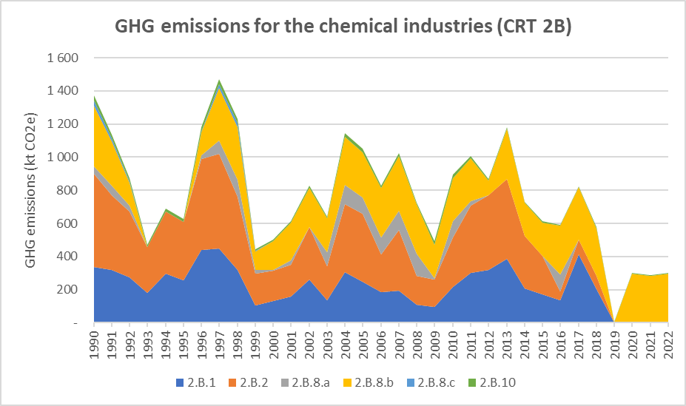
Figure 51: GHG emissions trends for the chemical industries (CRT 2B), for the period 1990-2022, per subcategory (in kt CO₂e)

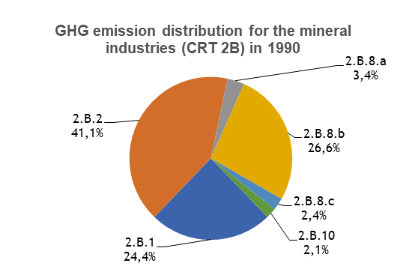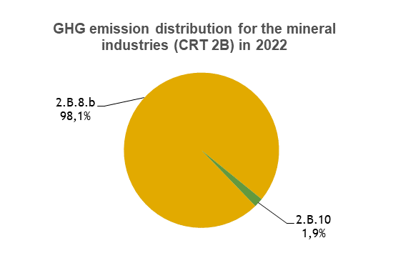
Figure 52: GHG emission distribution for chemical industries (CRT 2B), for the years 1990 and 2022, per subcategory (in %)

Ammonia production (CRT 2B1)

Category description
Ammonia is produced by catalytic steam reforming of natural gas in which hydrogen is chemically separated from natural gas and combined with nitrogen to produce ammonia (NH₃). CO₂ emissions occur during the process, as well as CO and NOx. The produced CO₂ is either vented to the atmosphere or used as a feedstock for downstream use such as urea production. CO₂ emissions used for urea production are not accounted in this category but are allocated into the category where the urea is consumed. Please refer to CRT 2D3 description for more details on urea use.
During the year 2018, the production of ammonia has permanently stopped.
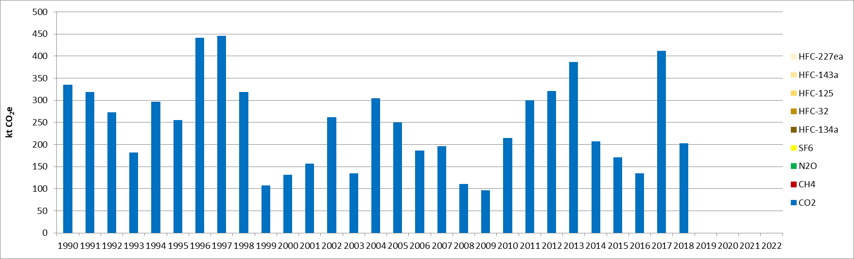
Figure 53 : GHG emissions for ammonia production (CRT 2B1), for the period 1990-2022 (in kt CO₂e)

In 2022, the category ammonia production is a key category for CO₂ emissions in emission trend, in the Republic of Serbia. This sector contributes to 0.9% in terms of emission trend (rank 25). Many variations occur for the activity data on the time series.

Methodological issues
The methodology used is Tier 1 and CO₂ emission estimates are sourced from Equation 3.1 of ammonia production section in 2006 IPCC Guidelines [I9].
Activity data used for the calculation are the national ammonia productions and are sourced from SORS (from 1990 Industrial Bulletin, and from 2010 from Statistical Yearbook) [I2].
Default emission factor for CO₂ is constant on the time series: 2,104 t CO₂/ t NH_{3.} The value is sourced from 2006 IPCC Guidelines [I10].
The natural gas is a raw material (non-energy use) and its consumption should be deducted to the energy balance. The methodology used to determine the natural gas consumption is based on CO₂ emissions and the default emission factor for natural gas.
Amount of CO₂ emissions recovered for urea production and not accounted in 2B1 category is estimated using urea production coming from SORS [I2] and conversion factor between urea and CO₂ molar mass. It is supposed that the whole urea production considered for Serbia is made from CO₂ recovery from Ammonia production.

Nitric acid production (CRT 2B2)

Category description
Nitric acid is produced by high temperature catalytic oxidation of ammonia. Two types of process can be used: single pressure plant and dual pressure plants. The overall reaction include oxidation and absorption stage is NH₃ + 2 O₂ -> HNO₃ + H₂O. During oxidation stages N₂O is generated as an unintended by product and released to the atmosphere.
The production of nitric acid has been stopped during the year 2018.
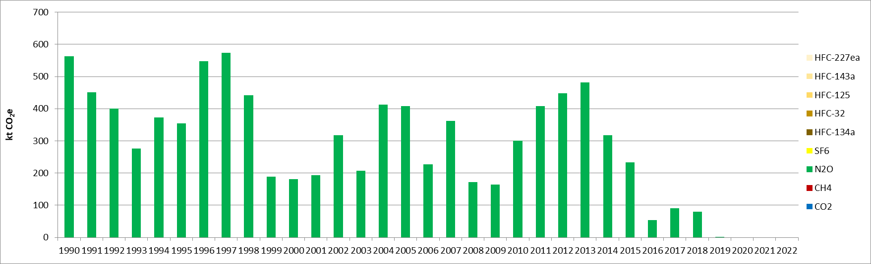
Figure 54 : GHG emissions for nitric acid production (CRT 2B2), for the period 1990-2022 (in kt CO₂e)

In 2022, the category nitric acid production is a key category for N₂O emissions in terms of emission trend, in the Republic of Serbia. This sector contributes 1.6% in terms of emission trend (rank 18)). Many variations occur for the activity data on the time series.

Methodological issues
The methodology used is Tier 1 and N₂O emission estimates are sourced from Equation 3.5 of nitric acid production section in 2006 IPCC Guidelines [I11].
Activity data used for the calculation are the national nitric acid productions and are sourced from SORS (from 1990 Industrial Bulletin, and from 2010 from Statistical Yearbook) [I2].
Default emission factor for N₂O is constant on the time series. The highest default value provided in 2006 IPCC Guidelines [I12] is applied with no abatement technology: 9 kg N₂O / t HNO_{3.}

Petrochemical and carbon black production (CRT 2B8)
The production of other chemicals such as petrochemicals or carbon black can be sources of CO₂ and CH₄ emissions. CH₄ emissions may be fugitive and/or process vent emissions. The only activities occurring in Serbia for this category are:
- methanol production (CRT 2B8a),
- ethylene production (CRT 2B8b),
- ethylene dichloride production (CRT 2B8c).
The subcategories and estimate methodology are described in the 3 following sections.

Methanol production (CRT 2B8a)

Category description
Methanol production is varying significantly over the timeseries and is even null for several periods (in 1993-1995 and 2012-2015) and since 2017, where the production stopped definitively. On the 2012-2015 period methanol complex in Kikinda was not working due to restructuring. The production temporarily continued in 2016, while in 2017 the installation was shout down. Hence, in 2022, the category methanol production is neither a key category in terms of emissions level nor in terms of emissions trend for GHG emissions in Serbia.
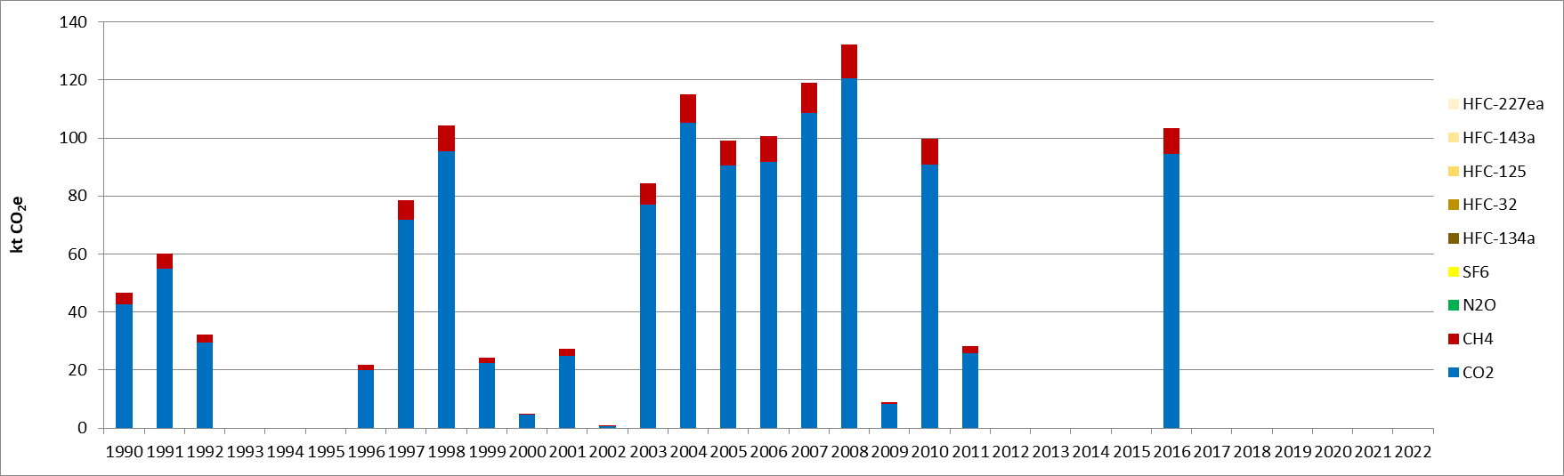
Figure 55 : GHG emissions for methanol production (CRT 2B8a), for the period 1990-2022 (in kt CO₂e)

Methodological issues
The methodology used is Tier 1 and CO₂ emission estimates are sourced from Equation 3.15 of petrochemical and carbon black production section in 2006 IPCC [I13]. The specific type of process used is not known. Activity data used for the calculation are the national methanol productions and are sourced from SORS [I2] from 2004 onwards. For 1994-2002 period, activity data values are sourced from industrial statistics [I14].
Default emission factors for CO₂ and CH₄ are constant on the time series and are sourced from 2006 IPCC Guidelines. Recommended applied values are respectively 0.67 t CO₂/ t methanol [I15] and 2.3 kg CH₄/ t methanol [I16].

Ethylene production (CRT 2B8b)

Category description
In 2022, the category ethylene production is a key category for CO₂ emissions in terms of emission levels in Serbia. This sector contributes to 0.5% in terms of emissions level (rank 26).
Many variations in the sector’s activity can be observed over the whole timeseries. Production has been stopped between 1993 and 1995 following the economic downturn. After recovering, until 1998, production decreased significantly in 1999 during the NATO bombing. Then, the activity progressively recovered and increased until 2007, before dropping in 2009 due to the global economic crisis. Since 2016, the activity was rather stable, except in 2019 where it temporarily stopped.
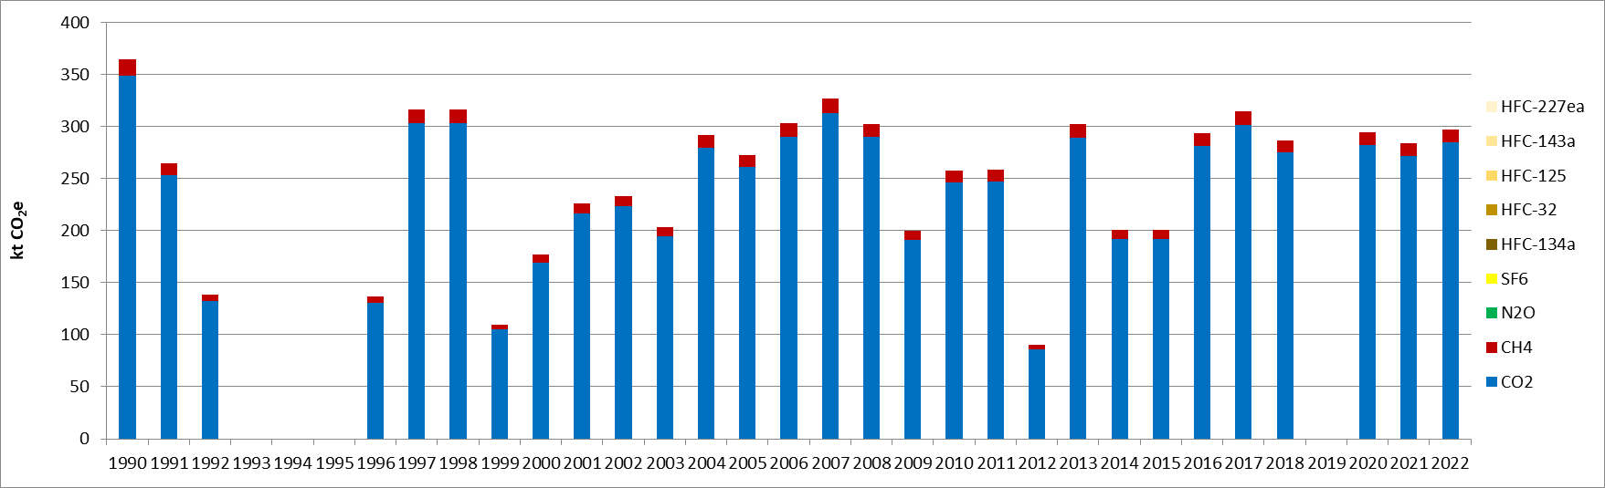
Figure 56 : GHG emissions for ethylene production (CRT 2B8b), for the period 1990-2022 (in kt CO₂e)

Methodological issues
The methodology used is Tier 1. CO₂ and CH₄ emission estimates respectively are sourced from Equation 3.15 and Equation 3.23 to 3.25 of petrochemical and carbon black production section in 2006 IPCC [I13].
Activity data used for the calculation are the national ethylene productions and are sourced from SORS [I2] for the time series.

Default emission factor for CO₂ and CH₄ are constant on the time series and are sourced from 2006 IPCC Guidelines for steam cracking of naphtha. Recommended applied values are respectively 1,73 t CO₂/ t ethylene [I17] and 3 kg CH₄/ t ethylene [I18].
Default geographic adjustment factor for CO₂ emissions provided in 2006 IPCC Guidelines for Eastern Europe is 110% [I19] and is applied to Serbia CO₂ emissions for ethylene production.

Ethylene dichloride and vinyl chloride monomer production (CRT 2B8c)

Category description
In 2022, the category ethylene dichloride and vinyl chloride monomer production is neither a key category in terms of emission levels nor in terms of emission trend in Serbia. There is only VCM production in Serbia and the activity was stopped in 1999. It is important to note that the plant was non-operational from 1993 to 1995 due to the economic downturn and was subsequently damaged by bombing in 1999.
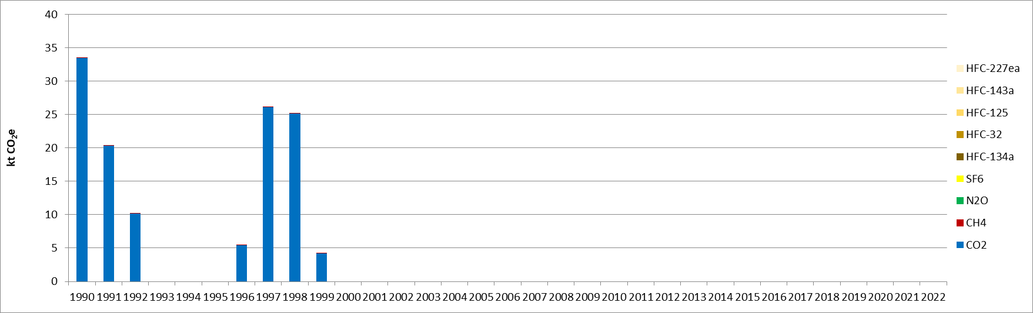
Figure 57 : GHG emissions for ethylene dichloride and vinyl chloride monomer production (kt CO₂e)

Methodological issues
The methodology used is Tier 1. CO₂ and CH₄ emission estimates respectively are sourced from Equation 3.15 and Equation 3.23 to 3.25 of petrochemical and carbon black production section in 2006 IPCC [I13].
Activity data used for the calculation are the national vinyl chloride monomer productions and are sourced from SORS [I2] for the time series.
Default emission factor for CO₂ [I20] and CH₄ [I21] are constant on the time series and are sourced from 2006 IPCC Guidelines for ethylene dichloride and vinyl chloride monomer production.

Other (2B10)

Category description
This category includes any other chemical production not considered in specific categories. In 2022, the category other chemical production is neither a key category in terms of emissions level nor in terms of emissions trend for GHG emissions in the Republic of Serbia. Emissions occurring in this category for Serbia are CO₂ emissions due to decolorization of HNO₃ and KAN.
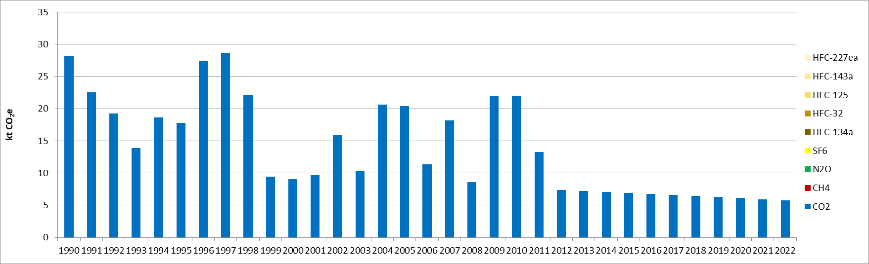
Figure 58 : GHG emissions for other chemical production (CRT 2B10) for the period 1990-2022 (in kt CO₂e)

Methodological issues
A Tier 1 methodology is applied to CO₂ emission estimates for decolorization of HNO₃ and KAN. Activity data for this category are the consumptions of natural gas needed for this process. The data came in the following way:
Ammonia production data are from Statistical yearbooks and are available for the period 1990-2013. By using the default IPCC 2006 fuel consumption ratio for producing ammonia, it is possible to calculate the consumption of natural gas. Nitric acid production data are also from Statistical yearbooks and are available for the same period. There is no default IPCC 2006 fuel consumption ratio for the production of nitric acid, and no natural gas consumption for this purpose can be calculated. Resolving this problem: Reliable data on natural gas consumption has been available for the period 2009-2014 from the PRTR report. On this basis, it was possible to calculate the actual fuel consumption for each individual production (NH₃ and HNO₃). Having a ratio for the years mentioned above, the average value of natural gas consumption can be calculated in previous years. In this case, the assumption is that the structure and efficiency of these industrial sectors have been constant throughout the whole period. For the period 2015-2022, the activity data are extrapolated based on the previous linear evolution.
Emission factor used are sourced from the 2006 IPCC guidelines for natural gas use, the default value of 56.1 t CO₂/TJ is used.

Uncertainties and time-series consistency
CO₂
Uncertainty estimates associated with activity data amount to 5%, accordingly to values reported in 2006 IPCC Guidelines (Volume 3 Chapter 3.2.3.2).
Uncertainty estimate associated with default emission factor amounts to 6%, accordingly to values reported in 2006 IPCC Guidelines (Volume 3 Chapter 3 Table 3.1).
Combined uncertainty for emissions is 0.04% in the total national levels of emission in 2022, excluding LULUCF contribution.

CH₄
The uncertainty estimate associated with activity data amounts to 2%, according to values reported in 2006 IPCC Guidelines (Volume 3 Chapter 3 Table 3.27).
Uncertainty estimate associated with default emission factor amounts to 2%, according to values reported in 2006 IPCC Guidelines (Volume 3 Chapter 3 Table 3.27).
Combined uncertainty for emissions is 0.0006% in the total national levels of emission in 2022, excluding LULUCF contribution.

N₂O
Uncertainty estimates associated with activity data amounts to 40%, according to values reported in 2006 IPCC Guidelines (Volume 3 Chapter 3.2.3.2).
Uncertainty estimate associated with default emission factor amounts to 6%, according to values reported in 2006 IPCC Guidelines (Volume 3 Chapter 3 Table 3.3).
Combined uncertainty for emissions in the total national levels of emission in 2022 is null as there is no emission of N₂O occurring

Category-specific QA/QC and verification
During the preparation of the inventory submission, activities related to quality control were mainly focused on proper use of notation keys in the CRT tables according to QA/QC plan.

Category-specific recalculations
The current report is the first National Inventory Document for Serbia. Therefore, there is no recalculation. Possible recalculation will be occurred and estimated in the next submission if necessary.

Category-specific planned improvements
Main planned improvements for chemical category concern petrochemical activities and improvement of the completeness of activity data sets.
It is planned to ask methanol activity data (2B8a) to the statistics office to have a production for the complete timeseries and compare with current reference data.
It is planned to check with plants that no ethylene production (2B8b) occurred between 1993 and 1995 due to war.

Metal industry (CRT 2C)
In Serbia, the metal industry covers the following four sub-sectors:
- The production of iron and steel (CRT 2C1), disaggregated between the steel (2C1a), sinter (2C1d) and pellet (2C1e) productions,
- The production of magnesium (CRT 2C4),
- The production of lead (CRT 2C5),
- The production of zinc (CRT 2C6).
In the Republic of Serbia, the sector of the metal production has always been among the highest contributor to the industry GHG emissions (its share was of 34% in 1990). Due to its significant and progressive growth, in particular in the most recent years, the metal industry is now the highest contributor to the GHG emissions of the CRT 2 with 59% in 2022. The Metal industry (CRT 2C) contributes to 4.9% of the total GHG emissions without considering LULUCF.
As for the other industrial subsectors, the metal industries have been impacted negatively by the periods of economic downturn and hyperinflation (1990-1993) and of the NATO bombing (1999). After a recovery, the emissions stagnate between 2000 and 2003, before increasing importantly with the development of the steel industry and the new development of sintering and pelletizing installations in 2004. The global economic crisis in 2009 implied a sudden production decrease but the most abrupt reduction in emissions is observed in 2012, following the sale of the site Železara Smederevo by US Steel company. Since then, the GHG emissions of the metal industry have been in a constant increase, except in 2020 due to the pandemic, in relation with the steel industry activity. The GHG emissions have been observed to increase by 63% for the CRT 2C in 2022, compared with the level of 1990.
Only almost CO₂ contributes to the total GHG emissions of the metal industries over the whole timeseries, representing 99% in 2022, the rest being SF₆ and CH₄.
The most predominant subsector in terms of GHG emissions is the Iron and steel industry (CRT 2C1), which represented 89% of the sector emissions in 1990, and has now a share of 98% in 2022. Among the iron and steel industry, the main activity is the steel production throughout the timeseries, but the sinter and pellet productions which started in 2004 have gained importance and now represent respectively 8% and 3% in 2022. The other subsector contributing in a non-negligible way is the magnesium production, which has seen its share decreased from 9% in 1990 to 2% in 2022. The lead and zinc industries, which were representing 0.2% and 2.2% in 1990, respectively, stopped their activities in 2014 and 2005, respectively.
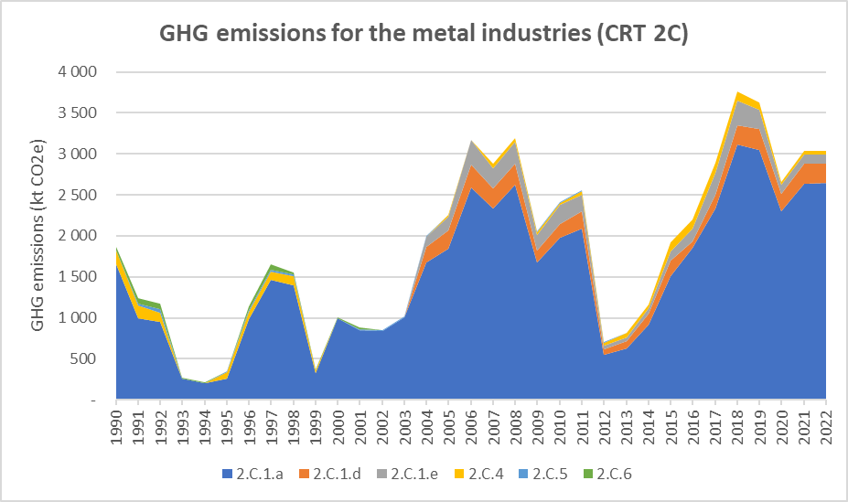
Figure 59: GHG emissions trends for the metal industries (CRT 2C), for the period 1990-2022, per subcategory (in kt CO₂e)
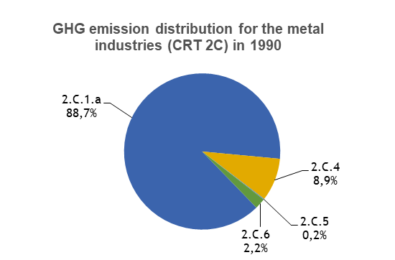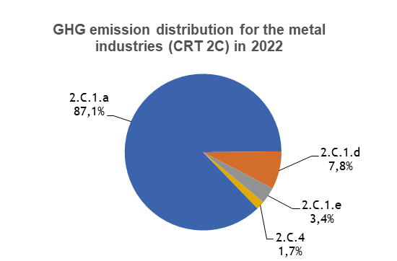
Figure 60: GHG emission distribution for metal industries (CRT 2C), for the years 1990 and 2022, per subcategory (in %)

Iron and steel (CRT 2C1)

Category description
In the Republic of Serbia, there is one integrated iron and steel plant, which operates with a basic oxygen furnace (BOF, or “oxygen converter”).
The pig iron produced in the blast furnaces is converted into steel via the BOF. Sinter and pellet productions began in 2004.
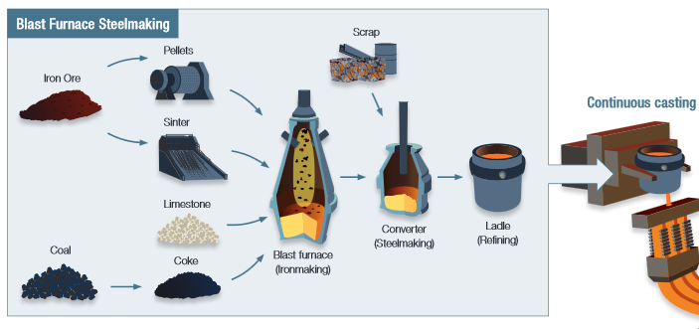
Figure 61: Overview of the integrated steel production

In Serbia, the iron and steel sector includes the following sub-sectors:
- Production of steel (CRT 2C1a),
- Production of sinter (CRT 2C1d),
- Production of pellets (CRT 2C1e).
It has to be noticed that the production of coke (which is consumed in the blast furnace) is dealt in the 1A1c section. For the purpose of GHG emission calculations, the production of pig iron (occurring in the blast furnace) is included in the CRT 2C1a.
The use of raw materials such as coke, coal, and carbonates, which contain carbon, lead to the emissions of CO₂ at all the steps of the iron and steel production process. Moreover, sinter production leads to CH₄ emissions. Other GHG emissions are not expected for this sector.
In 2022, the sub-category Production of steel (CRT 2C1a) is a key category for CO₂ emissions in the Republic of Serbia, both in terms of emission levels and trend. This sub-sector contributes to 4.2% in terms of emissions level (rank 3) and 5.1% in terms of emissions trend (rank 4).
In 2022, the sub-category Production of sinter (CRT 2C1d) is a key category for CO₂ emissions in Serbia, both in terms of emission levels and trend. This sub-sector contributes to 0.4% in terms of emissions level (rank 30) and 0.9% in terms of emissions trend (rank 27).
In 2022, the sub-category Production of pellets (CRT 2C1e) is a key category solely in terms of emissions trend. It contributes 0.4% to the national emission trend (rank 45).
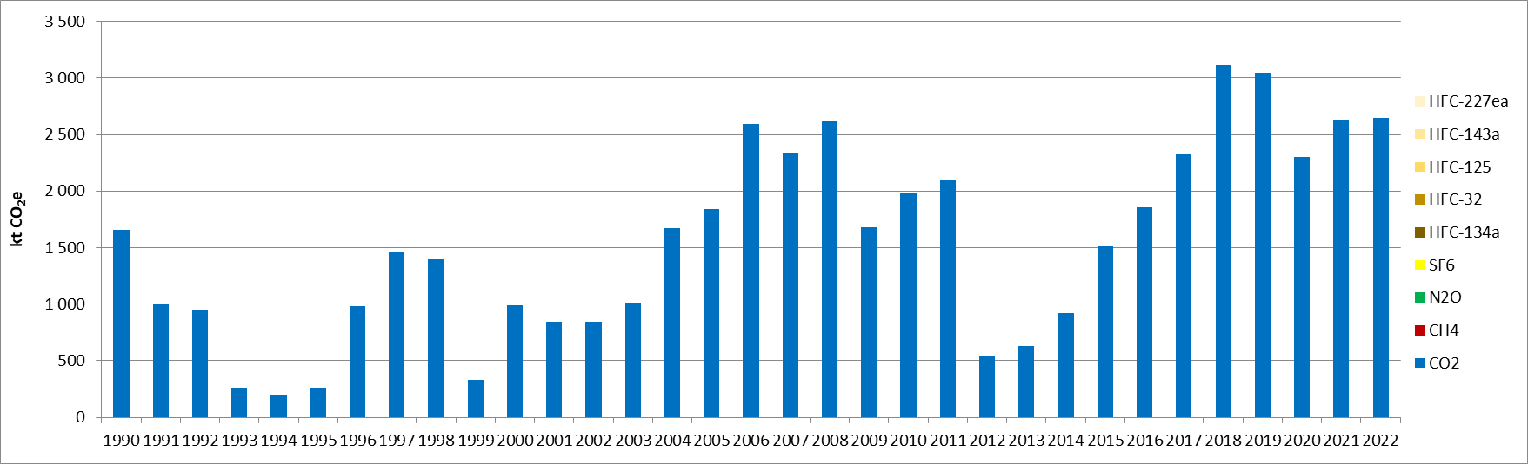
Figure 62: GHG emissions for steel production, for the period 1990-2022 (in kt CO₂e)

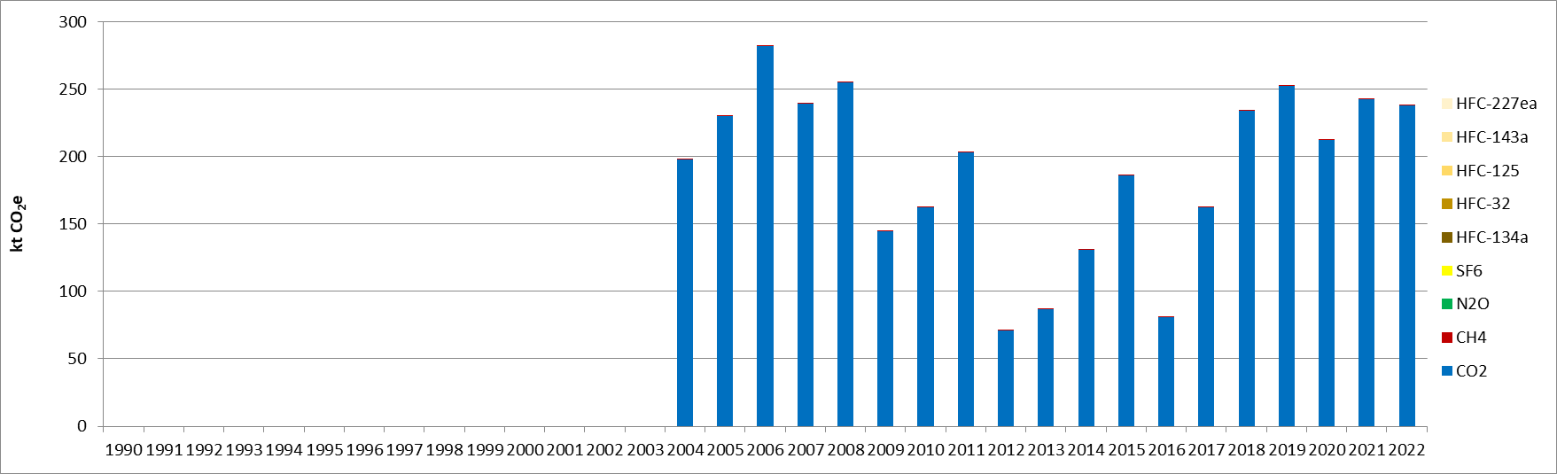
Figure 63: GHG emissions for sinter production, for the period 1990-2022 (in kt CO₂e)
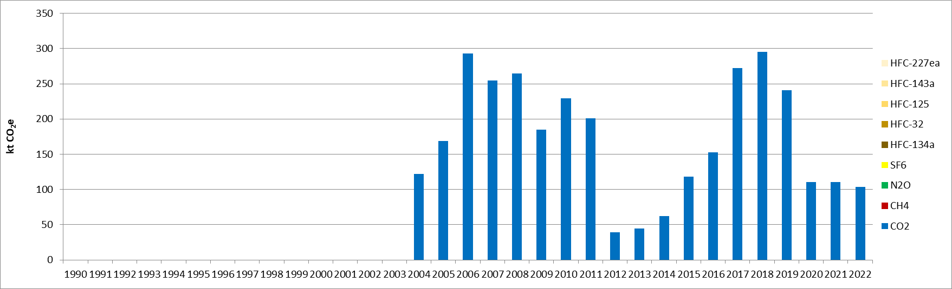
Figure 64: GHG emissions for pellet production, for the period 1990-2022 (in kt CO₂e)
CO₂ emissions from the iron and steel sector declined from 1990 to 1994 due to the decrease in industrial activities, caused by the collapse of Yugoslavia (common market) and economic downturn. In addition, sudden declines in activities are observed in 1999, due to the NATO bombing, in 2009 due to the global economic crisis, and in 2012 due to reduced market demand for iron and steel, which consequently led to a lower utilization of production capacities in these industries. The steel industry has significant production capacities, which have been renewed, and has significantly raised their production after privatization (since 2001).
Between 2012 and 2018, the steel production has significantly and progressively increased, by 470%, before slightly decreasing in 2020 due to the pandemic and being stable since then. It has to be noted that EU in 2019 introduced Tariff-Rate-Quotas (TRQs) which also affected the production in Serbia. Similar observations, to different extents, can be made for the other subsectors of the pellet and sinter productions.

Methodological issues
The Tier 1 method from the 2006 IPCC Guidelines is used to calculate the CO₂ and CH₄ emissions (equations 4.4, 4.7, 4.8 and 4.12 of the 2006 IPCC Guidelines [I22]). Tier 1 methodology provides equations for the calculation of:
- CO₂ and CH₄ emissions for sinter production,
- CO₂ emissions for pellets production,
- CO₂ emissions for iron and steel production (the equation includes pig iron production process and BOF steel production process).
The pig iron and crude steel productions are sourced from the WorldSteel statistical yearbook [I23]. It is assumed that all pig iron is converted into steel.
The sinter and pellet productions are sourced from SEPA questionnaires with the only operator [I24].
Default CO₂ emission factors from the 2006 IPCC Guidelines [I22] are used for steel production (1.46 t CO₂/t steel produced), sinter production (0.2 t CO₂/t sinter produced) and pellets production (0.03 t CO₂/t pellet produced).
Default CH₄ emission factor from the 2006 IPCC Guidelines [I22] is used for the sinter production (0.07 kg CO₂/t sinter produced).

Magnesium production (CRT 2C4)

Category description
This category refers to process emissions occurring in both primary and secondary magnesium productions. During the primary production manufacturing, carbonated raw materials such as dolomite or magnesite are used and release CO₂ during the calcination process. The secondary production includes recovery and recycling of magnesium. Magnesium casting process may involve primary and secondary magnesium. As molten magnesium burns in presence of oxygen, high GWP gaseous components such as SF₆ or HFC are used in required protection systems to prevent burning.
In the Republic of Serbia, primary magnesium is produced from dolomite casting. CO₂ and F-gases emissions are expected.
In the following graph, the GHG emissions from this source are displayed. Many variations are observed since 1990, being the highest emission level for the studied period. After a rapid decline between 1990 and 1993, where the activity stopped for two years (1993-1994) during the economic downturn, the emissions recovered until 1999 where a decrease is observed due to the NATO bombing. The GHG emissions are really marginal or even not occurring for the period 2000-2006, rather stable between 2007-2014, but at rather low levels compared with the pre-crisis levels (a ratio between half and a quarter). After a recovery of the GHG emission from this subsector between 2015 and 2019, a drop is observed in 2020 related to the pandemic. Since then, the activity, and hence emissions, from this subsector, remain rather low and, in 2022, the GHG emissions from magnesium processes are 69% lower than in 1990.
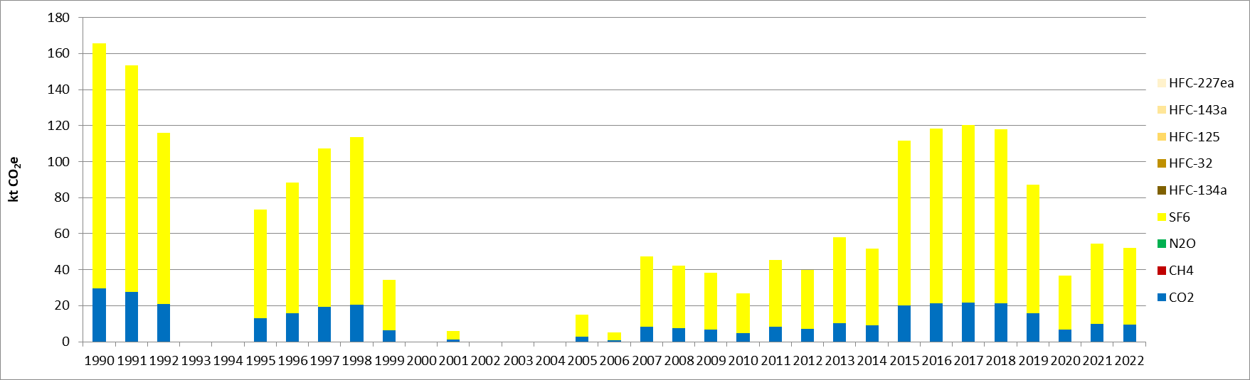
Figure 65 : GHG emissions for magnesium production, for the period 1990-2022 (in kt CO₂e)
In 2022, the subsector magnesium production is neither a key category in terms of emissions level nor in terms of emissions trend for GHG emissions, in Serbia.

Methodological issues
The methodology used is Tier 1. CO₂ and SF₆ emission estimates are sourced respectively from Equation 4.28 and 4.30 of magnesium production section in 2006 IPCC Guidelines [I25]. HFC emissions are not estimated since 2006 IPCC Guidelines do not provide Tier 1 or Tier 2 methodologies nor default emission factors, unless emissions can occur.
Activity data used for the calculation are national magnesium productions and are sourced from SORS [I2] for the time series.
Default emission factors for CO₂ and SF₆ are constant on the time series and are sourced from 2006 IPCC Guidelines. Recommended applied values are respectively 5.13 t CO₂/ t primary Mg [26] and 1 kg SF₆/ t Mg casting [I27].

Lead production (CRT 2C5)

Category description
This category refers to process emissions occurring in both primary and secondary lead productions. GHG emissions expected are CO₂ released from the use of carbonated reductants in the process.
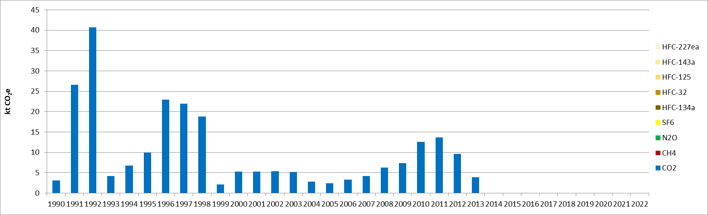
Figure 66 : GHG emissions for lead production, for the period 1990-2022 (in kt CO₂e)

Since 2014, the primary and secondary lead production stopped and is now considering as not occurring (NO).
Hence, in 2022, the category lead production is neither a key category in terms of emission levels nor in terms of emission trend for GHG emissions in Serbia.

Methodological issues
The methodology used is Tier 1. CO₂ emissions estimate is sourced from Equation 4.32 of lead production section in 2006 IPCC Guidelines [I28].
Activity data used for the calculation are national primary and secondary lead productions. The primary lead production does not occur in Serbia after 2003. The source of activity data for lead production is direct communication with the operator [I29]. There were no data for secondary lead before 2000. As the process is not known, it is assumed that activity data are disaggregated between Direct Smelting process (20%) and Imperial Smelting Furnace process (80%), accordingly, to default ratios provided in 2006 IPCC Guidelines [I28].
For primary production, default emission factor for CO₂ is constant by process on the time series and is sourced from 2006 IPCC Guidelines. Recommended applied values are 0.59 t CO₂/ t lead for ISF process and 0.25 t CO₂/ t lead for DS process [I30]. For secondary production, default emissions factor for CO₂ is constant on the time series. The value provided by 2006 IPCC Guidelines is 0.2 t CO₂/ t secondary lead [I30].

Zinc production (CRT 2C6)

Category description
This category refers to process emissions occurring in both primary and secondary zinc productions. GHG emissions expected are CO₂ released from the use of carbonates and reductants in the process. There is no more zinc production in the Republic of Serbia since 2004.
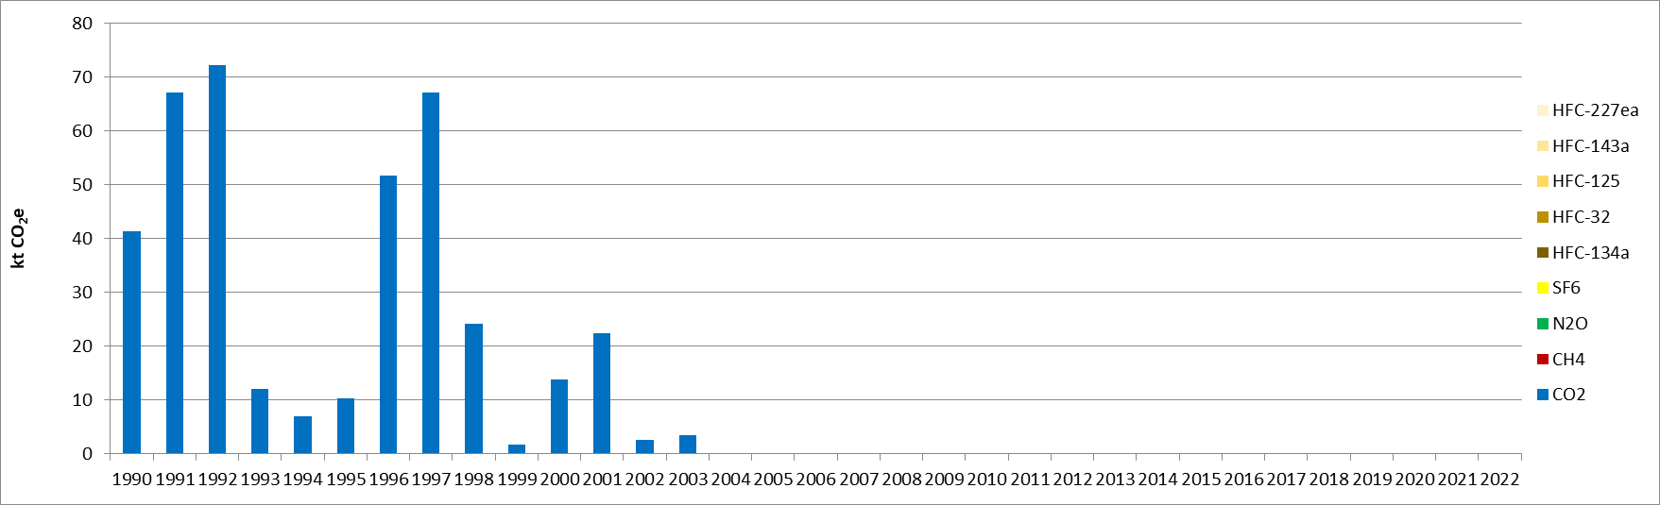
Figure 67 : GHG emissions for zinc production, for the period 1990-2022 (in kt CO₂e)

In 2022, the category zinc production is neither a key category in terms of emissions level nor in terms of emissions trend for GHG emissions in Serbia.

Methodological issues
The methodology used is Tier 1. CO₂ emission estimates are sourced from Equation 4.33 of zinc production section in 2006 IPCC Guidelines [I31].
Activity data used for the calculation are the national zinc productions. The source for activity data concerning this category is SORS [I2]. From 2004, zinc production does not occur.
As the process is not known, default emission factor for CO₂ of 2006 IPCC Guidelines is used and considered constant on the time series and are sourced. Recommended applied value is 1.72 t CO₂/ t zinc [I33].

Uncertainties and time-series consistency
CO₂
Uncertainty estimate associated with activity data for CRT 2C amounts to 10%, accordingly to values reported in 2006 IPCC Guidelines (Volume 3 Chapter 4 – Table 4.4).
Uncertainty estimate associated with default emission factor amounts to 25%, accordingly to values reported in 2006 IPCC Guidelines (Volume 3 Chapter 4 – Table 4.4).
Combined uncertainty for emissions is 1.3% in the total national levels of emission in 2022, excluding LULUCF contribution.
CH₄
Uncertainty estimate associated with activity data for CRT 2C amounts to 10%, accordingly to values reported in 2006 IPCC Guidelines (Volume 3 Chapter 4 – Table 4.4).
Uncertainty estimate associated with default emission factor amounts to 25%, accordingly to values reported in 2006 IPCC Guidelines (Volume 3 Chapter 4 – Table 4.4).
Combined uncertainty for emissions is 0.000001% in the total national levels of emission in 2022, excluding LULUCF contribution.
SF₆
Uncertainty estimate associated with activity data for CRT 2C amounts to 20% based on expert judgment.
Uncertainty estimate associated with default emission factor amounts to 5% based on expert judgment.
Combined uncertainty for emissions is 0.014% in the total national levels of emission in 2022, excluding LULUCF contribution.

Category-specific QA/QC and verification
During the preparation of the inventory submission, activities related to quality control were mainly focused on completeness and consistency of emission estimates, and on proper use of notation keys in the CRT tables.
Operators’ questionnaires are checked by the competent authority.

Category-specific recalculations
The current report is the first National Inventory Document for Serbia. Consequently, there is no recalculation. Possible recalculation will be occurred and estimated in the next submission if necessary.

Category-specific planned improvements
For the metal industry, especially for the iron and steel industry, magnesium production and the lead production, the completeness and the consistency of the activity data set have to be improved.

Non-energy products from fuels and solvent use (CRT 2D)
This CRT 2D category covers the following emission sources:
- The use of lubricant (CRT 2D1),
- The use of paraffin wax (CRT 2D2),
- The use of solvents (CRT 2D3).
All these emission sources are responsible of CO₂ emissions.
In 2022, in the Republic of Serbia, the CRT 2D is responsible of 0.1% of the national GHG emissions, excluding LULUCF contribution, and of 2% of the GHG emissions of CRT 2.
The following graph presents the GHG emission trend of the CRT 2D. After having undergone a significant reduction between 1990 and 1992, due to economic downturn, and a relatively stable period from 1992 to 1998, the GHG emissions are in a slow and constant increase since then. This evolution is in particular related to the increase in the use of lubricant, related to the traffic growth, whereas the emissions related to the solvent use (CRT 2D3) are rather stable, and even slightly decreasing (-28% over the whole period). In 2022, the emissions from this sector are almost evenly split between the CRT 2D1 and CRT 2D3 with respectively 48% and 50%, the rest being the paraffin wax use (CRT 2D2).
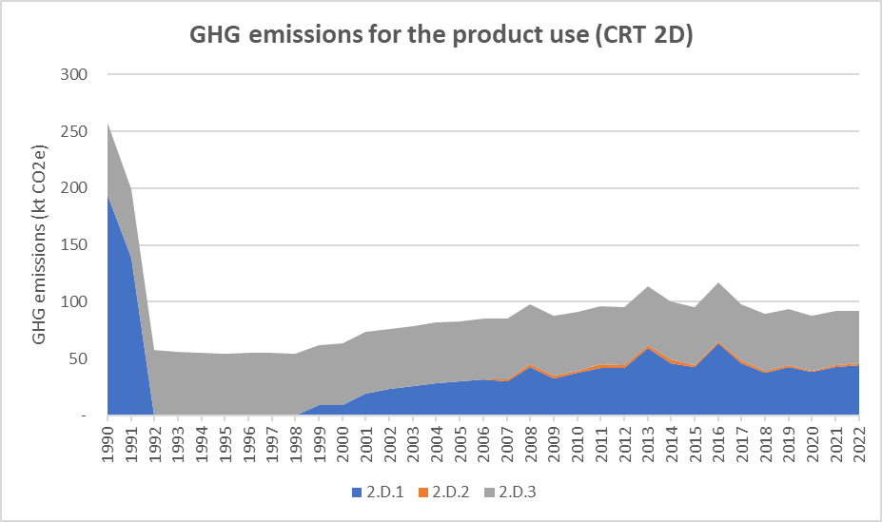
Figure 68: GHG emissions trends for the non-energy product uses (CRT 2D), for the period 1990-2022, per subcategory (in kt CO₂e)

Lubricant use (CRT 2D1)

Category description
CO₂ emissions are implied by the use of lubricant in industrial and road applications. In this sector, only emissions related to non-energy use of lubricants are considered. The use of lubricant in mixtures with fuel such as gasoline, where it is burned in engines, is not considered in this section but in the CRT 1A3b or the non-road mobile sectors.

In 2022, the category Lubricant use is a key category in terms of emissions trend, in the Republic of Serbia. This sector contributes to 0.4% in terms of emission trend (rank 44).
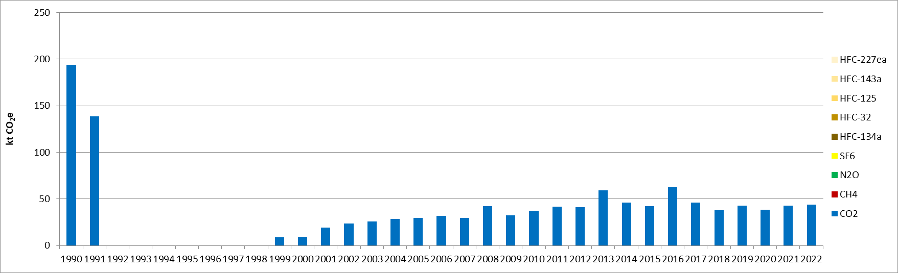
Figure 69: CO₂ emissions for lubricant use, for the period 1990-2022 (in kt CO₂e)

CO₂ emissions from lubricant use declined rapidly between 1990 and 1992, in relation with the economic downturn. Emissions related to lubricant use are then estimated from 1999 to 2022, increased progressively until 2008, before being rather stable and slightly oscillating up to 2022. The lubricant consumption varies partly in consequence of the road traffic.

Methodological issues
The Tier 1 method from the 2006 IPCC Guidelines is used to calculate the CO₂ emissions (equation 5.2 of the 2006 IPCC Guidelines [I34]).
The national non-energy lubricant consumption is sourced from the energy balance of Serbia [E2].
The default CO₂ emission factor from the 2006 IPCC Guidelines [I35] is used and its value is 20 t C/TJ. It is considered constant for the entire time-series. The default oxidation fraction parameter for lubricants is taken as default value from the 2006 IPCC Guidelines and is of 0.2 [I34].

Paraffin wax use (CRT 2D2)

Category description
CO₂ emissions are implied by the use of products such as paraffin wax, petroleum jelly, and other waxes, including ozokerite. Paraffin waxes are used in various types of products such as candles, paper coating, food production, surfactants, etc. Emissions arise when these products are either burned or incinerated. However, when paraffin wax products are incinerated, emissions should be considered in Energy or Waste sector depending on whether there is heat recovery.

In 2022, the category Paraffin wax use is neither a key category in terms of emission levels nor in emission trend, in the Republic of Serbia.
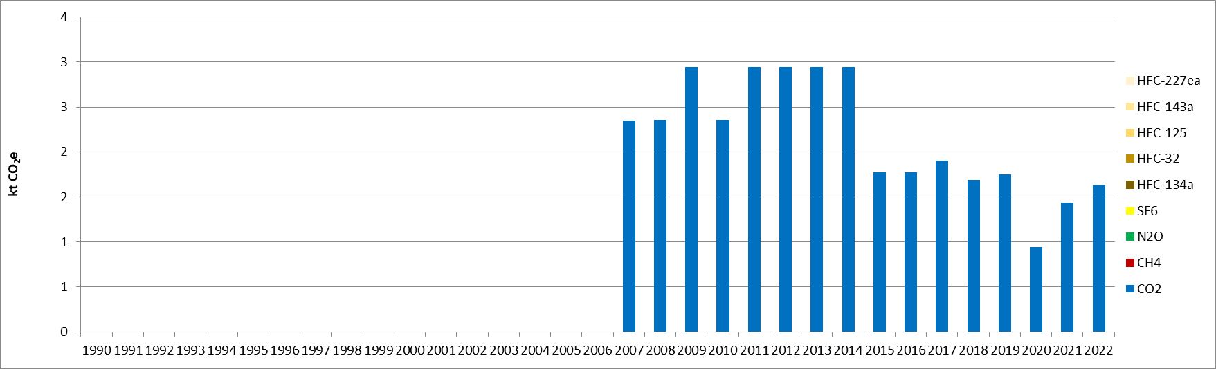
Figure 70: CO₂ emissions for paraffin wax use, for the period 1990-2022 (in kt CO₂e)

Methodological issues
The Tier 1 method from the 2006 IPCC Guidelines is used to calculate the CO₂ emissions (equation 5.4 of the 2006 IPCC Guidelines [I36]).
The national non-energy paraffin wax consumption is sourced from the energy balance of Serbia [E2].
The default CO₂ carbon content from the 2006 IPCC Guidelines is applied and is of 20 t C/TJ [I36]. It is considered constant for the entire time-series. The default oxidation fraction parameter for lubricants is taken as default value from the 2006 IPCC Guidelines and is of 0.2 [I36].

Solvent use (CRT 2D3)

Category description
The use of solvents is responsible for evaporative emissions of NMVOC, which can further be oxidised in the atmosphere and induce CO₂ emissions. If the solvents are made from fossil fuels, hence the oxidised carbon needs to be accounted the national totals. Fossil fuels used as solvents are principally white spirit and kerosene.

In 2022, the category Solvent use is neither a key category in terms of emission levels nor in emission trend, in the Republic of Serbia.
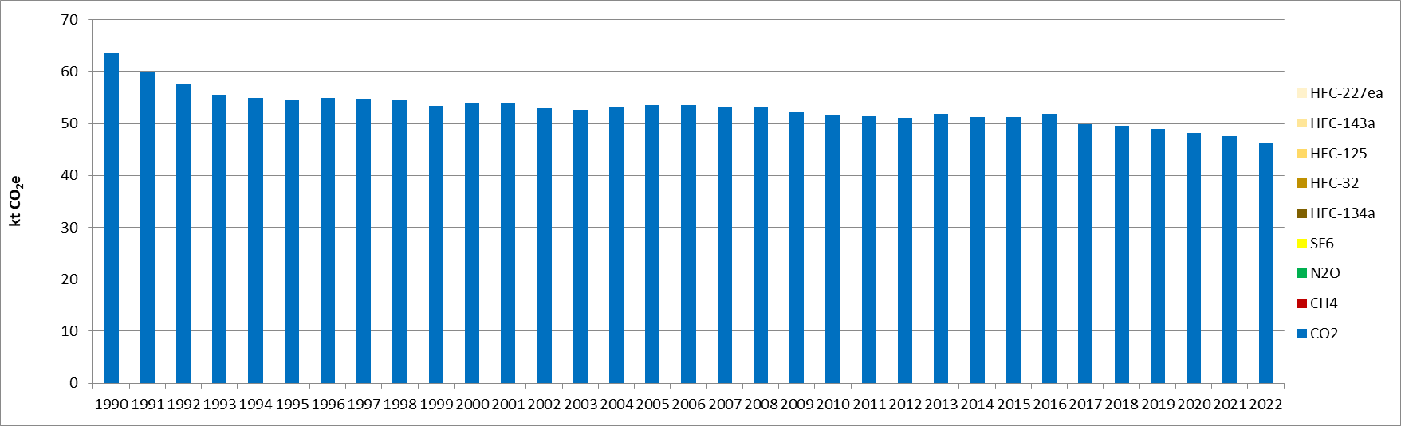
Figure 71: CO₂ emissions for solvent use, for the period 1990-2022 (in kt CO₂e)

The CO₂ emissions related to the use of solvent are slightly and continuously declining through the timeseries. The achieved emission reduction for the period 1990-2022 is of 28%.

Methodological issues
A mix of Tier 1 ad Tier 2 methods from the EMEP/EEA Guidelines is used to calculate the NMVOC emissions related to the solvent use, depending on the subsector. Hence, the associated CO₂ emissions are estimated based on the 2006 IPCC Guidelines [I37].
The activity data vary depending on the emission source and can be either population, the solvent-containing product consumptions such as paint or the production of specific products such as rubber. The activity data are sourced from the Statistical yearbook [I2].
The default fossil carbon content fraction of NMVOC applied is sourced from the 2006 IPCC Guidelines and its value is of 60% [I37].
Emissions related to the use of urea are not estimated as there is a lack of data accessibility concerning the imports and exports of this product.

Uncertainties and time-series consistency
CO₂
Uncertainty estimate associated with activity data for CRT 2D amounts to 15%, accordingly to values reported in 2006 IPCC Guidelines (Volume 3 Chapter 5.2.3.2).
Uncertainty estimate associated with default emission factor amounts to 50%, accordingly to values reported in 2006 IPCC Guidelines (Volume 3 Chapter 5.2.3.1).
Combined uncertainty for emissions is 0.08% in the total national levels of emission in 2022, excluding LULUCF contribution.

Category-specific QA/QC and verification
During the preparation of the inventory submission, activities related to quality control were mainly focused on completeness and consistency of emission estimates, and on proper use of notation keys in the CRT tables.

Category-specific recalculations
The current report is the first National Inventory Document for Serbia. Consequently, there is no recalculation. Possible recalculation will be occurred and estimated in the next submission if necessary.

Category-specific planned improvements
For the use of non-energy products, the completeness and the consistency of the activity data set could be improved, in particular for lubricants, paraffin wax, as well as data about the imports and exports of urea. Discussion with the Statistical office, which provides these data, will be conducted.

Product uses as substitutes for ODS (CRT 2F)
The CRT 2F category covers the following subsectors:
- Refrigeration and air conditioning (2F1),
- Foam blowing agents (2F2),
- Fire protection (2F3),
- Aerosols (2F4).
The Solvent sector (2F5) does not occur in the Republic of Serbia.
The category CRT 2F is the only contributor to HFC emissions in the Serbian inventory. In 2022, HFCs emissions contributed to 3.1% of the CRT 2 sectoral GHG emissions, as well as 0.3% to the total GHG emissions, excluding LULUCF contribution.
It can be observed that GHG emissions related to this activity appeared in 1997, increased slowly until 2007, and much faster between 2007 and 2014 (+542%), before decreasing progressively up to the latest year 2022. The growth is related to the development of the use of fluorinated gases, whereas the decline corresponds to the impact of the regulation on the use of such substances (Regulation on the treatment of fluorinated gases with a greenhouse effect, as well as on the conditions for issuing permits for the import and export of these gases (OJ No 120/13)). Between 2014 and 2022, the achieved emission reduction is of 66%.
The main emission source of the sector is the stationary air conditioning, commercial and industrial refrigeration (CRT 2F1f), which represents most of the emissions throughout the timeseries. In 2022, this subsector contributes to 73% of the sector GHG emissions.
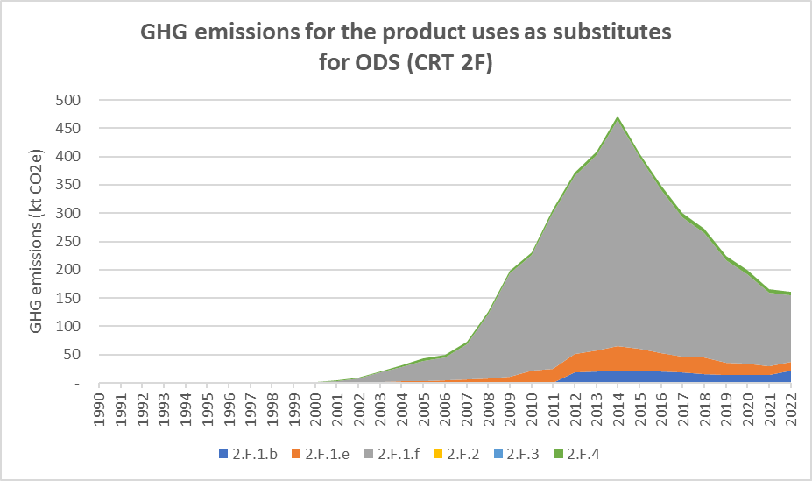
Figure 72: GHG emissions trends for the product uses as substitutes for ODS (CRT 2F), for the period 1990-2022, per subcategory (in kt CO₂e)

Refrigeration and air-conditioning (CRT 2F1)

Category description
Refrigeration and air conditioning accounts for the most of emissions in CRT 2F sector (96% in 2022). Emissions are released by the consumption of synthetic greenhouse gases (HFC-32, HFC-125, HFC-134a and HFC-143a), which are used as substitutes for cooling gases in refrigerating and air-conditioning systems that deplete the ozone layer (CFCs and HCFCs). This category includes the use of these substances in Commercial Refrigeration, Domestic Refrigeration, Industrial Refrigeration, Mobile Air-Conditioning and Stationary Air-Conditioning.
The 2F1 sector is split between 2F1b (domestic refrigeration), 2F1e (mobile air conditioning) and 2F1f (aggregated emission for stationary air conditioning, commercial and industrial refrigeration).
In 2022, the 2F1f subsector is a key category for HFCs emissions, in terms of emission trend, in the Republic of Serbia. This sector contributes to 0.4% in terms of emissions trend (rank 42). However, in 2022, the 2F1b and 2F1e subsectors are neither key category in terms of emission levels and emission trend for GHG emissions in Serbia.
Refrigerants used in Serbia are R-134a, R-404A, R-407C and R-410A. The emissions by subsectors are summarized below:
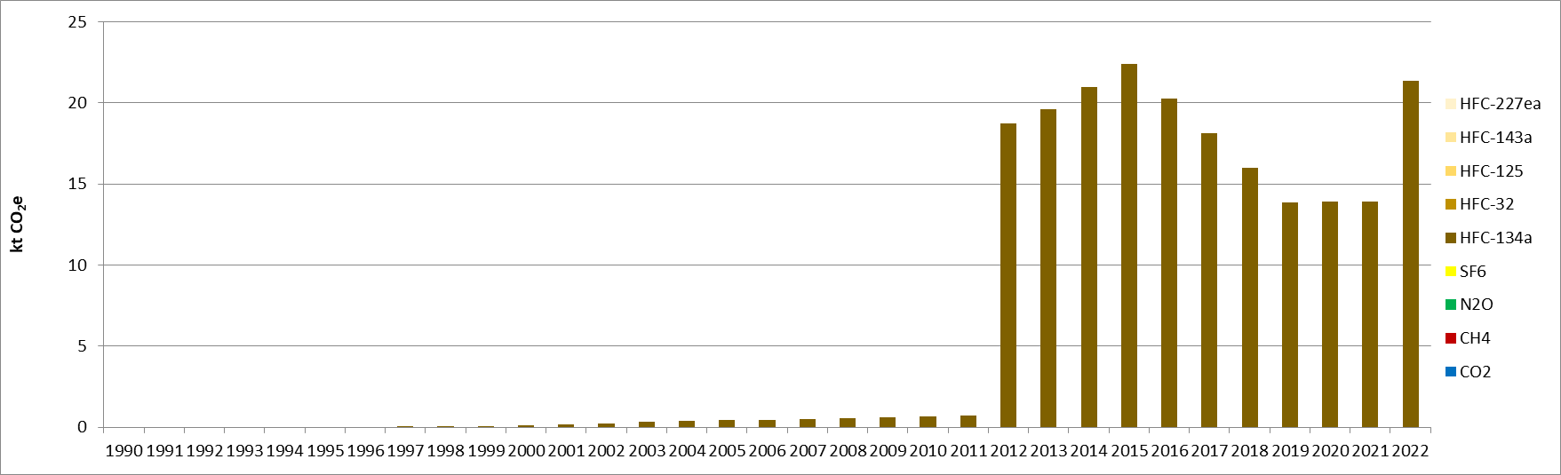
Figure 73: GHG emissions for domestic refrigeration, for the period 1990-2022 (in kt CO₂e)
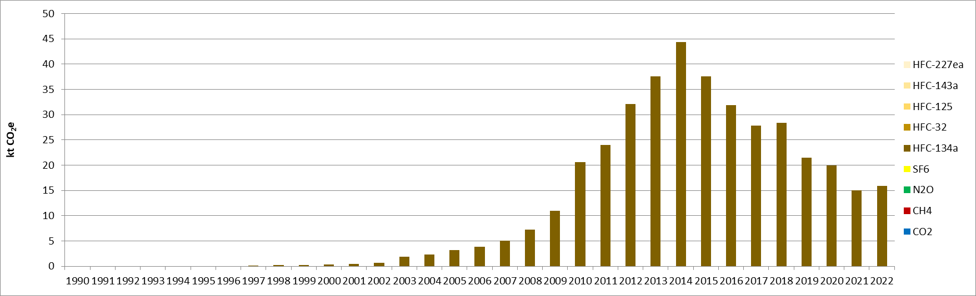
Figure 74: GHG emissions for mobile air-conditioning, for the period 1990-2022 (in kt CO₂e)
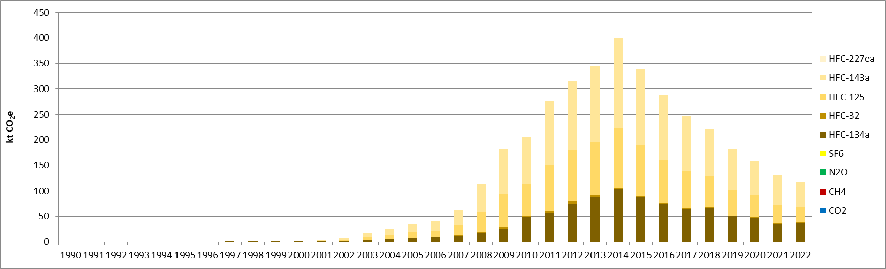
Figure 75: GHG emissions for commercial refrigeration, industrial refrigeration and stationary air-conditioning,
for the period 1990-2022 (in kt CO₂e)
HFCs started to be used in larger extent in the middle of 2000s but, due to the increase of average annual stock of refrigerant, the emissions started to be high in early 2010s. Concerning HFC-134a domestic emissions, the high increase from 2012 is caused by emissions at the end of life of the freezers. Indeed, it is assumed that there is no recovery of HFC at the decommissioning.
The implementation of the regulation on treatment and transfers of fluorinated gases implemented in 2013 enabled to achieve important emission reductions in CRT 2F1e and 2F1f since 2014.

Methodological issues
On one hand, Tier 1 methodology is used for 2F1e and 2F1f sectors due to the missing data on average annual stocks. On the other hand, Tier 2a methodology is used for 2F1b sector.

Domestic refrigeration (2F1b)
The amount of HFC-134a contained in freezers in the Republic of Serbia is estimated with the following parameters:
- number of households in Serbia each year,
- share of households equipped with a freezer each year,
- repartition of gases introduced in new freezers,
- gas amount per appliance.
The number of households in Serbia and the share of households equipped with a freezer are collected each year in the statistical book [I2].
The repartition of the types of gas introduced in the new freezers (CFC-12, HFC-134a, HC-600a) is provided by a UNEP report [I38] and the knowledge of Serbian situation. UNEP report notices that 100% of the refrigerants used in 1992 are CFC-12 for Eastern Europe region, then 53% of refrigerant used in new equipment are HFC-134a in 1996, 66% in 2000, 40% in 2004 and 2008. Serbian information enables to know that the year of HFC introduction was 1997.
The gas amount per appliance is sourced from 2006 IPCC Guidelines [I39].
The emissions are calculated with Equation 7.10 of the 2006 IPCC Guidelines [I44]. The annual emission rate is sourced from 2006 IPCC Guidelines [I39] and it is assumed that there is no recovery of HFC during decommissioning appliances.

Mobile air conditioning (2F1e)
The Serbian Ministry of Environmental protection yearly collects data on quantities of HFCs imported and exported. The share of HFC-134a imported and exported used for mobile air conditioning is distinguished. The IPCC tool [I45] is used for the calculation of HFC-134a emissions. The different parameters used in this tool are presented below:
- The year of introduction is 1997,
- The assumed equipment lifetime is 15 years,
- The emission factor from installed base is 15%,
- The percentage destroyed at end of life is 0% (no recovery).

Stationary air conditioning, commercial and industrial refrigeration (2F1f)
The Serbia’s Ministry of Environmental protection yearly collects data on quantities of HFCs imported and exported. The share of refrigerant by sub-application (stationary air conditioning, commercial, industrial refrigeration) is not available. Consequently, emissions are aggregated in the same CRT code. As for 2F1e subsector, IPCC tool [I45] is used for the calculation of HFCs emissions. The different parameters used in this tool are presented below:
- The year of introduction is 1997 for HFC-134a and 2001 for HFC-32, HFC-125 and HFC-143a,
- The assumed equipment lifetime is 15 years,
- The emission factor from installed base is 15%,
- The percentage destroyed at end of life is 0% (no recovery).

Foam blowing agents (CRT 2F2)

Category description
This sector is currently not estimated because of the lack of activity data available. Preliminary assessment of the expected emissions show that they will likely be below the level or relevance allowed in accordance with Decision 18/CMA.1 and will likely continue to be reported as “NE”. Regardless that preliminary assessment the Questionnaire has been sent to relevant institutions in order to better assess if HFCs are used in Serbia foam manufacturing industry.

Methodological issues
Not estimated.

Fire protection (2F3)

Category description
This sector is currently not estimated because of the lack of activity data available. Questionnaire has been sent in order to know if HFCs are used in Serbia fire protection operators (Cf. chapter on planned improvements).

Methodological issues
Category is not estimated.

Aerosols (2F4)

Category description
Metered dose inhalers (MDIs) are used to deliver certain pharmaceutical products as aerosols. For patients with respiratory illnesses, such as asthma and chronic obstructive pulmonary disease (COPD), medication needs to be delivered directly to the lungs. MDIs are one of the preferred means of delivering inhaled medication to patients with these illnesses. MDIs originally used CFC propellants but, as with industrial aerosols, concern over ozone destruction led to attempts to replace CFCs with HFCs.
In 2022, the category 2F4 aerosol is neither a key category in terms on emission level nor emission trend for GHG emissions in the Republic of Serbia.
The type of HFCs used are HFC-134a and HFC-227a. The emissions are summarized below:
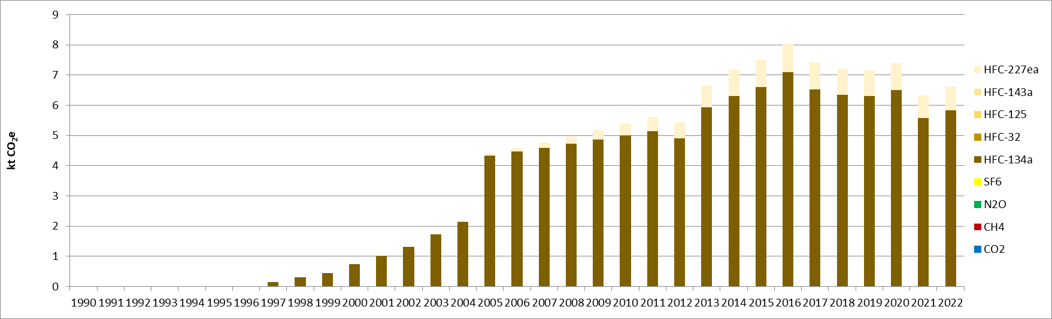
Figure 76: GHG emissions for pharmaceutical aerosols, for the period 1990-2022 (in kt CO₂e)

The number of MDIs sales which contained HFCs increase with the substitution of propellant gas (CFC to HFC) and the growth of respiratory illnesses.

Methodological issues
The methodology used to estimate HFCs emissions corresponds to an IPCC Tier 2 method. Indeed, specific data for pharmaceutical aerosols have been collected. The amount of HFC is estimated with the following parameters:
- quantity of MDIs sales (number of doses) in Serbia each year,
- number of asthma patients,
- amount of HFC in one dose,
- share of type of propellant (CFC, HFCs).
The quantity of MDI sales is provided by Medicines and Medical Devices Agency of Serbia from 2004.
The number of asthma patients is used in order to estimate the MDIs sales before 2016. Indeed, the ratio of number of asthma patients and MDI sales of 2016 is used to calculate MDI sales for years before 2004. The number of asthma patients is provided in the health statistical yearbook of Republic of Serbia [I40].
The average amount of HFC contained in one dose are sourced from the big manufacturer of MDI (GSK) [I41]. This quantity used is 12 g of HFC per dose.
The type of propellant used comes from a UNEP report and French information. Thus, it is assumed that 95% of HFC-134a and 5% of HFC-227ea are used in 2014 [I42]. The year of HFC-134a introduction to replace CFC is 1997 (approximately 4%) [I43]. The share of HFC-134a increase over time until 2005 (100%). From 2005 to 2014, the share of HFC-227ea gradually increased until 2014.
The emissions are calculated with Equation 7.6 of the 2006 IPCC Guidelines [I46]. It is assumed that all the HFC contained in the MDI is emitted in one year. Consequently, the emission factor used is 100%.

Uncertainties and time-series consistency
Uncertainty estimate associated with activity data amounts to 20%, based on expert judgment.
Uncertainty estimate associated with HFC emission factor amounts to 20%, also based on expert judgment.
Combined uncertainty for emissions is 0.07% in the total national levels of emission in 2022, excluding LULUCF contribution.

Category-specific QA/QC and verification
During the preparation of the inventory submission activities related to quality control were mainly focused on completeness and consistency of emission estimates and on proper use of notation keys in the CRT tables. Especially, new sectors have been estimated (domestic refrigeration and pharmaceutical aerosols).

Category-specific recalculations
The current report is the first National Inventory Document for Serbia. Consequently, there is no recalculation. Possible recalculation will be occurred and estimated in the next submission if necessary.

Category-specific planned improvements

Refrigeration and air conditioning (CRT 2F1)
- In the methodology used for 2F1e and 2F1f, estimated emissions based on the import/export data do not take into account the amounts of F-gases which are contained in the imported equipment in Serbia (example: stationary air conditioning or mobiles air conditioning). Consequently, one improvement would be to develop the Tier 2 methodology from 2006 IPCC guidelines to consider these quantities and to distinguish the different sub-applications (stationary air conditioning, commercial refrigeration and industrial refrigeration).

Foam blowing agents (CRT 2F2)
- This sector has been identified as a source of HFC emissions. This sector is currently not included in the inventory because no activity data is available. Survey was sent to concerned manufacturers/operators. Consequently, the improvement will be to estimate emission for foam blowing agents.

Fire protection (CRT 2F3)
- This sector has been identified as a source of HFC emissions. This sector is currently not included in the inventory because no activity data is available. Survey was sent to concerned manufacturers/operators. Consequently, the improvement will be to estimate emission for fire protection.

Aerosols (CRT 2F4)
- For the CRT 2F4 (pharmaceutical aerosol), the quantities of pharmaceutical aerosols sold in Serbia are only available for the years 2004 - 2022 by type of MDI. Consequently, the improvement would be to collect the amount of HFC contained in each product and to collect data MDI sales for the years before 2004.

Other product manufacture and use (CRT 2G)

Electrical equipment (CRT 2G1)

Category description
Sulphur hexafluoride (SF₆) is used in electrical equipment in order to insulate them and prevent current transmission. At each phase of the life cycle of the equipment, some emissions occur. The different phases of the life cycle include the manufacturing, installation, use, servicing and disposal. Two types of equipment need to be considered, the category “Sealed pressure systems” which do not require refilling, and the other “Closed pressure systems” which require refilling during its lifetime and contain much more gas (between 5 and several hundred kilograms).
In 2022, the category 2G1 electrical equipment is neither a key category in terms on emission level nor emission trend for GHG emissions in the Republic of Serbia.
SF₆ emissions related to electrical equipment started occurring in 2000 and increased progressively until 2013, before being rather stable until 2021.
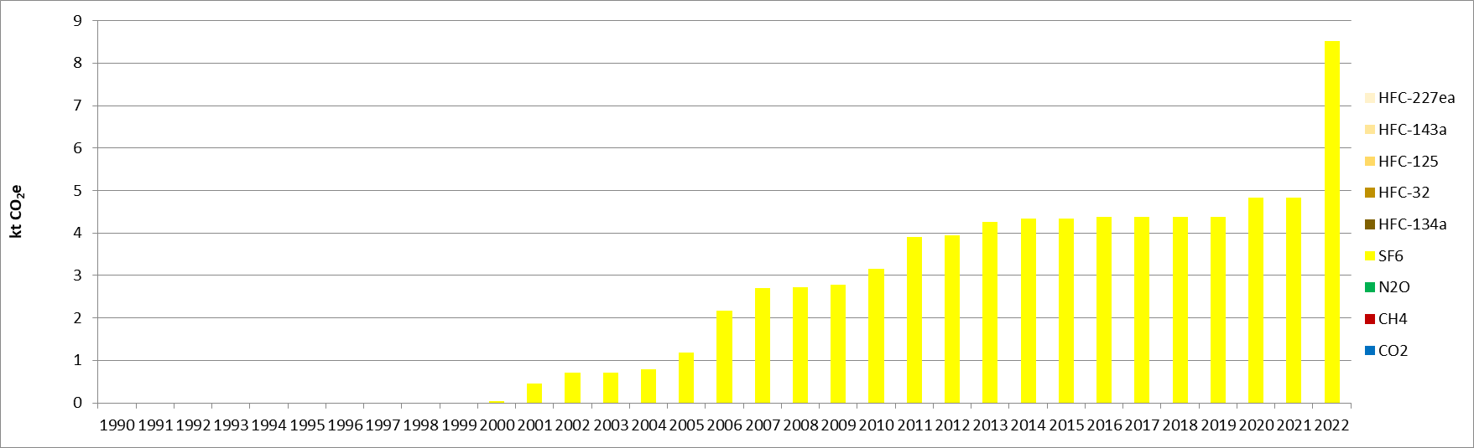
Figure 77: GHG emissions for electrical equipment, for the period 1990-2022 (in kt CO₂e)
Sudden increase in emissions in 2022 is likely caused by the error in emission calculation as detected by the peer-review during preparation of the NID. This issue will be addressed for the next NID submission. In addition, QC procedures in this minor category will be adjusted in order to identify such errors in the future.

Methodological issues
The methodology used is Tier 1. SF₆ emission estimates are sourced from Equation 8.1 of emissions of SF₆ and PFCs from electrical equipment section in 2006 IPCC Guidelines [I32].
Activity data used for the calculation are the nameplate capacity of installed equipment given for different values of voltage (110, 220 and 400 kV), for the period 2000-2022. The source for activity data concerning this category is the electricity supplier Elektromreža Srbije (EMS). No activity data are considered for medium voltage in the Republic of Serbia.
Default Tier 1 emission factors for SF₆ of 2006 IPCC Guidelines are applied and considered constant on the time series. The values for the SF₆ fractions in high voltage equipment considered are as follows, depending on the phase: manufacturing 8.5%, use 2.6%, disposal 95%.
Only emissions related to the use of high voltage equipment are estimated. For the other emission sources, there is a lack of activity data.

Category-specific planned improvements
In the upcoming emission inventories, activity data about the SF₆ consumption by equipment manufacturers and the nameplate capacity of retiring equipment will need to be collected to estimate emissions related to manufacturing and disposal, for high voltage equipment.
For medium voltage equipment, all activity data necessary to estimate associated emissions need to be collected.

Chapter 5: Agriculture (CRT sector 3)

Overview of sector
The Agriculture sector gathers all emissions related to agricultural activities other than the fuel combustion for the mobile engines, the heating of the buildings, the heating of greenhouses, etc., which are included in the CRT category 1A4c. In addition, the CO₂ emissions related to the carbon from soils and biomass related with agricultural activities are included in the LULUCF sector (CRT 4). This CRT 3 category covers the following sectors:
- Enteric fermentation (3A),
- Manure management (3B),
- Agricultural soils (3D),
- Field burning of agricultural residues (3F),
- Lime application (3G),
- Urea application (3H).
The activities of Rice cultivation (3C) and Prescribed burning of savannas (3E) do not occur in the Republic of Serbia. The emissions of the liming category (3G) are not estimated (NE), due to a lack of available activity data.
In 1990, without considering the LULUCF contribution, the CRT 3 category contributed to the national total emissions by: 0.05% for CO₂, 40.7% for CH₄, 60.6% for N₂O, and null for the other GHGs, which represented around 7.9% in terms of GHG emissions. In 2022, the same contributions evolved as follows: 0.4% for CO₂, 32.9% for CH₄, 81.6% for N₂O, none for the other GHGs, leading to a rather similar overall contribution in terms of GHG with 7.8% of the national emissions.
Hence, the agriculture sector is an important emissions source of methane and nitrous oxide in the Republic of Serbia, however it is almost negligible in terms of carbon dioxide, with only the application of urea (CRT 3G) being an emission source of this GHG.
The following graph presents the overall GHG emission trend for the agriculture in the Republic of Serbia, for the period 1990-2022, detailed by subsector.

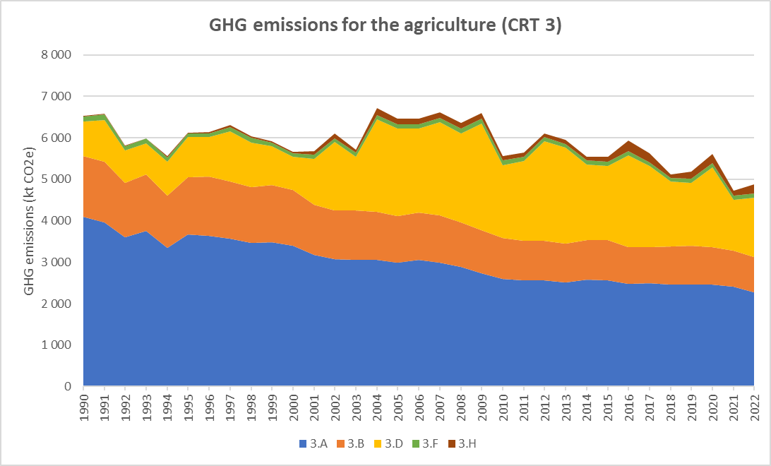
Figure 78: GHG emission trends for agriculture (CRT 3), for the period 1990-2022, per subcategory (in kt CO₂e)

Contrary to the CRT 1 or CRT 2, the trend of emissions of the CRT 3 is rather stable and the different events which occurred in the Republic of Serbia over the studied period did not have as much impact on the emissions as it is the case for the two other sectors. Over the whole studied period, it can be observed that the emissions of both the enteric fermentation (3A) and manure management (3B) progressively decrease, to achieve respectively - 44% and -42% in 2022, compared with 1990, in relation with the decline of the livestock, especially of cattle and swine. The emissions related to the agricultural soils (3D) are more varying over the studied period, increased a lot between 2004 and 2009 and reached its peak, due to the increasing use of inorganic N-fertilisers, and decreased significatively between 2016 and 2022 in relation with the same activity. In overall, the emissions of N₂O of this subsector increased by 71% for the period 1990-2022. Finally, the emissions related to the field burning (3F) are rather stable over the timeseries (-7%) and the emissions of urea application (3H) are varying but overall increasing significantly (+574%) over the period 1990-2022. Both these subsectors are rather marginal in the agriculture total emissions, contributing to 2% and 4%, respectively, in 2022. The main subsector contributing to the sector emissions is the category CRT 3A, which represented 63% in 1990 but has a share of 47% in 2022. The subsector of the manure management (CRT 3B), which was the second highest contributing sector in 1990 with 23% has now being overpassed by the N₂O emissions from agricultural soils (3D), which represent 29% of the share in 2022 (versus 18% for the CRT 3B), whereas it was contributing only to 13% in 1990.
In overall, in 2022, GHG emissions from CRT 3 amounted to 4.9 Mt CO₂e, compared to 6.5 Mt CO₂e in 1990, which correspond to a 25% reduction for the whole period. GHG emissions have decreased over the reporting period, mainly as a result of the decrease in the total cattle population (-49.7% from 1990 to 2022), which has not been compensated in emission totals by the increase in the use of inorganic N-fertilisers or the application of urea (+574%).

Enteric fermentation (CRT 3A)
The enteric fermentation category covers the emissions of methane (CH₄) from the different animal species: cattle (CRT 3A1), sheep (CRT 3A2), swine (CRT 3A3) and others (CRT 3A4), including goats and horses.
Among the enteric fermentation, the cattle category (CRT 3A1) is the main source of emissions over the whole studied period, representing 81% of the sector emissions in 1990 and 73% in 2022. Among the cattle category, the subcategory of the dairy cattle (CRT 3A1a) is the most dominant in terms of emissions over the period, with 59% of the CRT 3A1 category in 2022. The other most predominant subsector is the sheep livestock (CRT 3A2), which has an increasing contribution from 12% in 1990 to 19%, compensating the fall from the cattle subsector although the emissions are also in decline (-12%). Finally, the other contributing subsectors are the swine (CRT 3A3) and other (CRT 3A4) livestock, which have rather stable contributions between 1990 and 2022, about 5% and 2%, respectively, although their emissions decrease.
In overall, for the studied period 1990-2022, the emissions of the CRT 3A category are in continuous and progressive decline, achieving a total reduction of -44.4%.
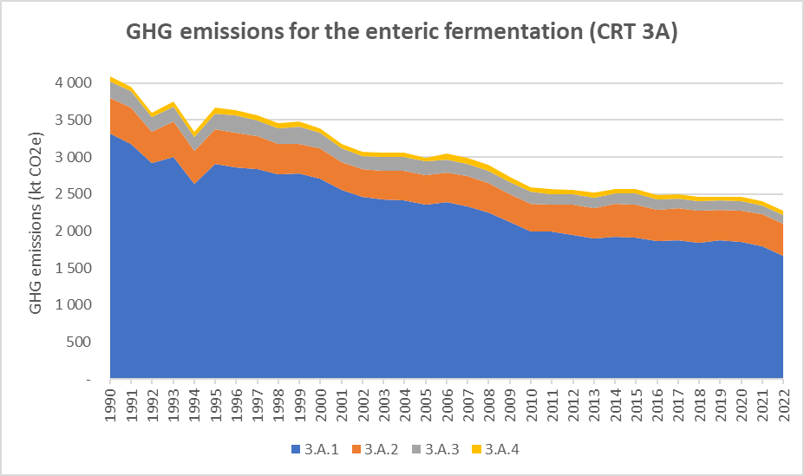
Figure 79: GHG emission trends for the enteric fermentation (CRT 3A), for the period 1990-2022, per subcategory (in kt CO₂e)

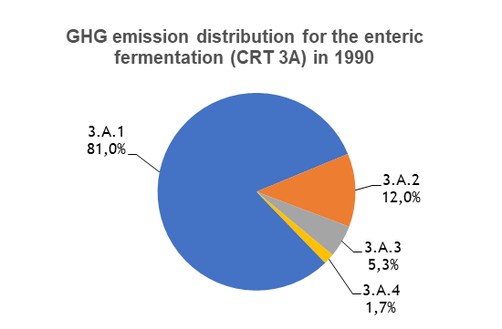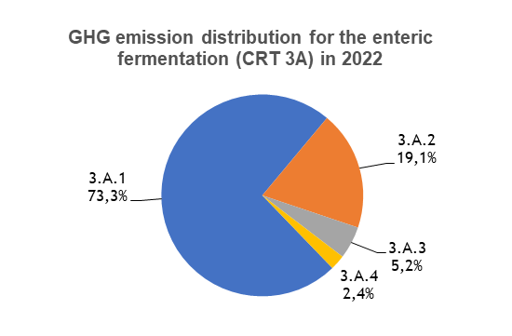
Figure 80: GHG emission distribution for enteric fermentation (CRT 3A), for the period 1990-2022, per subcategory (in %)
The Enteric fermentation (CRT 3A) has decreased its contributions to the total and sectoral GHG emissions. This category contributes to 3.6% of the total GHG emissions excluding LULUCF, in 2022, whereas it represented 4.9% of the national share in 1990. Concerning its part in the Agriculture (CRT 3) sector, in the Republic of Serbia, it is of 47% in 2022, and it was of 63% in 1990.

Cattle (CRT 3A1)

Category description
The enteric fermentation for cattle is subdivided in two subcategories: dairy cattle (CRT 3A1a) and non-dairy cattle (CRT 3A1b). The following graph gives the evolution of the livestock (by number of heads) of these two subcategories. It can be observed that both categories follow a progressive decreasing trend since 1990. The number of dairy cattle has been reduced by 53% over the studied period, and the number of other cattle by 44%.
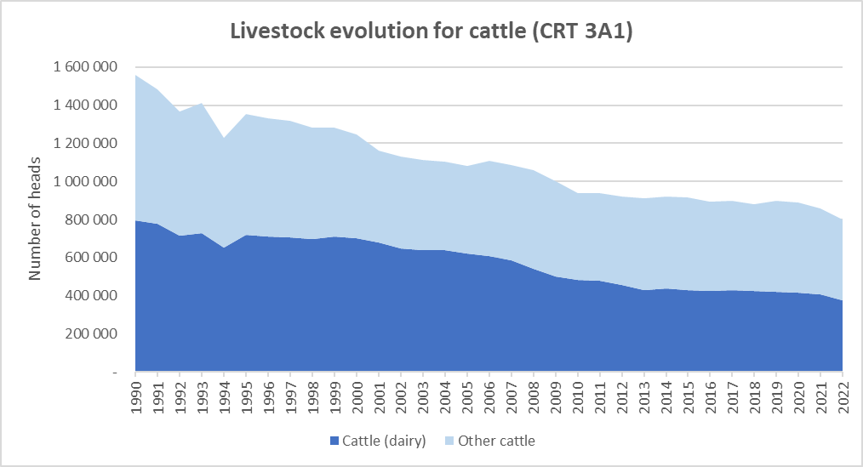
Figure 81 : Livestock evolution for cattle, in number of heads, for the period 1990-2022

The evolution of CH₄ emissions for the CRT 3A1a and 3A1b are proportional to the evolution of the livestock presented in the previous figure as constant default EF are applied over the timeseries.
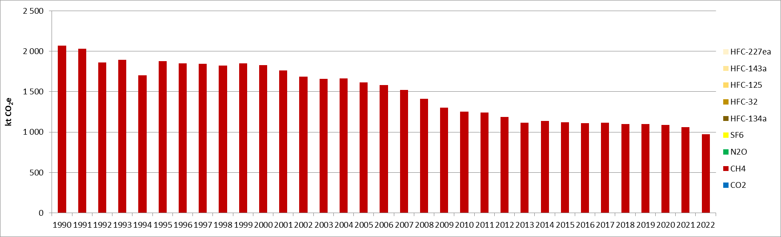
Figure 82 : GHG emissions for enteric fermentation of dairy cattle (CRT 3A1a) (kt CO₂e)

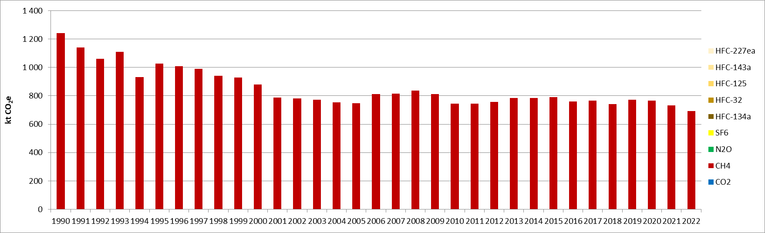
Figure 83 : GHG emissions for enteric fermentation of non-dairy cattle (CRT 3A1b) (kt CO₂e)

In 2022, the CRT 3A1a (dairy cattle) sector is a key category for CH₄ emissions in the Republic of Serbia, both in terms of emission levels and trend. This sector contributes to 1.6% in terms of emissions level (rank 8) and 2.2% in terms of emissions trend (rank 12).
In 2022, the CRT 3A1b (non-dairy cattle) sector is a key category both in emission level (1.1% of total emissions, rank 13) and in emission trend (1.0% of contribution, rank 23).

Methodological issues
Emissions of CH₄ from enteric fermentation are calculated with a Tier 1 approach which is in line with the 2006 IPCC Guidelines [A1].
Activity data used are the annual livestock (average population in heads), for each subcategory. These activity data for the entire time series are taken from the Serbian Statistical Yearbook [A2].
Emission factors used for calculating CH₄ emissions are sourced from 2006 IPCC guidelines [A3]. They are of 93 kg CH₄/head/year for dairy cattle and 58 kg CH₄/head/year for other cattle.

Sheep (CRT 3A2)

Category description
The enteric fermentation for CRT 3A2 is based only on the population of sheep, without further distinction. The population of sheep can be observed to be varying over the timeseries, being rather stable overall although a slight decline of 12% is recorded between 1990 and 2022. The total number of sheep in 2022 is around 1,721,000 heads. Except the sudden decline observed in 1992, a slow progressive reduction is observed until 2002, and after some variations between 2002 and 2011, a slight increase is observed for the period 2011-2022.
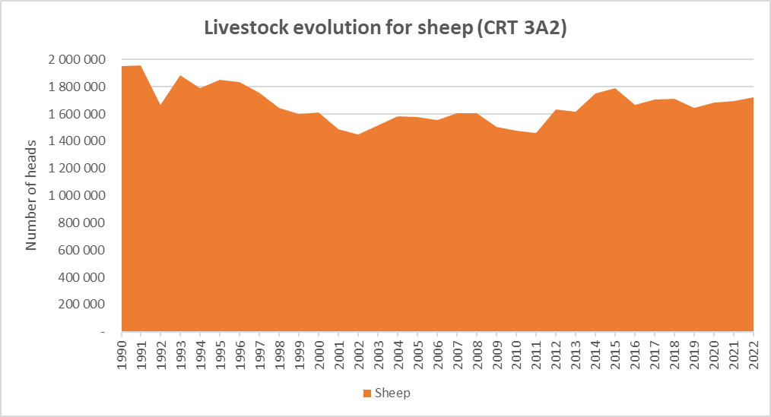
Figure 84 : Livestock evolution for sheep, in number of heads, for the period 1990-2022

The evolutions of CH₄ emissions for the CRT 3A2 are directly proportional to the evolution of the livestock presented in the previous figure.
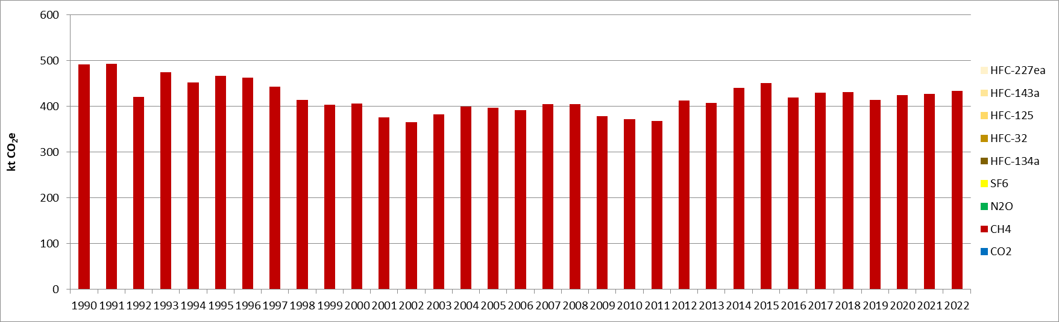
Figure 85 : GHG emissions for enteric fermentation of sheep (CRT 3A2) (kt CO₂e)

In 2022, the CRT 3A2 sector is a key category for CH₄ emissions in the Republic of Serbia, in emission levels but not in emission trend. This sector contributes to 0.7% in terms of emissions level (rank 21).

Methodological issues
Emissions of CH₄ from enteric fermentation are calculated with a Tier 1 approach which is in line with the 2006 IPCC Guidelines [A1].
Activity data used are the annual livestock (average population in heads). These activity data for the entire time series are sourced from the Serbian Statistical Yearbook [A2].
Emission factor used for calculating CH₄ emissions is taken from 2006 IPCC guidelines [A3], is constant over the timeseries and the value is 9 kg CH₄/head/year.

Swine (3A3)

Category description
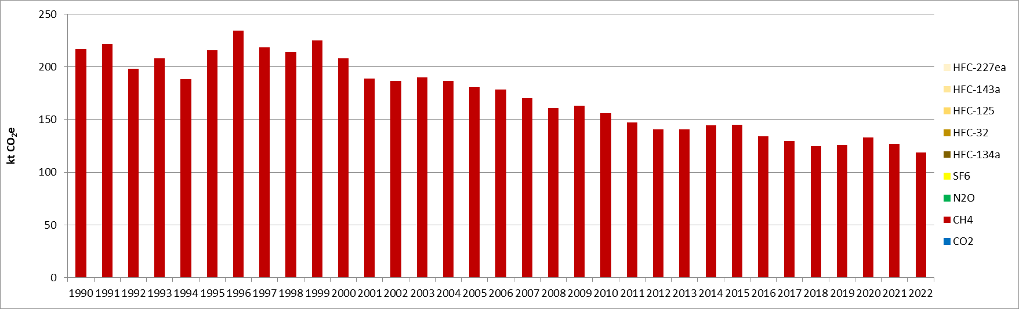
Figure 86 : GHG emissions for enteric fermentation of swine (CRT 3A3) (kt CO₂e)

In 2022, the category CRT 3A3 is neither a key category in terms of emission level nor in terms of emission trend, for GHG emissions, in the Republic of Serbia.

Methodological issues
Emissions of CH₄ from enteric fermentation are calculated with a Tier 1 approach which is in line with the 2006 IPCC Guidelines [A1].
Activity data used are the annual livestock (average population in heads). These activity data for the entire time series are taken from the Serbian Statistical Yearbook [A2].
Emission factors used for calculating CH₄ emissions are sourced from 2006 IPCC guidelines [A3], are equal for fattening pigs and sows, and the value is 1.5 kg CH₄/head/year.

Other livestock (3A4)

Category description
The enteric fermentation for other livestock is subdivided in two subcategories: horses and goats. The following graph gives the evolution of the livestock (by number of heads) of these two species. The number of horses has reduced significantly for the period 1990-2022, by 77%, and is rather marginal in the total livestock of this category, in number, with 24% of the share in 1990 and only 6% in 2022. On contrary, the number of goats has increased by 12% between 1990 and 2022.
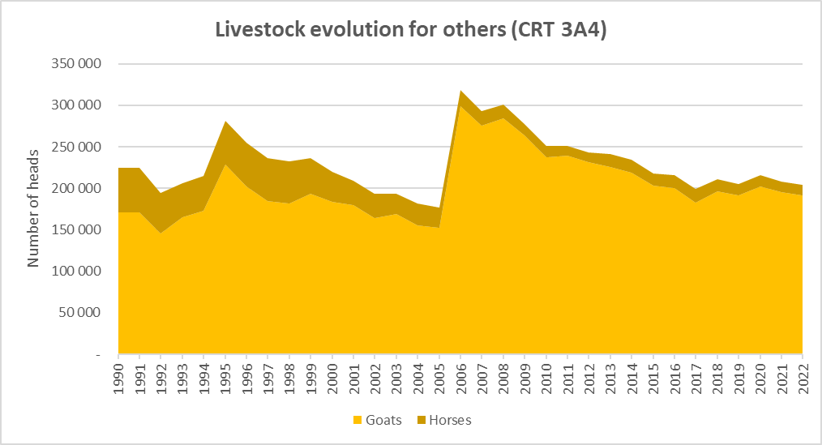
Figure 87 : Livestock evolution for other livestock, in number of heads, for the period 1990-2022
The evolutions of CH₄ emissions for this sector are proportional to the evolution of the livestock presented in the previous figure, as constant default EFs are applied over the timeseries. The emissions related to the enteric formation of horses are twice as much important by head than for goats. As a consequence, the sectoral emissions decrease faster (-22%) than the total livestock (-9%), over the studied period, but follow a similar trend.
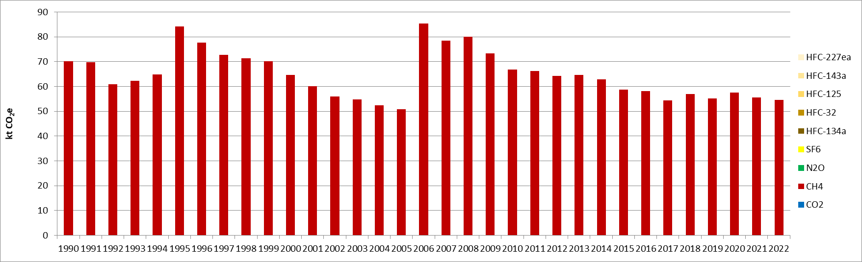
Figure 88 : GHG emissions for enteric fermentation of other livestock (CRT 3A4) (kt CO₂e)

In 2022, the category CRT 3A4 is neither a key category in terms of emission level nor in trend for GHG emissions in the Republic of Serbia.
To be noted: there is no CH₄ emissions from enteric fermentation from poultry.

Methodological issues
Emissions of GHG from enteric fermentation are calculated with a Tier 1 approach which is in line with the 2006 IPCC Guidelines [A1].
Activity data used are the annual livestock (average population in heads), for goats and horses. These activity data for the entire time series are taken from the Serbian Statistical Yearbook [A2].
Emission factors used for calculating CH₄ emissions are sourced from 2006 IPCC guidelines [A3], are constant over the timeseries and equal to 18 kg CH₄/head/year for horses and 9 kg CH₄/head/year for goats.

Uncertainties and time-series consistency
Uncertainty estimate associated with activity data amounts to 20%, based on 2006 IPCC Guidelines (Volume 4, Chapter 10, Section 10.2.3).
Uncertainty estimate associated with CH₄ emission factor amounts to 40%, also based on 2006 IPCC Guidelines (Volume 4, Chapter 10, Section 10.3.4).
The uncertainty combined for CH₄ emissions is 1.6% in the total national levels of emission in 2022, excluding LULUCF contribution. This makes it the 2nd highest sector contributing to the overall national uncertainty in GHG emissions, after the methane emissions from solid waste disposal on land (CRT 5A).

Category-specific QA/QC and verification
During the preparation of the inventory submission, activities related to quality control were mainly focused on completeness and consistency of emission estimates, and on proper use of notation keys in the CRT tables.

Category-specific recalculations
The current report is the first National Inventory Document for Serbia. Consequently, there is no recalculation. Possible recalculation will occur and be estimated in the next submission if necessary.

Category-specific planned improvements
For enteric fermentation, in the current inventory, the methodology used is the Tier 1. An improvement could be to launch a research project, look for publications to implement a Tier 2 method. A Tier 2 method involves the use of a lot of new parameters, among other the average gross energy intake, the average CH₄ conversion rate. This is a consequent improvement regarding the efforts, time, and research required.
Another significant improvement will be to move the emission estimation to the 2019 IPCC refinement.

Manure management (CRT 3B)
The manure management category covers the emissions of CH₄ (CRT 3B1) and N₂O (CRT 3B2) from the different livestock: cattle (CRT 3B1.1 and 3B2.1), sheep (CRT 3B12 and 3B22), swine (CRT 3B1.3 and 3B23.) and others (CRT 3B14 and 3B24), including goats, horses and poultry. For the categories related to cattle, a distinction is made between dairy cattle and other cattle. The swine category is separated between fattening pigs and sows. Finally, among the Other category, the poultry are distinguished among several animal species: layers, broilers, turkeys and others. The emissions related to poultry that are estimated in the manure management, and are rather negligible.
The following graph describes the evolution of the emissions of GHG, in equivalent CO₂, with details given by animal categories. In general, it can be observed that the GHG emissions from the manure management decrease progressively throughout the timeseries. In 2022, the achieved reduction for the sector is of 42%, compared with the emission levels from 1990. Both the emissions of CH₄ and N₂O have been reduced, at different rates, by 38% and 47%, respectively, over the same period. The share between the CH₄ and N₂O emissions is rather constant over the timeseries and, in 2022, methane represents 60% of the sector emissions. In the light of the fall in livestock, all emissions from the subcategories of the CRT 3B are in decline between 1990 and 2022.
The GHG emissions of the manure management are well distributed among several categories. The CH₄ emissions from manure management of swine (CRT 3B13) are the main source of emissions, representing about 32% of the sector emissions in 2022, and was at 31% in 1990, although a 39% drop for the period. Among the swine category, the manure management of fattening pigs is more important than the one for sows, representing 76% of the emissions of this subcategory in 2022. This is in particular due to the fact that the number of fattening pigs is much bigger and represents 84% of the swine livestock in 2022. In addition, the second most contributing sector in 2022 is the CH₄ emissions from manure management of cattle (CRT 3B1.1), which contributes to 21% of the sector emissions. Then, the N₂O emissions from manure management of swine (CRT 3B2.3) and cattle (CRT 3B2.1) are respectively the 3rd and 4th biggest contributing categories, with respective shares of 18.5% and 16.8%. In 1990, the shares of the N₂O emissions from swine and cattle and of the CH₄ emissions from cattle were slightly more equal with about 20% each, but the N₂O emissions have been reduced at a faster rate than the CH₄ emissions for both these two animal categories. The emissions from the sheep and other livestock are not negligible and represent about 11% of the sector totals in 2022, which is in slight progression compared with 1990, in particular related to manure management from poultry.
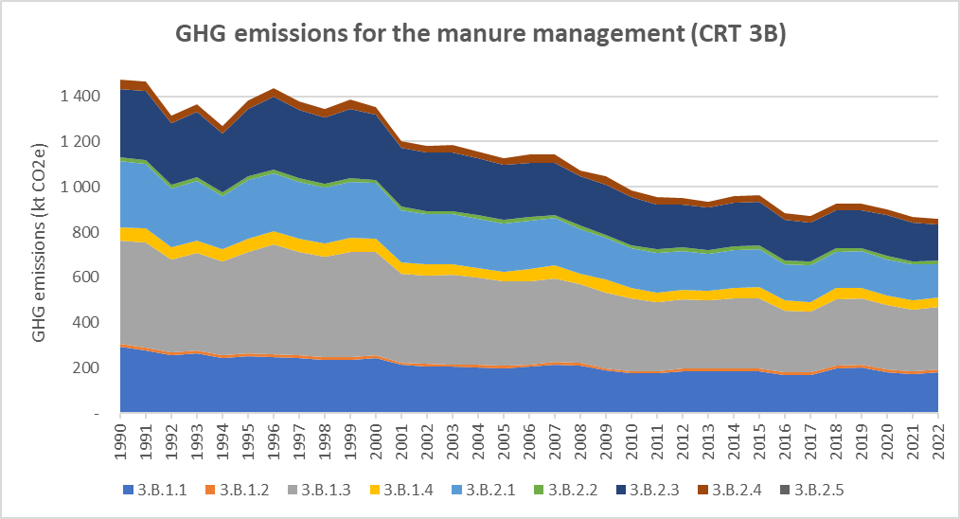
Figure 89: GHG emission trends for manure management (CRT 3B), for the period 1990-2022, per subcategory (in kt CO₂e)

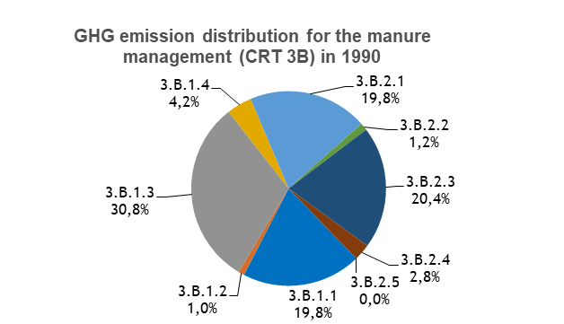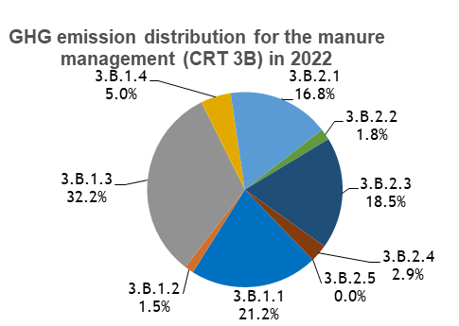
Figure 90: GHG emission distribution for manure management (CRT 3B), for the period 1990-2022, per subcategory (in %)
The emissions from Manure management (CRT 3B) have a slightly decreasing but rather constant share of the total and sectoral GHG emissions in 2022, compared with 1990. This category contributes to 1.4% of the total GHG emissions excluding LULUCF, in 2022, whereas it represented 1.8% of the national share in 1990. Concerning its share in the Agriculture (CRT 3) sector, in the Republic of Serbia, it went from 23% in 1990 to 18% in 2022.

CH₄ emissions from Manure management (CRT 3B1)

Category description
Methane emissions from Manure management are subdivided among the different livestock (cattle, sheep, swine, and others).
In addition of the graphs of the evolution of the different livestock categories already presented throughout Chapters 5.2.1 to 5.2.4, the evolution of the livestock of poultry, which impacts the CRT 3B14 Other livestock emissions, is presented in the following figure. The two main subcategories of poultry are layers and broilers, which represent 99% of the whole livestock of poultry in 2022. The population of broilers varies quite significantly throughout the timeseries, but is rather stable in number of heads for 1990 and 2022, with a small increase of 8%. However, the population of layers varies also for the studied period but a progressive decline is observed, until achieving an overall reduction of 41% in 2022. Thus, although the important reductions of the population of turkeys (-72%) and others (-78%), the livestock of poultry globally decreases by 24% over the period 1990-2022.
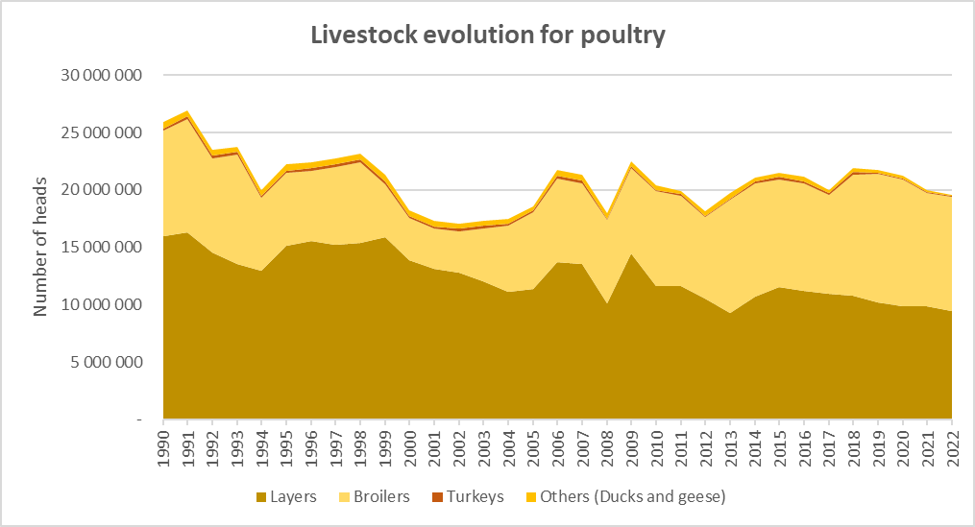
Figure 91 : Livestock evolution for poultry, in number of heads, for the period 1990-2022, per different animal species
The methane emissions associated with the manure management of dairy cattle, other cattle and sheep evolve in direct relation with the evolution of their respective livestock population presented in the previous section. In addition, the EF from dairy cattle increases by 7% between 1990 and 2022, whereas the one from other cattle increases by 28% (see Table 26 and Table 27). The evolution of the CH₄ EF is due to the evolution in the methane conversion factors (MCFs), in relation with the evolution of the average annual temperature, which varies but has globally increased, and by 17% between 1990 and 2022. Thus, the methane emissions from these two categories are being reduced at a slightly slower rate than the livestock, respectively by 50% (versus 53% for the dairy cattle population) and by 29% (versus 44% for the population of other cattle). For sheep, the EF considered for the manure management is constant over the timeseries and therefore the emission evolution is directly proportional to the livestock evolution (-12% for the same period).
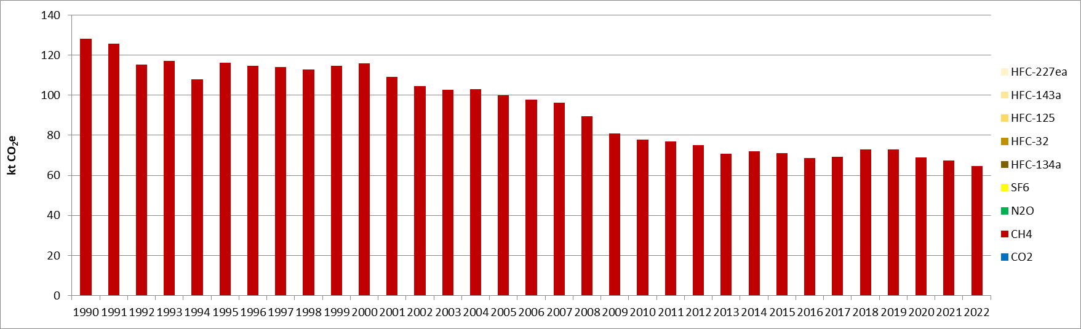
Figure 92 : CH₄ emissions for manure management of dairy cattle (CRT 3B11a) (kt CO₂e)
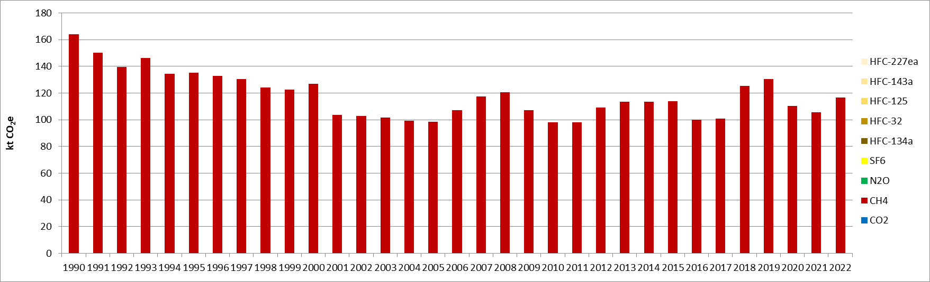
Figure 93 : CH₄ emissions for manure management of non-dairy cattle (CRT 3B11b) (kt CO₂e)

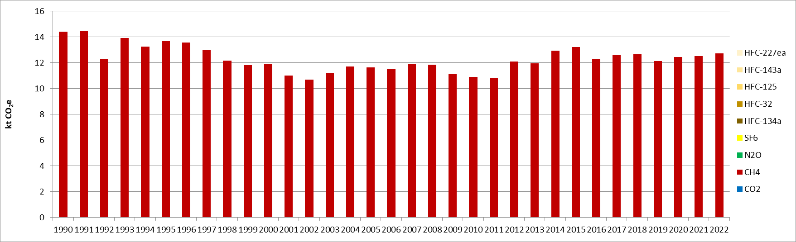
Figure 94 : CH₄ emissions for manure management of sheep (CRT 3B12) (kt CO₂e)
The methane emissions from the swine manure management evolve according to the evolution of the livestock of fattening pigs and sows, as well as the evolution of the EF. The later varies depending on the MCFs, and hence on the annual average temperature, which increased by 17% for the period 1990-2022. Overall, both EF from fattening pigs and sows increased by 15% for the studied period (see Table 26 and Table 27). All things combined, the methane emissions from these two categories have been reduced by 33% for fattening pigs (versus 41% for their population) and by 53% (versus 60% for their population). In total, considering the fact that the fattening pigs are more predominant in the swine livestock and represent 84% of the overall population in 2022, but the emission factor is 67% higher for sows than for fattening pigs, the emissions from the CRT 3B13 have been reduced by 39% over the timeseries.
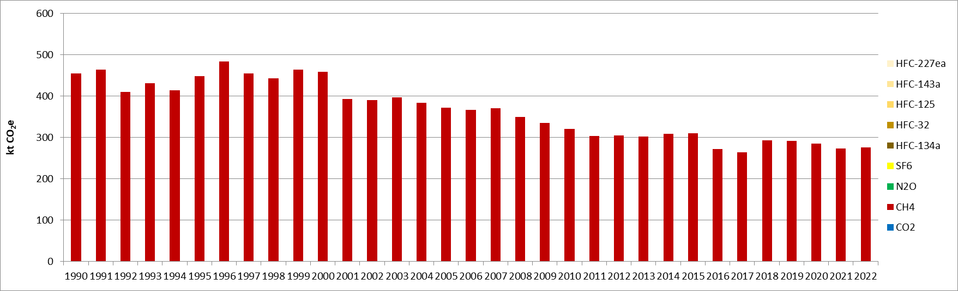
Figure 95 : CH4 emissions for manure management of swine (CRT 3B13) (kt CO₂e)
The methane emissions for the manure management of other livestock evolve depending on the evolution of the different livestock (goats, horses and poultry) and of the EF. The emissions related to manure management of horses and goats are rather marginal in the total of the category and represent less than 3% over the timeseries. Among the poultry livestock, the layers represent the most important share of emissions with 91% in 2022. The EF from the layers varies depending on the MCFs over the timeseries, which evolves according to the average annual temperature, and increases by 16% for the period 1990-2022 (see Table 26 and Table 27). The EF from the other poultry species (broilers, turkeys and others) are all constant over the timeseries. In total, the emissions from the CRT 3.B.1.4 have been reduced by 30% between 1990 and 2022.
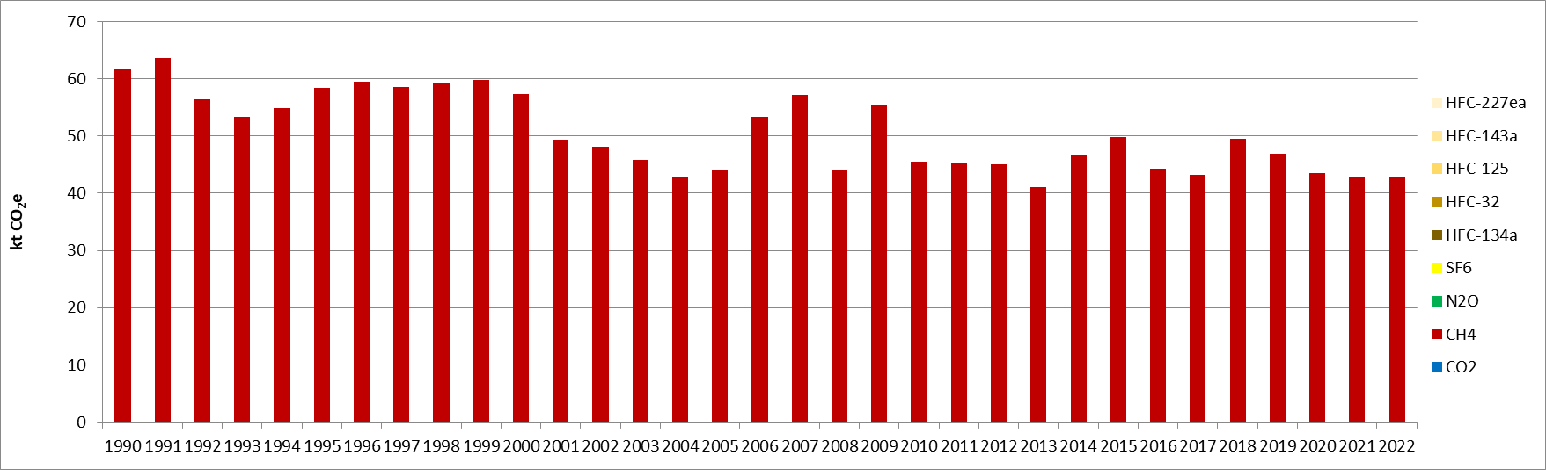
Figure 96 : CH4 emissions for manure management of other livestock (CRT 3B14) (kt CO₂e)

In 2022, none CRT 3B1 subcategories (CRT 3B11a, CRT 3B11b, CRT 3B12, CRT 3B13, CRT 3B14) are key categories in terms of emission level or trend, in the Republic of Serbia.

Methodological issues
Emissions of CH₄ from manure management are calculated with a Tier 2 approach, which is in line with the 2006 IPCC Guidelines [A4].
Activity data used are the annual livestock (average population in heads), for all different subcategories presented above. These activity data for the entire time series are sourced from the Serbian Statistical Yearbook [A2]. The activity data are then split by manure management system based on the 2019 IPCC Guidelines default values [A20]. Emissions factors used for calculating CH₄ emissions are taken from the Tier 2 from 2006 IPCC guidelines [A6]. The methane conversion factors (MCFs) vary depending on the average annual temperature, which is taken from the Copernicus website, and evolves as presented in the following figure. Considering the range of temperatures, the climate is considered to be cool. All other parameters are taken as default from the IPCC guidelines and are recalled in the following tables (the Bo values, the excretion rates VS, and the fractions of manure management system used per livestock category).
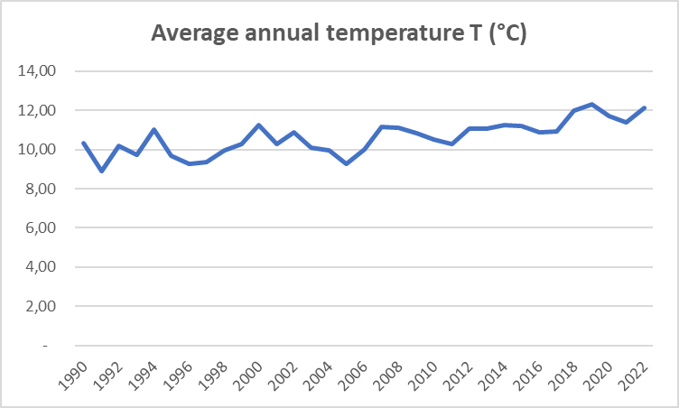
Figure 97 : Evolution of the average annual temperature, in the Republic of Serbia, for the period 1990-2022 (in °C)

Table 22: Fraction of livestock category’s manure handled by each manure management system (in %), from 2019 IPCC Guidelines, used in Serbian inventory
Livestock category | MS lagoon  (%) | MS liquid/ slurry (%) | MS solid storage (%) | MS dry lot  (%) | MS pasture range (%)
Dairy cattle | - | 5% | 74% | - | 20%
Other cattle | - | 64% | 5% | - | 31%
Sheep | - | - | 42% | - | 58%
Fattening pigs | 5% | 31% | 55% | 1% | -
Sows | 5% | 31% | 55% | 1% | -
Goats | - | - | 9% | - | 91%
Horses | - | - | - | - | 50%
Layers | - | - | - | 47% | -
Broilers | - | - | - | - | -
Turkeys | - | - | - | - | -
Other poultry | - | - | - | - | -
Livestock category | MS pit < 1 month (%) | MS pit > 1 month (%) | MS daily spread (%) | MS poultry with litter (%) | MS other  (%)
Dairy cattle | - | - | 1% | - | -
Other cattle | - | - | - | - | -
Sheep | - | - | - | - | -
Fattening pigs | 4% | 4% | - | - | -
Sows | 4% | 4% | - | - | -
Goats | - | - | - | - | -
Horses | - | - | 50% | - | -
Layers | - | 34% | - | 19% | -
Broilers | - | - | - | 100% | -
Turkeys | - | - | - | 100% | -
Other poultry | - | - | - | 100% | -
Table 23: Methane conversion factors per manure management system (in %), depending on the average annual temperature, from 2006 IPCC Guidelines, used in Serbian inventory
Manure management system | T=10°C | T=11°C | T=12°C | T=13°C | T=14°C
Lagoon | 66% | 68% | 70% | 71% | 73%
Liquid/Slurry | 10% | 11% | 13% | 14% | 15%
Solid storage | 2% | 2% | 2% | 2% | 2%
Dry lot | 1% | 1% | 1% | 1% | 1%
Pasture/range | 1% | 1% | 1% | 1% | 1%
Pit < 1 month | 3% | 3% | 3% | 3% | 3%
Pit > 1 month | 17% | 19% | 20% | 22% | 25%
Daily spread | 0.1% | 0.1% | 0.1% | 0.1% | 0.1%
Poultry manure with litter | 1.5% | 1.5% | 1.5% | 1.5% | 1.5%
Table 24: Daily volatile solid excreted VS, for each livestock category (in kg dry matter/animal/day), from 2006 IPCC Guidelines, used in Serbian inventory
Livestock category | VS (kg/animal/day)
Dairy cattle | 4.5
Other cattle | 2.7
Sheep | 0.4
Fattening pigs | 0.3
Sows | 0.5
Goats | 0.3
Horses | 2.13
Layers | 0.02
Broilers | 0.01
Turkeys | 0.07
Other poultry | 0.02
Table 25: Maximum methane producing capacities for manure produced by each livestock category (“Bo values”) (in m³ CH₄/kg of VS excreted), from 2006 IPCC Guidelines, used in Serbian inventory
Livestock category | Bo (m³/kg of VS)
Dairy cattle | 0.24
Other cattle | 0.17
Sheep | 0.19
Fattening pigs | 0.45
Sows | 0.45
Goats | 0.18
Horses | 0.3
Layers | 0.39
Broilers | 0.36
Turkeys | 0.36
Other poultry | 0.36

All elements combined, the methane emission factors for manure management evolve as follows:
Table 26: Manure management CH₄ EF (in kg/head), per livestock category, for the period 1990-2015, every 5 years
Livestock category | 1990 | 1995 | 2000 | 2005 | 2010 | 2015
Dairy cattle | 5,76 | 5,76 | 5,89 | 5,76 | 5,76 | 5,89
Other cattle | 7,64 | 7,64 | 8,36 | 7,64 | 7,64 | 8,36
Sheep | 0,26 | 0,26 | 0,26 | 0,26 | 0,26 | 0,26
Fattening pigs | 2,74 | 2,74 | 2,91 | 2,74 | 2,74 | 2,91
Sows | 4,57 | 4,57 | 4,84 | 4,57 | 4,57 | 4,84
Goats | 0,14 | 0,14 | 0,14 | 0,14 | 0,14 | 0,14
Horses | 0,86 | 0,86 | 0,86 | 0,86 | 0,86 | 0,86
Layers | 0,12 | 0,12 | 0,14 | 0,12 | 0,12 | 0,14
Broilers | 0,01 | 0,01 | 0,01 | 0,01 | 0,01 | 0,01
Turkeys | 0,09 | 0,09 | 0,09 | 0,09 | 0,09 | 0,09
Other poultry | 0,03 | 0,03 | 0,03 | 0,03 | 0,03 | 0,03
Table 27: Manure management CH₄ EF (in kg/head), per livestock category, for the period 2016-2022
Livestock category | 2016 | 2017 | 2018 | 2019 | 2020 | 2021 | 2022
Dairy cattle | 5.76 | 5.76 | 6.16 | 6.16 | 5.89 | 5.89 | 6.16
Other cattle | 7.64 | 7.64 | 9.80 | 9.80 | 8.36 | 8.36 | 9.80
Sheep | 0.26 | 0.26 | 0.26 | 0.26 | 0.26 | 0.26 | 0.26
Fattening pigs | 2.74 | 2.74 | 3.16 | 3.16 | 2.91 | 2.91 | 3.16
Sows | 4.57 | 4.57 | 5.26 | 5.26 | 4.84 | 4.84 | 5.26
Goats | 0.14 | 0.14 | 0.14 | 0.14 | 0.14 | 0.14 | 0.14
Horses | 0.86 | 0.86 | 0.86 | 0.86 | 0.86 | 0.86 | 0.86
Layers | 0.12 | 0.12 | 0.14 | 0.14 | 0.14 | 0.14 | 0.14
Broilers | 0.01 | 0.01 | 0.01 | 0.01 | 0.01 | 0.01 | 0.01
Turkeys | 0.09 | 0.09 | 0.09 | 0.09 | 0.09 | 0.09 | 0.09
Other poultry | 0.03 | 0.03 | 0.03 | 0.03 | 0.03 | 0.03 | 0.03

N₂O emissions from manure management (CRT 3B2)

Category description
Nitrous dioxide emissions from Manure management are subdivided by type of livestock (cattle, sheep, swine, other livestock). There is an extra CRT category (CRT 3B25) in which indirect N₂O emissions from volatilisation and leaching are reported. However, in a Tier 1 methodology, as used in the Serbian inventory for this category, indirect N₂O emissions from leaching and run-off from manure management are not estimated, according to the IPCC guidelines.
The direct emissions of N₂O from manure management are estimated based on a Tier 1 methodology, and the EF applied for each livestock category are constant over the timeseries (see chapter 5.3.2.2). Hence, the emissions for the CRT 3B21a, 3B21b and 3B22 are all directly proportional to the livestock and vary based on their evolution, as presented in the various graphs about the livestock in chapter 5.2.
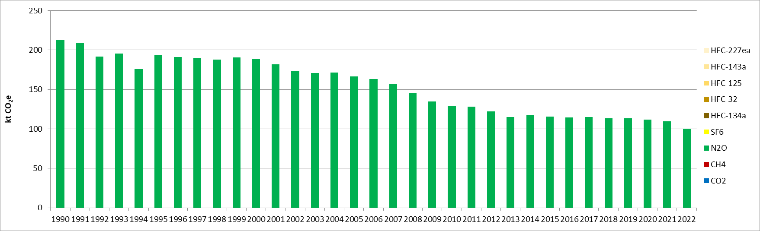
Figure 98 : N₂O emissions for manure management of dairy cattle (CRT 3B21a) (kt CO₂e)

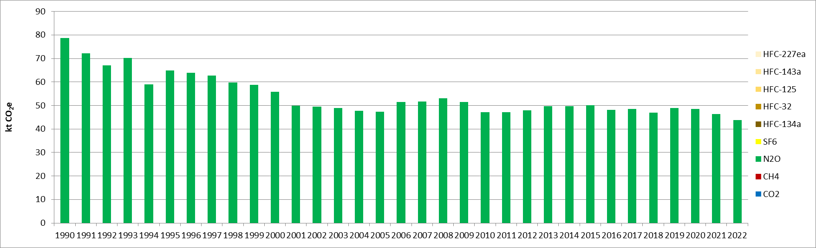
Figure 99 : N₂O emissions for manure management of non-dairy cattle (CRT 3B21b) (kt CO₂e)
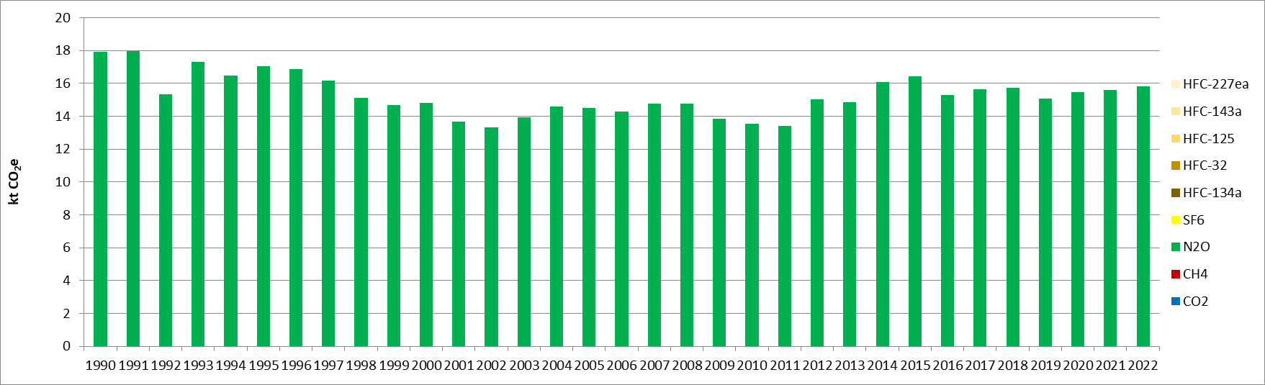
Figure 100 : N₂O emissions for manure management of sheep (CRT 3B22) (kt CO₂e)
For manure management from swine, the emissions evolve according to the variation of the livestock, as well as the share of livestock between fattening pigs and sows, considering the fact that the EF for sows is 62% higher than for fattening pigs (see chapter 5.3.2.2). However, as the population of fattening pigs is larger, the emissions related to this livestock contribute to 69% of the share in 1990 and 76% in 2022. Overall, the emissions from this category have been reduced by 47% for the period 1990-2022.
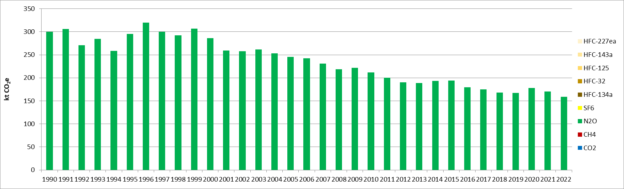
Figure 101 : N₂O emissions for manure management of swine (CRT 3B23) (kt CO₂e)
For the other livestock (i.e., horses, goats, poultry), the emission evolve depending on the population evolution of each animal category, as well as the manure produced by each of them. And, for the emissions related to manure management of other livestock, layers are predominant with 94% of the share in 1990 and 90% in 2022. Thus, the emissions from this category evolve principally in relation with the evolution of the population of layers, as presented in Figure 91.
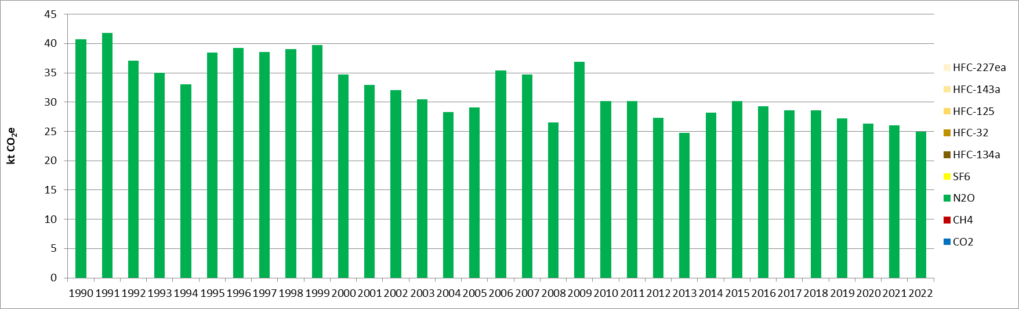
Figure 102 : N₂O emissions for manure management of other livestocks (CRT 3B24) (kt CO₂e)

The indirect N₂O emissions from volatilisation are mainly driven by cattle and pigs subcategories, as these animals produce around 85% of the N volatilised as NH₃ and NOx (building and storage) for the whole period.
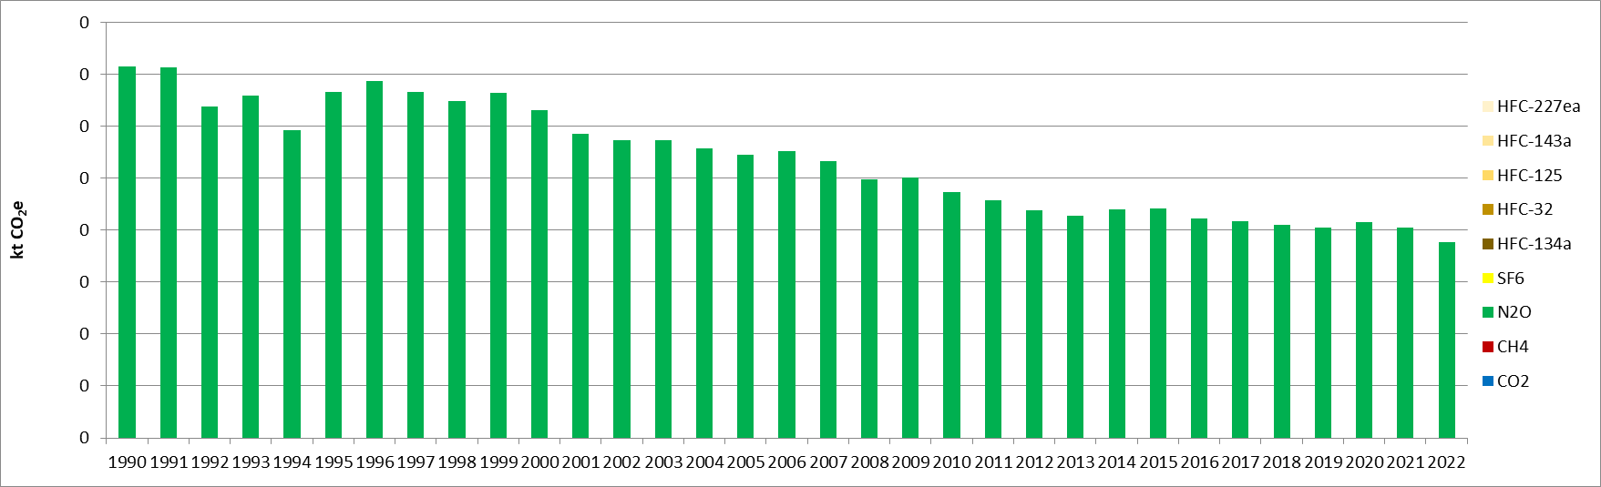
Figure 103 : Indirect N₂O emissions from volatilisation and leaching in manure management (CRT 3B25) (kt CO₂e)

In 2022, only N₂O emissions from manure management for swine (CRT 3B23) is a key category in emission level in the Republic of Serbia, contributing to 0.3% (rank 38) in the national totals. If the emissions from cattle were considered aggregating dairy and other cattle, it would also be a key category in emission level.
In terms of emission trend, in 2022, the N₂O emissions from manure management of swine (CRT 3B23) and dairy cattle (CRT 3B21a) are key categories, contributing respectively to 0.3% (rank 54) and 0.2% (rank 56) in the national totals.

Methodological issues
Emissions of N₂O from manure management are calculated with a Tier 1 approach which is in line with the 2006 IPCC Guidelines [A7].
Activity data used are annual livestock (average population in heads). These activity data for the entire time series are sourced from the Serbian Statistical Yearbook [A2]. The activity data are then split by manure management system and also consider the typical mass of each type of livestock based on the 2019 IPCC Guidelines default values [A20].
Emissions factors and all parameters used for calculating N₂O emissions are based on the 2019 IPCC guidelines [A20]. The values used are presented in the following tables. The fraction of manure management system used per livestock category are the same as the ones used for the methane emissions, presented in Table 22.
Table 28: Typical animal mass per livestock category (in kg/animal), from 2019 IPCC Guidelines, used in Serbian inventory
Livestock category | TAM (kg/animal)
Dairy cattle | 550
Other cattle | 389
Sheep | 40
Fattening pigs | 59
Sows | 204
Goats | 36
Horses | 377
Layers | 1.9
Broilers | 1.1
Turkeys | 6.8
Other poultry | 2.7
Table 29: Daily N excretion rate per animal (in kg N/t animal/day), from 2019 IPCC Guidelines, used in Serbian inventory
Livestock category | Nrate (kg N/t animal/day)
Dairy cattle | 0.42
Other cattle | 0.47
Sheep | 0.36
Fattening pigs | 0.77
Sows | 0.36
Goats | 0.44
Horses | 0.30
Layers | 0.81
Broilers | 1.12
Turkeys | 0.74
Other poultry | 0.83
Table 30: N₂O EF per manure management system (in kg N₂O-N/kg Nex) from 2019 IPCC Guidelines, used in Serbian inventory
Manure management system | EF (kg N₂O-N/kg Nex)
Lagoon | 0
Liquid/Slurry | 0.005
Solid storage | 0.01
Dry lot | 0.02
Pasture/range | -
Pit < 1 month | 0.002
Pit > 1 month | 0.002
Daily spread | 0
Poultry manure with litter | 0.001

The resulting EF for direct emissions of N₂O are as follows, for each livestock category:
Table 31: N₂O Emission factor for direct emissions from manure management (CRT 3B2) used in Serbian inventory
Livestock category | EF N₂O (kg/animal)
Dairy cattle | 1.01
Other cattle | 0.39
Sheep | 0.03
Fattening pigs | 0.19
Sows | 0.31
Goats | 0.008
Horses | 0
Layers | 0.009
Broilers | 0.0007
Turkeys | 0.003
Other poultry | 0.0013

Indirect emissions of N₂O from volatilization and leaching in manure management are calculated with a Tier 1 approach which is in line with the 2006 IPCC Guidelines [A4].
For indirect N₂O emission from volatilization, the activity data are the N volatilized as NH₃ and NOx. Relevant NH₃ and NOx emissions are taken from the pollutants inventory produced by Serbia for the CLRTAP. The emission factor applied comes from the 2006 IPCC guidelines [A9].

Uncertainties and time-series consistency
CH₄
Uncertainty estimate associated with activity data amounts to 20%, based on 2006 IPCC Guidelines (Volume 4, Chapter 10, Section 10.2.3).
Uncertainty estimate associated with CH₄ emission factor amounts to 30%, also based on 2006 IPCC Guidelines (Volume 4, Chapter 10, Section 10.4.4).
The uncertainty combined for emissions is 0.3% in the total national levels of emission in 2022, excluding LULUCF contribution.
N₂O
Uncertainty estimate associated with activity data amounts to 20%, based on 2006 IPCC Guidelines (Volume 4, Chapter 10, Section 10.2.3).
Uncertainty estimate associated with CH4 emission factor amounts to 50%, also based on 2006 IPCC Guidelines (Volume 4, Chapter 10, Section 10.5.5).
Combined uncertainty for emissions is 0.3% in the total national levels of emission in 2022, excluding LULUCF contribution.

Category-specific QA/QC and verification
During the preparation of the inventory submission, activities related to quality control were mainly focused on completeness and consistency of emission estimates, and on proper use of notation keys in the CRT tables.

Category-specific recalculations
The current report is the first National Inventory Document for Serbia. Consequently, there is no recalculation. Possible recalculation will be occurred and estimated in the next submission if necessary.

Category-specific planned improvements
Currently, the estimation of CH₄ and N₂O emissions from manure management mobilize many default parameters from the IPCC. An important improvement would be to move to national specific parameters to better reflect national circumstances.
Another significant improvement will be to move the emission estimation to the 2019 IPCC refinement.

Agricultural soils (CRT 3D)
The agricultural soils category covers the direct (3D1) and indirect (3D2) emissions of N₂O. For direct emissions, the following emission sources are covered in the Serbian inventory:
- Application of inorganic N fertilisers (CRT 3D1.1),
- Application of animal manure (CRT 3D1.2.a),
- Urine and dung deposited by grazing animals (CRT 3D1.3),
- Crop residues (CRT 3D1.4),
- Cultivation of organic soils (CRT 3D1.6).
Emissions related to the application of sewage sludge (CRT 3D12b), other organic fertilisers (CRT 3D1.2.c), mineralization/ immobilization associated with loss/gain of soil organic matter (CRT 3D15), are all considered as “not occurring” (NO).
For indirect emissions, the emissions are distinguished between the atmospheric deposition (CRT 3D21) and the nitrogen leaching and run-off (CRT 3D2.2).
For the period 1990-2022, the emissions of the CRT 3D category vary significantly and, after having peaked in 2009, follow a global decline since then. Overall, the emissions have increased by 71% over the studied period. From 2000 onwards, the emissions vary in particular in relation with the change in the amounts of inorganic fertilisers applied to the soils. Indeed, in 2022, the CRT 3D1.1 is the most important emission source, contributing to 44% to the sectoral emissions, whereas it was way less predominant in 1990 with 11%. This is due to an important increase in the use of inorganic fertilisers, whereas other important emissions sources such as crop residues (CRT 3D1.4) remained stable or decreased, such as the application of animal manure (CRT 3D1.2.a). The two other important categories of this sector are the CRT 3D1.4, which contributed to 33% in 1990 and 20% in 2022, and the indirect emissions from leaching and run-off (CRT 3D2.2) which as a rather stable to 20-21%.
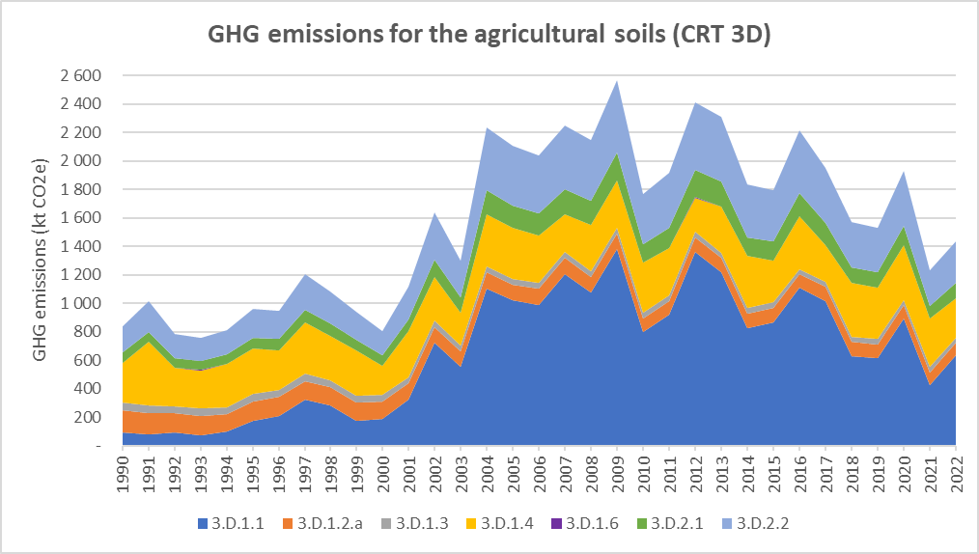
Figure 104: GHG emission trends for agricultural soils (CRT 3D), for the period 1990-2022, per subcategory (in kt CO₂e)
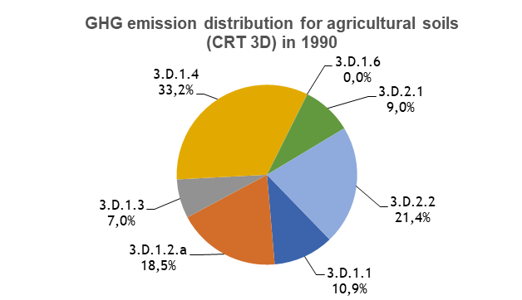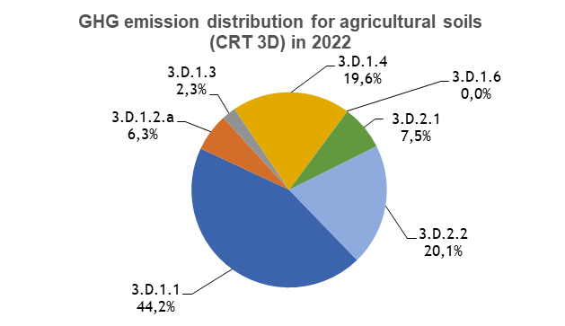
Figure 105: GHG emission distribution for agricultural soils (CRT 3D), for the period 1990-2022, per subcategory (in %)
The share of GHG emissions of the Agricultural soils (CRT 3D) category in the national totals, excluding LULUCF, has increased from 1.0% in 1990 to 2.3% in 2022. Concerning its contribution in the Agriculture (CRT 3) sector, in the Republic of Serbia, it increased from 13% in 1990 to 29% in 2022. In terms of N₂O emissions, this sector represents more than 65% of the national emissions in 2022, whereas its share was only of 34% in 1990.

Direct N₂O emissions from managed soils (CRT 3D1)

Category description
The activity data considered for the direct N₂O emissions from agricultural soils evolve as follows:
Table 32: Activity data for direct N₂O emissions from agricultural soils (3D1), for the period 1990-2010, every 5 years
Management system | 1990 | 1995 | 2000 | 2005 | 2010
Inorganic fertilizers  (kg N) | 21,781,776 | 40,740,000 | 45,101,000 | 245,487,662 | 191,248,900
Animal manure applied to soils (kg N) | 37,189,925 | 33,171,550 | 29,716,000 | 26,089,769 | 23,634,764
Urine and dung deposited by cattle, poultry and pigs (kg N) | 29,234,787 | 25,232,239 | 23,084,754 | 19,969,635 | 17,602,710
Urine and dung deposited by sheep and others (kg N) | 7,955,138 | 7,939,311 | 6,631,246 | 6,120,134 | 6,032,054
Crop residues (kg N) | 66,613,208 | 77,220,224 | 48,779,955 | 85,302,693 | 84,458,050
Managed/drained organic soils (ha) | 88 | 88 | 88 | 88 | 88

Table 33: Activity data for direct N₂O emissions from agricultural soils (3D1), for 2015 and 2019-2022
Management system | 2015 | 2019 | 2020 | 2021 | 2022
Inorganic fertilizers (kg N) | 208,354,610 | 147,451,663 | 213,373,773 | 101,021,198 | 151,994,841
Animal manure applied to soils (kg N) | 24,161,257 | 23,259,414 | 23,245,750 | 22,678,425 | 21,624,571
Urine and dung deposited by cattle, poultry and pigs (kg N) | 17,325,763 | 16,964,753 | 16,775,549 | 16,221,214 | 15,115,527
Urine and dung deposited by sheep and others (kg N) | 6,835,493 | 6,294,662 | 6,470,201 | 6,457,211 | 6,509,044
Crop residues (kg N) | 69,780,682 | 87,247,786 | 92,001,374 | 82,071,115 | 67,300,966
Managed/drained organic soils (ha) | 88 | 88 | 88 | 88 | 88
In short, the noticeable change in activity data is accounted for the application of inorganic N-fertilisers where a drastic increase is observed, and the overall growth for the period 1990-2022 is of +598%. In the most recent years, the activity related to this emission source fluctuates quite significantly but follows a downward trend since 2012 (-54% in 2022, compared with this year). The activity data related to the amounts of animal manure applied to soils and urine and dung deposited by the different livestock follow the same trend and know a progressive and continuous decline, to achieve a reduction of 42% in 2022, compared with 1990 levels. This decreasing trend is explained by the declining livestock as described earlier. Finally, the amounts of nitrogen for crop residues vary also importantly over the timeseries, from -27% to +60% compared with the level of 1990, but the activity recorded for 2022 is rather stable with the level of 1990, after being among the highest levels in 2018-2020.
The estimation methodology for this sector is based on the Tier 1 from the IPCC, and therefore the EF applied to the activity data are constant over the timeseries (see chapter 5.4.1.2). Hence, the direct emissions of N₂O from agricultural soils for the following categories evolve directly proportional to the activity data presented previously.
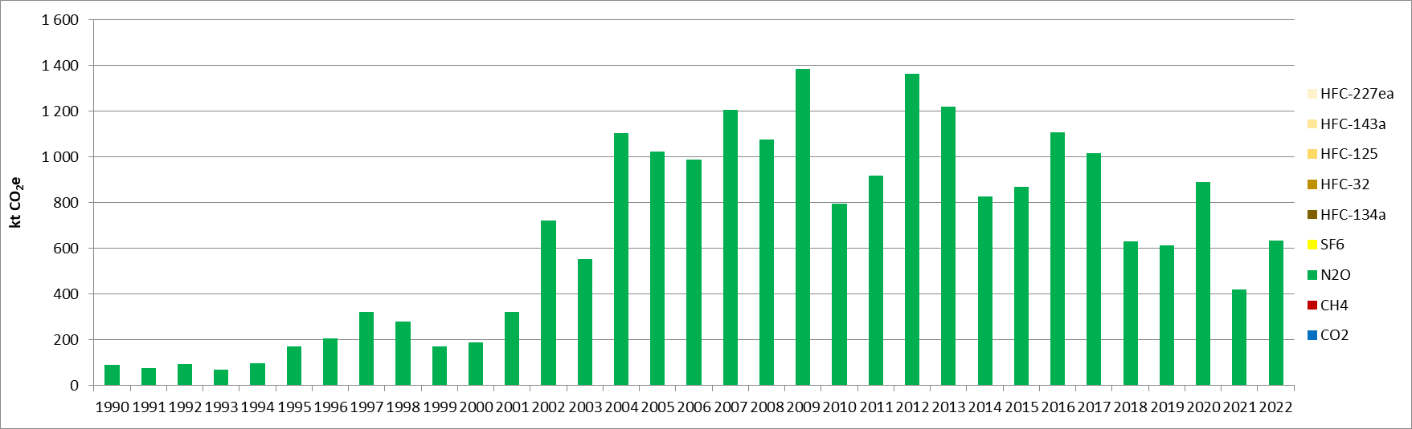
Figure 106 : N₂O emissions from inorganic N fertilisers (CRT 3D1.1) (kt CO₂e)
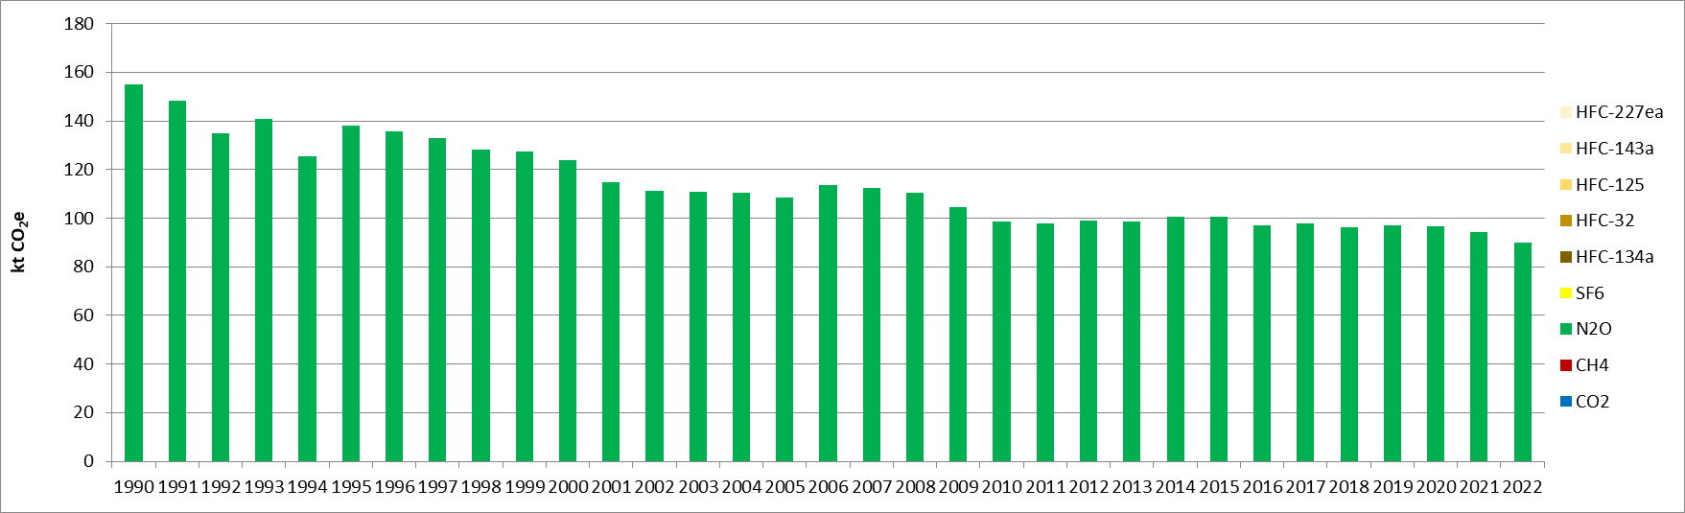
Figure 107 : N₂O emissions from organic N fertilisers (CRT 3D1.2.a) (kt CO₂e)
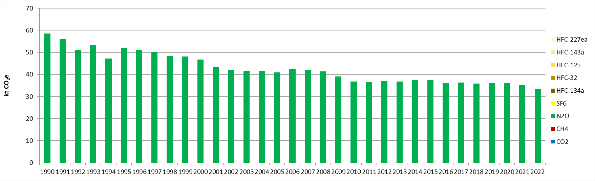
Figure 108 : N₂O emissions from urine and dung deposited by grazing animals (CRT 3D1.3) (kt CO₂e)
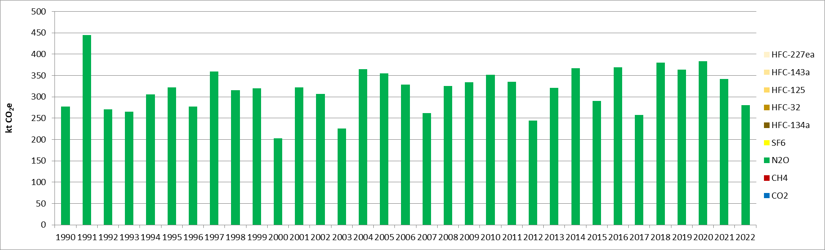
Figure 109 : N₂O emissions from crop residues (CRT 3D1.4) (kt CO₂e)

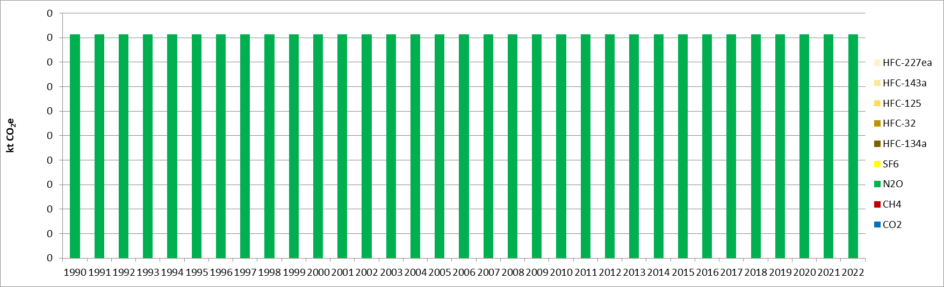
Figure 110 : N₂O emissions from cultivation of organic soils (CRT 3D1.6) (kt CO₂e)

In 2022, the CRT categories CRT 3D1.1 (inorganic N fertilisers) and CRT 3D1.4 (crop residues) are both key categories in terms of emission levels and trend, but all the other subsectors are not key categories in one or the other.
The N₂O emissions from the subsector inorganic N fertilisers are a key category and contribute to 1.0% in terms of emissions level (rank 15) and 2.1% in terms of emissions trend (rank 14).
The N₂O emissions from subsector crop residues are a key category and contribute to 0.4% in terms of emissions level (rank 27) and 0.3% in terms of emissions trend (rank 55).

Methodological issues
Direct emissions of N₂O from managed soils are calculated with a Tier 1 approach which is in line with the 2019 IPCC Guidelines [A21].
Activity data used are the quantities of inorganic fertilizer [A2], the amounts of animal manure and urine and dung deposited by animals, which are calculated through CRT 3B categories (livestock), the amounts of N from crop residues and the surface of managed/drained organic soils [A11].
For the crop residues, the estimations are based on calculations related to the total annual harvested crop areas [A2], the productions of crop [A2] and the amount of biomass burned in agriculture [A12], for each type of crop. Default parameters from the 2006 IPCC guidelines are used (dry matter content, N content of above and below ground residues, etc.).
Emissions factors used for calculating N₂O emissions are sourced from the 2019 IPCC guidelines [A21][A13] and the 2013 Wetland supplement [A22]. Those factors are presented in the following table.
Table 34: N₂O emission factors for agricultural soils (3D1), per management system, from 2019 IPCC Guidelines and 2013 Wetland supplement, used in Serbian inventory
Management system | EF (kg N₂O-N/kg N)
Inorganic fertilisers | 0.01
Animal manure applied to soils | 0.01
Urine and dung deposited by cattle, poultry and pigs | 0.004
Urine and dung deposited by sheep and others | 0.003
Crop residues | 0.01
Managed/drained organic soils | 5

Indirect N₂O emissions from managed soils (CRT 3D2)

Category description
The indirect emissions of N₂O from managed soils are separated between two subcategories: atmospheric deposition, and leaching and run-off. The emission estimation methodology used is based on Tier 1 from 2006 IPCC guidelines. The activity data used are the same as in the previous chapter, the amounts of N applied to soils, recalculated to obtain the amounts of N volatilised and added to/mineralised in soils through leaching and run-off.
The indirect emissions from leaching and run-off are directly proportional to the evolution of the sum of all activities from Table 32 and Table 33, except for organic soils. The emissions are slightly varying but rather stable from 1990 to 2001, before increasing progressively until 2009, where they reached their peak (+121% compared with 2001). From 2009 onwards, the emissions vary significantly but a global reduction is observed, and the emission levels achieved in 2022 are 43% below the one from 2009, but 61% higher than the one from 1990.
The indirect emissions related to volatilisation are lower in magnitude and represent only 27% of the total of the category 3D2 in 2022 (versus 30% in 1990). This is due to the fact the fractions of volatilised N are lower than the fraction of N leaching and running off (see chapter 5.4.2.2), in particular for synthetic fertiliser. Hence, the large variations of the amounts of inorganic N-fertilisers applied to soils have a more moderate impact on the emissions by atmospheric deposition. However, the observed trend is rather similar, and the same observations made previously for the emissions from leaching and run-off can be adapted to this subsector, with a different order of magnitude. Overall, an increase of 43% has been observed in the indirect emissions from atmospheric deposition, for the period 1990-2022.
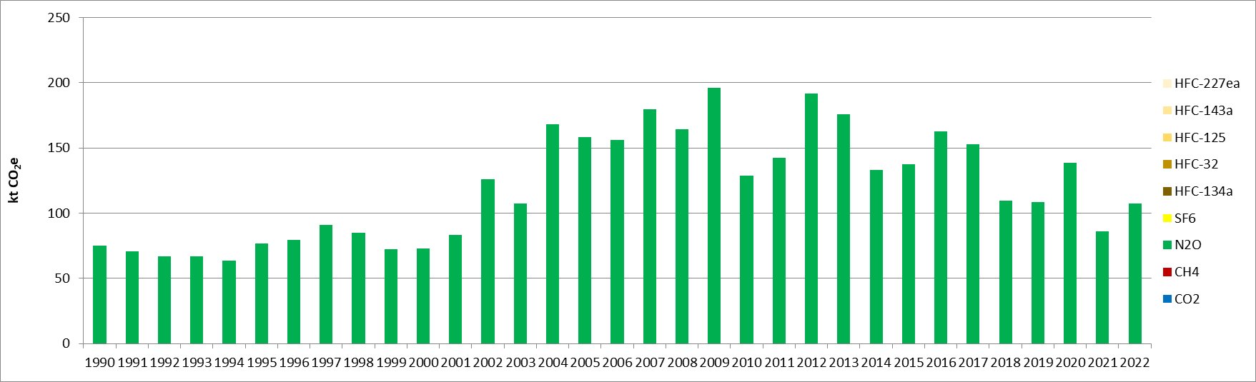
Figure 111 : Indirect N2O emissions from atmospheric deposition (CRT 3D2.1) (kt CO2e)
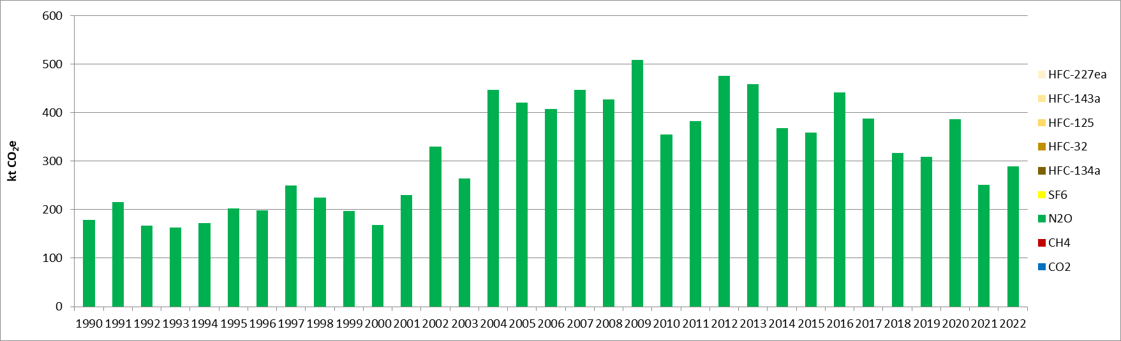
Figure 112 : Indirect N2O emissions from nitrogen leaching and run-off (CRT 3D2.2) (kt CO₂e)

In 2022, only the N₂O emissions from the CRT 3D22 (Nitrogen leaching and run-off) is a key category in the Republic of Serbia. This sector contributes to 0.5% in terms of emissions level (rank 24), and 0.6% in terms of trend (rank 38).

Methodological issues
Direct emissions of N₂O from managed soils are calculated with a Tier 1 approach in line with the 2019 IPCC Guidelines [A21].
Activity data used are the same as the one given in chapter 5.4.1.20, with some additional calculations in order to calculate the amounts of volatilized N and N lost through leaching and run-off, according to IPCC 2019 guidelines. The parameters used to estimate the appropriate activity data are: .
- Fraction of synthetic fertilizer N that volatilizes as NH₃ and NOx: F_{GASF} = 0.11 kg N volatilized/kg N applied;
- Fraction of organic fertilizer N (including urine and dung deposited by grazing animals) that volatilizes as NH₃ and NOx: F_{GASM} = 0.21 kg N volatilized/kg N applied or deposited;
- Fraction of all N added to/mineralized in managed soils in regions where leaching/runoff occurs:
F_{GASF} = 0.24 kg N volatilized/kg N additions.
Emissions factors used for calculating N₂O emissions are sourced from 2019 IPCC guidelines [A21] and are given in the following table:
Table 35: N₂O emission factors for indirect emissions from agricultural soils (CRT 3D1) from 2019 IPCC Guidelines, used in Serbian inventory
 | EF
Atmospheric deposition  (in kg N₂O-N/kg NH₃-N+Nox-N volatilized) | 0.01
Leaching and run-off  (in kg N₂O-N/kg N leaching/runoff) | 0.011

Uncertainties and time-series consistency
CRT 3D1
Uncertainty estimate associated with activity data amounts to 5%, based on expert judgment.
Uncertainty estimate associated with N₂O emission factor amounts to 28%.
The uncertainty combined for N₂O emissions from this category is of 0.5% in the total national levels of emission in 2022, excluding LULUCF contribution.

CRT 3D2
Uncertainty estimate associated with activity data amounts to 5%, based on expert judgment.
Uncertainty estimate associated with N₂O emission factor amounts to 101%, also based on 2006 IPCC Guidelines (Volume 4, Chapter 11, Table 11.3).
The uncertainty combined for N₂O emissions is 0.6% in the total national levels of emission in 2022, excluding LULUCF contribution.

Category-specific QA/QC and verification
During the preparation of the inventory submission, activities related to quality control were mainly focused on completeness and consistency of emission estimates, and on proper use of notation keys in the CRT tables.

Category-specific recalculations
The current report is the first National Inventory Document for Serbia. Consequently, there is no recalculation. Possible recalculation will be occurred and estimated in the next submission if necessary.

Category-specific planned improvements
For the CRT 3D1.4, not all crops have been taken into account in the calculation. Regarding the crop residues, progress can be made by adding other crops in the calculation.
For the CRT code 3D2, indirect N₂O emissions are estimated based on fractions that take the default values from the 2019 IPCC Guidelines. However, for atmospheric deposition, this can be improved by estimating the NH₃ and NOx emissions with the EMEP methodology. The work has been done for indirect N₂O from CRT 3B. Consequently, an improvement would be to also implement this methodology for 3.D to develop more accurate fraction of volatilization for future N₂O deposition.
In addition, another improvement will be to use the disaggregated EF included in the 2019 IPCC refinement to estimate the emissions by climate region (wet/dry).

Field burning of agricultural residues (CRF 3F)
The field burning of agricultural residues category covers the emissions of CH₄ and N₂O from the burning of wheat (CRT 3F11) and maize (CRT 3F13). The field burning from cultures of other cereals (i.e., barley and others) is not occurring, as well as for the other cultures: pulses (CRT 3F2), tubers and roots (CRT 3F3), sugar cane (CRT 3F4) and others (CRF 3F5).
Overall, the GHG emissions from Field burning (CRT 3F) have slightly reduced, by 7%, between 1990 and 2022, but follow an oscillating but rather stable trend. For the whole studied period, this sector is marginal in the national totals as well as in the agriculture totals. In 2022, it represents 2% of the CRT 3 GHG emissions and 0.2% of the national totals, excluding LULUCF contribution.
As there are only emissions related to the CRT 3F1 category, the emission trend description is given in the following chapter.

Cereals (CRF 3F1)

Category description
The following figures give the evolution of the GHG emissions from both subcategories from this sector, distinguished between CH₄ and N₂O emissions. For both emission sources, the emissions from methane are predominant and represent about 80% of the GHG totals.
The emission estimation methodology is based on the Tier 1 from 2006 IPCC guidelines (see chapter 5.5.1.2), hence the emission evolution is directly proportional to the changes in the amounts of maize and wheat burned.
In short, the GHG emissions from wheat burning have varied significantly from 1990 to 2004, and are more stable since then, achieving an overall reduction of 31% between 1990 and 2022. The GHG emissions from maize burning are more stable over the timeseries and, in 2022, a small increase of 2% is observed compared with 1990 emission levels. The emissions from maize burning are the main emission source and contribute to about 79% of the sector emissions in 2022. Its share is in growth compared with 1990 where it represented 72% of the sector emissions.
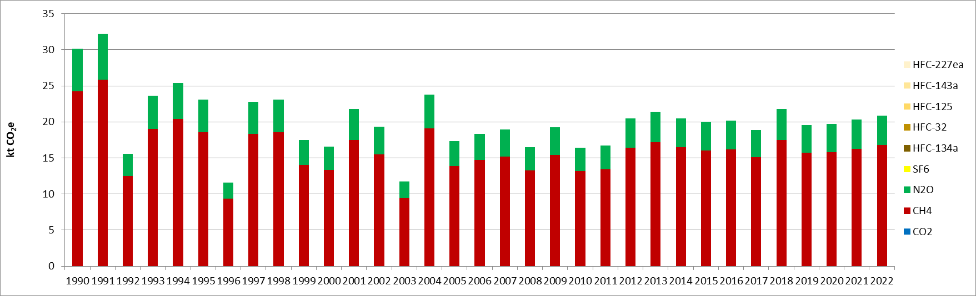
Figure 113 : GHG emissions from field burning of wheat (CRT 3F1.1) (kt CO₂e)
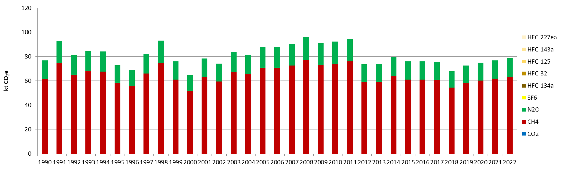
Figure 114 : GHG emissions from field burning of maize (CRT 3F1.3) (kt CO2e)
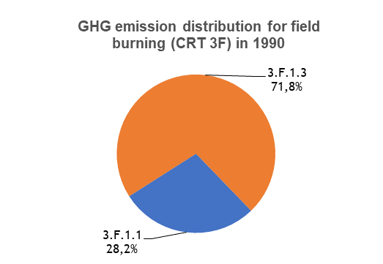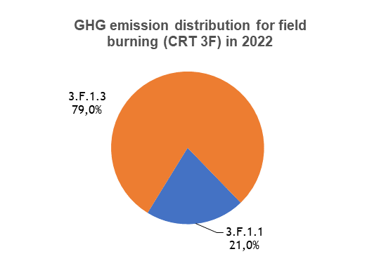
Figure 115: GHG emission distribution for field burning of agriculture residues (CRT 3F), for the period 1990-2022, per subcategory (in %)
In 2022, CRT 3F1 subcategories (CRF 3F1.1, CRF 3F1.3) are neither key categories in terms of emission levels nor in emission trend, in the Republic of Serbia.

Methodological issues
GHG emissions from field burning of agricultural residues are calculated with a Tier 1 approach which is in line with the 2006 IPCC Guidelines [A16].
Activity data used are the quantities of wheat and maize burned and are sourced from the FAO database [A12].
Emissions factors used for calculating GHG emissions are sourced from 2006 IPCC guidelines [A16] and are given in the following table. They are given as the product of the combustion factor, which depends on the crop and is of 0.9 for wheat and 0.8 for maize, with the EF for agricultural residues which are of 2.7 g CH₄/kg and 0.07 g N₂O/kg.
Table 36: N₂O emission factors for field burning of agricultural residues (CRT 3F), from 2006 IPCC Guidelines, used in Serbian inventory
Burned crop | EF CH₄  (g/kg) | EF N₂O  (g/kg)
Wheat | 2.43 | 0.063
Maize | 2.16 | 0.056

Uncertainties and time-series consistency
CH₄
Uncertainty estimate associated with activity data amounts to 30%, based on expert judgment.
Uncertainty estimate associated with CH₄ emission factor amounts to 100%, also based on expert judgment.
The uncertainty combined for emissions is 0.13% in the total national levels of emission in 2022, excluding LULUCF contribution.

N₂O
Uncertainty estimate associated with activity data amounts to 30%, based on expert judgment.
Uncertainty estimate associated with CH₄ emission factor amounts to 100%, also based on expert judgment.
The uncertainty combined for emissions is 0.03% in the total national levels of emission in 2022, excluding LULUCF contribution.

Category-specific QA/QC and verification
During the preparation of the inventory submission, activities related to quality control were mainly focused on completeness and consistency of emission estimates, and on proper use of notation keys in the CRT tables.

Category-specific recalculations
The current report is the first National Inventory Document for Serbia. Consequently, there is no recalculation. Possible recalculation will be occurred and estimated in the next submission if necessary.

Category-specific planned improvements
For the CRT 3F, the assumption made is that there is no burning of crop residues in Serbia, except for maize and wheat because data were found in the FAO statistics for these crops regarding biomass burnt. An improvement can be to further explore this question in order not to miss any emission source and ensure the completeness of this category.

Urea application (CRF 3H)

Category description
For this category, the emissions of CO₂ related to the application of urea onto agricultural fields are estimated. The emissions are calculated with a Tier 1 methodology, with a constant EF applied, hence the emissions are directly proportional to the evolution of the activity data. This sector represents the only emissions of CO₂ from the Agriculture sector (which are considered in the emission inventory scope, hence different from CO₂ related to biomass).
In the following figure, it can be observed that the emissions are rather stable from 1990 to 2000, before increasing rapidly between 2001 and 2004 (+379% compared with 2000 emission level). After that, a slight reduction is observed until 2014, before increasing significantly and rapidly up to 2016. From 2016 onwards, the data vary significantly. In 2022, the emissions have increased by +574% compared with 1990.
This sector has an important growing share in the national and sectoral emission totals. In 2022, this category contributes to 4.4% of the Agriculture sector emissions, whereas it was only 0.5% in 1990. In addition, in the national emissions excluding LULUCF contribution, its share is of 0.3% in 2022 (while it was 10 times less in 1990).
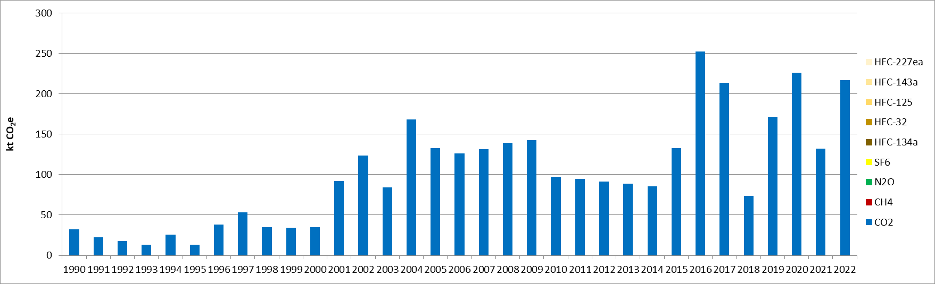
Figure 116 : GHG emissions from urea application (CRT 3H) (kt CO₂e)

In 2022, the CRT 3H sector is a key category for CO₂ in the Republic of Serbia, both in terms of emission levels and trend. This sector contributes to 0.3% in terms of emission level (rank 32) and to 0.7% in emission trend (rank 32).

Methodological issues
GHG emissions from urea application are calculated with a Tier 1 approach which is in line with the 2006 IPCC Guidelines [A17].
Activity data used are the annual quantities of urea applied to agricultural soils, which are taken from SORS [A18].
Emission factor used for calculating GHG emissions comes from 2006 IPCC guidelines [A19] and the value is of 0.2 t C/t urea, which corresponds to about 733.3 kg/t.

Uncertainties and time-series consistency
Uncertainty estimate associated with activity data amounts to 5%, based on expert judgment.
Uncertainty estimate associated with CO₂ emission factor amounts to 50%, also based on 2006 IPCC Guidelines (Volume 4, Chapter 11, p.11.32).
The uncertainty combined for emissions is 0.2% in the total national levels of emission in 2022, excluding LULUCF contribution.

Category-specific QA/QC and verification
During the preparation of the inventory submission, activities related to quality control were mainly focused on completeness and consistency of emission estimates, and on proper use of notation keys in the CRT tables.

Category-specific recalculations
The current report is the first National Inventory Document for Serbia. Consequently, there is no recalculation. Possible recalculation will be occurred and estimated in the next submission if necessary.

Category-specific planned improvements
No improvement is planned for this specific category, for the moment.

Chapter 6: Land Use, Land-Use Change and Forestry (CRT sector 4)

Overview of sector
This category includes all GHG emissions and absorptions (or “removals”, or “negative emissions”) due to land use, land use change and forestry (LULUCF). Since the sector present both emissions and absorptions, the term “flux” is used to mention all figures.
The CRT 4 category covers the following sectors:
- Forest land (CRT 4A), including Forest lands remaining forest lands (CRT 4A1), and Lands converted to forest lands (CRT 4A2) with croplands (CRT 4A2.1), grasslands (CRT 4A2.2), wetlands (CRT 4A2.3), settlements (CRT 4A2.4) and other lands (CRT 4A2.5),
- Cropland (4B), including Lands converted croplands (CRT 4B2) with forest lands (CRT 4B2.1), grasslands (CRT 4B2.2), wetlands (CRT 4B2.3) and settlements (CRT 4B2.4)
- Grassland (CRT 4C), including Grasslands remaining grasslands (CRT 4C1), and Lands converted to forest lands (CRT 4C2) with forest lands (CRT 4C2.1), croplands (CRT 4C2.2), wetlands (CRT 4A2.3), settlements (CRT 4A2.4) and other lands (CRT 4A2.5),
- Wetlands (CRT 4D), including Lands converted to another type of wetlands (CRT 4D2.3),
- Settlements (CRT 4E), including Lands converted to settlements (CRT 4E2), with forest lands (CRT 4E2.1), croplands (CRT 4E2.2) and grasslands (CRT 4E2.3),
- Other land (CRT 4F), including Lands converted to other lands (CRT 4F2), with forest lands (CRT 4F2.1), croplands (CRT 4F2.2) and grasslands (CRT 4F2.3),
- Harvested wood products (CRT 4G).
The subcategories Croplands remaining croplands (CRT 4B1), Wetlands remaining wetlands (CRT 4D1) and Settlements remaining settlements (CRT 4E1), are considered as not estimated (NE), applying the default Tier 1 approach of equilibrium assumption. In addition, the category Other (4H) and some other subcategories such as other lands converted to croplands (CRT 4B2.5), and Lands converted to peat extraction (CRT 4D2.1) are not occurring (NO) in the Republic of Serbia, for the reported period. Finally, the category Lands converted to flooded lands (CRT 4D2.2) is considered as included elsewhere (“IE”) in the emission inventory.
The LULUCF sector is a net sink, offsetting 1.7% of the GHG emissions in 1990 and 7.3% in 2022. CO₂ represents more than 97% of the sector fluxes in 1990 and more than 99% in 2022. The emissions of methane and nitrous oxide from LULUCF are rather negligible in the national totals, contributing to 0.07% and 0.71%, respectively, in 2022.
Considering all emissions and absorptions in absolute values, the main contributor subsector is the CRT 4A, in particular the CRT 4A1 which contributes to 96% of the fluxes of this subsector (74% in 1990 more than 88% in 2022). The fluxes related to croplands (CRT 4C), which were quite significant in 1990 and contributed to 13% of the sector totals, has decreased significantly and has a share of only 0.1% in 2022. Finally, to another extent, another significant contributor is the harvested wood product (HWP) category (CRT 4G), which has increased its share from 1.9% to 4.6%, between 1990 and 2022, due to an important increase of this net sink.

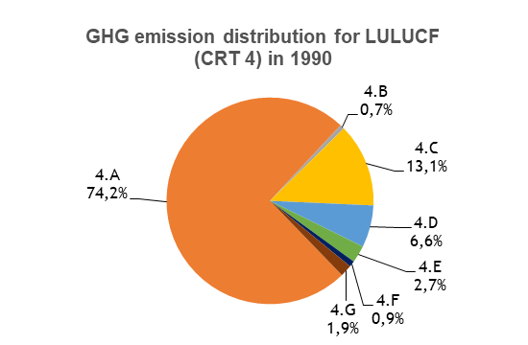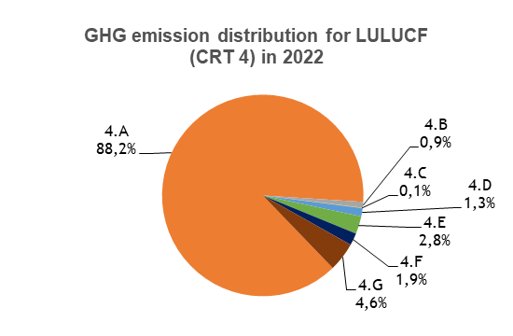
Figure 117: GHG emission distribution for LULUCF (CRT 4), for the period 1990-2022, per subsector (in %)

In the Republic of Serbia, as for the majority of EU Member states, the LULUCF sector has been a net sink during the historical period (from 1990), mostly due to the forest land, and seems to show an increasing trend in the 1990s, and a slightly declining trend from the 2000’s to the most recent years. The following graph presents the country’s LULUCF net sink evolution and each of the LULUCF categories results.
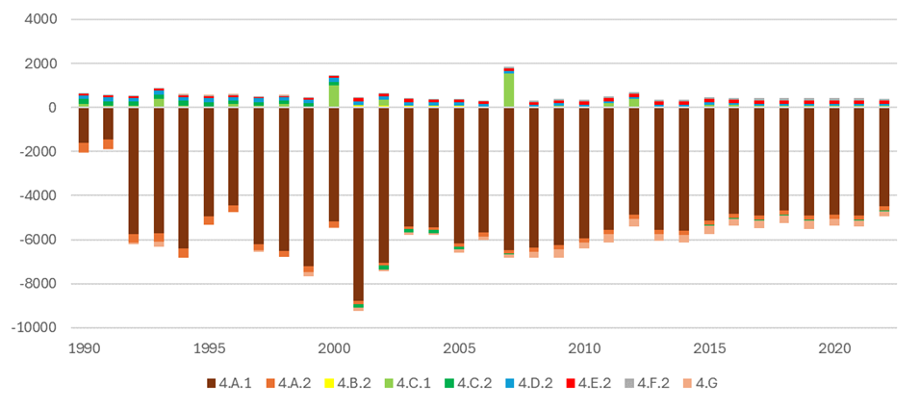
Figure 118: GHG emissions trends for LULUCF (CRT 4), for the period 1990-2022, per subcategory (in kt CO₂e)
In overall, in 2022, GHG emissions from CRT 4 LULUCF are a net removal of -4.5 Mt CO₂e, compared to -1.4 Mt CO₂e in 1990, corresponding to a 222% increase for the studied period. GHG emissions vary significantly during the reporting period, in particular until 2003, due in part to a lower harvesting rate (increase of sink) and wildfires (sink reduction). From 2008 onwards, the emissions from LULUCF are more stable and follow an increasing trend (i.e., the sink of emissions is getting smaller), and an overall increase of 30% is observed for the period 2008-2022. The significant reduction of the sinks in the Forest land category, in the 2010-2012 period, is the result of a significant drop of forest mass increment due to a drought in 2012, which explain the peak of emissions in 2012. In addition, the sinks are decreasing mainly due to the increased use in biomass and to natural disasters (e.g., fires, breakages due to storms, damage caused by insects and diseases).
Only Forest Land and Harvested Wood Products are categories that are net sinks, (Forest Land being approximately 15 times higher than HWP). HWP net sink increased from 1990 to 2019, and now decreases. All other categories are net sources of emissions, mostly due to land conversions or the burning of dry pastures, with small amounts. To summarize, during the last years, Forest Land represented approximately -5 Mt CO₂e of sink; HWP -0.3 Mt; and all other categories cumulated between 0.3 and 0.4 Mt.

Land-use definitions and the classification systems used and their correspondence to the land use, land-use change and forestry categories (e.g. land use and land-use change matrix)
The definition of forest is the one used by the Global Forest Resources Assessment 2015 (Country Report Serbia). The selected thresholds are:
- Minimum land area: 0.5 ha;
- Minimum canopy cover: 10% (in situ. i.e. potential of the standing stock to reach this threshold);
- Minimum height: 5 meters (in situ. i.e. potential of the standing stock to reach this threshold);
However, in the framework of the GHG inventory, all 6 land-use categories are directly connected with the definitions Corine Land Cover which is the main source used in the current Serbian inventory to determine areas. The nomenclature of Corine Land Cover was associated to 6 IPCC categories following this allocation table.
Table 37: Table of correspondence between CLC and IPCC classes
Code | CLC class | IPCC class
111 | Continuous Urban Fabric | Settlement
112 | Discontinuous Urban Fabric | Settlement
121 | Industrial or Commercial | Settlement
122 | Road and Rail networks | Settlement
123 | Sea Ports | Settlement
124 | Airports | Settlement
131 | Mineral extraction sites | Settlement
132 | Dump | Settlement
133 | Construction sites | Settlement
141 | Green Urban areas | Settlement
142 | Sport and Leisure facililies | Settlement
211 | Non-irrigated arable land | Cropland
221 | Vineyards | Cropland
222 | Fruit trees and berries plantations | Cropland
231 | Pastures | Grassland
242 | Complex cultivation | Cropland
243 | Land principally occupied by agriculture with areas of natural vegetation | Grassland
311 | Broad Leaved forest | Forest
312 | Coniferous forest | Forest
313 | Mixed forest | Forest
321 | Natural grassland | Grassland
324 | Transitional woodland shrub | Forest
331 | Beaches, dunes, sand | Other land
332 | Bare rocks | Other land
333 | Sparsely vegetated | Other land
334 | Burnt areas | Other land
411 | Inland Marshes | Wetlands
511 | Stream courses | Wetlands
512 | Water bodies | Wetlands

Information on approaches used for representing land areas and on land-use database used for the inventory preparation
The methodology to estimates land use matrixes corresponds to an approach 3 because the land-use changes are spatially explicit and gross changes are known.
Land use and land use change areas are based on monitoring data from Corine Land Cover. Currently, four editions of the CLC dataset are used in the Serbian inventory: 1990, 2000, 2006 and 2012. The land use changes have been estimated for the periods 1990-2000, 2000-2006 and 2006-2012. The 2018 edition and the 2012-2018 change map are not yet used.
Table 38: Annual land use changes for the period 1990-2000 (ha/year)
 | Forest | Cropland | Grassland | Wetland | Settlement | Other land
Forest |  | 64 | 223 | 94 | 55 | 24
Cropland | 283 |  | 953 | 105 | 403 | 0
Grassland | 425 | 242 |  | 192 | 127 | 5
Wetland | 34 | 24 | 40 |  | 8 | 38
Settlement | 113 | 55 | 29 | 2 |  | 0
Other land | 9 | 0 | 3 | 7 | 0
Table 39: Annual land use changes for the period 2000-2006 (ha/year)
 | Forest | Cropland | Grassland | Wetland | Settlement | Other land
Forest |  | 53 | 12 | 65 | 178 | 3
Cropland | 55 |  | 106 | 112 | 457 | 0
Grassland | 74 | 918 |  | 109 | 80 | 0
Wetland | 5 | 0 | 13 |  | 6 | 0
Settlement | 101 | 3 | 13 | 4 |  | 0
Other land | 125 | 0 | 0 | 4 | 0
Table 40: Annual land use changes for the period 2006-2012 (ha/year)
 | Forest | Cropland | Grassland | Wetland | Settlement | Other land
Forest |  | 24 | 5 | 27 | 211 | 139
Cropland | 183 |  | 222 | 45 | 384 | 0
Grassland | 134 | 287 |  | 83 | 111 | 0
Wetland | 111 | 31 | 30 |  | 7 | 0
Settlement | 171 | 8 | 30 | 8 |  | 0
Other land | 35 | 0 | 0 | 4 | 0
For the inventory it is necessary to estimate annual changes since 1970 to 2022, so the following treatments are implemented:
- During each monitoring period the changes are supposed to be constant, annual changes are thus estimated by dividing the changes of the period by the number of years of the period.
- Before 1990, land use changes are assumed to be equivalent to the period 1990-2000.
- After 2012, that land use changes are assumed to be equivalent to the period 2006-2012.
The year 2000 was chosen as the only reference for land use changes to avoid potential small discrepancies between maps. All the areas are calculated on the basis of 2000 areas combined with annual changes. The calculation of "area of land remaining land" is done by subtracting all the changes that become that land in that year from the area at the end of the year.
Figure 119: Evolution of the and use areas in the Republic of Serbia since 1990
This protocol allows building both annual and 20-year matrixes which are necessary for the calculation of carbon fluxes.
Table 41: Example of annual matrix for the year 2022 (ha)
 | Forest | Cropland | Grassland | Wetland | Settlement | Other land | Initial Area
Forest | 2,748,679 | 24 | 5 | 27 | 211 | 139 | 2,749,085
Cropland | 183 | 3,237,382 | 222 | 45 | 384 | 0 | 3,238,216
Grassland | 134 | 287 | 1,354,201 | 83 | 111 | 0 | 1,354,816
Wetland | 111 | 31 | 30 | 127,585 | 7 | 0 | 127,764
Settlement | 171 | 8 | 30 | 8 | 264,797 | 0 | 265,014
Other land | 35 | 0 | 0 | 4 | 0 | 22,180 | 22,219
Final Area | 2,749,314 | 3,237,732 | 1,354,488 | 127,752 | 265,510 | 22,319 | 7,757,115
Table 42: Example of 20-year matrix for the year 2022 (ha)
 | Forest | Cropland | Grassland | Wetland | Settlement | Other land | Initial Area
Forest | 2,737,718 | 601 | 131 | 688 | 4,082 | 2,240 | 2,745,460
Cropland | 3,142 | 3,228,240 | 3,967 | 1,171 | 7,980 | 0 | 3,244,500
Grassland | 2,445 | 8,270 | 1,349,320 | 1,760 | 2,092 | 0 | 1,363,886
Wetland | 1,801 | 489 | 534 | 123,906 | 139 | 0 | 126,870
Settlement | 3,142 | 131 | 536 | 150 | 251,217 | 0 | 255,177
Other land | 1,066 | 0 | 0 | 77 | 0 | 20,079 | 21,222
Final Area | 2,749,314 | 3,237,732 | 1,354,488 | 127,752 | 265,510 | 22,319 | 7,757,115

Common elements to all land uses (CRT 4)

Carbon stock changes
- Living biomass
All fluxes related to living biomass are estimated by the stock-difference method on areas with land use changes (equation 2.5 of the IPCC 2006 guidelines) and by the gain-loss method on forest remaining forest (equation 2.4 of the IPCC 2006 guidelines). For all land uses but forest, on land remaining land, living biomass is assumed to be in equilibrium and gains and losses are reported as not estimated.
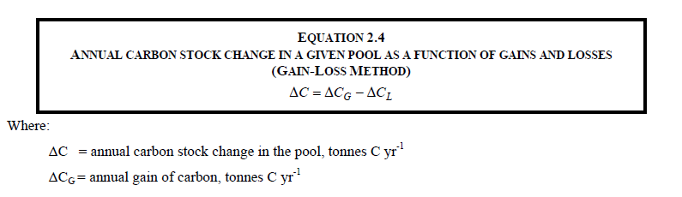
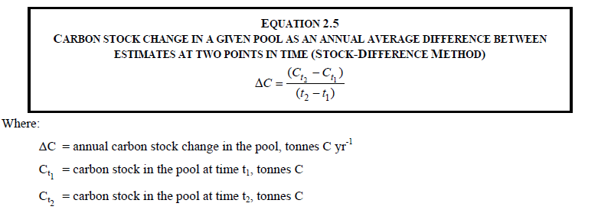
Default carbon stocks from 2006 IPCC guidelines are used in the current inventory for living biomass.
Table 43: Default carbon stocks from 2006 IPCC guidelines
 | Aboveground Biomass (t d.m/ha) | Root to shoot ratio | Carbon content  (tC/t d.m)
Forest | 120 | 0.3 | 0.47
Cropland | 10 | 0 | 0.47
Grassland | 6.5 | 0 | 0.47
Wetland | 0 | 0 | 0.47
Settlement | 0 | 0 | 0.47
Other land | 0 | 0 | 0.47
- Dead organic matter (dead wood, litter)
Data for deadwood carbon stocks are not available in the IPCC guidelines (Table 2.2).
The information regarding litter carbon stocks is extracted from the IPCC guidelines (Table 2.2), it is assumed that only forest areas have litter carbon stocks. This stock is assumed to be 16tC/ha.
All fluxes related to litter are estimated by the stock-difference method on areas with land use changes.
- Soils (mineral and organic soils)
In the Republic of Serbia, it is assumed that all soils are mineral soils. All fluxes related to organic soils are reported as not occurring.
IPCC default carbon stocks are not used, instead country-specific values from a study “Project on determining Soil organic carbon in Serbia” are applied and as follows:
Table 43: Carbon stock parameters used in the Serbian emission inventory, per type of land (in t C/ha)
 | SOC (tC/ha)
Forest | 132.3
Cropland | 77.4
Grassland | 61.6
Settlement | 0
Other land | 0
Wetland | 0

Direct N₂O Emissions from N Inputs to Managed Soils
It is assumed that no other land but agricultural land is fertilized in Serbia, thus direct N₂O emissions are reported as not occurring in LULUCF.

Emissions and removals from drainage and rewetting and other management of organic and mineral soils
Drainage and rewetting of organic and mineral soils are assumed to be not occurring in Serbia, thus related emissions and removals are reported as not occurring.

Direct N₂O Emissions from N Mineralization/Immobilization
Direct N₂O emissions from mineralization are estimated on lands where land use changes occur with a loss of carbon from soils. These emissions are estimated for forest converted to other lands, grasslands converted to other lands (but forests), croplands converted to other lands (but forests and grasslands).
These emissions are estimated thanks to equations 11.2 and 11.8 of the 2006 IPCC guidelines.
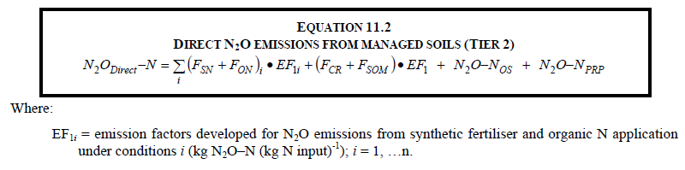
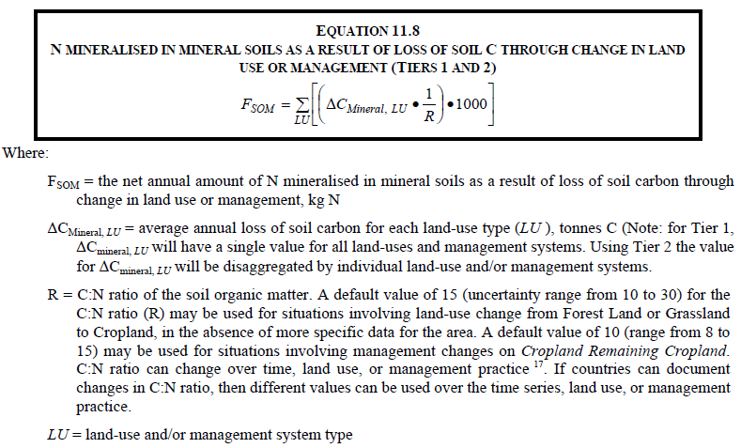

Indirect N₂O Emissions from Managed Soils
Indirect N₂O emissions from soils are currently not estimated in the Serbian inventory.

Biomass Burning
Controlled burning is not estimated on all lands and wildfires are estimated on forestlands and grasslands.
For wildfires the IPCC guidelines 2006 Tier 1 methodology is used (equation 2.27). Emissions from CO₂, CH₄, N₂O, NOx and CO are calculated.
Activity data for burning of forest lands are sourced from Global forest resources assessment 2015 Country report for Serbia. Activity for burning of forest lands is the area burnt (in ha). Two sets of data are available, for the periods 1990-2002 and 2003-2012. For years after 2012, an average from last 5 years is used (2008-2012) due to lack of activity data.
No activity for directly grassland is available. In Global Forest resources assessment 2010 Country report for Serbia, data for area of forest burned is available. Also, a total area burned of Forest, other wooded land and other land is available. Other lands are considered as grassland and area burned for grassland is calculated as a difference between total and area of forests burned. Activity for burning of grasslands is the area burnt in ha. Two sets of data are available, for period 1990-2002 and 2003-2012. For years after 2012, area of forest burned and total area are calculated as average of last 5 years and area of grassland burned is difference between those two areas.
Emission factor for calculations of direct emissions as well indirect emissions comes from IPCC guidelines 2006, Volume 4; Chapter 2 Generic Methodologies Applicable to Multiple Land use Categories. As it is a default emission factor it’s the same for all the years and is expressed in g/kg. For fuel biomass consumption also a direct value from IPCC guidelines 2006 is available in tones/ha. Emission factors for extra tropical forest are used because it includes all other forest types.
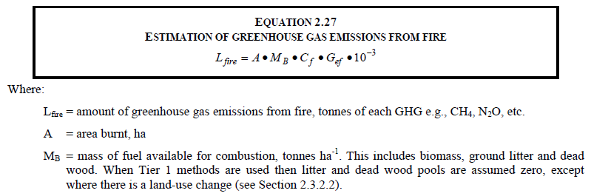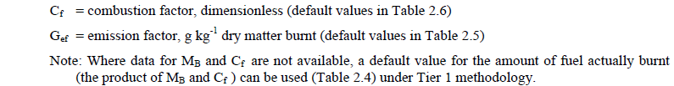

Forestlands (CRT 4A)

Description
This category comprises GHG emissions and removals arising from forestlands.
The following graphs give the GHG emission trends for the different subcategories where estimations are developed for Forest lands.
Based on the latest NID draft, there are two periods when assessing the historical trend of the net sink of LULUCF in Serbia: a first period of high variations of the sink from 1990 to the beginning of the 2000s, showing an increasing trend. The years 1990 and 1991 appears very low and the accuracy of their values and of the sharp increase between 1991 and 1992, is surely an artifact and is not considered here. A second period from the 2000’s to the latest years shows more stability but also a slowly decreasing trend, in particular after 2008. In the period 2007–2020, sinks are decreasing, mainly due to the increased use of biomass, some droughts such as in the period 2010-2012, and natural disasters (e.g. fires, breakages due to strong winds, damage caused by the effects of insects and diseases).
The quantities removed from the category of forest land (forestry) in 2020 were 17.6% less compared to 2010. The main reason for less sequestration can be attributed to the increased use of wood for industrial needs and for heating. Furthermore, disruption losses in 2020 were almost three times higher than in 2010. The lowest removals were observed in 1990 due to heavy commercial logging and industrial technical wood for the pulp and paper industry.
In total, the sink has been increased by 133% between 1990 and 2022, but decreased by 30% since 2007.
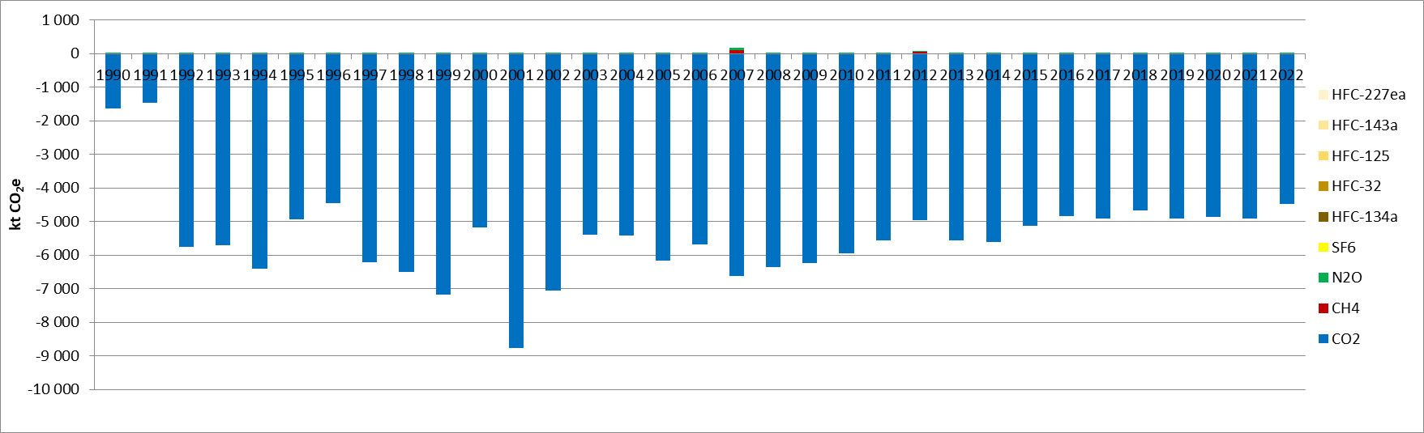
Figure 120: GHG emissions from Forest land remaining forest land (CRT 4.A.1) (kt CO_{2e})
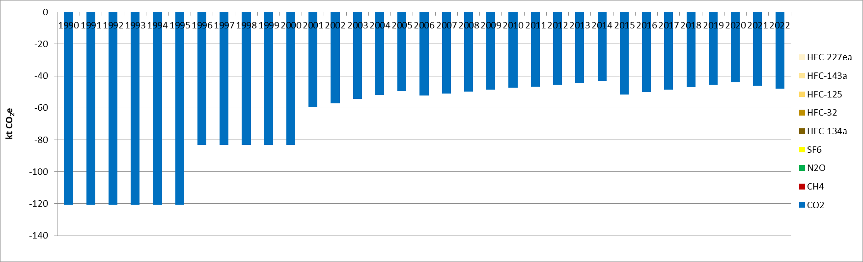
Figure 121: GHG emissions from cropland converted to forest land (CRT 4.A.2.1) (kt CO_{2e})

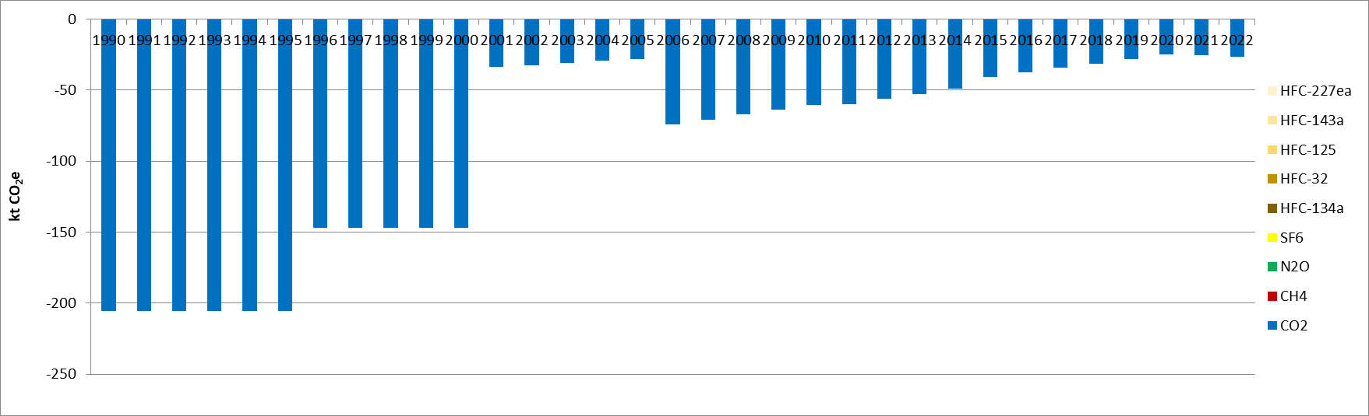
Figure 122: GHG emissions from grassland converted to forest land (CRT 4.A.2.2) (kt CO_{2e})
As shown in the figure above, trends in some subsectors are reflecting land-use change periods due to the annualization of CLC conversions, creating some abrupt changes between periods.
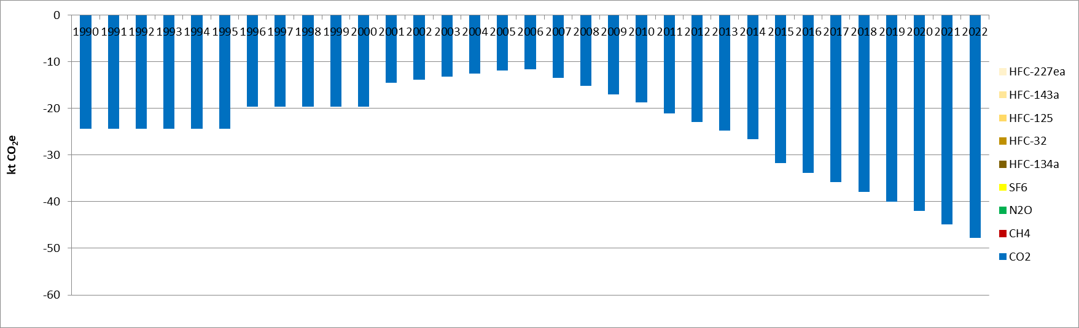
Figure 123: GHG emissions from wetlands converted to forest land (CRT 4.A.2.3) (kt CO_{2e})
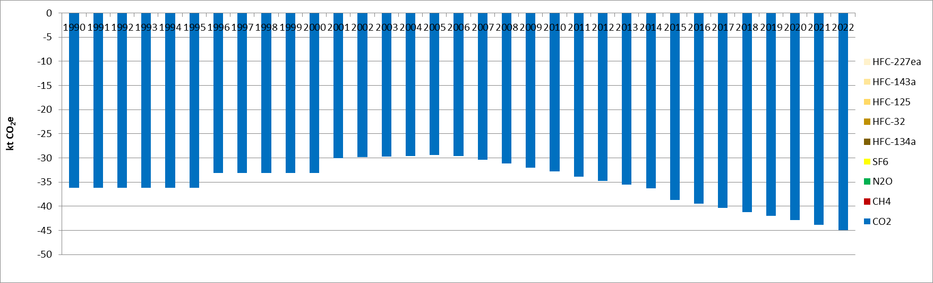
Figure 124: GHG emissions from settlements converted to forest land (CRT 4.A.2.4) (kt CO2e)
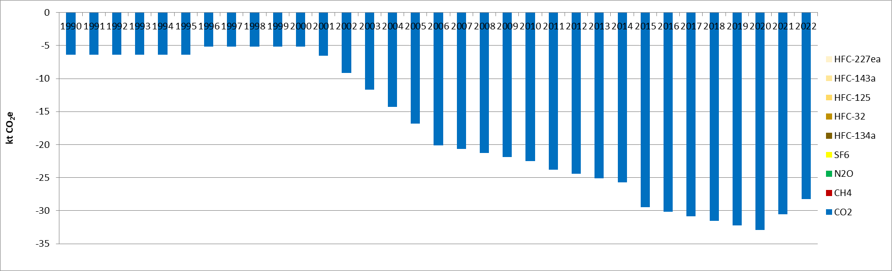
Figure 125: GHG emissions from other land converted to forest land (CRT 4.A.2.5) (kt CO_{2e})

Methodological issues

Forestlands remaining forestlands (CRT 4A1)

Carbon stock changes
- Living biomass
Carbon stock changes in living biomass in forest are estimated on the basis of the gains-losses method. The area of forest is divided between 3 categories of forest:
- Broadleaves
- Conifers
- Mixed
The increment of forest biomass comes from the publication of FRA 2015 of Serbia. Estimates are used for 2010 and 2015 for 2 categories of forests (broadleaves and conifers), since they are in correlation with data published in National Forest Inventory. The elementary increment of mixed forest is estimated by making the average of broadleaves and conifers. The values of increment per ha per year are prescribed before 2010, and linearly interpolated for the period 2010-2015.
Annual increment (m³/ha/yr)
 | 2010 | 2015
Broadleaves | 3.4 | 3.6
Conifers | 8 | 8
Mixed | 5.7 | 5.8
The increment of forest is calculated thanks to 2006 IPCC guidelines (equation 2.10, tier 2)
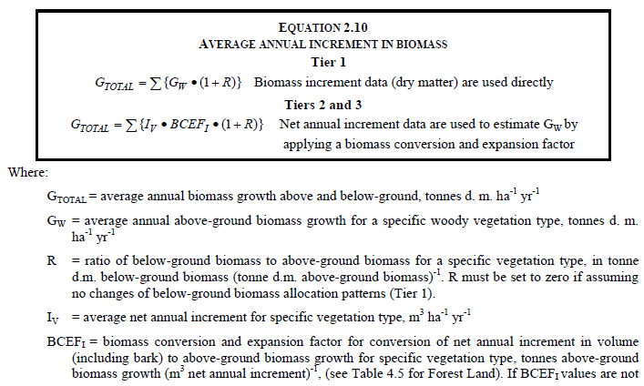
The losses of forest is calculated thanks to 2006 IPCC guidelines (equations 2.11 and 2.12).
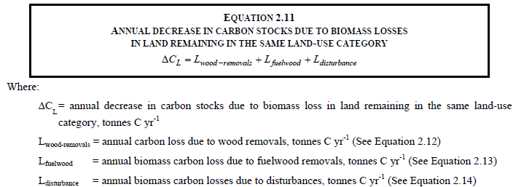
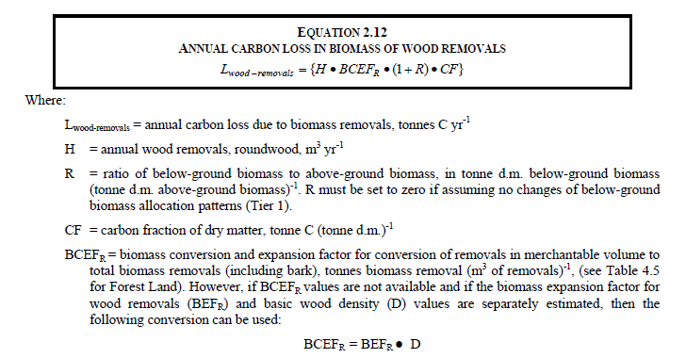
The losses are based on different sets of data. Commercial woods are based on statistical yearbooks and are available for the entire series 1990-2022.
Different types of data for harvest fuel wood exist:
- FAOSTAT data
- Statistical bulletin- Forestry in the Republic of Serbia 2005-2012
- Energy Balance of Serbia
Considering the recommendation of the forestry Service the most reliable data for fuel wood is the one of FAOSTAT for the most recent years (since 2010). Consequently FAO was chosen as the reference and the previous years are extrapolated on the basis of the yearbook.
- Dead organic matter (dead wood, litter)
On forest remaining forest equilibrium is assumed for dead organic matter, it is reported as not estimated in the Serbian inventory.
- Soils (mineral and organic soils)
It is assumed that in Serbia no organic soils exist in forestlands.
On forest remaining forest, equilibrium is assumed for mineral soil, it is reported as not estimated in the Serbian inventory.

Direct N₂O Emissions from N Inputs to Managed Soils
It is assumed that no other land but agricultural land is fertilized in Serbia, thus direct N₂O emissions are reported as not occurring.

Emissions and removals from drainage and rewetting and other management of organic and mineral soils
Drainage and rewetting of organic and mineral soils are assumed to be not occurring in Serbia, thus related emissions and removals are reported as not occurring.

Direct N₂O Emissions from N Mineralization/Immobilization
No carbon losses are estimated from soils, thus direct N₂O Emissions from N Mineralization are reported as not occurring for forest remaining forest.

Indirect N₂O Emissions from Managed Soils
No direct N₂O emissions are estimated on these areas, thus indirect N₂O emissions from soils are also assumed as not occurring.

Biomass Burning
It is likely that controlled burning exists in Serbia but no data are available. Currently it is reported as not estimated.
Wildfires are estimated and it is considered that all forest wildfires are in the category forestlands remaining forestlands.

Land converted to forestlands (CRT 4A2)

Carbon stock changes
- Living biomass
Fluxes on living biomass are estimated thanks to a Gain-loss method.
Gains are based on increment provided by the FRA 2015 report of Serbia. Losses of living biomass are not occurring because it is assumed that the forests are too young for harvesting. It is also important to note that it would be a challenge to distinguish living biomass losses between categories of forest.
- Dead organic matter (deadwood, litter)
Removals on land converted to forest are estimated for land converted to forest. IPCC guidelines do not provide default value for deadwood but a value of 16tC/ha (Table 2.2) for litter. All removals reported under land converted to forest for dead organic matters are related to litter.
- Soils (mineral and organic soils)
It is assumed that in Serbia no organic soils exist in forestlands.
Fluxes on mineral soils are estimated thanks to a stock-difference method.

Direct N₂O Emissions from N Inputs to Managed Soils
It is assumed that no other land but agricultural land is fertilized in Serbia, thus direct N2O emissions are reported as not occurring.

Emissions and removals from drainage and rewetting and other management of organic and mineral soils
Drainage and rewetting of organic and mineral soils are assumed to be not occurring in Serbia, thus related emissions and removals are reported as not occurring.

Direct N₂O Emissions from N Mineralization/Immobilization
No carbon losses are estimated from soils, thus direct N₂O Emissions from N Mineralization are reported as not occurring for land converted to forest.

Indirect N₂O Emissions from Managed Soils
No direct N₂O emissions are estimated on these areas, thus indirect N₂O emissions from soils are also assumed as not occurring.

Biomass Burning
It is likely that controlled burning exists in Serbia but no data are available. Currently it is reported as not estimated.
Wildfires are included elsewhere (in forestlands remaining forestlands).

Uncertainties and time-series consistency
Uncertainty estimate associated with activity data amounts to 10%, based on expert judgment.
Uncertainty estimates associated with emission factor are 20% for CO₂ and 100% for CH₄ and N₂O, based on expert judgement.
Combined uncertainties are 22% for CO₂ emissions and 100% for CH₄ and N₂O emissions. The uncertainties combined in the national totals of emissions are of 1.8%, 0.008% and 0.004% for CO₂, CH₄ and N₂O, respectively in 2022, in the Republic of Serbia.

Category-specific QA/QC and verification
During the preparation of the inventory submission, activities related to quality control were mainly focused on completeness and consistency of emission estimates, and on proper use of notation keys in the CRT tables.

Category-specific recalculations
The current report is the first National Inventory Document for Serbia. Consequently, there is no recalculation. Possible recalculation will be occurred and estimated in the next submission if necessary.

Category-specific planned improvements
For all LULULUCF sector, land-use and land-use change areas monitoring needs to be improved, at least to include more recent CLC datasets available such as 2018 edition; and at best to revise the land-use monitoring approach for enhanced spatial precision, compatibility with forest definition, and temporal consistency.
For the Forest sector, more recent NFI data will be used, if available, to update key parameters.

Croplands (CRT 4B)

Description
This category includes GHG emissions and removals arising from croplands.
In this category, emissions and absorptions are only estimated for land conversions. No emission estimation is calculated for croplands remaining croplands and for biomass burning (4.B.1).
The emission evolution for lands converted to croplands (4.B.2) reflects the trend in land-use change areas.
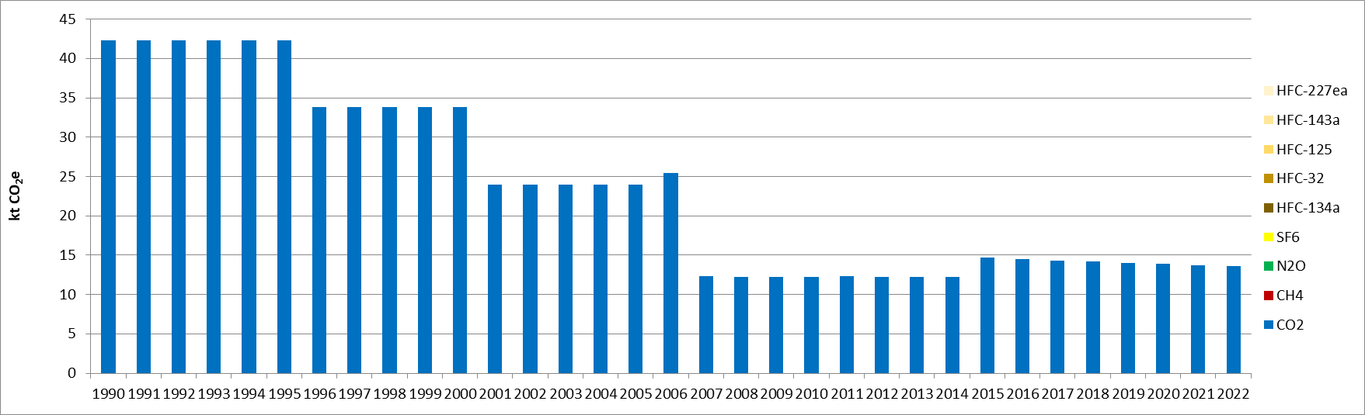
Figure 126: GHG emissions from forest land converted to cropland (CRT 4.B.2.1) (kt CO_{2e})
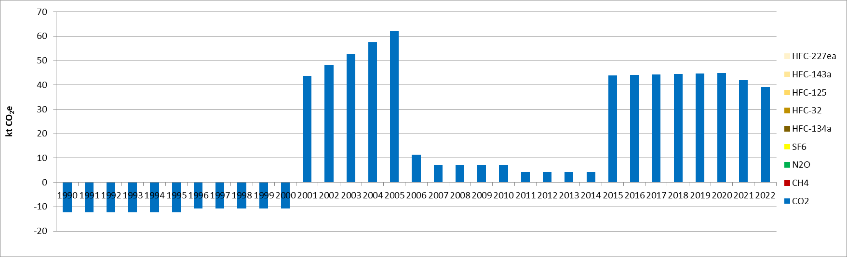
Figure 127: GHG emissions from grassland converted to cropland (CRT 4.B.2.2) (kt CO_{2e})
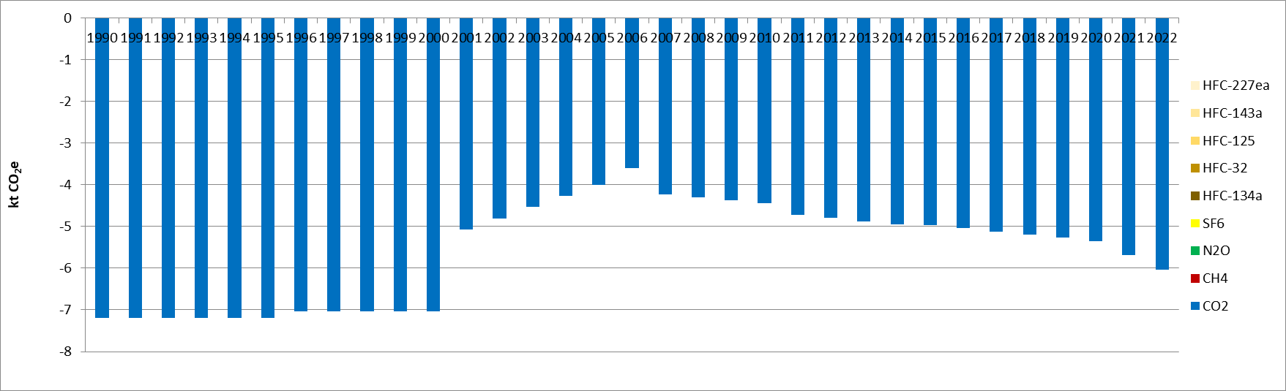
Figure 128: GHG emissions from wetlands converted to cropland (CRT 4.B.2.3) (kt CO_{2e})
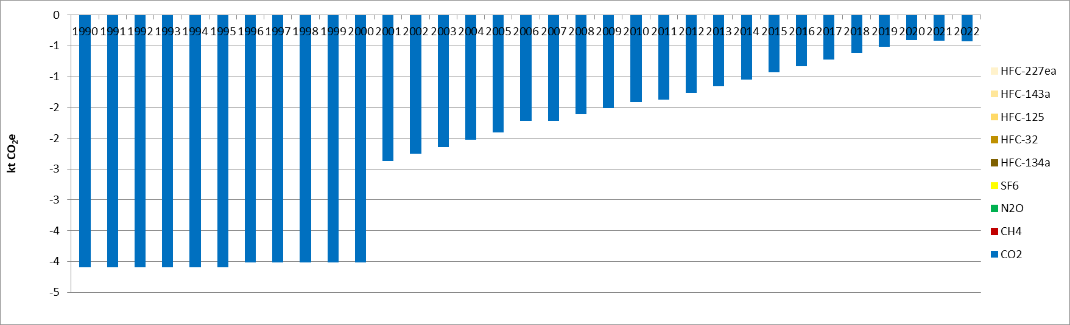
Figure 129: GHG emissions from settlements converted to cropland (CRT 4.B.2.4) (kt CO_{2e})
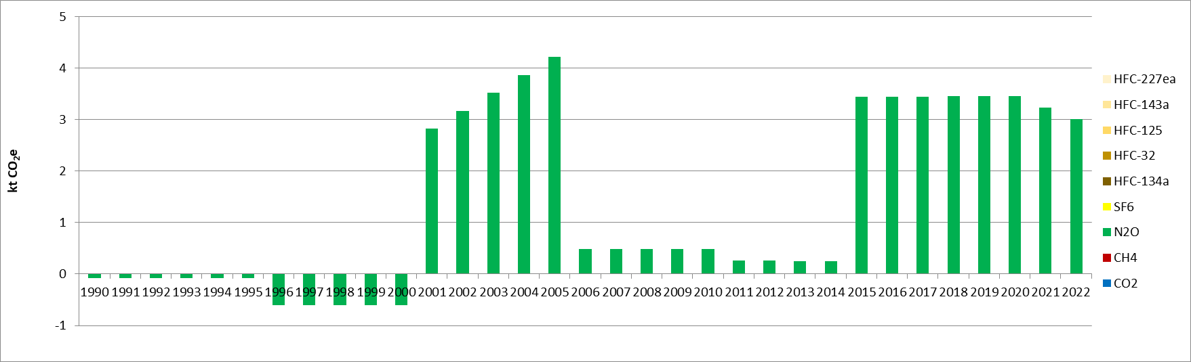
Figure 130: Direct N₂O emissions from N mineralization/immobilization in cropland (CRT 4.B.2) (kt CO_{2e})

Methodological issues

Croplands remaining croplands (CRT 4B1)

Carbon stock changes
- Living biomass
On cropland remaining cropland equilibrium is assumed for living biomass, it is reported as not estimated in the Serbian inventory.
- Dead organic matter (dead wood, litter)
On cropland remaining cropland equilibrium is assumed for dead organic matter, it is reported as not estimated in the Serbian inventory.
- Soils (mineral and organic soils)
On cropland remaining cropland equilibrium is assumed for mineral soils, it is reported as not estimated in the Serbian inventory.

Direct N₂O Emissions from N Inputs to Managed Soils
Direct N₂O emissions from agriculture are already reported under the sector agriculture.

Emissions and removals from drainage and rewetting and other management of organic and mineral soils
Drainage and rewetting of organic and mineral soils are assumed to be not occurring in Serbia, thus related emissions and removals are reported as not occurring.

Direct N₂O Emissions from N Mineralization/Immobilization
No carbon losses are estimated from soils, thus direct N₂O Emissions from N Mineralization are reported as not occurring for cropland remaining cropland.

Indirect N₂O Emissions from Managed Soils
Indirect N₂O emissions from agriculture are already reported under the sector agriculture.

Biomass Burning
It is assumed that no biomass burning is occurring on this type of land (prescribed burning of residues are reported under the sector agriculture).

Land converted to croplands (CRT 4B2)

Carbon stock changes
- Living biomass
Fluxes on living biomass are estimated thanks to a stock-difference method and default carbon stocks from IPCC guidelines.
- Dead organic matter (dead wood, litter)
Emissions on land converted to croplands are estimated for forest converted to cropland. IPCC guidelines do not provide default value for deadwood but a value of 16tC/ha (Table 2.2) for litter. All emissions reported under land converted to cropland for dead organic matters are related to litter.
- Soils (mineral and organic soils)
It is assumed that in Serbia no organic soils exist in croplands.
Fluxes on mineral soils are estimated thanks to a stock-difference method.

Direct N₂O Emissions from N Inputs to Managed Soils
Direct N₂O emissions from agriculture are already reported under the sector agriculture.

Emissions and removals from drainage and rewetting and other management of organic and mineral soils
Drainage and rewetting of organic and mineral soils are assumed to be not occurring in Serbia, thus related emissions and removals are reported as not occurring.

Direct N₂O Emissions from N Mineralization/Immobilization
Carbon losses are estimated from mineral soils, thus direct N₂O Emissions from N Mineralization are estimated in accordance with IPCC 2006 guidelines for land converted to croplands.

Indirect N₂O Emissions from Managed Soils
Indirect N₂O emissions from agriculture are already reported under the sector agriculture.

Biomass Burning
It is assumed that no biomass burning is occurring on this type of land (prescribed burning of residues are reported under the sector agriculture).

Uncertainties and time-series consistency
Uncertainty estimate associated with activity data amounts to 10%, based on expert judgment.
Uncertainty estimates associated with emission factor are 40% for CO₂ and 100% for N₂O, based on expert judgement.
Combined uncertainties are 41% for CO₂ emissions and 100% for N₂O emissions. The uncertainties combined in the national totals of emissions are of 0.03% and 0.005% for CO₂ and N₂O, respectively in 2022, in the Republic of Serbia.

Category-specific QA/QC and verification
During the preparation of the inventory submission, activities related to quality control were mainly focused on completeness and consistency of emission estimates, and on proper use of notation keys in the CRT tables.

Category-specific recalculations
The current report is the first National Inventory Document for Serbia. Consequently, there is no recalculation. Possible recalculation will be occurred and estimated in the next submission if necessary.

Category-specific planned improvements
For all LULULUCF sector, land-use and land-use change areas monitoring needs to be improved, at least to include more recent CLC datasets available such as 2018 edition; and at best to revise the land-use monitoring approach for enhanced spatial precision, compatibility with forest definition, and temporal consistency.
Negative emissions of N₂O from mineralization will be corrected so that only emissions are reported.

Grasslands (CRT 4C)

Description
This category comprises GHG emissions and removals arising from grasslands.
In this category, emissions and absorptions are only estimated for land conversions and for biomass burning. No emission estimation is calculated for croplands remaining croplands (including in 4C1).
The emission evolution for lands converted to croplands (4C2) reflects the trend in land-use change areas.
The following graphs give the GHG emission trend for the estimated categories.
The overall reduction in emissions is due to a significantly reduced area of grassland that was affected by fires, as well as due to a change in land use. The two peaks of emissions observed in 2000 and 2007 are related to biomass burning (CRT 4C1).
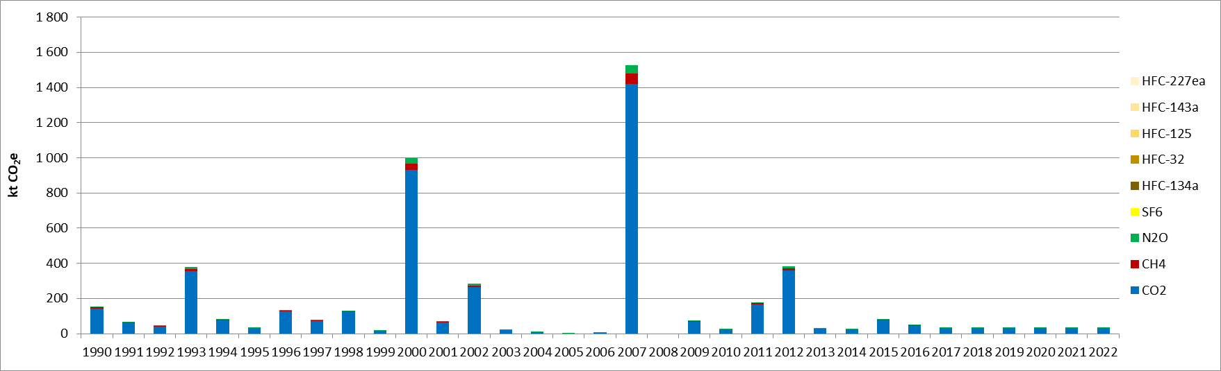
Figure 131: GHG emissions from wildfires (CRT 4.C.1) (kt CO_{2e})
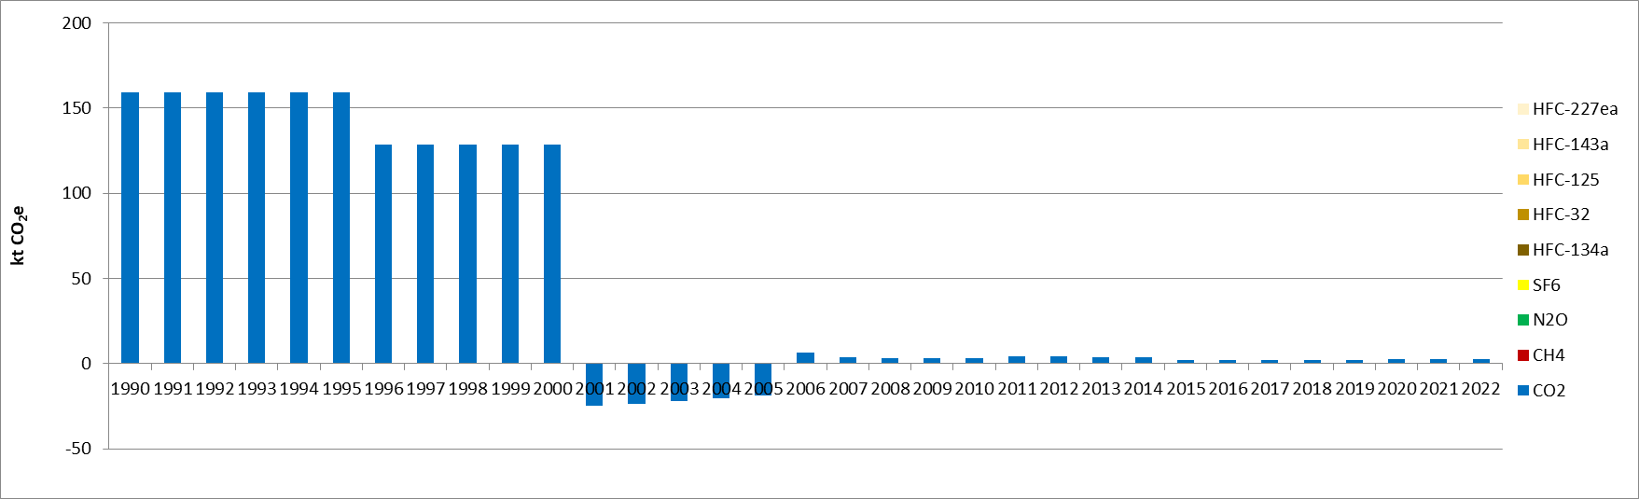
Figure 132: GHG emissions from forest land converted to grassland (CRT 4.C.2.1) (kt CO_{2e})
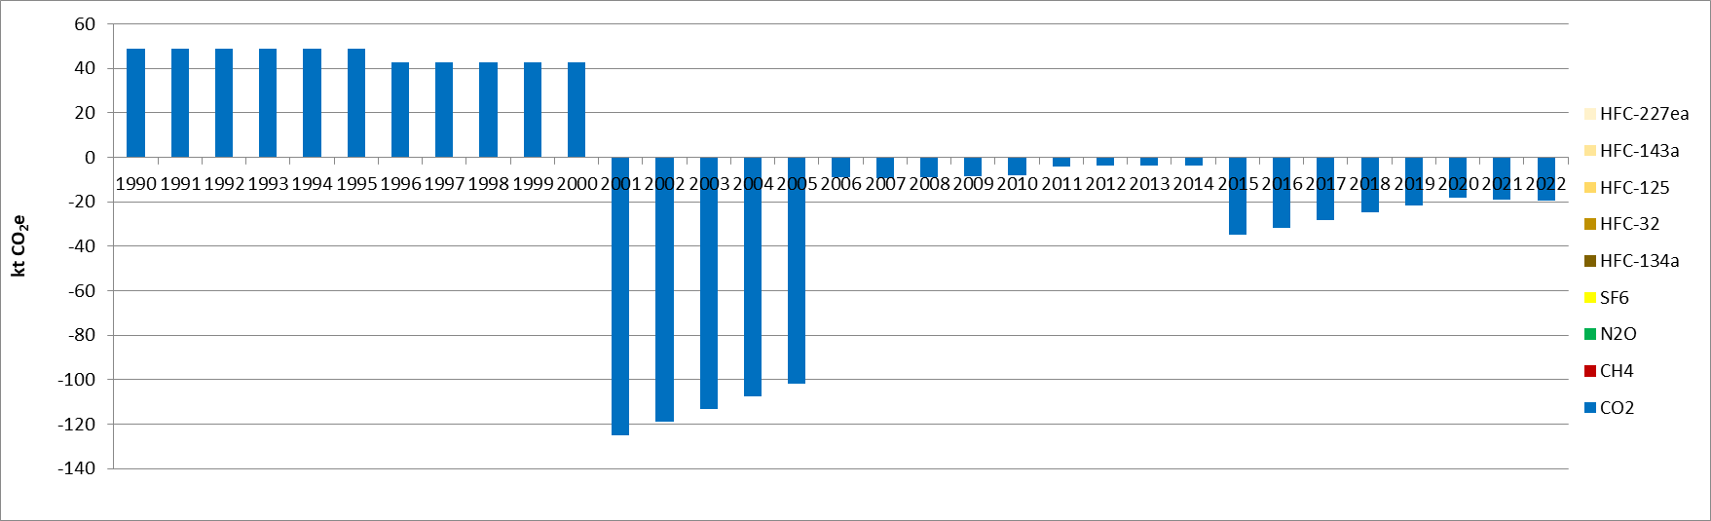
Figure 133: GHG emissions from cropland converted to grassland (CRT 4.C.2.2) (kt CO_{2e})
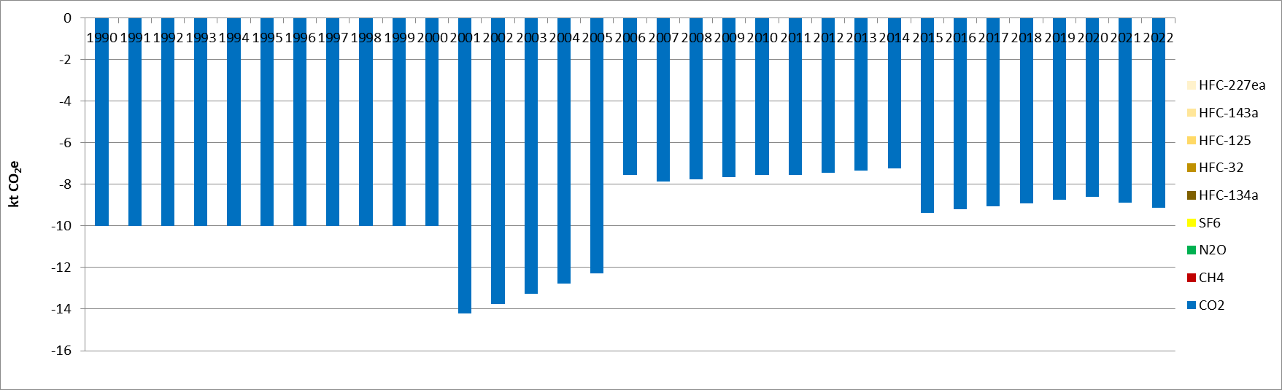
Figure 134: GHG emissions from wetlands converted to grassland (CRT 4.C.2.3) (kt CO_{2e})
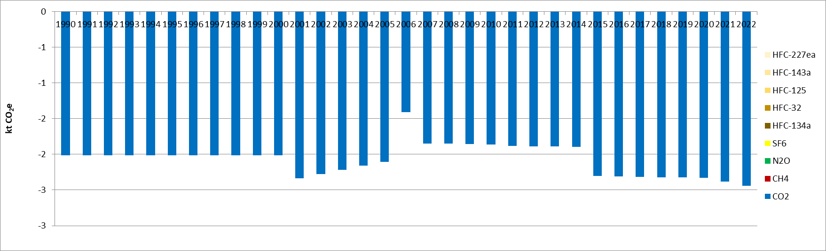
Figure 135: GHG emissions from settlements converted to grassland (CRT 4.C.2.4) (kt CO_{2e})
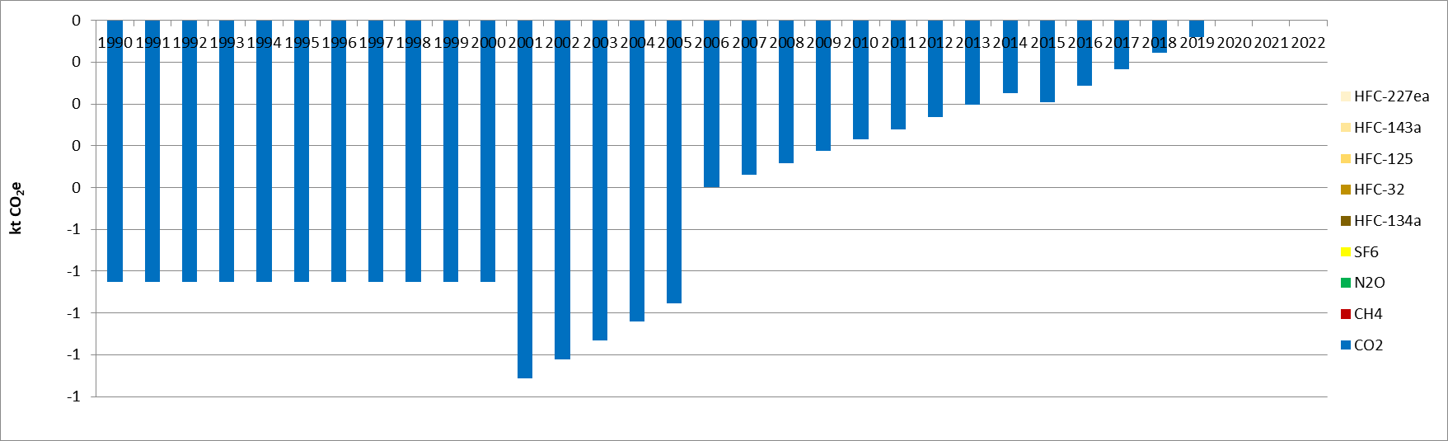
Figure 136: GHG emissions from other land converted to grassland (CRT 4.C.2.5) (kt CO_{2e})
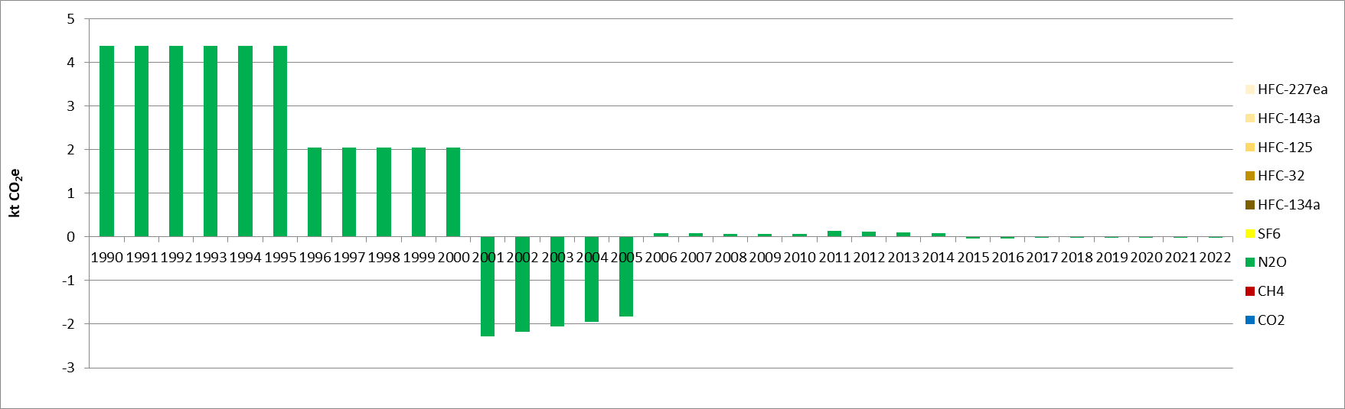
Figure 137: Direct N2O emissions from N mineralization/immobilization in grassland (CRT 4.C.2) (kt CO_{2e})

Methodological issues

Grasslands remaining grasslands (CRT 4C1)

Carbon stock changes
- Living biomass
On grassland remaining grassland equilibrium is assumed for living biomass, it is reported as not estimated in the Serbian inventory.
- Dead organic matter (dead wood, litter)
On grassland remaining grassland equilibrium is assumed for dead organic matter, it is reported as not estimated in the Serbian inventory.
- Soils (mineral and organic soils)
On grassland remaining grassland equilibrium is assumed for mineral soils, it is reported as not estimated in the Serbian inventory.

Direct N₂O Emissions from N Inputs to Managed Soils
Direct N₂O emissions from agriculture are already reported under the sector agriculture.

Emissions and removals from drainage and rewetting and other management of organic and mineral soils
Drainage and rewetting of organic and mineral soils are assumed to be not occurring in Serbia, thus related emissions and removals are reported as not occurring.

Direct N₂O Emissions from N Mineralization/Immobilization
No carbon losses are estimated from soils, thus direct N₂O Emissions from N Mineralization are reported as not occurring for grasslands remaining grasslands.

Indirect N₂O Emissions from Managed Soils
Indirect N₂O emissions from agriculture are already reported under the sector agriculture.

Biomass Burning
It is likely that some isolated controlled burning exists in Serbia but no data are available. Currently it is reported as not estimated.
Wildfires are estimated and it is considered that all wildfires are in category grasslands remaining grasslands.

Land converted to grasslands (CRT 4C2)

Carbon stock changes
- Living biomass
Fluxes on living biomass are estimated thanks to a stock-difference method and default carbon stocks from IPCC guidelines.
- Dead organic matter (dead wood, litter)
Emissions on land converted to grasslands are estimated for forest converted to grasslands. IPCC guidelines do not provide default value for deadwood but a value of 16tC/ha (Table 2.2) for litter. All emissions reported under land converted to grassland for dead organic matters are related to litter.
- Soils (mineral and organic soils)
It is assumed that in Serbia no organic soils exist in grasslands.
Fluxes on mineral soils are estimated thanks to a stock-difference method.

Direct N₂O Emissions from N Inputs to Managed Soils
Direct N₂O emissions from agriculture are already reported under the sector agriculture.

Emissions and removals from drainage and rewetting and other management of organic and mineral soils
Drainage and rewetting of organic and mineral soils are assumed to be not occurring in Serbia, thus related emissions and removals are reported as not occurring.

Direct N₂O Emissions from N Mineralization/Immobilization
Carbon losses are estimated from mineral soils, thus direct N₂O Emissions from N Mineralization are estimated in accordance with IPCC 2006 guidelines for land converted to grasslands.

Indirect N₂O Emissions from Managed Soils
Indirect N₂O emissions from agriculture are already reported under the sector agriculture.

Biomass Burning
It is likely that some isolated controlled burning exists in Serbia but no data are available. Currently it is reported as not estimated.
Wildfires are included elsewhere (in grasslands remaining grasslands).

Uncertainties and time-series consistency
Uncertainty estimate associated with activity data amounts to 10%, based on expert judgment.
Uncertainty estimates associated with emission factor are 50% for CO₂ and 100% for CH₄ and N₂O, based on expert judgement.
Combined uncertainties are51% for CO₂ emissions and 100% for CH₄ and N₂O emissions. The uncertainties combined in the national totals of emissions are of 0.001%, 0.002% and 0.002% for CO₂, CH₄ and N₂O, respectively in 2022, in the Republic of Serbia.

Category-specific QA/QC and verification
During the preparation of the inventory submission, activities related to quality control were mainly focused on completeness and consistency of emission estimates, and on proper use of notation keys in the CRT tables.

Category-specific recalculations
The current report is the first National Inventory Document for Serbia. Consequently, there is no recalculation. Possible recalculation will be occurred and estimated in the next submission if necessary.

Category-specific planned improvements
For all LULULUCF sector, land-use and land-use change areas monitoring needs to be improved, at least to include more recent CLC datasets available such as 2018 edition; and at best to revise the land-use monitoring approach for enhanced spatial precision, compatibility with forest definition, and temporal consistency.
Negative emissions of N₂O from mineralization will be corrected so that only emissions are reported.

Wetlands (CRT 4D)

Description
This category comprises GHG emissions and removals arising from wetlands.
In this category, emissions and absorptions are only estimated for land conversions. No emission estimation is calculated for croplands remaining croplands and for biomass burning (4.D.1). In addition, Lands converted to peat extraction (4.D.2.1) are not occurring (NO) in the Republic of Serbia, and the category Lands converted to flooded lands (4.D.2.2) is considered as included elsewhere (IE) in the Serbian inventory.
Hence, the emission evolution for lands converted to croplands (4.D.2.3) reflects the trend in land-use change areas. The following graphs give the GHG emission trend for the estimated categories. In overall, the GHG emissions from the Wetlands (4D) have been progressively and continuously reduced over the timeseries, and the achieved reduction is of 60%. This is mainly due to the decreasing area of wetlands from the category 4.D.2.3
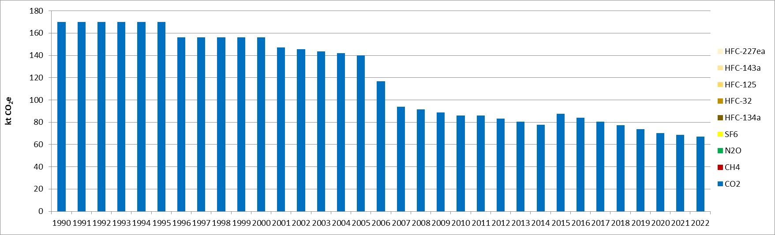
Figure 138: GHG emissions from land converted to other wetlands (CRT 4.D.2.3) (kt CO_{2e})
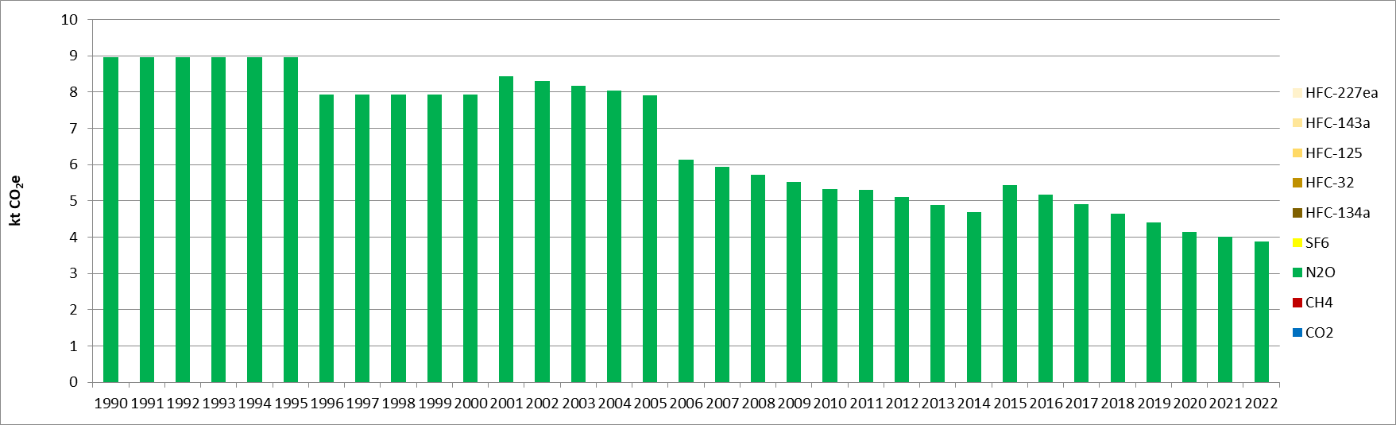
Figure 139: Direct N₂O emissions from N mineralization/immobilization in wetlands (CRT 4.D.2) (kt CO_{2e})

Methodological issues

Wetlands remaining wetlands (CRT 4D1)

Carbon stock changes
- Living biomass
Living biomass emissions from peat extraction are not occurring, because there is no peat extraction in Serbia.
Living biomass emissions for flooded and other wetlands are not estimated. Equilibrium is assumed, no stock variations are occurring in this category. Also no information on changes is available.
- Dead organic matter (dead wood, litter)
Dead organic matter emissions from peat extraction are not occurring, because there is no peat extraction in Serbia.
Dead organic matter emissions for flooded and other wetlands are not estimated. Equilibrium is assumed, no stock variations are occurring in this category. Also, no information on changes is available.
- Soils (mineral and organic soils)
Mineral and organic soil emissions from peat extraction are not occurring, because there is no peat extraction in Serbia.
Mineral soil emissions are not estimated and not occurring for organic soils. It is assumed that in Serbia no organic soils exist in grasslands. For mineral soils no stock variations are occurring in this category and no information related to stock variations are available.

Direct N₂O Emissions from N Inputs to Managed Soils
It is assumed that no other land but agricultural land is fertilized in Serbia, thus direct N₂O emissions are reported as not occurring.

Emissions and removals from drainage and rewetting and other management of organic and mineral soils
Drainage and rewetting of organic and mineral soils are assumed to be not occurring in Serbia, thus related emissions and removals are reported as not occurring.

Direct N₂O Emissions from N Mineralization/Immobilization
No carbon losses are estimated from soils, thus direct N₂O Emissions from N Mineralization are reported as not occurring for wetlands remaining wetlands.

Indirect N₂O Emissions from Managed Soils
No direct N₂O emissions are estimated on these areas, thus indirect N₂O emissions from soils are also assumed as not occurring.

Biomass Burning
It is assumed that no biomass burning is occurring on this type of land.

Land converted to wetlands (CRT 4D2)

Carbon stock changes
- Living biomass
There is no peat extraction in Serbia, thus emissions from peat extraction are reported as not occurring.
All losses from flooded and other wetlands are reported under land converted to other wetlands.
- Dead organic matter (dead wood, litter)
There is no peat extraction in Serbia, thus emissions from peat extraction are reported as not occurring.
All losses from flooded and other wetlands are reported under land converted to other wetlands.
- Soils (mineral and organic soils)
It is assumed that in Serbia no organic soils exist in wetlands.
There is no peat extraction in Serbia, thus emissions from peat extraction are reported as not occurring.
All losses from flooded and other wetlands are reported under land converted to other wetlands.

Direct N₂O Emissions from N Inputs to Managed Soils
It is assumed that no other land but agricultural land is fertilized in Serbia, thus direct N₂O emissions are reported as not occurring.

Emissions and removals from drainage and rewetting and other management of organic and mineral soils
Drainage and rewetting of organic and mineral soils are assumed to be not occurring in Serbia, thus related emissions and removals are reported as not occurring.

Direct N₂O Emissions from N Mineralization/Immobilization
Carbon losses are estimated from mineral soils, thus direct N₂O Emissions from N Mineralization are estimated in accordance with IPCC 2006 guidelines for land converted to wetlands.

Indirect N₂O Emissions from Managed Soils
Indirect N₂O emissions from soils are currently not estimated in the Serbian inventory.

Biomass Burning
It is assumed that no biomass burning is occurring on this type of land.

Uncertainties and time-series consistency
Uncertainty estimate associated with activity data amounts to 10%, based on expert judgment.
Uncertainty estimates associated with emission factor are 70% for CO₂ and 100% for N₂O, based on expert judgement.
Combined uncertainties are 71% for CO₂ emissions and 100% for N₂O emissions. The uncertainties combined in the national totals of emissions are of 0.08% and 0.007% for CO₂ and N₂O, respectively in 2022, in the Republic of Serbia.

Category-specific QA/QC and verification
During the preparation of the inventory submission, activities related to quality control were mainly focused on completeness and consistency of emission estimates, and on proper use of notation keys in the CRT tables.

Category-specific recalculations
The current report is the first National Inventory Document for Serbia. Consequently, there is no recalculation. Possible recalculation will be occurred and estimated in the next submission if necessary.

Category-specific planned improvements
For all LULULUCF sector, land-use and land-use change areas monitoring needs to be improved, at least to include more recent CLC datasets available such as 2018 edition; and at best to revise the land-use monitoring approach for enhanced spatial precision, compatibility with forest definition, and temporal consistency.

Settlements (CRT 4E)

Description
This category comprises GHG emissions and removals arising from settlements.
In this category, emissions and absorptions are only estimated for land conversions. No emission estimation is calculated for croplands remaining croplands and for biomass burning (4.E.1).
The emission evolution for lands converted to croplands (4.E.2) reflects the trend in land-use change areas. The following graphs give the GHG emission trend for the estimated categories. Overall, the GHG emissions from the land-use change in settlements (4E) are rather stable from 1990 to 2000, before increasing rapidly in 2001 (+80% compared with 2000) and reaching another plateau until 2006. In 2007, another sudden increase but smaller is observed (+12% compared with 2006), before being rather stable from 2007 to 2022, although a progressive and continuous growth in emissions is observed. In total, over the whole timeseries, the GHG emissions from settlements have slightly more than doubled (+105%).
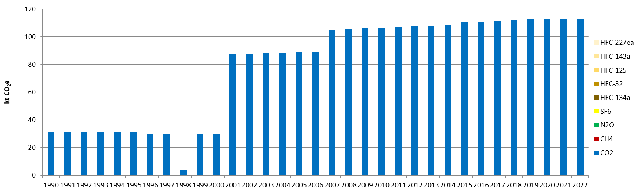
Figure 140: GHG emissions from forest land converted to settlements (CRT 4.E.2.1) (kt CO_{2e})
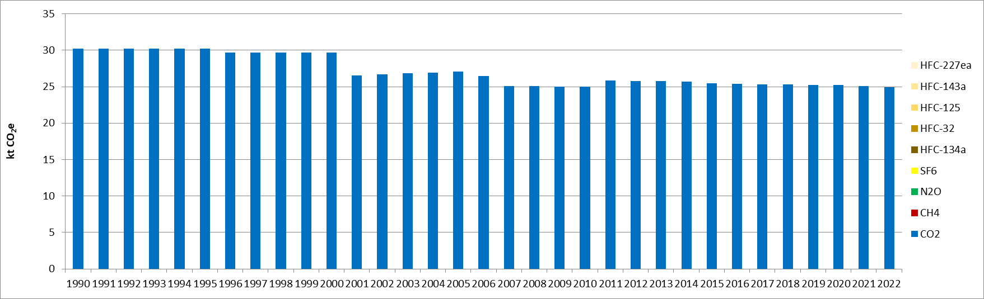
Figure 141: GHG emissions from cropland converted to settlements (CRT 4.E.2.2) (kt CO_{2e})
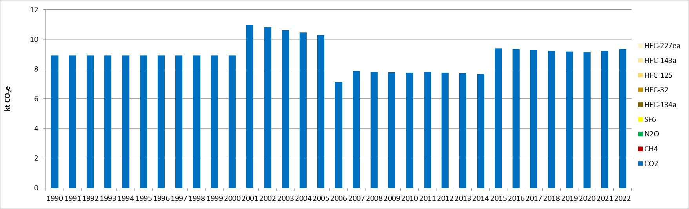
Figure 142: GHG emissions from grassland converted to settlements (CRT 4.E.2.3) (kt CO_{2e})
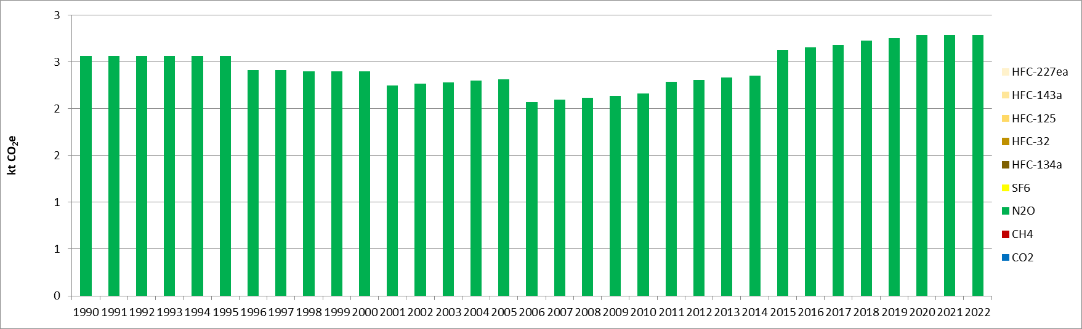
Figure 143: Direct N₂O emissions from N mineralization/immobilization in settlements (CRT 4.E.2) (kt CO_{2e})

Methodological issues

Settlements remaining settlements (CRT 4E1)

Carbon stock changes
- Living biomass
On settlement remaining settlement equilibrium is assumed for living biomass, it is reported as not estimated in the Serbian inventory.
- Dead organic matter (dead wood, litter)
On settlement remaining settlement equilibrium is assumed for dead organic matter, it is reported as not estimated in the Serbian inventory.
- Soils (mineral and organic soils)
On settlement remaining settlement equilibrium is assumed for mineral soils, it is reported as not estimated in the Serbian inventory.

Direct N₂O Emissions from N Inputs to Managed Soils
It is assumed that no other land but agricultural land is fertilized in Serbia, thus direct N₂O emissions are reported as not occurring.

Emissions and removals from drainage and rewetting and other management of organic and mineral soils
Drainage and rewetting of organic and mineral soils are assumed to be not occurring in Serbia, thus related emissions and removals are reported as not occurring.

Direct N₂O Emissions from N Mineralization/Immobilization
No carbon losses are estimated from soils, thus direct N₂O Emissions from N Mineralization are reported as not occurring for settlements remaining settlements.

Indirect N₂O Emissions from Managed Soils
No direct N₂O emissions are estimated on these areas, thus indirect N₂O emissions from soils are also assumed as not occurring.

Biomass Burning
It is assumed that no biomass burning is occurring on this type of land.

Land converted to settlements (CRT 4E2)

Carbon stock changes
- Living biomass
Fluxes on living biomass are estimated thanks to a stock-difference method and default carbon stocks from IPCC guidelines.
- Dead organic matter (dead wood, litter)
Emissions on land converted to settlements are estimated for forest converted to settlements. IPCC guidelines do not provide default value for deadwood but a value of 16tC/ha (Table 2.2) for litter. All emissions reported under land converted to settlements for dead organic matters are related to litter.
- Soils (mineral and organic soils)
It is assumed that, in the Republic of Serbia, no organic soil exists in settlements.
Fluxes on mineral soils are estimated thanks to a stock-difference method.

Direct N₂O Emissions from N Inputs to Managed Soils
It is assumed that no other land but agricultural land is fertilized in Serbia, thus direct N₂O emissions are reported as not occurring.

Emissions and removals from drainage and rewetting and other management of organic and mineral soils
Drainage and rewetting of organic and mineral soils are assumed to be not occurring in Serbia, thus related emissions and removals are reported as not occurring.

Direct N₂O Emissions from N Mineralization/Immobilization
Carbon losses are estimated from mineral soils, thus direct N₂O Emissions from N Mineralization are estimated in accordance with IPCC 2006 guidelines for land converted to settlements.

Indirect N₂O Emissions from Managed Soils
Indirect N₂O emissions from soils are currently not estimated in the Serbian inventory.

Biomass Burning
It is assumed that no biomass burning is occurring on this type of land.

Uncertainties and time-series consistency
Uncertainty estimate associated with activity data amounts to 10%, based on expert judgment.
Uncertainty estimates associated with emission factor are 30% for CO₂ and 100% for N₂O, based on expert judgement.
Combined uncertainties are 32% for CO₂ emissions and 100% for N₂O emissions. The uncertainties combined in the national totals of emissions are of 0.08% and 0.005% for CO₂ and N₂O, respectively in 2022, in the Republic of Serbia.

Category-specific QA/QC and verification
During the preparation of the inventory submission, activities related to quality control were mainly focused on completeness and consistency of emission estimates, and on proper use of notation keys in the CRT tables.

Category-specific recalculations
The current report is the first National Inventory Document for Serbia. Consequently, there is no recalculation. Possible recalculation will be occurred and estimated in the next submission if necessary.

Category-specific planned improvements
For all LULUCF sector, land-use and land-use change areas monitoring needs to be improved, at least to include more recent CLC datasets available such as 2018 edition; and at best to revise the land-use monitoring approach for enhanced spatial precision, compatibility with forest definition, and temporal consistency.

Other lands (CRT 4F)

Description
This category comprises GHG emissions and removals arising from other lands.
In this category, emissions and absorptions are only estimated for land conversions. No emission estimation is calculated for croplands remaining croplands and for biomass burning (4F1).
The emission evolution for lands converted to croplands (4.F.2) reflects the trend in land-use change areas. The emissions follow the trend of the category “forest land converted to other land” (4.F.2.1). After being rather stable from 1990 to 2006, they decreased for the period 2001 to 2006, until increasing significantly in 2007 (about 11 times more important). Since 2007, the emissions increase progressively, by 41% in 2022 compared with 2007, as the area of forest being converted to other lands grows.
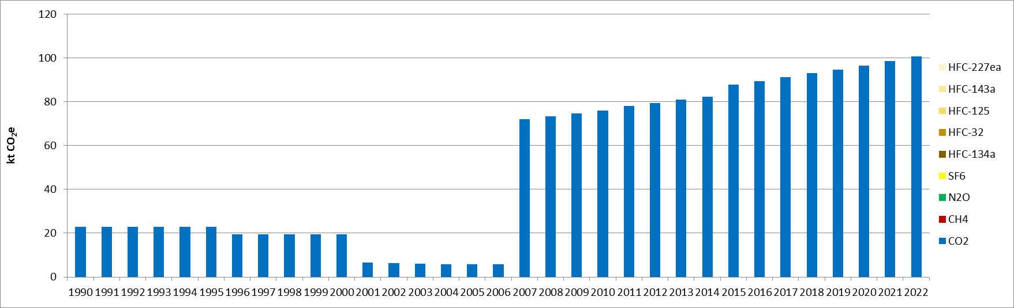
Figure 144: GHG emissions from forest land converted to other land (CRT 4.F.2.1) (kt CO_{2e})
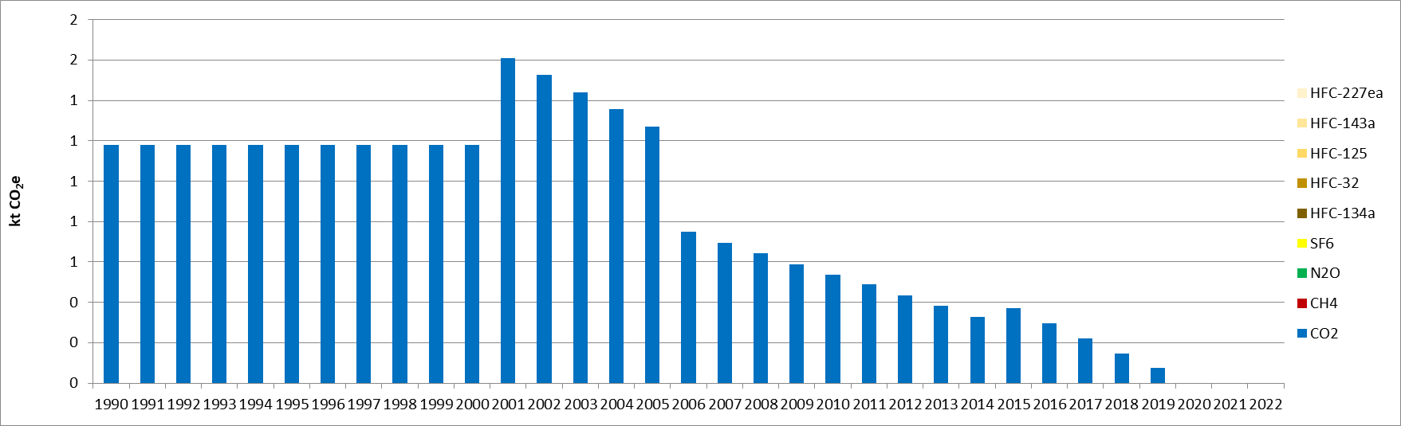
Figure 145: GHG emissions from grassland converted to other land (CRT 4.F.2.3) (kt CO_{2e})
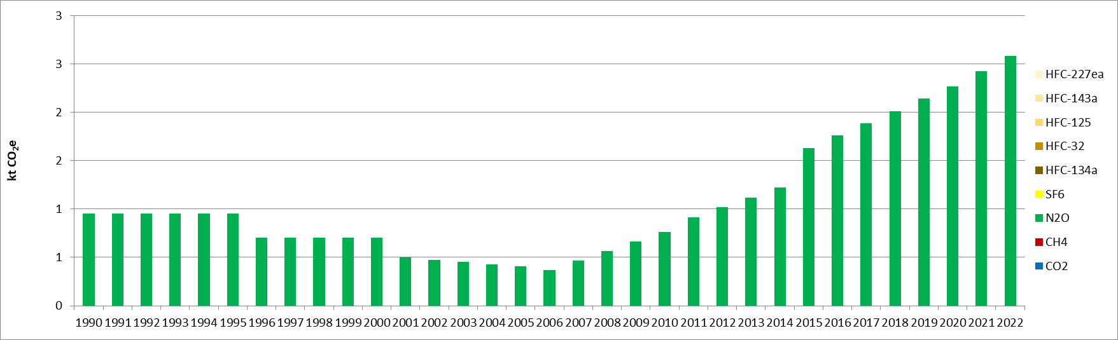
Figure 146: Direct N2O emissions from N mineralization/immobilization in other lands (CRT 4.F.2) (kt CO2e)

Methodological issues

Other lands remaining other lands (CRT 4F1)

Carbon stock changes
- Living biomass
On other lands remaining other lands equilibrium is assumed for living biomass, it is reported as not estimated in the Serbian inventory.
- Dead organic matter (dead wood, litter)
On other lands remaining other lands equilibrium is assumed for dead organic matter, it is reported as not estimated in the Serbian inventory.
- Soils (mineral and organic soils)
On other lands remaining other lands equilibrium is assumed for mineral soils, it is reported as not estimated in the Serbian inventory.

Direct N₂O Emissions from N Inputs to Managed Soils
It is assumed that no other land but agricultural land is fertilized in Serbia, thus direct N₂O emissions are reported as not occurring.

Emissions and removals from drainage and rewetting and other management of organic and mineral soils
Drainage and rewetting of organic and mineral soils are assumed to be not occurring in Serbia, thus related emissions and removals are reported as not occurring.

Direct N₂O Emissions from N Mineralization/Immobilization
No carbon losses are estimated from soils, thus direct N₂O Emissions from N Mineralization are reported as not occurring for other lands remaining other lands.

Indirect N₂O Emissions from Managed Soils
No direct N₂O emissions are estimated on these areas, thus indirect N₂O emissions from soils are also assumed as not occurring.

Biomass Burning
It is assumed that no biomass burning is occurring on this type of land.

Land converted to other lands (4.F.2)

Carbon stock changes
- Living biomass
Fluxes on living biomass are estimated thanks to a stock-difference method and default carbon stocks from IPCC guidelines.
- Dead organic matter (dead wood, litter)
Emissions on land converted to other lands are estimated for forest converted to other lands. IPCC guidelines do not provide default value for deadwood but a value of 16tC/ha (Table 2.2) for litter. All emissions reported under land converted to other lands for dead organic matters are related to litter.
- Soils (mineral and organic soils)
It is assumed that in Serbia no organic soils exist in other lands.
Fluxes on mineral soils are estimated thanks to a stock-difference method.

Direct N₂O Emissions from N Inputs to Managed Soils
It is assumed that no other land but agricultural land is fertilized in Serbia, thus direct N₂O emissions are reported as not occurring.

Emissions and removals from drainage and rewetting and other management of organic and mineral soils
Drainage and rewetting of organic and mineral soils are assumed to be not occurring in Serbia, thus related emissions and removals are reported as not occurring.

Direct N₂O Emissions from N Mineralization/Immobilization
Carbon losses are estimated from mineral soils, thus direct N₂O Emissions from N Mineralization are estimated in accordance with IPCC 2006 guidelines for land converted to other lands.

Indirect N₂O Emissions from Managed Soils
Indirect N₂O emissions from soils are currently not estimated in the Serbian inventory.

Biomass Burning
It is assumed that no biomass burning is occurring on this type of land.

Uncertainties and time-series consistency
Uncertainty estimate associated with activity data amounts to 10%, based on expert judgment.
Uncertainty estimates associated with emission factor are 80% for CO₂. For N2O, the uncertainty estimate for the emission factor has not been determined for this submission.
Combined uncertainties are 81% for CO₂ emissions. The uncertainty combined in the national totals of emissions is of 0.4% in 2022, in the Republic of Serbia.

Category-specific QA/QC and verification
During the preparation of the inventory submission, activities related to quality control were mainly focused on completeness and consistency of emission estimates, and on proper use of notation keys in the CRT tables.

Category-specific recalculations
The current report is the first National Inventory Document for Serbia. Consequently, there is no recalculation. Possible recalculation will be occurred and estimated in the next submission if necessary.

Category-specific planned improvements
For all LULULUCF sector, land-use and land-use change areas monitoring needs to be improved, at least to include more recent CLC datasets available such as 2018 edition; and at best to revise the land-use monitoring approach for enhanced spatial precision, compatibility with forest definition, and temporal consistency.

Harvested wood products (CRT 4G)

Description
This category includes GHG emissions and removals arising from biomass which is harvested in order to produce wood products, and hence sequester the CO₂, until its end-of use where it is released. Only CO₂ fluxes are applicable to this category.
The following graph gives the evolution of the annual amounts of harvested wood products (HWP), in carbon mass produced (tonnes of C), from domestic harvest. The three different types of products considered are sawnwood, wood-based panels, and paper and paperboard. In total, the carbon mass produced from domestic HWP increases continuously for the period 1990-2019, until slightly decreasing. In 2022, the amount of carbon mass produced is 78% superior to the level of 1990. All different types of products have increased over the studied period, by 36% for sawnwood, by 223% for wood-based panels and by 78% for paper and paperboard. In 2022, the amounts of carbon mass produced from domestic HWP are rather evenly spread between the different product types: 37% for sawnwood, 25% for wood-based panels and 38% for paper and paperboard.
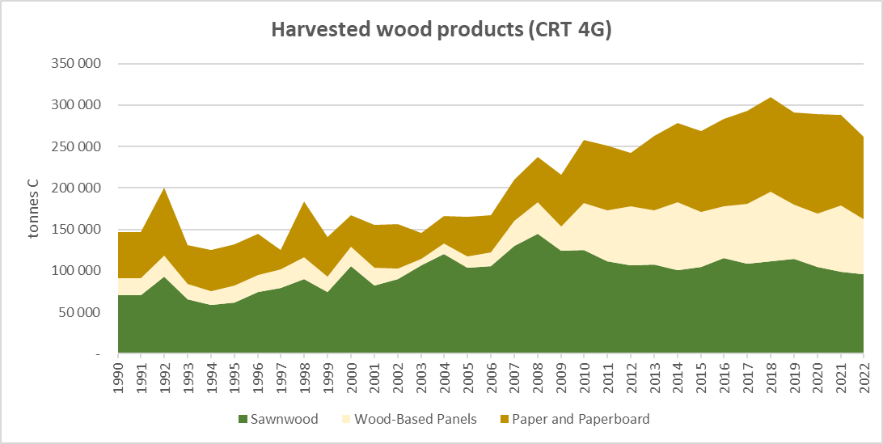
Figure 147: Carbon mass produced from domestic harvested wood products (CRT 4G), per product type (in t C)
The emissions from harvested wood products are given in the following graph. Some fluctuations are observed between 1990 to 2004, where most of the years the balances are net removals of CO₂ but, for some years, some net emissions are reported. The emission removals for the years 1993 and 1999 are particularly elevated, following the high levels of harvest wood products from 1992 and 1998 (see previous figure). Then, the net removals increased from 2008 onwards, following the higher level of harvesting observed starting from 2007. In total, the net removals have increased by 391% between 1990 and 2022.
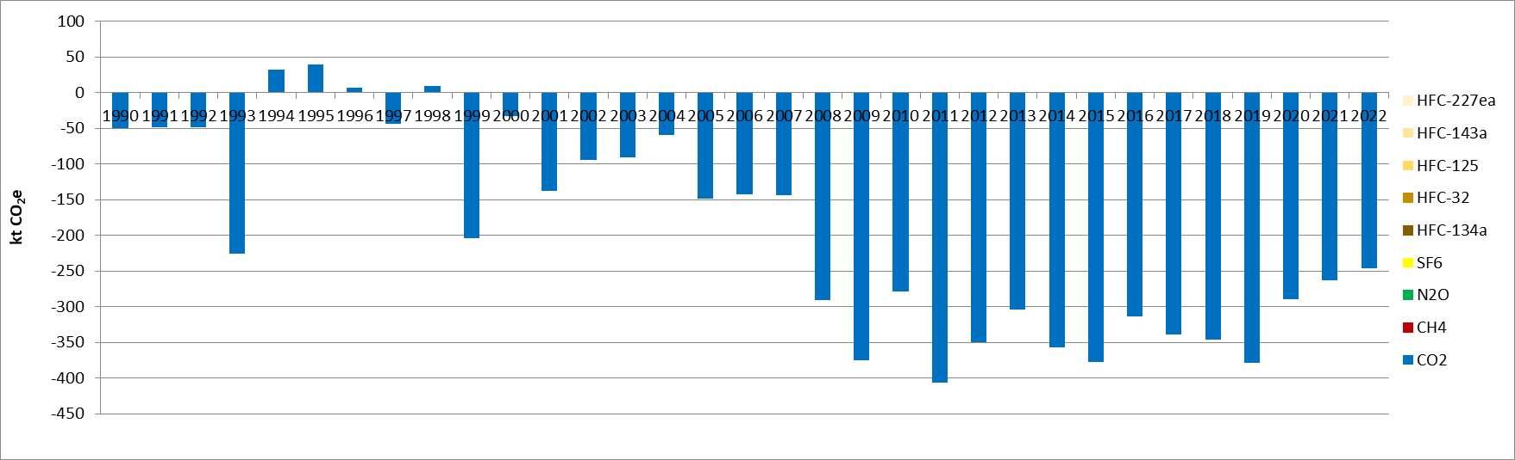
Figure 148: GHG emissions from harvested wood products (CRT 4G) (kt CO_{2e})

Methodological issues
GHG emissions from harvested wood products are calculated based on 2013 Revised Supplementary Methods and Good Practice Guidance Arising from the Kyoto Protocol.
Activity data used are the annual quantities of sawnwood, wood-based panels and paper and paperboard produced, imported and exported, which are taken from FAOSTAT [L1].
The emission factors and other parameters used to estimate the emissions are taken from the 2013 KP Supplement. The default values for densities, carbon conversion factors and half-lives, depending on the product type, are given in the following table.
Table 44: Default parameters for emission estimation, for harvested wood products (CRT 4G), used in Serbian inventory
Wood product | Density  (t/unit of product) | Carbon conversion factor  (t C/unit of product) | Half lives  (years)
Sawnwood (m³) | 0.458 | 0.229 | 35
Wood-based panels (m³) | 0.595 | 0.269 | 25
Paper and paperboard (t) | 0.9 | 0.386 | 2

Uncertainties and time-series consistency
Uncertainty estimate associated with activity data amounts to 10%, based on expert judgment.
Uncertainty estimate associated with emission factor is 100% for CO₂.
Combined uncertainty is 100% for CO₂ emissions. The uncertainty combined in the national totals of emissions is of 0.4% in 2022, in the Republic of Serbia.

Category-specific QA/QC and verification
During the preparation of the inventory submission, activities related to quality control were mainly focused on completeness and consistency of emission estimates, and on proper use of notation keys in the CRT tables.

Category-specific recalculations
The current report is the first National Inventory Document for Serbia. Consequently, there is no recalculation. Possible recalculation will be occurred and estimated in the next submission if necessary.

Category-specific planned improvements
Refined approach using national parameters could be implemented for this sector.

Chapter 7: Waste (CRT sector 5)

Overview of sector
In the Republic of Serbia, the Waste sector (CRT 5) includes the emissions from the following activities:
- Solid waste disposal (5.A) for managed waste (5.A.1),
- Wastewater treatment and discharge (5.D), including domestic (5.D.1) and industrial (5.D.2) wastewater.
There is no incineration of waste (5.C.1) in the Republic of Serbia for the studied period, neither composting (5.B.1) or biogas production (5.B2.). Open burning of waste (5.C.2) may occur in rural areas but there is no data about this practice and no estimations (“NE”) for the emissions of this sector in the current inventory.
Among the different GHG, only CH₄ and N₂O emissions are estimated for the Waste sector. In 2022, the CRT 5 contributes to 36% of the national CH₄ emissions and 3.8% of the national totals of N₂O, excluding LULUCF contribution. In 1990, the share in the national emissions for the methane was smaller (34%), meanwhile the share for N₂O was slightly higher (4.9%). Hence, the waste sector is particularly preponderant in the Serbian methane emissions. In terms of GHG contribution, the waste sector accounts for slightly more than 5% of the national emissions in 1990 and in 2022, and on average on the timeseries (with a maximum at 7%). For the sector CRT 5, the methane emissions are predominant and represent more than 97% of the emissions for the waste.
The following graph presents the GHG emission trend for the CRT 5.
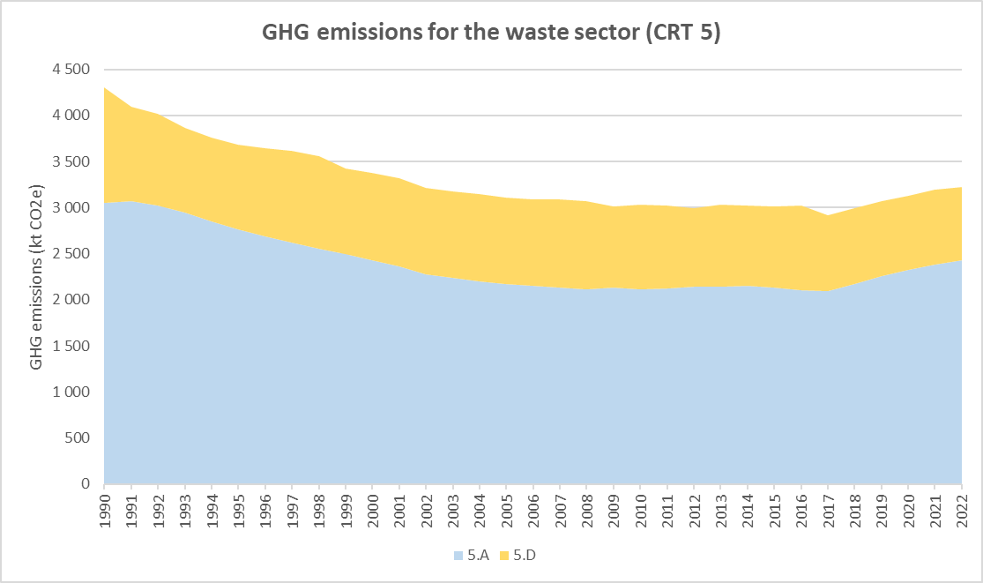
Figure 149: GHG emission trends for waste (CRT 5), for the period 1990-2022 (in kt CO₂e)

The trend of GHG emissions for the waste sector is rather stable and does not present significant and rapid changes related to events such as wars, economic crisis or meteorological phenomena (floodings, drought, etc.). This is not the case for subsectors related to industrial activity but the only here (5D2) is rather marginal in weight in the sector emissions. The emissions are observed to be slightly but progressively declining between 1990 and 2009 (-30%), before being rather constant until 2018. Then, from 2018 onwards, the emissions progressively and slowly increase until 2022, in particular due to the increase of solid waste disposal activity, but reach lower emission levels than in 1990. Overall, the CRT 5 GHG emissions have been reduced by 25% between 1990 and 2022, due to emission reductions in both categories.
In 2022, GHG emissions from Sector 5 Waste amounted to 3.2 Mt CO₂e, compared to 4.3 Mt CO₂e in 1990.
The following graph presents the GHG emission distribution between the different emission sources from the waste sector. The emissions from all subsectors decreased between 1990 and 2022, but to different orders of magnitude, hence the distribution of emissions also changed. Overall, the activity of managed waste disposal (5A1) is predominant for the sector GHG emissions, and its contribution increases from 71% in 1990 to 75% in 2022. The other major emission source is the domestic wastewater treatment (5D1), which is responsible for 24% of the sector GHG emissions in 1990 and 22% in 2022. Finally, the industrial wastewater treatment (5D2), which contributed to 5% of the sector emissions in 1990, has seen its share divided by 2 over the timeseries.
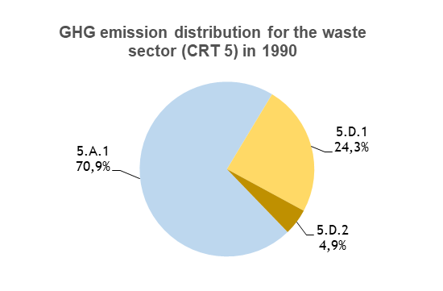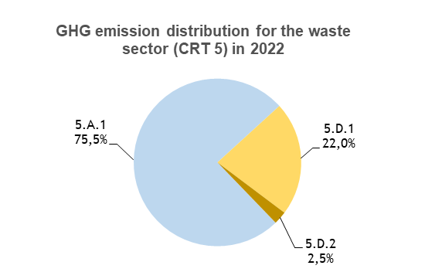
Figure 150: GHG emission distribution for waste sector (CRT 5), for the period 1990-2022, per subcategory (in %)

Managed waste disposal sites (CRFT 5A1)

Category description
The category of the disposal of managed waste (5.A.1) is responsible of emissions of methane (CH₄), and of biogenic CO₂, which is not reported in the national totals.
In 2022, the CRT category 5.A.1 Managed Waste Disposal Sites is a key category for CH₄ emissions in the Republic of Serbia, both in terms of emission levels as well as emission trend. This sector contributes to 3.9% in terms of emissions level without LULUCF (rank 4) and 0.4% in terms of trend (rank 46).
The evolution of the emissions is presented in the following graph. Three distinct phases can be observed: a gradual emission reduction from 1991 to 2007 (-31%), a stagnation between 2008 and 2017, before a progressive increase from 2018 to 2022 (+12%). In total, the methane emissions have been reduced by 20% over the whole timeseries.
The managed industrial waste, which contributed to 44% of the emissions of the CRT 5.A.1 in 1990, is responsible for an important part of this reduction, with a decrease of its emissions by 70% between 1990 and 2015, due to a large reduction of the amounts of industrial waste deposited in disposal sites for 1990-2014 (-87%), although some important variations are observed over the period. In particular, there has been a huge drop in the amount of industrial waste disposed between 1990 and 1993 (-80%), due to the fall in GDP and in the waste generation rate, in relation with the war and the hyperinflation in that period. Nevertheless, the emissions decrease in a less drastic way but more progressively, as it depends on the kinetic of degradation of the waste.
For domestic waste, the amounts being deposited to landfill vary directly proportional to the population, which varies less rapidly, although a significant reduction of 20% is observed between 1990 and 1991. For the rest of the studied period, the population decreases continuously and slowly, and the overall reduction is of 15% for 1991-2022. In addition, the amount of domestic waste deposited varies depending on the annual waste generation rate per inhabitant. This latter is constant from 1990 to 2008, varies slightly up to 2013, before decreasing significantly from 2013 to 2015 (-24%), before increasing significantly in 2017 (+50% compared with 2016), and then slightly but progressively increasing between 2018 and 2022 (+20%, see Table 45). As a consequence, after a sudden drop of 20% in 1991, compared with 1990, a progressive but slow decline of 8% is observed in the total amounts of domestic waste deposited for the period 1991-2015. Then, in 2017, a rapid increase is observed compared with 2016, of +47%, mostly based on the generation rate. Finally, for the period 2017-2022, the slow reduction in the Serbian population does not compensate the increase of the generation rate, hence the amount of domestic waste disposed into landfill increases by 18%. In terms of methane emissions generated, the domestic waste, which accounted for 59% of the CRT 5.A.1 emissions in 1990, has a share of 84% of the emissions in 2022.
The emissions presented in the graph below evolve according to a mix of the different analyses given above, about the evolution of the amounts of industrial and domestic waste, as well as the fact that from 2002 onwards, 10% of the waste disposed are considered to be managed in an anaerobic manner, due to the first landfill site compliant with the EC regulation which has been built.
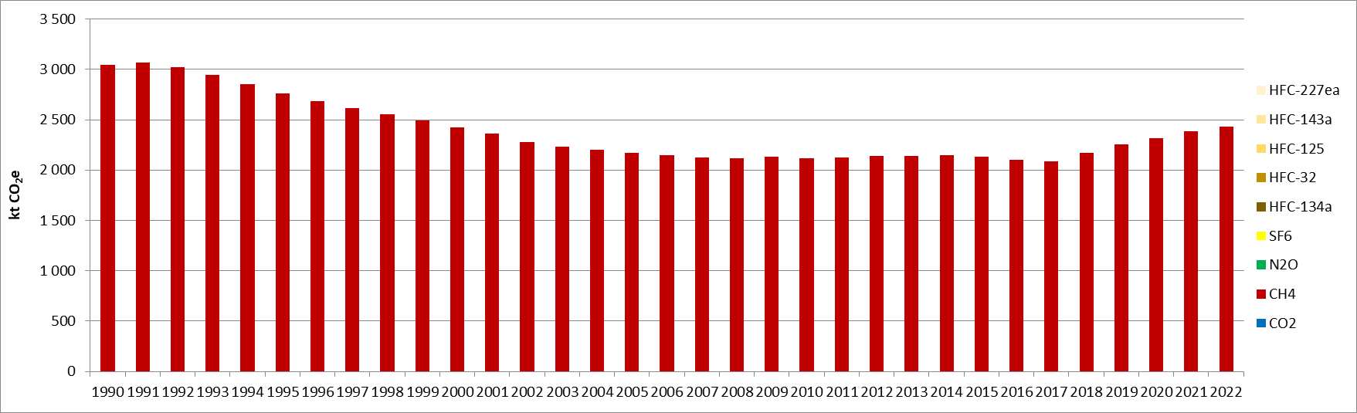
Figure 151: GHG emissions for managed waste disposal sites (kt CO₂e)
The first landfill compliant with the EC regulation has been built in 2002. These landfills received municipal solid waste as well as commercial and industrial waste.

Methodological issues
A Tier 1 methodology recommended by the 2006 IPCC Guidelines is applied. The IPCC Waste Software proposed by the IPCC is implemented, more especially the “waste by composition” approach.
As far as possible country-specific parameters have been used as input data in the IPCC Waste Software.

Municipal Solid Waste (MSW)

Population and fraction of urban population
National data on population used in the Serbian inventory are from Statistical Office.
Concerning waste disposal, the Serbian inventory has been developed to allow a distinction between urban and rural population. Anyway, up to now national data are not precise enough and the same average generation rate is applied to urban and rural population.

Municipal Solid Waste (MSW) generation rate
The Serbian generation rate is based on national data. SEPA collects annual data on the average coverage of waste collection (fraction of generated MSW going to landfills) and the amount of waste reported from municipal companies in local self-governments in accordance with the Rulebook on the Form of daily records and annual report on waste (Official Gazette of RS, number 95/10). In accordance with the Rulebook on the methodology for collecting data on composition and quantities municipal waste in the territory of the local self-government unit (Official Gazette of the Republic of Serbia, No. 61/2010), local governments have an obligation to conduct four times a year analyses of quantities and composition of municipal waste on its territory.
Table 45: MSW generation rate, for the period 1990-2022, used in the Serbian inventory (in kg/inhabitant/year)
Year | Generation rate (kg /inhab./year)
1950-2008 | 350
2009 | 360
2010 | 360
2011 | 370
2012 | 360
2013 | 340
2014 | 300
2015 | 260
2016 | 270
2017 | 390
2018 | 401
2019 | 405
2020 | 419
2021 | 416
2022 | 467
The regional default value proposed in the 2006 IPCC Guidelines (Vol 5, Chap 2, table 3.3) is 380 kg/inhabitant/year in the 2000th, which is quite consistent with the country-specific historical values. It has to be noted that Serbia’s MSW generation rate is increasing due to growth in purchase power and increase in urban population.

Fraction of generated MSW going to landfills (% to SWDS)
The fraction of generated MSW going to landfills is based on national data, provided in the described manner.
Table 46: Fraction of generated MSW going to landfills, for the period 1990-2022, used in the Serbian inventory (in %)
Year | % to SWDS
1950-2008 | 60.0%
2009 | 60.0%
2010 | 72.0%
2011 | 77.0%
2012 | 70.0%
2013 | 80.0%
2014 | 80.0%
2015 | 82.0%
2016 | 82.0%
2017 | 83.7%
2018 | 87.2%
2019 | 86.2%
2020 | 86.4%
2021 | 88.0%
2022 | 87.0%

In absence of further information, these fractions are applied both in urban and rural areas.
The regional default value proposed in the 2006 IPCC Guidelines (Vol 5, Chap 2, table 3.3) is 90% in the 2000th.

MSW disposed in landfills
The amount of MSW disposed in landfills is estimated based on the parameters presented above and evolves as follows.
Table 47: Evolution of the amount of MSW disposed in landfills, for the period 1990-2022, in the Republic of Serbia (in kt)
Year | MSW in landfills (Gg) | Year | MSW in landfills (Gg) | Year | MSW in landfills (Gg) | Year | MSW in landfills (Gg)
1950 | 1,414.1 | 1970 | 1,760.9 | 1990 | 2,049.0 | 2010 | 1,889.8
1951 | 1,433.5 | 1971 | 1,777.9 | 1991 | 1,643.3 | 2011 | 2,067.8
1952 | 1,449.0 | 1972 | 1,794.5 | 1992 | 1,644.7 | 2012 | 1,814.1
1953 | 1,469.8 | 1973 | 1,809.6 | 1993 | 1,646.6 | 2013 | 1,947.5
1954 | 1,491.6 | 1974 | 1,826.4 | 1994 | 1,648.3 | 2014 | 1,711.2
1955 | 1,514.3 | 1975 | 1,843.6 | 1995 | 1,649.8 | 2015 | 1,511.6
1956 | 1,529.2 | 1976 | 1,861.7 | 1996 | 1,647.2 | 2016 | 1,561.8
1957 | 1,544.6 | 1977 | 1,879.5 | 1997 | 1,643.9 | 2017 | 2,291.5
1958 | 1,559.3 | 1978 | 1,896.3 | 1998 | 1,639.5 | 2018 | 2,440.7
1959 | 1,576.7 | 1979 | 1,912.5 | 1999 | 1,634.0 | 2019 | 2,419.3
1960 | 1,592.4 | 1980 | 1,937.7 | 2000 | 1,626.9 | 2020 | 2,487.0
1961 | 1,609.4 | 1981 | 1,959.7 | 2001 | 1,622.7 | 2021 | 2,488.3
1962 | 1,627.1 | 1982 | 1,970.9 | 2002 | 1,575.0 | 2022 | 2,698.3
1963 | 1,644.7 | 1983 | 1,981.6 | 2003 | 1,570.8
1964 | 1,660.9 | 1984 | 1,992.7 | 2004 | 1,567.2
1965 | 1,678.7 | 1985 | 2,003.2 | 2005 | 1,562.4
1966 | 1,696.8 | 1986 | 2,013.5 | 2006 | 1,556.3
1967 | 1,712.8 | 1987 | 2,022.7 | 2007 | 1,550.0
1968 | 1,729.4 | 1988 | 2,023.1 | 2008 | 1,543.5
1969 | 1,745.5 | 1989 | 2,041.0 | 2009 | 1,581.1

Waste composition
The MSW composition is based on national data, through the project "Determination of waste composition and quantity estimation in order to define a management strategy secondary raw materials within the sustainable development of the Republic of Serbia ". Methodology for estimating the generated quantities and composition of municipal waste used, is the result of analysis by the experiences of EU Member States and is proposed as the official method under the name S.W.A.-Tool (Development of a Methodological Tool to enhance the Precision & Comparability of Solid Waste Analysis Data). The goal of its development is to increase precision and comparability of municipal waste data at the level of Europe. The methodology consists of two segments. The first segment is to evaluate the generated amount of municipal waste in the selected municipalities of Serbia, in the period from seven days of the amount of municipal waste before its disposal to the landfill. The second step represents the sampling and analysis of the morphological composition of waste for reference municipalities in accordance with defined catalogue for classification of waste. In this way, municipalities with associated districts will have a clear insight into the amount of generated waste in its territory, as well as the structure of that waste. Also, municipalities are representative in terms of using adequate statistical instruments, so that data obtained can be projected at the level of the entire Republic.
Table 48: Municipal solid waste composition used in the Serbian inventory, per waste category (in %)
Year | Food (%) | Garden (%) | Paper (%) | Wood (%) | Textile (%) | Nappies (%) | Plastics, other inert (%)
1950-1990 | 32% | 13% | 18% | 0% | 6% | 0% | 31%
1991-2022 | 31% | 12% | 17% | 0% | 5% | 4% | 31%

Industrial waste disposed in SWDS
The Gross Domestic Product (GDP) is used in the Serbian Inventory to estimate the amount of industrial waste generated, and based on national data published on Worldbank website.
The Industrial waste production per GDP unit is based on national data.
The fraction of industrial waste going to landfills is calculated according to data provided by Statistical Office.
Table 49: Industrial waste generation and destination, for the period 1990-2022, used in the Serbian inventory
Year | GDP  ($ millions) | Waste generation rate  (Gg/$m GDP/yr) | Total industrial waste (Gg) | % to SWDS  (%)
1950-1990 | 40,444 | 0.144 | 5,817.35 | 24%
1991 | 36,915 | 0.132 | 4,856.66 | 23%
1992 | 27,132 | 0.097 | 2,626.02 | 22%
1993 | 19,325 | 0.069 | 1,329.81 | 21%
1994 | 20,249 | 0.072 | 1,459.46 | 20%
1995 | 16,750 | 0.078 | 1,302.40 | 19%
1996 | 20,949 | 0.083 | 1,737.25 | 18%
1997 | 24,148 | 0.081 | 1,947.59 | 17%
1998 | 18,284 | 0.075 | 1,378.47 | 16%
1999 | 18,409 | 0.048 | 888.09 | 15%
2000 | 6,540 | 0.039 | 253.66 | 14%
2001 | 12,267 | 0.051 | 623.06 | 13%
2002 | 16,117 | 0.067 | 1,080.10 | 12%
2003 | 21,189 | 0.087 | 1,840.93 | 11%
2004 | 24,861 | 0.105 | 2,612.17 | 10%
2005 | 26,252 | 0.112 | 2,943.31 | 9%
2006 | 30,608 | 0.130 | 3,974.31 | 8%
2007 | 40,290 | 0.129 | 5,183.32 | 7%
2008 | 49,260 | 0.212 | 10,454.31 | 7%
2009 | 42,617 | 0.179 | 7,622.09 | 4%
2010 | 39,460 | 0.189 | 7,445.96 | 3%
2011 | 46,467 | 0.132 | 6,115.30 | 2%
2012 | 40,742 | 0.201 | 8,207.00 | 3%
2013 | 45,520 | 0.193 | 8,773.35 | 2%
2014 | 44,211 | 0.139 | 6,124.98 | 3%
2015 | 37,160 | 0.207 | 7,690.97 | 4%
2016 | 38,300 | 0.191 | 7,307.10 | 5%
2017 | 41,430 | 0.225 | 9,327.61 | 6%
2018 | 50,597 | 0.185 | 9,366.23 | 6%
2019 | 51,409 | 0.187 | 9,613.48 | 5%
2020 | 52,960 | 0.180 | 9,532.80 | 5%
2021 | 63,070 | 0.140 | 8,829.80 | 4%
2022 | 63,563 | 0.130 | 8,263.19 | 2%

- Repartition between management practices
The same repartition between management practices is applied to MSW and Industrial waste.
Table 50: Repartition between management practices, used in the Serbian inventory
Year | Unmanaged, shallow  (%) | Unmanaged, deep  (%) | Managed  (%) | Managed, semi-aerobic  (%) | Uncategorised  (%)
1950-2001 | 25% | 55% | 0% | 0% | 20%
2002-2022 | 25% | 55% | 10% | 0% | 10%

Default values recommended by the 2006 IPCC Tool have been applied for the other parameters:

Degradable organic carbon (DOC) content of each category of waste
Table 51: Degradable Organic Content (DOC), used in the Serbian inventory, per waste type
DOC  (weight fraction, wet basis) | Range | IPCC Default | Applied
Food waste | 0.08-0.20 | 0.15 | 0.15
Garden | 0.18-0.22 | 0.2 | 0.2
Paper | 0.36-0.45 | 0.4 | 0.4
Wood and straw | 0.39-0.46 | 0.43 | 0.43
Textiles | 0.20-0.40 | 0.24 | 0.24
Disposable nappies | 0.18-0.32 | 0.24 | 0.24
Sewage sludge | 0.04-0.05 | 0.05 | 0.05
Industrial waste | 0-0.54 | 0.15 | 0.15
*Recommended in the 2006 IPCC Guidelines, Vol5, Chap 2, Table 2.4

Fraction of DOC dissimilated (DOC_{f}):
Table 52: Dissimilated degradable organic content (DOC_{f}), used in the Serbian inventory
Parameter | IPCC Default | Applied
DOC_{f} | 0.5 | 0.5
*Recommended in the 2006 IPCC Guidelines, Vol5, Chap 3, page 3.13

Methane generation rate constant (k):
On the basis of the map of delineation of major climatic zones presented in the chapter 3.A.5 of the 2006 IPCC Guidelines, the climatic Zone of Serbia is between “Warm temperate Moist” and “Cool Temperate Moist”. Therefore, the Serbian Republic has been classified as “Temperate Wet” in the IPCC Waste Software.
The default values recommended in the 2006 IPCC Guidelines for a climate “Temperate Wet” are applied to each category of waste.
Table 53: Methane generation rate constant (k), used in the Serbian inventory, per waste type (in years⁻¹)
k (years⁻¹) | Range | IPCC Default* | Applied
Food waste | 0.1–0.2 | 0.185 | 0.185
Garden | 0.06–0.1 | 0.1 | 0.1
Paper | 0.05–0.07 | 0.06 | 0.06
Wood and straw | 0.02–0.04 | 0.03 | 0.03
Textiles | 0.05–0.07 | 0.06 | 0.06
Disposable nappies | 0.06–0.1 | 0.1 | 0.1
Sewage sludge | 0.1–0.2 | 0.185 | 0.185
Industrial waste | 0.08–0.1 | 0.09 | 0.09
*Recommended in the 2006 IPCC Guidelines, Vol5, Chap 3, Table 3.3

Methane Correction Factor (MCF):
The default values of the methane correction factors (MCF) used in the Serbian inventory, for both municipal and industrial waste, are as follows:
Table 54: Methane correction factor (MCF) , used in the Serbian inventory, per waste management type
MCF | Unmanaged shallow | Unmanaged deep | Managed | Managed,  semi-aerobic | Uncategorised
IPCC default | 0.4 | 0.8 | 1 | 0.5 | 0.6
Applied | 0.4 | 0.8 | 1 | 0.5 | 0.6
*Recommended in the 2006 IPCC Guidelines, Vol5, Chap 3, Table 3.1

Oxidation factor (OX):
An average oxidation factor (OX) is calculated. An OX of 0.1 is applied to sanitary landfills assuming in-operation covering as required in recent EC landfills. The fraction of waste disposed in sanitary landfills is rather low (10% since 2002). Therefore, the averaged OX is low.
Table 55: Oxidation factor (F), used in the Serbian inventory, for the period 1990-2022
F | IPCC default for  managed landfills covered with oxidating material* | IPCC default for other landfills | Averaged OX
1950-2001 | 0.1 | 0 | 0
2002-2022 | 0.1 | 0 | 0.01
*Recommended in the 2006 IPCC Guidelines, Vol5, Chap 3, Table 3.2

Uncertainties and time-series consistency

Uncertainty estimate associated with activity data amounts to 30%, based on 2006 IPCC Guidelines (Volume 5, Chapter 3, Table 3.5).
Uncertainty estimate associated with emission factor amounts to 175%, based on expert judgment.
Combined uncertainty for emissions is 178%. The uncertainty combined in the national total emissions, excluding LULUCF contribution, is of 6.8% in 2022, and contributes the highest to the overall emission inventory uncertainty between all sectors.

Category-specific QA/QC and verification
During the preparation of the inventory submission, activities related to quality control were mainly focused on completeness and consistency of emission estimates, and on proper use of notation keys in the CRT.

Category-specific recalculations
The current report is the first National Inventory Document for Serbia. Consequently, there is no recalculation. Possible recalculation will be occurred and estimated in the next submission if necessary.

Category-specific planned improvements

Concerning landfilling, the planned improvements deal mainly with the historical trends of the country-specific parameters, especially concerning the following aspects:
- improve the historical trend of the parameters considered as constant over the timeseries (MSW generation rate, waste composition…),
- improve the repartition between management practices on the basis of the landfill database managed by the SEPA.
- improve the estimations using 2019 Refinement to the 2006 IPCC Guidelines for National Greenhouse Gas Inventories (new default values for DOC_{f})
In addition, open burning of waste (5C2) will be included when some data are available.

Wastewater treatment and discharge (CRT 5D)

Category description
In 2022, the category 5D Wastewater treatment and discharge is a key category for CH₄ emissions in the Republic of Serbia, both in terms of emission levels and trend. The methane emissions related to domestic wastewater treatment and discharge (5D1) contribute to 1.0% in terms of emissions level without LULUCF (rank 16), and to 0.3% in terms of emission trend (rank 52). The methane emissions related to industrial wastewater (5D2) are only a key category in terms of emission trends, with a contribution to 0.3% (rank 51).
Under this category, the following sources must be considered:
- Wastewater treatment (domestic and industrial),
- Water discharge in water bodies,
- One plant biogas production.
In the Republic of Serbia, for urban areas, a fraction of domestic wastewater treatment occurs in centralized WasteWater Treatment Plants (WWTP, about 20%), another part is treated in septic tanks (around 10%), another fraction is treated in flowing sewer (around 20%) and, the remaining fraction (i.e., 50%), is directly discharged in water bodies without treatment. For rural areas, half the share is considered to be treated in septic tanks, 10% in flowing sewer and the rest (i.e., 40%) is treated in stagnant sewer (see Figure 155). For the industry, the generated wastewater is based on the industrial productions of some products (see Table 63).
Data concerning industrial wastewater treatment are available through SEPAs Information system.
On-site biogas production in WWTP does not occur over the territory.
The GHG emission trends for these two categories are presented in the following graphs.
For the CRT 5D1, after a sudden decline in 1991 (-20% compared with 1990), for both CH₄ and N₂O, the GHG emissions from domestic industrial wastewater treatment and discharge are rather stable until 1998, before slowly but progressively declining up to 2022. The GHG emissions actually follow exactly the population trend as all other parameters are taken as constant over the timeseries (see chapter 7.3.2.1 for the emission methodology). Overall, a total GHG emission reduction of 32% is achieved in 2022, compared with 1990 emission levels.
For the CRT 5D2, the methane emissions are proportional to the evolution of the industrial productions, as well as the average wastewater generation rate and the chemical oxygen demand (COD) of each product. For example, the pulp and paper industries produce large volumes of wastewater which contain high levels of degradable organics (1,458 kg COD/t product), whereas other products have a much lower COD production rate, such as meat and poultry (53 kg COD/t product). However, depending on their production, the different products have various impacts on the emissions from the industrial wastewater treatment and discharge. Indeed, as all the industrial wastewater is considered to be directly discharged, no matter the product, the emission are directly proportional to the total chemical oxygen demand aggregated among the different productions. In 1990, organic chemicals were responsible for more than half the emissions from the CRT 5D2, and after the emission trend follows closely the evolution of this production, the other productions being less preponderant or more stable (see Table 63). The figure gives the evolution of the chemical oxygen demand by product type. In 2017, the organic chemical production stopped and thus, the CH₄ emissions of industrial wastewater treatment and discharge decreased significantly, before being rather stable up to 2022. Overall, the methane emissions from this category have been reduced by 61% for the period 1990-2022.
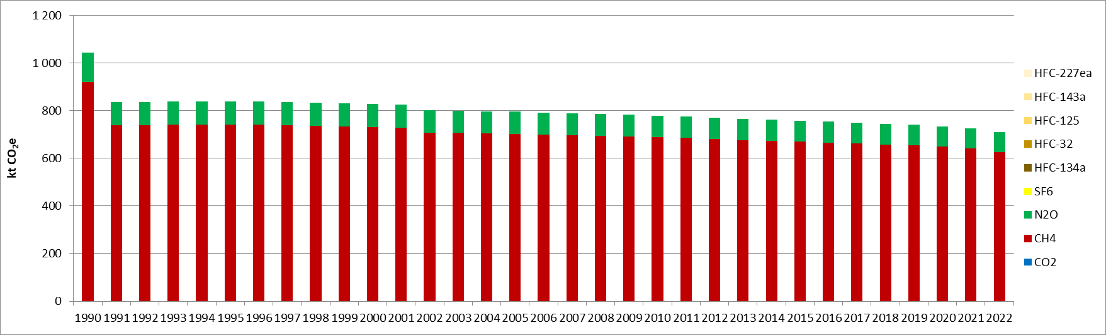
Figure 152: GHG emissions for domestic wastewater treatment and discharge (CRT 5.D.1) (kt CO₂e)
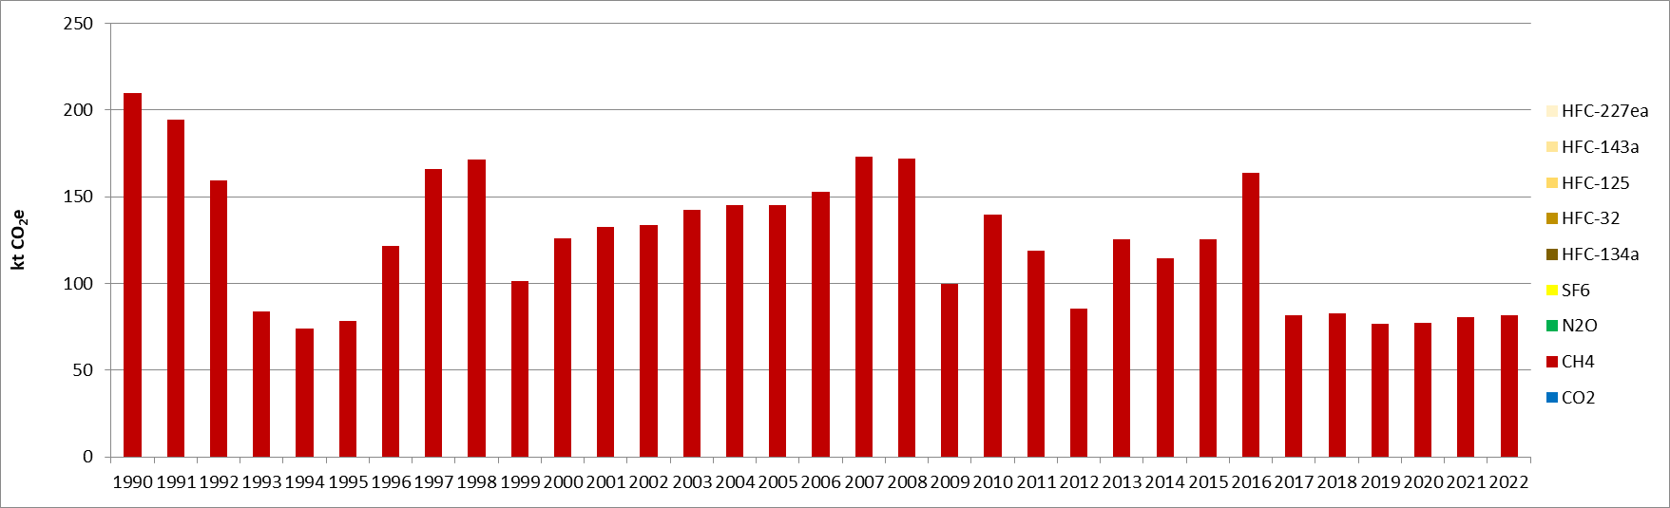
Figure 153: GHG emissions for industrial wastewater treatment and discharge (CRT 5.D.2) (kt CO₂e)
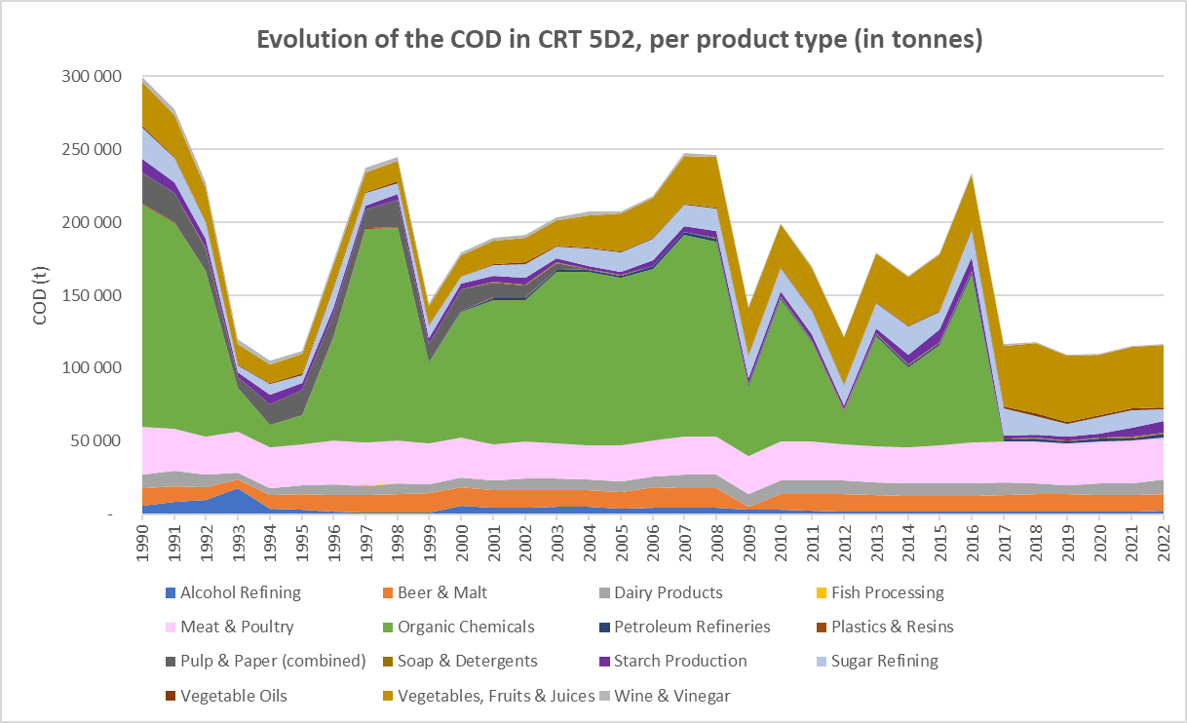
Figure 154: Evolution of the COD for industrial wastewater, depending on the product type (CRT 5.D.2) (in t)

Methodological issues
A Tier 1 methodology recommended by the 2006 IPCC Guidelines is applied to estimate CH₄ and N₂0 emissions from domestic and industrial wastewater treatment and discharge.

Domestic wastewaters (DWW)

CH₄ emissions
The treatment systems and discharge pathways presented in Figure 6.1 of the 2006 IPCC Guidelines have been adapted to national circumstances.

Urban areas Rural areas

Figure 155: Serbia’s treatment systems and pathways for domestic wastewater
In order to estimate CH₄ emissions from domestic wastewater treated and discharged, the equation 6.1 of the 2006 IPCC Guidelines is applied.

- Total organically degradable material (TOW)
TOW in domestic wastewater is estimated using the equation 6.3 of the 2006 IPCC Guidelines.
As far as possible, country-specific parameters have been used as input data in the calculation.
- Population (P)
National data on population used in the Serbian inventory are from Statistical Office. The population data used for the category 5D are consistent with the data used for the category 5A.
Table 56: Evolution of Serbian population (P), in millions of inhabitants, for the period 1990-2022
 | 1990 | 1991 | 1992 | 1993 | 1994 | 1995 | 1996 | 1997 | 1998 | 1999 | 2000 | 2001 | 2002 | 2003 | 2004 | 2005 | 2006
Population  (Millions inhab.) | 9.76 | 7.83 | 7.83 | 7.84 | 7.85 | 7.86 | 7.84 | 7.83 | 7.81 | 7.78 | 7.75 | 7.73 | 7.50 | 7.48 | 7.46 | 7.44 | 7.41
 | 2007 | 2008 | 2009 | 2010 | 2011 | 2012 | 2013 | 2014 | 2015 | 2016 | 2017 | 2018 | 2019 | 2020 | 2021 | 2022
Population  (Millions inhab.) | 7.38 | 7.35 | 7.32 | 7.29 | 7.26 | 7.20 | 7.16 | 7.13 | 7.09 | 7.05 | 7.02 | 6.96 | 6.93 | 6.87 | 6.80 | 6.64

- Fraction of urban/rural population (Ui)
Concerning wastewater treatment, consistently with the 2006 IPCC Guidelines recommendation, the Serbian inventory has been developed to allow a distinction between urban and rural populations.
The fraction of urban population is considered to be 59% all over the timeseries.
- Degree of utilisation of treatment/discharge pathway or system (Ti,j)
Two Ti,j are used in the Serbian inventory, one dedicated to urban areas and the other one to rural areas. These parameters are considered as constant all over the timeseries.
Table 57: Degree of utilisation of treatment/discharge pathway or system (Ti,j), used in Serbian inventory
Treatment/discharge system | Urban | Rural
Wastewater treatment plants well managed | 10% | 0%
Wastewater treatment plants not well managed | 10% | 0%
Anaerobic shallow lagoons | 0% | 0%
Anaerobic deep lagoons | 0% | 0%
Discharge of treated wastewater | 0% | 0%
Direct discharge (Untreated) | 50% | 0%
Septic tanks | 10% | 50%
Latrine | 0% | 0%
Flowing sewer (open or closed) | 20% | 10%
Stagnant sewer | 0% | 40%

- Correction factor for additional Industrial BOD (I)
The default I values proposed in the 2006 IPCC Guidelines are considered for all different treatment and discharge system.
Table 58: Correction factor for additional Industrial BOD (I), per treatment/discharge system
I (ratio) | Applied
Wastewater treatment plants well managed | 1.25
Wastewater treatment plants not well managed | 1.25
Anaerobic shallow lagoons | 1
Anaerobic deep lagoons | 1
Discharge of treated wastewater | 1.25
Direct discharge (Untreated) | 1
Septic tanks | 1
Latrine | 1
Flowing sewer (open or closed) | 1.25
Stagnant sewer | 1.25

Organic component removed as sludge (S)
In absence of data, the default value recommended in the 2006 IPCC Guidelines (0) is applied in the Serbian inventory.

Emission factor (EF)
Emission factors for domestic wastewater, for each discharge/treatment system, are estimated using the equation 6.2 of the 2006 IPCC Guidelines.
- Methane Correction factor (MCF)
In the Serbian inventory, the default values recommended in the 2006 IPCC Guidelines are applied to each treatment system and discharge pathway.
Table 59: Methane correction factor per treatment systems and discharge pathways (MCF)
MCF (ratio) | Applied
Wastewater treatment plants well managed | 0
Wastewater treatment plants not well managed | 0.3
Anaerobic shallow lagoons | 0.2
Anaerobic deep lagoons | 0.8
Discharge of treated wastewater | 0
Direct discharge (Untreated) | 0
Septic tanks | 0.5
Latrine | 0.7
Anaerobic digester for sludge | 0.8
Flowing sewer (open or closed) | 0
Stagnant sewer | 0.5

- Maximum CH₄ producing capacity (B₀)
In the Serbian inventory, the default value recommended in the 2006 IPCC Guidelines (0.6 kg CH₄/kg BOD) is applied.

Amount of CH4 recovered (R)
In absence of national data, the default value recommended in the 2006 IPCC Guidelines (0) is applied in the Serbian inventory.

N₂O emissions from wastewater discharge
In order to estimate N₂O emissions from domestic wastewater discharged, the equation 6.7 of the 2006 IPCC Guidelines is applied.

Total nitrogen in effluent (Neffluent)
TOW in domestic wastewater is estimated using the equation 6.3 of the 2006 IPCC Guidelines.
- Population (P)
The population data used for the category 5D are consistent with the data used for the category 5A and population data used for CH₄ emissions from 5D.
- Annual per capita protein consumption (Protein)
National data on the annual amount of protein consumed per capita used in the Serbian inventory are from FAO Statistics (Dietary Protein Consumption: g/person/day); average data in kg/year are considered in calculations. The value is used all over the time series.
Table 60: Protein consumption per capita (Protein)
Parameter | Applied
Protein (kg/person/year) | 27.3
- Fraction of Nitrogen in protein (F_{npr}), Factor for non-consumed protein (F_{non-con}) and factor for industrial and commercial co-discharged (F_{ind-com})
In absence of country specific information, default values recommended in the 2006 IPCC Guidelines are applied for the fraction of Nitrogen in protein, the factor for non-consumed protein added to the wastewater and for the factor for industrial and commercial co-discharged protein into the sewer system.
Table 61: Fraction of Nitrogen in protein (Fnpr), Factor for non-consumed protein (Fnon-con) and factor for industrial and commercial co-discharged (Find-com)
Parameters | IPCC Default* | Applied
Fraction of Nitrogen in protein (kg N/kg protein) | 0.16 | 0.16
Factor for non-consumed protein (F_{non-com}) | 1.1 | 1.1
Factor for industrial and commercial co-discharged (F_{ind-com}) | 1.25 | 1.25
*Recommended in the 2006 IPCC Guidelines, Vol5, Chap 5, paragraph 6.3.1.3

Nitrogen removed with sludge (Nsludge)
In absence of country specific information, the default value recommended in the 2006 IPCC Guidelines is applied.
Table 62: Nitrogen removed with sludge (N_{sludge}) (in kg N/year)
Parameter | IPCC Default* | Applied
Nsludge- Nitrogen removed with sludge, kg N/yr | 0 | 0
*Recommended in the 2006 IPCC Guidelines, Vol5, Chap 5, page 6.25

Emission factor (EF)
The default EF recommended in the 2006 IPCC Guidelines (0.005 kg N₂O-N/kg N) is applied in the Serbian inventory.

N₂O emissions from advanced WWTP
In order to estimate N₂O emissions from domestic wastewater discharged, the equation 6.9 of the 2006 IPCC Guidelines is applied.

Degree of utilisation of modern, centralized WWTP (T_{plant})
In the Serbian inventory, a distinction is done between urban and rural areas. In the urban areas Tplant is considered to be 20% and in rural areas it is considered to be 10%. These values are applied all over the timeseries.
Population data (P) and the fraction of industrial and commercial co-discharged protein into the sewer system (Find-com) are consistent with the values presented above.

Emission factor (EF)
The default EF recommended in the 2006 IPCC Guidelines (3.2 g N₂O-N/person) is applied in the Serbian inventory.

Industrial wastewaters (IWW)
In order to estimate CH₄ emissions from industrial wastewater treated and discharged, the equation 6.4 of the 2006 IPCC Guidelines is applied.

Total organically degradable material for industry I (TOW_{i})
TOW in industrial wastewater is estimated using the equation 6.6 of the 2006 IPCC Guidelines.
- Total industrial product (P_{i})
National data on total industrial product used in the Serbian inventory are from Statistical Office.
Table 63: Total industrial productions (Pi) used in the CRT 5D2, for the period 1990-2022, in the Republic of Serbia (in kt)
Pi (kt) | 1990 | 1991 | 1992 | 1993 | 1994 | 1995 | 1996 | 1997 | 1998 | 1999 | 2000
Alcohol Refining | 21,996 | 30,668 | 35,934 | 66,988 | 13,831 | 12,350 | 5,605 | 3,494 | 3,798 | 3,624 | 22,701
Beer & Malt | 653,505 | 614,543 | 502,877 | 326,175 | 532,526 | 588,077 | 650,056 | 650,594 | 708,698 | 717,942 | 694,386
Dairy Products | 486,486 | 535,877 | 435,686 | 268,695 | 244,414 | 302,425 | 359,648 | 348,692 | 377,818 | 349,920 | 330,637
Fish Processing | 644 | 568 | 516 | 546 | 549 | 553 | 591 | 578 | 579 | 544 | 542
Meat & Poultry | 616,000 | 543,000 | 493,000 | 522,000 | 525,000 | 529,000 | 565,000 | 553,000 | 554,000 | 520,000 | 518,000
Organic Chemicals | 757,563 | 703,160 | 564,273 | 150,631 | 73,846 | 99,446 | 350,479 | 728,610 | 724,091 | 275,060 | 426,769
Petroleum Refineries | NO | NO | NO | NO | NO | NO | NO | NO | NO | NO | 1,134,610
Plastics & Resins | 232,667 | 194,388 | 115,259 | 12,248 | 13,491 | 13,778 | 95,016 | 203,901 | 214,610 | 78,151 | 126,966
Pulp & Paper (combined) | 14,686 | 13,788 | 10,571 | 4,807 | 9,865 | 11,769 | 11,282 | 8,752 | 12,783 | 8,756 | 10,028
Soap & Detergents | 80,427 | 47,893 | 71,709 | 46,404 | 41,226 | 51,129 | 61,679 | 76,870 | 71,107 | 57,261 | 51,144
Starch Production | 101,710 | 77,114 | 73,172 | 37,903 | 70,921 | 51,811 | 43,377 | 32,351 | 45,465 | 40,418 | 47,449
Sugar Refining | 619,213 | 469,520 | 314,227 | 126,646 | 209,964 | 155,750 | 382,040 | 239,527 | 212,874 | 248,442 | 115,440
Vegetable Oils | 375,593 | 429,254 | 365,290 | 365,375 | 364,662 | 396,517 | 342,346 | 392,192 | 398,447 | 294,645 | 239,866
Vegetables, Fruits & Juices | 303,288 | 285,717 | 225,572 | 140,338 | 122,820 | 131,847 | 149,749 | 129,642 | 140,914 | 126,140 | 145,208
Wine & Vinegar | 97,834 | 123,704 | 115,807 | 82,857 | 86,253 | 66,946 | 79,306 | 92,256 | 83,374 | 59,657 | 61,766

Pi (kt) | 2001 | 2002 | 2003 | 2004 | 2005 | 2006 | 2007 | 2008 | 2009 | 2010 | 2011
Alcohol Refining | 17,434 | 16,969 | 19,166 | 20,166 | 15,286 | 17,761 | 16,543 | 16,553 | 12,702 | 11,159 | 9,135
Beer & Malt | 638,216 | 644,141 | 631,954 | 591,520 | 594,380 | 733,840 | 739,817 | 739,950 | 97,611 | 603,157 | 607,970
Dairy Products | 368,976 | 423,436 | 410,288 | 390,053 | 398,541 | 408,644 | 469,448 | 478,676 | 468,834 | 496,932 | 503,858
Fish Processing | 367 | 470 | 434 | 556 | 245 | 837 | 857 | 925 | 257 | 545 | 227
Meat & Poultry | 455,000 | 481,000 | 451,000 | 445,000 | 460,000 | 458,000 | 498,000 | 492,000 | 481,000 | 496,000 | 502,000
Organic Chemicals | 493,954 | 481,870 | 584,032 | 590,327 | 571,479 | 587,232 | 688,068 | 665,934 | 237,417 | 485,963 | 337,799
Petroleum Refineries | 2,060,114 | 2,601,276 | 2,564,281 | 2,734,216 | 2,599,138 | 2,486,890 | 2,443,181 | 2,412,889 | 2,258,953 | 2,009,319 | 1,775,260
Plastics & Resins | 154,771 | 161,036 | 140,088 | 94,926 | 114,028 | 102,410 | 113,655 | 128,409 | 107,353 | 99,692 | 110,842
Pulp & Paper (combined) | 7,271 | 5,672 | 3,196 | NO | NO | NO | NO | NO | NO | NO | NO
Soap & Detergents | 57,597 | 45,809 | 68,349 | 75,911 | 89,542 | 101,085 | 122,128 | 134,865 | 143,077 | 169,395 | 156,765
Starch Production | 46,287 | 51,355 | 32,560 | 22,268 | 20,663 | 38,546 | 39,955 | 51,417 | 42,908 | 33,795 | 39,226
Sugar Refining | 209,475 | 282,442 | 222,576 | 340,000 | 387,000 | 430,000 | 427,000 | 445,000 | 433,000 | 469,000 | 463,103
Vegetable Oils | 203,855 | 298,055 | 331,489 | 302,671 | 323,647 | 276,804 | 229,948 | 307,228 | 345,421 | 257,666 | 229,012
Vegetables, Fruits & Juices | 162,474 | 173,182 | 172,267 | 223,501 | 258,372 | 273,563 | 327,672 | 343,446 | 317,708 | 289,672 | 291,497
Wine & Vinegar | 55,311 | 44,768 | 62,489 | 75,626 | 35,937 | 43,253 | 47,728 | 44,263 | 36,501 | 23,582 | 22,382

Pi (kt) | 2012 | 2013 | 2014 | 2015 | 2016 | 2017 | 2018 | 2019 | 2020 | 2021 | 2022
Alcohol Refining | 7,593 | 7,588 | 5,775 | 6,006 | 6,460 | 7,389 | 7,226 | 7,143 | 6,757 | 7,407 | 8,023
Beer & Malt | 638,064 | 598,498 | 592,531 | 608,753 | 601,991 | 614,067 | 638,032 | 644,923 | 604,721 | 625,788 | 641,116
Dairy Products | 483,587 | 455,513 | 452,803 | 431,845 | 449,121 | 455,275 | 405,956 | 316,568 | 447,211 | 406,679 | 521,805
Fish Processing | 239 | 200 | 192 | 194 | 50 | 101 | 1 | 2 | 6 | 194 | 6
Meat & Poultry | 472,000 | 463,000 | 473,000 | 493,000 | 523,000 | 524,000 | 539,000 | 538,000 | 541,000 | 548,000 | 546,000
Organic Chemicals | 108,687 | 377,336 | 270,453 | 341,226 | 573,064 | NO | NO | NO | NO | NO | NO
Petroleum Refineries | 1,526,159 | 1,937,787 | 2,105,846 | 2,393,902 | 2,482,231 | 2,658,813 | 2,874,262 | 2,678,192 | 2,705,027 | 2,959,652 | 3,428,015
Plastics & Resins | 232,714 | 194,404 | 174,918 | 202,198 | 238,367 | 160,530 | 160,185 | 164,448 | 158,056 | 167,950 | 162,246
Pulp & Paper (combined) | NO | NO | NO | NO | NO | NO | NO | NO | NO | NO | NO
Soap & Detergents | 167,224 | 157,590 | 152,730 | 157,619 | 152,988 | 162,256 | 171,056 | 157,710 | 190,791 | 223,789 | 234,013
Starch Production | 32,919 | 32,836 | 75,188 | 97,779 | 102,665 | 19,451 | 24,942 | 25,529 | 27,359 | 70,848 | 86,715
Sugar Refining | 402,593 | 508,452 | 545,957 | 329,440 | 536,121 | 528,417 | 361,746 | 247,194 | 330,046 | 328,879 | 235,300
Vegetable Oils | 247,709 | 236,567 | 262,232 | 274,342 | 535,374 | 558,161 | 563,288 | 629,254 | 562,635 | 500,245 | 544,772
Vegetables, Fruits & Juices | 316,186 | 331,236 | 333,847 | 388,661 | 366,771 | 414,404 | 480,440 | 449,707 | 412,911 | 423,274 | 423,274
Wine & Vinegar | 21,740 | 22,827 | 19,623 | 23,863 | 35,665 | 32,950 | 29,225 | 27,543 | 21,190 | 20,662 | 17,796

- Chemical Oxygen Demand (COD_{i}), wastewater generated (W_{i})
Default values recommended in the 2006 IPCC Guidelines are applied in the Serbian inventory.
Table 64: Chemical Oxygen Demand (COD_{i}) and Wastewater generated (W_{i}), per product type
Industrial sector (i) | CODi  (kg COC/m³) | Wi  (m³/t of product)
Alcohol Refining | 11.00 | 24.00
Beer & Malt | 2.90 | 6.30
Dairy Products | 2.70 | 7.00
Fish Processing | 2.50 | 13.00
Meat & Poultry | 4.10 | 13.00
Organic Chemicals | 3.00 | 67.00
Petroleum Refineries | 1.00 | 0.60
Plastics & Resins | 3.70 | 0.60
Pulp & Paper (combined) | 9.00 | 162.00
Soap & Detergents | 0.85 | 3.00
Starch Production | 10.00 | 9.00
Sugar Refining | 3.20 | 11.00
Vegetable Oils | 0.85 | 3.10
Vegetables, Fruits y& Juices | 5.00 | 20.00
Wine & Vinegar | 1.50 | 23.00

- Degree of utilisation of treatment/discharge pathway or system (T_{j})
All industrial wastewater, whatever is the industrial sector, is considered as discharged in water bodies without treatment.
Table 65: Correction factor used for additional industrial BOD, per treatment/discharge system
 | MCF
Wastewater treatment plants well managed | 1.25
Wastewater treatment plants not well managed | 1.25
Anaerobic shallow lagoons | 1
Anaerobic deep lagoons | 1
Discharge of treated wastewater | 1.25
Direct discharge (Untreated) | 1
Septic tanks | 1
Latrine | 1
Flowing sewer (open or closed) | 1.25
Stagnant sewer | 1.25

Organic component removed as sludge (S_{i})
In absence of data, the default value recommended in the 2006 IPCC Guidelines (0) is applied in the Serbian inventory.

Emission factor (EF)
Emission factor for domestic wastewater is estimated using the equation 6.2 of the 2006 IPCC Guidelines.
- Methane Correction factor (MCF)
In the Serbian inventory, the default value of 0.1 recommended in the 2006 IPCC Guidelines is applied to the direct discharge.
- Maximum CH₄ producing capacity (B₀)
In the Serbian inventory, the default value recommended in the 2006 IPCC Guidelines (0.25 kg CH₄/kg COD) is applied.

Amount of CH₄ recovered (R_{i})
In absence of national data, the default value recommended in the 2006 IPCC Guidelines (0) is applied in the Serbian inventory.

Uncertainties and time-series consistency

Uncertainty estimate associated with activity data amounts to 50%, based on expert judgment.
Uncertainty estimates associated with emission factor amount to 50% for CH₄ and 100% for N₂O, based on 2006 IPCC Guidelines (Volume 5, Chapter 6, Table 6.11).
Hence, combined uncertainties for emissions are 71% for CH₄ and 112% for N₂O. The uncertainties combined in the total national emissions, excluding LULUCF contribution, in 2022, are of 0.8% and 0.15%, for CH₄ and N₂O, respectively, in the Republic of Serbia.

Category-specific QA/QC and verification
During the preparation of the inventory submission, activities related to quality control were mainly focused on completeness and consistency of emission estimates, and on proper use of notation keys in the CRT tables.

Category-specific recalculations
The current report is the first National Inventory Document for Serbia. Consequently, there is no recalculation. Possible recalculation will be occurred and estimated in the next submission if necessary.

Category-specific planned improvements

Concerning wastewater treatment, the planned improvements deal mainly with the historical trends of the country-specific parameters, especially concerning the following aspects:
- improve the historical trend of the parameters considered as constant over the timeseries (degree of utilisation of treatment/discharge pathway or system, degree of utilisation of modern centralized WWTP, fraction of urban/rural population, protein consumption).
- Improve the estimations using 2019 Refinement to the 2006 IPCC Guidelines for National Greenhouse Gas Inventories.

Chapter 8: Other
Serbia has no additional information on emissions to add in this chapter.

Chapter 9: Indirect CO₂ and N₂O emissions
9.1. Description of sources of indirect emissions in GHG inventory

Following an EU WG1 recommendation, indirect emissions of CO₂ from NMVOC of solvents are accounted for in CRT 2D3, for which emission estimations and methodologies are presented in chapter 4.6.3.
No indirect emissions of N₂O are estimated in the Serbian inventory, except those of agricultural soils, which are directly estimated and presented in the agriculture sector (CRT 3, see chapter 5.4.2).

9.2. Methodological issues

Not concerned.

9.3. Uncertainties and time-series consistency

Not concerned.

9.4. Category-specific QA/QC and verification

Not concerned.

9.5 Category-specific recalculations

Not concerned.

9.6. Category-specific planned improvements

None.

Chapter 10: Recalculations and improvements
The current report is the first National Inventory Document for Serbia. Consequently, there is no recalculation. Possible recalculation will occur and be estimated in the next submission.

10.1. Explanations and justifications for recalculations, including in response to the review process

Not concerned for this submission.

10.2. Implications for emission and removal levels

Not concerned for this submission.

10.3. Implications for emission and removal trends, including time-series consistency

Not concerned for this submission.

10.4. Areas of improvement and/or capacity building in response to the review process

As the Serbian inventory and NID have not been reviewed officially yet, this chapter is not applicable to this submission.

Annex 1: Key categories from CRT Reporter
Table 66: Key Source Categories for the latest reported year (including and excluding LULUCF) – CRT Reporter
Table 67: Key Source Categories for the base year (including and excluding LULUCF) – CRT Reporter

Annex 2: Assessment of uncertainty
Table 68: Uncertainty estimates excluding LULUCF, base year to the latest reported year
Table 69: Uncertainty estimates including LULUCF, base year to the latest reported year
Table 70: Uncertainty estimates for the base year (including and excluding LULUCF)

Annex 3: Detailed description of the reference approach (including inputs to the reference approach such as the national energy balance) and the results of the comparison of national estimates of emissions with those obtained using the reference approach
The comparison of the reference approach with the sectoral approach is presented in chapter 3.2.1. The carbon contents (or CO₂ EF) and NCV used are given in chapter 3.2.4.

Annex 4: QA/QC procedures.
The following table and figure present a list of QA/QC tasks for each actor of the inventory system and for each step of the inventory where each actor needs to intervene. They are not all applied yet but Serbia will improve its system yearly and tends to fulfil all these tasks.
Function | Tasks
(1) Sectoral expert | Q1 Coordination and planning:  - Records the identified errors on the emission calculations;  - Documents, analyzes and processes the comments and recommendations of the UNFCCC reviews.
(1) Sectoral expert | Q2 Data sources  - Is responsible for checking the documentation on assumptions and criteria for the selection of activity data, emission factors, and other estimation parameters;  - Is in charge of the verification of data transcription;  - Is responsible for the time series consistency;  - Is in charge of checking the availability of input data;  - Checks the quality of external data;  - Records and archives the data sources;  - Verifies if external data providers have a QA/QC system.
(1) Sectoral expert | Q3 Emissions calculations  Tasks for the expert in charge of emission calculation (Calculation files author):  - Ensures the consistency between the tool used for calculation and the reporting format required by UNFCCC and EC ;  - Compares results with the estimates of the previous inventory;  - Compares results of Tier 1 method with Tier 2 method when appropriate;  - Clearly displays the unit and the reference of the data used;  - Avoids methodological inconsistencies or break in time-series;  - Draws graphs showing emissions evolutions and explain significant variations;  - Does specific checks when using model or database to estimate the emissions;  - Indicates which data are confidential so they are not publicly published;  - Records all data which are used to calculate the emissions;  - Fills in the follow-up sheet with the name of the author, the description of the actions made for the emission calculations, and the date;  - Compares methodologies used by other countries or other organisations with the national ones;  - Records the results of the expert peer review and implements actions if needed.  Tasks for the expert in charge of calculation verification (Calculation files verifier):  - Checks the calculation formulas;  - Checks the comparison of the results of Tier 1 and Tier 2 methods (if relevant);  - Checks the units used;  - Checks if the color code is correctly used (see explanations in the detailed text below);  - Checks time series consistency;  - Checks the “follow-up” sheet and fills in it with the name of the verifier and the date;  - Checks if the transversal data used are well updated in compliance with the latest common file done by the generalist expert;  - Checks the correct use of confidential notation keys;  - Checks that all data which are used to calculate the emissions are recorded and archived;  - Checks the implementation of actions coming from the peer reviews;  - Fills in the “checklist” sheet.
(1) Sectoral expert | Q4 Data reporting  Tasks for the calculation files author:  - Ensures the completeness of the data exported;  - Explains the potential outliers in the database;  - Explains the recalculations in the "follow-up" sheet of the calculation file.  Tasks for the calculation files verifier:  - Checks that the explanations of any changes or recalculations are well recorded as stated in the QA/QC plan.
(1) Sectoral expert | Q8/Q9/Q10 Proxy GHG inventories (X-1)  - Complies with the current QA/QC procedures for the GHG inventory.
(2) Inventory manager | Q1 Coordination and planning  - Prepares the QA/QC plan and updates on annual basis;  - Ensures the good application of the QA/QC system;  - Is responsible for planning and monitoring the QC activities;  - Checks and validates the sectoral experts’ answers to the comments and recommendations of the UNFCCC reviews.
(2) Inventory manager | Q2 Data sources  - Checks the record of a sample of data sources to verify that they are all archived;
(2) Inventory manager | Q3 Emissions calculations  - Implements an automatic calculation procedure which checks that AD x EF = E;  - Ensures the consistency between the units used for activity data, emission factors and emissions;  - Checks the common file with the common data (e.g. NCVs, number of inhabitants);  - Checks the uncertainties estimates;  - Archives the calculation files.
(2) Inventory manager | Q4/Q5 Data reporting  - Checks consistency between calculation tool and the final reporting products (CRT tables);  - Archives all reporting products;  - Checks the good import of all data into the database (completeness and date of the import);  - Plans trend checks on the database;  - Compares the current inventory results vs. the previous one and asks sectoral experts for explaining the potential changes, recalculations to detect potential errors;  - Ensures that all recommendations from international reviews have been taken into consideration by the involved sectoral expert;  - Verifies if the complementary information on national emission inventory under the MMR is well fulfilled and updated for the next submission.
(2) Inventory manager | Q6/Q7 National Inventory Document  - Supports the NID expert in checking and validating the chapters written by other organisations;  - Validates the NID;  - Archives all information relating to the planning, preparation and management of the NID;  - Checks that the tasks of the NID expert are correctly done.
(2) Inventory manager | Q8/Q9/Q10 Proxy GHG inventories (X-1)  - Checks that QA/QC procedures are well implemented.
(3) Coordination Group of National Inventories | Q1 Coordination and planning  - Validates the improvement plan, gives its opinion and approves the methodological changes.
(3) Coordination Group of National Inventories | Q3 Emissions calculations  - Gives opinion on the results of estimations produced in the inventories.
(4) ETS expert | Q5 Data reporting  - ESD template: compares the total CO₂eq emissions filled in the ESD template and the emissions reported under UNFCCC inventory; compares the ETS emissions filled in the ESD template and the official final total of annual ETS emissions transmitted by the Member state to the European Union Register;  - Consistency with ETS data: does cross-checks between the data sources and the reported data.
(5) Inventory manager or sectoral experts | Q2 Data sources  - In charge of the verification of data transcription;  - Responsible for the temporal consistency.
(5) Inventory manager or sectoral experts | Q3 Emissions calculations  - Fills in the follow-up sheet with the name of the verifier and the date for the calculations files checked;  - Fills in the checklist sheet for the calculation files checked;  - Updates a common file with the common data (e.g. NCVs, number of inhabitants).
(6) CRT reporter expert | Q4/Q5 Data reporting  - Checks the consistency between export sheets and the XML files in terms of units and sector aggregation (input of the CRT Reporter);  - Checks total CO₂eq in the database vs. total CO₂eq in the XML files;  - Checks the consistency between the database and the CRT tables produced by the online CRT reporter => plausibility of the implied emission factor in the CRT tables; comparison of total CO₂eq in the CRT tables and the database; checks on a sample of data in one CRT sector; checks the completeness of the notation keys in the CRT tables.
(7) Ministry in charge of Environment | Q1 Coordination and planning:  - Validates the final National Inventory Document;  - Checks if mitigation activities/measures have been appropriately reflected in time series calculations.
(7) Ministry in charge of Environment | Q3 Emissions calculations  - Checks if mitigation activities/measures have been appropriately reflected in time series calculations.  - Validates and approves the results of the emissions calculated and transmitted by the national inventory agency.
(7) Ministry in charge of Environment | Q5 Data reporting  - Archives all the products sent to UNFCCC and EC.
(7) Ministry in charge of Environment | Q6/Q7 National Inventory Document  - Approves the NID before the national submission;  - Leads audits about the consistency between the document FCCC/CP/2013/10/Add3 and the NID produced.
(8) NID expert | Q6/Q7 National Inventory Document  - Checks that there is detailed documentation to support the estimations and to enable reproduction of the emissions, removal and uncertainty estimates;  - Checks that the timetable is respected and recorded in the NID action plan when a task is realized;  - Checks and validates the chapters written by the sectoral experts or other organisations;  - Checks if the general structure of the NID is updated regarding the document FCCC/CP/2013/10/Add3;  - Archives all the data concerning the NID (inventory data, discussions with the UNFCCC NID/BR/NC expert of MAEP, final version of the NID, exchanges with other countries, etc.).
(9) Proxy expert | Q8/Q9/Q10 Proxy GHG inventories (X-1)  - Complies with the current QA/QC procedures for the GHG inventory;  - Compares the previous proxy (year X-2) and the current estimates done in the inventory for the year X-2 => identifies discrepancies and then identifies proxy methodologies more appropriate (other surrogate parameters).

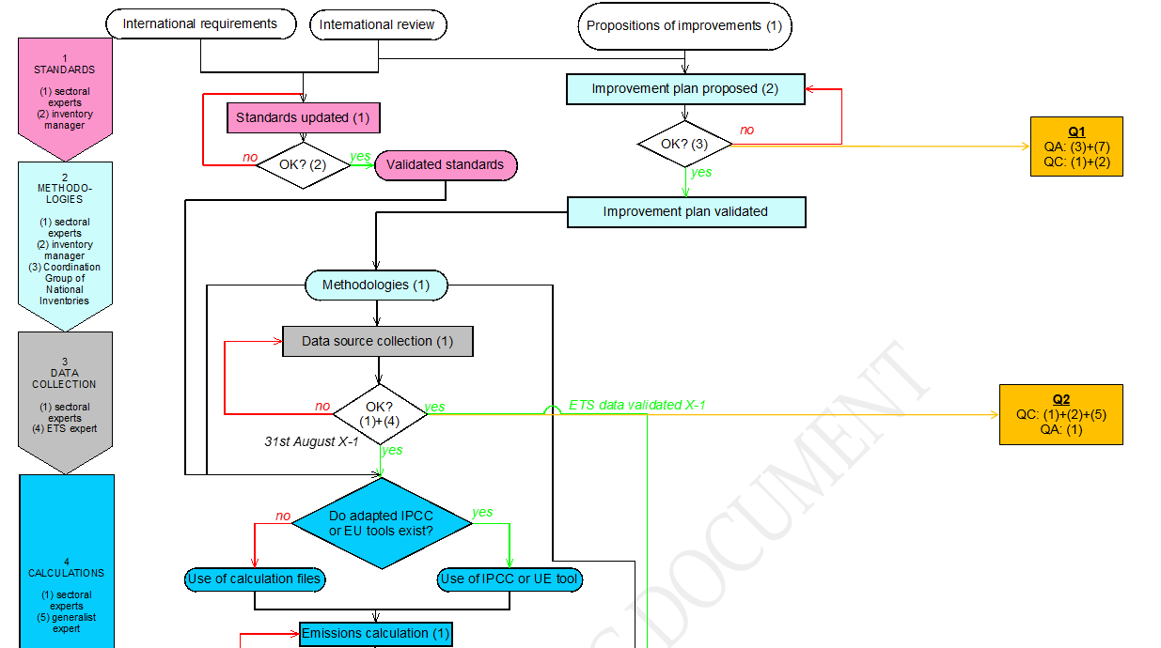
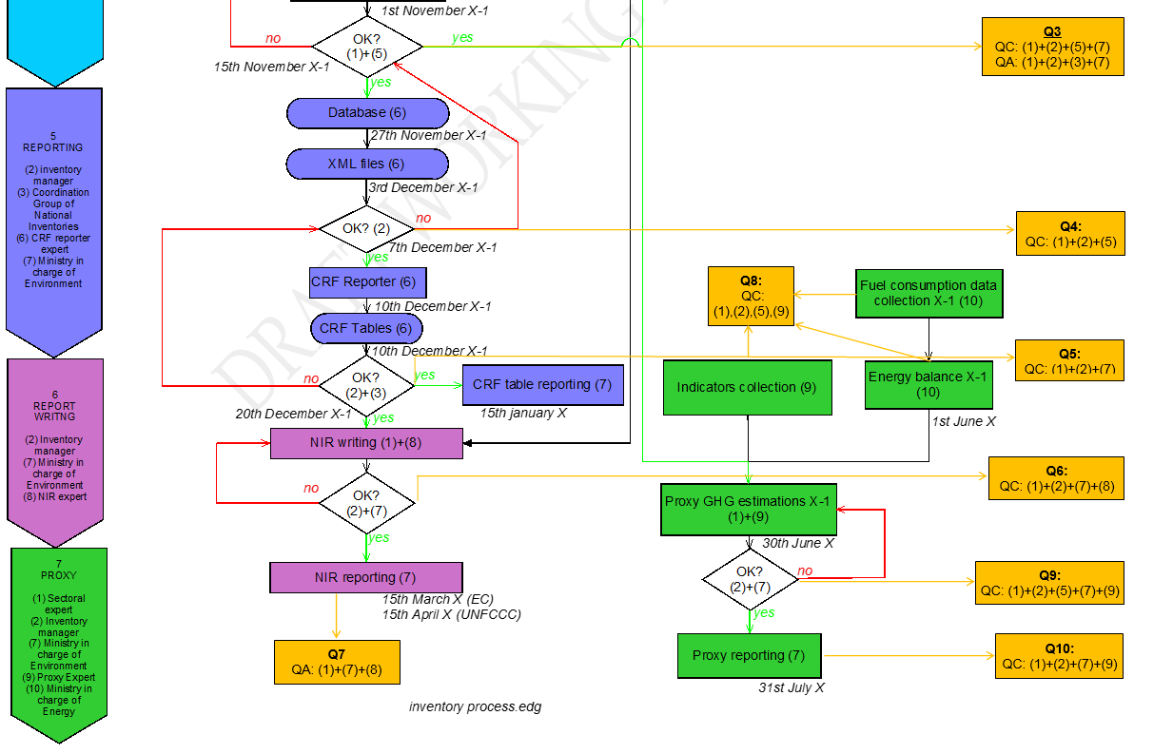

Annex 5: Any additional information, as applicable, including detailed methodological descriptions of source or sink categories and the national emission balance
All the required information about emission estimation methodologies is presented in the sectoral chapters. Hence, this Annex is kept empty thus far.

References
Energy (CRT 1)
- 2006 IPCC Guidelines, Volume 2, Chapter 2
- Serbian energy balance, yearly (International Energy Agency - IEA questionnaires)
- 2006 IPCC Guidelines, Volume 2, Chapter 2, Table 2.2
- Individual data from refineries, SEPA, yearly (2000 to 2016)
- 2006 IPCC Guidelines, Volume 2, Chapter 2, Table 2.15
- 1996 IPCC Guidelines, Volume 1, Table A1-1
- 2006 IPCC Guidelines, Volume 2, Chapter 2, Table 2.12
- 2006 IPCC Guidelines, Volume 2 Chapter 3, Table 3.2.1
- 2006 IPCC Guidelines, Volume 2 Chapter 3, Table 3.2.2
- 2006 IPCC Guidelines, Volume 2 Chapter 3
- 2006 IPCC Guidelines, Volume 2 Chapter 3 Table 3.5.2
- 2006 IPCC Guidelines, Volume 2 Chapter 4

Industrial processes (CRT 2)

- 2006 IPCC Guidelines, Volume 3, Chapter 2, equation 2.1
- Statistical annual reports, Statistical Office of the Republic of Serbia (SORS), yearly
- 2006 IPCC Guidelines, Volume 3, Chapter 2, equation 2.4
- 2006 IPCC Guidelines, Volume 3, Chapter 2, section 2.3
- 2006 IPCC Guidelines, Volume 3, Chapter 2, Table 2.4
- 2006 IPCC Guidelines, Volume 3, Chapter 2, equation 2.10
- 2006 IPCC Guidelines, Volume 3, Chapter 2, equation 2.15
- 2006 IPCC Guidelines, Volume 3, Chapter 2, Table 2.1
- 2006 IPCC Guidelines, Volume 3, Chapter 3, section 3.2
- 2006 IPCC Guidelines, Volume 3, Chapter 3, Table 3.1
- 2006 IPCC Guidelines, Volume 3, Chapter 3, section 3.3
- 2006 IPCC Guidelines, Volume 3, Chapter 3 – Section 3.3, table 3.3
- 2006 IPCC Guidelines, Volume 3, Chapter 3 – Section 3.9
- 2003 Industrial Commodity Statistics Yearbook p388
- 2006 IPCC Guidelines, Volume 3, Chapter 3 – Section 3.9, table 3.12
- 2006 IPCC Guidelines, Volume 3, Chapter 3 – Section 3.9, p 3.74
- 2006 IPCC Guidelines, Volume 3, Chapter 3 – Section 3.9, table 3.14
- 2006 IPCC Guidelines, Volume 3, Chapter 3 – Section 3.9, table 3.16
- 2006 IPCC Guidelines, Volume 3, Chapter 3 – Section 3.9, table 3.15
- 2006 IPCC Guidelines, Volume 3, Chapter 3 – Section 3.9, table 3.17
- 2006 IPCC Guidelines, Volume 3, Chapter 3 – Section 3.9, table 3.19
- 2006 IPCC Guidelines, Volume 3, Chapter 4
- Worldsteel Association, Steel statistical yearbook, yearly
- Operators’ questionnaires, SEPA, yearly
- 2006 IPCC Guidelines, Volume 3, Chapter 4, Section 4.5
- 2006 IPCC Guidelines, Volume 3, Chapter 4, Table 4.19
- 2006 IPCC Guidelines, Volume 3, Chapter 4, Table 4.20
- 2006 IPCC Guidelines, Volume 3, Chapter 4, Section 4.6
- Activity data provided by operator for lead production
- 2006 IPCC Guidelines, Volume 3, Chapter 4, Table 4.21
- 2006 IPCC Guidelines, Volume 3, Chapter 4, Section 4.7
- 2006 IPCC Guidelines, Volume 3, Chapter 8, Section 8.2, Tables 8.2 and 8.3
- 2006 IPCC Guidelines, Volume 3, Chapter 4, Table 4.24
- 2006 IPCC Guidelines, Volume 3, Chapter 5, Section 5.2, Table 5.2
- 2006 IPCC Guidelines, Volume 2, Chapter 1, Table 1.3
- 2006 IPCC Guidelines, Volume 3, Chapter 5, Section 5.3
- 2006 IPCC Guidelines, Volume 3, Chapter 5, Section 5.5
- UNEP - REPORT OF THE REFRIGERATION, AIR CONDITIONING AND HEAT PUMPS TECHNICAL OPTIONS COMMITTEE - 2010 - Table 3-1
- 2006 IPCC Guidelines - Volume 3, Chapter 7, Table 7.9
- Health statistical yearbook of Republic of Serbia - General practice services, Diseases of the respiratory system - Every year
- French National Inventory Report 2017 - p300
- UNEP - MEDICAL TECHNICAL OPTIONS COMMITTEE – 2014
- Excel file on the trend of the share of CFC and HFC in the sales of MDI - French data – 2017
- 2006 IPCC Guidelines - Volume 3, Chapter 7, Equation 7.10
- IPCC tool for 2F1 HFC emission calculation - V3_An1_Calculation_example_for_2F1.xls
- 2006 IPCC Guidelines - Volume 3, Chapter 7, Equation 7.6

Agriculture (CRT 3)

- 2006 IPCC Guidelines, Volume 4, Chapter 10, paragraph 10.3.1 Choice of method
- Statistical Yearbooks published every year : annual livestocks / N from synthethic fertilizer / harvested crop areas / production from crops
- 2006 IPCC Guidelines, Volume 4, Chapter 10, paragraph 10.3.2 Choice of emission factors
- 2006 IPCC Guidelines, Volume 4, Chapter 10, paragraph 10.4.1 Choice of method
- 2006 IPCC Guidelines, Volume 4, Chapter 10, Annex 10A.2, Tables 10A-4 through 10A-9: Manure management system in climate region (MS) and typical animal mass for livestock category (TAM)
- 2006 IPCC Guidelines, Volume 4, Chapter 10, paragraph 10.4.2 Choice of emission factors
- 2006 IPCC Guidelines, Volume 4, Chapter 10, paragraph 10.5.1 Choice of method
- 2006 IPCC Guidelines, Volume 4, Chapter 10, paragraph 10.5.2 Choice of emission factors
- 2006 IPCC Guidelines, Volume 4, Chapter 11, paragraph 11.2.2.3, Table 11.3
- 2006 IPCC Guidelines, Volume 4, Chapter 11, paragraph 11.2.1.1 Choice of method
- KNOEMA database for cultivation of organic soils from 1990-2050.
- FAO Statistics-database on burning crop residues http://www.fao.org/faostat/en/#data/GB
- 2006 IPCC Guidelines, Volume 4, Chapter 11, paragraph 11.2.1.2, Table 11.1
- 2006 IPCC Guidelines, Volume 4, Chapter 11, paragraph 11.2.2.1 Choice of method
- 2006 IPCC Guidelines, Volume 4, Chapter 11, paragraph 11.2.2.3, Table 11.3
- 2006 IPCC Guidelines, Volume 4, Chapter 2, paragraph 2.1.4 and Table 2.6
- 2006 IPCC Guidelines, Volume 4, Chapter 11, paragraph 11.4.1 Choice of method
- Direct communication with Statistical Office of the Republic of Serbia (SORS)
- 2006 IPCC Guidelines, Volume 4, Chapter 11, paragraph 11.4.2 Choice of emission factors
- 2019 Refinement to the 2006 IPCC Guidelines, Volume 4, Chapter 10
- 2019 Refinement to the 2006 IPCC Guidelines, Volume 4, Chapter 11
- 2013 Supplement to the 2006 IPCC Guidelines: Wetlands, Chapter 2

LULUCF (CRT 4)

- Food and Agriculture Organization Statistics (FAOSTAT) for harvested wood products

Capacity values vary over the period 1990-2022 due retirements of some units and improvements

