The first global stocktake (GST)
Inputs to the TD1.3 call for poster inputs

This call for inputs is separate to the GST call for submissions to the technical dialogue and to the political output components and poster session inputs submitted to the GST call for submissions will not be included:
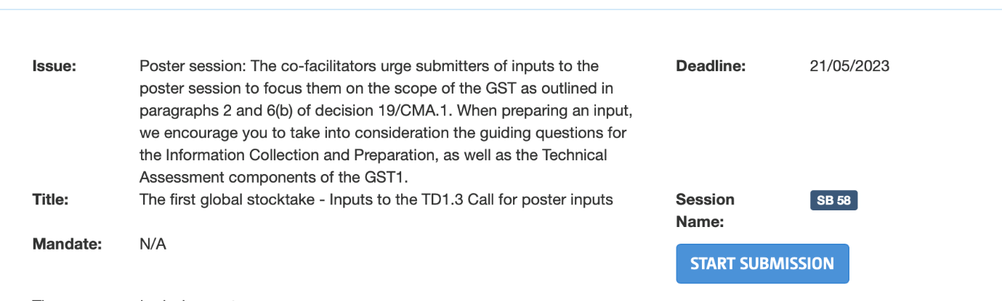

Licensing Agreement: https://unfccc.int/documents/614379 - Must be signed and added to the submission
The co-facilitators of the first technical dialogue of the global stocktake (GST1) issued a call for a poster session to take place at SB 58:
- The co-facilitators also urge submitters of inputs to the poster session to focus them on the scope of the GST as outlined in paragraphs 2 and 6(b) of decision 19/CMA.1. When preparing an input, we encourage you to take into consideration the guiding questions for the Information Collection and Preparation, as well as the Technical Assessment components of the GST1.
- A guide to submitting to both can be found here. We strongly encourage you to read this before submitting.
- For any queries, please contact gst@unfccc.int
Please ensure the link of content of your input is share-able with the UNFCCC
Your name | Click or tap here to enter text.
Poster link | Choose an item.
Attending SB 58 in person | ☐
Confirm you are self-funded | ☐

☐ By ticking this box and e-signing under it, I confirm that I am self-funded, and have attached the licensing agreement to my submission

