Speakers:
Speakers Organization | Name, Title and Email | Biography | Photo
ECOWAS | Mr Konan Raoul KOUAME,  Programme Officer, Climate Change & Climate Services  Environment Directorate, ECOWAS Commission  Email: kokouame@ecowas.int | Mr Raoul KOUAME, based in Abuja, Federal Capital Territory, Nigeria, is currently a Programme Officer, Climate Change and Climate Services at the ECOWAS Commission. | 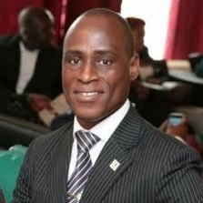
UNDP | Benjamin Larroquette  Global Advisor Early Warning Systems/Climate Information  And Regional Technical Advisor- Climate Change Adaptation  Email: benjamin.larroquette@undp.org | Mr. Benjamin Serves as the UNDP Lead on EWS and Climate Information. A seasoned development and emergency specialist, he has extensive experience with UNDP, the EU, and USAID across Asia and Africa. He recently gained the approval of the vital EW4All (Early Warnings for All) UNDP GCF funded program. Benjamin excels in designing and managing grant-making systems, financial management, and community-based development. He previously managed large-scale post-tsunami recovery operations for the UN in Indonesia and India. He holds an MSc in Environment and Development. | 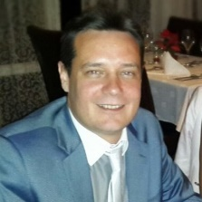
GCF | Dr. Joseph Daniel Intsiful - Senior Climate Information and Early Warning Systems Specialist, Green Climate Fund | Dr. Joseph Daniel Intsiful - Senior Climate Information and Early Warning Systems Specialist, Green Climate Fund: Part of his work at GCF involves Project origination, review and submission to the CGF board for approval, support the development of policy and sector guidance for project design and implementation. | 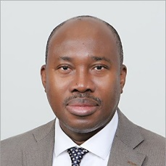
SOFF | Ms. Olga Miltcheva: Deputy Director at Systematic Observations Financing Facility (SOFF) Secretariat | Ms. Olga Miltcheva is the Deputy Director at Systematic Observations Financing Facility (SOFF) Secretariate  Her new challenge, as part of the vibrant team at the Systematic Observations Financing Facility (SOFF), is to help close the critical weather and climate data gap. A gap profoundly affects climate adaptation, early warning systems, and ultimately human lives and livelihoods. | 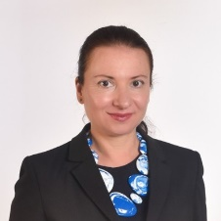
CREWS | Maria Lourdes Kathleen Santos Macasil  Senior Programme Officer, Climate Risk and Early Warning Systems (CREWS) Secretariat | Ms. Maria leads programme design, project development, and monitoring and evaluation, and provides technical oversight for the management of the global portfolio of CREWS initiatives across Least Developed Countries (LDCs) and Small Island Developing States (SIDS). Maria brings extensive experience in strategic programming, policy analysis, and results-based management, with a strong background in multidisciplinary and integrated development planning. | 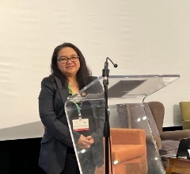
ICPAC | Dr Paulino Omoj Omay.  Acting head of climate change unit and IGAD Designated Contact Point (DCP) with UNFCCC | Dr. Paulino Omoj Omay is Head of ICPAC Climate change Unit and IGAD DCP to UNFCCC. Prior to that, he worked as a Weather Forecaster at the Sudan Meteorological Authority and senior Weather Forecaster at the South Sudan Meteorological Department. His research interests focus on extreme climate events, climate change and food security, climate change and health nexus | 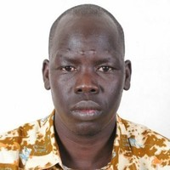
Countries presentation
Rwanda | Fidele Maniraguha, PhD Rwanda- National Focal Point – WMO Weather Radar Database (WRD)  Email f.maniraguha@meteorwanda.gov.rw | A Radar Software and Data Processing Specialist with over 8 years of experience in weather, climate, and environmental monitoring, including climate change impacts. At Meteo Rwanda, He leads radar software development, data processing, and integration for projects like the Volcano Community Resiliency Project (VCRP), supporting impact-based early warning systems, nowcasting, and climate services. | 
Eswatini | Mr Siboniso Mavuso  Director Early Warning,  MET department | Mr. Siboniso Mavuso is the Early Warning Coordinator for Eswatini’s National Disaster Management Agency (NDMA), where he leads efforts to strengthen the country’s disaster preparedness through advanced early warning systems. He is a certified drone pilot and former Regional Coordinator for the Manzini Region.  Mavuso plays a crucial role in ensuring that Eswatini’s early warning systems align with global best practices. His work includes initiatives like the development of the Composite Drought Index, set to launch in 2025, aimed at enhancing drought preparedness. | 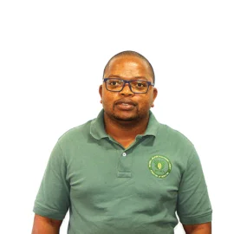
Liberia | Albert Momolu Sherman is a Meteorologist and Agro-meteorologist, and the Director of the Division of Meteorology at Liberia's Ministry of Transport. | As Director, he is Liberia's official representative to the World Meteorological Organization (WMO). His responsibilities are both strategic and technical. He serves as the WMO National Focal Point for OSCAR/Surface, acting as the primary contact for managing Liberia's environmental observation station data. As a technical expert in climate data and analysis, he provides critical data that informs national planning, especially in the health and agriculture sectors. A key part of his role involves coordinating with international partners like the WMO to improve Liberia's climate resilience and early warning systems. | 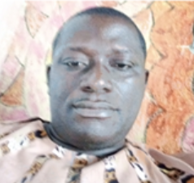
Burkina Faso | Mr. Jean Philippe Badolo: Officer in charge of Adaptation at the Permanent Secretariat of the National Council for Sustainable Development (SP/CNDD) | Mr. Jean Philippe Badolo is currently the Officer in charge of Adaptation at the Permanent Secretariat of the National Council for Sustainable Development (SP/CNDD. | 