Decoding UNFCCC Language

Mitigation and Adaptation
____________________________________________________________________________________________________________________________________________________________________________________________________________________________________________________________________________________________________________________________________________________________________________________________________________________________________________________________________________________________________________________________________________________________________________________________________________________________________________________________________________________________________________________________________________________________________________________________________________________________________________________________________________________________________________________________________________________________________________________________________________________________________________________________________________________________________________________________________________________________________________________________________________

Loss and Damage
_____________________________________________________________________________________________________________________________________________________________________________________________________________________________________________________________________________________________________________________________________________________________________________________________________________________________________________________________________________________________________________________________________________________________________________________________________________________________________________________________________________________________________________________________________________________________________________________________________________________________________________________________________________________________________________________________________________________________________________________________________________________________________________________________________________________________________________________________________________________________________________________________________________________________________________________________________________________________________________

Just Transition
_____________________________________________________________________________________________________________________________________________________________________________________________________________________________________________________________________________________________________________________________________________________________________________________________________________________________________________________________________________________________________________________________________________________________________________________________________________________________________________________________________________________________________________________________________________________________________________________________________________________________________________________________________________________________________________________________________________________________________________________________________________________________________________________________________________________________________________________________________________________________________________________________________________________________________________________________________________________________________________

Paris Agreement – Article 4.4
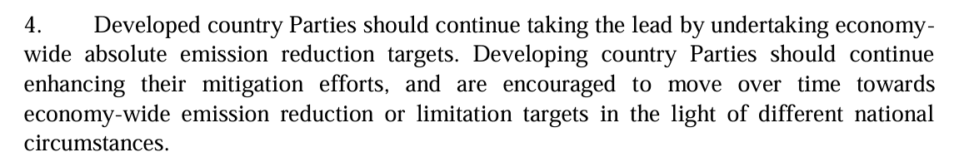Glasgow Climate Pact – Article 36
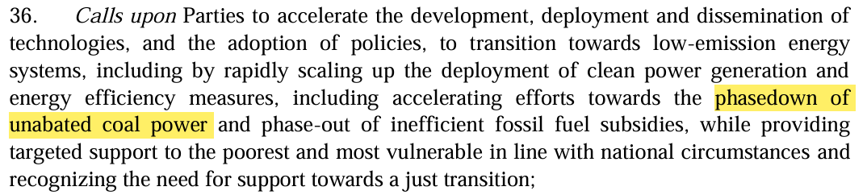Article 28
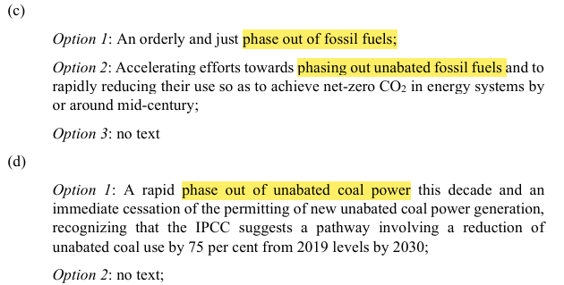
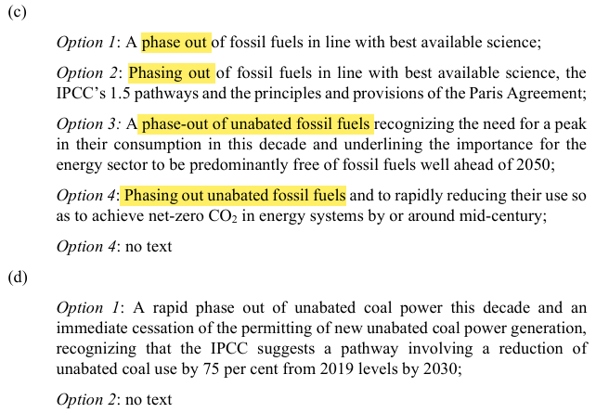
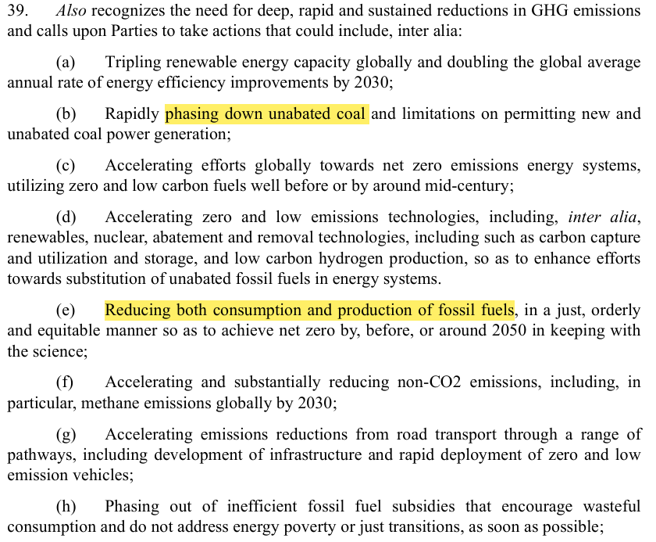
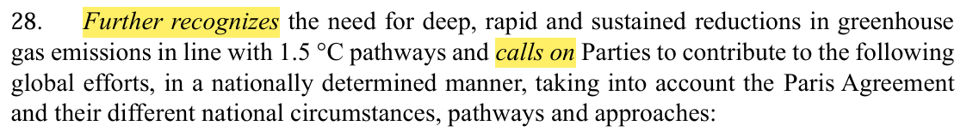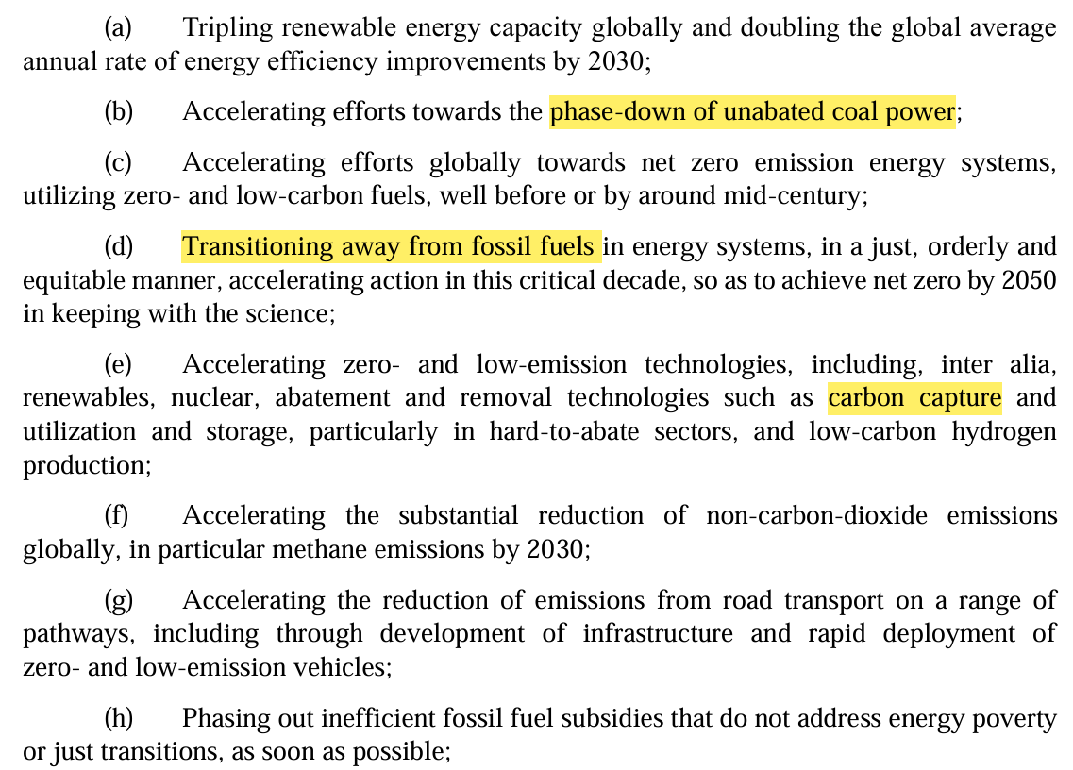

First Global Stocktake – Article 29

