Tables on ERT’s findings from TRR

Table 1
Findings on the mitigation actions and their effects from the review of the third biennial report
No. | Reporting requirement, issue type and assessment | Description of the finding with recommendation or encouragement
1 | Reporting requirement specified in  Choose an item. | The Party [reported that] [not reported] … in its BR3. The ERT noted that this is not in accordance to the UNFCCC reporting guidelines on BRs. [Please include incomplete or non-transparent information and reference to the reporting requirement this incomplete or non-transparent information is linked to.]  During the review [Party] [explained that] [provided information on] … [Please include additional information provided by the Party during the review]  The ERT [recommends] [encourages] … [Include ERT finding]
1 | Issue type:  Choose an item.
1 | Assessment:  Choose an item.
2 | Reporting requirement specified in  Choose an item. | The Party [reported that] [not reported] … in its BR3. The ERT noted that this is not in accordance to the UNFCCC reporting guidelines on BRs. [Please include incomplete or non-transparent information and reference to the reporting requirement this incomplete or non-transparent information is linked to.]  During the review [Party] [explained that] [provided information on] … [Please include additional information provided by the Party during the review]  The ERT [recommends] [encourages] … [Include ERT finding]
2 | Issue type:  Choose an item.
2 | Assessment:  Choose an item.
3 | Reporting requirement specified in  Choose an item. | The Party [reported that] [not reported] … in its BR3. The ERT noted that this is not in accordance to the UNFCCC reporting guidelines on BRs. [Please include incomplete or non-transparent information and reference to the reporting requirement this incomplete or non-transparent information is linked to.]  During the review [Party] [explained that] [provided information on] … [Please include additional information provided by the Party during the review]  The ERT [recommends] [encourages] … [Include ERT finding]
3 | Issue type:  Choose an item.
3 | Assessment:  Choose an item.
Note: Paragraph number listed under reporting requirement refers to the relevant paragraph of the UNFCCC reporting guidelines on BRs. The reporting on the requirements not included in this table is considered to be complete, transparent and adhering to the UNFCCC reporting guidelines on BRs.

Table 2
Findings on estimates of emission reductions and removals and the use of units from the market-based mechanisms and land use, land-use change and forestry from the review of the third biennial report
No. | Reporting requirement, issue type and assessment | Description of the finding with recommendation or encouragement
1 | Reporting requirement specified in  Choose an item. | The Party [reported that] [not reported] … in its BR3. The ERT noted that this is not in accordance to the UNFCCC reporting guidelines on BRs. [Please include incomplete or non-transparent information and reference to the reporting requirement this incomplete or non-transparent information is linked to.]  During the review [Party] [explained that] [provided information on] … [Please include additional information provided by the Party during the review]  The ERT [recommends] [encourages] … [Include ERT finding]
1 | Issue type:  Choose an item.
1 | Assessment:  recommendation
2 | Reporting requirement specified in  Choose an item. | The Party [reported that] [not reported] … in its BR3. The ERT noted that this is not in accordance to the UNFCCC reporting guidelines on BRs. [Please include incomplete or non-transparent information and reference to the reporting requirement this incomplete or non-transparent information is linked to.]  During the review [Party] [explained that] [provided information on] … [Please include additional information provided by the Party during the review]  The ERT [recommends] [encourages] … [Include ERT finding]
2 | Issue type:  Choose an item.
2 | Assessment:  recommendation
Note: Paragraph number listed under reporting requirement refers to the relevant paragraph of the UNFCCC reporting guidelines on BRs. The reporting on the requirements not included in this table is considered to be complete, transparent and adhering to the UNFCCC reporting guidelines on BRs.
Projections
    - Projections overview, methodology and results
      - Technical assessment of the reported information
          - [Party] reported updated projections for 2020 and 2030 relative to actual inventory data for [year] under the WEM scenario. The WEM scenario reported by [Party] includes implemented and adopted PaMs [ until XXXX].
          - In addition to the WEM scenario, [Party] reported the [WAM] [and] [WOM] [scenario]. [The WAM scenario includes planned PaMs [, while the WOM scenario excludes all PaMs implemented, adopted or planned after [year].] [[Party] provided a definition of its scenarios, explaining that its WEM scenario includes policies such as [XXX][, while its WAM scenario includes [XXX]] [describe the scenarios as reported by the Party].] The definition[s] indicate[s] that the scenario[s] [was/were] [not] prepared according to the UNFCCC reporting guidelines on NCs. [[Party] did not provide any definitions of its scenarios.]
          - The projections are presented on a sectoral basis, using [the same][different] sectoral categories [as][from] those used in the reporting on mitigation actions, and on a gas-by-gas basis for CO₂, CH₄, N₂O, PFCs, HFCs and SF₆ (treating PFCs and HFCs collectively in each case) [as well as NF₃] for 19XX–20XX. The projections are also provided in an aggregated format for each sector as well as for a Party total using global warming potential values from the [AR2][AR4].
          - [Party] [reported][did not report] emission projections for indirect GHGs such as carbon monoxide, nitrogen oxides, non-methane volatile organic compounds or sulfur oxides.[check whether this information was reported]
          - Emission projections related to fuel sold to ships and aircraft engaged in international transport were [not] reported separately and [were not] included in the totals. [Party] reported on factors and activities affecting emissions for each sector. [check whether this information was reported]
      - Methodology, assumptions and changes since the previous submission
          - The methodology used for the preparation of the projections is [identical to] [different from] that used for the preparation of the emission projections for the BR2. [[Party] reported supporting information further explaining the methodologies and the changes made since the [NC6][BR2].] [Describe the methodology and differences or changes in the methodology]
          - To prepare its projections, [Party] relied on the following key underlying assumptions: [list the assumptions relating to population, energy prices, economic development indicators, etc, as relevant]. These variables and assumptions were reported in CTF table 5. The assumptions were [not] updated on the basis of the most recent economic developments known at the time of the preparation of the projections. [Describe the assumptions as reported in CTF table 5, the use of models, results of the analysis, etc.]
          - [Party] provided information in CTF table 5 on assumptions, methodologies, models and approaches used and on the key variables and assumptions used in the preparation of the projection scenarios. To explain the changes, [Party] provided supporting documentation. [Party] also provided information on sensitivity analyses.
          - Sensitivity analyses were conducted for a number of important assumptions, such as [population trends][energy prices][economic development indicators][other]. [Describe the results of the analyses, if provided.]
      - Results of projections
          - The projected emission levels under different scenarios and information on the quantified economy-wide emission reduction target are presented in table 18 and the figure below.
Table 3
Summary of greenhouse gas emission projections for Party X
 | GHG emissions  (kt CO₂ eq per year) | Changes in relation to  base-yeara level (%) | Changes in relation to  1990 level (%)
Quantified economy-wide emission reduction target under the Convention^{d} | [NA] | [NA] | [NA]
Inventory data 1990e
Inventory data 2015ª
[WOM projections for 2020ª]
[WEM projections for 2020ª]
[WAM projections for 2020ª]
[WOM projections for 2030ª]
[WEM projections for 2030ª]
[WAM projections for 2030ª]
- From Party X’s BR3 CTF table 6.
Greenhouse gas emission projections reported by Party X
[This figure will be prepared using an Excel template provided by the secretariat in a separate file. In that file you should fill in quantitative information on the projection scenarios for 2013–2030 (as reported in the BR3) and indicate the target level of emissions for 2020 in accordance with the description of the target. Please note that the WAM and WOM scenarios are not mandatory requirements. Please cut and paste from the Excel file into the Word file using the option “Paste as a picture”.]
[Below is the figure for non-EU countries]
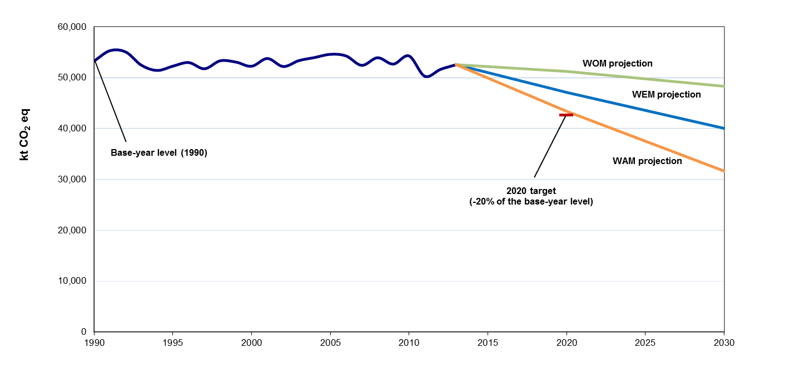
- Sources: (1) data for the years 1990–2015: Party X’s 2017 annual inventory submission, version 3; total GHG emissions excluding LULUCF; (2) data for the years 2015–[2020][2030]: Party X’s BR3; total GHG emissions excluding LULUCF;

Table 4
Findings on greenhouse gas emission projections reported in the seventh national communication of Party X
[For each reporting requirement, describe only one finding. In the second column, for each finding choose from the dropdown menus: the relevant paragraph of the reporting guidelines, the type of issue and the type of finding. In the third column, describe which information is incomplete or non-transparent and what was reported during the review and provide the assessment of the ERT, as required. In cases where previously made recommendations and encouragements included in the review reports were not addressed and resolved, reiterate them, if relevant. In case there are no issues, delete the table.]
No. | Reporting requirement, issue type and assessment | Description of the finding with recommendation or encouragement
1 | Reporting requirementª specified in  Choose an item. | Party X [reported that] [not reported] … in its NC7. The ERT noted that this is not in accordance to the UNFCCC reporting guidelines on NCs. [Please include incomplete or non-transparent information and reference to the reporting requirement this incomplete or non-transparent information is linked to.]  During the review Party X [explained that] [provided information on] … [Please include additional information provided by the Party during the review]  The ERT [recommends] [encourages] … [Include ERT finding]
1 | Issue type:  Choose an item.
1 | Assessment:  Choose an item.
2 | Reporting requirementª specified in  Choose an item. | Party X [reported that] [not reported] … in its NC7. The ERT noted that this is not in accordance to the UNFCCC reporting guidelines on NCs. [Please include incomplete or non-transparent information and reference to the reporting requirement this incomplete or non-transparent information is linked to.]  During the review Party X [explained that] [provided information on] … [Please include additional information provided by the Party during the review]  The ERT [recommends] [encourages] … [Include ERT finding]
2 | Issue type:  Choose an item.
2 | Assessment:  Choose an item.
3 | Reporting requirementª specified in  Choose an item. | Party X[reported that] [not reported] … in its NC7. The ERT noted that this is not in accordance to the UNFCCC reporting guidelines on NCs. [Please include incomplete or non-transparent information and reference to the reporting requirement this incomplete or non-transparent information is linked to.]  During the review Party X [explained that] [provided information on] … [Please include additional information provided by the Party during the review]  The ERT [recommends] [encourages] … [Include ERT finding]
3 | Issue type:  Choose an item.
3 | Assessment:  Choose an item.
4 | Reporting requirementª specified in  Choose an item. | Party X [reported that] [not reported] … in its NC7. The ERT noted that this is not in accordance to the UNFCCC reporting guidelines on NCs. [Please include incomplete or non-transparent information and reference to the reporting requirement this incomplete or non-transparent information is linked to.]  During the review Party X [explained that] [provided information on] … [Please include additional information provided by the Party during the review]  The ERT [recommends] [encourages] … [Include ERT finding]
4 | Issue type:  Choose an item.
4 | Assessment:  Choose an item.
5 | Reporting requirementª specified in  Choose an item. | Party X [reported that] [not reported] … in its NC7. The ERT noted that this is not in accordance to the UNFCCC reporting guidelines on NCs. [Please include incomplete or non-transparent information and reference to the reporting requirement this incomplete or non-transparent information is linked to.]  During the review Party [explained that] [provided information on] … [Please include additional information provided by the Party during the review]  The ERT [recommends] [encourages] … [Include ERT finding]
5 | Issue type:  Choose an item.
5 | Assessment:  Choose an item.
6 | Reporting requirement^{b} specified in  Choose an item. | Party X [reported that] [not reported] … in its NC7. The ERT noted that this is not in accordance to the UNFCCC reporting guidelines on NCs. [Please include incomplete or non-transparent information and reference to the reporting requirement this incomplete or non-transparent information is linked to.]  During the review Party X [explained that] [provided information on] … [Please include additional information provided by the Party during the review]  The ERT [recommends] [encourages] … [Include ERT finding]
6 | Issue type:  Choose an item.
6 | Assessment:  Choose an item.
Note: The reporting on the requirements not included in this table is considered to be complete, transparent and adhering to the UNFCCC reporting guidelines on NCs and on BRs.
- Paragraph number listed under reporting requirement refers to the relevant paragraph of the UNFCCC reporting guidelines on NCs.

