A6.4-AMT-008

Methodological tool
Analysis of lock-in risk
Version 01.0

TABLE OF CONTENTS Page
1. Introduction 3
1.1. Scope 3
1.2. Entry into force and validity 3
2. Definitions 3
2.1. General terms 3
2.2. Methodological terms and definitions 3
3. Normative and informative references 4
4. Applicability 4
5. Methodological approaches 6
5.1. Step 1: Technical or operational lifetime assessment 6
5.2. Step 2: Greenhouse gas intensity assessment 7
5.3. Step 3: Resource use efficiency assessment 9
5.4. Relevance of scale assessment 12

- Introduction
  - Scope
- This methodological tool provides a stepwise approach for conducting a lock-in risk analysis for activities under the Article 6.4 mechanism.
  - Entry into force and validity
- This methodological tool enters into force on 21 May 2026.
- This methodological tool remains valid for five years, until 20 May 2031, unless an earlier date applies if the methodological tool is revised or withdrawn in accordance with the “Procedure: Development, revision and clarification of methodologies and methodological tools” (A6.4-PROC-METH-001).
- Definitions
  - General terms
- The following general terms are applied to the methodological tool:
  - “Shall” is used to indicate requirements that must be followed;
  - “Should” is used to indicate that, among several options, one course of action is recommended as particularly suitable; and
  - “May” is used to indicate what is permitted.
  - Methodological terms and definitions
- The following methodological terms and definitions are applied to the methodological tool:
  - Comparable activity: an activity that delivers the same or similar type(s) of output and provides the same or similar level(s) of service as the proposed Article 6.4 activity and has a capacity or output that is within the applicable range (if considered relevant);
  - Level of service: the quality, reliability, and scale of an output provided by an Article 6.4 activity and/or in the baseline scenario;
  - Lock-in risk: the risk that the implementation of an Article 6.4 activity results in the adoption, or prolongation of the lifetime, of technologies, measures, or practices that are incompatible with the long-term goals of the Paris Agreement, taking into account different national circumstances, approaches and pathways;
  - Operational lifetime: the period during which a technology, measure, or practice is expected to remain in operation from the date of its first commissioning, considering not only its technical lifetime, where applicable, but also its economic viability, the regulatory environment, user preferences, and market or policy conditions;
  - Output: each good or service provided by the Article 6.4 activity and/or in the baseline scenario, as specified in the mechanism methodology; and
  - Technical lifetime: the total period during which an equipment can be expected to remain functional and deliver its intended service if maintained according to the manufacturer’s specifications or standard industrial practices, as measured from the date of commissioning.
- Furthermore, the terms in the “Glossary: Article 6.4 mechanism terms” (A6.4-GLOS-GOV-001) and the definitions and terms in the methodological tool(s) referred to in section 3 shall apply.
- Normative and informative references
- The following document is indispensable for the application of this methodological tool. When applying this methodological tool, a valid version of the document listed below shall be used:
  - “Methodological tool: Determination of the technical lifetime of equipment” (A6.4-AMT-006), where applicable.
- The following documents provide supporting information that may assist in the application of this methodological tool:
  - “Standard: Demonstration of additionality in mechanism methodologies” (A6.4-STAN-METH-003); and
  - “Standard: Setting the baseline in mechanism methodologies” (A6.4-STAN-METH-004).
- Applicability
- This methodological tool is applicable to Article 6.4 activities:
  - That introduce greenfield technologies, measures, and/or practices where none existed previously;
  - That generate at least one measurable output; and
  - Whose greenhouse gas (GHG) intensity and resource use intensity, if required, can be reasonably determined.
- This methodological tool is only applicable where the referring mechanism methodology specifies:
  - The main technology, practice, or measure for which lock-in risk shall be assessed;
  - The type of lifetime that shall be determined for the applicable activities, either technical lifetime or operational lifetime;
  - How to identify the relevant region (e.g., global, multi-national, national, or sub-national jurisdiction) that shall be considered when identifying comparable activities in steps 2 and 3;
  - How to calculate the GHG emissions intensity of (i) the Article 6.4 activity, (ii) the business as usual (BAU) scenario, and (iii) the lowest emissions intensity alternative;
  - Whether the list of comparable alternatives identified in steps 2 and 3 shall: (i) only include alternatives that the activity participants can implement; or (ii) also include alternatives that third parties could implement;
  - The type of resource(s) subject to resource use efficiency assessment or the approach used to identify them, as well as the appropriate resource use intensity indicator, and the approach used to calculate its value;
  - For each relevant resource, the threshold for resource use intensity above which the resource shall be deemed inefficiently used in step 3;
  - Whether a scale assessment is required, with justification, and if so, the approach for such an assessment; and
  - The threshold value of the applicable lifetime, selected under ‎10(b) for which it is assumed that no lock-in risk exists, as 10 years or an alternative value of less than 10 years (no lock-in lifetime threshold).
- Mechanism methodologies may provide further specifications and requirements for how activity participants shall apply this methodological tool in the context of the type of mitigation activities covered by the mechanism methodology, and in the context of programmes of activities, and, inter alia, for different values for F_{lock-in} if the approach in equation 2 would exclude technologies, measures or practices that would not cause lock-in risk.
- Where the mechanism methodology referring to this tool specifies approaches that differ from those described in this methodological tool, the requirements contained in the mechanism methodology shall take precedence.
- Methodological approaches
- Activity participants shall apply the following steps to assess whether a proposed Article 6.4 activity involves a lock-in risk:
  - Step 1: Technical or operational lifetime assessment (section 5.1);
  - Step 2: Greenhouse gas intensity assessment (section 5.2);
  - Step 3: Resource use efficiency assessment (section 5.3);
  - Scale assessment (as per the mechanism methodology, if applicable).
  - Step 1: Technical or operational lifetime assessment
- Activity participants shall determine the technical or operational lifetime of the main technology, measure, or practice implemented by the proposed Article 6.4 activity.
- Activity participants shall apply one of the following approaches to determine the technical or operational lifetime:
  - To determine the technical lifetime, activity participants shall use the “Methodological Tool: Determination of the technical lifetime of equipment” (A6.4-AMT-006), if the tool is applicable to the Article 6.4 activity;
  - In cases where the “Methodological Tool: Determination the technical lifetime of equipment” is not applicable to the Article 6.4 activity, activity participants shall use procedures and specifications established in recognized standards (e.g., ISO); or
  - In cases where sub-paragraphs (a) and (b) are not applicable, and where the activity does not involve equipment but instead introduces new measures or practices, a third-party assessment by certified or suitably qualified experts shall be used to determine the operational lifetime of the measure or practice. In such cases, the activity participants shall provide justification and credible evidence in the PDD for the determination of the operational lifetime and explain why options (a) and (b) are not applicable.
- Based on this assessment, activity participants shall proceed as follows:
  - If the applicable lifetime is equal to or less than the no lock-in lifetime threshold, specified in ‎10(i), then the Article 6.4 activity shall be deemed not to involve a lock-in risk; or
  - If the applicable lifetime is more than the no lock-in lifetime threshold, specified in ‎10(i), activity participants shall proceed to step 2.
  - Step 2: Greenhouse gas intensity assessment
- Activity participants shall assess the greenhouse gas intensity of the proposed Article 6.4 activity (GI_{A6.4}) and compare it with a greenhouse gas intensity threshold (GI_{threshold}).
- Activity participants shall specify the relevant region for the assessment in accordance with the applied mechanism methodology.
- Activity participants shall compile a list of all credible alternatives comparable to the proposed Article 6.4 activity that can deliver the same or similar level of service, taking into account relevant national circumstances. This shall follow any requirements and guidance in the applicable mechanism methodology, in particular the provisions referred to in paragraph ‎10‎(e). Where applicable, the list of alternatives shall be consistent with the alternatives considered in the additionality assessment under the applicable mechanism methodology. The list of alternatives to be compiled by activity participants shall include:
  - Technologies, measures, or practices that are commercially available and financially feasible;
  - Technologies, measures, or practices reasonably expected to become commercially available and financially feasible and supported by adequate infrastructure, within 5 years of the start date of the Article 6.4 activity; and
  - Where the conditions specified under paragraph ‎10‎(e) apply, technologies, measures or practices that are not implemented solely due to commercial viability (e.g., through public works programmes).
- Activity participants shall calculate the greenhouse gas intensity, following the requirements and guidance in the applicable mechanism methodology, of:
  - The alternative with the lowest greenhouse gas intensity (GI_{lowest});
  - The BAU scenario (GI_{BAU}), using the BAU scenario and the quantified BAU emissions determined in accordance with the applicable mechanism methodology; and
  - The proposed Article 6.4 activity (GI_{A6.4}).
- Activity participants shall calculate the greenhouse gas intensity threshold for assessing lock-in risk (GI_{threshold}), which depends on the technical or operational lifetime of the proposed Article 6.4 activity, as follows:
$${GI}_{threshold}={GI}_{lowest}+F_{lock-in}×( {GI}_{BAU}-{GI}_{lowest})$$
Where:
GI_{threshold} | = | Greenhouse gas intensity threshold for assessing lock-in risk (t CO₂eq/output)
$${GI}_{lowest}$$ | = | Greenhouse gas intensity of the alternative with the lowest GHG emissions intensity (t CO₂eq/output)
F_{lock-in} | = | Factor used to calculate the greenhouse gas intensity threshold for assessing lock-in risk (dimensionless)
$${GI}_{BAU}$$ | = | Greenhouse gas intensity of the BAU scenario (t CO₂eq/output)
- Unless the mechanism methodology referring to this tool specifies other values or methods, the value for F_{lock-in} shall be calculated based on the technical or operational lifetime of the Article 6.4 activity (L), as follows:
$$F_{lock-in}=max\left[A \{1-\frac{1-A}{25 - B} ×\left(L-B\right)\}\right]$$
Where:
L | = | Technical or operational lifetime of the Article 6.4 activity
A | = | 0.2 or an alternative value to be specified in the mechanism methodology
B | = | No lock-in lifetime threshold specified in 10(i), as 10 years or an alternative value of less than 10 years
- Where the greenhouse gas intensity of the proposed Article 6.4 activity (GI_{A6.4}) is equal to or lower than the greenhouse gas intensity threshold (GI_{threshold}), activity participants shall proceed to step 3. Otherwise, the proposed Article 6.4 activity shall be deemed to involve a lock-in risk and therefore shall not be considered additional.
- The above approach is also illustrated in Figure below.
Figure. Illustration of the thresholds for assessing lock-in risk from GHG intensity
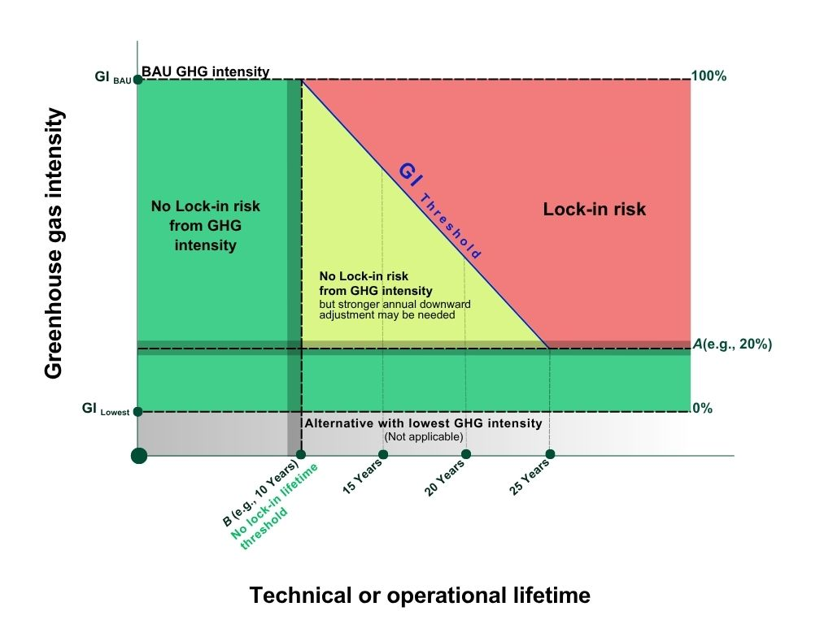
  - Step 3: Resource use efficiency assessment
- Activity participants shall assess the use of resources by the proposed Article 6.4 activity to determine whether the activity involves a technology, measure, or practice that constitutes an inefficient use of resources that are important for mitigating climate change or achieving other policy objectives.
- The type of resource(s) to be analysed shall be those specified in the mechanism methodology or identified in accordance with the relevant approach specified in the mechanism methodology. Relevant resources may include, for example, land, freshwater, biomass residues, or other relevant resources.
- Activity participants shall undertake, for each identified resource, an assessment of the resource use efficiency as per the following provisions:
  - Select, from the list of comparable activities compiled in step 2, all activities that use the identified resource and that are financially feasible for the Article 6.4 activity participant, including revenues from Article 6, paragraph 4, emission reductions (A6.4ERs) where applicable;
  - Calculate the resource use intensity of the comparable activities and of the proposed Article 6.4 activity, using the indicator (e.g., m³ of water/unit output, TJ/unit output, ha/unit output, etc.) and the approach specified in the mechanism methodology;
  - Identify the best resource use intensity value (i.e., the lowest resource use per unit output according to the indicator among the comparable activities);
  - Calculate the resource use intensity limit by applying the threshold defined in the mechanism methodology to the best resource use intensity value; and
  - Compare the resource use intensity indicator of the proposed Article 6.4 activity with the resource use intensity limit.
- If the resource use intensity of the proposed Article 6.4 activity is not greater than the resource use intensity limit, then the proposed Article 6.4 activity shall be deemed to avoid the inefficient use of the resource and activity participants shall proceed to the scale assessment, as defined in the mechanism methodology, if applicable.
- Otherwise, the alternative with the best resource use intensity value shall be included in the remaining additionality demonstration of the proposed Article 6.4 activity alongside the other identified alternatives to the Article 6.4 activity. This demonstration shall proceed in accordance with the applicable requirements of the mechanism methodology, including the use of any methodological tools.
- Where an investment analysis is conducted to demonstrate additionality, and if alternatives to the proposed Article 6.4 activity exist with more efficient resource use, the results of the resource use efficiency assessment shall be considered as follows:
  - If the proposed Article 6.4 activity is less financially attractive than the alternatives without the incentives from the mechanism, then it is deemed that there is a risk that the proposed Article 6.4 activity locks in a resource-inefficient activity (see case A in Table 1);
  - If the proposed Article 6.4 activity is more financially attractive than the alternatives without the incentives from the mechanism, then it is inconclusive whether the proposed Article 6.4 activity locks in a resource-inefficient activity (see case B in Table 1);
  - If the alternative becomes equally or more financially attractive than the proposed Article 6.4 activity when analysed with the incentives from the mechanism, then the proposed Article 6.4 activity locks in a resource-inefficient activity (see case C in Table 1);
  - Otherwise, the proposed Article 6.4 activity shall be deemed not to constitute an inefficient use of resources and activity participants shall proceed to the scale assessment, as defined in the mechanism methodology, if applicable.
Table 1. Interpreting results of the resource use efficiency assessment where an investment analysis is conducted to demonstrate additionality
 | Investment analysis
 | First analysis |  | Second analysis (if needed)
Consideration of incentives | Both without incentives |  | Both with incentives
 | A | B | C | D
A6.4 Activity (less efficient resource use) | Less attractive | More attractive | Less or equally attractive | More attractive
Alternative (more efficient resource use) | More attractive | Less attractive | More or equally attractive | Less attractive
Results | Conclusion: Lock-in-risk exists | Inconclusive: Continue to second analysis | Conclusion: Lock-in-risk exists | Conclusion: No Lock-in-risk from inefficient resource use
- Where a barrier analysis is conducted to demonstrate additionality, and if alternatives to the proposed Article 6.4 activity exist with more efficient resource use, the results of the resource use efficiency use assessment shall be considered as follows:
  - If the proposed Article 6.4 activity faces barriers compared with the alternative without incentives from the mechanism, then there is a risk that the proposed Article 6.4 activity locks in resource-inefficient activity (see case A in Table 2);
  - If the proposed Article 6.4 activity faces fewer barriers than the alternative without incentives from the mechanism, then it is inconclusive whether the proposed Article 6.4 activity locks in resource-inefficient activity (see case B in Table 2);
  - If the alternative faces fewer barriers or if the barriers are alleviated when analysed with incentives from the mechanism, the proposed Article 6.4 activity locks in a resource-inefficient activity (see case C in Table 2);
  - Otherwise, the proposed Article 6.4 activity shall be deemed not to constitute an inefficient use of resources and activity participants shall proceed to the scale assessment, as defined in the mechanism methodology, if applicable.
Table 2. Interpreting results of the resource use efficiency assessment where a barrier analysis is conducted to demonstrate additionality
 | Barrier analysis
 | First analysis |  | Second analysis (if needed)
Consideration of incentives | Both without incentives |  | Both with incentives
 | A | B | C | D
A6.4 Activity (less efficient resource use) | Faces barriers | Faces barriers | Barriers remain | Fewer barriers relative to the alternative or barriers alleviated
Alternative (more efficient resource use) | Does not face barriers | Faces equal or more barriers | Fewer barriers relative to the activity or barriers alleviated | Barriers remain
Results | Conclusion: Lock-in-risk exists | Inconclusive: Continue to second analysis | Conclusion: Lock-in-risk exists | Conclusion: No Lock-in-risk from inefficient resource use
  - Relevance of scale assessment
- Scale assessment is only applicable if the output of the proposed Article 6.4 activity can be delivered by entities other than the Article 6.4 activity participant(s), e.g., grid-connected power plants. If the output of the proposed Article 6.4 activity can only be delivered by the Article 6.4 activity participants (e.g., captive facilities), then scale assessment is not applicable.
- Scale assessment may be relevant when the output provided by the Article 6.4 activity occupies such a large market share that it limits or prevents the supply of the same or similar outputs by others, e.g., under monopoly conditions.
- Scale assessment may also be relevant when an Article 6.4 activity, if replicated widely, may generate impacts on a dominant emission-intensive sector thereby further consolidating that sector.
- In other circumstances, scale assessment is unlikely to be relevant for analysing lock-in risk.
- - - - -
Document information
Version | Date | Description
01.0 | 21 May 2026 | SBM021, Annex 2.  Initial adoption.
Decision Class: Regulatory
Document Type: Tool
Business Function: Methodology
Keywords: A6.4 mechanism, additionality, analysis of lock-in risk, methodologies, project activities

See https://unfccc.int/sites/default/files/resource/A6.4-PROC-METH-001.pdf.
Example of practices may include agricultural practices such as rice cultivation.
The operational lifetime may be shorter (e.g., due to changes in the regulatory environment) or longer (e.g., due to retrofits, or economic incentives for prolonged operation) than the technical lifetime.
See https://unfccc.int/sites/default/files/resource/A6.4-Glossary.pdf.
See https://unfccc.int/sites/default/files/resource/A6.4-AMT-006-v01.0.pdf.
See https://unfccc.int/sites/default/files/resource/A6.4-STAN-METH-003.pdf.
See https://unfccc.int/sites/default/files/resource/A6.4-STAN-METH-004.pdf.
This methodological tool is not applicable to activities which repair or modify existing technologies, measures and/or practices (retrofit activities).
For example, in the case of an activity participant that is specialized in a specific greenfield power plant technology, it is reasonable to assume that third parties may build less greenhouse gas intensive power plants if an activity participant would not proceed with their Article 6.4 activity. By contrast, in the case of a project implementing a new landfill with gas capture and flaring, it is reasonable to consider only alternatives that the activity participants could implement, due to the site-specific circumstances.
Relevant resources may, for example, include fuels and feedstocks, as well as land and water resources. Where applicable, the assessment of which resources are relevant, may also be guided by resources identified in accordance with the provisions in section 6.3 of the “Tool: Article 6.4 sustainable development tool” (A6.4-TOOL-AC-001).
For further information on the relevance of the scale assessment see section 5.4.
The main technology, measures, or practices refers to the key component (for example, the photovoltaic module for a solar mini grid). In some cases, there may be more than one main technology, measure or practice relevant for lock-in risk analysis (for example a reservoir and a turbine in the case of a hydro power plant), in which case the lock-in risk analysis shall be carried out separately for each one in accordance with the relevant guidance provided in the mechanism methodology.
An example of such standards is ISO/TS 24094:2022 aimed at predicting lifetime and reliability of PV modules.
Identification of such alternatives may consider for inclusion, technologies, measures or practices already implemented as pilot or demonstration projects, and technologies, measures or practices that are implemented in countries other than where the Article 6.4 activity is located.
The ratio in the equation divides the proportion that is outside the no lock-in risk area (1 – A = 0.8) by the difference in lifetime thresholds (25 – B = 15), where as an example variable B is set at 10 years and A at 0.2.
For activities whose technical or operational lifetime exceeds 25 years, the mechanism methodology should set a threshold equal to or below 20 per cent. However, the 20 percent threshold for activities with a long lifetime above 25 years may lead to exclusion of certain technologies whose implementation does not cause lock-in as per its definition. For this reason, mechanism methodology proponents may propose a different threshold (leading to different values for the parameter Flock-in) if it is deemed that the default parameter would exclude technologies, measures or practices that would not cause lock-in risk. As an example, for landfill gas (LFG) capture methodology (if the lifetime is higher than 25 years), if LFG capture and flaring emissions intensity is higher than the emissions intensity corresponding to 20 per cent, the mechanism methodology may propose a higher threshold in order not to exclude such technology, if it is deemed that it will not cause lock-In risk.
In instances where the technical or operational lifetime of the Article 6.4 activity is between 11 and 25 years and the greenhouse gas intensity of the Article 6.4 activity is larger than the 20 percent threshold (or other threshold specified in the mechanism methodology) and below the greenhouse gas intensity threshold (GI_{threshold}), a larger annual downward adjustment may be warranted to set incentives for the adoption of less GHG intensive technologies and/or practices, pursuant to paragraph 70 of the “Standard: Setting the baseline in mechanism methodologies” (A6.4-STAN-METH-004).
The figure is an illustrative example of the case where variable B is set at 10 years and A at 0.2.
This applies to the cases specified under both (i) and (ii) in paragraph 9 (e).

