Eurelectric input into Talanoa Dialogue

October 2018

European power sector – Eurelectric - input to Talanoa Dialogue
Eurelectric is the sector association which represents the common interests of the electricity industry at a European level, plus its affiliates and associates on several other continents. We welcome the opportunity to submit our input into the Talanoa Dialogue. As a strong supporter of the Paris Climate Agreement we believe it is crucial for Europe to lead by example and facilitate its implementation.

While all sectors clearly need to deliver to achieve the Paris Agreement, the European power sector is a critical enabler and a front runner. We remain committed to decarbonising the European power generation well before 2050 and express our confidence in electricity as an energy carrier, which will play a major role in decarbonising other energy using sectors.

The European power sector is a global pioneer in decarbonisation efforts proud to continue delivering on the Paris Agreement objectives. The first part of Eurelectric’s ‘decarbonisation pathways’ study, published in June 2018 shows that a 95% decarbonisation of the European economy by 2050 would require a direct electrification rate of 60% across all energy using sectors. Therefore, electricity is the key to successful implementation of the Paris Agreement in Europe.

At the next COP 24 in Katowice we would like to present our vision of delivering carbon neutral electricity to enable deep decarbonisation of the European economy, which we would like to discuss in an inclusive, respectful, open, and transparent Talanoa Dialogue, which we hope to be a part of.

Commitment of the power sector – Carbon neutral well before 2050
The European power sector is at the heart of the European fight against climate change. Europe’s ability to meet the ambitions of the Paris Agreement depends heavily on our industry’s ability to decarbonise the power sector. Eurelectric and its members accept this responsibility, acknowledging the urgency to address climate change, air pollution and the depletion of natural resources. Our engagement also comes with the conviction that energy using sectors also need to make major efforts in order to reach the goals of the Paris Agreement.

Our sector is currently in the midst of a deep transformation driven by technology, digitalisation and more active customers. Taking on the challenge to decarbonise therefore also comes with a clear recognition of the importance of cost-efficiency and the need to deliver secure and affordable energy while modernising our infrastructure, taking into account data protection and public acceptance challenges.

With this in mind, Eurelectric launched its new industry vision in December 2017, fully committing Eurelectric members to invest in clean electricity generation and transition-enabling technologies such as storage and demand response in order to deliver carbon neutral electricity well before 2050. This commitment followed a statement made earlier that year where the industry declared that it does not intend to invest in new coal plants after 2020.

Progress to meet this ambition is well underway. Data from the European Environment Agency (EEA), Eurostat and Eurelectric show how the European power sector is making significant strides towards decarbonisation. As a key indicator the CO₂ emission intensity for EU electricity & heat generation declined by more than 40% between 1990 and 2016, from a level of 431 gCO₂/kWh in 1990 to 257 gCO₂/kWh in 2016. Further, between 2010 and 2017 the amount of power generated across the EU coming from carbon-free sources rose from 46.5% to 57.5%, with the Renewables share reaching 30% in 2017. Further reduction of CO2 emission intensity of the power sector creates economic and technological challenges and opportunities that require additional efforts and commitment at the global level.

Beyond our drive for environmental sustainability, it becomes increasingly clear that value for companies is generated not only through business operations but also in the way they are carried out. Eurelectric is deepening its engagement in social sustainability, expanding partnerships with social and local actors. Delivering on this commitment truly enables our sector to support the economy-wide shift to an efficient climate-friendly society.

Enabling the transition – key policy aspects for a 2050 strategy
The electricity sector is ready to lead the ambitious journey toward decarbonisation. Enabling the transition and truly unlocking the opportunities it brings is therefore the primary concern of Eurelectric and its members. We believe that global climate policies should be built on the following pillars:

- Ensuring cost-efficiency. As they move towards decarbonisation, each country is facing different challenges and opportunities. Global policy must therefore provide instruments which enable the development and deployment of all transition enabling technologies. This includes a global carbon market that delivers a meaningful price that ensures implementation of the Paris Agreement. It necessitates channelling of sustainable climate and energy financing toward the relevant technologies. It also includes framework conditions that allow innovation, research and commercialisation of new and more efficient solutions throughout the entire value chain of the electricity sector.

- Delivering efficient electrification. Decision makers and investors have begun to recognise the key role clean electricity has to play in allowing other, fossil fuel dependent sectors to decarbonise and become more efficient. Smarter and better regulation is needed to promote the take-up of energy efficient electric and power to gas technologies, including clean & sustainable heating and cooling in residential and industrial buildings, clean electric mobility and more efficient industrial processes. The first part of Eurelectric’s ‘decarbonisation pathways’ study, published in June 2018 shows that a 95% decarbonisation of the European economy by 2050 would require a direct electrification rate of 60% across all energy using sectors.

- Unlocking the benefits of digitalisation. Over the past decade utilities and energy businesses have introduced digital innovation to optimise processes while new technologies and services continue to disrupt and transform the traditional power sector value chain. The digital future of the electricity system will require making smart grids a reality so as to integrate centralised and decentralised technologies, promote customer participation in a secure, flexible and cost-effective manner. It is therefore key to address existing challenges to unlock new business models and align strategies on triggering investments in clean technologies across sectors. Overcoming the slow development of regulatory frameworks and asynchronous investment strategies will only be possible with a cross-sectoral approach to innovation and digitalisation.

- Ensure a well-functioning power market. The power sector transition will require very significant investments over the next decades, in generation, storage, demand response and networks. Giving the right signals to investors must therefore be a priority for policy makers and the private sector. If the global economy is to unlock the investments needed, the Talanoa Dialogue must foresee the promotion of sustainable electricity markets.

- Enabling a fair transition. The commitment and ambition expressed in our vision are challenging, especially for countries with low GDP/capita and regions which depend on high carbon value chains. When looking toward 2050, the UNFCCC needs to carefully take into account potential negative impacts on business, employment and living conditions. This social sustainability dimension requires close cooperation between regional and local governments, Social Partners, as well as the industry. The power sector is engaged in discussions on transforming European carbon-intensive regions to leverage financing of their energy transition. As such, Eurelectric is supportive of Just Energy Transition for successful restructuring of all EU carbon intensive regions.

Electricity as the key - a 95% reduction target requires a 60% electrification of EU energy consumption in 2050
As the energy needs of modern society evolve and the focus shifts from access to sustainability, security and affordability, electricity is ready to reveal its true potential. It is set to become the leading energy vector to decarbonise other sectors of the economy as well, such as transport, heating and cooling.

To substantiate the power sector commitment to be carbon neutral well before 2050, Eurelectric conducted a new study showing the close connection between electrification and deep decarbonisation. The analysis shows that for the EU to reach 80% - 95% GHG emissions reduction by 2050, electricity needs to cover between 38% and 60% of final energy consumption. This is achievable with a 1% to 1.5% year-on-year growth of EU direct electricity consumption whilst at the same time reducing the EU’s energy consumption by 0.6 % - 1.3% per year through energy efficiency improvements.

Electrification does more than remove CO₂ emissions. It reduces the use of fossil fuels by replacing these energy carriers with locally produced electricity. It also enhances energy efficiency by incentivising the roll-out of more efficient technologies. And it improves air quality – especially in our cities. Electrification also creates significant opportunities for technology leadership, exports and job creation that can be harnessed through a well-managed energy transition.

There is no single silver bullet in decarbonising the global economy. The challenges differ considerably from country to country. It is however clear that for many energy-based applications, energy efficient electrification is the most direct, effective and efficient way of reaching the decarbonisation objectives. Electricity is flexible and versatile; it can be used in almost all energy using sectors either directly or indirectly. Our study finds that in a deeply decarbonised Europe in 2050:

- Electricity will play a leading role in transport, where up to 63% of total final energy consumption in Europe will be electric in our most ambitious scenario. With major car manufacturers increasingly moving towards electric fleets (see BMW, Volvo, VW etc.) the shift toward electrification of road transport is already initiated for passenger cars, but also for buses and trucks. In the future, successful decarbonisation of all segments of the transport sector, in particular aviation and maritime, will also rely on hydrogen and synthetic methane produced from carbon neutral electricity, as well as availability of other clean fuels. The infrastructure requirements of this transition will need to be carefully managed in an integrated manner with a rapid increase in the number of charge points required to meet an increase in Electric Vehicles. These charging points should be deployed ‘smart ready’ so that vehicle-to-grid services can be utilised providing benefits to both network companies, and the consumer.

- In buildings, energy efficiency is a key driver of emission reductions while 45% to 63% of European buildings’ energy consumption could be electric in 2050 mainly driven by adoption of electric heat pumps. A smart management of these heat pumps will be required as peak demand from heating can be many times higher than current peak electricity demand in some regions. Flexible, digital and automated solutions, demand response and storage technologies will be critical to enable this transition at the least cost.

- A series of industrial processes in Europe can technically be electrified with up to 50% direct electrification in 2050. The relative competitiveness of electricity against other carbon-neutral fuels will be the critical driver for this shift. Hydrogen and other carbon-neutral alternatives will also play a role and drive indirect electrification. In some industrial sectors an increased use of electricity will facilitate the achievement of circular economy. In other sectors electrification will enable sector coupling and trigger joint cooperation opportunities in CCS/CCU infrastructure development. Public and non-public preferential financing of installations allowing re-use of captured CO2 in another technological process will be key to succeeding in this

Figure 1: Electricity share in final energy consumption across sectors to achieve deep decarbonisation

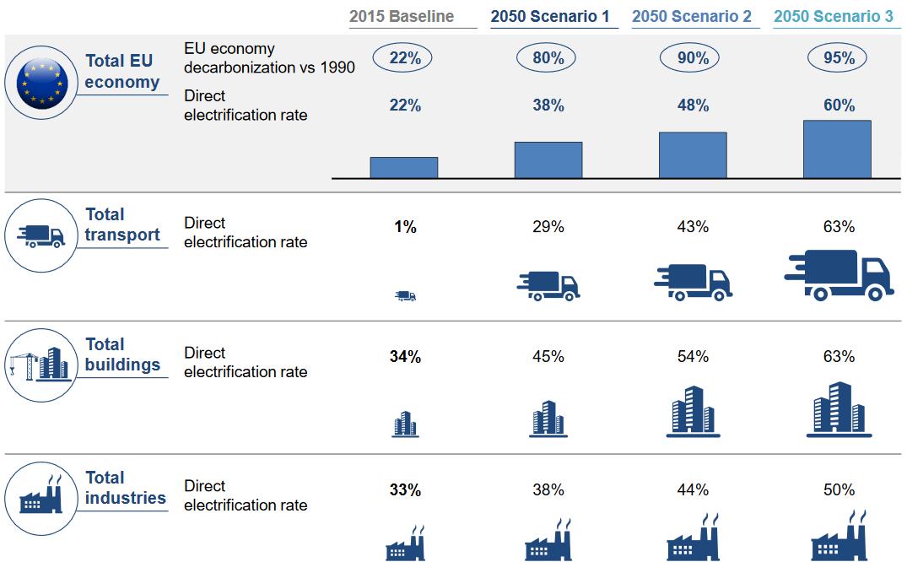

Deep decarbonisation requires the removal of critical barriers on electrification, energy efficiency and other non-emitting fuels. The Talanoa Dialogue will be an essential guide for current and future policy makers to get the global economy on the track to meeting its Paris ambitions. Political focus on shaping a fair transition and leaving room for regional nuances will be key to its successful delivery.

More specifically with regards to the UNFCCC process, we find the following aspects key to deliver ambitious commitments:
- The role of electricity as a key decarbonisation enabler must be recognised at the global level
- The recognition of different starting points between different countries will be key to enabling just energy transition towards carbon neutral economy
- The Paris Agreement Working Program will have to be completed on time to allow smooth operationalisation of the Paris Agreement by providing meaningful investment signals to the private sector
- Global climate policy must ensure predictability to facilitate more climate action
- The Talanoa Dialogue conclusions need to serve as a push for ambitious climate action
- Business must be an active agent both at national and international level
- Public-private partnerships and alliances are essential to enhance climate action and better inform policy decisions
- The market mechanisms such as carbon markets, technology and innovation are essential tools to increase ambition and deliver on the climate commitments
- All sectors of the economy need to be involved in the transition

At the next COP 24 in Katowice we plan to present our vision of delivering carbon neutral electricity to enable deep decarbonisation of the economy on the example of Europe. We hope to be able to exchange on our vision in an inclusive, respectful, open, and transparent dialogue with other participants of the Talanoa Dialogue conference.

https://cdn.eurelectric.org/media/3172/decarbonisation-pathways-electrificatino-part-study-results-h-AD171CCC.pdf
https://cdn.eurelectric.org/media/2189/vision-of-the-european-electricity-industry-02-08-2018-h-864A4394.pdf
https://cdn.eurelectric.org/media/3172/decarbonisation-pathways-electrificatino-part-study-results-h-AD171CCC.pdf
‘Decarbonisation Pathways’, June 2018 – available at www.eurelectric.org

