**ParlAmericas Contribution to Talanoa Dialogue**

Please click the following link to see ParlAmericas’ video contribution to the Dialogue: [**https://www.youtube.com/watch?v=o6rOS0fsliw&feature=youtu.be**](https://www.youtube.com/watch?v=o6rOS0fsliw&feature=youtu.be)

[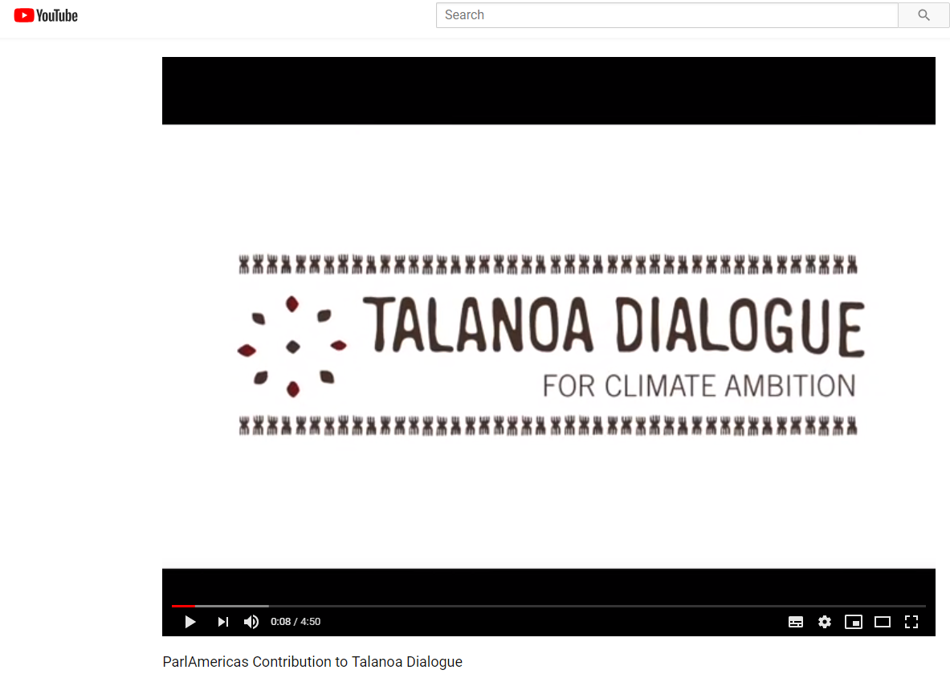](https://www.youtube.com/watch?v=o6rOS0fsliw&feature=youtu.be)