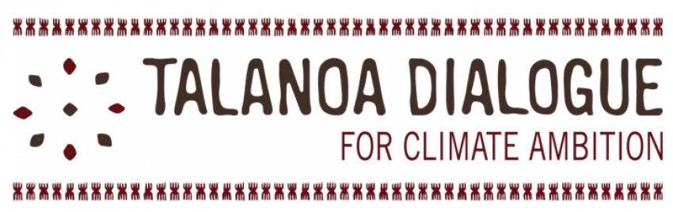
August and September saw Talanoa Dialogues conducted by Islamic Relief in Pakistan, Malawi, Niger, Mali, Somalia, Gaza, South Sudan, Kenya, Jordan, Bangladesh, United Kingdom & Russia. Three questions about climate change were considered by IR, CSO and NGO staff, primary stakeholders, politicians, community and religious leaders. The results have been submitted to the UN and included in the IR Climate Change Policy Review. The exercise will help country programmes to contribute to their national disaster risk and climate adaptation plans.
Where are we?
We are creating climate change through cutting of trees, overuse of chemical and plastic products, poor waste management, irresponsible energy consumption, unnecessary air travel and driving. This has led to water crises, physical and mental health problems, energy disruption, food insecurity, and species loss. Women are most effected. Governments are not addressing issues. People lack information.

Where do we want to go?
Coordinated local, national and international strategies to fight climate change and to achieve sustainable development goals. Informed society where all champion for mitigation and adaption including integrating climate change to faith and education.

How do we get there?
Informed about the hazards, local communities know what is needed relevant to their context. They should participate in policy-making, have roles in accountability and monitoring of municipalities and government. Resources should be concentrated accordingly. Plant trees and care for them. Women can lead activities to cope with climate change issues.

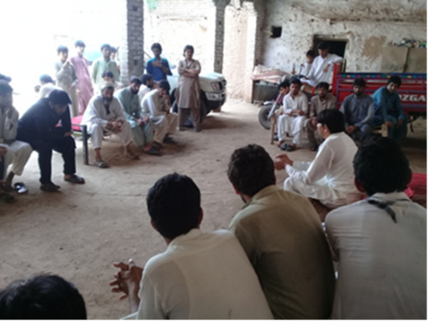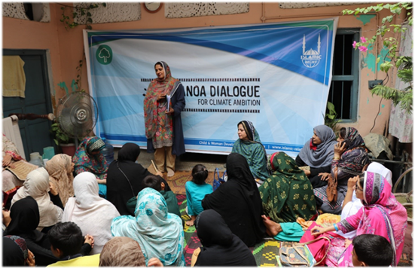
Talanoa Dialogues in Pakistan

