Sweden’s Initial Report under the Kyoto Protocol
Calculation of Assigned Amount

SWEDISH ENVIRONMENTAL PROTECTION AGENCY

Swedish EPA
Tel +46 (0)8-698 10 00, fax +46 (0)8-20 29 25
E-mail: natur@naturvardsverket.se
Postal address: Naturvårdsverket, SE-106 48 Stockholm
Internet: www.naturvardsverket.se

© Swedish Environmental Protection Agency 2006

Preface
As a party to the Kyoto Protocol, Sweden shall submit an Initial Report (the decision 19/CP.7, referring to article 7(4) of the Kyoto Protocol, where adopted by COP/MOP 1) containing calculations of the Assigned Amount to the UNFCCC due December 31, 2006. Since Sweden is an EU member state and EU is a party to the Kyoto Protocol, Sweden is, according to Decision 280/2004/EC, obligated to submit the Initial Report to the European Commission no later than January 15, 2006.

The EU15 in accordance with Article 4 of the Kyoto Protocol, agreed to fulfil its commitments under the Kyoto Protocol jointly (Decision 2002/358/EC). The quantified emission limitation and reduction commitments agreed by the EU for the first commitment period, 2008-2012, are set out in Annex II of Decision 2002/358/EC. Sweden’s quantified emission limitation is 104 % of base year emissions.

The calculation of Sweden’s Assigned Amount is based on the Swedish Greenhouse Gas Inventory submission 2006.

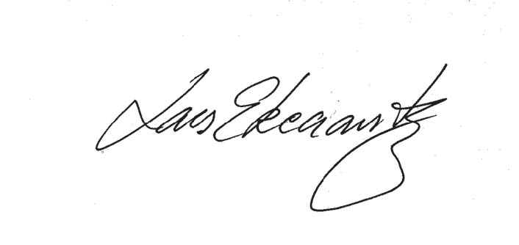
Lars Ekecrantz
Deputy Director General

Contents
Preface 3
Contents 4
Summary 5
1 Introduction 8
2 Sweden’s Greenhouse gas Inventory Emissions 10
3 Calculation of Sweden’s Assigned Amount 11

3.1 Agreement under Article 4 of the Kyoto Protocol 11

3.2 Selected base year for hydrofluorocarbons, perfluorocarbons and sulphur hexafluoride 11

3.3 Calculation of Sweden’s Assigned Amount 11
4 Land use, land use change and forestry (LULUCF) 16

4.1 Definition of forest for reporting under Article 3.3 and 3.4 of the Kyoto Protocol 16

4.2 Method for identification of land areas associated with LULUCF-activities 16

4.3 Selection of activities under Article 3.4 of the Kyoto Protocol 16

4.4 Accounting 16
5 Sweden’s national system for climate reporting 17

5.1 Background 17
5.1.1 Quality principles of the national system 17

5.2 Legal arrangements of the Swedish 19
5.2.1 Ordinance Concerning Climate Reporting 19
5.2.2 Other supporting legislation 20
5.2.3 Contracts with consultants 21

5.3 Institutional arrangements of the Swedish national system 21
5.3.1 Ministry of Sustainable Development 22
5.3.2 Swedish Environmental Protection Agency (Swedish EPA) 22
5.3.3 Other government agencies 23
5.3.4 Responsibilities of consultants 24

5.4 Procedural arrangements of the Swedish national system 25
5.4.1 Yearly Inventory and Report 25
5.4.2 Methodologies used for the National Inventory Report 26
5.4.3 The quality system 29
6 Sweden’s National Registry 37

6.1 Registry Administrator 37

6.2 Technical Description 37

6.3 Calculation of the commitment period reserve 39
7 References and sources 40
Annex 1 41

Appendix 1 Swedish greenhouse gas inventory 1990-2004 in CRF reporter
Appendix 2 Swedish National Inventory Report submission 2006

Summary

The Initial Report under the Kyoto Protocol includes Sweden’s complete inventory of anthropogenic emissions by sources and removals by sinks of greenhouse gases not controlled by the Montreal Protocol. The time series cover the years 1990–2004 for all greenhouse gases. Together with the complete time series, Sweden’s National Inventory Report is included to enable a review of the inventory quality, i.e. to ensure that the inventory is transparent, consistent, comparable, complete and accurate.

During the past five years, Sweden has carried out extensive work to build up a comprehensive climate reporting system, which in a consistent manner can meet the Kyoto Protocol requirements. In addition, considerable work has been done between 2003 and 2005 to establish a national system for climate reporting.

The quantified emission limitation and reduction commitments agreed by the European Community and its Member States for the purpose of determining the emission levels allocated to each of them for the first commitment period, from 2008 to 2012, are set out in Annex II of Decision 2002/358/EC. In accordance with Annex II, Sweden’s quantified emission limitation commitment as agreed in accordance with Article 4(1) of the Kyoto Protocol is 104 % of base year emissions.

Sweden’s assigned amount for the commitment period (2008-2012) is calcutated as the total greenhouse gas emissions (in carbon dioxide equivalents) in 1990, excluding LULUCF and fluorinated gases, added together with the emissions of fluorinated gases (in carbon dioxide equivalents) in 1995, multiplied by Sweden’s quantified emission limitation commitment (104 %) and multiplied by 5:

(71639,161+ 642.438) * 1.04 * 5 = 375864.317 Gg CO₂ equivalents

The assigned amount averaged over the first commitment period is thus (Sweden’s Assigned Amount / 5):

375864,317 / 5 = 75172.863 Gg CO₂ equivalents
Figure S1 Emissions of greenhouse gases (excluding LULUCF) in CO₂ equivalents 1990-2004 and averaged assigned amount 2008-2012.
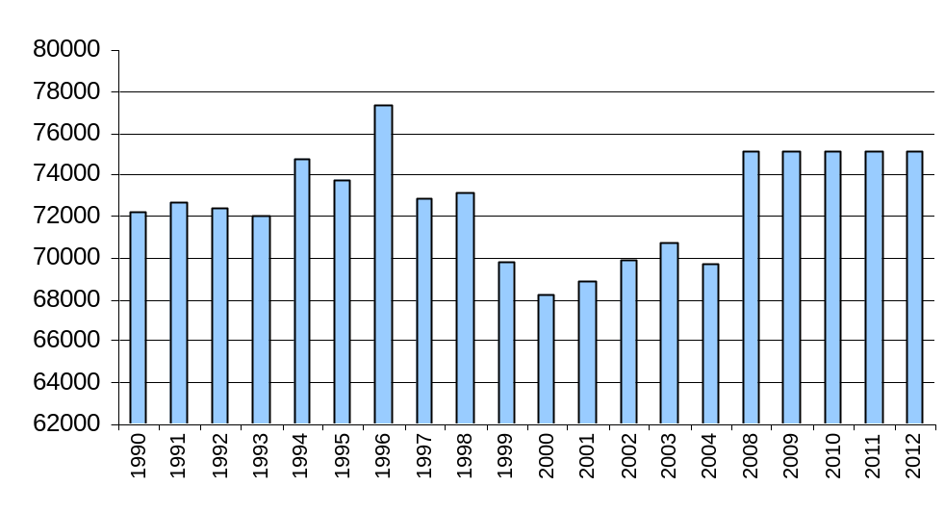
For reporting purposes under the Kyoto Protocol, forest is defined, according to the FAO definition, as land with a tree crown cover of more than 10 %, an area of more than 0.5 ha. and trees that should be able to reach a minimum height of 5 m at maturity. For the accounting of LULUCF-activities under article 3.4 for the first commitment speriod, Sweden will use Forest Management.

In the Initial Report under the Kyoto Protocol a technical description of the National Registry is presented in accordance with the reporting requirements laid down in Annex II under decision 22/CP.7 in FCCC/CP/2001/13/add.3. The Swedish Energy Agency acts as the National registry administrator. Sweden will maintain a commitment period reserve in its national registry which should not fall short of 90 % of Sweden’s Assigned Amount.

Under Article 5(1) of the Kyoto Protocol each party to Annex I shall have in place a national system for estimating anthropogenic emissions by sources and removals by sinks of all greenhouse gases not controlled by the Montreal Protocol by 31 December 2006. The national system is to be designed in compliance with UNFCCC decision 20/CP.7. Under the terms of Decision No. 280/2004/EC of the European Parliament and of the Council, the national system has to be in place by the end of 2005.

Under UNFCCC decision 20/CP.7, the national system has to ensure that all the institutional, legal and procedural arrangements required to calculate emissions and removals of greenhouses gases function.

In Sweden, the Ministry of Sustainable Development is the national entity with overall responsibility for the national system. The Swedish Environmental Protection Agency (Swedish EPA) has been designated under Ordinance (2005:626) Concerning Climate Reporting to coordinate national work for Swedish climate reporting and maintaining the climate reporting system. This is done in consultation with other concerned government agencies, consultants and organisations.

The ordinance concerning Climate Reporting (2005:626) describes the responsibilities of other government agencies in the context of climate reporting. Under the Ordinance, the Swedish EPA has also been given the right to inform government agencies of the timing and delivery of documentation to ensure that reporting takes place in a timely manner so that Sweden is able to fulfil its obligations.

The Swedish EPA engages consultants to calculate greenhouse gas emissions and removals. The responsibilities of the consultants are described in framework contracts drawn up between the Swedish EPA and the consultants in compliance with the Public Procurement Act. The consultants comprise a consortium known as the Swedish Environmental Emissions Data (SMED).

The choice of methodology to calculate greenhouse gas emissions and removals is described within the framework of the national system for the procedural arrangements, i.e. how the annual inventory and reporting are to be carried out.

A quality system has been introduced in the framework of the national system to ensure that the inventory and reporting are systematically planned, prepared and followed up in accordance with specified quality requirements so that the inventory
is continuously developed and improved. The quality system relates to both the government agencies and the work of the consultants, who all have internal quality systems which are linked to the national quality system.

Introduction

As a party to the Kyoto Protocol, Sweden has to submit an Initial Report to UNFCCC by 31 December 2006, ahead of the first commitment period under the Kyoto Protocol. Since Sweden is a member state of the EU, which in turn is a separate party to the Kyoto Protocol, the EU has stipulated in Decision 280/2004/EC that Sweden is to submit its Initial Report to the European Commission no later than January 15, 2006. The purpose of this is to give the EU time to compile a joint Initial Report to the UNFCCC for the EU as a party.

In accordance with Decision 280/2004/EC each Member State has to, by 15 January 2006 submit the following information to the Commission:

- the complete time series of inventories as anthropogenic emissions by sources and removals by sinks of greenhouse gases not controlled by the Montreal Protocols as reported to the UNFCCC;

- the identification of its selected base year for hydrofluorocarbons, perfluorocarbons and sulphur hexafluoride as reported to the UNFCCC;

- its proposal for its emission level in terms of tonnes of carbon dioxide equivalents pursuant to Article 3 of Decision 2002/358/EC and Article 3(7) and (8) of the Kyoto Protocol, following the establishment of definitive base-year emission figures and on the basis of the quantified emission limitation or reduction commitments set out in Annex II to Decision 2002/358/EC and the Kyoto Protocol, taking into account the methodologies for estimating anthropogenic emissions by sources and removals by sinks referred to in Article 5(2) of the Kyoto Protocol and the modalities for the calculation of assigned amount pursuant to Article 3(7) and (8) of the Kyoto Protocol;

- the calculation of its commitment period reserve as 90 per cent of its proposed assigned amount or 100 per cent of five times its most recently reviewed inventory, whichever is the lowest;

- The identification of its selection of single minimum values for tree crown cover, land area and tree height for use in accounting for its activities under Article 3 (3) and (4) of the Kyoto Protocol, together with a justification of the consistency of those values with the information that has been historically reported to the Food and Agriculture Organisation of the United Nations or other bodies, and in the case of difference, an explanation of why and how such values were chosen, in accordance with definitions, modalities, rules and guidelines relating to land use, land-use change and forestry activities under the Kyoto Protocol;

- the identification of its election of activities under Article 3(4) for inclusion in its accounting for the first commitment period, together with the information on how its national system under Article 5(1) of the Kyoto Protocol will identify land areas associated with the activities, in accordance with definitions, modalities, rules and guidelines relating to land use, land-use change and forestry activities under Kyoto Protocol;

- the identification of whether, for each activity under Article 3(3) and (4) of the Kyoto Protocol, it intends to account annually or for the entire commitment period;

- a description of its national system in accordance with Article 5(1) of the Kyoto Protocol, in accordance with the guidelines under Article 7 of the Kyoto Protocol;

- a description of its national registry, in accordance with the guidelines under Article 7 of the Kyoto Protocol.

Sweden’s Greenhouse gas Inventory Emissions

Appendix 1 of this report presents Sweden’s complete inventory for the years 1990-2004 as anthropogenic emissions by sources and removals by sinks of greenhouse gases not controlled by the Montreal Protocol. Together with the complete time series, Sweden’s National Inventory Report is included in Appendix 2 to enable a review of the inventory quality, i.e. ensure that the inventory is transparent, consistent, comparable, complete and accurate.

Calculation of Sweden’s Assigned Amount

Agreement under Article 4 of the Kyoto Protocol

In Annex B of the Kyoto Protocol, Sweden has a quantified emission limitation or reduction commitment of 92 % of the base year. But, in accordance with Article 4 of the Kyoto protocol, the EU member states have agreed to fulfil their commitments jointly in accordance with Decision 2002/358/EC. The quantified emission limitation and reduction commitments agreed by the EU15 for the first commitment period, 2008-2012, are set out in Annex II of the Decision 2002/358/EC. Sweden’s quantified emission limitation is 104 % of the base year (1990) emissions.

Selected base year for hydrofluorocarbons, perfluorocarbons and sulphur hexafluoride

According to Article 3(8) of the Kyoto Protocol, any Party to Annex I may use 1995 instead of 1990 as its base year for hydrofluorocarbons, perfluorocarbons and sulphur hexafluoride. Sweden chooses 1995 as the base year for the greenhouse gases hydroflourcarbons, perflourcarbons and sulphur hexafluoride.

Calculation of Sweden’s Assigned Amount

The calculation of Sweden’s Assigned Amount is based on the 2006 submission to the European Community and the UNFCCC of the complete 1990-2004 inventory as anthropogenic emissions by sources and removals by sinks of greenhouse gases not controlled by the Montreal Protocol.

During the past five years, Sweden has carried out extensive work to build up a comprehensive climate reporting system, which in a reliable manner can meet the Kyoto Protocol requirements. In addition, considerable work has been done between 2003 and 2005 to establish a national system for climate reporting.

The Ministry of Sustainable Development assigned the Swedish EPA to develop and establish a national system for inventory and reporting in accordance with Article 5 of the Kyoto Protocol and UNFCCC decision 20.CP.7, containing guidelines for national systems. The assignment also covered requirements within the EU for a national system in accordance with Decision No 280/2004/EC of the European Parliament and of the Council of 11 February 2004 concerning a mechanism for monitoring Community greenhouse gas emissions and for implementing the Kyoto Protocol, as well as the Commission’s implementing provisions, in accordance with Commission Decision 2005/166/EC of 10 February 2005 laying down rules implementing Decision 280/2004/EC of the European Parliament and of the Council.

The assignment, which began in the spring of 2003, has been undertaken in project form in close cooperation with concerned ministries, government agencies and organisations. Experience has been swapped with other countries within the framework of the EU and the UNFCCC workshops for national systems.

Measures have been taken during implementation of the national system to ensure that the legal, institutional and procedural arrangements required for the national system in Sweden are established no later than by the end of 2005. Within the framework of the procedural arrangements, Sweden has invested large resources in improving the quality of the methodology, a methodology in line with the Revised 1996 IPCC Guidelines and the IPCC Good Practice Guidance, for the whole time series to calculate greenhouse gas emissions and removals. This has been done through major development efforts and investigations in various sectors.

In the Energy sector, best use of emission data from the EU trading sceme has been investigated. Energy statistics, industrial statistics, “Other sectors” (residential, service and agriculture/forestry/fisheries) statistics and the quality of the calculations of methane emissions from small-scale combustion of biomass fuels have been improved.

In the Industrial Processes sector, methodology has been improved to calculate emissions of fluorinated greenhouse gases. In the Solvent and Other Product Use sector, an improved and uniform method and model for annual calculations of emissions of NMVOCs based on the National Products Register have been drawn up in cooperation with the Swedish Chemicals Inspectorate.

In the Agriculture sector, a new determination of the acreage of organogenic arable land has been carried out.

In the LULUCF sector, methodology has been developed for instance to calculate changes in the soil carbon pool in forest soil, and an existing model (the ICBM model) has been adapted for calculation of the carbon balance of arable land. In addition, a database has been developed that handles data from the National Forest Inventory (RIS) at the Swedish University of Agricultural Sciences. Because both reporting format and methodology have been modified, the whole time series were recalculated for the LULUCF sector in the submission 2006.

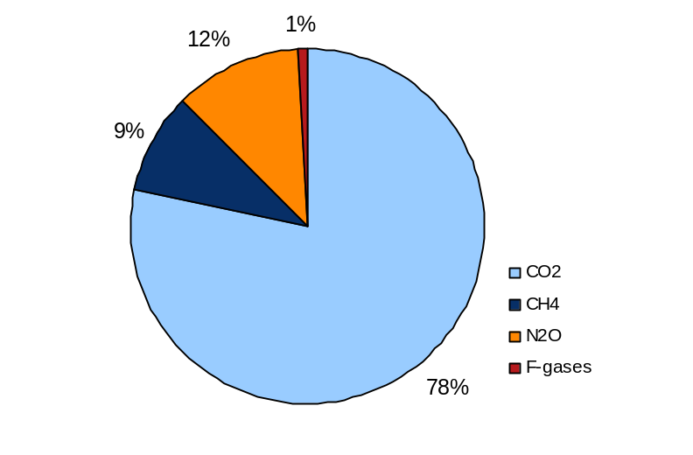
There were no immediate needs for improvements of the methodology in the Waste sector. However, in 2005, a study was carried out to look at the possabilities to include methane emissions from non-specific industrial waste and construction- and demolition waste in the subsector waste disposal on land. The study resulted in an inclusion of the aforementioned waste categories for the complete time series.
Figure 3.1 Emissions of greenhouse gases 1990 in CO₂ eqvivalents (excluding LULUCF).

In 1990, 78 % of the greenhouse gas emissions consisted of carbon dioxide (CO₂), 9% methane (CH₄), 12 % nitrous oxide (N₂O) and 1 % fluorinated gases (F-gases) (Figure 3.1). The energy sector (excluding transport) dominates the emissions in 1990 with 49 %. The emissions from the transport sector stands for 26 %, the agricultur sector for 13 % and the sector of industrial processes for 8 %. The waste sector stands for 4 % of the emissions in 1990 and the sector solvent and other product use for only 0.5 % (Figure 3.2).
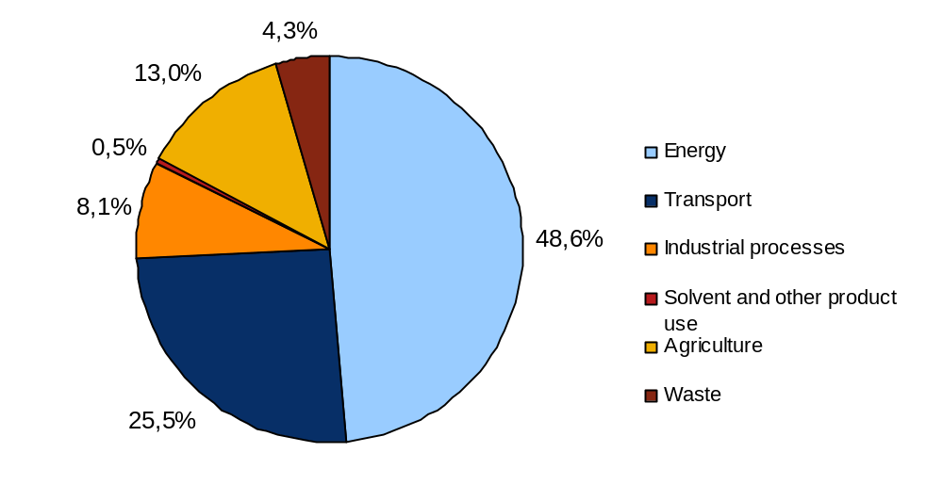
Figure 3.2 Emissions of greenhouse gases per sector 1990 in CO₂ eqvivalents (excluding LULUCF).

Table 3.1 Emissions of greenhouse gases excluding LULUCF 1990-2004
Year | Total emissions of greenhouse gases in CO₂ equivalents (Gg) | Emissions of fluorinated gases in CO₂ equivalents (Gg)
1990 | 72190.529 | 551.367
1991 | 72650.746 | 549.101
1992 | 72360.654 | 454.566
1993 | 72033.273 | 477.171
1994 | 74746.909 | 521.667
1995 | 73746.694 | 642.438
1996 | 77373.569 | 657.093
1997 | 72791.313 | 782.581
1998 | 73133.745 | 789.751
1999 | 69814.710 | 909.371
2000 | 68257.497 | 915.617
2001 | 68916.980 | 974.094
2002 | 69917.919 | 1 044.163
2003 | 70769.081 | 1 046.814
2004 | 69729.140 | 1 094.388

Sweden’s assigned amount for the commitment period (2008-2012) is calculated as the total greenhouse gas emissions (in carbon dioxide equivalents) in 1990 (bolded in table 3.1), excluding LULUCF and fluorinated gases, added together with the emissions of fluorinated gases (in carbon dioxide equivalents) in 1995 (bolded in table 3.1), multiplied by Sweden’s quantified emission limitation commitment (104 %) and multiplied by 5:

Sweden’s Assigned Amount = ((GHG 1990 excl LULUCF and F-gases) + (F-gases 1995)) * 1.04 * 5

This means that Sweden’s Assigned Amount is:

(71639,161+ 642.438) * 1.04 * 5 = 375864.317 Gg CO₂ equivalents

(equivalent to 375,864,317 metric tons of CO₂ equivalents).

The assigned amount averaged over the commitment period is thus (Sweden’s Assigned Amount / 5):

375864,317 / 5 = 75172.863 Gg CO₂ equivalents

In Figure 3.1 the emissions of greenhouse gases 1990-2004 and the average assigned amount 2008-2012 can be seen.
Figure 3.3 Emissions of greenhouse gases (excluding LULUCF) in CO₂ equivalents 1990-2004 and averaged assigned amount 2008-2012.

Land use, land use change and forestry (LULUCF)

Definition of forest for reporting under Article 3.3 and 3.4 of the Kyoto Protocol

For reporting purposes under the Kyoto protocol, forest land is defined, according to the FAO definition, as land with a tree crown cover (or equivalent stocking level) of more than 10 % and an area of more than 0.5 ha. The trees should be able to reach a minimum height of 5 m at maturity. Assessed land that meet the forest criteria above but where other land-use are predominating are not considered forest. Tree-rows narrower than 10 meters are not considered forest. Roads and power-line routes within forests are considered forest only if they are narrower than 5 metres.

The FAO definition is used for the whole time series for reporting to the UNFCCC submission 2006 as well as reporting to FRA 2000 and 2005.

Method for identification of land areas associated with LULUCF-activities

LULUCF-activities will be identified within a geographic boundary encompassing units of land or land subject to multiple article 3.3 and 3.4 activities (reporting method 1).

Selection of activities under Article 3.4 of the Kyoto Protocol

For the accounting of LULUCF-activities under article 3.4 during the first commitment period, Sweden will use Forest Management.

Accounting

For the activities under Article 3.3 as well as for Forest management under Article 3.4, Sweden intends to account for the entire commitment period.

Sweden’s national system for climate reporting

Background

Under Article 5 of the Kyoto Protocol, each party in Annex 1 has to introduce a national system for estimating anthropogenic emissions by sources and removals by sinks of all greenhouse gases not controlled by the Montreal Protocol by 1 January 2007.

Under UNFCCC decision 20/CP.7, the national system has to ensure the function of all the institutional, legal and procedural arrangements required to calculate emissions and removals of greenhouses gases. Furthermore, under the terms of Decision No. 280/2004/EC of the European Parliament and of the Council, the national system has to be in place by the end of 2005.

The aim of the Swedish national system which came into force on 1 January 2006 is to ensure that climate reporting to the secretariat of the Convention (UNFCCC) and the European Commission complies with specified requirements. This means, among other things, estimating and reporting anthropogenic greenhouse gas emissions and removals in accordance with the Kyoto Protocol, facilitating the review of submitted information, ensuring and improving the quality of the Swedish inventory and guaranteeing that submitted data is officially approved.

This chapter describes how the national system for Sweden has been designed. The description consequently relates to the legal and organisational structure of the Swedish national system, methods required to calculate greenhouse gas emissions and removals, and the quality system which has been introduced to ensure that climate reporting is done systematically so that specified quality requirements are met. The quality system relates to both the government agencies and the work of the consultants, who all have internal quality systems which are linked to the national quality system.

Quality principles of the national system

The national system has to ensure high quality in the inventory, i.e. to ensure that the inventory is transparent, consistent, comparable, complete and accurate. These terms are defined in the UNFCCC guidelines on yearly inventories FCCC/CP/2002/8 and are described below. These principles guide the Swedish EPA, other government agencies and consultants who assist in the inventory and reporting.

The Swedish EPA communicates the principles to involved government agencies and consultants on the basis of their role in climate reporting. The principles are described below.

Transparency means that the assumptions and methodologies used for an inventory should be clearly explained to facilitate enquiries and assessments by users of the reported information.

Consistency means that all aspects of an inventory should be internally consistent with inventories from previous years. An inventory is consistent if the same methodologies are used for the base year and all subsequent years to estimate emissions and removals of greenhouse gases by sources or sinks. Even if different methodologies have been used for different years, the inventory can nevertheless be regarded as consistent if conversions have been made in accordance with IPCC Good Practice Guidance and Uncertainty Management in National Greenhouse Gas Inventories (IPCC Good Practice Guidance) .

Comparability means that estimates of emissions and removals by sinks reported in the inventory should be comparable with the estimates of other countries. Classification by emission sources should follow the requirements stated in the Revised 1996 IPCC Guidelines for National Greenhouse Inventories (IPCC Guidelines).

Completeness means that an inventory should cover all sources and sinks as well as all gases included in the IPCC Guidelines. All known gaps should be specified in the reporting. The requirement of completeness also means the sources should have full geographical coverage.

Accuracy means an assessment of exactness/precision in the measurement of the emission or removal. This means that the measurements should be correct in the sense that they are systematic and that the estimates made of emissions are plausible and that uncertainties are reduced as far as practicable.

The guidelines in IPCC Good Practice Guidance should be followed so that the level of quality in accordance with these terms can be ensured. IPCC Good Practice Guidance specifies what is to be regarded as ”Good Practice,” that is to say what is acceptable quality with regard to estimation of greenhouse gas emissions and removals. The guidelines guide the Swedish EPA, concerned government agencies and consultants in their work of estimating greenhouse gas emissions and removals.

Legal arrangements of the Swedish
national system

The Ministry of Sustainable Development (previously the Ministry for the Environment) is responsible, within the Government Offices, for reporting to the UNFCCC secretariat and the European Commission. The Swedish EPA coordinates the preparation of the reports for the Ministry of Sustainable Development.

Ordinance Concerning Climate Reporting

The Ordinance concerning Climate Reporting (2005:626) provides the basis for the national system and describes the roles and responsibilities of the government agencies in the context of climate reporting (Annex 1 Ordinance concerning Climate Reporting (2005:626)).

Under Section 2 of the Ordinance, the Swedish EPA is responsible for coordinating national work for Swedish climate reporting and maintaining the reporting system required for reporting. This means that the Swedish EPA annually puts together documentation for reporting and submits the documentation to the Swedish Government. This documentation is submitted to the Government no later than twenty working days before the latest day by which Swedish climate reporting has to be done.

Under Section 4, the government agencies stated in Sections 6-19 have to submit the documentation required so that the Swedish EPA in turn is able to compile the annual documentation for reporting. The documentation has to be submitted to the Swedish EPA in a timely manner for the Agency to submit its documentation to the Swedish Government in time.

It is stated in Sections 6-19 which government agencies are involved in climate reporting, what documentation each government agency is obliged to send to the Swedish EPA and which government agencies have a role to play as expert peer reviewers.

Under Section 3, government agencies which take part in the climate-reporting work have to ensure that the methods applied in the reporting and inventory of emissions and removals attain the quality required for it to be possible for Swedish climate reporting to be done in the correct manner and with correct information.

Under Section 3, the government agencies also have to establish internal routines to plan, do, check and follow up the quality work and consult one another with the aim of developing and maintaining a coordinated quality system.

If it emerges in connection with an international peer review that a government agency's methods or routines need to be amended, under Section 3 of the Ordinance the government agency has to take the action required following consultation with the Swedish EPA. The action taken must be compatible with the quality requirements which apply to climate reporting.

Under Section 4, second paragraph, the Swedish EPA has the right, in consultation with other participating government agencies, to inform at what times the documentation needs to be submitted and how the documentation needs to be formulated in order to accomplish Swedish climate reporting.

Under Section 5, the government agencies affected by the Ordinance have to assist the Swedish EPA during an international peer review with the information required for this review.

Other supporting legislation

There is legislation in Sweden which is not primarily intended to apply to climate reporting but indirectly supports the work by providing a basis for the estimation of greenhouse gas emissions and removals. There is an obligation for annual environmental reports under Chapter 26 Section 19 of the Environmental Code (1998:808), to be submitted for certain environmentally hazardous activities so that government agencies can undertake supervision.

Rules on environmental reports are also contained in Ordinance (1998:88) Concerning Environmentally Hazardous Activities and Health Protection, Swedish EPA Regulations (NFS 2000:15) Concerning Measurements and Sampling in Certain Activities and Swedish EPA Regulations (NFS 2000:15) Concerning Environmental Reports for Environmentally Hazardous Activities for which it is mandatory to obtain a permit. The environmental reports contain figures which are used among other things to estimate emissions from the industrial processes sector.

The General Statistics Act (SFS 2001: 99) and the associated Ordinance (1992:1668) Concerning Official Statistics impose an obligation on companies and other organisations to submit annual figures. The figures then serve as a basis for estimating greenhouse gas emissions and removals in several sectors.

In addition, the government agencies are obliged to comply with the Secrecy Act (1980:100) and the Secrecy Ordinance (1980:657) and to archive documents in accordance with the Archives Act (1990:782).

Contracts with consultants

The Swedish EPA engages consultants with expert skills to conduct the inventory and reporting in the area of climate change. During the spring of 2005, the Swedish EPA completed a negotiated procurement of services under the terms of the Public Procurement Act.

After procurement had been completed, a framework contract was signed with the consortium Swedish Environmental Emissions Data (SMED), consisting of the Swedish Meteorological and Hydrological Institute, Statistics Sweden, the Swedish University of Agricultural Sciences and the Swedish Environmental Research Institute.

The contract between the Swedish EPA and SMED runs for nine years. A more detailed account of the consortium’s assignments under the framework contract is presented under the heading of “Institutional arrangements of the Swedish national system”.

Institutional arrangements of the Swedish national system

The yearly inventory report describes greenhouse gas emissions from six different sectors: energy (including transport), industrial processes, solvent and other
product use, agriculture, waste and the land use, land-use change and forestry sector.

To enable the Swedish EPA to draw up the yearly inventory report and other reports to the European Commission and the UNFCCC, the Swedish EPA coordinates its work with concerned ministries, government agencies, consultants, universities, companies and various industry organisations.

The illustration below and the associated text describe in broad terms which organisations are involved in the work of compiling documentation for the yearly inventory report and for other reporting to the European Commission and the UNFCCC. The tasks of the government agencies are described in more detail in Sections 6-19 of Ordinance (2005: 626) Concerning Climate Reporting (Annex 1). The tasks of the consultants are set forth in more detail in a framework contract with the Swedish EPA.
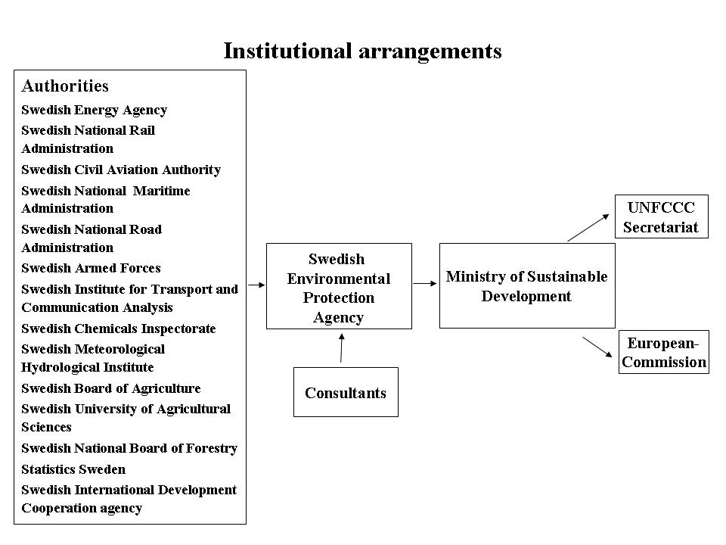

Ministry of Sustainable Development

The Ministry of Sustainable Development has overall responsibility for the national system. The Ministry is responsible for the national system and for ensuring that the Ministry sends an inventory report annually to the UNFCCC and to the European Commission. The Ministry of Sustainable Development is also responsible for the European Commission receiving other reports which are not produced annually and which only have to be submitted to the EU. Before the Ministry of Sustainable Development sends the report to the UNFCCC secretariat and to the European Commission, the matter is undergoing interservice consultations in the Government Offices.

Swedish Environmental Protection Agency (Swedish EPA)

The Swedish Environmental Protection Agency (Swedish EPA) has responsibility on behalf of the Ministry of Sustainable Development for drawing up documentation for the required reporting. This means that the Swedish EPA ensures that the documentation for the yearly inventory report and other reports is sent to the Ministry of Sustainable Development. The Swedish EPA is thus responsible for coordinating the national work for Swedish climate reporting and maintaining the reporting system required for reporting.

The Swedish EPA also has special responsibility in climate reporting for the sectors industrial processes, solvent and other product use, waste and land use, land-use change and forestry (LULUCF).

Other government agencies

Sections 6-19 of the Ordinance (2005:626) Concerning Climate Reporting describe the tasks of the government agencies in the context of the yearly inventory and reporting activity. Depending on the role of the government agencies in climate-reporting activity, this responsibility may range for example from supplying data and producing emission factors/calorific values to carrying out calculations to estimate emissions or conducting a national peer review.

The documentation drawn up by the government agencies is subsequently used by the Swedish EPA and consultants engaged by the Swedish EPA to calculate emissions and compile the yearly inventory report and other reporting to the European Commission and the secretariat of the Convention (UNFCCC).

Under the Ordinance (2005:626) Concerning Climate Reporting, the Swedish EPA is responsible for implementing a quality system within the framework of a coordinated quality system. The government agencies are responsible for maintaining their internal quality systems. The Swedish EPA and certain government agencies are appointed as reviewers in different sectors and consequently as independent experts to ensure the quality of the estimated emissions in different sectors. When the Swedish EPA and designated government agencies have reviewed the yearly inventory report, it is sent to the Ministry of Sustainable Development.

Energy sector (including transport)
To be able to calculate emissions from the energy sector (including transport), the Swedish EPA receive documentation from the Swedish Energy Agency, the National Rail Administration, the Swedish Civil Aviation Authority, the National Maritime Administration, the National Road Administration and the Swedish Armed Forces. The Swedish Energy Agency is responsible for conducting peer reviews of the energy sector and the Swedish Institute for Transport and Communications Analysis for the transport sector. The Swedish Energy Agency also assists the Swedish EPA in the work of developing documentation concerning flexible mechanisms and emissions projections as well as extracts from and information about changes to the national register.

Industrial processes sector
In order to calculate emissions from the industrial processes sector, the Swedish EPA receive documentation from the Swedish Chemicals Inspectorate, which presents data from the Product Register for certain fluorinated greenhouse gases. The Swedish EPA and the Swedish Chemicals Inspectorate are responsible for conducting peer reviews in the industrial processes sector, where the Swedish Chemicals Inspectorate in particular is responsible for a peer review of fluorinated greenhouse gases being conducted. The Swedish EPA reviews other areas in the industrial processes sector.

Solvent and other product use sector
For the solvent and other product use sector the Swedish EPA receive documentation from the Swedish Chemicals Inspectorate, which presents data from the Product Register for the calculation of volatile organic compounds (NMVOC) emissions. The Swedish Chemicals Inspectorate is also appointed to conduct a peer review in this sector.

Agriculture sector
In order to calculate emissions from the agricultural sector, the Swedish EPA receive documentation from the Swedish Board of Agriculture and Statistics Sweden. In this sector, the Swedish Board of Agriculture is responsible for conducting peer reviews.

Land use, land-use change and forestry sector
To enable the Swedish EPA to calculate emissions from the land use, land-use change and forestry sector (LULUCF), the Swedish University of Agricultural Sciences, Statistics Sweden, the National Board of Forestry, the Swedish Meteorological and Hydrological Institute and the Swedish Board of Agriculture must supply documentation. The National Board of Forestry is responsible for conducting a peer review in this sector other than the parts which relate to agriculture, where the Swedish Board of Agriculture is responsible for a peer review being carried out.

Waste sector
The Swedish EPA is appointed as the sector authority in the waste sector. The Swedish EPA produces data to be used in the calculation of emissions and conducts peer reviews in this sector.

Reporting relating to efforts in developing countries
With regard to reporting in relation to efforts which relate to developing countries, the Swedish International Development Cooperation Agency is responsible for presenting documentation to the Swedish EPA.

Responsibilities of consultants

Consultants are appointed in the context of public procurement. Selected consultants are members of a consortium known as Swedish Environmental Emission Data (SMED). One of the parties to SMED is the Swedish Meteorological and Hydrological Institute, which is responsible within the consortium for tools for quality control, calculation of geographical distribution of emissions and normal-year correction. The Swedish University of Agricultural Sciences, which is another party to SMED, is responsible within the consortium for the sector LULUCF. Within SMED, the Swedish Environmental Research Institute is responsible for the industrial processes sector and the solvent and other product use sector, and Statistics Sweden is responsible for the energy, agriculture and waste sectors. The legal responsibilities of the consultants are described in a framework contract between the Swedish EPA and the consultants. The contract governs the extent of the assignment, use of methodology, requirements for quality systems, reporting times, assistance in development projects and international meetings.

On behalf of the Swedish EPA, consultants process the documentation received from the government agencies, as well as support documentation produced by the Swedish EPA itself, and carries out calculations to estimate Swedish greenhouse gas emissions, as well as compiling the result in the yearly inventory report. They also assist in certain development projects to meet specified requirements for the reporting. When consultants calculate emissions from certain sectors such as industrial processes and solvent and other product use, in addition to documentation from the government agencies, environmental reports and documentation from other industry organisations and companies are required.

The Swedish EPA has laid down requirements in the framework contract for the consultants’ quality system to ensure that it meets the requirements within the framework of the national system.

Procedural arrangements of the Swedish national system

Yearly Inventory and Report

The illustration below shows a process description of Swedish inventory and reporting activity

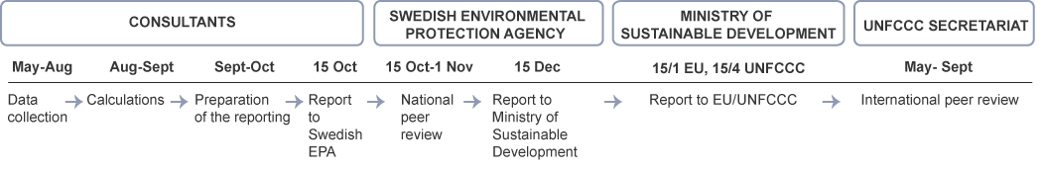
The Swedish EPA’s consultants gather documentation from various government agencies, organisations and companies over the period from May to August with the aim of being able to carry out emission calculations. The calculations are performed in models, statistics programs and calculation programs in August and September. Over the period from September to October, the material is put together in a reporting format and data and documetation is reviewed by both the inventory personnel and national peer reviewers.

The Swedish EPA supplies documentation for Swedish climate reporting to the Ministry of Sustainable Development 20 working days before the reporting date.

The Ministry attends to joint preparation of the reporting documentation. The Ministry of Sustainable Development reports to the European Commission on 15 January and the secretariat of the Convention on 15 April. Reported data relates to emissions year X-2, in other words emissions which took place during 2004 are reported in 2006.

The secretariat of the Convention then administers an international peer review of Swedish reporting. The results from this review form part of the planning documentation with a view to improving the quality of the Swedish inventory.

Methodologies used for the National Inventory Report

This section describes the choice of methodology to calculate greenhouse gas emissions and removals. Swedish methodology for documentation gathering and calculation of emissions is described in more detail for each reporting sector in the yearly inventory report, Sweden’s National Inventory Report.

Energy

The energy sector is divided into stationary combustion and transport. A description of how activity data is collected for sub-sectors of stationary combustion is given below.

- Production of electricity, heating and fuels: Data comes from a total survey where collected figures are available at installation level and per type of fuel.
- Industrial combustion: Calculated on the basis of a sample survey scaled up to a total level. Data is collected at installation level and per type of fuel.
- Residential and service sector: Data used is taken from official statistics at national level, broken down by type of fuel.

The calculations of emissions from transport are based on activity data on total quantities of fuels at national level and per type of fuel. These figures are supplemented by information and calculations from responsible government agencies regarding road transport, rail transport, use in the armed forces, shipping and aviation, after which allocation to the various sub-sectors takes place.

Activity data is multiplied by calorific values and emission factors to obtain resultant emissions. National calorific values and emission factors are principally used for calculations in the energy sector in Sweden. A model, ARTEMIS, which has been developed to reflect national conditions is used for calculations of emissions from road transport.

Emissions from international aviation and shipping are not included in the national combined emissions and are reported separately. For emissions to be attributed to this category, according to the IPCC guidelines and Swedish methodology the fuel has to be purchased in Sweden and used for transport from a Swedish sea port or airport to a foreign destination.

Industrial processes and use of fluorinated greenhouse gases

Emissions from industrial processes and the use of fluorinated greenhouse gases are predominantly calculated on the basis of figures from two types of information sources:

- Environmental reports or other information direct from companies.
- Official statistics or other information at national level, for example from industry organisations.

Under Swedish environmental legislation, companies that undertake environmentally hazardous operations for which a permit is required have to present an account of their operations in an environmental report. Figures relating to emissions presented in environmental reports are principally based on measurements, mass balances or calculations using installation-specific or nationally developed emission factors.

In some industries, environmental reports are not sufficiently wide-ranging to be able to provide a basis for calculations of emissions. This applies for example when a substantial proportion of the emissions from an industry originates from small installations which are not covered by the requirement to compile environmental reports. In such cases emissions are wholly or partially calculated on the basis of activity data at national level combined with nationally developed emission factors, often based on figures from representative installations in the same industry. International standard values are only used to a minor extent.

Carbon dioxide emissions from industrial processes are calculated on the basis of activity data relating to the use of raw materials or alternatively production. In cases where fuels are used as a raw material in industrial processes, activity data is obtained from national energy statistics.

Solvent and other product use

In the sector of solvent and other product use, the Product Register at the Swedish Chemicals Inspectorate is the main data source. Emission factors are generally nationally developed.

Agriculture

Emissions of nitrous oxide and methane from agriculture are calculated on the basis of activity data at national level and nationally developed emission factors or standard values proposed by IPCC. Activity data is made up of agricultural statistics, which include figures on livestock numbers, areas under cultivation, harvests, manure management, harvest residues and specific dung/nitrogen production. Supplementary information is obtained from industry organisations and research institutes.

LULUCF

The system for determining emissions and removals in the LULUCF sector will be based on the permanent trial areas in the National Forest Inventory (RIS). Around 40 000 permanent trial areas were established in RIS in 1983-1987 which have since been re-inventoried at 5-10 year intervals. The trial areas cover all types of land use in Sweden and will constitute the basis for determining types of land use and changes of land use as well as activities, as described in Articles 3.3 and Article 3.4 of the Kyoto Protocol. To tax the area of deforestation and associated carbon losses, it is likely that taxes based on the permanent trial areas will be supplemented by remote sending within the framework of the mapping of felling by the Swedish Forest Administration.

In calculating changes in the five carbon pools (living biomass above and bolow ground, dead organic matter above and below ground and soil organic carbon), specific methodology is used for each category of land use and land-use change. However, for practical reasons similar approaches are used for the different categories as far as possible. The changes will be principally calculated through:
- Estimates based on repeated measurements.
- Estimates based on modelling.
- Estimates based on default values.

The principal sources of data are the National Forest Survey (RIS-RT) and the Forest Soil Inventory (RIS-MI), both of which form part of the National Forest Inventory. Data are also obtained from the Swedish Board of Forestry (felling, nitrogen fertilisation), the Swedish Board of Agriculture (harvest statistics), Statistics Sweden (sales of lime) and the Swedish Meteorological and Hydrological Institute (climate data). Methodology based on repeated measurements in RIS will principally be used for most changes in the carbon pools. In several cases it will, however, be necessary to supplement these with modelling and default values.

Waste

Activity data for the waste sector consists among other things of the quantity of waste sent to landfill, landfill gas recovery and emissions of nitrogen from wastewater treatment. Data on emissions from the incineration of hazardous waste are compiled from the environmental reports of the installations concerned. The emission factors used are for the most part international standard values.

Process for the recalculation of previously submitted inventory data

If new and better information regarding underlying data becomes available, or in the case of methodological changes and refinements, recalculations are undertaken where possible by using consistent activity data and the new methodology for the whole time series. If this is not possible, alternative recalculation techniques according to good practice as described in Chapter 7.2 in IPCC Good Practice Guidance and Uncertainty Management in National Greenhouse Gas Inventories are applied.

The quality system

In compliance with UNFCCC decision 20/CP.7 and in accordance with decisions within the EU, the Swedish EPA and the concerned government agencies and consultants have introduced internal quality systems to ensure a high quality in the annual inventory and reporting.

The responsibilities of the Swedish EPA and the other government agencies for the quality system is described in Ordinance (2005:626) Concerning Climate Reporting. Under Section 3, the Swedish EPA and other government agencies which take part in the climate-reporting work have to ensure that the methodologies applied in the reporting and inventories of emissions and removals attain the quality required for it to be possible for Swedish climate reporting to be done in the correct manner and with correct information. The government agencies also have to have internal routines to plan, prepare, check and act/follow up the quality work and consult one another with the aim of developing and maintaining a coordinated quality system.

The responsibility of the consultants to maintain and develop an internal quality system is described in the framework contract between the Swedish EPA and the consultants.

The quality system contains a description of how the inventory and reporting are to be undertaken systematically so that high quality in the inventory and reporting is maintained and developed in compliance with specified requirements.

The quality system also covers the development projects the Swedish EPA undertakes with a view to improving and developing the reporting. This is done in cooperation with the consultants. The Swedish EPA commissions the consultants to develop the prioritised areas and the projects are carried out in close cooperation with the Swedish EPA.

Aim, structure and contents

The aim of the quality system is to safeguard the level of quality in the inventory, i.e. to ensure transparency, consistency, comparability, completeness and accuracy in the inventory. These principles guide the Swedish EPA and other government agencies, as well as consultants who assist in the inventory and reporting.

To ensure quality, IPCC Good Practice Guidance is followed. This guidance indicates what “Good Practice” means by describing different approaches to ensure that the inventory is accurate in the sense that it is systematic and that the estimates made of emissions are plausible and that uncertainties are reduced as far as practicable.
IPCC Good Practice Guidance also contains general guidelines for certain areas within the framework of the quality system. Chapter 6 contains methods for estimating uncertainties, Chapter 7 identification of key source categories, Chapter 8 routines for quality control (QC), quality assurance (QA) and requirements for documentation and archiving. An Annex to IPCC Good Practice Guidance also contains general guidelines for verification of emission data.

The Swedish quality system is based on the structure described in UNFCCC decision 20/CP.7. The structure in turn complies with the PDCA cycle (Plan, Do, Check, Act), which is an adopted model for how systematic quality and environmental management activity is to be undertaken according to international standards to ensure that quality is maintained and developed.


The figure above shows the plan, do, check, act cycle for the inventory.

In Chapter 8, Quality Assurance and Quality Control, of IPCC Good Practice Guidance (GPG), reference is made to international standards on quality activities in support of efforts to ensure quality in the inventory and reporting. These standards describe how quality systems can be introduced, how data is to be documented and how quality audits can be conducted. The Swedish EPA and the majority of concerned consultants and government agencies are either certified to the ISO 9001:2000 and ISO 14001:2004 standards or operate in compliance with these standards.

The Swedish EPA has compiled a document which describes the national system for climate reporting. This document contains references to normative and descriptive documents which govern the inventory and reporting. As large parts of the operational inventory work are carried out by government agencies and consultants, there are also references under each section of the document to the internal quality systems of the government agencies and consultants.

The quality systems of the government agencies and consultants have been developed in close cooperation with the Swedish EPA and are therefore based on a similar structure to the contents of the document describing the national system. One of the purposes of the document is to describe how the national system works as a whole and how the different parts work together.

Inventory planning

Requirements, decisions and guidelines
The Swedish EPA, involved government agencies and the consultants annually plan the inventory and reporting on the basis of new international and national requirements, decisions and guidelines which exist within the framework of climate reporting.

The Swedish EPA and other government agencies take part in international negotiations and working groups to ensure that applicable requirements, decisions and guidelines are interpreted and complied with. In cases where expert support is required, concerned agencies, consultants and other organisations can take part in the work referred to above. If an goverment agency or a consultant which is involved in the inventory work in turn appoints a consultant to carry out a particular task, the agency or consultant has to ensure that this consultant fulfils the requirements laid down in relation to climate reporting.

Quality objectives and activity plans
The Swedish EPA annually draws up quality objectives and activity plans with a view to steadily develop and improve the inventory and reporting, in accordance with the overall principles of quality activity. The activity plans describe the action to be taken to attain the quality objectives, who is responsible and what resources have been earmarked for the purpose.

Quality plans
Each government agency which supplies documentation to the Swedish EPA has an internal quality system containing a quality plan with references to necessary quality control routines to ensure the quality of data and to ensure that the documentation is supplied to the Swedish EPA at the right time and in the right format.

The consultants who carry out the calculations on behalf of the Swedish EPA have a quality system which, among other things, contains a quality plan that is updated annually. The quality plan contains a description of the activities to be carried out during the inventory. The consultants have documents for each sector describing how calculations of emissions and sink removals are to be done, as well as how the quality control and quality assurance are carried out to ensure a high level of quality during and after performance of the calculations. These documents are regularly updated ahead of future inventory and reporting.

Key Source analysis
With the assistance of consultants, the Swedish EPA carries out an annual analysis to identify the emission sources to which priority is to be given under the inventory work, known as Key Source Categories. The result of the Key Source analysis represents an important basis for the annual planning of the inventory, and together with other underlying data can provide guidance on what areas need to be improved and whether any development projects need to be set up.

The Swedish EPA communicates any changes to the contents of the key-source analysis to concerned government agencies so that they can assess the choice of methodologies and routines required for quality control and quality assurance.

Estimations of uncertainty
The Swedish EPA makes an estimate of the uncertainties contained in data and emission factors in cooperation with government agencies and consultants. The assumptions on which the estimation of uncertainty is based are documented for each emission source. Calculations for estimations made of uncertainty are checked for each emission source and for the complete inventory. Uncertainties are estimated in different sectors and then for the whole inventory.

Preparation of the inventory

The Ministry of Sustainable Development has overall responsibility for the national system. The Swedish EPA is tasked with coordinating national work for Swedish climate reporting and maintaining the reporting system required for reporting. This means continuously identifying tasks which need to be carried out under the national system, assessing how tasks should be shared between the Swedish EPA, government agencies, consultants and other organisations and proposing possible changes to statutory instruments and assessing needs for resources.

Training, awareness and skills
Training, awareness and skills in climate reporting are essential to maintain the level of quality required according to specified requirements. Skills are ensured for the Swedish EPA and the majority of the government agencies involved in the work by the government agency being the sector government agency with staff who have particular skills in different specialist areas.

Skills on the part of consultants are ensured in accordance with the requirements laid down in the framework contract between the Swedish EPA and the consultants. The skills levels of consultants are continuously reviewed.

Calculation of emissions and removals of greenhouse gases
In cooperation with concerned government agencies and consultants, the Swedish EPA has identified various types of documents which are normative and descriptive of the inventory and reporting work. There are documents describing the quality systems of the government agencies, containing quality plans with references to work documentation which describe how data is produced and supplied to the Swedish EPA. The consultants have work documentation which describes how emissions and removals of greenhouse gases are calculated for each sector. There are also documented routines and checklists for quality control and quality assurance.

Both the government agencies and the consultants have routines which describe how these documents are to be identified, kept, updated and archived and how they are to be reviewed and approved. The documents serve as important support material so that the work can be continuously monitored. The documents are also used in conjunction with quality audits and peer reviews which are conducted at international and national level.

Inventory checking

Quality control
The Swedish EPA has introduced routines for quality control in cooperation with concerned government agencies and consultants. This quality control is the check that is made during the inventory on different types of data, emission factors and calculations that have been made. The quality control takes place according to general requirements (Tier 1) which apply to all types of data used as support material for the reporting, and specific requirements for quality control (Tier 2) which are applied to certain types of data and/or emission sources.

Quality assurance
Quality assurance comprises national peer reviews which are conducted when the inventory is carried out. In cooperation with concerned government agencies, the Swedish EPA conducts a peer review of the inventory at national level. The peer review is defined in the Ordinance concerning Climate Reporting (2005:626) as a review of calculations, assumptions and results of inventories which are covered by climate reporting, where the review is conducted by a person who has not taken part in the work.

The Swedish EPA is responsible for coordinating the annual peer review in consultation with concerned government agencies. This means, among other things, ensuring that the peer reviewers have received the necessary training.

The peer review is conducted annually when the inventory has been carried out and the consultants have sent the draft inventory report to the Swedish EPA. The review covers calculations which have been performed and assumptions on which the estimation of emissions has been based. This entails a review of documents which describe the choice of activity data, emission factors, completeness of reporting, consistent time series, routines for quality control and so on. The aim is to ensure that results, the assumptions which have been made and the methodologies which have been applied are plausible.

All independent reviews are documented in the form of reports, in which deviations and proposals for improvements are noted. The Swedish EPA compiles the opinions of the reviewers and decides on the need for measures to be taken in consultation with concerned government agencies.

The Swedish EPA conducts quality audits on its own internal work with the assistance of peer personnel within the Swedish EPA or external quality auditors. The Swedish EPA is responsible for consultants conducting internal quality audit during the inventory and assisting with the Swedish EPA’s quality audits of their work. The government agencies assess the need for internal quality audits within the framework of their operations. On request by a government agency, the Swedish EPA can assist by providing support for the government agency’s internal quality audits.

International peer review
The Swedish EPA has drawn up routines for handling the independent reviews which are made of Swedish conditions and are conducted by an expert group in accordance with the rules contained in the United Nations Framework Convention on Climate Change and in the Kyoto Protocol.

If it emerges in connection with an international independent review that the government agency’s methods or routines need to be amended, under Section 3, second paragraph, of Ordinance concerning Climate Reporting (2005:626) the government agency has to take the measures required after consultation with the Swedish EPA.

Deviations, corrective and preventive measures
The Swedish EPA has drawn up routines for handling deviations and corrective and preventive measures in cooperation with concerned government agencies and consultants. The purpose is to intercept deviations at an early stage and decide on corrective and preventive measures. These measures may result in new quality targets for the inventory work. Handling deviations and discovering improvements is important in maintaining and developing the quality of inventory and reporting work.

Follow-up and continuous improvement of the inventory
The inventory and reporting are to be steadily developed and improved. This necessitates following up and evaluating the work when the inventory has been conducted. In consultation with concerned government agencies and consultants, the Swedish EPA has devised routines to continuously follow up the work and after the inventory has been conducted to hold a debriefing meeting to discuss the past year’s inventory and reporting. There are special routines in connection with peer reviews and quality audits for how deviations and proposals for improvements are to be documented and sent to the Swedish EPA.

The result of the follow-up provides the basis for the Swedish EPA’s planning of the next year’s inventory and reporting. Measures are prioritised and quality targets and activity plans are drawn up. In this way the systematic approach of the quality system is maintained and the inventory and reporting are continuously improved.

Sweden’s National Registry

Registry Administrator

Name | Mattias Eriksson
Address | Box 310
Postcode | SE-631 04
City | Eskilstuna
Country | Sweden
Phone | +46 (0)16 544 2173
Facsimile number | +46 (0)16 544 2099
E-mail | Mattias.eriksson@stem.se

Technical Description

This technical description of the National Registry is presented in accordance with the reporting requirements laid down in Annex II under decision 22/CP.7 in FCCC/CP/2001/13/add.3.

The Swedish National Registry has been created as a Swedish registry and not as part of a consolidated transnational registry with other countries. The Swedish Energy Agency acts as the registry administrator. The registry core software is acquired from the Department of Environment, Food and Rural Affairs (United Kingdom) on licence. A front end to the registry and country-specific features have been developed by a separate private enterprise and uses the application programming interface in the core code of the registry.

The registry uses a Microsoft SQL Server relational database management system with a dedicated model for supporting registry operations. It is run in a virtual server environment with the ability to dynamically increase the capacity. The absolute maximum size of a SQL Server 2000 database is 1,048,516 Terabytes or 50 Terabytes per single file entry. SQL Server database model is also scalable up to 32 processors with 64 gigabytes of memory. The server capacity is over-dimensioned.

The registry system has been developed for the EU Emissions Trading Scheme. This scheme requires its Member States’ registries to be compliant with the United Nations Data Exchange Standards (UN DES) specified for the Kyoto Protocol. Currently, the development adheres to the standards specified in Draft #7 of the UN DES document. The Swedish Registry system was tested successfully with the European Commission in April 2005 and is now live.

As part of the EU Registry development, the registry has developed functionalities for issuance, conversion, external transfer, (voluntary) cancellation, retirement and reconciliation processes using XML messages and web services as specified in draft #7 of the UN DES document.

The Swedish National Registry fulfils all required processes to minimise discrepancies in issuance, transactions, cancellation and retirement of ERUs, CERs, AAUs or RMUs. Every transaction is carried out according to the UN DES to minimise the risk of inconsistent data in the Swedish National Registry and the independent transaction log (ITL) and EU supplementary transaction log (CITL). The transaction is not finalised until the transaction is registered on both registries servers. The transaction is cancelled if the ITL or CITL sends an error code. The Registry Administrator is to contact the central administrator at the ITL or CITL for instructions if the registry fails to terminate the transaction. Manual corrections in the registry can be preformed by the registry administrator commissioned by the central administrator.

According to the European Commission’s registry regulations, username and passwords are the only required level for secure log-in. In addition, an electronic ID is required for logging in to the Swedish National Registry.

Database manipulations are only carried out by protected, internal stored procedures which are not accessible directly from the user interface and can only be invoked by our internal web services.

The Swedish National Registry can be accessed through the following web portal: http://www.utslappshandel.se/index_eng.html

The Swedish Energy Agency utilises IBM's Tivoli Storage Manager (TSM) for backup, restore and archiving. The TSM server and its tape robots with media are situated off-site about 10 km away, connected by fibre optics.

TSM uses a backup strategy called \u201cincremental forever\u201d. In this strategy only the files changed since last backup are copied to the TSM server. The TSM server keeps track of all files backed up and can combine files in different ways to make complete or partial restores or point-in-time restores.

Scheduled backups are made every night and utilise special backup agents for databases to insure on line backups of the databases. For virtual servers additional backups (snapshots) of the virtual disks are made weekly to ensure rapid recovery of servers in the event of an emergency.

The virtual servers reside in a farm of multiple physical servers. In case of scheduled maintenance of the physical hardware, a virtual server can be moved live to another physical server. It's also possible to balance the utilisation of the physical server by moving virtual servers around. In case of a physical server failure, the virtual servers can be restarted on another physical server. In the case of a total failure (fire etc.), virtual server disc snapshots can be restored to another physical server and restarted.

Currently, our registry system for the EU Emissions Trading Scheme uses the security mechanism as specified within the EU Regulation; (Annex XV); that is, it uses basic authentication and SSL. For Kyoto, digital certification and VPN will be used when the ITL becomes available. This will be included in a future phase of the project.

Calculation of the commitment period reserve

Sweden will maintain, in its National registry, a commitment period reserve which should not fall short of 90 percent of Sweden’s assigned amount as presented in Chapter 3.3.

The commitment period reserve, as carbon dioxide equivalents, in the Swedish National registry will be:

0.9 * 375864,317 Gg = 338277,885 Gg CO₂ equivalents

References and sources

United Nations Framework Convention on Climate Change

The Kyoto Protocol to the Convention on Climate Change

UNFCCC decision 20.CP.7, guidelines for national systems

Decision No. 280/2004/EC of the European Parliament and of the Council of 11 February 2004 concerning a mechanism for monitoring Community greenhouse gas emissions and for implementing the Kyoto Protocol

Commission’s implementing provisions, in accordance with Commission Decision No. 2005/166/EC of 10 February 2005 laying down rules implementing Decision No 280/2004/EC of the European Parliament and of the Council concerning a mechanism for monitoring Community greenhouse gas emissions and for implementing the Kyoto Protocol

Revised 1996 IPCC Guidelines for National Greenhouse inventories
(IPCC Guidelines)

IPCC Good Practice Guidance and Uncertainty Management in National Greenhouse Gas Inventories (IPCC Good Practice Guidance)

IPCC Good Practice Guidance for LULUCF

UNFCCC guidelines on annual inventories FCCC/CP/2002/8.

Sweden’s national system for inventory and reporting in accordance with the Kyoto Protocol and decisions within the EU

Ministry of Sustainable Development
Focal point: jessica.andersson@sustainable.ministry.se

Annex 1

Ordinance (2005:626) Concerning Climate Reporting

/Enters into force 01.08.2005/

Section 1 For the purposes of this Ordinance

the Kyoto Protocol means the Kyoto Protocol to the United Nations Framework Convention on Climate Change,

Decision 280/2004/EC means Decision No 280/2004/EC of the European Parliament and of the Council of 11 February 2004 concerning a mechanism for monitoring Community greenhouse gas emissions and for implementing the Kyoto Protocol,

the Commission’s implementing provisions means Commission Decision 2005/166/EC of 10 February 2005 laying down rules implementing Decision No 280/2004/EC of the European Parliament and of the Council of 11 February 2004 concerning a mechanism for monitoring Community greenhouse gas emissions and for implementing the Kyoto Protocol,

climate reporting means reporting which is required under agreements which Sweden has entered into through or within the framework of the Kyoto Protocol and in accordance with Decision 280/2004/EC, and in compliance with the Commission's implementing provisions,

sector means a sector in accordance with the definitions and demarcations of sectors referred to in the Kyoto Protocol,

emission factor means a factor for the calculation of quantity emitted,

peer review means a review of calculations, assumptions and results of inventories which are covered by climate reporting, where the review is conducted by a person who has not taken part in the work on the calculations, assumptions and results of inventories which are reviewed, and international peer review means a peer review where the review relates to Swedish conditions and is conducted by an expert group in accordance with the rules contained in the United Nations Framework Convention on Climate Change and the Kyoto Protocol.

Section 2 The Swedish Environmental Protection Agency shall coordinate national activity for Swedish climate reporting and maintain the reporting system which is required for reporting. The Agency shall annually compile documentation for the reporting and submit this documentation to the government. The documentation shall be submitted to the government no later than twenty working days prior to the latest day by which Swedish climate reporting has to be accomplished.

Section 3 The government agencies which in accordance with this Ordinance take part in the climate-reporting work shall ensure that the methods applied for the reporting and for inventories of emissions and removals attain the quality which is required for it to be possible for Swedish climate reporting to be done in the correct manner and with correct information. The government agencies shall have internal routines to plan, prepare, check and follow up the quality work and consult one another with the aim of developing and maintaining a coordinated quality system.

If it emerges in connection with an international peer review that a government agency's methods or routines need to be amended, the government agency shall take the action required following consultation with the Swedish Environmental Protection Agency. The action taken shall be compatible with the quality requirements which apply to climate reporting.

Section 4 The government agencies stated in Sections 6-19 shall, on those matters which are covered by their participation in climate-reporting activity, submit the documentation which is required for the compilation of documentation by the Swedish Environmental Protection Agency referred to in Section 2. The documentation shall be submitted to the Swedish Environmental Protection Agency in a sufficiently timely manner that the Agency is able to submit its documentation to the government at the correct time.
In consultation as referred to in the first paragraph of Section 3, the Swedish Environmental Protection Agency shall inform the other participating government agencies at what times the documentation needs to be submitted and how the documentation needs to be formulated for it to be possible to fulfil the task of Swedish climate reporting.

Section 5 In international peer review, the government agencies stated in Sections 6-19, on matters covered by their participation in climate-reporting activity, shall assist the Swedish Environmental Protection Agency with the information needed for the review.

Section 6 The Swedish Energy Agency shall take part in Swedish climate-reporting activity by

1. for the energy sector including transport providing calorific values and emission factors for carbon dioxide,

2. for the energy sector excluding transport providing emission factors for methane and nitrous oxide,

3. in its capacity as a government agency with responsibility for statistics for the field of energy under the Ordinance (2001:100) Concerning Official Statistics for the Energy Sector providing the statistics which are required in relation to fuel statistics for energy and industry, energy statistics for houses, apartment blocks and commercial premises and fuel, gas and stock statistics,

4. in its capacity as a expert government agency for the flexible mechanisms of the Kyoto Protocol and accounting government agency as referred to in the Law (2004:1199) on Emissions Trading and in Commission Regulation (EC) No 2216/2204 of 21 December 2004 for a standardised and secured system of registries pursuant to Directive 2003/87/EC of the European Parliament and of the Council and Decision No 280/2004/EC of the European Parliament and of the Council

a) providing information on who is entitled to take part in the flexible mechanisms of the Kyoto Protocol and

b) providing the registry data on use of the flexible mechanisms which are required for reporting in accordance with Article 7.1 of the Kyoto Protocol and decisions which have been taken on behalf of the European Community to comply with the reporting requirements,

5. for the energy sector providing such data on the use of flexible mechanisms as are referred to in Articles 3.2.a (vi) and 3.2.d of Decision 280/2004/EC and in such provision complying with Article 11 of the Commission’s implementing provisions,

6. for the energy sector providing such projections as are referred to in Article 3.2.b of Decision 280/2004/EC and creating documentation for the projections from the Swedish Institute for Transport and Communications Analysis and the Swedish National Institute of Economic Research, and

7. within the energy sector excluding transport conducting peer review of calculated greenhouse gas emissions.

Section 7 The National Rail Administration shall take part in Swedish climate-reporting activity by, for the use of the rail network which the State owns and administers

1. providing data on the quantity of motor fuels consumed,

2. providing emission factors for methane, nitrous oxide, nitrogen oxides, sulphur dioxide, carbon monoxide and volatile organic compounds, and

3. calculating emissions of carbon dioxide, methane, nitrous oxide, nitrogen oxides, sulphur dioxide, carbon monoxide and volatile organic compounds.

Section 8 The Swedish Civil Aviation Authority shall take part in Swedish climate-reporting activity by, for aviation in the transport sector

1. providing data on the quantity of motor fuels consumed and the use of energy,

2. providing emission factors for methane, nitrous oxide, nitrogen oxides, sulphur dioxide, carbon monoxide and volatile organic compounds,

3. calculating emissions of methane, nitrous oxide, carbon dioxide, nitrogen oxides, sulphur dioxide, carbon monoxide and hydrocarbons, and

4. providing data on the split between domestic traffic and international traffic, on the split between traffic covered by the landing and take-off phase (LTO) and traffic which does not form part of the landing and take-off phase (cruise) and on the number of landing and take-off cycles (LTO cycles).

Section 9 The National Maritime Administration shall take part in Swedish climate-reporting activity by, for shipping in the transport sector, providing emission factors for methane, nitrous oxide, nitrogen oxides, sulphur dioxide, carbon monoxide and volatile organic compounds.

Section 10 The National Road Administration shall take part in Swedish climate-reporting activity by, for road traffic in the transport sector

1. providing data on traffic mileage for different categories of vehicles

2. providing data on the quantity of motor fuels consumed,

3. providing emission factors for methane, nitrous oxide, nitrogen oxides, sulphur dioxide, carbon monoxide and volatile organic compounds, and

4. calculating emissions of carbon dioxide, methane, nitrous oxide, nitrogen oxides, sulphur dioxide, carbon monoxide and volatile organic compounds.

Section 11 The Swedish Armed Forces shall take part in Swedish climate-reporting activity by providing data on the quantity of motor fuels consumed in the Swedish Armed Forces.

Section 12 The Swedish Institute for Transport and Communications Analysis shall take part in Swedish climate-reporting activity by conducting peer review in the transport sector.

Section 13 The Swedish Chemicals Inspectorate shall take part in Swedish climate-reporting activity by

1. providing background data from its products register on imports of the fluorinated gases perfluorohydrocarbons, fluorohydrocarbons and sulphur hexafluoride for verification of calculated emission quantities,

2. providing background data from its products register on solvent and other product use for the calculation of emissions of volatile organic compounds,

3. conducting peer review of the collective emissions of fluorinated gases calculated in the inventory,

4. conducting peer review of the collective emissions calculated in the inventory of volatile organic compounds and nitrous oxide from the "solvent and other product use” sector, and

5. conducting peer review of the conversion factor between volatile organic compounds and carbon dioxide.

Section 14 The Swedish Board of Agriculture shall take part in Swedish climate-reporting activity by

1. providing statistics on the use of arable acreage and harvest statistics in eight areas of production,

2. providing statistics on livestock numbers in the agriculture sector
and regularly updating data on specific manure production for pigs and cattle,

3. in the agricultural sector conducting peer review of calculated greenhouse gas emissions, and

4. in the part of the “land use, land-use change and forestry” sector which relates to use of agricultural land conducting peer review of calculated greenhouse gas emissions.

Section 15 The Swedish University of Agricultural Sciences shall take part in Swedish climate-reporting activity by providing statistics in the "land use, land-use change and forestry" sector for the calculation of greenhouse gas emissions and removals and for the determination of types of land use. The statistics shall be based on the national forest inventory which the Swedish University of Agricultural Sciences conducts.

Section 16 Statistics Sweden shall take part in Swedish climate-reporting activity by, for the agricultural sector and for the part of the "land use, land-use change and forestry" part of the sector which relates to land use, providing statistical documentation for the calculation of greenhouse gas emissions. The documentation shall relate to

1. production of harvest residues,

2. sales of fertilisers and lime to agriculture,

3. supply of nitrogen with commercial fertiliser and farmyard manure to agricultural land, and

4. production, handling and storage of farmyard manure.

Section 17 The Forest Agancy shall take part in Swedish climate-reporting activity by

1. providing statistics on logging and the quantity of nitrogen supplied through forest fertilisation, and

2.in the part of the “land use, land-use change and forestry” sector which does not relate to use of agricultural land conducting peer review of calculated greenhouse gas emissions and removals.

Section 18 The Swedish Meteorological and Hydrological Institute shall take part in Swedish climate-reporting activity by providing climate data (temperature, precipitation, global radiation and cloud cover) in grids for model calculation of the carbon balance of arable land in the “land use, land-use change and forestry” sector.

Section 19 The Swedish International Development Cooperation Agency shall take part in Swedish climate-reporting activity by providing documentation for the reporting of efforts relating to cooperation between the government agency and developing countries.

Climate Reporting Ordinance (Section 1 Definition of climate reporting), Annex 1
Sweden’s national system for inventory and reporting in accordance with the Kyoto Protocol and decisions within the EU
IPCC Good Practice Guidance indicates what “Good Practice” means by describing different approaches to ensure that the inventory is accurate in the sense that it is systematic and that the estimates made of emissions are plausible and that uncertainties are reduced as far as practicable.
Sweden’s national quality system for inventory and reporting in accordance and decisions within the EU
Quality control comprises general methods of checking that the collection of data and the calculations performed are in agreement with standardised procedures for estimating emissions, calculating uncertainties and archiving and reporting data. Higher levels of quality control also cover the review of emission sources, selection of methods and review of activity data and emission factors.
Quality assurance comprises a system of procedures where independent people (peers) review whether a desired quality of data has been attained to ensure that the inventory contains the best conceivable estimate of emissions and sinks on the basis of available scientific and technical data.

