Bulgaria's Initial Report
under the Kyoto Protocol

Report to facilitate the calculation of the assigned amount pursuant to Article 3, paragraphs 7 and 8 of the Kyoto Protocol

Submission to the UN FCCC Secretariat, July 2007

Introduction

The Parliament of Bulgaria ratified the UN Framework Convention on Climate Change in March 1995.
The Convention separates the countries in two main groups: the first one is the group of countries listed in the Annex 1 (so-called Annex I Countries) and the second one is of these countries outside of this Annex 1. Countries of Annex I are the industrial countries which are members of the Organization for Economic Cooperation and Development (OECD) and countries with economy in transition (Russia, Baltic countries, Ukraine and Central and East Europe Countries). Bulgaria is a part of the group of countries with economy in transition.
The Kyoto Protocol (KP) was approved on the Third session of the Conference of the Parties in December 1997 in Kyoto, Japan. Bulgaria ratified it on August 15th, 2002. After its ratification by the Russian Federation in November 2004, the Kyoto Protocol entered into force on February 16th 2005.
With Kyoto Protocol, the Parties to the Convention assumed the obligation not only to stabilize the GHG emissions, but also to reduce them with a certain rate regarding the base year for each country.
Ministry of the Environment and Water has prepared this report to the UN
FCCC Secretariat, to facilitate the calculation of the assigned amount of the Republic of Bulgaria pursuant to Article 3, paragraphs 7 and 8 of the Kyoto Protocol. The report is in accordance with paragraphs 6-8 of the Annex to decision 13/CMP.1 (Modalities for the accounting of the assigned amounts under Article 7, paragraph 4, of the Kyoto Protocol) divided into two parts.

PART 1
- greenhouse gas emissions in the year 1988 and in the period 1989-2005;
- base year for HFCs, PFCs and SF₆- 1995;
- calculation of Bulgaria’s assigned amount;

PART 2
- calculation of Bulgaria’s commitment period reserve;
- selection of threshold values for forests under Articles 3.3 and 3.4 of the Kyoto Protocol;
- activities under Articles 3.3 and 3.4;
- description of Bulgaria’s National System for estimation of anthropogenic emissions sources and removals by sinks of GHG;
- description of Bulgaria’s Registry System.

CONTENTS

Part 1 3
1 Greenhouse gas inventories for 1988-2005 3
1.1 National Inventory Report and CRF Tables 3
1.2 Base year emissions and time series consistency 3
1.3 GHG emissions by gas 4
1.4 GHG emissions by sectors 6
2 Selected base year for HFCs, PFC and SF₆ in accordance with Article 3.8 11
3 Calculation of Bulgaria's assigned amount 12
Part 2 13
4 Calculation of Bulgaria's commitment period reserve 13
5 Selection of threshold values for the forest definition to be used for reporting under Articles 3.3 and 3.4 14
6 Selection of activities under Article 3.4 17
7 Choice of accounting periodicity for activities under Article 3, paragraphs 3 and 4 18
8 Bulgaria’s National GHG Inventory System 19
8.1 Description of the present institutional arrangement for inventory preparation 19
8.2 Brief description of the present process of inventory preparation 21
8.3 Brief General Description of Methodologies and Data Sources Used 21
8.4 Original Data Sources for the Inventory 23
8.5 Key Source Category Analysis 26
8.6 Information on the QA/QC Plan Including Verification and Treatment of Confidentiality Issues 26
8.7 General Uncertainty Evaluation 30
9 Bulgaria’s National Registry 31

Part 1

Greenhouse gas inventories for 1988-2005
  - National Inventory Report and CRF Tables
A complete inventory on greenhouse gas emission and removals for the base year 1988 and for the period 1989-2005 is provided in the Bulgaria’s National Inventory Report 2007. The methodologies used for estimating GHG emissions are consistent with the Revised 1996 IPCC Guidelines for National Greenhouse Gas Inventories and the IPCC Good Practice Guidance and Uncertainty Management in National Greenhouse Gas Inventories.
For the submission 2007, Bulgaria made some improvements recommended by ERT from previous reviews. The most important are:
- preparing for first time complete 1989 inventory;
- use of improved EF for LPG consumption emissions from transport;
- use of more adequate set of data about amount and composition of solid waste which have been disposed on the SWDS from 1960 on and implementation of the Tier 2 method;
- revision of the EF for GHG emissions from combustion of biomass;
- actualization of the EF for clinker and ammonia production
- improvement of estimates on GHG emissions from LULUCF sub- sectors Cropland and Grassland according to the new IPCC Good Practice Guidance on Land Use, Land Use Change and Forestry.
The recalculations have resulted in the following changes: the base year total emissions without LULUCF have increased for 0.2% and in 2005 for 2.4%.
  - Base year emissions and time series consistency
In 1988 (base year), total GHG emissions accounted for 132 612.58 Gg CO₂ eq. The biggest fraction among gases belongs to CO₂ (74.5%), followed by CH₄ with 16.4%, N₂O with 9.1% and F–gases with 0.0% of GHG emissions.
The largest fraction in emissions among the sectors (without LUCF) belongs to the energy sector (71.4%), agriculture accounts for 10.98% of total GHG emissions, waste for 9.67% and industrial processes for 7.97%.
In 2005 (last submission), total GHG emissions accounted for 69.995 Tg CO₂ eq. The biggest fraction among gases belongs to CO₂ (78.5%), followed by CH₄ with 14.6%, N₂O with 6.2% and F–gases with 0.006% of GHG emissions.
The largest fraction in emissions among the sectors (without LUCF) belongs to the energy sector (75%), waste accounts for 9.3% of total GHG emissions, industrial processes for 8.8214% and agriculture for 6.9%
The most important emission source in energy sector with 96.7% of emissions is the fuel combustion sub-sector, which is split further into energy supply (57.3%), transport (15.7%), Other (3.6%), and Manufacturing Industry and Construction sectors (20.0%).
CO₂ emission sinks due to the Land Use Change and Forestry in 2005 are assumed to amount to 6.785 Tg which is 9.7% from total GHG emission (without LULUCF).
Compared to the base year, the greatest fraction has increased from 71.4% in 1988 to 75% in 2005.
As a result of the change and restructuring of economy after 1989, the lowest emission level was reached and the total GHG emissions keep the level about 67 Tg. According to the economic growth after 2002 the emissions start to increase.
  - GHG emissions by gas
The emissions of main GHG in base year are as followed: CO₂- 98 792 Gg (without LULUCF), CH₄-21 759 Gg CO₂eq. and N₂O – 12 061 Gg CO₂eq.
Reduction of the CO₂ overall emissions in 2005 compared to the base 1988 was 47.2%. That reduction was conditioned mostly by the reduction in industry – 58%, in transport - 41%, and especially in households - 81%. The lower reduction was in the Energy sector - 31%, due to the structure of the electrical production facilities, including the significant output of electrical power, produced in the Nuclear Power Plant.
Reduction of the CH₄ overall emissions in 2005 compared to the base 1988 was 52.8%. That reduction is conditioned mostly by the reduction in agriculture – 66%, in fugitive emissions from coal mining and gas and oil systems - 47%, and particularly in the solid waste - 47%. The reduction in the wastewater treatment is essential - 65%. The indicated reductions describe best the processes of changes and restructuring of the agricultural production.
The overall N₂O emission reduction in 2005, compared to the base 1988, was 63.7%. That reduction is conditioned mostly by the reduction in the industrial processes - 59%, and particularly in the agriculture – 67.7%. The indicated reductions describe best the processes of fertilizers and manure handling, and the reduction of plant crops.
Carbon dioxide – CO₂
CO₂ emissions in the period 1988-2005 may be split into tree segments. In the first segment, 1988-1992, emissions diminished due to reduction of industrial production and change of control of economics. In segment two, Emissions rose in the 1993 and keep a level about 64% of the base year till 1997. In the last segment they decrease on the level of the 50% compare to base year and start the new tendency to growth from 2002 till now.
In that entire period of time, the CO₂ emissions from transport decrease by 61.7% to 1997 and after there is a stable trend to increase- by 53.5% in 2005 compare to 1997.
Methane – CH₄
Methane emissions have in the 1988-2005 period constantly kept diminishing from 21 759 Gg CO₂ eq. in 1988 to about 11 200 Gg CO₂ eq. in 2001-2005.

Table 1.1:GHG emission trends by gas, CO₂equ. (Gg)
GREENHOUSE GAS EMISSIONS | Base year* | 1988 | 1990 | 1995 | 2000 | 2003 | 2004 | 2005 | Change from base to latest reported year
 | Gg | Gg | Gg | Gg | Gg | Gg | Gg | Gg | (%)
CO2 emissions including net CO₂ from LULUCF | 93 659 | 93 659 | 80 089 | 58 815 | 41 487 | 46 804 | 45 298 | 47 982 | -48.8
CO2 emissions excluding net CO₂ from LULUCF | 98 792 | 98 792 | 86 246 | 66 340 | 50 463 | 53 860 | 53 264 | 54 978 | -44.3
CH₄ | 21 759 | 21 759 | 19 915 | 14 921 | 11 708 | 11 335 | 11 222 | 10 260 | -52.8
N₂O | 12 061 | 12 061 | 10 450 | 5 838 | 4 918 | 4 446 | 4 394 | 4 366 | -63.8
HFCs | NA | NA | NA | 2.95 | 96.02 | 120.6 | 217.3 | 386.8 | 1-
PFCs | NA | NA | NA | NA | N0 | N0 | N0 | N0 | N0
SF₆ | NA | NA | NA | 1.26 | 2.23 | 2.52 | 3.68 | 4.42 | 78,8
Total (including net CO₂ from LULUCF) | 127 563 | 127 563 | 126 284 | 79 759 | 58 280 | 62 856 | 61 295 | 63 209 | -50.4
Total (excluding net CO₂ from LULUCF) | 132 613 | 132 613 | 131 823 | 87 102 | 67 188 | 69 764 | 69 100 | 69 995 | -47.2
* Base year = 1988 and 1995 for F-gasses
Figure 1.1: GHG Emissions in Bulgaria by gas
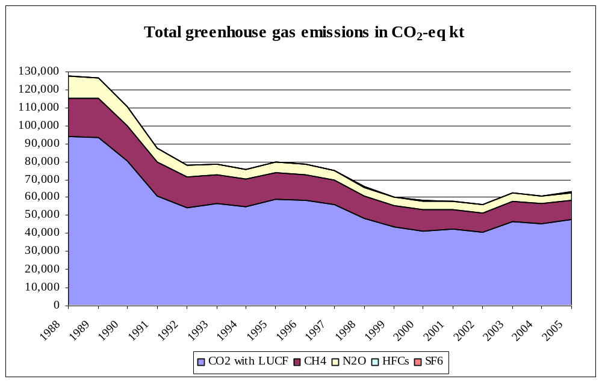

Nitrous oxide - N₂O
N₂O emissions have been reduced from 12 061 Gg CO₂ eq. in 1988 to 4 402 Gg CO₂ eq. in 1998 and keep emission about 4 400-4 500 Gg by 2005.the last fig2004. In agriculture, which is the main source of N₂O emissions, emissions diminished chiefly due to reduced number of animals and the reduced extent of arable crop production.
Recently, an increase of the fraction of traffic in total N₂O emissions has been observed, this fraction rising from 0.8% in 1988 to 1.45% in 2005.
Hydro-fluorocarbons - HFC
HFC emissions keep growing from year to year. In 2005, emissions increased by 78% compared to the previous year, which is mostly the consequence of increasing fraction of stationary and mobile conditioners in motor vehicles.
Per-fluorocarbons - PFC
There is no source of PFC in the Republic of Bulgaria.
Sulphur-hexafluoride - SF₆
The main source of SF₆ emissions is high-voltage gas insulated switchgear and circuit breakers. SF₆ emissions represent only 0.0063% of total GHG emissions.
  - GHG emissions by sectors
In accordance with UNFCCC Reporting Guidelines, inventories are grouped into six emission categories: Energy, Industrial Processes, Solvent use, Agriculture, Land-Use, Land Use Change and Forestry, and Waste.
Energy Sector
The Bulgarian Energy sector has key position in the national economy. It is the source of over 71% of the aggregated GHG emissions for base year and 74% for the last inventory 2005.
In the year 2005 the decrease in overall CO₂ emissions compared with the basis year 1988 is 45%. This decrease is conditioned in the great value from the decrease in Industry – 57.9%, in Transport – 41.2% and especially in residential sector – 81%. Less decrease is in Energy industries– 31%, which is due to the structure of electricity production. A significant part of electricity production is from nuclear energy.
In comparison with the preceding 2004, in the present year is shown a growth in CO₂ emissions by 3.3%. That note, that the tendency of liveliness in economy and increase of the energy efficiency are supporting for the third year in a row.
Sub-sector Energy industries have the largest share. Only the Energy industry registered an increase in the relative share regarding the base year 1988 – from 47.6% to 59.4% in 2005. This share has decreased: in the Manufacturing Industry – from 27.3% to 20.8% and mostly in the Commercial and Residential sector – from 9.8 to 3.4%.
The trend of Transport sub sector shows steady growth in the last five years, as in 2005 the emissions increased by 9.4% compared to 2004 and they form 16.3% of the overall emissions of CO₂ in the Energy sector. The fluctuations in bigger degree are in relation in with the change in liquid fuel price as well as the process of increase of number of cars and restructure and renovation of the car park.
In sub-sector Other sectors (Services, Residential, Agriculture and Forestry) the general tendency varies as well.
The CO₂ emissions from non-energy use of fuels are accustomed to be reported in this sector and not in sector Industrial Processes.

Table 1.2: Bulgaria GHG emissions and removals by sector
GREENHOUSE GAS EMISSIONS | 1988 | 1990 | 1995 | 2000 | 2004 | 2005 | Change from base to latest reported year
 | CO₂ eq. (Gg) | CO₂ eq. (Gg) | CO₂ eq. (Gg) | CO₂ eq. (Gg) | CO₂ eq. (Gg) | CO₂ eq. (Gg) | (%)
1. Energy | 94 666 | 81 466 | 61 974 | 48 178 | 50 662 | 52 186 | -44.9
2. Industrial Processes | 10 570 | 9 893 | 8 959 | 5 982 | 5 881 | 6 138 | -41.9
3. Solvent and Other Product Use | - |  |  |  |  | - | -
4. Agriculture | 14 559 | 12 953 | 5 935 | 5 394 | 5 081 | 4 804 | -67
5. Land Use, Land-Use Change and Forestry | -5049 | -6074 | -7344 | -8908 | -7805 | -6785 | 34.4
6. Waste | 12 817 | 12 300 | 10 230 | 7 536 | 7 255 | 6 475 | -49.5
7. Other | NA | NA | NA | NA | NA | NA | 0,0
Total (including net CO₂ from LULUCF)⁽³⁾ | 127 564 | 110 537 | 79 758 | 58 280 | 61 295 | 63 210 | -50.4
Total (excluding net CO₂ from LULUCF)^{(3), (6)} | 132 613 | 116 611 | 87 102 | 67 188 | 69 100 | 69 995 | -47.2

Fugitive emissions of methane from mining and systems for extraction and distribution of oil and natural gas are part of the Energy sector as well.
The Coal Mining in Bulgaria is concentrated mainly in mines Maritza East basin where lignite coals are extracted in surface mines.
Petroleum and natural gas extraction is in a small scale – less than 1% from the total consumption in the country. Due to its geographical position, Bulgaria is natural energy centre in the region and because of that reason; the transit flows of the natural gas are significant. They are over three times higher than the country’s overall consumption.
Industrial Processes
The emissions from Industrial processes comprise emissions of all the main GHGs and GHG-precursors. A special attention is paid to the emissions of F-gases.
For all the categories of sources in this sector, there is a stable trend for emission’s reduction from 1988 until 1998-1999, after that begins a stable growth especially for CO₂.
In the current year, there was registered growth by 4.3% of the total emissions from the sector compared to the year 2004. In Figure 1.2 are presented the emission trends for CO₂ for the main sub-sectors.
Figure 1.2: CO₂ Emissions from industrial processes
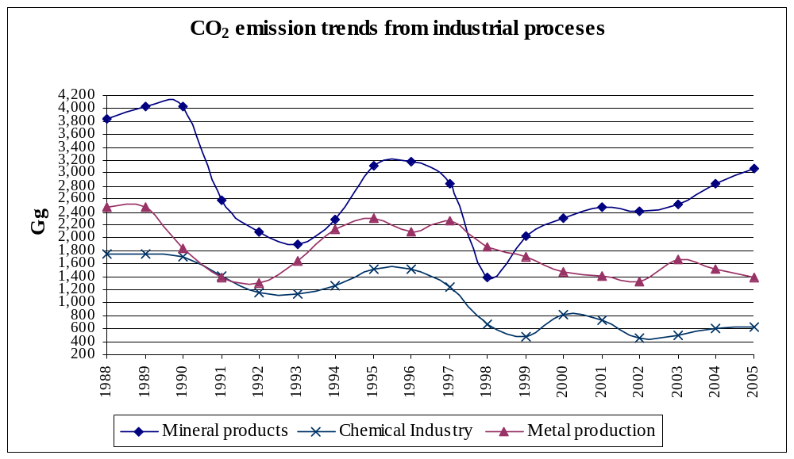
Solvent Use
The N₂O emissions are not estimated in the Inventories of Bulgaria due to the lack of data for the use substances for anaesthesia, production of medicines, aerosol packages, etc.
Agriculture
The general reduction of GHG emissions from Agriculture for the period from the year 1988 (base year- 14 559 Gg CO2-eqv.) is 67%. All emission categories of the sector decreased on the average with the same percents.
In the present year, a reduction of sector emissions is observed toward the year 2004 with 5.4%. There are fluctuations around one average level of 4.8 millions of tons.
In Figure 1.3 the methane emission trends are presented. They form 41% of the overall sectors emission expressed in CO₂-eq.
There is a stable trend in emission’s increase from 2001 up to now. Nevertheless, the drop related to the base year 1988 stands a very large one – above 65%.
The N₂O emissions from the sector are also large in volume. The most significant portion is released from agricultural soils. For the year 2005 it constituted over 86%, and for the entire period (1988-2004) this share remains in the range of 83 – 88%. The N₂O emissions from manure management and field burning of agricultural residues are one magnitude lower and they both total up to 13 – 14% of the overall N₂O emissions from this sector.
In 2005, as general, the N₂O emissions, expressed in CO₂-eq., are about 43% higher than the CH₄ emissions, expressed in CO₂-eq.
Land Use Change and Forestry
Due to the great diversity and complicity of CO₂ sequestration and emitting, in the Revised IPCC Guidelines are defined several categories:
- Changes in Forest and Other Woody Biomass Stocks;
- Forest and Grassland Conversion;
- Abandonment of Managed Lands;
- CO₂ Emissions and Removals from Soil;
- Other.
Figure 1.3: CH₄ Emissions from agriculture
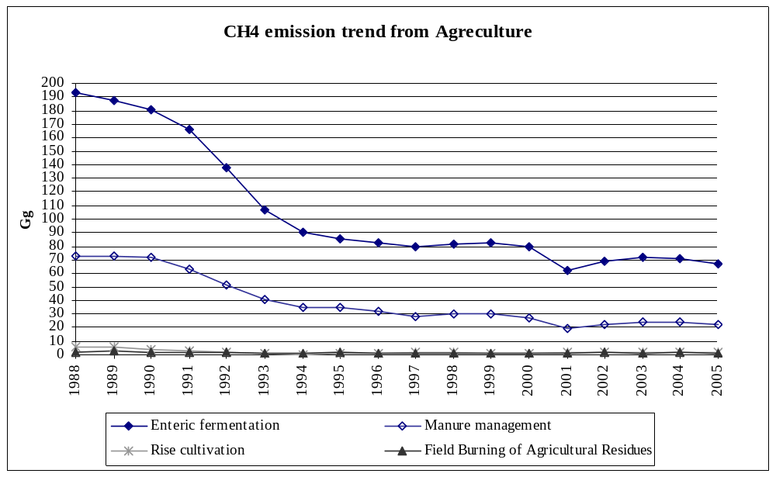

In the GHG Inventory for the year 2005, as well as for the previous years the net CO₂ removals from category Land Use Change and Forestry are. CO₂ emissions or removal of CO₂ from rest of the above categories were determined in accordance to the new structure of the sector, which is proposed by the Good Practice Guidance in this sector.
The forests in Bulgaria are from the temperate zone. They are mainly two types of forests – broad-leaved and coniferous. The area of the forests in Bulgaria is around 30% from the total territory of the country. The varied relief suggests the existence of huge forest areas at the mountain and hilly regions of Central and South Bulgaria.
The woody reserves of the Bulgarian forests is more than 530 millions m³ with average annual growth of around 13-14 millions m³. For the year 2005 the cut is in the range of 7.05 millions m³.
Waste
The GHG emissions from the Waste sector (base year- 12 817 CO₂eqv., 64 75 CO₂eqv. result from the process of accumulation, disposal and management of solid wastes from the households and industry and industrial wastewater handling.
In 2005 too the emissions from solid waste disposal head the first place of methane sources in Bulgaria and the fifth place from all GHG emission sources in the country.
The trend analysis shows, that the CH₄ emissions from solid waste disposal have a stable trend of reduction and remain relatively stable during the last three years.
The CH₄ emissions from wastewater and sludge are significantly smaller and have a trend, which does not vary to such a degree as it is for the solid waste trend.
Figure 1.4:Total GHG Emissions in CO₂-eq. in Bulgaria by sector: 1988-2005
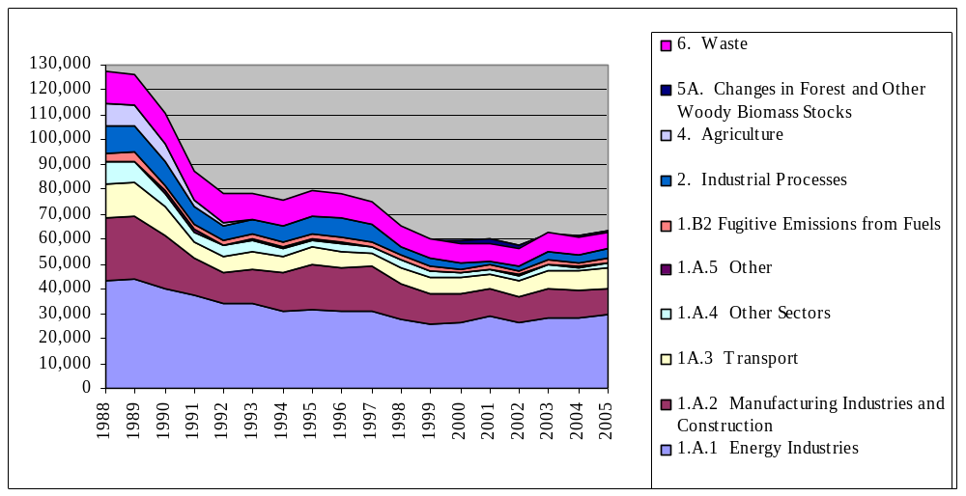

Selected base year for HFCs, PFC and SF₆ in accordance with Article 3.8
The time series for the emissions of the hydrofluorocarbons (HFC), perfluorocarbons (PFC) and sulphur hexafluoride (SF6) are presented in Table 2.1. The emissions in 1995, expressed in CO₂ equivalent are 4.2 Gg CO₂ equivalent and if including only potential HFC- 63.42.
In accordance with Article 3.8 of the Kyoto Protocol, Bulgaria has chosen the year 1995 as the base year for the emissions of the hydrofluorocarbons (HFC), perfluorocarbons (PFC) and sulphur hexafluoride (SF₆).
Table 2.: Emissions of HFCs, PFCs, SF6 for the period 1995-2005
 | 1995 | 1996 | 1997 | 1998 | 1999 | 2000 | 2001 | 2002 | 2003 | 2004 | 2005
HFCs | 62,16 | 109,30 | 188,15 | 576,65 | 102,80 | 96,02 | 97,50 | 89,59 | 120,60 | 217,30 | 386,84
PFC’s | - | - | - | - | - | - | - | - | - | - | -
SF6 | 1,26 | 1,31 | 1,75 | 1,83 | 1,88 | 2,23 | 2,29 | 2,51 | 2,52 | 3,68 | 4,42
Total | 63,42 | 110,61 | 189,90 | 578,48 | 104,68 | 98,25 | 99,80 | 92,10 | 123,12 | 220,98 | 391,26

Calculation of Bulgaria's assigned amount
The assigned amount is calculated according to Articles 3, paragraphs 7 and 8 of the Kyoto Protocol, taking into account Decision 13/CMP.1
According to Article 3, paragraph 7 of the Kyoto Protocol the assigned amount for each Party included in Annex 1 shall be equal to the percentage inscribed for it in Annex B of its aggregate anthropogenic carbon dioxide equivalent emissions on GHG listed in Annex A in the base year multiplied by fife.
Article 3 paragraph 8 allows to choose the year 1995 as the base year for F-gases.
Bulgaria’s estimate of its assigned amount is derived from the base year emissions (1988, 1995 for F-gasses), multiplied by the limit implied by the Bulgaria’s 8% Kyoto target i.e. 0,92, multiplied by 5 representing the five years of the first commitment period.
Table 3.3:Bulgaria’s assigned amount
Emission
(Mg CO₂ eq,)
Emissions (without F-gasses and LUCF) in 1988 | 132 612 581
Emissions of F-gasses in 1995 | 63 422
TOTAL Base Year Emission | 132 676 003
Kyoto target | -8%
Annual average emissions (2008-2012) | 122 061 923
Estimated assigned amount | 610 309 614
Bulgaria’s AA= 132 676 003.0 x 0.92 x 5 = 610 309 614 Mg CO₂ equivalent

Part 2

Calculation of Bulgaria's commitment period reserve
The commitment period reserve (CPR) is calculated in accordance with decision 11/CMP.1 (Article 17 of Kyoto protocol) as 90% of the proposed assigned amount or 100% of its most recently reviewed inventory times five, whichever is lowest.
The first method calculation as 90% of the proposed assigned amount of Bulgaria gives the estimate:
CPR = 0,9 x 610 309 614 = 549 278 653 Mg CO₂ equivalent
The second method calculation as 100% of the most recently reviewed inventory of Bulgaria times five gives the estimate:
CPR = 1.0x 5 x 69 994 879= 349 974 395 Mg CO₂ equivalent
Therefore Bulgaria's estimated CPR is 349 974 395 Mg CO₂ equivalent (100% of the last inventory – Submission 2007multiplied fife times).

Selection of threshold values for the forest definition to be used for reporting under Articles 3.3 and 3.4
Bulgaria, as any other Annex I country to the Kyoto Protocol has to submit in its Initial report to the Secretariat of the United Nations Framework Convention on Climate Change (UNFCCC) decisions by Bulgaria about the definition of forest, and whether Bulgaria selects activities under Article 3.4 of the KP: “Cropland management”, “Grazing land management”, “Revegetation”.
Article 3.3 of the Kyoto Protocol requires Parties in meeting their emissions reduction commitments to account for Afforestation, Reforestation and Deforestation (ARD) since 1990. Accounting ARD under Article 3.3 requires:
- definition of forest,
- knowledge of forest type and planting/deforestation date,
- geographical location, and
- method to distinguish deforestation from areas harvested and replanted.
For the purposes of applying the definition of “forest” every Annex 1 country shall select single minimum value of the following parameters:
- Tree crown cover;
- Tree height;
- Minimum forest area.
The Kyoto protocol defines the following minimum value parameters:
- Tree crown cover - between 10 and 30%;
- Tree height - between 2 and 5 meters;
- Minimum forest area between 0.05 and 1 ha.
According to the Kyoto protocol “Forest” is a minimum area of land of 0.05–1.0 hectare with tree crown cover (or equivalent stocking level) of more than 10–30 per cent with trees with the potential to reach a minimum height of 2–5 meters at maturity in situ. A forest may consist either of closed forest formations where trees of various storeys and undergrowth cover a high proportion of the ground or open forest. Young natural stands and all plantations which have yet to reach a crown density of 10–30 per cent or tree height of 2–5 meters are included under forest, as are areas normally forming part of the forest area which are temporarily unstocked as a result of human intervention such as harvesting or natural causes but which are expected to revert to forest
For defining forest, in Bulgaria is used the definition in the Forest Act: Forest is area, covered with forest tree species on area not less than 0.1 ha. It is foreseen an amendment in the Forest Act, which will change also the definition of a forest for covering the requirements of the KP. For reaching the targets of KP have to be chosen minimal figures of the above listed parameters for tree height, tree crown cover and minimum area.
As pointed above, regarding the Forest Act forest is area, covered with forest tree species on area not less than 0.1 ha. Forest Fund in the Forest Act is territory, with main purpose to be forest and covers forests, bushes, and land for afforestation and non timber production lands, listed in the cadastre. Urbanized areas, separated settlements and agriculture lands are not included in the Forest Fund.
According their functions, forests are divided in: forests for timber production, protective and recreation forests and forest in protected areas.
An amendment to the Forest Act is foreseen, which will change also the definition of the forest for covering the requirements of the Kyoto protocol. The draft act for amendment of the Forest Act defines forest as:
“Area over 0.1 ha, covered with forest tree species higher than 5 meters and tree crown cover over 10% or with trees which can reach these parameters in natural environment.
Forests are also:
  - areas which are in a process of recovering and are still under the parameters, but it is expected to reach forest crown cover over 10% and tree height 5 meters;
  - areas, which as the result of anthropogenic factors of or natural reasons are temporary deforested, but will be reforested;
  - protective forest belts, as well as tree lines with area over 0.1 ha and width over 10 meters;
  - cork oak stands.”
For reaching the targets of KP the minimal figures of the above listed parameters for tree height, tree crown cover and minimum area have been chosen:
- Minimum forest area – 0.1 ha;
- Tree crown cover -10%;
- Tree height - 5 meters.
In accordance with Article 7 of the Kyoto Protocol the country will report in the National Inventories the following activities, following the definitions of the forest related activities, as given in Decision 16/CMP.1 Land use, land-use change and forestry:
- “Afforestation” as a direct human-induced conversion of land that has not been forested for a period of at least 50 years to forested land through planting, seeding and/or the human-induced promotion of natural seed sources
- “Reforestation” as a direct human-induced conversion of non-forested land to forested land through planting, seeding and/or the human-induced promotion of natural seed sources, on land that was forested but that has been converted to non-forested land. For the first commitment period, reforestation activities will be limited to reforestation occurring on those lands that did not contain forest on 31 December 1989
- “Deforestation” as a direct human-induced conversion of forested land to non-forested land
The management of the State Forest Fund and the control over and the lands and forests in Forest Fund is responsibility of the National Forestry Board within the Ministry of Agriculture and Forestry – a legal person on a budget.
Forests and lands from the Forest Fund are managed and utilized based on the Forest Management Projects, Plans and Programmes. The Forest Management Projects, Plans and Programmes are elaborated on ownership base according the order and period pointed in the Regulation for planning the management of forests and lands in the Forest Fund of the Republic of Bulgaria, issued by the Minister of Agriculture and Forestry on a proposal of the Head of the National Forestry Board.
The Forest Management Projects are approved by the Head of the National Forestry Board after coordination with other stakeholder ministries and organizations.
The funds, needed for elaboration of Forest Management Projects, Plans and Programmes are responsibility of the owners of the lands and forests in the Forest. The elaboration of the Forest Management Projects, Plans and Programmes for the forests and lands in the Forest Fund with total area over 50 ha, which owners are combined in the management of their forests, is covered from the State Budget. For forests and lands from the Forests Fund les than 2 ha – owned by physical and legal persons, elaboration of Forest Management Projects, Plans and Programmes is not obligatory. Owners of forests and lands in the Forest Fund have the right to grant the management to a State Forestry or other persons.
National Forestry Board is responsible for a Register for all the forests and lands in the Forest Fund, which Register consists information for the ownership, the area and type of forests, and the changes in these forests. The Register is public and is made on a model, approved by the Head of the National Forestry Board, coordinated with the National Statistics Institute. The reporting is made on types and categories of forests, on ownership, on village areas, municipalities, districts and for the country as a total, as well as on State Forestries, State Hunting Areas and Regional Forestry Boards. In case of changing the ownership, the new owner is responsible in 14 days to inform the relevant State Forestry. National Forestry Board makes account of the changes in the ownership of all forests and lands in the Forest Fund, and supports a national database with information for the changes.
The forest definition for Bulgaria under the Kyoto protocol slightly differ from the forest definition from the Forest Act. The difference will influence insignificantly the results of the Forest Planning and Inventory of the forests and lands in the Forest Fund. This difference will not reflect on the reporting to FAO or other international organizations.

Selection of activities under Article 3.4
Bulgaria may choose to account for anthropogenic greenhouse gas emissions by sources and removals by sinks resulting from any or all of the following human-induced activities, other than afforestation, reforestation and deforestation, under Article 3, paragraph 4, in the first commitment period:
- “Forest management” as a system of practices for stewardship and use of forest land aimed at fulfilling relevant ecological (including biological diversity), economic and social functions of the forest in a sustainable manner
- “Cropland management” as a system of practices on land on which agricultural crops are grown and on land that is set aside or temporarily not being used for crop production
- “Grazing land management” as a system of practices on land used for livestock production aimed at manipulating the amount and type of vegetation and livestock produced.
- “Revegetation” as a direct human-induced activity to increase carbon stocks on sites through the establishment of vegetation that covers a minimum area of 0.05 hectares and does not meet the definitions of afforestation and reforestation contained here
Bulgaria has decided not to elect any of the activities under Article 3, paragraph 4, in the first commitment period.

Choice of accounting periodicity for activities under Article 3, paragraphs 3 and 4
Bulgaria has chosen to account for each activity under Article 3, paragraph 3 for the entire commitment period at the end of the commitment period.

Bulgaria’s National GHG Inventory System
Article 5 paragraph 1 of the Kyoto Protocol mandates that all parties included in Annex-I to establish and maintain a national system for estimation of anthropogenic emissions for all GHG not covered by the Montreal Protocol. The system shall follow the Guidelines for National Systems as stated on Decision 19/CMP.1. As a Party included in Annex I to the UN Framework Convention on Climate Change (UNFCCC), Bulgaria implements annual inventories of greenhouse gas (GHG) emissions by sources and removals by sinks using the GHG inventory methodology approved by the UNFCCC.
The Ministry of Environment and Water (MOEW) has made the decision (Order No 54/25.01.2007) to implement the National System as subsystem to the National Air Pollution Monitoring System. This order is a temporary one and ensure performance of the procedures related to the national inventories based on the relevant texts of the Chapter 2 “Information about Environment” and Chapter 8 “National System for monitoring of the Environment” of the Environmental Protection Act, keeping in mind the available administrative structures of the MoEW and ExEA.
The process is under way within the MOEW structures with assignment of an external institute from the Bulgaria Academy of Sciences, which implements a relevant project.
The project is composed of two parts- “Development of General Methodology for Inventory of pollutant emissions under the Long Range Trans-boundary Air Pollution and the Framework Convention on Climate Change” and “Creation of Data Quality Control System, including organization and Procedures for data collection for Calculation of Air Pollutant Emissions”. The first part of the project will be finalized in October 2007 and the second part is planned to be finalized in early 2008.
The new organization of national inventories based on the results of the above mentioned project most probably will require changes and amendments to the legislation and regulations, as well as changes in the administrative structure of the institutions involved in order to enable them to fulfill the delegated competences.
The current institutional arrangements and the fulfilment of the requirements to the National system for assessment of anthropogenic emissions for all GHG not covered by the Montreal Protocol and the process of the Inventory and National Inventory Reports preparation is reported here.
  - Description of the present institutional arrangement for inventory preparation
All activities on preparation of GHG inventories in Bulgaria are coordinated and managed on a state level by the Ministry of Environment and Water.
In the Republic of Bulgaria, the institution charged with the overall responsibility for Management of the GHG inventory process is the Executive Environmental Agency of the Republic of Bulgaria (Order No 54/25.01.2007 of the Minister of Environment and Water). In accordance with its tasks and obligations to international institutions, the Executive Environmental Agency is charged with managing inventories of GHG emissions as well as emissions that are defined in the Convention on Long Range Transboundary Air Pollution within the laid-down time-limit. In managing the inventories, the Agency cooperates with numerous other institutions and administrative bodies which relay the necessary activity data and other necessary data for compilation of the GHG inventories.
The Executive Environmental Agency (ExEA) is a subsidiary authority to the Ministry of Environment and Water. The ExEA coordinates all activities, related to collecting activity data on sources of GHG emissions and is archiving the activity data and inventory results for every of the inventory submissions. It submits the inventory information to European Environment Agency. MOEW submits the annual inventory and the NIR to the European Union and to the UNFCCC Secretariat.
ExEA is the core body for collecting inventory data, aggregated on a national level by the following state authorities:
- National Statistical Institute (NSI);
- Road Control Department (RCD) within the Ministry of Internal Affairs;
- Statistics Department within Ministry of Agriculture and Forestry (MAF);
- Ministry of Economy and Energy;
- Forestry Department within MAF;
- Soil Resource Executive Agency within MAF;
- National Service for Plant Protection, Quarantine and Agro chemistry;
- Energy Efficiency Agency;
- Large industrial plants;
- Branch Business Associations.
The information is collected on the annual basis. The ExEA sends every year letters with particular questionnaires to the every one of the information sources. The environmental regulations require any environmental questionnaire to be filled in and sent back in timely manner.
The NSI plays a special role in data collection system for the inventory. Data for energy and material balances of the country, as well as major part of the calculations on the national inventory under the CORINAIR methodology are prepared at NSI.
NSI uses up-to-date statistical methods and procedures for data summarizing and structuring, harmonized with the provisions and methods of EUROSTAT. NSI has a two level hierarchical structure – National office and regional offices. The primary statistical questionnaires are collected at the regional statistical offices, examined for consistency of data and processed. The National office receives the primary information and the processed information from the regional offices and develops the National totals and balances.
At present the ExEA every year selects a performer of the inventory elaboration and NIR development through an open tender procedure under the rules of the Public Procurement Law. The procedure may take from three to eight months from the date of tender announcement to the contracting date.
Until now, all the eighteen national GHG inventories have been processed and all the NIRs prepared on annual contractual basis by the Energy Institute JSC – a registered in Bulgaria independent joint stock company.
The processed annual inventory and the NIR are presented by the Energy Institute to the ExEA Expert Council for Environment for approval. The Council finally approves the Inventory and allows its submission to the UN FCCC Secretariat.
  - Brief description of the present process of inventory preparation
The GHG inventory represents a process, covering the following main activities:
- Collecting, processing and assessment of input data on used fuels, materials and other GHG emission sources;
- Selection and application of emission factors for estimating the emissions;
- Determination of the basic (key) GHG emission sources and assessment of the results uncertainty.
As a whole, the inventory is an open system, which can be expanded, improved and modified in regard to the country specific circumstances such as the fuel mix, technology level, national statistic practices, etc.
Each year during inventory processing, some changes occur that affect directly the activities above enlisted. Important inventory stage is the process of data transformation into a form, suitable for CRF. During this process, aggregation of the fuels by type is made (solid, liquid and gaseous), and further data is added, regarding parameters and indices, specifying the systems for transportation and distribution of oil and natural gas, milk production, protein consumption by the humans, the systems for fertilizer processing, etc. These activities are just a part of additional data, filled in the CRF Tables.
  - Brief General Description of Methodologies and Data Sources Used
The GHG inventory is carried out in compliance with the 1996 Revised IPCC Guidelines, at closer abidance to the Good Practice Guidance recommendations LULUCF. Good Practice Guidance.
The basic sources for emission factors for the inventories are the local practice, IPCC Revised Guidelines and the Good Practice Guidelines. Some data from the CORINAIR methodology are also used.
The specific Bulgarian circumstances for many activities were recognized, applying relevant parameters and emission factors. It concerned particularly the emission factors in the sectors Energy, Agriculture, some industrial processes and particularly the road transport. The transport data is obtained based on scientific and practical research, considering the specifics of the motor fleet in the country.
Table 8.1 shows the methods and the emission factors applied, according to the adopted designations in the IPCC methodology, as follows:
Methods applied
D – IPCC standard method;
T 1, 2, 3 – methods of the type Tier 1, 2, 3;
NO – such method/emission factor not available;
RA – reference method;
NE – no estimation available.
Emission factors applied
D – standard IPCC emission factor;
C – by CORINAIR;
CS – specific for the country.
Table 8.1 CRF Summary 3 table with methods and emission factors applied
GREENHOUSE GAS SOURCE AND SINK CATEGORIES | CO₂ |  | CH₄ |  | N₂O
GREENHOUSE GAS SOURCE AND SINK CATEGORIES | Method applied | Emission factor | Method applied | Emission factor | Method applied | Emission factor
1. Energy | T1,T2 | CS,D | T1,T2 | CS,D | T1,T2 | CS,D
A. Fuel Combustion | T1,T2 | CS,D | T1,T2 | CS,D | T1,T2 | CS,D
1. Energy Industries | T2 | CS | T2 | CS | T2 | D
2. Manufacturing Industries and Construction | T2 | CS | T2 | CS | T2 | D
3. Transport | T1,T2 | CS,D | T1,T2 | CS,D | T1,T2 | CS,D
4. Other Sectors | T2 | CS | T2 | CS | T2 | D
5. Other | NA | NA | T1 | D | T1 | D
B. Fugitive Emissions from Fuels | NA | NA | T1 | D | NA | NA
1. Solid Fuels | NA | NA | T1 | D | NA | NA
2. Oil and Natural Gas | NA | NA | T1 | D | NA | NA
2. Industrial Processes | D,T1,T2 | CS,D | D | CR,D | D | D
A. Mineral Products | D,T1,T2 | D | NA | NA | NA | NA
B. Chemical Industry | D,T1 | CS,D | D | CR | D | D
C. Metal Production | D | CS | D | D | NA | NA
D. Other Production | NA | NA
E. Production of Halocarbons and SF6
F. Consumption of Halocarbons and SF6
G. Other | NA | NA | NA | NA | NA | NA
3. Solvent and Other Product Use | NA | NA |  |  | NA | NA
4. Agriculture |  |  | D,T1,T2 | CS,D | D | CS,D
A. Enteric Fermentation |  |  | T1 | D
B. Manure Management |  |  | T1,T2 | CS,D | D | D
C. Rice Cultivation |  |  | D | CS
D. Agricultural Soils |  |  | NA | NA | D | D
E. Prescribed Burning of Savannas |  |  | NA | NA | NA | NA
F. Field Burning of Agricultural Residues |  |  | D | CS,D | D | CS,D
G. Other |  |  | NA | NA | NA | NA
5. Land Use, Land-Use Change and Forestry | T1 | CS | NA | NA | NA | NA
A. Forest Land | T1 | CS | NA | NA | NA | NA
B. Cropland | T1 | CS | NA | NA | NA | NA
C. Grassland | T1 | CS | NA | NA | NA | NA
D. Wetlands | NA | NA | NA | NA | NA | NA
E. Settlements | NA | NA | NA | NA | NA | NA
F. Other Land | NA | NA | NA | NA | NA | NA
G. Other | NA | NA | NA | NA | NA | NA
6. Waste
A. Solid Waste Disposal on Land | NA | NA | T2 | CS,D
B. Waste-water Handling |  |  | D | CS,D | D | D
C. Waste Incineration | NA | NA | NA | NA | NA | NA
D. Other | NA | NA | NA | NA | NA | NA
7. Other (as specified in Summary 1.A) | NA | NA | NA | NA | NA | NA
GREENHOUSE GAS SOURCE AND SINK CATEGORIES | HFCs |  | PFCs |  | SF6
GREENHOUSE GAS SOURCE AND SINK CATEGORIES | Method applied | Emission factor | Method applied | Emission factor | Method applied | Emission factor
2. Industrial Processes | NA | NA | NA | NA | D | D
A. Mineral Products
B. Chemical Industry |  |  |  |  | NA | NA
C. Metal Production | NA | NA | NA | NA | NA | NA
D. Other Production
E. Production of Halocarbons and SF6 | NA | NA | NA | NA | NA | NA
F. Consumption of Halocarbons and SF6 | NA | NA | NA | NA | D | D
G. Other | NA | NA | NA | NA | NA | NA
7. Other (as specified in Summary 1.A) | NA | NA | NA | NA | NA | NA

The data flow, for the time being, of Bulgarian inventory system for estimation of the anthropogenic GHG emissions is shown in Figure 8.1.
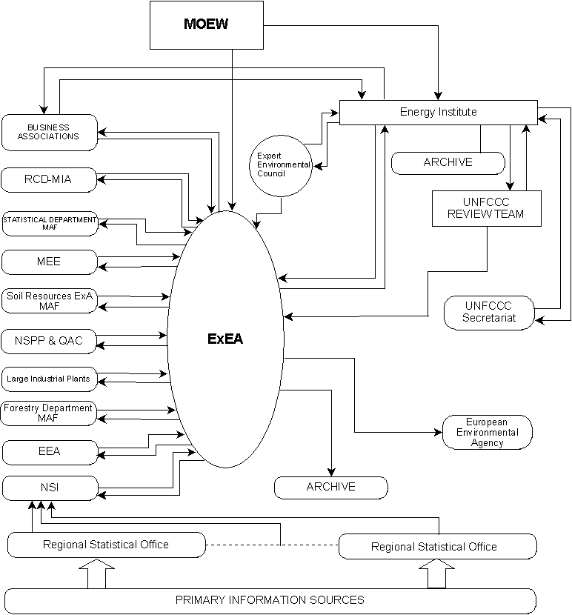

Figure 8.1: Data flow of Bulgarian Inventory System for Estimation of the Anthropogenic GHG Emissions
Subsequent to the finalization of an inventory submission, all support files are frozen so that they may not be changed anymore. CRF tables are stored both in digital form as well as a hard copy.
  - Original Data Sources for the Inventory
The original data sources on GHG are as follows:
- data on used fuels: general energy balance of Bulgaria, prepared by NSI;
- data on consumed households biomass: MAF statistics and NSI energy balance;
- vehicles number, types and models – MIA – Department of the road control;
- industrial output – companies’ reports summarized in the material balances of NSI; independent companies’ reports etc.
- SF₆ fugitive emissions: reports from the units of the Ministry of Economy and Energy (MEE); reports of industrial power-plants to companies;
- number of farming animals and plant crops: “Agro statistics” Department within MAF;
- quantity of used synthetic fertilizers: National Service for Plant Protection, Quarantine and Agro chemistry within MAF;
- land-use change and forestry: National Forestry Administration within MAF;
- disposal of solid waste and quantity of waste water: “Ecology” Department of NSI and “Waste” Department within MoEW.
Certain portion of the above-mentioned data is available on the web pages of NSI, MEE and MAF.
The general structure of the inventory institutional arrangements and data sources is shown in table 8.2.
Table 8.2: Inventory Institutional Arrangements and Data Sources
IPCC category | IPCC sub-category | Sources of data
CRF 1 A  Fuel Combustion | CRF 1A1 - Energy Industry | - NSI  - Large Combustion Plants (LCP)  - Energy Efficiency Agency  - Ministry of Economy and Energy
CRF 1 A  Fuel Combustion | CRF 1A2 - Manufacturing Industries and Construction | - NSI  - Large industrial plants;  - Branch Business Associations.  - Energy Efficiency Agency  - Ministry of Economy and Energy
CRF 1 A  Fuel Combustion | CRF 1A3 – Transport | - NSI  - Road Control Department (RCD) within the Ministry of Internal Affairs
CRF 1 A  Fuel Combustion | CRF 1A4 – Other Sectors | - NSI  - Energy Efficiency Agency
CRF 1 B  Fugitive Emissions |  | - NSI  - Ministry of Economy and Energy
CRF 2  Industrial Processes | CRF 2A – Mineral Products | - NSI  - Large industrial plants;  - Branch Business Associations.
CRF 2  Industrial Processes | CRF 2B – Chemical Industry | - NSI  - Large industrial plants;  - Branch Business Associations.
CRF 2  Industrial Processes | CRF 2C – Metal Production | - NSI  - Large industrial plants;  - Branch Business Associations.
CRF 2  Industrial Processes | CRF 2D – Other Production | - NSI  - Large industrial plants;  - Branch Business Associations.
CRF 2  Industrial Processes | CRF 2F – Consumption of Halocarbons and SF6 | - Executive Environmental Agency
CRF 3  Solvent and Other Product Use |  | - NSI
CRF 4  Agriculture |  | - Statistics Department within Ministry of Agriculture and Forestry (MAF)  - Soil Resource Executive Agency within MAF;  - National Service for Plant Protection, Quarantine and Agro chemistry
CRF 5  Land Use Change and Forestry |  | - Forestry Department within MAF;  - Soil Resource Executive Agency within MAF
CRF 6  Waste | CRF 6A – Solid Waste Disposal on Land | - Executive Environmental Agency  - NSI
CRF 6  Waste | CRF 6B – Wastewater Handling | - NSI
  - Key Source Category Analysis
The key sources are defined by the Energy Institute according to the IPCC classification. It is advisably the key sources that in superior degree are correspondent to the structure of the fuels and the activities in the country. This is the reason for the appliance of the methods for determination of the list of the key sources for Bulgaria in line with the practice in the country.
By method type Tier 1 are defined key sources accounting two rules:
- Rule A – Level assessment of the GHG emissions in absolute value expressed in Gg;
- Rule B – Trend assessment of the emissions from the base year till the current year of the inventory.
By applying rule A is used information for the volume of the source emissions only for the current year of the inventory. In this sense it gives the most complete assessment of the key sources for the current year.
The application of rule B requires information for the GHG emissions for the base year in the country. That means that the trend assessment includes additional information and gives the possibility for thorough analysis of the key sources.
The application of method from type Tier 2 requires the introduction of uncertainty assessments for each source of GHG emissions. After this an arrangement of these sources is done in accordance with the above mentioned rules A and B.
  - Information on the QA/QC Plan Including Verification and Treatment of Confidentiality Issues
Drawing up the GHG inventory is an aggregate of activities, subject of quality assurance and quality control. There are no formal Quality Assurance and Quality Control (QA/QC) procedures implemented in Bulgaria. The country has not yet developed a formal Quality Assurance and Quality Control plan as recommended by IPCC Good Practice Guidelines (IPCC 2000).
In spite of the not developed QA/QC plan, data control procedures covered by the internal regulations, rules and job descriptions of the companies and organizations are in use in the inventory process from primary data collection and verification, through data aggregation to the final processing of the inventory and preparation of the NIR. The items verified are input data at the all levels of activity, the appropriateness of chosen emission factors, the applied methodology as well as intermediate and final calculations of emissions.
The systems for QA/QC are part of working procedures in the Bulgarian companies and organizations, and in the companies they are subject of international quality control certification.
Issues on quality management of the following two stages of preparing the inventory will be discussed herein: preparation of initial data, calculation of the GHG emissions and compiling of original CRF Tables and the National Inventory Report.
Quality Management of the Sources of Initial Data
Each organization – data source, solves the quality management issues in accordance with its internal rules and provisions.
The primary sources of information (companies, municipalities, etc.) fill in special questionnaires. All the large enterprises have well arranged and effective quality management systems. Most of them have introduced quality management systems based on ISO 9001:2000 standard.
With some of the sources as NSI, ministries, agencies, etc., those rules follow strictly the international practices. For example, quality assessment/quality control procedures with NSI have been harmonized with the relevant instructions and provisions of EUROSTAT.
Quality Management of the compilation of the National Inventory Report and the CRF Tables
The final results of the inventory are reported in the National Inventory Report and the CRF Tables. The process of preparation of these two documents is subject of control from the Quality Management System (QMS), which has been introduced in the Energy Institute. This system is certified on ISO 9001:2000 standard.
The QMS contains all rules and procedures for management and control of the entire inventory process. Furthermore, specific checks are to be made at different stages, thus additionally verifying the data, received by the original sources.
The Inventory Processing System that is implemented at the Energy Institute is shown in Figure 8.2.
The short and strict time limits for the inventory processing and the vast volumes of information to be processed require special organization of the works and implementation of QC procedures (data checks) to avoid delay and reporting of wrong results. The inventory processing involves the following steps:
- Data check of the incoming from ExEA information flows. In some cases additional information is requested mainly from the large industrial plants and Branch Associations of particular industries. Data check is performed by sectoral experts and economists. Up to 5 employs are involved at this stage.
- Input of the information in special electronic data sheets. In most cases parallel performance of the input by two persons is done and the files compared for differences.
- Calculation of emission estimates by sources at the level of activity data disaggregation. Data check by sectoral experts. Cross check of the results.
- Input of data for the transport and waste models. Models run and data check.
- Aggregation of emission estimates to the level required by the CRF tables.
- Key sources and Uncertainty analyses.
- Input of data into the CRF reporter sectoral computers.
- Compilation of the general CRF Reporter.
- Recalculations, if required. Data check and introduction of the recalculations into the CRF Reporter.
- Draw up and input of additional information and comments in the CRF Reporter.
- Output of the CRF tables. Data checks. Introduction of corrections.
- Compilation of the NIR.
- Quality control of NIR
- Approval of the NIR and CRF by the Company Scientific Council, recommendations for corrective measures (Quality Assurance).
Archiving of the input information, processed information and results is performed at every stage of the process.
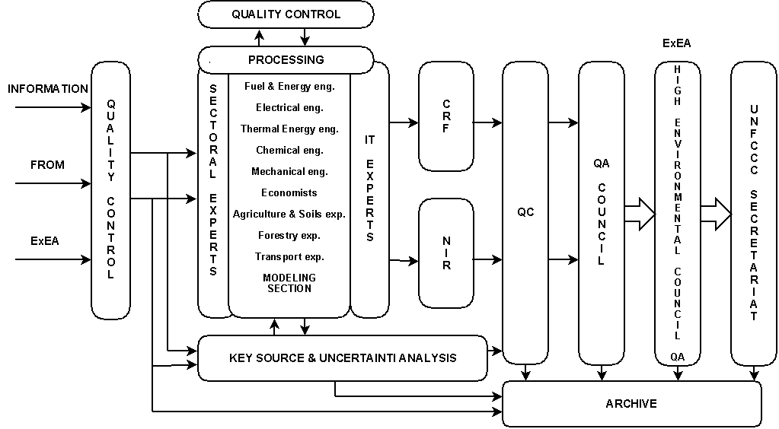
Figure 8.2: Inventory Processing System at the Energy Institute
Totally between 12 and 15 Energy Institute employees including fuel and energy, electrical, thermal energy, mechanical and chemical engineers and transport, agriculture, soil and forestry experts and economists contribute to the processing of the CRF and NIR and quality control and quality assurance of the process of preparation of the CRF and NIR every year. The Modelling section of the Institute is involved in the process of estimation of the transportation and municipal solid waste disposal emissions.
Confidentiality
Some of the data from the national statistics are treated as confidential. The National Statistical Law limits the publication of data about production volumes in some cases of limited number of participants in certain category.. The emission volumes are calculated by the NSI. The calculation formulas are given to the NSI by the Energy Institute. The emissions are reported as IE.
  - General Uncertainty Evaluation
As a whole, the performed at the Energy Institute uncertainty assessment of the GHG inventories follows the methodology of Good Practice Guidance.
It is known that the overall uncertainty is closely related to the GHG emission sources data uncertainty (fuels, activities, processes, etc.) and to the emission factor uncertainty.
The uncertainty of the GHG emission sources can be defined during data collection and processing, and it is a part of procedures, applied by the statistical agencies and organizations. Different criteria for uncertainty assessment are used, for example as statistical subtraction, on basis on differences between the production, import, export and consumption of fuels, through expert assessments, etc.
The uncertainty of the emission factors depends on the origin of the factors applied. In case the emission factors result from direct periodical measurements, the uncertainty is determined by the relevant methodology, related to the measuring methods and apparatuses.
The overall uncertainty of the GHG inventory is determined by combining the emission sources uncertainty and the emission factors uncertainty.
Two rules are applied in this process:
- Rule A – combination of the uncertainties by summing;
- Rule B – combination of the uncertainties by multiplying.
Since the GHG inventories are sums of products of emission sources, multiplied by emission factors, the two rules above can be used for determining the overall uncertainty of the inventory.
Rules A and B represent the foundation of the Tier 1 method, recommended in the Good Practice Guidance.

Bulgaria’s National Registry
Bulgaria as an Annex 1 Party to the Kyoto Protocol has to establish and maintain a national registry, as one of the eligibility criteria for using the flexible mechanisms of the Kyoto Protocol. The purpose of the registry is to ensure accurate accounting of the issuance, holding, transfer, acquisition, cancellation and retirement of ERUs, CERs, AAUs and RMUs and the carry-over of ERUs, CERs and AAUs.
Bulgaria started to set up the national registry, complying with the basic registry requirements as well as the registry is in compliance with the requirements for the EU ETS registries as elaborated by the European Commission and presented in the Commission Regulation no. 2216/2004/EC for a standardized and secured system of registries pursuant to Directive 2003/87/EC and Decision 280/2004/EC.
The availability of functioning National registry for accounting of the issue, holding, acquisition, transfer cancellation and retirement of GHG emissions allowance in Bulgaria is an obligation proceeding under art 131к (1) of Environmental protection act and is one of the indispensable conditions for the adequate and undisturbed functioning of the EU Scheme for GHG emissions allowance trading and also the allowance transfer pursuant to Kyoto Protocol mechanisms.
According to ORDINANCE on the rules and procedures concerning the functioning of the National registry for accounting of the issue, holding, acquisition, transfer cancellation and retirement of GHG emissions allowance (art. 3. (1)) the building up and keeping the registry shall be managed by the Minister of the environment and waters.
Art. 3(2) reads that the current keeping and realization of the registry is a task performed by the Executive Environmental Agency that shall play a role of registry administrator as stated in Commission Regulation 2216/2004.
Bulgaria owns “GRETA” software code that Danish Environmental Agency bayed from UK for the purposes of MoEW. “GRETA” is a licensed product meeting all EU and UN requirements.
The GRETA registry system used in Bulgaria has been developed for the EU Emissions Trading Scheme. This scheme requires its Member States registries to be compliant with the UN Data Exchange Standards specified for the Kyoto Protocol.
The National Registry under EU Emission Trading Scheme is not functional yet and is expected to start operating in October 2007. However, Bulgaria is participating in the EU Emission Trading Scheme. The Registry test by the European Commission is planed in September 2007.
The National Registry under Article 7 of the Kyoto Protocol is not functional yet and the national as well EU decisions on how it will be implemented are not taken yet. The National Registry under the Kyoto Protocol will be built on the registry developed for the EU Emission Trading Scheme. In this description, the technical information on the National Registry required in the Guidelines for the preparation of the information required under Article 7 of the Kyoto Protocol builds on the performance and technical properties of the registry developed for the EU Emission Trading Scheme, complemented with information available on issues specific to the registry under the Kyoto Protocol.
- Name and contact information of the registry administrator designated by the Party to maintain the national registry
The registry administrator designated by Bulgaria to maintain the national registry is:
Executive Environment Agency
Address: 136 Tzar Boris III Blvd., P.O. Box 251
1618 Sofia
Bulgaria
Tel.:+359 2 9559011
Fax: +359 2 9559015
E-mail: registry@nfp-bg.eionet.eu.int
Contact person: Mrs.Gergana Koleva, Tel.: +359 2 940 64 16
- Any other Party with which the Party cooperates by maintaining their respective registries in a consolidated system
In the EU Emission Trading scheme all Member States are included in the common system. The Bulgarian Registry will be first linked to the other operational EU member states’ National Registries by way of the European Commission CITL (Community Independent Transaction Log).
The names of the other Parties with which the Bulgaria will cooperates by maintaining their national registries in a consolidated system under the Kyoto Protocol has not been decided when writing this description.
- A description of the database structure to be used in the national registry
The national registry will incorporate the hardware and software set out in Annex I, be accessible via the Internet, and conform to the functional and technical specifications required by Commission Regulation (EC) No. 2216/2004.
- Active network equipment
The active network equipment provides the following functions and interfaces:
- Firewall – ensure the protection of DMZ, Intranet servers and data bases. The Cisco ASA5510 model disposes of 5 ports 10/100Base-T.
- Commutators – Ethernet commutators serving to provide the connection between servers and the other network equipment. Cisco Catalyst 3560G model disposes of 24 ports 10/100/1000Base-T.
- SAN switch – provides connection between servers and data storage devices. Cisco MDS 9124 model disposes of 24 ports (8 are active) 4/2/1Gbps for connection purposes.
All devices have redundant connections in a way that the system keeps its functions in a case of failure of some of the devices and the function is entirely covered by the redundant device.
- Servers and devices for data storage
The equipment is conventionally classified in tree parts:
- DMZ cluster – take a service of the system public partition. It is executed in reference to an Active-Standby scheme, e.g. if the active server fails the system service is automatically assumed by the Standby server. It consists in two servers, model: NEC Express5800 120Rg-1. They are equipped with Intel® Xeon® Processor E5335 (2.0GHz/2x4MB/1333MHz) allowing the integration of a second processor. There 2 GB RAM installed with an extension option up to 24 GB. The hard disk space consist of 3 disks, each with 36 GB SAS at 15,000 revolutions organized in RAID 1 + 1 Hotspare aiming a higher failure resistance. All critical elements are redundant – power supply, disks, RAID controller, LAN cards. A third LAN card is added serving for the direct contact between the two servers – Heart beat signal. The computer operating system is Microsoft Windows Server 2003 R2 Standard Edition, and with the purpose to increase the failure resistance of the system the claster software Express Cluster from NEC is installed
- Intranet Cluster – provides the service of the protected system part – TESTA2. it is implemented according the same scheme and by the same server models with the same characteristics like DMZ Cluster.
- Database Cluster – provides the data base service. Disk space for data base storage is proposed to be 2 TB (with an option to extend up to 18 TB if required). The cluster is implemented with 2 servers NEC Express5800 120Ri-2 and 2 data storage devices - NEC S1500, connected to two SAN commutators. With this connection scheme the single point of failure is avoided. The increased thickness is required because of the increased work performances with SAN cluster. Each server is equipped with 1 Intel® Xeon® Processor E5335 (2.0GHz/2x4MB/1333MHz) with an option to integrate another processor. They dispose of 8 GB RAM installed with an option of extension up to 48 GB. The disk space consists in 3 disks each with 36 GB SAS at 15,000 revolutions organized in RAID 1 + 1 Hotspare aiming to increase failure resistance. All critical elements are redundant – power supplies, disks, RAID controlled, LAN cards, cooling ventilation. The supplementary third LAN added for direct connection between servers is a Heart beat signal. The access to SAN (Storage Area Network) is provided via 2 Fibre Channel adapters for each server, aiming to increase the failure resistance. The computer operation system is Microsoft Windows Server 2003 R2 Enterprise Edition, in view to propose the failure resistance offered by Microsoft Cluster Services. The 2 servers have an installed Microsoft SQL server 2005 standard edition. The local RAID massifs of all servers are designed only for this operating system and the application. All data shall be storied at the devices dedicated for data storage S1500. These devices are with redundant critical modules as per supply, RAID controllers and disks. The disk space is implemented as RAID 6 organization system, that allows the easy functioning of the massive even in case of two of its disks failure.
- Cable system, UPS
In each of the two server rooms shall be installed distribution cabinet 42U, 800 х 1000, where the equipment will be installed. Between the two cabinets will be laid down the following cables ensuring whole system redundancy:
- Optic cable – 24 filaments, multimode, 62,5/125μm, with a layout at 19” ODF in each cabinet
- 14 units FTP, cat. 6, with a layout at 19” panel in each cabinet
The equipment in the server rooms will be provided with a stand by power supply (UPS) that is with a capacity to maintain the work at least 30 minutes after main supply blackout.
- Technical standards for the purpose of ensuring the accurate, transparent and efficient exchange of data between national registries, the clean development registry and the independent transaction log, including below.
The national registry system will follow the UN Data Exchange Standards.
Procedures for administration and operation of the registry
The procedures for administration and operation are described in the Commission Regulation no. 2216/2004 on a standardized and secure system of registries adopted pursuant to the Parliament and Council Directive 2003/87/EC and the Parliament and Council Decision 280/2004/EC. The national registry will be in compliance with the procedures stated in the regulation.
The national registry conforms to the technical standards for data exchange between registry systems as follows:
- The GRETA registry system used in Bulgaria has been developed for the EU Emissions Trading Scheme. This scheme requires its Member States registries to be compliant with the UN Data Exchange Standards specified for the Kyoto Protocol. Currently, the development adheres to the standards specified in Draft #7of the UN DES document.
- As part of the GRETA Registry development, functionality has been developed to perform issuance, conversion, external transfer, (voluntary) cancellation, retirement and reconciliation processes using XML messages and web-services as specified in draft #7 of the UN Data Exchange Standards document.
- In addition, 24 Hour Clean-up, Transaction Status enquiry, Time Synchronization, Data Logging requirements (including, Transaction Log, Reconciliation Log, Internal Audit Log and Message Archive) and the1 See decision 24/CP.8.different identifier formats as specified in the UN DES document have been implemented. Extensive tests on these functionalities can therefore be arranged with the ITL test system once Bulgaria registry becomes available and tested with the CITL for the EU ETS.
- With regards to performing tests with the CDM Registry (external transfer for example) this can also be performed once the Bulgaria registry becomes available and tested with the CITL for the EU ETS..
- The following additional Kyoto functionalities have been identified by Greta that would need to be developed for our Registry and tested against the ITL test system: Replacement of t-CER or l-CER, Carry-Over, Expiry Date Change (for t-CER and l-CER) and the whole area of functionality for ITL Notices (and the Notification Log).
Greta intends to schedule the development of these functionalities in their future releases in order to meet with the timetable required for Kyoto.
For the Greta Registry the following security measures have been taken:
- By default, access to the Registry is via Username and Password though a different authentication module can be added locally, if required;
- The actions that a user can perform are controlled by a permissions system, hence preventing unauthorized access to restricted actions;
- Database manipulations are only carried out by protected, internal stored procedures which are not accessible directly from the user interface and can only be invoked by our internal web-services;
In order to preventing operator errors, our Registry software incorporates the following design:
- Applies validation on all user inputs to ensure that only valid details are submitted for processing;
- Displays confirmation of user input to help the user to spot any errors that had been made;
- Implements an internal approval process for secondary approval for relevant operations before submitting the details to the ITL for processing.
Currently, the Greta registry system for the EU Emissions Trading Scheme uses the security mechanism as specified within the EU Regulation; (Annex XV); that is, it uses basic authentication and SSL.
For Kyoto, digital cert and VPN will be included in future phase of the Greta registry development project.
5. Information publicly accessible through the user interface to the national registry.
Only the information stated in Article 9 and the corresponding appendices of the European Commission Regulation no. 2216/2004 is available to the public.
The Registry terms and conditions, operator’s guide, forms and guidance for opening the holding accounts will be published at the website of Executive Environment Agency.
6. Access to information through the user interface of the national registry.
The internet address of the Bulgarian registry will be presented later, when the registry gets operational.

Other sectors represent emissions that are caused by fuel combustion, in commercial sector, in households and in agriculture/ forestry/fishery.
Bulgaria's most recent reviewed inventory will be the inventory submitted in 2007. This inventory will be subject to a review process before the beginning of the commitment period.

