HELLENIC MINISTRY FOR THE ENVIRONMENT, PHYSICAL PLANNING AND PUBLIC WORKS

CLIMATE CHANGE


INITIAL REPORT OF GREECE UNDER THE KYOTO PROTOCOL

DECEMBER 2006

Introduction
In accordance with the decision 13/CMP.1 of the first Conference of the Parties serving as a Meeting of the Parties to the Kyoto Protocol (COP/MOP), each Party included in Annex I of the United Nations Framework Convention on Climate Change (UNFCCC) with a commitment inscribed in Annex B of the Kyoto Protocol shall submit to the UNFCCC secretariat, prior to 1 January 2007 or one year after the entry into force of the Kyoto Protocol for that Party, whichever is later, a report to
- facilitate the calculation of the Assigned Amount pursuant to Article 3, paragraphs 7 and 8of the Kyoto Protocol and
- demonstrate its capacity to account for its emissions and assigned amount for the first commitment period under the Kyoto Protocol.
The information to be included in this report arranged in two parts, is specified in the Annex to the decision 13/CMP.1, paragraphs 7 and 8.
Part 1 of the report shall contain the following information, or references to such information previously submitted to the secretariat:
(a) Complete inventories of anthropogenic emissions by sources and removals by sinks of greenhouse gases not controlled by the Montreal Protocol for all years from 1990, or another approved base year or period under Article 3, paragraph 5, to the most recent year available, prepared in accordance with Article 5, paragraph 2, and relevant decisions of the COP/MOP, taking into account any relevant decisions of the Conference of the Parties (COP).
(b) Identification of its selected base year for hydrofluorocarbons, perfluorocarbons and sulphur hexafluoride in accordance with Article 3, paragraph 8.
(c) The agreement under Article 4, where the Party has reached such an agreement to fulfil its commitments under Article 3 jointly with other Parties.
(d) Calculation of its assigned amount pursuant to Article 3, paragraphs 7 and 8, on the basis of its inventory of anthropogenic emissions by sources and removals by sinks of greenhouse gases not controlled by the Montreal Protocol.
Part 2 of the report shall contain the following information, or references to such information previously submitted to the secretariat:
(a) Calculation of its commitment period reserve in accordance with decision 11/CMP.1.
(b) Identification of its selection of single minimum values for tree crown cover, land area and tree height for use in accounting for its activities under Article 3, paragraphs 3 and 4, together with a justification of the consistency of those values with the information that has been historically reported to the Food and Agriculture Organisation of the United Nations or other international bodies, and in the case of difference, an explanation of why and how such values were chosen, in accordance with the decision 16/CMP.1.
(c) Identification of its election of activities under Article 3, paragraph 4, for inclusion in its accounting for the first commitment period, together with information on how its national system under Article 5, paragraph 1, will identify land areas associated with the activities, in accordance with the decision 16/CMP.1.
(d) Identification of whether, for each activity under Article 3, paragraphs 3 and 4, it intends to account annually or for the entire commitment period.
(e) A description of its national system in accordance with Article 5, paragraph 1, reported in accordance with the guidelines for the preparation of the information under Article 7 of the Kyoto Protocol.
(f) A description of its national registry, reported in accordance with the guidelines for the preparation of the information under Article 7 of the Kyoto Protocol.
This report is the submission of Greece to the UNFCCC to facilitate the calculation of the assigned amount pursuant to Article 3, paragraphs 7 and 8, and demonstrate its capacity to account for its emissions and assigned amount for the first commitment period under the Kyoto Protocol. The information provided in this report is complemented with the National Inventory Report (including the Common Reporting Format tables) submitted to the secretariat in April 2006.

Table of contents
Introduction 1
Table of contents 3
1. Greenhouse gas inventory information 5
1.1 Overview of GHG emissions trends 5
1.2 GHG emissions trends per sector 6
1.3 GHG emissions trends per gas 10
2. Calculation of assigned amount pursuant to Article 3 Paragraphs 7 and 8 of the Kyoto Protocol 17
2.1 Identification of base year for the F-gases 17
2.2 Agreement under Article 4 of the Kyoto Protocol 17
2.3 Calculation of assigned amount 17
3. Calculation of commitment period reserve 19
4. Issues related to Article 3, paragraphs 3 and 4 of the Kyoto Protocol 20
4.1 Selection of single minimum values for tree crown cover, land area and tree height 20
4.2 Activities under Article 3, paragraph 4 of the Kyoto Protocol 20
4.3 Accounting under Article 3, paragraphs 3 and 4 of the Kyoto Protocol 20
5. Description of National System under Article 5, paragraph 1 of the Kyoto Protocol 21
5.1 General information 21
5.2 Roles and responsibilities of the various agencies and entities in relation to the inventory development process 21
5.3 Inventory preparation process 24
5.4 Identification of key categories 28
5.5 Recalculations 29
5.6 Quality assurance – Quality control plan 30
5.7 Description of procedures for the official consideration and approval of the inventory 32
6. Description of National Registry 33
6.1 Name and contact information of the registry administrator 33
6.2 Consolidated systen with other Parties 33
6.3 Database Structure and Capacity 33
6.4 Conformity with Data Exchange Standards 35
6.5 Minimisation of Discrepancies 36
6.6 Security measures 37
6.7 Information publicly available by means of the user interface 39
6.8 Internet address 41
6.9 Safeguard and Recovery of Data 41
6.10 Test Procedures 43

Greenhouse gas inventory information
Following paragraph 7(a) of the annex to the decision 13/CMP.1, this chapter presents information on inventories of anthropogenic emissions by sources and removals by sinks of greenhouse gases (GHG) not controlled by the Montreal Protocol for all years from 1990 to 2004 for Greece. For more details please refer to the latest National Inventory Report (NIR) of Greece submitted to the UNFCCC secretariat on April 2006.

Overview of GHG emissions trends
In 2004, GHG emissions (without Land Use, Land Use Change and Forestry - LULUCF) amounted to 137.63 Mt CO₂ eq (Table 1) showing an increase of 26.6% compared to 1990 levels. If emissions / removals from LULUCF were included then the increase would be 25.3% (from 105.55 Mt CO₂ eq in 1990 to 132.23 Mt CO₂ eq in 2004).
CO₂ emissions accounted for 80% of total GHG emissions in 2004 (without LULUCF) and increased by approximately 31% from 1990. N₂O emissions accounted for 10% of total GHG emissions in 2004 and decreased by 7% from 1990, while CH₄ emissions accounted for 6% of the total GHG emissions in 2004 and decreased by 8% from 1990. Finally, F-gases emissions that accounted for 4% of total GHG emissions in 2004, increased by more than five times since 1990.
- Emissions from Energy in 2004 accounted for 78.6% of total GHG emissions (without LULUCF) and increased by 32% compared to 1990 levels. The living standards improvement, due to the economic growth of the period 1990 – 2004, the important growth of the services sector and the introduction of natural gas in the Greek energy system represent the basic factors affecting emissions trends from Energy.
- Emissions from Industrial processes in 2004 accounted for 10.3% of the total emissions (without LULUCF) and increased by 60% compared to 1990 levels due to the increasing production of mineral products (mainly cement) as well as the gradual substitution of ozone depleting substances from halocarbons.
- The contribution of the sector Solvents and other products use to total GHG emissions is minor, (0.1% of the total emissions) and decreased by 8% compared to 1990 levels.
- Emissions from Agriculture that accounted for 8.7% of total emissions in 2004 (without LULUCF), decreased by approximately 12% compared to 1990 levels. Emissions reduction is mainly due to the reduction of Ν₂Ο emissions from agricultural soils, because of the reduction in the use of synthetic nitrogen fertilizers.
- Emissions from Waste (2.4% of the total emissions, without LULUCF), decreased by approximately 27% from 1990. Living standards improvement resulted in an increase of the generated waste and thus of emissions. Moreover, the increase of the number of managed solid waste disposal sites, without a systematic exploitation of the biogas produced, and the limited application of alternative management practices resulted in the increase of methane emissions. At the same time, emissions from wastewater handling have considerably decreased, due to the continuous increase of the population served by aerobic wastewater handling facilities.

GHG emissions trends per sector
GHG emissions trends by sector for the period 1990 - 2004 are presented in Table 2.
- Emissions from Energy in 2004 (Figure 1) accounted for 78.6% of total GHG emissions (without LULUCF) and increased by 32% compared to 1990 levels.
The living standards improvement, due to the economic growth of the period 1990 – 2004, the important growth of the services sector and the introduction of natural gas in the Greek energy system represent the basic factors affecting emissions trends from Energy.
The living standards improvement resulted in an increase of energy consumption and particularly electricity consumption (mainly in the residential – tertiary sector), of passenger cars ownership and transportation activity. The increase of electricity consumption led not only to the increase of direct emissions (due to combustion for electricity generation) but also of fugitive methane emissions from lignite mining. At the same time total CO₂ emissions per electricity produced from fossil fuels have decreased by 17% (from 1300 kg CO₂ / MWh in 1990 to 1070 kg CO₂ / MWh in 2004) mainly as a result of the introduction of the natural gas into the electricity system. It should be mentioned that the availability of hydropower has a significant effect to emissions trends (see NIR, Chapter 3). For instance, the significant increase of electricity demand in 1999 was not followed by a similar increase of emissions because of the penetration of natural gas and the high availability of hydropower (the highest of the period 1990 – 2004).
The increase of energy consumption in the domestic and tertiary sector in combination with the delays in the construction of natural gas distribution networks (restricting the penetration of natural gas) as well as with the limited penetration of energy conservation measures and RES technologies (with the exception of the use of solar energy for water heating) resulted in a continuous increase of GHG emissions.
The substantial increase of GHG emissions from road transport is directly linked to the increase of vehicles fleet but also to the increase of transportation activity. The renewal of the passenger car fleet (cars of new technology constitute 60% of total passenger cars in 2004) and the implied improvement of energy efficiency limit the increase of GHG emissions. However, the positive results from the improvement of the vehicles performance are reduced by the high use of passenger cars in transportation activity.
Table 1 GHG emissions/removals in Greece (in kt CO₂ eq) for the period 1990-2004
 | 1990 | 1991 | 1992 | 1993 | 1994 | 1995 | 1996 | 1997 | 1998 | 1999 | 2000 | 2001 | 2002 | 2003 | 2004
Α. GHG emissions per gas (without LULUCF)
CO₂ | 84313.57 | 83866.76 | 85242.64 | 85408.59 | 87306.80 | 87426.12 | 89622.76 | 94361.24 | 98965.82 | 98141.08 | 103962.81 | 106209.85 | 105905.19 | 109914.39 | 110280.16
CH₄ | 9119.50 | 9097.30 | 9123.20 | 9098.18 | 9185.67 | 9187.65 | 9335.62 | 9299.48 | 9345.51 | 9128.10 | 8950.41 | 8562.50 | 8552.84 | 8477.26 | 8412.02
N₂O | 14113.45 | 13821.97 | 13879.03 | 13070.10 | 13350.84 | 13073.31 | 13552.62 | 13327.87 | 13192.98 | 13201.17 | 13408.34 | 13217.32 | 13168.92 | 13251.66 | 13155.22
HFC | 935.06 | 1106.82 | 908.39 | 1606.65 | 2143.93 | 3421.01 | 4113.16 | 4537.86 | 5132.38 | 6123.37 | 5282.43 | 5203.33 | 5297.55 | 5558.78 | 5709.43
PFC | 257.62 | 257.56 | 252.30 | 152.59 | 93.62 | 82.97 | 71.74 | 165.34 | 203.75 | 131.72 | 148.38 | 91.38 | 88.33 | 77.30 | 71.71
SF₆ | 3.07 | 3.16 | 3.26 | 3.35 | 3.45 | 3.59 | 3.68 | 3.73 | 3.78 | 3.87 | 3.99 | 4.06 | 4.25 | 4.25 | 4.47
Total | 108742.26 | 108153.58 | 109408.82 | 109339.46 | 112084.30 | 113194.63 | 116699.57 | 121695.52 | 126844.22 | 126729.32 | 131756.36 | 133288.43 | 133017.08 | 137283.64 | 137633.02
Β. GHG emissions / removals from LULUCF
CO₂ | -3248.20 | -3596.04 | -3074.99 | -3879.75 | -3553.42 | -4406.97 | -3993.22 | -3957.00 | -3590.82 | -4436.43 | -3141.90 | -5323.63 | -5459.73 | -5533.46 | -5414.52
CH₄ | 49.87 | 25.48 | 75.40 | 66.35 | 62.25 | 34.76 | 21.75 | 46.65 | 125.11 | 9.71 | 166.10 | 22.88 | 3.20 | 4.48 | 11.08
N₂O | 5.06 | 2.59 | 7.65 | 6.73 | 6.32 | 3.53 | 2.21 | 4.73 | 12.70 | 0.99 | 16.86 | 2.32 | 0.33 | 0.45 | 1.12
Total | -3193.27 | -3567.97 | -2991.93 | -3806.66 | -3484.86 | -4368.69 | -3969.27 | -3905.62 | -3453.02 | -4425.74 | -2958.93 | -5298.43 | -5456.21 | -5528.53 | -5402.32
C. GHG emissions from International Transport
CO₂ | 10475.30 | 9478.60 | 10665.71 | 12212.33 | 13251.52 | 13862.55 | 12399.31 | 12343.16 | 13595.02 | 12685.32 | 13857.13 | 13351.48 | 12214.71 | 13150.47 | 13327.28
CH₄ | 16.73 | 15.37 | 17.67 | 20.55 | 21.83 | 23.39 | 20.62 | 20.76 | 23.14 | 20.72 | 23.83 | 23.17 | 20.80 | 21.34 | 21.53
N₂O | 90.21 | 81.50 | 91.52 | 104.26 | 113.64 | 118.06 | 106.04 | 105.86 | 116.41 | 109.99 | 118.83 | 114.49 | 105.12 | 114.16 | 115.76
Total | 10582.24 | 9575.47 | 10774.91 | 12337.14 | 13387.00 | 14004.00 | 12525.96 | 12469.78 | 13734.57 | 12816.03 | 13999.80 | 13489.14 | 12340.63 | 13285.97 | 13464.57

Table 2 Total GHG emissions (in kt CO₂ eq) by sector for the period 1990-2004
Year | 1990 | 1991 | 1992 | 1993 | 1994 | 1995 | 1996 | 1997 | 1998 | 1999 | 2000 | 2001 | 2002 | 2003 | 2004
Energy | 81762.63 | 81377.46 | 82935.17 | 82826.61 | 84889.30 | 84570.34 | 87012.51 | 91614.23 | 96536.07 | 95585.07 | 101508.11 | 103791.84 | 103726.47 | 107820.03 | 108135.69
Industrial processes | 8845.58 | 8849.96 | 8742.23 | 9409.91 | 9825.30 | 11549.86 | 12302.98 | 13010.65 | 13399.11 | 14423.02 | 13801.99 | 13715.32 | 13664.52 | 13942.41 | 14142.91
Solvents | 169.71 | 175.78 | 172.84 | 170.12 | 163.22 | 154.65 | 152.16 | 153.07 | 152.39 | 159.96 | 157.33 | 154.67 | 155.12 | 155.50 | 155.87
Agriculture | 13519.23 | 13306.17 | 13101.49 | 12503.16 | 12736.05 | 12486.24 | 12776.15 | 12486.82 | 12342.24 | 12364.27 | 12357.76 | 12144.28 | 12079.00 | 11998.61 | 11936.71
Waste | 4445.10 | 4444.21 | 4457.09 | 4429.67 | 4470.42 | 4433.54 | 4455.77 | 4430.75 | 4414.40 | 4197.01 | 3931.16 | 3482.32 | 3391.97 | 3367.09 | 3261.83
Total ¹⁾ | 108742.26 | 108153.58 | 109408.82 | 109339.46 | 112084.30 | 113194.63 | 116699.57 | 121695.52 | 126844.22 | 126729.32 | 131756.36 | 133288.43 | 133017.08 | 137283.64 | 137633.02
LULUCF | -3193.27 | -3567.97 | -2991.93 | -3806.66 | -3484.86 | -4368.69 | -3969.27 | -3905.62 | -3453.02 | -4425.74 | -2958.93 | -5298.43 | -5456.21 | -5528.53 | -5402.32
Index per sector
Energy | 100.0 | 99.5 | 101.4 | 101.3 | 103.8 | 103.4 | 106.4 | 112.0 | 118.1 | 116.9 | 124.1 | 126.9 | 126.9 | 131.9 | 132.3
Industrial processes | 100.0 | 100.0 | 98.8 | 106.4 | 111.1 | 130.6 | 139.1 | 147.1 | 151.5 | 163.1 | 156.0 | 155.1 | 154.5 | 157.6 | 159.9
Solvents | 100.0 | 103.6 | 101.8 | 100.2 | 96.2 | 91.1 | 89.7 | 90.2 | 89.8 | 94.3 | 92.7 | 91.1 | 91.4 | 91.6 | 91.8
Agriculture | 100.0 | 98.4 | 96.9 | 92.5 | 94.2 | 92.4 | 94.5 | 92.4 | 91.3 | 91.5 | 91.4 | 89.8 | 89.3 | 88.8 | 88.3
Waste | 100.0 | 100.0 | 100.3 | 99.7 | 100.6 | 99.7 | 100.2 | 99.7 | 99.3 | 94.4 | 88.4 | 78.3 | 76.3 | 75.7 | 73.4
Total ²⁾ | 100.0 | 99.5 | 100.6 | 100.5 | 103.1 | 104.1 | 107.3 | 111.9 | 116.6 | 116.5 | 121.2 | 122.6 | 122.3 | 126.2 | 126.6
¹⁾ Emissions / removals from Land Use, Land Use Change and Forestry are not included in national totals
²⁾ Land Use, Land Use Change and Forestry is not included

- Emissions from Industrial processes in 2004 accounted for 10.3% of the total emissions (without LULUCF) and increased by 60% compared to 1990 levels due to the increasing production of mineral products (mainly cement) as well as the gradual substitution of ozone depleting substances from halocarbons.
- The contribution of the sector Solvents and other products use to total GHG emissions is minor (0.1% of the total emissions) and decreased slightly since 1990.
- Emissions from Agriculture that accounted for 8.7% of total emissions in 2004 (without LULUCF), decreased by approximately 12% compared to 1990 levels. Emissions reduction is mainly due to the reduction of Ν₂Ο emissions from agricultural soils, because of the reduction in the use of synthetic nitrogen fertilizers (see NIR, Chapter 6). The changes of the rest determining parameters of GHG emissions from the sector (e.g. animal population, crops production etc.) have a minor effect on GHG emissions trend.
- Emissions from the sector Waste (2.4% of the total emissions, without LULUCF), decreased by approximately 27% from 1990.
Living standards improvement resulted in an increase of the generated waste and thus of emissions. Moreover, the increase of the number of managed solid waste disposal sites, without a systematic exploitation of the biogas produced, and the limited application of alternative management practices resulted in the increase of methane emissions. At the same time, emissions from wastewater handling have considerably decreased, due to the continuous increase of the population served by aerobic wastewater handling facilities.

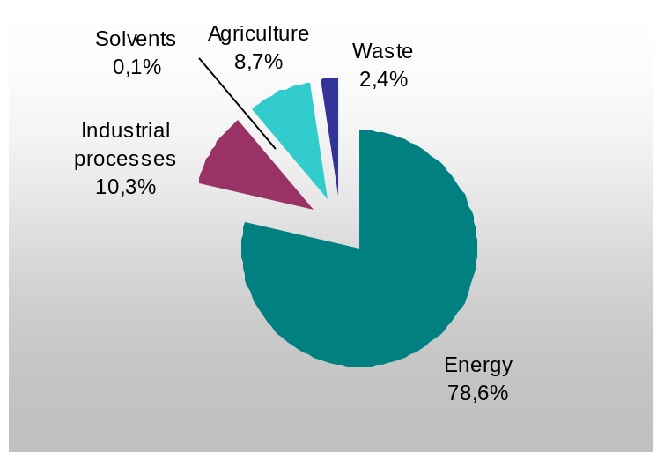
Figure 1 Relative contribution of activity sectors to total GHG emissions (without LULUCF) in 2004

GHG emissions trends per gas

Carbon dioxide
The trend of carbon dioxide emissions from 1990 to 2004 by source category is presented in Table 3. Total CO₂ emissions increased from 84.3 Mt in 1990 to 110.3 Mt in 2004 (without LULUCF). This upward trend (increase of 31% from 1990 to 2004) is mainly attributed to the increased electricity production as well as to the increased energy consumption in the residential and transport sectors.
CO₂ emissions from Energy increase almost continuously, from 77.2 Mt in 1990 to 110.3 Mt in 2004, presenting a total increase of 32% from 1990 to 2004. Carbon dioxide emissions from Industrial processes in 2004 increased by 15% compared to 1990 levels. On the contrary, emissions from Solvents and other products use decreased by 8% compared to 1990 levels. Finally, emissions from Waste in 2004 increased almost 6.5 times compared to 1990 (Figure 2).

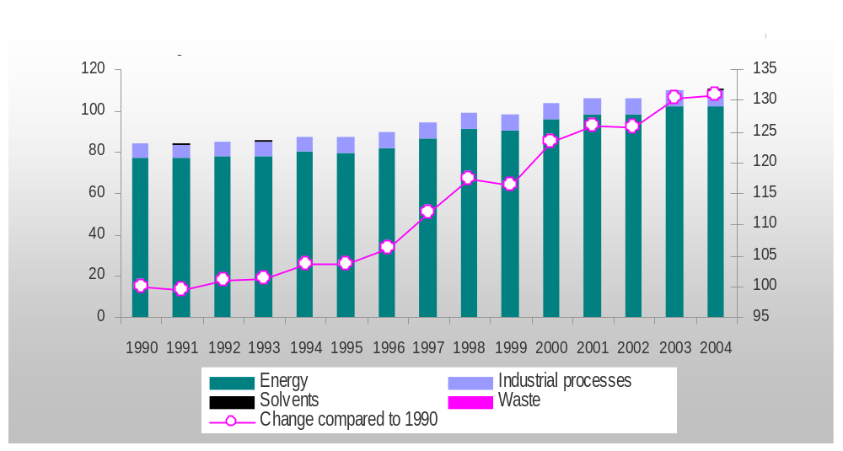
Figure 2 CO₂ emissions by sector (in Mt) for the years 1990 – 2004 (without LULUCF)
Table 3 CO₂ emissions / removals by sector for the period 1990-2004 (in kt)
Year | 1990 | 1991 | 1992 | 1993 | 1994 | 1995 | 1996 | 1997 | 1998 | 1999 | 2000 | 2001 | 2002 | 2003 | 2004
Total (with LULUCF) | 81065.36 | 80270.73 | 82167.66 | 81528.84 | 83753.38 | 83019.15 | 85629.53 | 90404.24 | 95375.00 | 93704.65 | 100820.92 | 100886.22 | 100445.45 | 104380.92 | 104865.64
Total (without LULUCF) | 84313.57 | 83866.76 | 85242.64 | 85408.59 | 87306.80 | 87426.12 | 89622.76 | 94361.24 | 98965.82 | 98141.08 | 103962.81 | 106209.85 | 105905.19 | 109914.39 | 110280.16
1. Energy | 77207.34 | 76796.80 | 78106.59 | 78175.30 | 80127.27 | 79794.38 | 82001.58 | 86471.34 | 91220.84 | 90301.64 | 95934.50 | 98055.76 | 97877.06 | 101826.96 | 102118.73
A. Fuel combustion | 77137.11 | 76725.90 | 78048.39 | 78127.98 | 80082.05 | 79755.65 | 81957.98 | 86432.20 | 91193.66 | 90300.19 | 95846.94 | 97949.32 | 97793.35 | 101727.44 | 102000.18
1. Energy industries | 43199.23 | 42016.15 | 43914.06 | 44164.60 | 46149.95 | 44882.39 | 44035.64 | 47541.78 | 50144.92 | 50445.32 | 54931.73 | 55457.91 | 54885.95 | 56104.60 | 57458.39
2. Man. industry and Construction | 10457.13 | 10160.94 | 9525.25 | 9275.65 | 9096.12 | 9855.78 | 10546.98 | 10649.91 | 10833.78 | 9639.64 | 10614.29 | 10633.19 | 10252.63 | 10102.97 | 9405.91
3. Transport | 15354.85 | 16127.66 | 16549.58 | 16769.01 | 16857.81 | 16966.00 | 17422.37 | 18022.31 | 19649.18 | 19823.49 | 19303.49 | 20013.56 | 20267.80 | 21233.85 | 21646.07
4. Other sectors | 8125.91 | 8421.16 | 8059.51 | 7918.71 | 7978.16 | 8051.48 | 9952.98 | 10218.20 | 10565.78 | 10391.74 | 10997.42 | 11844.66 | 12386.97 | 14286.02 | 13489.81
Β. Fugitive emissions | 70.23 | 70.90 | 58.20 | 47.33 | 45.22 | 38.73 | 43.60 | 39.15 | 27.18 | 1.44 | 87.56 | 106.44 | 83.71 | 99.52 | 118.55
2. Industrial processes | 6936.36 | 6894.04 | 6963.06 | 7063.02 | 7016.16 | 7476.94 | 7468.87 | 7736.67 | 7592.44 | 7679.34 | 7870.84 | 7999.26 | 7872.59 | 7931.14 | 8004.58
A. Mineral products | 6454.21 | 6407.56 | 6486.63 | 6588.73 | 6565.24 | 7008.64 | 7036.66 | 7256.48 | 7064.93 | 7166.91 | 7303.83 | 7357.73 | 7102.65 | 7201.46 | 7197.47
C. Metal production | 482.15 | 486.48 | 476.44 | 474.29 | 450.92 | 468.30 | 432.21 | 480.19 | 527.51 | 512.43 | 567.01 | 641.52 | 769.94 | 729.69 | 807.11
3. Solvents | 169.71 | 175.78 | 172.84 | 170.12 | 163.22 | 154.65 | 152.16 | 153.07 | 152.39 | 159.96 | 157.33 | 154.67 | 155.12 | 155.50 | 155.87
5. LULUCF | -3248.20 | -3596.04 | -3074.99 | -3879.75 | -3553.42 | -4406.97 | -3993.22 | -3957.00 | -3590.82 | -4436.43 | -3141.90 | -5323.63 | -5459.73 | -5533.46 | -5414.52
6. Waste | 0.15 | 0.15 | 0.15 | 0.15 | 0.15 | 0.15 | 0.15 | 0.15 | 0.15 | 0.15 | 0.15 | 0.15 | 0.41 | 0.79 | 0.98
International transport ¹⁾ | 10475.30 | 9478.60 | 10665.71 | 12212.33 | 13251.52 | 13862.55 | 12399.31 | 12343.16 | 13595.02 | 12685.32 | 13857.13 | 13351.48 | 12270.12 | 13150.47 | 13327.28
Aviation | 2447.55 | 2110.50 | 2201.85 | 2343.60 | 2781.45 | 2608.20 | 2497.95 | 2416.05 | 2535.75 | 2847.60 | 2497.95 | 2321.55 | 2321.55 | 3021.87 | 3106.36
Marine | 8027.75 | 7368.10 | 8463.86 | 9868.73 | 10470.07 | 11254.35 | 9901.36 | 9927.11 | 11059.27 | 9837.72 | 11359.18 | 11029.93 | 9948.57 | 10128.61 | 10220.92
¹⁾ Emissions from International transport are not included in national totals.

Methane
The trend of methane emissions from 1990 to 2004 by source category is presented in Table 4 and in Figure 3.
Agriculture represents the largest anthropogenic source of methane emissions in Greece since 2001 (with enteric fermentation being the main source category in the sector), accounting for 42% of total methane emissions in 2004 (without LULUCF). Methane emissions from Agriculture in 2004 increased by 1% compared to 1990 levels. Methane emissions from Waste in 2004 accounted for 34% of total methane emissions and decreased by 30% from 1990. Methane emissions from the Energy sector (mainly fugitive emissions from coal mining and production, processing, and distribution of liquid fuels and natural gas) account for the remaining 24% of the total methane emissions and increased by 31% from 1990.

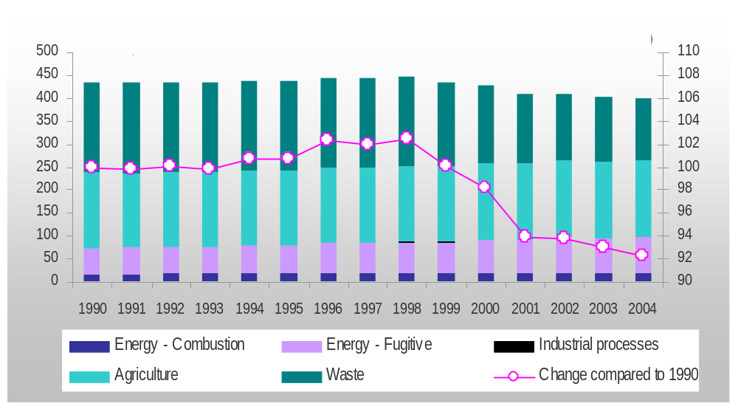

Nitrous oxide
The trend of nitrous oxide emissions from 1990 to 2004 by source category is presented in Table 5 and in Figure 4.
Agriculture represents the largest anthropogenic source of nitrous oxide emissions in Greece (64% approximately of the total nitrous oxide emissions in 2004, without LULUCF). Emissions from this sector decreased by 16% since 1990, mainly because of new agricultural practices applied, affecting the use of synthetic nitrogen fertilizers.
Table 4 CH₄ emissions by source category for the period 1990-2004 (in kt)
Year | 1990 | 1991 | 1992 | 1993 | 1994 | 1995 | 1996 | 1997 | 1998 | 1999 | 2000 | 2001 | 2002 | 2003 | 2004
Total (with LULUCF) | 436.64 | 434.42 | 438.03 | 436.41 | 440.38 | 439.16 | 445.59 | 445.05 | 450.98 | 435.13 | 434.12 | 408.83 | 407.43 | 403.89 | 401.10
Total (without LULUCF) | 434.26 | 433.20 | 434.44 | 433.25 | 437.41 | 437.51 | 444.55 | 442.83 | 445.02 | 434.67 | 426.21 | 407.74 | 407.28 | 403.68 | 400.57
1. Energy | 73.35 | 74.46 | 76.64 | 75.89 | 77.72 | 78.78 | 83.92 | 83.43 | 86.45 | 86.46 | 89.86 | 92.49 | 96.33 | 94.53 | 96.18
A. Fuel combustion | 16.83 | 17.27 | 17.58 | 17.79 | 17.95 | 18.18 | 18.69 | 18.85 | 19.12 | 18.98 | 19.11 | 19.21 | 18.95 | 19.03 | 18.88
1. Energy industries | 0.34 | 0.33 | 0.35 | 0.35 | 0.36 | 0.36 | 0.37 | 0.38 | 0.39 | 0.40 | 0.44 | 0.44 | 0.43 | 0.44 | 0.46
2. Manufacturing industry and Construction | 0.90 | 0.93 | 0.88 | 0.87 | 0.85 | 0.88 | 0.87 | 0.86 | 0.87 | 0.77 | 0.84 | 0.85 | 0.74 | 0.65 | 0.61
3. Transport | 5.45 | 5.76 | 6.13 | 6.36 | 6.51 | 6.76 | 7.16 | 7.30 | 7.59 | 7.65 | 7.61 | 7.72 | 7.70 | 7.82 | 7.66
4. Other sectors | 10.14 | 10.25 | 10.22 | 10.21 | 10.23 | 10.18 | 10.28 | 10.31 | 10.27 | 10.16 | 10.22 | 10.21 | 10.07 | 10.12 | 10.16
B. Fugitive emissions from fuels | 56.52 | 57.18 | 59.07 | 58.10 | 59.77 | 60.59 | 65.23 | 64.58 | 67.33 | 67.48 | 70.75 | 73.27 | 77.39 | 75.51 | 77.29
1. Solid fuels | 52.16 | 52.96 | 55.33 | 55.09 | 56.96 | 57.95 | 60.08 | 59.14 | 61.19 | 62.36 | 64.21 | 66.68 | 70.82 | 68.64 | 70.39
2. Oil and natural gas | 4.36 | 4.23 | 3.74 | 3.01 | 2.82 | 2.64 | 5.15 | 5.44 | 6.14 | 5.12 | 6.54 | 6.60 | 6.57 | 6.87 | 6.90
2. Industrial processes | 0.02 | 0.03 | 0.02 | 0.03 | 0.03 | 0.03 | 0.03 | 0.03 | 0.03 | 0.03 | 0.03 | 0.03 | 0.03 | 0.03 | 0.04
4. Agriculture | 164.70 | 162.87 | 161.63 | 162.47 | 163.50 | 164.44 | 165.22 | 165.55 | 165.54 | 165.94 | 166.63 | 166.78 | 166.80 | 166.26 | 166.58
A. Enteric fermentation | 136.47 | 134.82 | 134.07 | 133.90 | 134.15 | 134.76 | 135.09 | 135.28 | 135.80 | 136.67 | 137.84 | 137.95 | 137.82 | 137.27 | 137.43
B. Manure management | 23.66 | 23.30 | 23.15 | 23.11 | 23.07 | 23.01 | 23.00 | 23.03 | 23.15 | 23.29 | 23.42 | 23.18 | 23.12 | 23.20 | 23.19
C. Rice cultivation | 3.29 | 2.95 | 2.94 | 4.05 | 4.74 | 5.22 | 5.72 | 5.82 | 5.25 | 4.67 | 3.98 | 4.22 | 4.48 | 4.52 | 4.55
F. Field burning of agricultural residues | 1.29 | 1.81 | 1.47 | 1.41 | 1.53 | 1.44 | 1.41 | 1.43 | 1.34 | 1.32 | 1.39 | 1.42 | 1.38 | 1.27 | 1.42
5. LULUCF | 2.37 | 1.21 | 3.59 | 3.16 | 2.96 | 1.66 | 1.04 | 2.22 | 5.96 | 0.46 | 7.91 | 1.09 | 0.15 | 0.21 | 0.53
6. Waste | 196.19 | 195.85 | 196.14 | 194.87 | 196.17 | 194.26 | 195.38 | 193.82 | 193.01 | 182.24 | 169.69 | 148.44 | 144.11 | 142.86 | 137.78
A. Solid waste disposal on land | 85.76 | 87.82 | 89.85 | 92.15 | 94.62 | 95.24 | 98.11 | 101.11 | 103.07 | 98.05 | 101.94 | 106.72 | 108.10 | 112.72 | 113.12
B. Wastewater handling | 110.43 | 108.03 | 106.28 | 102.72 | 101.55 | 99.02 | 97.27 | 92.70 | 89.94 | 84.19 | 67.75 | 41.72 | 36.00 | 30.14 | 24.66
International Transport ¹⁾ | 0.80 | 0.73 | 0.84 | 0.98 | 1.04 | 1.11 | 0.98 | 0.99 | 1.10 | 0.99 | 1.13 | 1.10 | 1.00 | 1.02 | 1.03
Aviation | 0.02 | 0.02 | 0.03 | 0.03 | 0.03 | 0.03 | 0.03 | 0.03 | 0.04 | 0.04 | 0.04 | 0.04 | 0.04 | 0.04 | 0.04
Marine | 0.77 | 0.71 | 0.81 | 0.95 | 1.01 | 1.08 | 0.95 | 0.96 | 1.07 | 0.95 | 1.09 | 1.06 | 0.96 | 0.98 | 0.98
¹⁾ Emissions from International Transport are not included in national totals

Nitrous oxide is also produced from the reaction between nitrogen and oxygen during fossil fuel combustion. Nitrous oxide emissions from fossil fuels combustion (accounting for 30% of total nitrous oxide emissions in 2004) increased by 33% from 1990. This increase is mainly attributed to the transport sector as a result of the increasing number of new technology, catalytic passenger cars.
Production of nitric acid is the major source of N₂O emissions from Industrial processes and accounts for 3% of total N₂O emissions in 2004. Nitrous oxide emissions from this source decreased by 51% from 1990, due to the reduction of nitric acid production in Greece.

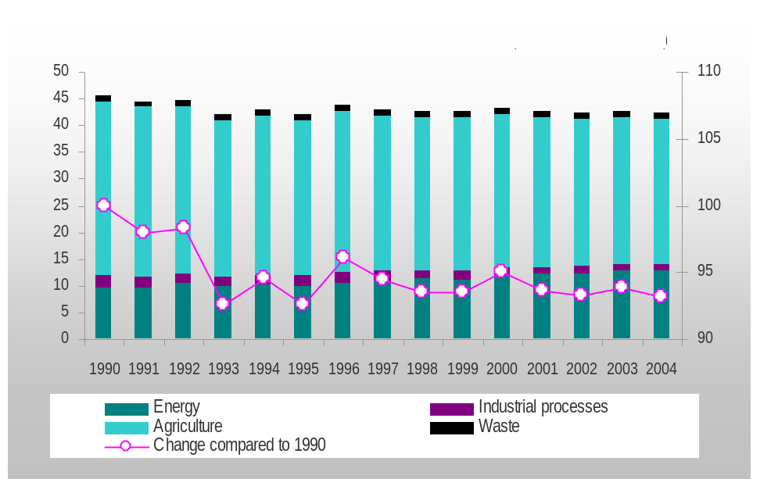
Figure 4 N₂O emissions by sector (in kt) for the period 1990 – 2004 (without LULUCF)

Halocarbons and sulphur hexafluoride
HFC and PFC are chemical substances, the production of which aims mainly to the substitution of ozone depleting substances (see Montreal Protocol – 1987). HFC and PFC are not harmful to the stratospheric ozone layer and thus their emissions are not controlled by the above-mentioned Protocol. However, many of these substances, as well as SF6, are powerful greenhouse gases; in addition, apart from being characterized by a high Global Warming Potential (GWP), these gases have extremely long atmospheric lifetimes, resulting in their essentially irreversible accumulation in the atmosphere. Especially sulphur hexafluoride is the most potent greenhouse gas according to the IPCC evaluation.
Emission estimates of these gases presented in Table 6 originate from:
Table 5 Ν₂Ο emissions by source category for the period 1990-2004 (in kt)
Year | 1990 | 1991 | 1992 | 1993 | 1994 | 1995 | 1996 | 1997 | 1998 | 1999 | 2000 | 2001 | 2002 | 2003 | 2004
Total (with LULUCF) | 45.54 | 44.60 | 44.80 | 42.18 | 43.09 | 42.18 | 43.73 | 43.01 | 42.60 | 42.59 | 43.31 | 42.64 | 42.48 | 42.75 | 42.44
Total (without LULUCF) | 45.53 | 44.59 | 44.77 | 42.16 | 43.07 | 42.17 | 43.72 | 42.99 | 42.56 | 42.58 | 43.25 | 42.64 | 42.48 | 42.75 | 42.44
1. Energy | 9.73 | 9.73 | 10.38 | 9.86 | 10.10 | 10.07 | 10.48 | 10.94 | 11.29 | 11.19 | 11.89 | 12.24 | 12.34 | 12.93 | 12.89
A. Fuel combustion | 9.73 | 9.73 | 10.38 | 9.86 | 10.10 | 10.07 | 10.48 | 10.94 | 11.29 | 11.19 | 11.89 | 12.24 | 12.34 | 12.93 | 12.89
1. Energy industries | 5.74 | 5.65 | 6.43 | 6.00 | 6.23 | 6.11 | 6.07 | 6.42 | 6.63 | 6.64 | 7.07 | 7.15 | 7.04 | 7.23 | 7.37
2. Man. industry and Construction | 1.34 | 1.34 | 1.31 | 1.25 | 1.24 | 1.33 | 1.46 | 1.45 | 1.43 | 1.25 | 1.40 | 1.42 | 1.37 | 1.31 | 1.25
3. Transport | 0.57 | 0.59 | 0.60 | 0.61 | 0.62 | 0.67 | 0.75 | 0.83 | 0.96 | 1.04 | 1.09 | 1.22 | 1.35 | 1.49 | 1.60
4. Other sectors | 2.08 | 2.15 | 2.05 | 2.00 | 2.01 | 1.95 | 2.20 | 2.23 | 2.28 | 2.26 | 2.33 | 2.45 | 2.59 | 2.90 | 2.68
Β. Fugitive emissions from fuels | 0.00 | 0.00 | 0.00 | 0.00 | 0.00 | 0.00 | 0.00 | 0.00 | 0.00 | 0.00 | 0.00 | 0.00 | 0.00 | 0.00 | 0.00
2. Industrial processes | 2.30 | 1.90 | 1.98 | 1.88 | 1.83 | 1.82 | 2.08 | 1.83 | 1.50 | 1.56 | 1.60 | 1.34 | 1.29 | 1.19 | 1.14
4. Agriculture | 32.45 | 31.89 | 31.31 | 29.33 | 30.01 | 29.14 | 30.02 | 29.07 | 28.60 | 28.64 | 28.58 | 27.88 | 27.66 | 27.44 | 27.22
B. Manure management | 0.97 | 0.95 | 0.93 | 0.92 | 0.91 | 0.91 | 0.91 | 0.91 | 0.92 | 0.93 | 0.94 | 0.93 | 0.92 | 0.91 | 0.91
D. Agricultural soils | 31.45 | 30.90 | 30.35 | 28.37 | 29.06 | 28.19 | 29.08 | 28.12 | 27.65 | 27.68 | 27.60 | 26.91 | 26.71 | 26.50 | 26.28
F. Field burning of agr. residues | 0.03 | 0.04 | 0.04 | 0.04 | 0.04 | 0.04 | 0.04 | 0.04 | 0.03 | 0.03 | 0.03 | 0.04 | 0.03 | 0.03 | 0.04
5. LULUCF | 0.02 | 0.01 | 0.02 | 0.02 | 0.02 | 0.01 | 0.01 | 0.02 | 0.04 | 0.00 | 0.05 | 0.01 | 0.00 | 0.00 | 0.00
6. Waste | 1.05 | 1.07 | 1.09 | 1.09 | 1.13 | 1.14 | 1.14 | 1.16 | 1.16 | 1.19 | 1.19 | 1.18 | 1.18 | 1.18 | 1.19
International transport ¹⁾ | 0.29 | 0.26 | 0.30 | 0.34 | 0.37 | 0.38 | 0.34 | 0.34 | 0.38 | 0.35 | 0.38 | 0.37 | 0.34 | 0.37 | 0.37
Aviation | 0.09 | 0.07 | 0.08 | 0.08 | 0.10 | 0.09 | 0.09 | 0.09 | 0.09 | 0.10 | 0.09 | 0.09 | 0.09 | 0.11 | 0.11
Marine | 0.21 | 0.19 | 0.22 | 0.25 | 0.27 | 0.29 | 0.25 | 0.25 | 0.28 | 0.25 | 0.29 | 0.28 | 0.26 | 0.26 | 0.26
¹⁾ Emissions from International transport are not included in national totals

- The production of HCFC-22 (emissions of HFC-23) and aluminium production (emissions of CF₄ and C₂F₆). HFC-23 emissions have been increasing steadily up to 1999 due to an equivalent increase in the production of HCFC-22, while PFC emissions from aluminium have dropped due to the control/reduction of the "anode effect" during the production process, since 1990 (with the exception of the period 1997 – 2000).
- Manufacturing, operation and maintenance of refrigeration and air conditioning equipment. HFC emissions increased significantly since 1995 (base year), mainly due to the increase of air conditioning equipment in the residential sector and the new passenger cars with air-conditioning systems.
- The use of SF₆ in the electricity transmissions / distribution system.
Table 6 Actual F-gases emissions for the period 1990-2004 (in kt CO₂ eq)
 | 1990 | 1991 | 1992 | 1993 | 1994 | 1995 | 1996 | 1997 | 1998 | 1999 | 2000 | 2001 | 2002 | 2003 | 2004
HFC | 935.06 | 1106.82 | 908.39 | 1606.65 | 2143.93 | 3421.01 | 4113.16 | 4537.86 | 5132.38 | 6123.37 | 5282.43 | 5203.33 | 5297.55 | 5558.78 | 5709.43
HFC-23 | 935.06 | 1106.82 | 908.39 | 1606.64 | 2143.91 | 3253.07 | 3746.34 | 3960.22 | 4359.89 | 5023.04 | 3735.11 | 3181.46 | 3194.57 | 2661.05 | 2550.60
HFC-32 |  |  |  |  |  |  |  |  |  |  | 0.51 | 1.70 | 4.27 | 12.42 | 23.99
HFC-125 |  |  |  |  |  |  |  |  |  |  | 2.28 | 7.55 | 19.02 | 54.67 | 105.49
HFC-134a |  |  |  | 0.01 | 0.02 | 167.94 | 366.82 | 577.64 | 772.49 | 1100.33 | 1544.52 | 2012.61 | 2079.69 | 2830.64 | 3029.35
PFC | 257.62 | 257.56 | 252.30 | 152.59 | 93.62 | 82.97 | 71.74 | 165.34 | 203.75 | 131.72 | 148.38 | 91.38 | 88.33 | 77.30 | 71.71
SF₆ | 3.07 | 3.16 | 3.26 | 3.35 | 3.45 | 3.59 | 3.68 | 3.73 | 3.78 | 3.87 | 3.99 | 4.06 | 4.25 | 4.25 | 4.47
Total | 1195.75 | 1367.54 | 1163.95 | 1762.59 | 2241.00 | 3507.56 | 4188.58 | 4706.93 | 5339.91 | 6258.96 | 5434.80 | 5298.76 | 5390.13 | 5640.33 | 5785.61

Calculation of assigned amount pursuant to Article 3 Paragraphs 7 and 8 of the Kyoto Protocol

Identification of base year for the F-gases
In accordance with Article 3, Paragraph 8 of the Kyoto Protocol, Greece identifies 1995 as its base year for hydrofluorocarbons, perfluorocarbons and sulphur hexafluoride, for the purposes of the calculation of the Assigned Amount for the first commitment period.

Agreement under Article 4 of the Kyoto Protocol
The Kyoto Protocol, under Article 4, provides the option for Parties to fulfil their commitments under Article 3 jointly, acting in the framework of and together with a regional economic integration organisation. The agreement of the European Community and its Member States to fulfil the commitments under Article 3, paragraph 1 of the Kyoto Protocol jointly established quantified emission limitation and reduction commitments for the Community and its Member States for the first commitment period, from 2008 to 2012. These commitments define the Member States’ assigned amount under the Kyoto Protocol. The full text of this agreement is contained in the Council Decision 2002/358/EC approving the Kyoto Protocol and was notified to the UNFCCC upon ratification by the Community and its Member States.
Council Decision 2002/358/EC that approved the Kyoto Protocol on behalf of the European Community transposed the joint agreement under Article 4 of the Kyoto Protocol into European law. The quantified emission limitation and reduction commitments agreed by the European Community and its Member States for the first commitment period, from 2008 to 2012, under the Kyoto Protocol are set out in Annex II to Council Decision 2002/358/EC.

Calculation of assigned amount
Under Council Decision 2002/358/EC concerning the approval, on behalf of the European Community, of the Kyoto Protocol and the joint fulfilment of commitments thereunder (in accordance with the provisions of Article 4 of the Kyoto Protocol), Greece has committed to limit the increase of its greenhouse gases emissions for the period 2008 – 2012 to 25% compared to base year emissions. The base year for CO₂, CH₄ and N₂O emissions is 1990, while for F-gases (PFCs, HFCs, SF₆) the base year is 1995, as mentioned in Paragraph 2.1.
Given the fact that LULUCF sector was a sink for greenhouse gas emissions in 1990, greenhouse gas removals by this sector are not taken into account when calculating the Assigned Amount during the first period of commitment under the Kyoto Protocol (2008-2012), according to Article 3, paragraph 7 of the Kyoto Protocol. As a result, base year emissions for Greece are estimated at 111,054,072 t CO₂ eq (Table 7).
The Assigned Amount for a Party during the first period of commitment under the Kyoto Protocol (2008-2012) is calculated from the base year emissions and the emission reduction target. More specifically, according to the above the Assigned Amount for Greece during the period 2008 – 2012 is estimated at 694,087,947 t CO₂ eq (1.25 * base year emissions * 5).
Table 7 Calculation of base year emissions and Assigned Amount (in t CO₂ eq) for Greece under the Kyoto Protocol
Carbon dioxide | 84,313,566
Methane | 9,119,496
Nitrous oxide | 14,113,449
Hydrofluorocarbons | 3,421,008
Perfluorocarbons | 82,968
Sulphur hexafluoride | 3,585
Base year emissions | 111,054,072
Assigned amount (1.25 * Base year emissions * 5) | 694,087,947

Calculation of commitment period reserve
The commitment period reserve, maintained in the national registry of a Party included in Annex I, is calculated as 90% of its proposed assigned amount or 100% of five times its most recently reviewed inventory, whichever is the lowest. The most recently reviewed inventory of Greece (at the time of the initial review under the Kyoto Protocol) would be the 2006 submission (i.e. the submission on which the calculation of the assigned amount is based).
The former leads to an estimate of 624,679,152 t CO₂ eq, while the later leads to an estimate of 668,165,077 t CO₂ eq (Table 8).
Table 8 Estimation of the commitment period reserve (in t CO₂ eq)
 | 90% of its proposed assigned amount | 100% of five times its most recently reviewed inventory
Carbon dioxide |  | 110,280,159
Methane |  | 8,412,020
Nitrous oxide |  | 13,155,223
Hydrofluorocarbons |  | 5,709,431
Perfluorocarbons |  | 71,713
Sulphur hexafluoride |  | 4,469
Assigned amount | 694,087,947
 | 624,679,152 | 668,165,077

As a result the commitment period reserve is estimated at 624,679,152 t CO₂ eq.

Issues related to Article 3, paragraphs 3 and 4 of the Kyoto Protocol

Selection of single minimum values for tree crown cover, land area and tree height
Greece has identified the following single minimum values for tree crown cover, land area and tree height for use in accounting for its activities under Article 3, paragraphs 3 and 4 of the Kyoto Protocol:
- Tree crown cover: 25%
- Land area: 0.3 Ha
- Tree height: 2 m
According to the Food and Agricultural Organization (FAO) of the United Nations forest is defined as "Land spanning more than 0.5 hectares with trees higher than 5 meters and a canopy cover of more than 10 percent, or trees able to reach these thresholds in situ" (Global Forests Resources Assessment 2006. Progress towards sustainable forest development, FAO 2006). Greece uses different single minimum values compared to those of FAO in order to ensure consistency with national legislation

Activities under Article 3, paragraph 4 of the Kyoto Protocol
Further investigation is needed to determine whether Greece intends to account for activities under Article 3, para 4 of the Kyoto Protocol. The decision is to be communicated to the UNFCCC Secretariat as soon as possible.

Accounting under Article 3, paragraphs 3 and 4 of the Kyoto Protocol
Greece will account for activities under Article 3, paragraph 3 for the entire commitment period.

Description of National System under Article 5, paragraph 1 of the Kyoto Protocol

General information
The Ministry for the Environment, Physical Planning and Public Works (henceforth Ministry for the Environment) is the governmental body responsible for the development and implementation of environmental policy in Greece, as well as for the provision of information concerning the state of the environment in Greece in compliance with relevant requirements defined in international conventions, protocols and agreements. Moreover, the Ministry for the Environment is responsible for the co-ordination of all ministries involved, as well as any relevant public or private organization, in relation to the implementation of the provisions of the Kyoto Protocol according to the Law 3017/2002 with which Greece ratified the Kyoto Protocol.
In this context, the Ministry for the Environment has the overall responsibility for the national GHG inventory (Contact person: Ms. Elpida Politi, Division of Air Pollution and Noise Control, Address: 147, Patission Av., 11251, Athens, Greece, e-mail: epoliti@minenv.gr, tel.: ++30 210 8677012).

Roles and responsibilities of the various agencies and entities in relation to the inventory development process
The entities participating in the National System are the Ministry for the Environment, the national institution with the technical responsibility for the compilation of the annual inventory that is designated by the Ministry for the Environment on a contract basis and the data providers.
Figure 5 provides an overview of the current organisational structure of the National System.
The roles and responsibilities of the above-mentioned entities are as follows:

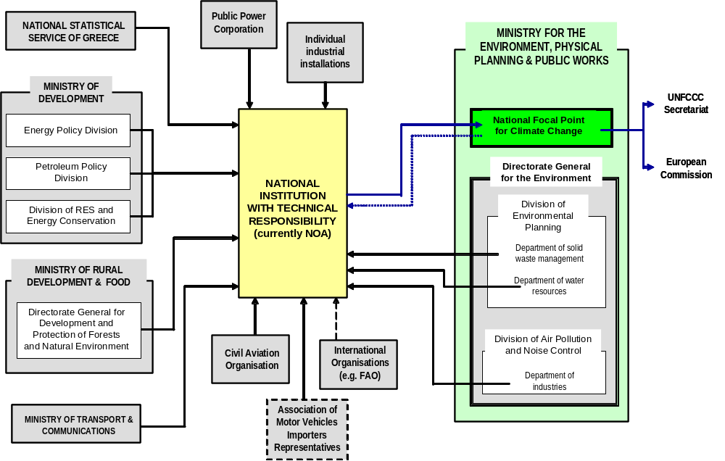
Figure 8 Current organizational structure of the national inventory system
- The Ministry for the Environment has the overall responsibility for the national GHG inventory. In this context, it oversees the operation of the National System and decides on the necessary arrangements to ensure compliance with relevant decisions of the COP and the COP/MOP.
The official consideration and approval of the inventory prior to its submission lies within the responsibilities of the Ministry for Environment. For that reason, a committee has been set up within the Ministry, aiming at the monitoring of the inventory preparation/compilation process so as to officially consider and approve the GHG inventory prior to its submission to the European Commission and to the UNFCCC Secretariat and ensure its timely submission.
Procedures have been established for providing responses to any issues raised by the inventory review process
- The Ministry for the Environment has designated, on a contract basis and for the period 2004 - 2006, the National Observatory of Athens (NOA) as the national institution that has the overall technical responsibility for the compilation of the annual national inventory (inventory team). In this framework, the inventory team at NOA is responsible for the choice of methodologies, data collection (activity data and emission factors, provided by statistical services and other organisations), data processing and archiving, as well as the implementation of general quality control procedures.
According to the contract signed between the Ministry for the Environment and NOA, the latter has the following obligations in relation to GHG emissions/removals inventory:
- Estimation of GHG emissions/removals per source / sink category.
- Compilation of the National Inventory Report and the Common Reporting Format tables.
- Reporting of the required information according to Article 3 of the Decision 280/2004/EC of the European Parliament and of the Council.
- Improvement of the existing inventory system
The inventory team at NOA co-operates with a number of government agencies and other entities for the preparation of the inventory. It should be mentioned that this co-operation is not restricted to data collection but is also concerns methodological issues as appropriate
- Data providers, mainly government agencies, develop and maintain, within their terms of operation, data sets necessary for the estimation of GHG emissions / removals.
- The Ministry for the Environment provides information and data for Large Combustion Plants (fuel consumption, NOx and SO₂ emissions - Department of industries), solid waste management (Department of solid waste management) and domestic wastewater handling practices (Department of water resources).
- The National Statistical Service of Greece, supervised by the Ministry of Economy and Finance, represents the main source of information for the estimation of emissions / removals from most of the IPCC source / sink categories
- The Ministry for Development, is responsible for reporting and maintaining annual statistical data for energy consumption and production (more specifically: Energy policy division – Solid fuels and electricity; Petroleum policy division – Liquid and gaseous fuels; Division of RES and energy conservation – Renewable energy sources) as well as for providing those data to international organizations such as the International Energy Agency (IEA), the European Statistical Service EUROSTAT, etc
- The Ministry of Rural Development and Food provides information and data (through the National Statistical Service of Greece which processes primary data collected by the Ministry) for the main indices and parameters of rural economy (e.g. animal population, cultivated areas, crops production, etc.) and forestry
- The Ministry of Transport and Communications provides information and data for the vehicle fleet and its technical characteristics. Data from the Association of Motor Vehicles Importers Representatives are supplementary to the official data and are only used in cases where official data are temporarily not available.
- The Civil Aviation Organisation provides information on Landing and Take-off cycles for both domestic and international aviation
- Information from the Public Power Corporation is used in combination with the data from the national energy balance with a view to improve the representation of the power plants as electricity generation is the main source of GHG emissions in Greece.
- The inventory team is in contact with Individual industrial installations in order to handle confidentiality issues (e.g. aluminium production, production of chemical compounds).

Inventory preparation process
The preparation of the Greek GHG emissions inventory is largely based on the application of the CORINAIR (CORINe AIR emissions inventory) methodology. This methodology was developed within the framework of the CORINE work programme, which was established by the European Environment Council on 27 June 1985 (Decision 85/338/EEC). The objective of the program was the collection, maintenance and management of information regarding the state of the environment in the European Community in a way that would ensure of the validity and comparability of the information provided.
The compilation of the inventory is completed in three main stages (Figure 6), while the timetable for the completion of those stages in the annual inventory cycle is presented in Figure 7.
- The first stage consists of data collection and check for all source/sink categories. The main data sources used are the National Statistical Service of Greece (NSSG), the government agencies involved and large private enterprises.
Quality control of activity data include the comparison of the same or similar data from alternative data sources (e.g. National Statistical Service of Greece and International Iron & Steel Institute for steel production) as well as time-series assessment in order to identify changes that cannot be explained. In cases that problems are identified, then those problems are addressed to the responsible data provider.
- Once the reliability of the data is assessed, emissions/removals per source/sink category are estimated (Stage 2). Emissions estimates are then transformed to the format required by the CRF Reporter (as of the 2006 submission). This stage also includes the evaluation of the emission factors used and the assessment of the consistency of the methodologies applied in relation to the provisions of the IPCC Guidelines, the IPCC Good Practice Guidance and the LULUCF Good Practice Guidance. A detailed description of the methodologies applied per source / sink category can be found in the latest inventory submission of Greece (submission 2006, chapters 3 – 9).
Quality control checks when at this stage are related to time-series assessment as well as to the identification and correction of any errors / gaps while estimating emissions / removals and filling in the CRF Reporter.
- The last stage (Stage 3) involves the compilation of the NIR and its internal (i.e. within the inventory team) check, which is then commented by the involved government agencies. On the basis of these comments, the final version of the report is compiled and then NIR submitted, by the Ministry for Environment, to the European Commission and to the UNFCCC Secretariat.
The information that is related to the annual GHG emissions inventory (activity data, emission factors, analytic results, compilation in the required analysis level of the CRF tables) is stored in MS Excel spreadsheets. Moreover, the final results (NIR and CRF tables) are available in the address www.climate.noa.gr.
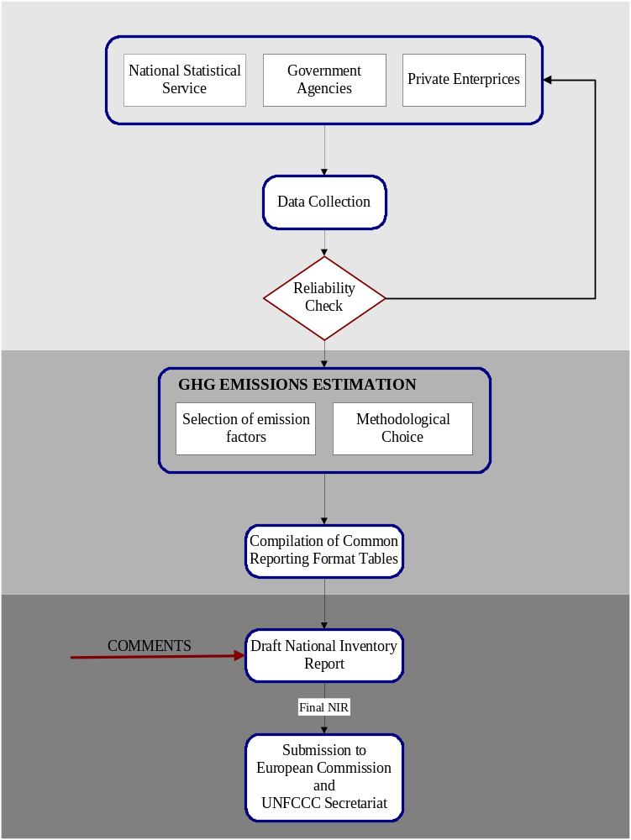
Figure 6 GHG emissions inventory preparation process in Greece
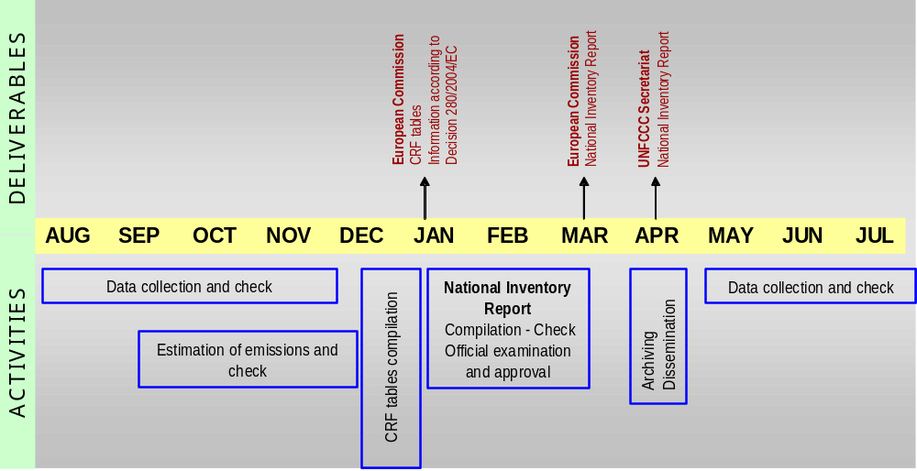
Figure 7 Timetable for the preparation and submission of GHG emissions/removals inventory in Greece
In addition and within the context of the Quality Assurance / Quality Control (QA/QC) system developed (see Paragraph 5.6) two master files have been organized aiming at the systematic and safe archiving of inventory information: the Input Data File and the Centralised Inventory File.
- The Input Data File contains (in electronic format and/or hard copy) all input data and parameters that are necessary for the estimation of GHG emissions / removals. Data are stored in files by sector and reference year.
- The Centralised Inventory File includes all information relevant to the GHG emissions / removals inventory. At the end of each stage of the inventory preparation all inventory related information is handled to the person responsible for keeping the Centralised Inventory File, who in turn gives the latest version of all relevant files (calculation files and NIR) to the inventory team at the beginning of the next inventory cycle.
More specific the information stored in the Centralised Inventory Files includes:
- A list of the reports, the input data files and the calculation files.
- The members of the inventory team.
- Final versions, in electronic format and hard copy, of the NIR.
- CRF tables in electronic format and a hard copy of the CRF tables for the last year covered by each submission.
- Calculation files, including the uncertainty estimation files.
- Expert review reports.
- Any comments from the public review of the inventory.
- A list of permissions given for the modification of elements stored in the Centralised Inventory File.

Identification of key categories
The IPCC Good Practice Guidance defines procedures (in the form of decision trees) for the choice of estimation methods within the context of the IPCC Guidelines. Decision trees formalize the choice of the estimation method most suited to national circumstances considering at the same time the need for accuracy and the available resources (both financial and human). Generally, inventory uncertainty is lower when emissions are estimated using the most rigorous methods, but due to finite resources, this may not be feasible for every source category. Therefore it is good practice to identify those source categories (key source categories) that have the greatest contribution to overall inventory uncertainty in order to make the most efficient use of available resources.
In that context, a key source category is one that is prioritised within the national inventory system because its estimate has a significant influence on a country’s total inventory of direct greenhouse gases in terms of the absolute level of emissions (level assessment) or/and to the trend of emissions (trend assessment). As far as possible, key source categories should receive special consideration in terms of two important inventory aspects.
- The use of source category-specific good practice methods is preferable, unless resources are unavailable.
- The key source categories should receive additional attention with respect to quality assurance (QA) and quality control (QC).
As a result of the adoption of the LULUCF Good Practice Guidance (Decision 13/CP.9) the concept of key sources has been expanded in order to cover LULUCF emissions by sources and removals by sinks. Therefore the term key category is used in order to include both sources and sinks.
The determination of the key categories for the Greek inventory system is based on the application of the Tier 1 methodology (see Annex I for an analytic presentation of calculations) described in the IPCC Good Practice Guidance, adopting the categorization of sources that is presented in table 7.1 of the IPCC Good Practice Guidance.
Tier 1 methodology for the identification of key categories assesses the impacts of various source categories on the level and the trend of the national emissions inventory. Key categories are those which, when summed together in descending order of magnitude, add up to over 95% of total emissions (level assessment) or the trend of the inventory in absolute terms.
The results of the key categories analysis (without LULUCF) for the 2006 inventory submission are presented in Table 9. The comparison of the results of the analysis with and without LULUCF reveals no differences in the source categories identified.
Table 9 Key categories for the Greek inventory system without LULUCF
Source categories | Gas | Criteria
Energy
Stationary combustion – Solid fuels | CO₂ | Level, Trend
Stationary combustion – Solid fuels | N₂O | Level
Stationary combustion – Liquid fuels | CO₂ | Level, Trend
Stationary combustion – Liquid fuels | N₂O | Level
Stationary combustion – Gaseous fuels | CO₂ | Level, Trend
Transport – Road transport | CO₂ | Level, Trend
Transport – Road transport | N₂O | Trend
Transport – Navigation | CO₂ | Level
Transport - Aviation | CO₂ | Trend
Coal mining and handling | CH₄ | Level
Industrial processes
Cement production | CO₂ | Level, Trend
Nitric acid production | N₂O | Trend
Iron & steel production | CO2 | Trend
HCFC-22 production | HFC-23 | Level, Trend
Ozone depleting substances substitutes | F-gases | Level, Trend
Agriculture
Enteric fermentation | CH₄ | Level, Trend
Agricultural soils – Direct emissions | N₂O | Level, Trend
Agricultural soils – Animal production | N₂O | Level, Trend
Agricultural soils – Indirect emissions | N₂O | Level, Trend
Waste
Solid waste disposal on land | CH₄ | Level, Trend
Wastewater handling | CH₄ | Trend

Recalculations
Methodological choice and, following the provisions of the IPCC Good Practice Guidance, recalculations of emissions estimates represent a major activity in the annual inventory development process. Both processes are under the responsibility of the inventory team.
Decisions, following the relevant procedures of the QA/QC plan in place, of the inventory team on the recalculations to be applied are based on:
- The results of the inventory review process under the UNFCCC;
- The results of the internal review within the framework of the QA/QC plan developed;
- The results of the key categories analysis and
- The availability of resources.

Quality assurance – Quality control plan
The development and the implementation of an inventory Quality Assurance / Quality Control (QA/QC) plan represents a key tool for meeting the objectives of National Systems under Article 5, paragraph 1 of the Kyoto Protocol as described in Decision 19/CMP.1.
With the Kyoto Protocol into force, it is expected that the pressure upon national GHG emissions inventories will increase and therefore quality management would be essential to comply with the requirements of (a) producing transparent, consistent, comparable, complete and accurate emissions estimates, (b) establishing a reliable central archiving system concerning all necessary information for GHG emissions inventories development and (c) compiling national reports according to the provisions of the adopted decisions.
In this framework, the inventory team at NOA, under the contract with the Ministry for the Environment, has developed an inventory QA/QC system that is being implemented since April 2004. The system is based on the ISO 9001:2000 standard and its quality objectives, as stated in the quality management handbook, are the following:
- Compliance with the IPCC guidelines and the UNFCCC reporting guidelines while estimating and reporting emissions/removals.
- Continuous improvement of GHG emissions/removals estimates
- Timely submission of necessary information in compliance with relevant requirements defined in international conventions, protocols and agreements.
The accomplishment of the above-mentioned objectives can only be ensured by the implementation, from all the members of the inventory team (see Figure 8 for the organisation chart of the inventory team activities), of the QA/QC procedures included in the plan for:
- data collection and processing,
- applying methods consistent with IPCC Good Practice Guidance and LULUCF Good Practice Guidance for calculating / recalculating emissions or removals,
- making quantitative estimates of inventory uncertainty,
- archiving of information and record keeping and
- compiling national inventory reports.
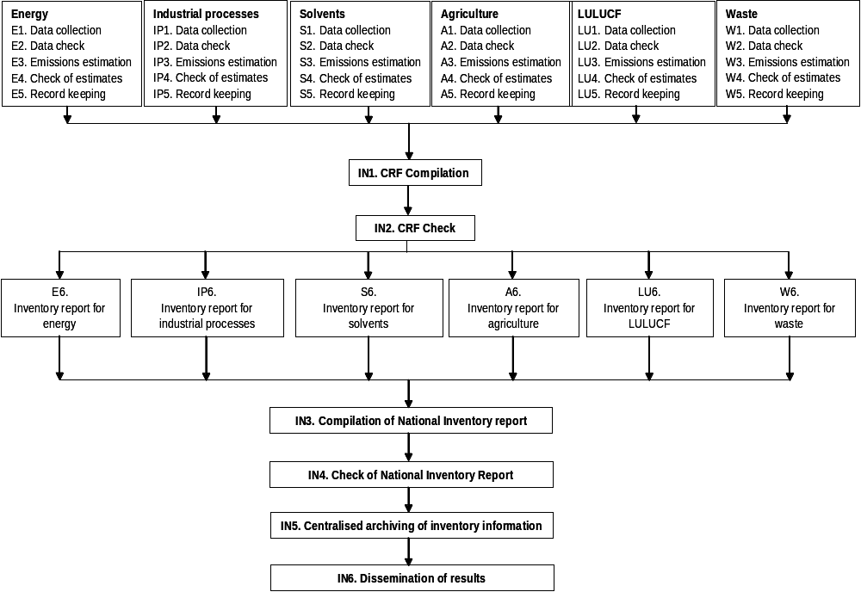
Figure 8 Organisation chart of the inventory team activities
The QA/QC system developed covers the following processes (see Table 10 for the list of procedures within each process and Figure 9 for the relationship between the processes and the activities of the inventory team):
- QA/QC system management, comprising all activities that are necessary for the management and control of the inventory agency in order to ensure the accomplishment of the above-mentioned quality objectives.
- Quality control that is directly related to the estimation of emissions. The process includes activities related to (a) data inquiry, collection and documentation, (b) methodological choices in accordance with IPCC Good Practice Guidance, (c) quality control checks for data from secondary sources and (d) record keeping.
- Archiving of inventory information, comprising activities related to centralised archiving of inventory information and the compilation of the national inventory report.
- Quality assurance, comprising activities related to the different levels of review processes including the review of input data from experts if necessary, and comments from the public.
- Estimation of uncertainties, defining procedures for estimating and documenting uncertainty estimates per source / sink category and for the whole inventory.
- Inventory improvement, that is related to the preparation and the justification of any recalculations made.
Table 10 Quality assurance / quality control procedures for the Greek GHG emissions inventory
Process | Procedure code | Procedures
Quality management | QM 01 | System review
 | QM 02 | System improvement
 | QM 03 | Training
 | QM 04 | Record keeping
 | QM 05 | Internal reviews
 | QM 06 | Non compliance – Corrective and preventive actions
 | QM 07 | Supplies
 | QM 08 | Quality management system
 | QM 09 | Documents control
 | QM 10 | Internal communication
Quality control | QC 01 | Data collection
 | QC 02 | Estimation of emissions / removals
 | QC 03 | Data quality control check
 | QC 04 | Input data record keeping
Archiving of inventory information | ΑI 01 | Centralised archiving of inventory information
 | ΑI 02 | Compilation of reports
Quality assurance | QA 01 | Expert review of input data and parameters
 | QA 02 | Expert review of GHG emissions / removals inventory
 | QA 03 | Review from public
Estimation of uncertainties | ΕU 01 | Uncertainty analysis
Inventory improvement | II 01 | Recalculations management

Description of procedures for the official consideration and approval of the inventory
The final draft version of the Greek GHG inventory submission (NIR and CRF tables) prepared by the inventory team is considered and circulated to other Ministries involved, by the Ministry for the Environment and finally approved and sent to the UNFCCC secretariat by the designated representative of the Ministry.

Description of National Registry

Name and contact information of the registry administrator
Information regarding the registry administrator is provided in the following table.
Table 11 Registry administrator
Name | National Center for the Environment and Sustainable Development (NCESD)
Address | KIFISIAS & GR. LAMBRAKI 1
City | ATHENS
Postcode | EL-145 61
Country | GREECE
Telephone number | +30 210 8089271
Facsimile number | +30 210 8084707
E-mail | registry@ekpaa.gr (General Address)  pappasio@ekpaa.gr (I. Pappas, Reg. Admin)  voudouri@ekpaa.gr ( A. Voudouri, Reg. Admin)  gtavo@ekpaa.gr ( G. Tavoularis, Reg. Admin)  epapavas@ekpaa.gr (E. Papavasilopoulos, Reg. Admin)

Consolidated system with other Parties
Greece cooperates with the member states of the European Union and with the supplementary transaction log (STL) and the registry of the European Community by maintaining the national registries in a consolidated system. The names of the other member states are: Austria, Belgium, Cyprus, Czech Republic, Denmark, Estonia, Finland, France, Germany, Hungary, Ireland, Italy, Latvia, Lithuania, Luxembourg, Malta, Netherlands, Poland, Portugal, Slovak Republic, Slovenia, Spain, Sweden and United Kingdom.

Database Structure and Capacity

A description of the database structure of the national registry
An overview of the database structure is shown in Figure 9.

The capacity of the National Registry
The capacity of the registry is designed for 5000 accounts. 141 Operator Holding Accounts plus 6 Personal Holding Accounts are currently installed.
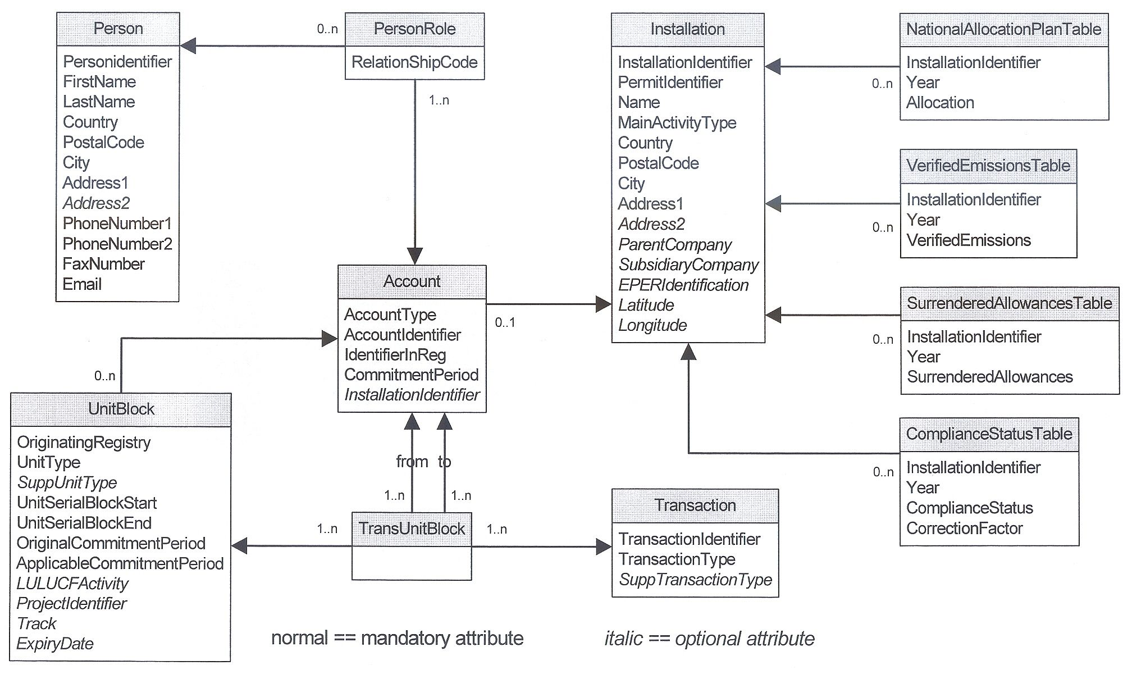
Figure 9 Overview of the registry database structure

Conformity with Data Exchange Standards
The software version 1.1.9.2 of the Greek national registry which is currently used is programmed according to the data exchange standards for registry systems under the Kyoto Protocol (DES), technical specifications Version 1.0. Version 1.1.10.0 of the registry software, which will be tested with the International Transaction Log (ITL) in 2007, will be programmed according to the DES, technical specifications Version Draft 1.1b.
- A description of the formats used in the national registry for account numbers, serial numbers for ERUs, CERs, AAUs and RMUs, including project identifiers and transaction numbers:
The formats in the national registry are used according to DES 1.0 Annex F – Definition of Identifiers.
- A list, and the electronic format, of the information transmitted electronically when transferring ERUs, CERs, AAUs and/or RMUs to other registries:
The formats for information transmitted electronically to the transaction log and other registries are used as specified for messages in DES 1.0.
- A list, and the electronic format, of the information transmitted electronically when acquiring ERUs, CERs, AAUs and/or RMUs from other national registries or the CDM registry;
The formats for information transmitted electronically to the transaction log and other registries when acquiring Kyoto units are used as specified for acquiring messages in DES 1.0.
- A list, and the electronic format, of the information transmitted electronically from the national registry to the independent transaction log when issuing, transferring, acquiring, cancelling and retiring ERUs, CERs, AAUs and/or RMUs:
The formats for information transmitted electronically to the transaction log and other registries are used as specified for messages in DES 1.0.
The supplementary transactions log (STL) of the European Community is based on DES 1.0. With test procedures that have been performed with the Greek national registry and the European STL, the accuracy of the implementation according to the DES has been tested.
Some of the registry procedures will be implemented in the next registry software version, which is planned for release in 2007 and will then be tested with the ITL test environment according to the ITL test schedule. These procedures are:
- Handling of tCERs and lCERs (such as replacement, expiry date change, cancellations),
- Carry-over,
- Notification log and handling of notifications,
- Net-source cancellations, non-compliance cancellations, excess issuance cancellations and other procedures like expiry date change of tCER and lCER that are performed after notifications from the ITL,
- Commitment period reserve checks

Minimisation of Discrepancies
To prevent discrepancies, internal checks and routines are implemented as far as possible. In the on-coming software version, the checks are planed to be available for initialisation tests in 2007:
- Checks concerning the handling of tCERs and lCERs (such as replacement, expiry date change, cancellations),
- Checks concerning carry-over procedures,
- Checks concerning the handling of notifications,
- Checks concerning net source cancellations and non-compliance cancellations and other procedures that are performed after notification from the ITL,
- Commitment period reserve checks.

Measures to deal with discrepancies
1. Whenever a possible discrepancy is detected by the internal checks, no transaction will be started.
2. Unit blocks involved in a pending transaction are locked for use in any other transaction.
3. There will be an automatic termination of the transaction that has caused the discrepancy (i.e. response code sent by ITL or STL in a web service request).
4. In the event of a failure to terminate the transaction, an inconsistency with the ITL or STL will be detected during the subsequent reconciliation process. The ITL or STL will then block any transaction involving the related blocks. The status of the blocks will afterwards be corrected manually by the registry administrator with the help of a manual intervention function. This intervention will be logged automatically in the registry. If no inconsistencies are detected during the next reconciliation process with the ITL or STL, the related unit blocks will be unblocked so that further transactions with these blocks will be possible.

Measures to prevent or handle communication problems with the ITL or STL
1. In case of communication or connection problems (response message of web service, time-out or negative acknowledgement of the message), if this problem continues after some retries, the transaction stays pending to avoid inconsistent transaction statuses between the registry and ITL or STL. In this case the registry operator can retry the message manually after fixing the connection problem or he can start a rollback of the transaction manually (only if there is no automatic deletion of the transaction by the ITL or STL).
2. Deletion of transactions after 24 hours upon request by STL.

Measures to prevent the reoccurrence of discrepancies
To prevent the reoccurrence of any type of discrepancies, the following measures will be taken by the technical staff of the Greek registry service administrator:
1. Locate the error (error hypothesis, repetition of the steps in the test environments if necessary, contact with the European ITL/STL helpdesk, isolation of individual processes to identify the factor causing the error).
2. Check the related part of the data exchange standards for registry systems under the Kyoto Protocol, technical specifications (current version).
3. If necessary: correction of the error.
4. Regression test on the test system.
5. Implementation of the corrected software version in the productive system.

Security measures
The security features comprise those features that ensure the protection of the product against intervention from outside.

Identification and Authentication
Every user of the system is identified by an unambiguous Login name and authenticated via a personal password of at least 8 characters and must contain at least three of the four categories: small letters, capital letters, numbers and special characters. Passwords are stored with the help of one-way coding, which ensures that the plain text of the passwords cannot be viewed by anyone (not even by administrators).
The identification and authentication take place before any other interaction with the system. Queries referred to the system via the WEB Services de-fined in the specification are authenticated by means of certificates.

Access control
The system manages access rights to those objects that are subject to administrative rights (accounts and installations) for each user and for a particular role to the user. Only users with the role "Register Administrator" are authorised to set up, delete or change these objects and to assign ac-cess rights themselves. Users with the role "Operator of an installation" are only allowed to view their own objects. Changes to the account balance are only possible indirectly through the initiation of transactions. Further roles are possible according to the specification. With each access to an object or with the initiation of transactions, it is first verified whether the user has the corresponding rights.
Authentication attempts and access to objects are correspondingly logged with the Login name or ID, date and time, type of access as well as success or failure of the access (“Audit Trailing“). With authentification attempts, the identification of the client (IP-address) is also logged. The sys-tem provides corresponding tools with which the above mentioned logs can be analysed (filter by user, time range and type of access).

Access Protection
Apart from the measures within the software for the identification and authentication of authorised users (described in the previous section), the following technical and organisational measures are also in place, in order to prevent access to the data by third parties:
- SSL-based encoding of the data transmission in the WEB and user authentication to gain entry to the system.
- Employment of continuously updated virus-scanner software on the servers and the clients of the registry administration.
- Continuous security updates of the system software, multi-stage access control for the staff of the computer centre, which is located in Austria (the IT part of Greek registry is located in Vienna, Austria, operating by Smart Technologies GmbH via a Hosting Contract with the NCESD):
- Duty of identification when entering the premises.
- Electronic access control before entering the staff offices in the computer centre.
- Security channel in front of the computer rooms.
- Lockable computer rooms.
- Network infrastructure with hardware firewalls of renowned manu-facturers and setup of a demilitarised zone for the interfacing of the WEB server with the Internet.
- Continuous check of the firewall logs for attack attempts.
- All persons employed in the operation and maintenance of the emission trading registry system has appropriate clauses in their service contracts regarding confidentiality when handling data.

Information publicly available by means of the user interface
1. The following information for each account is available on request in the week after the account has been created in a registry, and is updated on a weekly basis:
(a) Account holder name: the holder of the account (person, operator, Party);
(b) Alphanumeric identifier: the identifier specified by the account holder assigned to each account;
(c) Name, address, city, postcode, country, telephone number, facsimile number and email address of the primary and secondary authorised representatives of the account specified by the account holder for that account.
2. The following additional information for each operator holding account is available on request in the week after the account has been created in the registry, and is updated on a weekly basis:
(a) Installation parent company, installation subsidiary company and EPER (European Pollutant Emission Register) identification;
(b) Permit identification code: the code assigned to the installation related to the operator holding account comprising the elements set out in Annex VI, Regulation (EC) No 2216/2004 of the European Commission;
(c) Installation identification code: the code assigned to the installation related to the operator holding account comprising the elements set out in Annex VI, Regulation (EC) No 2216/2004 of the European Commission;
(d) Allowances and any force majeure allowances allocated to the installation related to the operator holding account, which is part of the national al-location plan table or is a new entrant, under Article 11 of Directive 2003/87/EC of the European Commission.
3. The following additional information for each operator holding account for the years 2005 onwards is available on request in accordance with the following specified dates:
(a) Verified emissions figure for the installation related to the operator holding account for year X is displayed from 15 May onwards of year (X+1);
(b) Allowances surrendered pursuant to Articles 52, 53 and 54, by unit identification code, for year X are displayed from 15 May onwards of year (X+1);
(c) A symbol identifying whether the installation related to the operator holding account is or is not in breach of its obligation under Article 6(2)(e) of Directive 2003/87/EC of the European Commission for year X is displayed from 15 May onwards of year (X+1).
4. The following holding and transaction information, by unit identification code comprising the elements set out in Annex VI, Regulation (EC) No 2216/2004 of the European Commission, relevant for that registry for the years 2005 onwards is available on request in accordance with the following specified dates:
(a) The total quantity of ERUs, CERs, AAUs and RMUs held in each account (person holding, operator holding, Party holding, cancellation, re-placement or retirement) on 1 January of year X is displayed from 15 January onwards of year (X+5);
(b) The total quantity of AAUs issued in year X on the basis of the assigned amount pursuant to Article 7 of Decision No 280/2004/EC of the European Commission is displayed from 15 January onwards of year (X+1);
(c) The total quantity of ERUs issued in year X on the basis of project activity implemented pursuant to Article 6 of the Kyoto Protocol is displayed from 15 January onwards of year (X+1);
(d) The total quantity of ERUs, CERs, AAUs and RMUs acquired from other registries in year X and the identity of the transferring accounts and registries is displayed from 15 January onwards of year (X+5);
(e) The total quantity of RMUs issued in year X on the basis of each activity under Article 3, paragraphs 3 and 4 of the Kyoto Protocol is displayed from 15 January onwards of year (X+1);
(f) The total quantity of ERUs, CERs, AAUs and RMUs transferred to other registries in year X and the identity of the acquiring accounts and registries is displayed from 15 January onwards of year (X+5);
(g) The total quantity of ERUs, CERs, AAUs and RMUs cancelled in year X on the basis of activities under Article 3, paragraphs 3 and 4 of the Kyoto Protocol is displayed from 15 January onwards of year (X+1);
(h) The total quantity of ERUs, CERs, AAUs and RMUs cancelled in year X following determination by the compliance committee under the Kyoto Protocol that the Party is not in compliance with its commitment under Article 3, paragraph 1 of the Kyoto Protocol is displayed from 15 January onwards of year (X+1);
(i) The total quantity of other ERUs, CERs, AAUs and RMUs, or allowances, cancelled in year X and the reference to the Article pursuant to which these Kyoto units or allowances were cancelled under Regulation (EC) No 2216/2004 of the European Commission is displayed from 15 January onwards of year (X+1);
(j) The total quantity of ERUs, CERs, AAUs, RMUs and allowances retired in year X is displayed from 15 January onwards of year (X+1);
(k) The total quantity of ERUs, CERs, AAUs carried over in year X from the previous commitment period is displayed from 15 January onwards of year (X+1);
(l) The total quantity of allowances from the previous commitment period cancelled and replaced in year X is displayed from 15 May onwards of year X;
(m) Current holdings of ERUs, CERs, AAUs and RMUs in each account (person holding, operator holding, Party holding, cancellation or retirement) on 31 December of year X are displayed from 15 January onwards of year (X+5).
5. The total number of CERs and ERUs which operators are allowed to use for each period pursuant to Article 11a (1) of Directive 2003/87/EC of the European Commission is available on request in accordance with Article 30 (3) of Directive 2003/87/EC of the European Commission.
6. The commitment period reserve, calculated in accordance with Decision 18/CP.7 of the Conference of the Parties to the UNFCCC as 90 % of the Party's assigned amount or 100 % of five times its most recently reviewed inventory, whichever is lowest, and the number of Kyoto units by which the Party is exceeding, and therefore in compliance with, its commitment period reserve is available on request.

Internet address
The internet address of the national registry is:
https://registry.ekpaa.gr/crwebekpaa/startApp.do/

Safeguard and Recovery of Data

Safety Features (safety)
The safety features comprise those characteristics that ensure the safety of the system. Hence, those features limit the possibility of damage following a software error or system failure. Therefore, the following measures are implemented:
- All database transactions are logged with database resources. These "Database-Logs" are secured together with the daily data backup and enable, after a system crash, a continuous and consistent restoration of the data stock up to the last completed transaction before the crash. Database logs reside on a different hardware RAID system. Therefore they should not be affected by a system failure on the database server itself.
- Daily incremental and weekly total backups of the whole system. This enables a fast recovery of individual servers ("Disaster Recovery").
- The backup hardware (tape robot) is located separately from the computer hardware. With that, even following a destruction of the computer room, e.g. due to fire, the data stock is protected. Based on the above described measures, the data recovery can be executed in the following way: If the database has been corrupted due to a hardware or software failure, the system and the data are recovered from the latest backup tape onto the repaired or replaced hardware. If the database logs can be restored from the RAID system, a data recovery up to the last completed transaction before the crash is carried out. Only if database logs are lost, the data can be recovered only up to the time of last night’s backup before the system crash.

Stability features (reliability)
The stability features comprise defined characteristics providing information about the reliability and availability of the system.
- Power supply from the public power supply network through two separate feeding points.
- Uninterruptible power supply on battery basis.
- Guarantee of the supply through diesel emergency power aggregate in the event of prolonged failure of the public power supply network.
- All servers (Database, Application Server and WEB Server) exist two-folded.
- All essential hardware components of the server are implemented with redundancy (power supply, multiprocessor, hard-disks RAID). In the event of a failure of one component, operation is still possible with reduced performance. If necessary, the components can be exchanged while the operation is in progress without any interruption of the operation.
- The interfacing to the Internet takes place via WAN Ports implemented with redundancy in different locations. The WAN Ports are connected via separate routes to two different telephone exchanges. Interconnection with the two telephone exchanges is ensured via backbone networks of different providers. Regarding the choice of providers, attention was paid to the fact that their back-bone networks are as independent of each other as possible.
- The database servers are operated as a cluster. This guarantees fast switchover.
- The WEB and Application servers are operated with Load Balancing and Fail Over. Therefore, in the event of a failure of one of the two servers, uninterrupted operation can be guaranteed. This con-cept also ensures simple scalability with increased demands (e.g. an increase in the number of accesses to the system).
- All important services are monitored 24 x 7 hours to permit the timely detection of errors. WEB service monitoring takes place by including the Internet interface.

Test Procedures

Tests according to test book phase-12-tests of the European Commission, 24 – 25 April 2006
Step 1 – Step 23 as described in Annex 2.4 regarding commitment period 0 of the European Emission Trading Scheme.
Step 23 – Step 32 as described in Annex 2.4 concerning the issuance, cancellation and replacement, retirement, conversion, external transfer, allocation and update of verified emissions, as well as the surrender and retirement in Commitment Period 1 (the first Kyoto commitment period).
Step 33 - Issuance, in a Party holding account within the national registry of Greece, of AAUs having 2 as both original and applicable commitment period.
Step 34 - Cancellation and replacement of allowances having 1 as both original and applicable commitment period into allowances having 2 as both original and applicable commitment period.
Step 35 - Retirement of allowances having 1 as both original and applicable commitment from a Party holding account to a retirement account having 1 as applicable commitment period.
Step 36 – Negative reconciliation.
Step 37 – Positive reconciliation.
All test steps of the test book phase-12-tests have been completed successfully.

Tests according Annex H of DES 1.0
The test steps according to Annex H of DES 1.0 are planned to be performed with the test environment of the International Transaction Log (ITL) in 2007, according to the ITL test schedule. Additional test cases which will be elaborated in DES 1.1 will be included in the test procedures.

Security Checks
In addition to the security features described in section 6.7, the following security checks have been performed:
- Inspection of the physical location of the hardware in the data centre by a representative of the European Commission on April 2006, in the premises of Smart Technologies GmbH, in Vienna, Austria.

