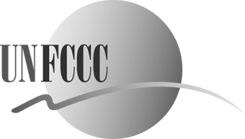
FRAMEWORK CONVENTION ON CLIMATE CHANGE - Secretariat
CONVENTION - CADRE SUR LES CHANGEMENTS CLIMATIQUES - Secrétariat

GOOD PRACTICES

Please submit good practices to the implementation of Article 6 of the UNFCCC using the form below. All types of activity are welcome, so please do not hesitate to share more than one submission. The UNFCCC secretariat will use this information to ensure that diverse practices related to the implementation of Article 6 are covered during the workshop. This compilation will serve as the basis for information-sharing and discussion during the workshop, and will also help shape follow-up activities.

I. Contact Information

Contact person name:
Position/Title:
Organization name:
National Government Non-governmental organization

Local government Private sector

International organization Academic or scientific organization

Address and postal code:
City and country:
Email:
Phone and Fax number:
Web page:

II. Good Practice information

Name of the activity:

Target groups:
Farmers Children and youth

Women Indigenous people

Scientific and technologic community Non-Governmental Organizations Local Authorities Workers and Trade Unions

Business and Industry

Please check the theme of the proposed contribution below:
Education Public participation

Training Access to information

Awareness-raising International cooperation

Performance scale:
International Regional

National Local

Objectives:

Brief description:

Number of people reached:

Main achievements

Partnerships (did you cooperate with other organizations such as NGOs, government agencies, etc?):

Media coverage:

Length of the activity:

Did you produce any materials? Are they available for reproduction?

Lesson learned:

Sustainability of the good practice (can it be replicated over time?):

Budget:

Web page information:

Participants who wish to make a presentation regarding:
(a) Education;
(b) Training;
(c) Public Awareness;
(d) Public Participation;
(e) Access to information and/or;
(f) International Cooperation;
are invited to fill in this form and return it as soon as possible and no later than 16 August 2010 to Ms Enrica Melandri, Fax: (+49-228) 815-1999, or E-mail: emelandri@unfccc.int

