Call for input on

Actions undertaken by accredited observer organizations relevant to the Technology Executive Committee in performing its functions.

Background

- The COP at its sixteenth session decided to establish a Technology Mechanism to enhance action on technology development and transfer to support action on mitigation and adaptation in order to achieve the full implementation of the Convention. The Technology Mechanism comprises a Technology Executive Committee (TEC) and a Climate Technology Centre and Network. The TEC facilitates the effective implementation of the Technology Mechanism, consistent with its functions.

- In accordance with decision 1/CP.16, the functions of the TEC are to:

- Provide an overview of technological needs and analysis of policy and technical issues related to the development and transfer of technologies for mitigation and adaptation;
- Consider and recommend actions to promote technology development and transfer, in order to accelerate action on mitigation and adaptation;
- Recommend guidance on policies and programme priorities related to technology development and transfer with special consideration given to the least developed country Parties;
- Promote and facilitate collaboration on the development and transfer of technologies for mitigation and adaptation between governments, the private sector, non-profit organizations and academic and research communities;
- Recommend actions to address the barriers to technology development and transfer in order to enable enhanced action on mitigation and adaptation;
- Seek cooperation with relevant international technology initiatives, stakeholders and organizations, and promote coherence and cooperation across technology activities, including activities under and outside of the Convention;
- Catalyse the development and use of technology road maps or action plans at the international, regional and national levels through cooperation between relevant stakeholders, particularly governments and relevant organizations or bodies, including the development of best practice guidelines as facilitative tools for action on mitigation and adaptation.

- Drawing on the agreed functions of the TEC as decided by the COP, the TEC considered the following items as the six key elements of its modalities:

- Analysis and synthesis;
- Policy recommendations;
- Facilitation and catalysing;
- Linkage with other institutional arrangements;
- Engagement of stakeholders;
- Information and knowledge sharing.

- The modalities related to these six key elements are provided in the annex.

Call for input

The TEC, at its third meeting, agreed to launch a call for input on actions undertaken by accredited observer organizations relevant to the TEC in performing its functions. The inventory of actions undertaken by these organizations would provide a basis for the TEC to identify relevant organizations for cooperation. The input from this call will be considered at the fourth meeting of the TEC.

Observer organizations accredited by the UNFCCC are invited to provide their input on actions undertaken by these organizations which are relevant to the TEC in performing its functions by using the template in the annex. Kindly send your input through email to tec@unfccc.int by 31 July 2012.

Annex: Template for the call for input

Key element 1: Analysis and synthesis

Technology Executive Committee
Key element 1: Analysis and synthesis
Key modalities:
- Producing periodic technology outlooks; collating, collecting and synthesizing a range of information on technology research and development and other technology-related activities from various sources, including, but not limited to, national communications, nationally determined technology needs and technology needs assessments, national adaptation programmes of action, nationally appropriate mitigation actions, national adaptation plans, and technology road maps and action plans; and examining the policy implications and opportunities for advancing technology development and transfer;
- Producing a series of technical papers on specific policies and technical issues, including those arising from technology needs assessments;
- Conducting a regular overview of existing technology development, transfer initiatives, activities and programmes with a view to identifying key achievements and gaps, good practices and lessons learned.

Organization name: ECN
Key element 1: Analysis and synthesis
Actions undertaken by the organization relevant to the TEC in performing its functions:

- Related to technology roadmaps:

Low climate impact scenarios and their implications for strategy (LIMITS)
Implementing an effective response to climate change will require a fundamental restructuring of energy and land management, including related policies. LIMITS (EU-FP7) addresses critical questions in this field, on economic, technical and political feasibility, innovation and investments, and policies recognising regional diversities. The LIMITS consortium comprises the key EU experts in this topic. ECN participates with its TIAM-ECN model.
Website: http://www.feem-project.net/limits/index.html
Contact: Bob van der Zwaan (vanderzwaan@ecn.nl)
Climate, technology and development
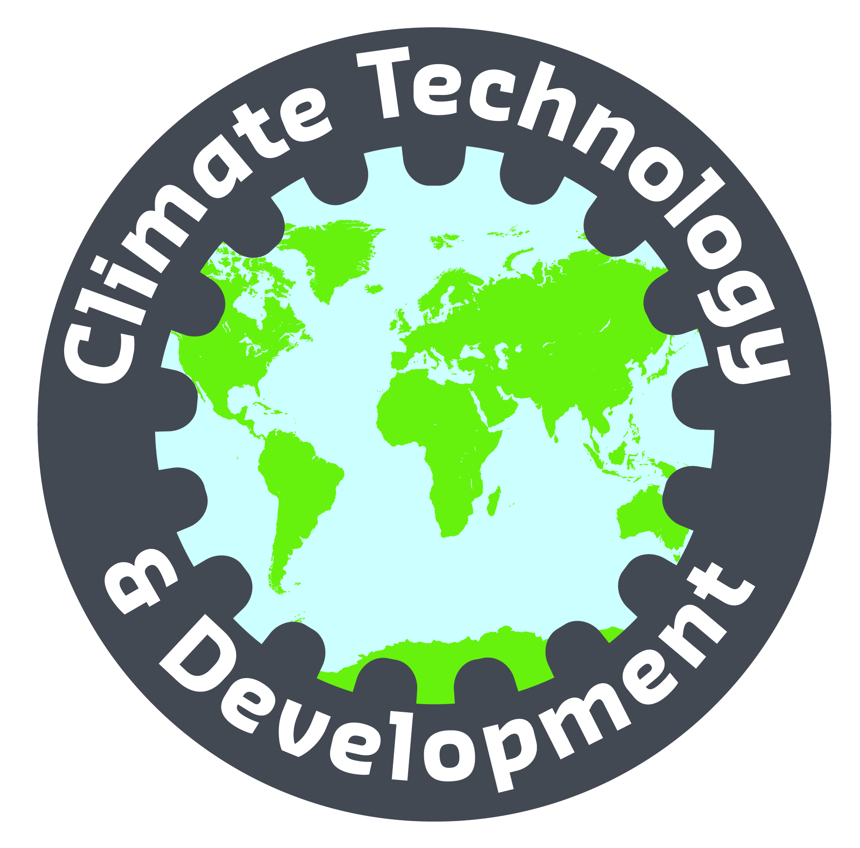
With the Technology Mechanism in operation since 2011, the UNFCCC has a mechanism to enhance technology develop-ment and transfer. But how can developing countries benefit? What should be principles of technology collaboration and what does scientific literature say about it? This project, funded by the CDKN Innovation Fund and with University of Sussex, IIT Delhi, UNICEN in Argentina and Tufts University, aims to improve international technology policies.
Website: http://cdkn.org/project/fostering-low-carbon-technology-innovation-and-transfer-an-in-depth-study/
Contact: Heleen de Coninck (deconinck@ecn.nl)

Human resource implications of a national Reneweable Energy target
For the Kuwait Institute for Scientific Research (KISR), ECN has analysed the consequences that a 10% renewable energy objective could have for human resources needed within the country, and related challenges for its educational system.
Contact: Bob van der Zwaan (vanderzwaan@ecn.nl)

- Related to technologies and NAMAs:

Mitigation Momentum
The Mitigation Momentum project aims to support the development of Nationally Appropriate Mitigation Actions (NAMAs) by contributing to the development of concrete NAMA proposals, and to foster cooperation and knowledge exchange within the NAMA community. Mitigation Momentum is a collaboration between ECN Policy Studies and Ecofys Germany. The project is part of the International Climate Initiative supported by the German Federal Ministry for the Environment, Nature Conservation and Nuclear Safety.
Website: www.mitigationmomentum.org
Contact: Xander van Tilburg (vantilburg@ecn.nl)


Kenya’s Climate Change Action Plan
In April 2010 the Government of Kenya published its National Climate Change Response Strategy. Work is now ongoing on an Action Plan that identifies the intermediate actions that are needed in order to make coordinated and practical progress. ECN and IISD, along with local experts, are currently working with government ministries and the Climate Change Secretariat to undertake a sectoral analysis of different mitigation options. This work is undertaken in close cooperation with local stakeholder groups and includes a broader analysis of the associated development benefits and barriers to implementation. The Action Plan is being developed with support from CDKN, DFID and other donors.
Contact: Laura Würtenburger (wuertenberger@ecn.nl)
National climate policy in Ghana
ECN, in close collaboration with the University of Ghana and other local partners, assisted the Ghanaian Ministry for the Environment, Science and Technology in producing a discussion document that formed the first step in developing a National Climate Change Policy Framework for Ghana. ECN also supported the mapping and analysis of climate and development initiatives in Ghana, as well as producing a series of policy briefs. Funding was provided by CDKN.
Website: http://cdkn.org/project/assisting-ghana-to-deliver-climate-compatible-development/
Contact: Xander van Tilburg (vantilburg@ecn.nl)
Transport NAMAs in Colombia, Indonesia and South Africa
Discussions on existing and future climate instruments are ongoing in the international climate and development communities. Nationally Appropriate Mitigation Actions (NAMAs) for the transport sector could lead to triple wins around development, economic efficiency and greenhouse gas emissions. The Transfer project, funded by ICI, works on transport NAMAs in Colombia, Indonesia and South Africa. ECN is working with GIZ and the Ministry of Transport in Indonesia on their transport and low-carbon development strategies.
Website: www.transferproject.org
Contact: Marc Londo (londo@ecn.nl)

- Related to energy planning and technology transfer:
CASINDO: Capacity for energy planning in Indonesia
CASINDO is a capacity development programme that aims to build and strengthen institutional and human capacity for energy policy formulation and development of renewable energy and energy efficiency projects both at the national and regional level. The programme has been developed in close collaboration with the Indonesian partners and SenterNovem. The project ends in May 2012.
Website: www.casindo.info
Contact: Nico van der Linden (n.vanderlinden@ecn.nl)
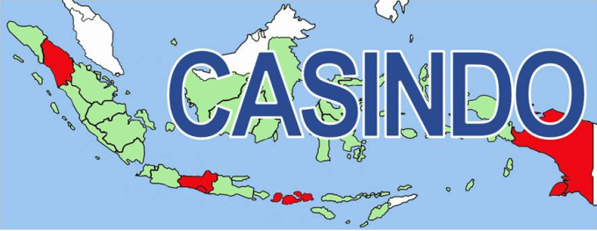

Key element 2: Policy recommendations

Technology Executive Committee
Key element 2: Policy recommendations
Key modalities:
- Recommending to the COP, or other relevant bodies under the Convention, actions to promote technology development and transfer and to address barriers;
- Recommending guidance on policies and programme priorities related to technology development and transfer, with special consideration given to the least developed country Parties.

Organization name: ECN
Key element 2: Policy recommendations
Actions undertaken by the organization relevant to the TEC in performing its functions:

Almost all activities mentioned under Key element 1 include the provision of policy recommendations.

Key element 3: Facilitation and catalysing

Technology Executive Committee
Key element 3: Facilitation and catalysing
Key modalities:
- Promoting and collaborating with relevant organizations, resources permitting, in organizing workshops and forums to increase the opportunities for sharing experience with experts in developing and implementing technology road maps and action plans as well as other technology-related activities;
- Establishing an inventory of existing collaboration activities and a regular review process, with a view to identifying key achievements and gaps, good practices and lessons learned;
- Making recommendations on actions to promote collaboration;
- Making recommendations on best practices and relevant tools to develop technology road maps and action plans;
- Establishing an inventory of technology road maps and action plans;
- Making recommendations on concrete actions, such as an international process for the development of technology road maps and action plans as well as support required to enhance the development of these items, and in particular capacity-building programmes that may be appropriate.

Organization name:
Key element 3: Facilitation and catalysing
Actions undertaken by the organization relevant to the TEC in performing its functions:
IRENA renewable energy technology cooperation
For the International Renewable Energy Agency, ECN is conducting a mapping of renewable energy technology initiatives with a view of identifying the good practices that IRENA could help in implementing globally. The study involved several in-depth case studies in addition to the results of a survey among members, and it looks at the role of technology centres as well as collaborations.
Website: www.irena.org
Contact: Heleen de Coninck (deconinck@ecn.nl)

ECN-JRC/IET joint workshop on technology learning
Together with JRC-IET, ECN organised a workshop with leading global experts on the use of learning curves in technology assessment. Specific topic was the merits of two-factor learning, an approach that attempts to disentangle learning by research and learning by deployment. The results can also be relevant in the context of technology transfer.
Contact: Koen Schoots (schoots@ecn.nl)

Key element 6: Information and knowledge sharing

Technology Executive Committee
Key element 6: Information and knowledge sharing
Key modalities:
- The TEC should disseminate its outputs and facilitate knowledge sharing through a well-functioning information platform that responds to the information and knowledge service requirements of its potential users, including Parties and a wide range of technology actors, experts and stakeholders.
- The platform would be a tool used to promote the collaboration between various actors and to seek cooperation with relevant international organizations and initiatives. It would support the efforts of the TEC in the following ways: exploring opportunities for information sharing, establishing links with existing knowledge platforms and implementing joint initiatives and programmes.
- The TEC should consider upgrading TT:CLEAR with an expanded and more strategic focus, tailored to the functions of the TEC, and building on existing technology information networks.

Organization name: ECN
Key element 6: Information and knowledge sharing
Actions undertaken by the organization relevant to the TEC in performing its functions:

Energy Research Knowledge Centre (ERKC)
The overarching objective of the project is to develop and maintain the Energy Research Knowledge Centre (ERKC) web portal. The ERKC will collect, analyse and organise information on energy research programmes, projects and their results from across the EU and beyond. The goal is that the ERKC should become the leading web portal on energy research in the EU.
ERKC is developed as a part of the EC SET-Plan Information System (SETIS). The project is financed under the 7th Framework Programme for Research and Technological Development (FP7).

Contact: Koen Schoots (schoots@ecn.nl)

Decision 1/CP.16, paragraph 121.
FCCC/CP/2011/8, paragraph 11.

