Investigating a method for apportioning the share of global climate change indicators between regional emitters.

Jason A. Lowe
September 2002

Key words: -

Regional apportionment, climate change, regional emissions
- Introduction
In this report we discuss the first steps in a pragmatic approach to apportion the amount of various global climate change indicators to regional greenhouse gas emitters using simple gas concentration models and a simple climate model.

The study has been carried out in response to an invitation by the UNFCCC to investigated the methodologies and, together with the results from other centres, will form the basis of evidence submitted to SBSTA later in 2002. The motivation for this work is that it could provide a framework for a second phase of UNFCCC emission reduction negotiations. The first phase involved the development of the Kyoto protocol.

The idea of using an estimate of the relative share of historical climate change in order to derive a share of future emissions reductions was put forward by the delegation of Brazil in 1996. In 1997, the year the Kyoto Protocol was adopted the methodological aspects of Brazil’s proposal was referred to SBSTA. Since then a number of meetings and side events have discussed aspects of the proposal (for instance a side event in 1998 during CoP4 in Brazil and further expert meetings in 1999 in Brazil and 2001 in Bonn). The most recent expert meeting identified a number of potential problems, such as availability and uncertainty in early emissions and how to include aerosols, but also suggested the next steps as: -

- Additional analyses on indices for contributors to change
- Calculation by different simple models with harmonised input
- Assessment of the influence of different parameters

To this end the invitation was extended on 26th March 2002 by the UNFCCC for research groups to investigate the methodology further and to broaden the participation. The preliminary results will be discussed at an expert meeting in September 2002.

- Methodology
From a technical perspective the initial proposal by the delegation of Brazil in 1996 has been considerably refined. However, the basic idea of apportioning the share of climate change indicators to different regional emitters using simple and transparent models remains. In this section of the report we describe the methods used by the Met Office’s Hadley Centre. These are just one set of a range of potential models.

  - Overview
Several potential global climate indicators have been suggested, including anthropogenic greenhouse gas emissions, cumulative emissions, gas concentrations, radiative forcing, temperature rise and sea-level rise. Consequently, it is necessary to be able to convert anthropogenic emissions to greenhouse gas concentration changes, concentration changes to radiative forcing and forcing to climate change. It is also proposed to extend the apportionment calculations beyond present day using a future emissions scenario. Carbon dioxide, Methane and Nitrous oxide will be used in the apportionment calculation.

  - Emissions datasets
Time series of historical emissions of anthropogenic greenhouse gas have been produced for a number of geographical regions and are of varying lengths. The relative uncertainty in the emissions tends to be largest for very early emissions and there are differences between different reconstructions, which depend on the data included and methods used. In this work, historical emissions from the CDIAC and EDGAR-HYDE 1.4 datasets have been used. Future emissions will be taken from the IPCC Special Report on Emissions Scenarios (SRES) for the A1FI and the A2, B2 and B1 marker scenarios.

When data is presented with a frequency of less than annual, linear interpolation has been used to provide data on a yearly basis. It has also been used between the end of the observed historical emissions and year 2000 of the SRES scenario data.

  - Converting emissions to atmospheric gas concentrations
In the case of carbon dioxide gas the atmospheric concentration crucially depends on simulating the sinks of this gas. These include the ocean and the biosphere. Some of these sinks themselves depend on the amount of carbon dioxide in the atmosphere and the amount of climate change and, in reality, there are numerous feedbacks processes. Observed carbon dioxide concentrations during the 19th and 20th centuries can be simulated using a carbon cycle model such as the Bern carbon cycle model used in the IPCC 2nd and 3rd climate assessments. These models can also be used to simulate the future concentrations resulting from various emissions scenarios. In the current work we will use a simpler linear carbon cycle model in which the parameters have been derived by tuning the simple model to the complete Bern carbon cycle model for a pulse input of carbon emissions. This simple model does not explicitly include feedbacks, for instance, involving temperature.

The other greenhouse gases included in this work (CH4 and N2O) are treated more simply using a single fixed lifetime for each gas, taken from the IPCC report, respectively. In the real atmosphere the lifetime of these gases is not fixed and various strongly with the concentration of atmospheric hydroxyl radicals, which in turn depend on atmospheric chemical composition, temperature and humidity.

In the simple gas models the loss of greenhouse gases from the atmosphere depends on the concentration of the gases so will be greater when concentrations are higher.

  - Converting gas concentrations to radiative forcings
Simple formulae exist for estimating the radiative forcing for a change in greenhouse gas concentrations. The versions used in the current work are those utilised in IPCC 3rd assessment report. The overlap term for CH4 and N2O is a consequence of the strong overlap of the absorption spectra of these gases.

The formulae are non-linear, indicating that changes in radiative forcing caused by a unit increase gas concentration depend on the concentration of the gas already present. In practical terms this means that concentration increases at, say, 1860 will have a different effect to those at 2000 because of the different concentration of greenhouse gases at these times.

  - Converting radiative forcing to climate change
In response to a the radiative forcing resulting from increases in greenhouse gas concentration the climate system warms until the increase in outgoing planetary radiation this produces becomes large enough to establish a new radiative balance. However, because the climate system possess thermal inertia this warming can take some considerable time. Until the new balance is reached there is a net flow of energy into the climate system, much of which will be stored in the oceans.

It is common for calculations of global warming to be carried out using state-of-the-art coupled ocean-atmosphere general circulation models. In these models the equations governing the climate response (including Newton’s second law of motion and the conservation of energy) are solved on a series of grids spread over the surface of the earth and at various heights though the atmosphere or at various depths in the ocean. In the Hadley Centre coupled model (HadCM3) the ocean grid has a horizontal resolution of 1.25o by 1.25o and 20 vertical levels while the atmosphere has a horizontal resolution of 2.5o by 3.75o and 19 vertical levels. On spatial scales finer than the model resolution physical processes are represented using parameterisations. Unfortunately, these models are very computationally expensive and require a few weeks of time to simulate periods of 100 years; consequently they will not be used here directly. Instead, a simple linear climate model will be used. The parameters for this model were derived by fitting the simple model to an idealised HadCM3 experiment in which the carbon dioxide concentration was quadrupled from pre-industrial levels over a period of 70 years then stabilised while the model simulates a further 1000 years. A similar model can be used for sea-level rise.

It is worth noting that there are many types of simple climate model with varying degrees of freedom. However, as with the carbon cycle model, treating the climate system is an approximation whose quality depends on the range over which it is used.

  - The attribution calculation
It is the aim of the attribution calculation to split the global climate change indicator between regional emitters. The regional location of the emitters is not important because we are considering fairly well mixed gases and the global mean response. Because we expect the response of climate indicators further down the chain than emissions (i.e. concentrations, forcing or climate change) to depend on the gas concentrations at the time of the emissions it is necessary to allow for this in the attribution calculations. Two approaches have been considered here, the “marginal” approach and the “all minus one” approach.

In the marginal approach the rate of change of the indicator variable with emissions is derived for each climate indicator for each point in time using the global mean results when all emissions are included. The change in the indicator variable for each region can then be estimate by integrating over time the rate of change of the indicator variable with total emissions and the rate of gas emission. Unfortunately, this method is not applicable in its most simple form when the rate of gas emission is set to zero because the indicator gradients are then no longer defined.

In the all minus one approach the change in the indicator variable for a given region is found as the difference between a simulation with emissions from all regions included and one in which emissions from all regions except the region of interest are included. This is most accurate if the emissions from the region of interest are small compared to the sum of the emissions from all other regions.

  - Uncertainties and assumptions
We have made several assumptions in developing the simple model framework; the major assumptions are listed below.

- That a linear carbon cycle model can adequately simulate atmospheric CO2 concentrations.
- That single fixed lifetime gas cycle models with the chosen parameters can adequately represent the CH4 and N2O concentrations.
- That a linear climate model can be used to convert forcing to temperature rise.
- That the parameters of the linear models have been derived using suitable experiments.
- That the drift in the climate model parameters as the climate sensitivity varies over a long period does not affect the results.
- That other greenhouse gases do not need to be included.
- That the aerosol forcing in the HadCM3 model is adequate.

In addition to these assumptions there are also a number of uncertainties, including those in the emissions and the values of parameters derived from observations or simulations (such as the climate model response times). The results of the more complex carbon cycle and climate models themselves contain uncertainties.

  - Extensions to the basic models
It is well known that the responses of many potential carbon cycle sinks, such as the ocean, are temperature dependent. To account for these feedbacks in a very crude manner the carbon cycle response has been modified by a temperature dependent multiplying factor. The climate model response has also been tuned slightly so that it also includes a non-linear temperature feedback term, and better represents the A2 scenario results predicted by HadCM3. The introduction of the temperature feedback meant that an iterative approach was necessary with several passes through the emissions to concentration to forcing to climate change calculations.

2.9 Experiments
In phase 1 we have attempted to establish whether or not the simple gas cycle and climate models can adequately reproduce observations and the results of more complex model simulations.

In phase 2 we have attempted to perform attribution calculations and assess the sensitivity of the attribution calculations to a range of factors. In contrast to the initial invitation we have chosen to use the EDGAR-HYDE dataset for the base emissions dataset for most of the results.

Two types of questions are considered. Some of them ultimately represent political choices while others are purely scientific.
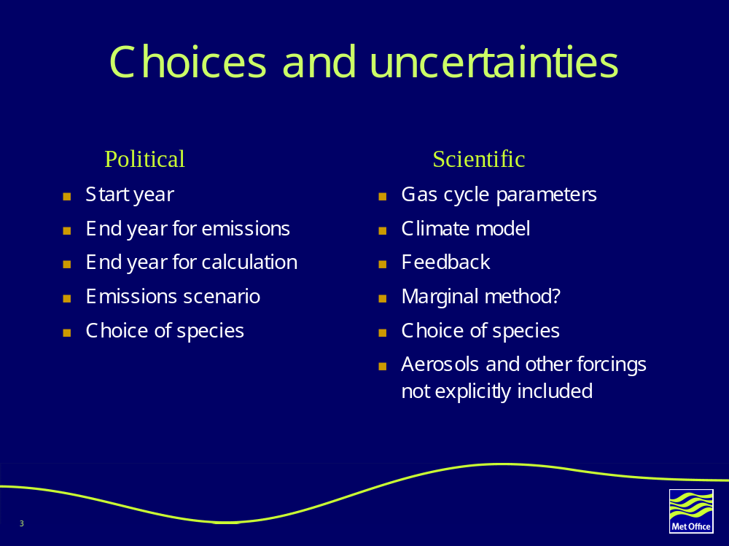

- Results
These are attached as a separate pdf.

