CGE TRAING MATERIALS FOR VULNERABILITY AND ADAPTATION ASESSMENT

Chapter 1: Introduction

Contents
1.1 Introduction 1
1.1.1 About the Training Materials 1
1.1.2 Role of the Training Materials 2
1.1.3 Structure of the Training Materials 3
1.1.4 Key Sources of Related Information 5
1.1.5 Definition of Key Terms 7
1.1.6 Acknowledgements 8
annex 1: ExTract from National Communication Guidelines 10

Introduction

About the Training Materials
All Parties not included in Annex I to the United Nations Framework Convention on Climate Change (UNFCCC) (non-Annex I Parties) are required to report periodically to the UNFCCC secretariat on their activities to implement the provisions of the Convention. Most non-Annex I Parties are now preparing their second or third national communications. The Conference of the Parties (COP) decision 17/CP.8 details the reporting requirements for non-Annex I Parties and what should be reported in the vulnerability and adaptation to climate change sections of their national communications.
Decision 17/CP.8, paragraph 29, states that:
“…non-Annex I Parties should provide information on their vulnerability to the adverse effects of climate change, and on adaptation measures being taken to meet their specific needs and concerns arising from these adverse effects.”
Decision 17/CP.8 includes an annex entitled Guidelines for the preparation of national communications from Parties not included in Annex I to the Convention. Section IV.B. of that annex covers “programmes containing measures to facilitate adequate adaptation to climate change.” Section IV.B is included in Appendix 1.
Through its on-going work programme, the Consultative Group of Experts (CGE) on national communications from Parties not included in Annex I to the Convention provides advice to the subsidiary bodies of the Convention on good practice on key aspects of drafting national communications. In 2005, the CGE produced a suite of materials for a series of hands-on training workshops including a supporting resource called “CGE Training Materials on Vulnerability and Adaptation Assessment” (hereinafter referred to as the Training Materials on V&A Assessment). This document is the second edition of those support materials.
The key drivers for the development of the first edition included advice from the CGE to subsidiary bodies of the Convention that, in the first round of national communications, information varied widely. This was in part because of different levels of expertise in analysing climate change and because of the use of different methods and tools. In addition, the CGE reported that many of the national communications focused on the application of methods, at the expense of thorough analysis of results and implications, as well as integration and synthesis.
These documents builds on the feedback from the CGE progress report on “National Communications from Parties not included in Annex I to the Convention”. In particular, two key documents informed the changes made in the second edition; the results of a survey of non-Annex I Parties to the Convention (FCCC/SBI/2010/21/Add.1); and the workshop process conducted through the CGE to exchange views on possible elements to be considered in a future revision of the UNFCCC guidelines for the preparation of national communications from non-Annex 1 Parties (FCCC/SBI/2011/5/Add.1).
It is recognised that there are other important work streams under the Convention that can provide significant support on the V&A components of national communications. Of particular interest are the Cancun Adaptation Framework (1/CP.16), the Nairobi Work Programme on impacts, vulnerability and adaptation to climate change and the programme to support the development of NAPs agreed at COP 17 (draft decision/CP.17).

Role of the Training Materials
The purpose of these Training Materials on V&A Assessment and supporting materials is to assist non-Annex I Parties in the preparation of the vulnerability and adaptation sections of their second national communications. The materials provide a synopsis of some of the main methods being used by non-Annex I Parties to assess vulnerability and adaptation to climate change. They emphasize methods that are readily accessible, applicable and/or have been used in the preparation of national communications to date. Selected examples from Annex I Parties are also included where there is potential applicability within the context of non-Annex I Parties. The Training Materials also provide guidance on obtaining data with relevance in the application of specific methods and tools.
The Training Materials are accompanied by a series of PowerPoint presentations, which assist non-Annex I Parties in using the materials as a training resource. The presentations include notes to presenters and provide more detail on some of the methods, data sources and examples of how and where the methods have been applied. These two resources are intended for use together.
Before using these Training Materials for V&A Assessment, it is important to understand that the materials provide an overview of methods, tools and data, including advantages and limitations. Information is provided on where readers can obtain software, find further information on methods and access additional resources. The materials do not provide a detailed discussion of the array of available methods and models, nor do they provide detailed information on a particular framework for assessing vulnerability and adaptation, or on particular assessment methods. These decisions must be made by non-Annex I Parties and tailored specifically within each Party’s context.
Importantly, it is recognised that the role of the Training Materials is to support the skills and experience development by non-Annex I Parties through their previous experiences with V&A assessment. This experience may have been gained through the completion of previous national communications, or other initiatives such as the national adaptation programmes of action (NAPAs), activities through the Nairobi Workshop Programme or those undertaken within country (or regional groups) for national-level impact assessment and adaptation planning.

Structure of the Training Materials
The Training Materials for V&A Assessment are structured to address key topic areas and broadly follow the first edition to ensure consistency and also to take account of user feedback.
The materials intend to:
- Integrate both a sectoral perspective on vulnerability and adaptation (e.g. coasts, health, water resources) with a process perspective (e.g. tools, data, best practice, policy integration); and
- Move toward a ‘practical guidance’ approach from the more generic approach used in the first edition, particular by seeking to integrate case studies and examples from national communications submitted to date.
To meet the above requirement, the same style of key diagram from the US EPA templates has been used to organize the Training Materials, shown in Figure 1 - 1. The structure of the Training Materials follows the diagram, with separate chapters for each ‘segment’ of the wheel, namely chapters 2–4 and chapters 9–10. Sector chapters, namely chapters 5–8 have been restructured from the first edition to ensure consistent guidance on the key sectoral drivers, sensitivity, vulnerability, data, methods and tools.
Figure 1 - 1 Structure of the Training Materials for V&A Assessment

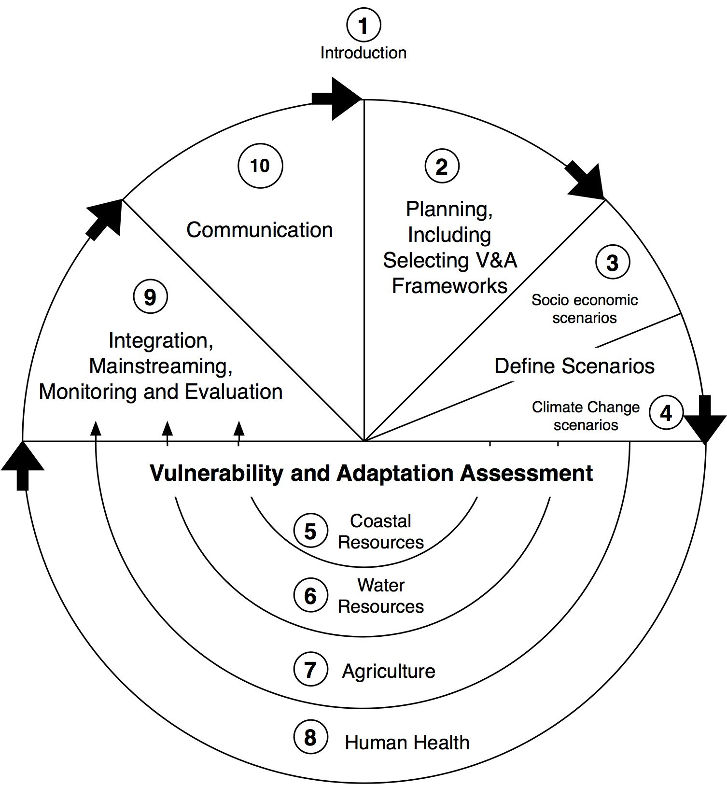

Ten chapters make up the Training Materials for V&A Assessment:
- Introduction (this chapter);
- Planning, Including Selecting Vulnerability and Adaptation Frameworks;
- Baseline Socio-economic Scenarios;
- Climate Change Scenarios;
- Coastal Resources;
- Water Resources;
- Agriculture;
- Human Health;
- Integration, Mainstreaming, Monitoring and Evaluation; and
- Communication of V&A Analysis in national communications.

Key Sources of Related Information
The materials presented here should be read in conjunction with companion documents, prepared by the UNFCCC secretariat, that provide technical assistance to non-Annex I Parties in the preparation of their national communications (see Table 1-1).
Additional sources of information specific to particular aspects of V&A assessment are provided in each chapter. Published national communications provide a value source of information. There are also various online databases of V&A assessments, practices and experiences shown in Table 1-2.
Table 1-1 Key companion documents to these Training Materials for V&A Assessment
Source | Title | Description | Link
UNFCCC | Reporting on Climate Change: user Manual for the guidelines on national communications from non-Annex I Parties | User manual launched at COP 9 in 2003, is designed for use by Parties and national experts responsible for the preparation of the various sections of national communications | <http://unfccc.int/resource/userman_nc.pdf>
UNFCCC | UNFCCC Compendium on methods and tools to evaluate impacts of, and vulnerability and adaptation to climate change | Compendium launched in 2008 as part of the Nairobi Work Programme on impacts, vulnerability and adaptation to climate change covering emerging assessment methodologies and tools on a sector level | <http://unfccc.int/adaptation/nairobi_workprogramme/knowledge_resources_and_publications/items/5457.php>
UNFCCC | UNFCCC resource guide for preparing the national communications of non-Annex I Parties – Modules 1–4 | Resource guide launched in 2008 consisting of four modules; The Process of National Communications from Non-Annex I Parties, Vulnerability and Adaptation to climate change, National Greenhouse Gas Inventories and Measures to mitigate climate change | <http://unfccc.int/essential_background/background_publications_htmlpdf/items/2625.php>
UNFCCC | Annotated guidelines for the preparation of National Adaptation Programmes of Action | Guidelines designed for Least Developed Countries (LDCs) to plan for addressing the urgent and intermediate needs of adapting to the adverse effects of climate change | <http://unfccc.int/essential_background/library/items/3599.php?such=j&symbol=FCCC/PRT/202%20B#beg%29>

UNFCCC | National Adaptation Programmes of Action: Overview of preparation, design of implementation strategies and submission of revised project lists and profiles | The technical paper drafted by the Least Developed Countries Expert Group describes the steps in the preparation of NAPAs and explores options for addressing problems identified by NAPA teams, while building upon lessons learned and best practices. This is a useful resource, while recognising the transition during 2012 to the new National Adaptation Plan process (outlined in chapter 2) | <http://unfccc.int/essential_background/library/items/3599.php?rec=j&priref=6988#beg%29>
UNDP-NCSP | The National Communications Process – National Communications Support Programme: Resource Kit | UNDP National Communications Support Programme Resource Kit released in 2006 that provides guidance on the key sources of information and planning steps required for the preparation of national communications | <http://ncsp.undp.org/sites/default/files/NatCom%20Process.pdf>

Table 1-2: Selected online resources for vulnerability and adaptation assessments, practices and experiences
Source | Title | Contents | Link
UNDP | Adaptation Learning Mechanism (ALM) | The ALM represents a collaborative, global learning process, with leadership, facilitation seeking to provide stakeholders with a common platform for sharing and learning of adaptation issues | <http://www.adaptationlearning.net/>
Stockholm Environment Institute + Partners | weADAPT | weADAPT is an online ‘open space’ on climate adaptation issues which allows practitioners, researchers and policy makers to access credible, high-quality information and to share experiences and lessons learned with the weADAPT community. weADAPT is the result of collaboration with knowledge partners from bilateral, multilateral, NGO and commercial parties | <http://www.weadapt.org/>
IDS, in collaboration with ENDA, FARA, IGAD and ICPAC | AfricaAdapt | AfricaAdapt is an independent bilingual network (French/English) focused exclusively on Africa. The Network’s aim is to facilitate the flow of climate change adaptation knowledge for sustainable livelihoods between researches, policy makers, civil society organizations and communities who are vulnerable to climate variability and change across Africa | <http://africa-adapt.net/AA/>

UNEP | Regional Climate Change Adaptation Knowledge Platform | The UNEP web portal is designed to link regional adaptation knowledge to country level adaptation programmes in the Asia-Pacific Region | <www.rrcap.unep.org/knowledge/ccakp.cfm>
UNFCCC | Adaptation Practices Interface | The Adaptation Practices Interface provides a summary of adaptation practices by a large range of organizations, agencies and businesses, along with descriptions and relevant links and publication | <http://unfccc.int/adaptation/nairobi_work_programme/knowledge_resources_and_publications/items/4555.php>
UNFCCC | Nairobi work programme (NWP): Partners, Action Pledges and Experts Database | The NWP Partners, Action Pledges and Experts Database is easily searchable database for NWP work areas, sector, region and/or adaptation delivery activities | <http://unfccc.int/adaptation/nairobi_work_programme/items/3633.php>
In addition to the adaptation networks listed in Table 1-2 other networks and resources can be found through the UNFCCC knowledge resources and publications on adaptation knowledge platforms/networks.

Definition of Key Terms
Before getting started it is important to understand the concept of vulnerability to climate change and to be consistent in the use of specific terms. The terminology used throughout these Training Materials is based on the Glossary of Terms used in the Intergovernment Panel on Climate Change (IPCC) Fourth Assessment Report (IPCC AR4), which has a specific Glossary for Policy Makers, and additional technical glossaries, all of which are available online. Key terms used throughout this resource are defined below.
- Vulnerability: is the degree to which a system is susceptible to, and unable to cope with, adverse effects of climate change, including climate variability and extremes. Vulnerability is a function of the character, magnitude and rate of climate change and variation to which a system is exposed, its sensitivity and its adaptive capacity.
- Sensitivity: is the degree to which a system is affected, either adversely or beneficially, by climate variability or climate change. The effect may be direct (e.g. a change in crop yield in response to a change in the mean, range, or variability of temperature) or indirect (e.g. damage caused by an increase in the frequency of coastal flooding due to sea level rise).
- Adaptive capacity: is the whole of capabilities, resources and institutions of a country or region to implement effect adaptation measures.
- (Climate change) impacts: are the effects of climate change on natural and human systems. Depending on the consideration of adaptation, one can distinguish between potential impacts and residual impacts:
  - Potential impacts: all impacts that may occur given a projected change in climate, without considering adaptation;
  - Residual impacts: the impacts of climate change that would occur after adaptation.
- Adaptation: is initiatives and measures to reduce the vulnerability of natural and human systems against actual or expected climate change effects. Various types of adaptation exist, e.g. anticipatory and reactive, private and public, and autonomous and planned. Examples are raising river or coastal dikes, the substitution of more temperature-shock resistant plants for sensitive ones, and so on.

Acknowledgements
Dr Robert Kay of AdaptiveFutures, Perth, Australia, prepared the revised Training Materials for V&A Assessment and an accompanying set of PowerPoint presentations under contract 11/B149 with the UNFCCC secretariat.
Grateful acknowledgement is given to the authors of the first edition, on which these materials are based:
- Joel Smith, Stratus Consulting Inc. Boulder, Colorado, USA ( chapters 2, 4, 9 and 10);
- Dr Brian Hurd, New Mexico State University, Las Cruces, New Mexico, USA; and Joel Smith ( chapter 3);
- Dr Julie Richards and Dr Robert Nicholls, University of Southampton, Southampton, UK ( chapter 5);
- Dr David Yates, National Center for Atmospheric Research, Boulder, Colorado, USA; and Alyssa McCluskey, University of Colorado, Boulder, USA ( chapter 6);
- Dr Ana Iglesias, Universidad Politecnica de Madrid, Madrid, Spain ( chapter 7); and
- Dr. Kristie Ebi ( chapter 8, 9 and 10).
The Training Materials for V&A Assessment and presentations were prepared for testing and refinement at the Vulnerability and Adaptation Assessments Hands-on Training Workshops conducted by the Consultative Group of Experts (CGE) on National Communications from Parties not included in Annex I to the Convention. The CGE provided comments on the chapters and PowerPoint presentations and these were subsequently revised.
The chapters and presentations could not have been prepared without the input from CGE members and the sector experts who peer-reviewed the training materials and participated in the CGE Training Workshops, namely:
- Dianne Katscherian, Western Australia Department of Health (Human Health );
- Dr Sonia Quiroga, Universidad de Alcalá (UAH) – Madrid (Agriculture);
- Dr Francis Gichuki, University of Nairobi (Water resources);
- Dr Amadou Thierno Gaye, Universit Cheikh Anta Diop –Dakar (Climate change scenarios and socio-economic scenarios);
- Dr Md Rashed Chowdhury, University of Hawaii – Manoa (Coastal resources)
Finally, the staff of AdapativeFutures are acknowledged for their support in the preparation of the Training Materials, particularly Luke Dalton, Ania Niedzwiadek, Caro Kay, Carmen Elrick-Barr and Dr Ailbhe Travers.

Annex 1: ExTract from National Communication Guidelines
Section IV.B. from the “Guidelines for the preparation of national communications from Parties not included in Annex I to the Convention”
Contained in Decision 17/CP.8
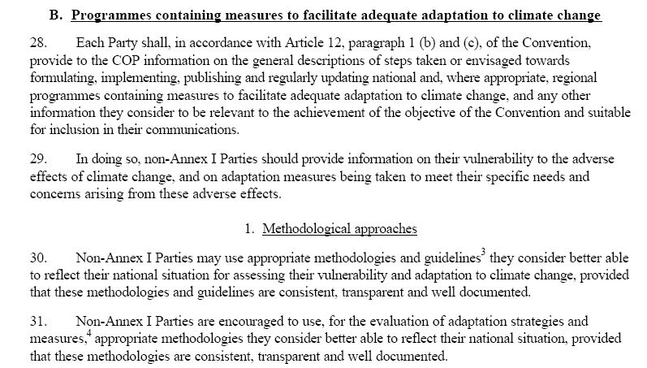
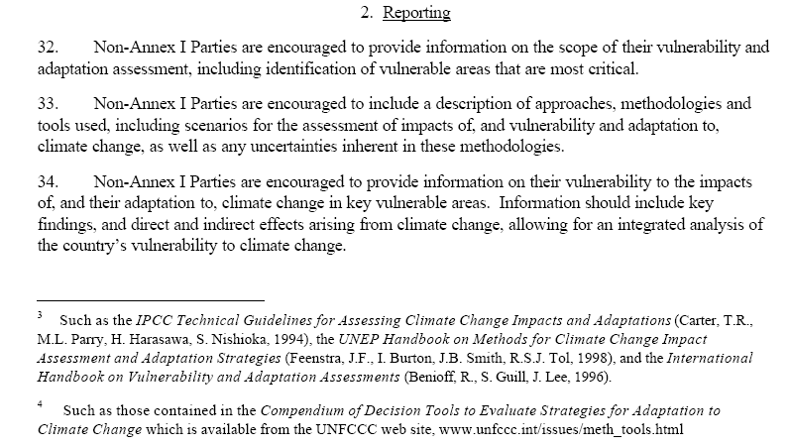

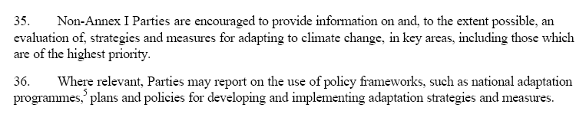

<http://unfccc.int/national_reports/non-annex_i_natcom/items/2979.php>.
<http://unfccc.int/adaptation/nairobi_work_programme/knowledge_resources_and_publications/items /5135.php>.
<http://www.ipcc.ch/publications_and_data/publications_and_data_glossary.shtml#.UKKdpiIQPNQ>.
a) A hands-on training workshop for the Africa region on V&A assessment, held in Nairobi, Kenya, from 7 to 11 November 2011; b) A hands-on training workshop for the Latin America and Caribbean region on V&A assessment, held in Saint Mary’s from 9 to 13 July 2012; c) A hands-on training workshop for the Asia and Pacific region on V&A assessment, held in Vientiane from 8 to 12 October 2012.

