CGE Training Materials for Vulnerability and Adaptation Assessment

Chapter 10: Communication of V&A Assessment in National Communications

Contents
10.1 Introduction 1
10.1.1 Communicating the National Communication 1
10.1.2 Good Practice in Communicating National Communications 2
10.2 Approaches, Methods and Tools 6
10.2.1 Presentation of Methods 7
10.2.2 Presentation of Vulnerability Results 7
10.2.3 Presentation of Adaptation Results 10
10.3 Conclusions 11
10.4 References 12

Introduction
The UNFCCC stresses the importance of ensuring that national communications are effective in communicating first to the requirements of the Convention and then to key stakeholders, providing maximum benefit to policymakers. Key stakeholders include those involved in developing the national communications and, increasingly, those who can contribute positively to mainstreaming (see chapter 9), within Parties and international stakeholders (e.g. multilateral funding agencies, non-governmental organizations and United Nations agencies).
Consequently, ‘communication’ is interpreted in this chapter to mean both the requirements and processes for the drafting and submission of the national communications itself and the use of the national communication as a strategic communication tool to promote the mainstreaming of climate change adaptation.
This chapter draws on examples of the different range of presentation of results used in the most recently submitted national communications of non-Annex I Parties, information communicated officially to the UNFCCC as of 15 December 2011. It presents suggestions for communicating results from national communications, which are also applicable for climate change communication more broadly (mainstreaming). Specific to national communications, this chapter addresses how to communicate methods, vulnerability assessment results, and adaptation strategies and measures.

Communicating the National Communication
The purpose of a vulnerability and adaptation (V&A) section of a national communication is to ‘communicate’ the result of V&A assessments, as well as to provide information on the application of these results to interpret what are the greatest vulnerabilities and most urgent adaptation measures.
UNFCCC Parties must periodically communicate information on their implementation efforts, and on constraints, problems and gaps, to the Conference of the Parties (COP). This information is provided in the form of national communications, which include information on emissions by sources and removals by sinks of greenhouse gases, and regional programmes containing measures to facilitate adequate adaptation to climate change.
COP decision 17/CP.8 in its annex on “Guidelines for the preparation of national communications from Parties not included in Annex I to the Convention” (the UNFCCC guidelines) provides specific requirements for the contents of the national communications. These are outlined, and interpreted, in the User Manual for the Guidelines on National Communications from Non-Annex I Parties. Important requirements outlined in the UNFCCC guidelines include:
Paragraph 32. Non-Annex I Parties are encouraged to provide information on the scope of their vulnerability and adaptation assessment, including identification of vulnerable areas that are most critical.
Paragraph 33. Non-Annex I Parties are encouraged to include a description of approaches, methodologies and tools used, including scenarios for the assessment of impacts of, and vulnerability and adaptation to, climate change, as well as any uncertainties inherent in these methodologies.
Paragraph 34. Non-Annex I Parties are encouraged to provide information on their vulnerability to the impacts of, and their adaptation to, climate change in key vulnerable areas. Information should include key findings, and direct and indirect effects arising from climate change, allowing for an integrated analysis of the country’s vulnerability to climate change.
Paragraph 35. Non-Annex I Parties are encouraged to provide information on and, to the extent possible, an evaluation of, strategies and measures for adapting to climate change, in key areas, including those which are of the highest priority.
Paragraph 36. Where relevant, Parties may report on the use of policy frameworks, such as national adaptation programmes, plans and policies for developing and implementing adaptation strategies and measures.
The decision states that ‘key findings’ should be presented, which emphasizes synthesizing information in the national communication so that it is clear what sectors, issues and/or geographic areas are most vulnerable and what findings are key.

Good Practice in Communicating National Communications
Communication of V&A assessments involves clearly, concisely and effectively describing results. Good communication also means interpreting and synthesizing results to indicate which vulnerabilities may be of greatest concern and which adaptations are the most urgent or the highest priority. It is important that information on climate change vulnerabilities be translated from scientific research into language and time scales appropriate for policy makers. This ensures clear communication at the international level (through formal UNFCCC and other processes) and supports in-country policy makers in the implementation of adaptation strategies.
Communicating the results of the V&A analysis involves considering the key audiences, the kind of information needed for incorporation into the national communications, the key messages that emerge from the V&A assessment, and how the effectiveness of the communication will be monitored. The national communication needs to clearly communicate:
- Who and what is vulnerable (and how that may vary over time and across geographic region);
- Which measures are needed to reduce vulnerability (including where and when)..
Effective communication requires a conscious effort, often with the support of communications specialists to ensure the key messages are organized clearly and simply. It helps to think about the four ‘Cs’ of communication. Is your communication Clear, Convincing, Consistent and Credible? To achieve this, care should be taken to tailor technical or scientific content and, where appropriate, provide information that is relevant for policy makers and stakeholders. This means the key target audience has the opportunity to fully understand the policy implications of the results and support the implementation of adaptive actions.
The national communication should be tailored to the needs of the target audience and not to the needs of the people or institutions generating the information. One useful method used is to ensure the scientific and technical credibility of underpinning information. This can be achieved by also preparing technical supporting material that can be placed on Parties’ national communication websites.

Creating a simple communication plan
There is a wealth of information available to support Parties to develop an effective communication approach for their national communication. Most often these are called ‘communication strategies’. The UN System Staff College (UNSSC) has produced a useful list of UN Strategic Communication Resources. In addition, the internet is opening up the availability of more information around the topic of science communication and the challenges scientists face when communicating technical results to stakeholders, including the general public. Countries can look at how they engage with their audiences, and how to communicate results in ways that are more meaningful to these audiences.
The best approach is to draft a simple communication plan that includes the following key headings:
- Communication objectives;
- Audience analysis;
- Key messages;
- Communication tools;
- Action plan.
Communication objectives
What is the objective and is there more than one? Is it to inform and disseminate the results of the work or will engagement be required for people to take a recommended action? Quite simply, the objectives could range from:
- Raising awareness, informing and influencing;
- Changing attitudes;
- Changing behaviour.
Audience analysis
Audience here can also include the term stakeholders and it may be useful to do a full analysis that identifies stakeholders that are the most important and influential, compared to those who are less influential but who still need to be communicated to. It is worth brainstorming all the people who have a ‘stake’ in the work or how they will be affected by it. A useful resource is the Mindtools website, in particular some of the Stakeholder Analysis articles.
This online resource takes what can be a complex subject and provides easy to use tools to help frame the communication responsibilities in an enjoyable way. By understanding the audience/stakeholders the remaining components of the communication plan fall into place much easier.
Key messages
How the audience perceives the credibility of the results is essential. The target audience needs to know that the results are trustworthy, provide transparency, and are based on evidence.
Before drafting key messages, draw on what have already been learned about the target audience in your analysis above. Some useful questions are:
- What does my audience think?
- How do you get my audience to think about these issues?
- How do I get my audience to think about the issue in such a way they will take on the results and include them in policy decisions or recommended actions?
In this section of a communications plan, ensure that there is context provided to the audience. The key messages drafted eventually help guide the content and purpose behind the communication tools selected. It is recommended to create consistent messages that are audience specific where appropriate. For example, some identified stakeholders may have a better understanding of the scientific information presented, whereas other stakeholders will need content where the scientific information is explained.
Communication tools
Communication can be split into two parts; the key message or content, and the channel or tool it is transmitted on. In this section of a communication plan, the range of communication tools or channels to be used to help reach your audience is identified. These can range from traditional methods such as newsletters, fact sheets, briefings, papers, forums, symposia and conferences, through to digital methods that now include websites that push information out via subscription to social network media, including tools such as Facebook and Twitter.
When choosing appropriate communication tools or channels think about the statement; Is it fit for purpose? Some messages are better relayed than others and thinking about the tool which best fits the message and the target audience helps to strengthen the communication effort. For example, the uptake of Twitter for business and scientific messages is still emerging, but if part of your stakeholder analysis is to attract and reach out to younger people, then this would be an excellent channel.
Once the key tools and messages have been identified and aligned, they can be outlined in a table or matrix and mapped to the target audience as well.
Action plan
A standard action plan includes the elements of: What, Where, Who, When and How. The how part is the evaluation and it can be added either to the action plan or be developed as a separate evaluation action plan. To determine how communication success will be measured or evaluated, consider using tools such as surveys, focus groups or even the use of media tracking services if a public relations approach has previously been used.

Approaches, Methods and Tools
Non-Annex I Parties are encouraged to include a description of, including scenarios for the assessment of impacts of, and vulnerability and to, climate change, as well as any uncertainties inherent in these methodologies.
A selection of communication resources to assist in the presentation of these descriptions is shown Table 10 - 1]

Table 10 - : Selected strategic communication resources
Resource | Type | Description | Link
Communication as a Reform Tool for the UN | PDF | A pocket guide for practitioners including an outline of UN Secretariat Relations with the Media, a definition of strategic communication, and tips on media relations, presentations, crisis management, as well as a section on principles of communication in emergencies and a list of recommended websites | <http://www.unssc.org/web1/programmes/sc/documents/Booklet_FINAL_3.25.02.pdf>.
A European Association for the Promotion of Science and Technology Website | Website | The workgroup on science communication was initiated in June 2009. Its main purpose is to share experiences and best practices in communicating topics from the ‘hard’ sciences and humanities with non-experts and a broader audience. The site includes tip sheets on a range of topics including consistency in design, reaching out to your community and using web 2.0 and Twitter | <http://www.euroscience.org/science-communication,33521,en.html>
Communicating Climate Change: A Toolbox for Local Organizations in the Caribbean | PDF | A simple toolbox to communicating climate change for local organizations, prepared by the Caribbean Natural Resources Institute. Helps organizations to become more effective in communicating about issues related to climate change. The focus is to provide tools and approaches that are low cost and easy to apply, including using the internet, email and video | <http://www.canari.org/documents/CommunicatingclimatechangeAtoolboxforlocalorgansationspdf.pdf>

Presentation of Methods
The national communication should include a brief discussion of the approaches, methodologies and tools used in the V&A assessment. This discussion should also outline the input data used, including climate change and socio-economic scenarios, and limitations, uncertainties and assumptions (see Table 10- for an example). This knowledge of methods will aid readers in interpreting the results.
The discussion of methods should be concise and written in simple language so a non-technical audience can understand. A more in-depth description of methods could be placed in an appendix or be made available in supporting documents that can be downloaded from a Party’s website, such as the website for India’s second national communication.
Table 10-: Example table used to communicate information on methods used for impact assessment (Jamaica, second national communication, 2011)
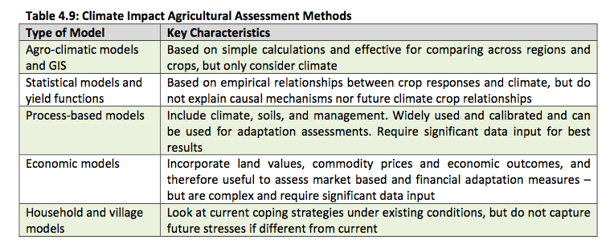

Presentation of Vulnerability Results
Vulnerability assessment results are often presented in national communications using a combination of descriptive narrative text, aided by selected summary tables and figures. Summary maps, tables and diagrams can often aid the communication of vulnerability assessment results. If presented well, these can provide powerful images of potential impacts. Some examples from most recent national communications are shown below (see extract from Mongolia in Figure 10-, Bhutan in Figure 10-, and Viet Nam in Figure 10-). The key is organization, clarity, and simplicity.
Importantly, Parties should report on ‘key’ vulnerabilities in areas that are most critical. This infers that there has been a process undertaken to determine the relative vulnerabilities to climate change across sectors, perhaps undertaken through specific sectoral assessments (see chapters 5–8), or identified in key geographical areas. Methods and approaches to support this process are outlined in chapter 9.

Figure 10-: Natural zones and aridity index distribution map (Mongolia, second national communication, 2010)
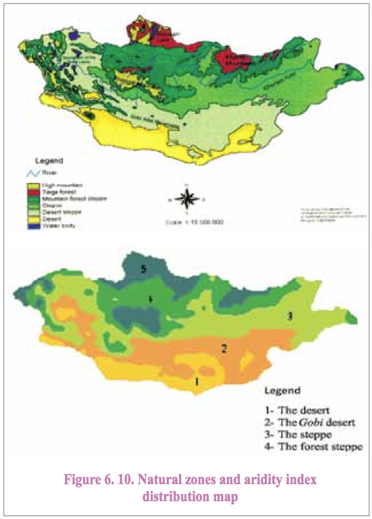
Figure 10-: Summary temperature changes for Bhutan (Bhutan, second national communication, 2011)
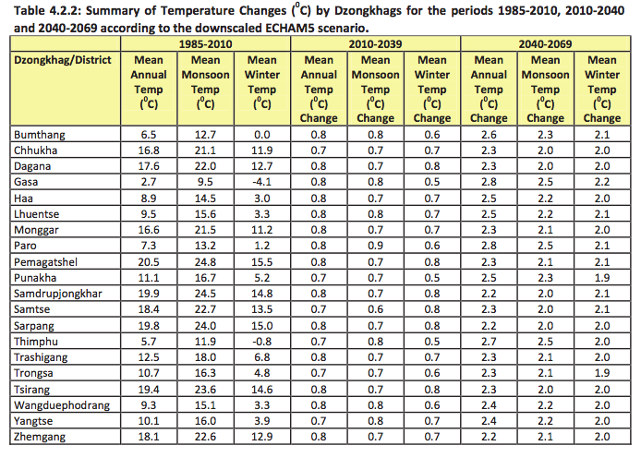
Figure 10-: Projected changes in Vietnamese closed tropical moist semi-deciduous forests (shown in green), under climate change scenario B2 (Vietnam, second national communication, 2010)
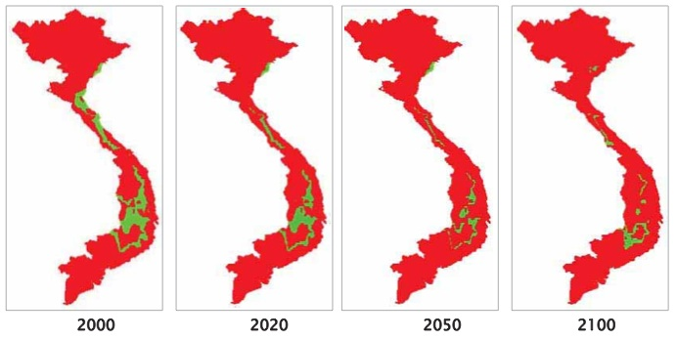

Presentation of Adaptation Results
Unlike the presentation of vulnerability results, adaptation results are most often presented as narrative text. A clearer way of presenting adaptation results is to use tables or bullet point lists, which allows the reader to quickly see the key adaptation options and strategies proposed, or to differentiate between sector adaptations. An example of this structure is presented in Table 10-. It also allows for adaptations to be evaluated or ranked, which aid in integration and mainstreaming (refer to chapter 9).

Table 10-: Extract from Table 34: Strategies and adaptation measures envisaged (Guinea-Bissau, second national communication, 2011)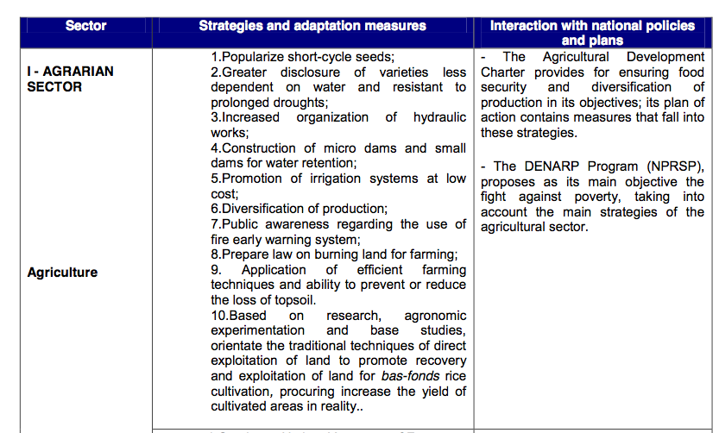

Conclusions
In presenting results of V&A assessments in national communications, it is important to keep in mind paragraphs 34 and 35 in the guidelines annexed to decision 17/CP.8. These paragraphs call for a clear, concise and accessible description of key vulnerabilities and adaptation. Without a clear synthesis of results, readers of national communications may not understand which vulnerabilities are key and what adaptations are needed to address them.
In conclusion, a useful checklist to assess if a national communication has successfully met the necessary criteria was developed in the UNFCCC Resource Guide Module on Vulnerability and Adaptation. The Resource Guide suggested that success criteria includes providing answers to the following questions:
- Does the national communication clearly communicate who and what is vulnerable to climate change?
- How does vulnerability vary across time and geographic region and across different sectors?
- Are limitations of the findings clearly outlined?
- Are the vulnerability and adaptation frameworks, methods, tools and models used clearly described?
- Are any assumptions and context-specific interpretations outlined transparently?
- Who will need to adapt to climate change?
- Where and when are adaptation strategies planned?
- What needs to be done to ensure that implementation of adaptation strategies will be effective?
10.4 further reading
Whitmarsh L, O’Neill S and Lorenzoni I. (eds.). 2011. Engaging the public with climate change: behaviour change and communication. London: Earthscan.
Advancing Science Serving Society. 2011. Communicating Science – Tools for Scientists and Engineers. Available at <http://communicatingscience.aaas.org/Pages/newmain.aspx>.
Chris Mooney. 2010. Do scientists understand the public? American Academy of Arts and Sciences. Available at <http://www.amacad.org/pdfs/scientistsUnderstand.pdf>.
Moser SC and Dilling L. 2007. Creating a Climate for Change: Communicating Climate Change and Facilitating. Cambridge: Cambridge University Press.
Big Think. 2011. Re-Defining Science Communication: Emerging Best Practices that Empower the Public. Available at <http://bigthink.com/ideas/37755>.

<http://unfccc.int/national_reports/non-annex_i_natcom/items/2979.php>.
<http://unfccc.int/national_reports/non-annex_i_natcom/guidelines_and_user_manual/items/2607.php>.
<http://unfccc.int/national_reports/non-annex_i_natcom/guidelines_and_user_manual/items/2607.php>.
< http://www.unssc.org/home/resources/learning-lab>.
<http://www.mindtools.com/pages/article/newPPM_07.htm>.
<http://www.natcomindia.org/>.
<http://unfccc.int/resource/docs/publications/08_resource_guide2.pdf>.

