Consultative Group of Experts on National Communications from Parties not included in Annex I to the Convention
(CGE)


Handbook on the Industrial Processes Sector

CONTENTS
1. Introduction 4
2. Revised 1996 IPCC Guidelines Approach and Steps 5
2.1 Definition of IP Sector Activities 5
2.2 Differentiation of Non-energy- and Energy-related Emissions 5
2.3 IPCC Source and Subsource Categories or Disaggregation 5
2.4 Estimation Methods 5
2.4.1 Choice of Methods 6
2.4.2 Choice of Activity Data 6
2.4.3 Choice of Default Emission Factors 7
2.5 Tools Facilitating Choice of EF and Reporting 7
2.5.1 IPCC Emission Factor Database 7
2.5.2 Tools Facilitating Reporting 8
3. GPG 2000 Approach and Steps 10
3.1 Good Practice Principles 10
3.2 Choice of Methods 10
3.3 Potential Key Categories Identified 10
4. Review of Problems Encountered in Using the Revised 1996 IPCC Guidelines, their Effects, and Suggested Approaches and GPG 2000 Options 12
4.1 Difficulty in Disaggregation of Country-Relevant Sources into IPCC
Categories 12
4.2 Activity Data Collection and Confidential Business Information 13
4.3 Emission Estimation Methods and Reporting 14
4.4 Subsource Categories Not Listed in Revised 1996 IPCC Guidelines 14
4.5 Reporting of Non-energy Use of Fuel Feedstock 14
4.6 Inappropriateness of Stoichiometric Ratios As EFs 14
4.7 Lack of Development of Country-specific Emission Factors 15
4.8 Use of Notation Keys in Reporting Tables 1and 2 15
4.9 Activity Data Collection and Reporting 15
4.10 Institutional Arrangements 15
Recommended capacity building 16
5. GPG 2000 Improvements in IP Sector Inventory 17
5.1 Recommended Good Practice for the Estimation of AD and EFs, and Applying Revised 1996 IPCC Guidelines Based on National Circumstances 17
EMISSION FACTOR ESTIMATION (Tier 1) 18
Subsource category: 2A2 CO₂ – Lime production 18
Estimate component lime EFs 18
PROCESS EMISSIONS ESTIMATION 18
Subsource category: 2C1 CO₂ – Iron and steel production 19
Estimate emissions based on Tier 1 method as follows: 19
ESTIMATE AD FOR REDUCING AGENTS BASED ON PROCESS REACTION 19
Estimate mass of reducing agent from coke and charcoal consumption based on stoichiometry of iron ore reduction in integrated iron and steel industry production including EAF electrodes where applicable 19
AD (mass of reducing agent) 19
Use DEFAULT EF by reducing agent type 19

1. Introduction

The Consultative Group of Experts hands-on training for Parties not included in Annex I to the Convention (non-Annex I Parties) for the industrial processes (IP) sector inventories has been designed to address the main problems that were encountered by non-Annex I Parties in the preparation of the initial national communications using the Revised 1996 IPCC Guidelines for National Greenhouse Gas Inventories (hereinafter referred to as the Revised 1996 IPCC Guidelines). The main objective of these training materials is to build the capacity of non-Annex I Parties in the application of currently available greenhouse gas (GHG) inventory tools and methods to improve IP sector inventories, to facilitate the meeting of their obligations in inventory reporting under the UNFCCC guidelines for the preparation of national communications.

- The training, which is participatory in nature, emphasizes, among other things, the demonstration of:

    - The use the UNFCCC inventory software, and the IPCC emission factors database (EFDB) to facilitate the application of the Revised 1996 IPCC Guidelines;
    - The accuracy of technology-based default emission factors (EFs), particularly in the IP sector (and build confidence in their application using the case of aluminium production in Ghana);
    - How Good Practice Guidance and Uncertainty Management in National Greenhouse Gas Inventories ((hereinafter referred to as the IPCC good practice guidance) addresses the problems of methodological choices (tier level), activity data (AD), EFs, uncertainty estimation, prioritization of source categories to maximise resource use for specific IP sector source categories listed in the IPCC good practice guidance, based on national circumstances determined by the decision tree approach;
    - The advantages of the application of good practice principles to the Revised 1996 IPCC Guidelines source categories not listed in the IPCC good practice guidance, particularly where the default EFs are determined solely by the stoichiometric ratios of process reaction, to increase accuracy, transparency and comparability and reduce uncertainty.

2. Revised 1996 IPCC Guidelines Approach and Steps

2.1 Definition of IP Sector Activities

Production-related emissions are NOT classified under the IP sector but under the energy sector. However, GHGs released as a result of fuel combustion as feedstock during production activities (i.e. heat, process steam or electricity generation) are reported in the IP sector.

2.2 Differentiation of Non-energy- and Energy-related Emissions

The chemical reactions involved in the source categories listed below are described in the specified sections in the Revised 1996 IPCC Guidelines (Volume 3). The respective chemical equations generally indicate energy/heat requirement initiation and/or sustaining the chemical reaction kinetically and thermodynamically. The emissions associated with the energy input are not regarded as IP emissions and therefore not included in the EF estimation. They are accounted for under source category 1A2 – Manufacturing industries and construction in the energy sector. To avoid double counting, it is recommended that the emissions related to non-energy uses (NEU) be reported in the IP sector, and these should be computed based on the use of the reducing agents, particularly for the source categories in metal production:

- Cement production 2.3.1;
- Lime production 2.4.1;
- Soda ash production and use 2.6.1;
- Ammonia production 2.8.1 and 2.8.2;
- Silicon carbide 2.11.1;
- Calcium carbide 2.11.2;
- Iron and steel 2.13.3.2;
- Ferro alloys 2.13.5.1;
- Aluminium 2.13.5.1.

2.3 IPCC Source and Subsource Categories or Disaggregation

The UNFCCC inventory software (electronic version of the IPCC worksheets) and the EFDB are tools that help to identify IPCC categorization/disaggregation.

2.4 Estimation Methods

The general approach to estimating IP emissions is the application of the equation below:

TOTAL_{ij} = AD_{j} × EF_{ij}

Where:

TOTAL_{ij} = process emission (tonnes) of gas, i, from industrial sector, j;
AD_{j} = amount of activity or production of process material (AD) in industrial sector, j (tonne/yr);
EF_{ij} = emission factor associated with gas, i, per unit of activity in industrial sector, j (tonne/tonne).

2.4.1 Choice of Methods

For certain industrial processes, more than one estimation methodology is presented. These are:
- Simplified approach, referred to as Tier 1;
- More detailed methodology, referred to as Tier 2.

Several options are also provided for certain industrial processes under Tier 1, as Tier 1a, 1b, 1c, based on data availability and suitability of methods. In such cases the order of preference for Tier 1 methods is 1a > 1b > 1c.

Typical selected tiers by subsource categories in the Revised 1996 IPCC Guidelines are summarized as follows:

- 2B1 – Ammonia production (CO₂):
Tier 1a – AD as natural gas consumption (m³) and EF (kgC/m³);
Tier 1b – AD as ammonia production (tonnes) and EF (tonne CO₂/tonne NH₃);

- 2C5 – Calcium carbide production (CO₂):
Tier 1a – Consumption of petroleum coke (tonnes) and EF (tonne C/tonne coke type);
Tier 1b – Production of carbide;

- 2C – Metal production (iron and steel, Al, ferro alloys);
Tier 1a – Consumption of reducing agent (tonne) and EF (tonne C/tonne reducing agent);
Tier 1b – Production of the metal (tonnes) and EF (tonne CO₂/tonne metal);

- PFCs from aluminium production:
Tier 1a – Direct plant emissions data;
Tier 1b – Estimation based on plant measurements and empirical estimation;
Tier 1c – Based on aluminium production (tonnes) and default EF (kg/tonne Al);

- 2E – HCFC manufacture (HFC-23 release):
Tier 1 – AD total production (tonnes) and Default EF (% of total production);
Tier 2 – Direct emissions from plant-specific measurements using standard methods;

- 2F – Consumption of ozone depleting substances (ODS) substitutes (HFCs, PFCs and SF₆):
Tier 1a and Tier 1b – Potential emissions;
Tier 2 – Actual emissions.

2.4.2 Choice of Activity Data

Activity data sources include:

- Plant-level measurements or direct emissions reports with documented methodologies;
- Where direct measurements are not available, estimations may be based on calculation with plant-specific data;
- International data sets (United Nations data sets and industry associations);
- National databases, where available, from appropriate government ministries (e.g. statistics services, environmental protection agencies);
- Standard production statistics from national statistical publications.

2.4.3 Choice of Default Emission Factors

The various types of EFs can be classified as follows:

- Process-reaction-based EFs (stoichiometric ratios);
- Production-based EFs;
- Technology-specific EFs;
- Reported country/region-specific plant-level measurements.

Tools Facilitating Choice of EF and Reporting

2.5.1 IPCC Emission Factor Database

The IPCC Emission Factor Database comprises different types default emissions factors, including process reaction stoichiometric ratios, technology-specific EFs and country-specific documented factors that meet the IPCC database criteria.

The stoichiometric ratios are based on process chemical reactions. The method assumes complete reaction, 100% purity factors of raw materials. These ratios therefore represent a fairly good first estimate where plant-level and technology-specific EFs are not available.

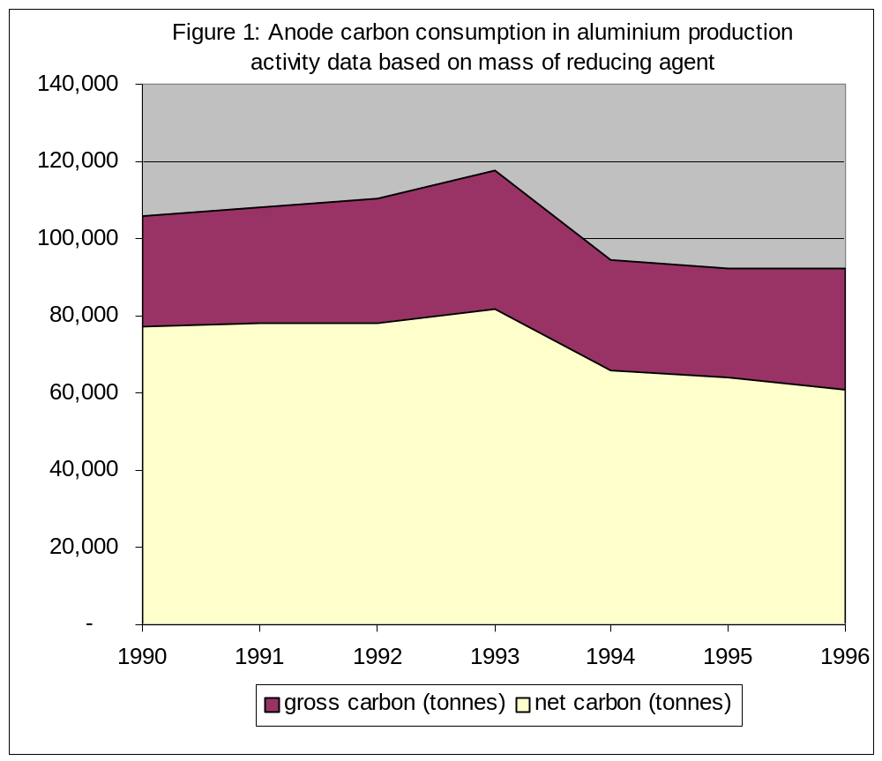The technology-based default EFs generally compare well with plant-level measurements where there is good practice at the industry level. For instance, the estimated CO₂ emissions from plant-level AD of a pre-baked anode process aluminium smelter in Ghana gave average specific net carbon (C) consumption as 0.445 tonne C per tonne aluminium (Ghana’s initial national communication, 2000) over the operating period of 1990–1996, representing an EF of 1,630 tCO₂/t aluminium based on net carbon consumption (figure 1). The corresponding IPCC technology-based default is 1.5 for pre-baked anode process (Revised 1996 IPCC Guidelines, Volume 3 section 2.13.5) indicating that the technology-specific IPCC default approximates very well to plant-level data and is therefore of low-level uncertainty.

2.5.2 Tools Facilitating Reporting

The UNFCCC inventory software employs default EFs (EF-D) from the IPCC EFDB to generate the emission estimates when AD are filled in the worksheets. The software also automatically generates the IPCC inventory reporting Table 7A and 7B which, hither to, inventory experts completed manually. The tool therefore avoids manual filling in of worksheets and thus improves inventory compilation effectiveness and reduces reporting errors.

The notation keys developed to improve completeness and transparency are summarized in box 1, below. The appropriate use of the keys as defined below will be discussed as part of the training, particularly “NE” and “NA”, to ensure that inventory experts use them to improve quality.

Box 1. Notation keys

NO (not occurring) for activities or processes that do not occur for a particular gas or source/sink category within a country
NE (not estimated) for existing emissions and removals that have not been estimated
NA (not applicable) for activities in a given source/sink category that do not result in emissions or removals of a specific gas
IE (included elsewhere) for emissions and removals estimated but included elsewhere in the inventory (Parties should indicate where the emissions or removals have been included)
C (confidential) for emissions and removals that could lead to the disclosure of confidential business information (CBI).

3. GPG 2000 Approach and Steps

3.1 Good Practice Principles

The general principles of good practice include: key category analysis and the determination key categories for prioritization; tier level determination by decision trees; choice of EFs; choice of AD; element of completeness and transparent AD; consistency in the time series; and uncertainty assessment. The cross-cutting issues include reporting and documentation, and inventory quality assurance/quality control (QA/QC).

The main objective is to produce inventories that neither overestimate nor underestimate emissions so far as can be judged based on the principle of “TCCCA”, namely transparency, consistency over time, completeness, comparability and accuracy.

The other objectives are:
- To use limited resources more efficiently by focusing on key categories;
- To reduce levels of uncertainty;
- To improve reporting and documentation;
- To apply QA/QC.

3.2 Choice of Methods

The GPG2000 approach:

- Identifies potential IP sector key categories;
- Provides decision tree analysis for the selected sources;
- Describes category-specific good practice methods in adapting the Revised 1996 IPCC Guidelines to country-specific circumstances;
- Defines tier numbers for alternative names of methods that are described in the Revised 1996 IPCC Guidelines but which are not numbered;
- Provides good practice guidance for various tier levels of assessment (Tiers 1, 2, 3) for selected source categories.

3.3 Potential Key Categories Identified

The IPCC good practice guidance has been developed for major emissions source categories, which could be potential key categories in many countries, based on trends and absolute levels or both. The categories are listed as follows:

- 2A1 – CO₂ Emissions from Cement Production;
- 2A2 – CO₂ Emissions from Lime Production;
- 2C1 – CO₂ Emissions from the Iron and Steel Industry;
- 2B3 and 2B4 – N₂O Emissions from Adipic Acid and Nitric Acid Production;
- 2C3 – PFCs Emissions from Aluminium Production;
- 2C4 – Sulphur hexafluoride (SF₆) emissions from Magnesium Production;
- 2E1 – HFC-23 Emissions from HCFC-22 Manufacture;
- 2F(1–5) – Emissions from Substitutes for Ozone Depleting Substances (ODS substitutes) from HFCs and PFCs used in refrigeration, air conditioning, foam blowing, fire extinguishers, aerosols, solvents);
- 2F7 – SF₆ Emissions from Electrical Equipment;
- 2F8 – SF₆ Emissions from Other Sources of SF₆;
- 2E3 – SF₆ Emissions from Production of SF₆;
- 2F₆ – PFC, HFC, and SF₆ Emissions from Semiconductor Manufacturing.

The IPCC good practice guidance has not yet been developed for the following source categories described in the Revised 1996 IPCC Guidelines, Chapter 2, Industrial Processes: limestone and dolomite use (including use in the iron and steel industry); soda ash production and use; production and use of miscellaneous mineral products; ammonia production; carbide production; production of other chemicals; ferroalloys; CO₂ emissions from aluminium production; other metal production; SF₆ used in aluminium and magnesium foundries; pulp and paper industries; and food and drink industries.

For sources not covered by the IPCC good practice guidance, the principles of good practice should be adopted to improve quality. The main purpose of good practice guidance is to produce inventories that meet the TCCCA criteria. The approach helps ensure that the limited resources available to conduct inventories are used efficiently and that uncertainty is reduced. It is good practice to use higher tier methods for key categories (i.e. category-specific good practice methods) for the preparation of estimates.

4. Review of Problems Encountered in Using the Revised 1996 IPCC Guidelines, their Effects, and Suggested Approaches and GPG 2000 Options
Specific problems identified by non-Annex I Parties and the impacts on the inventory quality are outlined in point form in this chapter. Suggested approaches and GPG 2000 options, where applicable, are also provided.

4.1 Difficulty in Disaggregation of Country-Relevant Sources into IPCC Categories

Problem: Difficulty in disaggregating country-relevant sources into IPCC categories.

Mapping national industry classifications with IPCC source categories, particularly subsource categories not listed in the Revised 1996 IPCC Guidelines, is recommended as a practical approached (see example in Table 1).

Table 1. Mapping national sources with IPCC source categories
IPCC source category | Potential national IP sources
2A1 Cement Production | Cement (decarbonizing)
2A2 Lime Production | Lime Production (decarbonizing)
2A3 Limestone and Dolomite Use | Glass Production: Limestone and Dolomite  Iron and Steel (Blast Furnace): Limestone and Dolomite
2A4 Soda Ash Production and Use | Glass Production: Soda Ash
2A5 Asphalt Roofing
2A6 Road Paving with Asphalt | Road Construction
2A7 Other | Brick Manufacture (Fletton)  Glass (continuous filament glass fibre)  Glass (glass wool)
2B1 Ammonia Production | Ammonia Feedstock
2B2 Nitric Acid Production | Nitric Acid Production
2B3 Adipic Acid Production | Adipic Acid Production
2B4 Carbide Production
2B5 Other | Sulphuric Acid Production  Chemical Industry  Chemical Industry (Carbon Black)  Chemical Industry (Ethylene)  Chemical Industry (Methanol)  Chemical Industry (Nitric Acid Use)  Chemical Industry (Pigment Manufacture)  Chemical Industry (Reforming)  Chemical Industry (Sulphuric Acid Use)  Coal, Tar and Bitumen Processes  Solvent and Oil Recovery  Ship Purging
2C1 Iron and Steel | Iron and Steel (other)  Iron and Steel (Basic Oxygen Furnace)  Iron and Steel (Electric Arc Furnace)  Iron and Steel Flaring (Blast Furnace Gas)  Rolling Mills (Hot & Cold Rolling)
2C2 Ferroalloys Productions | No Comparable Source Category
2C3 Aluminium Production | Non-Ferrous Metals (Aluminium Production)
2C4 SF₆ Used in Aluminium and Magnesium Foundries | SF₆ Cover Gas
2C5 Other | Non-Ferrous Metals (other non-ferrous metals)  Non-Ferrous Metals (primary lead/zinc)  Non-Ferrous Metals (secondary Copper)  Non-Ferrous Metals (secondary lead)
2D1 Pulp and Paper | Wood Products Manufacture
2D2 Food and Drink | Brewing (barley malting, fermentation, wort boiling)  Bread Baking  Cider Manufacture  Other Food (animal feed; cakes, biscuits, cereals; coffee, malting, margarine and other solid fats; meat, fish and poultry; sugar)  Spirit Manufacture (barley malting, casking, distillation, fermentation, maturation, spent grain drying)  Wine Manufacture
2E1 Halocarbon and SF₆ By-Product Emissions  2E2 Halocarbon and SF₆ Fugitive Emissions | Halocarbons Production (By-Product and Fugitive)
2E3 Halocarbon and SF₆ Other | Not Estimated
2F1 Refrigeration and Air Conditioning | Refrigeration  Supermarket Refrigeration  Mobile Air Conditioning
2F2 Foam Blowing | Foams
2F3 Fire Extinguishers | Fire Fighting
2F2 Aerosols | Metered Dose Inhalers  Aerosols (Halocarbons)
2F2 Solvents | Not Occurring
2F2 Other | Electronics  Training Shoes  Electrical Insulation

4.2 Activity Data Collection and Confidential Business Information

Problem: Direct reporting of emissions without AD and/or EF to national institutions responsible for data collection because of confidential business information (CBI).

This reduces transparency and comparability. The IPCC good practice guidance recommends plant-level verification and assessment of the measurement standards and QA/QC plan of the industry.

4.3 Emission Estimation Methods and Reporting

Problem: The reporting of industrial process emissions from non-energy use (NEU) of feedstock produced in combination with fuel combustion under the energy sector due to the difficulty in differentiation and possible double counting of CO₂.

The problem leads to underestimation of the contribution of the IP sector to national emissions (e.g. the use of natural gas in ammonia production, and coke as reducing agent in iron and steel production). The IPCC good practice guidance recommends stoichiometric estimation of the NEU and subtraction from the energy statistics to avoid double counting.

4.4 Subsource Categories Not Listed in Revised 1996 IPCC Guidelines

Problem: Direct plant-level reporting of industrial process emissions of CO₂ from chemical processes or stage processes in combination with fuel combustion emissions from energy uses of feedstock under the energy sector (e.g. CO₂ emissions from CaCO₃ decomposition reactions that use metallurgical coke or other fossil fuels as energy sources (e.g. cement, lime, and carbide production)).

This leads to underestimation of IP sector emissions and contribution to national totals. The IPCC good practice guidance recommends QA/QC checks of the industry and plant-level verification.

4.5 Reporting of Non-energy Use of Fuel Feedstock

Problem: The reporting of non-energy use of fuel feedstock in the energy sector due to the difficulty in distinguishing whether a process emission from the fuel feedstock is energy related or industrial-processes-based.

This leads to underestimation of IP sector emissions and contribution to national totals (e.g. oxidation of coke used as a reducing agent in iron and steel production, which releases heat). The IPCC good practice guidance recommends QA/QC checks of the industry and plant-level verification, and the estimation of the IP emissions from the stoichiometric reactions based on the mass of reducing agent.

4.6 Inappropriateness of Stoichiometric Ratios As EFs

Problem: Where technology-specific or plant-level data are not available, EF (default) is based on stoichiometric ratios of process reactions.

This leads to over/underestimation by not taking into account factors that influence the emissions, including per cent purity of raw materials and products, emissions mitigation technologies, raw material or product types/composition and production/process efficiency factors. Further, it increases the uncertainties in EFs.

The IPCC good practice guidance provides guidance on choice of EFs and AD to correct any errors or deficiencies and compensate for the significant factors ignored by applying the Revised 1996 IPCC Guidelines, thus improving accuracy and reducing uncertainties.

4.7 Lack of Development of Country-specific Emission Factors

Problem: Lack of development of plant-level EFs, which leads to the estimation of EFs based on top-down ratios calculated as EF = Emissions/Aggregate AD. Such EFs lack transparency and comparability, and the method is not considered good practice.

The IPCC good practice guidance provides good practice based on a decision tree approach to applying Revised 1996 IPCC Guidelines (see chapter 5, Table 2, below).

4.8 Use of Notation Keys in Reporting Tables 1and 2

Problem: Inappropriate use and/or limited use of notation keys (“NO”, “NE”, “NA”, “IE”, “C”) in UNFCCC reporting Table 1 and Table 2.

This results in lack of transparency and does not address completeness of the inventory coverage (see box 1, above).

4.9 Activity Data Collection and Reporting

Various problems have been identified:

- Production data on large point sources may be available in various national institutions in data sets that are not easily converted to GHG inventory data;
- Where available, mandatory or voluntary plant-level data reports total emissions without AD and EFs;
- Lack of AD or deficiencies in data collection in the informal/small point sources;
- Mandatory industry reports (e.g. annual environmental reports) provide only emissions estimates without AD and/or EFs;
- Lack of IPCC default EFs due to differences in IPCC source and subsource categories and disaggregation of country-relevant sources.

4.10 Institutional Arrangements

Specific issues raised on institutional arrangement include:

- National institutions and industry associations collect and present data in formats not appropriate for GHG estimation because they are normally aggregated in data sets relevant for the purposes for which the date were collected;
- Limited awareness among industry/industry associations of opportunities under the Convention and therefore lack of motivation to develop capacity for reporting GHG inventories;
- Lack of institutional arrangements and clarity over roles and responsibilities of experts carrying out the technical studies;
- Lack of legal and institutional authority to demand data from industry to carry out the inventories (reporting is basically voluntary);
- Non-involvement of universities and/or research centres that could help evolve a more sustainable inventory system;
- Lack of mainstreaming climate change related data collection by national statistical services and industry associations;
- Lack of QA/QC and uncertainty analysis by data collection institutions.

Recommended capacity building

- Institute a national working group of relevant stakeholders for plant-level verification and peer review of the inventory report;
- Organize a capacity-building seminar for all institutions and relevant GHG contributing industries to disseminate the IP inventory data sets, convey the need for QA/QC and plant-specific good practice for development and reporting AD and EFs in GHG inventory data sets;
- Adapt Revised 1996 IPCC Guidelines and the IPCC good practice guidance and develop country-specific workbooks documenting methods, AD and EFs to increase transparency and preserve institutional memory;
- In a capacity-building workshop disseminate information about opportunities for emission reduction under the Convention and the financing mechanisms under the Kyoto Protocol to motivate industry participation.

5. GPG 2000 Improvements in IP Sector Inventory

The source categories that are potentially key categories, and for which good practice has been developed, are listed in sections 3.3 of this Handbook.”. Unlike the Revised 1996 IPCC Guidelines, where tiers are specified for some sources, the IPCC good practice guidance introduces systematic methodologies that facilitate the choice of the tier level of assessment (the tier approach). It uses a decision tree and key sources for the determination of tiers for all categories for which good practice guidance has been developed. Sample decision trees are referenced as follows (cross-references are to figures in the IPCC good practice guidance):

- 2A1 – Cement production (CO₂ figure 3.1 p. 3.11);
- 2C1 – Iron and Steel Production (CO₂ figure 3.2 p. 3.21);
- 2B1 and 2B2 – Nitric Acid and Adipic Acid (NO₂) (figure 3.4 p. 3.32);
- 2C1 – Aluminium production (PFC) (figure 3.5 p. 3.40);
- 2C – Use of SF₆ in magnesium production (SF₆) (figure 3.6 p. 3.49);
- 2E and 2F – ODS Substitutes (figure 3.11 p. 3.80).

5.1 Recommended Good Practice for the Estimation of AD and EFs, and Applying Revised 1996 IPCC Guidelines Based on National Circumstances
The problems associated with lack of appropriate AD (particularly purity factors and process technologies considerations that influence the levels of emissions) and default EFs inappropriate to national circumstances are resolved in the IPCC good practice guidance categories by providing good practice methods that apply Revised 1996 IPCC Guidelines to various national circumstances.

Tables 2.1 to 2.3 summarize sample recommended good practice in adapting the Revised 1996 IPCC Guidelines to country-specific circumstances for the estimation of EFs and/or AD where plant-level data or country-specific (CS) EFs are unavailable.

Table 2.1
2A1 CO₂ – Cement production, from IPCC good practice guidance (2000)
Subsource category: 2A1 CO₂ – Cement production
National circumstance | Good practice approach | Reference (IPCC good practice guidance)
Plant-level clinker production data not available | Obtain AD from national cement statistics, industry association, or international data sources | Decision Tree, Figure 3.1
Plant-level clinker production data not available | Estimate emissions using Tier 1 method based on cement data based on clinker produced in country | Decision Tree, Figure 3.1
Cement types are known | Use default fractions for various cement types to estimate clinker fractions in each cement type | Tables 3.1, 3.3A; 3.3B
Fraction of cement types not available | Use default fractions (e.g. 95% clinker for essentially Portland cement) (Note: 98% default in Revised 1996 IPCC Guidelines is considered too high by the IPCC good practice guidance) | Page 3.14 para 1
CaO content of clinker not available | Use default lime (CaO) content value of 65%

Subsource category: 2A1 CO₂ – Cement production
National circumstance | Good practice approach |  |  | Reference (IPCC good practice guidance)
 |  | EMISSION FACTOR ESTIMATION (Tier 1)
Country-specific EF not developed and documented |  | Estimate EF emissions based on Equation 3.3 (EF = 0.785 tonne CO₂/tonne pure lime * CaO pure lime/tonne pure clinker) * f pure clinker/total clinker (with other non-carbonaceous materials, e.g. gypsum-CaSO₄) | Page 3.12
 |  | PROCESS EMISSIONS ESTIMATION (Tier 1)
Process emissions not estimated for because of lack of EF |  | For Portland cement :  EF = stoichiometric ratio (0.785) * Default lime content in clinker depending on cement type(s) (CaO) * Default clinker ratio (f)
Where:
Stoichiometric ratio = 0.785 tonne CO₂/tonne pure
Default lime content in clinker = 0.65 pure lime/tonne pure clinker
Default clinker ratio = 0.95 pure clinker/tonne total clinker
 |  | = 0.785 tonne CO₂/tonne pure lime * 0.65 pure lime/tonne pure clinker * 0.95 pure clinker/tonne total clinker
 |  | = 0.485 tonne CO₂/tonne total clinker
 |  | Emissions = AD tonnes total clinker/year * EF tonne CO₂/tonne total clinker

Table 2.2
2A2 CO₂ – Lime production, from IPCC good practice guidance (2000)

Subsource category: 2A2 CO₂ – Lime production
National circumstance | Recommended good practice | Reference (IPCC good practice guidance)
Plant-level lime production data not available | Estimate total production (from national statistics, industry associations, international data) | Decision Tree Figure 3.2
 | Include estimate of commercial and captive lime production from other sources, e.g. iron and steel plants
Fractions (purity) of lime types not available | Use default CaO and CaOMgO fractions (purity) | Table 3.4
 | f (quick lime) = 0.95 tonne pure CaO/tonne total lime | Table 3.4
 | f (dolomite) = 0.85/95 tonne CaOMgO/tonne total dolomite | Table 3.4
 | f (hydraulic lime) = 0.75 tonne CaO/tonne total hydraulic | Table 3.4
Country-specific EFs not developed | EF estimation method
 | EF (by lime type) = stoichiometric ratio (lime type) * purity factors (f) (by lime type)
 | Estimate component lime EFs
 | EF (quick lime) = 0.785 * f(1) = 0.785 *0.95 = | Table 3.4
 | EF (dolomite lime) = 0.913 * f(2) = 0.913 * 0.85 = | Table 3.4
 | EF (hydraulic lime) = 0.785 * f(3) = 0.785 * 0.75= | Table 3.4
Fractional composition of lime available | Estimate aggregate EF based on fractions of lime types using equations 3.5A and 3.5B
 | EF (aggregate):
 | = p * EF (quick lime)+ q * EF (dolomite) + r * EF (hydraulic lime)
 | where p, q, r are proportions/lime fractions by type | Page 3.20
 | PROCESS EMISSIONS ESTIMATION
 | CO₂ Emissions = Aggregate EF tonne/tonne total aggregate lime * AD tonne total aggregate lime

Table 2.3
2C1 CO₂ – Iron and steel production, from IPCC good practice guidance (2000)

Subsource category: 2C1 CO₂ – Iron and steel production
National circumstance | Recommended good practice |  | (Reference)
Data on reducing agents or plant-specific information on fuels used as reducing agent (CO, H₂, natural gas) not available | Use nationally compiled production data on iron/steel production |  | Decision Tree Figure 3.3  (IPCC good practice guidance)
Country-specific methodology not developed and/or documented | Estimate emissions based on Tier 1 method as follows:
 | ESTIMATE AD FOR REDUCING AGENTS BASED ON PROCESS REACTION
 | Process Reaction:
 | Fe₂O₃ + 3C = 2Fe + 3/2 CO₂
 | Stoichiometric ratio = 36 tonnes C/ X tonnes of pig iron
 | Estimate mass of reducing agent from coke and charcoal consumption based on stoichiometry of iron ore reduction in integrated iron and steel industry production including EAF electrodes where applicable

AD (mass of reducing agent)
= 36 tonnes C/X tonnes pig iron * Q total pig iron production
Lack ofEFs | Use DEFAULT EF by reducing agent type
 | Coal | 2.5 tonne CO₂/tonne reducing agent | Table 2-12 (Revised 1996 IPCC Guidelines)
 | Coke | 3.1 tonne CO₂/tonne reducing | Table 2-12 (Revised 1996 IPCC Guidelines)
 | Petrol coke | 3.6 tonne CO₂/tonne reducing agent | Table 2-12 (Revised 1996 IPCC Guidelines)
Source category not estimated (NE) | PROCESS EMISSIONS ESTIMATION
 | Estimate emissions based on mass of reducing agents using default EFs |  | Table 3.6 (IPCC good practice guidance)
CO₂ emissions
= EF tonnes CO₂/tonne reducing agent C (type) * AD tonne C (type)
 | Subtract fuels used as reducing agent from 1A1-fuel combustion sub-source to avoid double counting |  | Decision tree 3.3 Box 1  (IPCC good practice guidance)
 | Note: The method overestimates net CO₂ emissions by the neglect of carbon storage from steel production (default mass storage C = 2.5–3.5 kg/tonne steel) |  | Section 2.13.3.2 (Revised 1996 IPCC Guidelines)

5.2 Aggregate Emission Factor Estimation

Aggregate emission factor estimations are also normally reported without the required transparency. Sample estimations of aggregate EFs using the Revised 1996 IPCC Guidelines’ default and good practice principles are thus presented as follows:

CO₂: 2.A.2 Lime Production, Revised 1996 IPCC Guidelines Aggregate EF (default) Estimation

CO₂ emissions = EF x Lime production
Where :
EF (lime) = f * EF
f = purity/lime content assumed 100% in IPCC (default)
EF = Stoichiometric ratio assuming that the purity of lime f = 100%
EF(1) (quick lime) = x = 0.79 tonne/tonne lime
EF (2) (dolomite lime) = y = 0.91 tonne/tonne lime
EF(3) (hydraulic lime) = z = 0.79 tonne/tonne lime

Aggregate EF (Default) = xEF(1) + yEF(2) + zEf (3)
= 0.79x + 0.91y + 0.79z
Where x, y and z represent proportions in the lime

Aggregate EF applying good practice principles (IPCC good practice guidance):

CO₂ emissions = EF * Lime production
Where:
EF (lime type) = f * EF
f is CaO content (Equation 3.5A p. 3.20)
f is also a function of lime type given as follows (Table 3.4):
Hi-calcium = 0.95
Dolomitic = 0.85/0.95
Hydraulic = 0.75

The component EFs applying the purity factors as a function of lime type are as follows:
EF (quick lime) = 0.785 f(1) tonne CO₂/tonne lime
EF (dolomite lime)= 0.913 f(2) tonne CO₂ /tonne dolomite lime
EF (hydraulic lime)= 0.785 tonne CO₂/tonne lime

The aggregate EF based on fractions of the lime types in country’s lime production is estimated as follows:

EF (aggregate) = (p*0.785*0.95) + (q*0.913*0.85) + (r*0.785*0.75)
Where p, q, and r represent the fraction of the lime types.5.3 Improved AD and EFs Compared with Revised 1996 IPCC Guidelines Based on National Circumstances and Decision Trees

Tables 2.4–2.7 below summarize sample recommended good practice in adapting the Revised 1996 IPCC Guidelines to country-specific circumstances for the estimation of EFs and/or AD based on the decision trees and national circumstances regarding various levels of data availability. For instance, the EFs for cement production in tonne CO₂ per tonne cement production are 0.499 (Revised 1996 IPCC Guidelines default) and 0.507 (Tier 1) and 0.520 (Tier 2) (IPCC good practice guidance). The analysis based on the good practice guidance demonstrates the differences in EFs depending on the types of AD available at the country level.
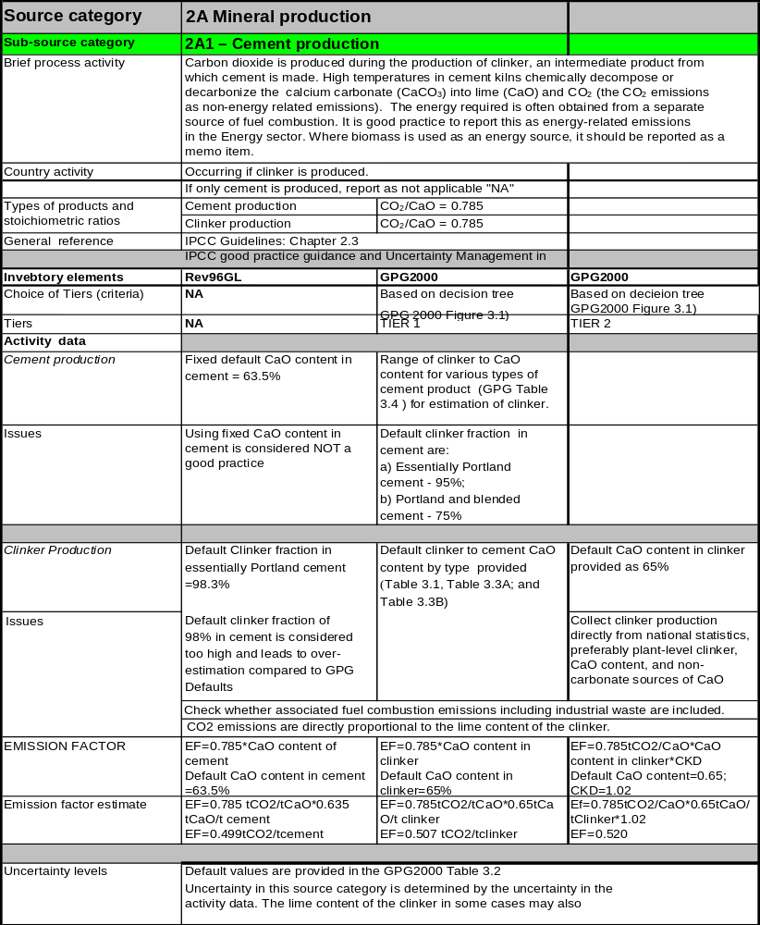Table 2.4
2A1 – CO₂ from cement production
Table 2.5
2A2 – CO₂ from lime production
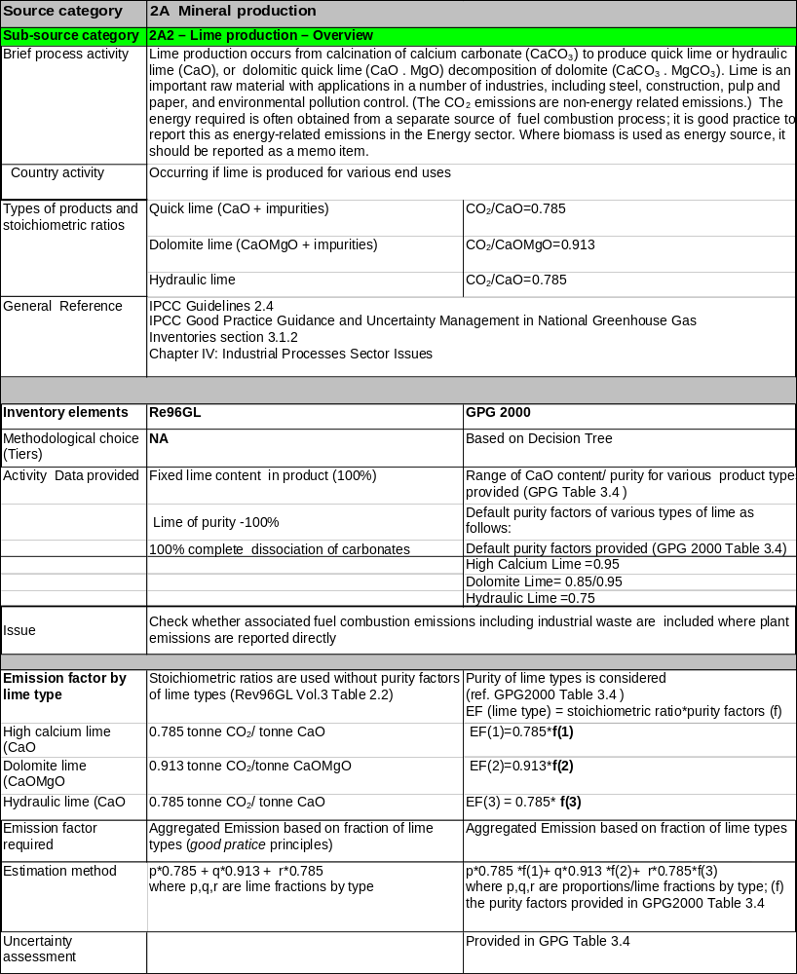
Table 2.6
2A 3 – Limestone and dolomite use (based on good practice principles)
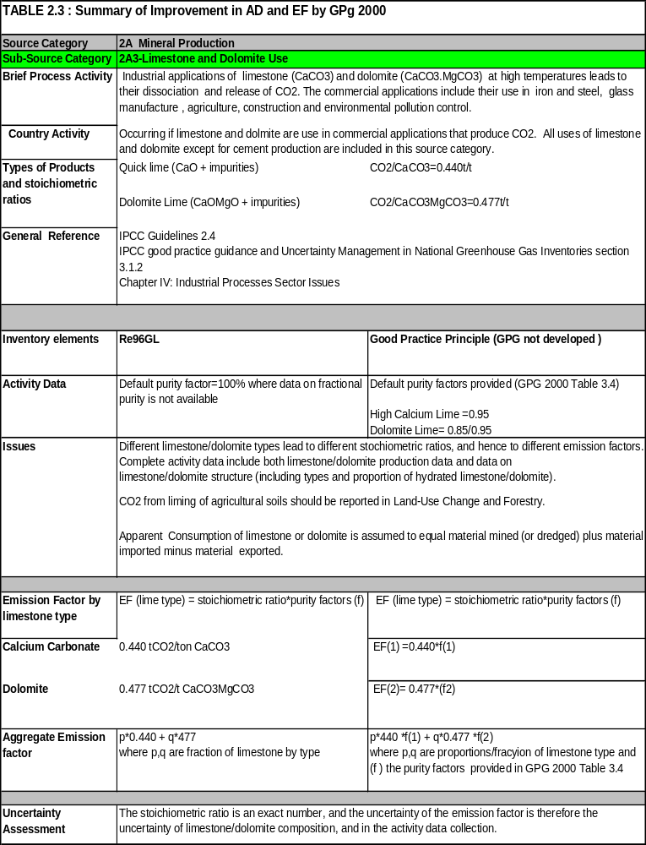
Table 2.7
2C1 – CO₂ from iron and steel production
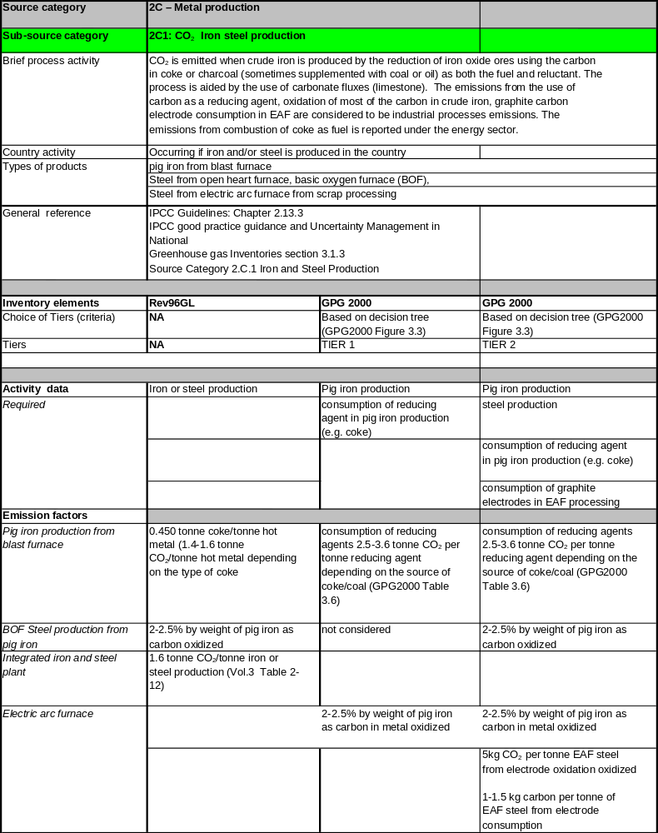
Table 2.7
2C1 – CO₂ from iron and steel production (continued)


