Consultative Group of Experts on National Communications from Parties not included in Annex I to the Convention
(CGE)



Handbook on the
Energy sector
Fuel Combustion

CONTENTS
1 Introduction 3
2 Sources and activities 3
3 Basic emission processes 4
3.1 CO₂ emissions 4
3.2 Non-CO₂ emissions 6
4 Choice of method 7
4.1 CO₂ emissions 7
4.2 Non-CO₂ emissions 17
5 Relative importance of the Energy Sector – Fuel combustion 26
6 Relationships with other sources and sectors 26
6.1 Interaction with Industrial Processes Sector 26
6.2 Interaction with the Waste and Land-Use Change and Forestry Sectors 28
6.3 Autoproduction of electricity 29
6.4 Fuel use for military purposes 29
6.5 Mobile sources in Agriculture 29
7 Quality control and completeness 29
8 Uncertainty 30
9 UNFCCC Software and reporting tables 30
10 Reference materials 30
11 Closing 31
12 Glossary 31

- Introduction
The aim of this handbook is to improve your skills and knowledge regarding the preparation of greenhouse gas inventories. Specifically, this handbook focuses on the fuel combustion portion of the energy sector, in keeping with the Revised 1996 IPCC Guidelines for National Greenhouse Gas Inventories (hereinafter referred to as the Revised 1996 IPCC Guidelines) and taking into consideration the Good Practice Guidance and Uncertainty Management in National Greenhouse Gas Inventories (hereinafter referred to as the IPCC good practice guidance).
- Sources and activities
Energy systems are extremely complex and widespread components of national economies, making assembly of a complete record of the quantities of each fuel type consumed for each ‘end use’ activity a considerable task. Greenhouse gas emissions in the energy sector result from the production, transformation, handling and consumption of energy commodities. This handbook discusses, specifically, emissions due to the combustion of fuels to produce energy (e.g. electricity and heat).

The energy sector includes two major combustion-related activities: 1) stationary combustion and 2) transport or mobile combustion. Each of these activities includes various sources that emit carbon dioxide (CO₂), methane (CH₄) and nitrous oxide (N₂O).

Stationary combustion source categories include:
- Energy industries, which include activities such as energy extraction, energy production and transformation, including electricity generation, petroleum refining, etc. Emissions due to autoproduction of electricity are included in this source category, and are attributed to the industrial categories in which the generation activity occurs.

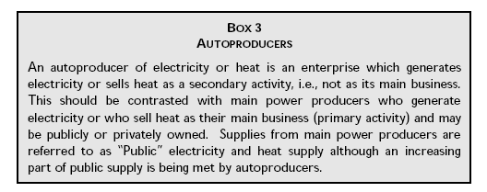
Source: Revised 1996 IPCC Guidelines, Reference Manual – Volume 3, p. 1.32.

- Manufacturing industries and construction, which include activities such as iron and steel production, non-ferrous metal production, chemical manufacturing, pulp, paper and print, food processing, beverages and tobacco, etc.

- Other sectors such as commercial/institutional, residential, and agriculture/forestry/fisheries.

Mobile source categories include:
- Civil aviation
- Road transportation (cars, light duty trucks, heavy duty trucks and buses, motorcycles, etc.)
- Railways
- Navigation
- Other transportation activities, such as gas pipeline transport.

International bunker fuels, which include navigation and civil aviation fuel emissions from international transport activities (i.e. bunker fuels), should be reported separately and excluded from the national totals.
- Basic emission processes
Emissions relating to energy use include emissions of CO₂ , CH₄, N₂O, nitrogen oxides (NO_{x}), carbon monoxide (CO) and non-methane volatile organic compounds (NMVOCs). They also include emissions of sulphur dioxide (SO₂).
  - CO₂ emissions
Carbon dioxide emissions result from the oxidation of the carbon in fuels during combustion. In perfect combustion conditions, the total carbon content of fuels would be converted to CO₂. However, real combustion processes are not perfect and result in small amounts of partially oxidized and unoxidized carbon.
Incomplete oxidation occurs due to inefficiencies in the combustion. The carbon flow for a typical combustion process can be described as follows:
- Most carbon is emitted as CO₂ immediately;
- A small fraction of the fuel carbon escapes immediate oxidation to CO₂. Most of this fraction is emitted as non-CO₂ gases such as CH₄, CO and NMVOCs. The carbon in these gases, though, is assumed to oxidize ultimately to CO₂ in the atmosphere and is therefore integrated into the overall calculation of CO₂ emissions (i.e. the carbon content value). Therefore, the carbon in these non-CO₂ molecules is intentionally ‘double counted’ because it is eventually transformed into a CO₂ molecule;
- The remaining part of the fuel carbon is unburned (i.e. unoxidized) and remains as soot and ash. In general, this fraction of the fuel carbon is assumed to remain stored indefinitely (i.e. not emitted in gaseous form).
To account for the unburned fraction of fuel carbon, the Revised 1996 IPCC Guidelines suggest the use of the following oxidation factors:
- For natural gas, generally less than 1 per cent of the carbon is left unburned during combustion. This carbon remains as soot in the burner, stack or in the environment. The IPCC default oxidation factor is 99.5 per cent. The unburned fraction of natural gas, however, can be much higher for flares in the oil and gas industry;
- For oil, about 1.5 ± 1 per cent of fuel carbon passes through the burners without being oxidized. The IPCC default oxidation factor is 99 per cent;
- For coal, the amount of unoxidized carbon, primarily in the form of ash, has been found to be higher and can vary considerably with different combustion technologies and efficiencies (e.g. range from 0.6 to 6.6 per cent). The IPCC default oxidation factor is 98 per cent.

The carbon content of a fuel is an inherent chemical property (i.e. mass of carbon atoms relative to total mass of the fuel). The carbon content of crude oil is often measured in degrees using the API (American Petroleum Institute) gravity scale. Using an estimate of world average API gravity of 32.5 ±2 degrees, the global average carbon composition of crude oil would be about 85 ±1 per cent. A summary of default carbon content factors from the Revised 1996 IPCC Guidelines is given in the following table.

Table 1 IPCC default carbon content factors for major primary and secondary fossil fuels.
Liquid | (t C/TJ) | Solid | (t C/TJ) | Gaseous | (t C/TJ)
Primary fuels |  | Primary fuels |  | Natural gas (dry) | 15.3
Crude oil | 20.0 | Anthracite | 26.8
Orimulsion | 22.0 | Coking coal | 25.8
N. gas liquids | 17.2 | Other bit. coal | 25.8
Secondary fuels |  | Sub-bit. coal | 26.2
Gasoline | 18.9 | Lignite | 27.6
Jet kerosene | 19.5 | Oil shale | 29.1
Other kerosene | 19.6 | Peat | 28.9
Shale oil | 20.0 | Secondary fuels
Gas/diesel oil | 20.2 | BKB and patent fuel | 25.8*
Residual fuel oil | 21.1 | Coke oven/gas coke | 29.5
LPG | 17.2
Ethane | 16.8
Naphtha | 20.0*
Bitumen | 22.0
Lubricants | 20.0*
Petroleum coke | 27.5
Refinery feedstocks | 20.0*
Other oil | 20.0*
* Preliminary values identified by the IPCC. Countries should only use these when no other data are available.
Reference: Table 1.1 in Revised 1996 IPCC Guidelines, vol. 3.
Note: Energy units expressed in terms of net calorific value (NCV).

The energy content (i.e. calorific value or heating value) of fuels is also an inherent chemical property. However, calorific values vary more widely between and within fuel types, because they are dependent upon the composition of chemical bonds in the fuel. Given these variations and the relationship between carbon content and calorific values, carbon content values for estimating CO₂ emissions from fossil fuel combustion are expressed in terms of carbon per energy unit. This form generally provides more accurate emission estimates than if carbon content factors were expressed in terms of mass or volume, assuming reasonably accurate calorific values are available to convert fuel statistics into energy units.
Net calorific values (NCVs) measure the quantity of heat liberated by the complete combustion of a unit volume or mass of a fuel, assuming that the water resulting from combustion remains as a vapour, and the heat of the vapour is not recovered. Gross calorific values (GCVs), in contrast, are estimated assuming that this water vapour is completely condensed and the heat is recovered, and are therefore slightly larger. Default data in the Revised 1996 IPCC Guidelines are based on NCVs.
  - Non-CO₂ emissions
Due to incomplete combustion of hydrocarbons in fuel, small proportions of carbon are released as CO, CH₄ or NMVOCs, all of which eventually oxidize to CO₂ in the atmosphere. In addition, combustion processes result in emissions of N₂O and NO_{x}.
Unlike CO₂, emission estimates of CH₄, N₂O, NO_{x}, CO and NMVOCs require detailed process information. Accurate estimation of these emissions depends on knowledge of several interrelated factors, including combustion conditions, size and vintage of the combustion technology, maintenance, operational practices, emission controls, as well as fuel characteristics. The methods should be applied at a detailed activity/technology level so as to take, to the extent possible, these factors into account.
Methane is produced in small quantities from fuel combustion due to incomplete combustion of hydrocarbons in fuel. Methane emissions are usually an indication of inefficiency in the combustion process. The production of CH₄ is dependent on the temperature in the boiler/kiln/stove. In large, efficient combustion facilities and industrial applications, the emission rate is very low. In smaller combustion sources, emission rates are often higher, particularly when smoldering occurs. The highest rates of CH₄ emissions from fuel combustion occur in residential applications (small stoves and open burning).
Methane emissions from mobile sources are a function of the CH₄ content of the motor fuel, the amount of hydrocarbons passing unburned through the engine, the engine type, and any post-combustion controls. In vehicles without emission controls the amount of CH₄ emitted is highest at low speeds and when the engine is idle. Poorly tuned engines may have a particularly high output of CH₄.
Nitrous oxide is produced directly from fuel combustion. It has been determined that, in general, lower combustion temperatures cause higher N₂O emissions. The mechanisms of N₂O chemistry seem to be relatively well understood, but experimental data are limited.
Nitrous oxide emissions from vehicles have only recently been studied in detail. Emission controls on vehicles (especially catalysts in road vehicles) can increase the rate of N₂O generation. The degree to which N₂O emissions have increased (or decreased) depends upon factors such as driving practices (i.e. number of cold starts) and the type and age of the catalyst. Nitrous oxide emissions from mobile sources for countries with a high number of road vehicles with emission controls, therefore, can be substantial.
Nitrogen oxides are indirect greenhouse gases. Fuel combustion activities are the most significant anthropogenic source of NO_{x}. Within fuel combustion, the most important sources are energy industries and mobile sources. Generally, two different formation mechanisms can be distinguished:
- Formation of ‘fuel NO’ from the conversion of chemically bound nitrogen in the fuel;
- Formation of ‘thermal NO’ from the fixation of the atmospheric nitrogen in the combustion process.
Carbon monoxide is an indirect greenhouse gas. The majority of CO emissions from fuel combustion come from motor vehicles. Small residential and commercial combustion activities are also large contributors to CO emissions. Carbon monoxide is an intermediate product of the combustion process. The formation mechanism of CO is directly influenced by usage patterns, technology type and size, vintage, maintenance and operation of the technology. Emission rates may vary by several orders of magnitude for facilities that are poorly operated or improperly maintained, such as might be the case of older units.
Non-methane volatile organic compounds are indirect greenhouse gases. Emissions of NMVOCs (e.g. olefins, ketones and aldehydes) are the product of incomplete combustion. The most important sources of NMVOCs from fuel combustion activities are mobile sources and residential combustion, especially biomass combustion (e.g. firewood). NMVOCs emission levels are directly influenced by fuel used, usage patterns, technology type and size, vintage, maintenance and operation of the technology. The emissions are very low for large combustion plants. NMVOC emissions tend to decrease with increases in plant size and increasing efficiency of the combustion process. Emission rates may also vary by several orders of magnitude for facilities that are poorly operated or improperly maintained, such as might be the case of older units.
Sulphur dioxide is an aerosol precursor, and its presence in the atmosphere may have a cooling effect on climate. Sulphur dioxide can react with a variety of photochemically produced oxidants to form sulphate aerosols. The concentration of these particles increases with the burning of fossil fuels that contain sulphur. Emissions of SO₂ are closely related to the sulphur content of fuels.
- Choice of method
The choice of estimation method is country-specific and determined by the level of detail in the activity data available. Decision trees for selecting the methods for estimating CO₂ and non-CO₂ emissions are included in the IPCC good practice guidance.
  - CO₂ emissions
It is possible to estimate national CO₂ emissions by accounting for the carbon in fossil fuels supplied to an economy. In many countries, statistics on the production, import, export and stock changes for fuels are more likely to be available than detailed end-use consumption statistics. Therefore, CO₂ emissions from fuel combustion can be calculated accurately at a highly aggregated level, provided that complete fuel consumption statistics and their typical carbon contents are available. These data provide a sound starting point for the estimation of CO₂ emissions from energy use. Estimates of CO₂ emissions then require adjustments for non-oxidized carbon, carbon stored in products and international bunker fuels.

Supply data for commercial fuels are generally available at the national level, and national inventories should use local energy data and factors where available. Official international databases (e.g. International Energy Agency – IEA) also include data that are directly supplied by the countries themselves. Other regional organizations also collect and analyse energy data from member countries (e.g. Latin American Energy Organization – OLADE). Although carbon content of the fuels consumed may differ somewhat between countries, there is a limited range of variability in carbon contents within standard classes of fuels. Therefore, Parties not included in Annex I to the Convention (non-Annex I Parties) will benefit most from investing their limited resources in collecting high-quality fuel consumption data and not on developing local carbon content factors, except in cases where local fuels are expected to differ dramatically from default values.

There are three methods provided in the Revised 1996 IPCC Guidelines for estimating CO₂ from fuel combustion: two Tier 1 approaches (i.e. the reference approach and the sectoral approach) and the Tier 2 and Tier 3 approaches (i.e. bottom-up approaches). The Tier 2 and Tier 3 methods provide more detailed results for those countries whose energy consumption data are collected at a detailed level. The Tier 1 reference approach provides only aggregate estimates of emissions by fuel type distinguishing between primary and secondary fuels, whereas the sectoral approach allocates these emissions by source category.

The IPCC good practice guidance provides a decision tree to help Parties select the appropriate tier based on their own national circumstances (see below).

All three tiers rely on the same fundamental equation for estimating CO₂ emissions, which is given below:

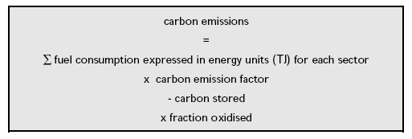

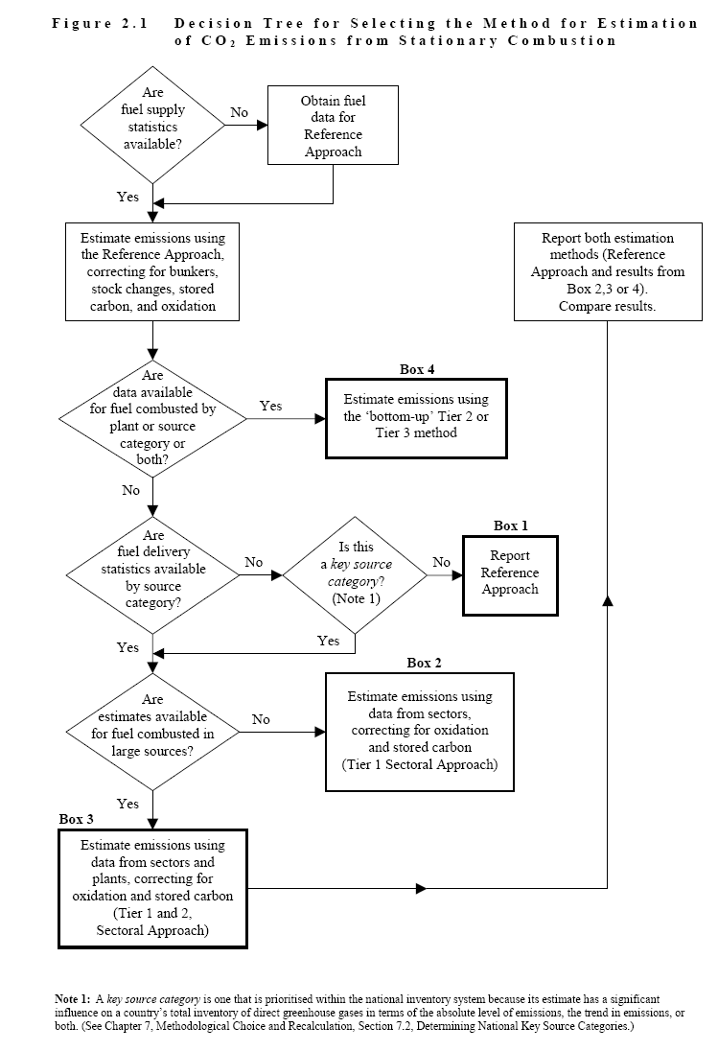
Source: IPCC good practice guidance, p. 2.10.
The reference approach (Tier 1) estimates only CO₂ emissions from fuel combustion. The reference approach for CO₂ can be performed quickly provided that the basic energy balance sheet for a country is available. Carbon dioxide emissions may also be calculated at the more detailed (i.e. sectoral) level.

The reference approach provides a potentially useful way of cross-checking emission estimates of CO₂ with the sectoral approach and thus helps identify inconsistencies or mistakes. The sectoral approach provides greater detail as to the combustion activities responsible for emissions and is used for reporting by most Parties to the United Nations Framework Convention on Climate Change (UNFCCC).

Estimation steps
The estimation process for estimating CO₂ emissions from fuel combustion using the Tier 1 reference or the Tier 2 or 3 sectoral approaches can be divided into of the following steps:

- Collect fuel consumption data:

- The first step of the IPCC reference approach is to estimate apparent consumption of fuels within the country. This step requires a balance of primary fuels produced, plus imports, minus exports, minus international bunkers and the net changes in stocks. In this way carbon is brought into the country from energy production and imports (adjusted for stock changes) and moved out of the country through exports and international bunkers. In order to avoid double counting it is important to distinguish between primary fuels, which are fuels found in nature, such as coal, crude oil and natural gas, and secondary fuels or fuel products, such as gasoline and lubricants, which are derived from primary fuels. Note that ‘apparent consumption’ of secondary fuels can result in negative numbers when a net export or stock of a particular fuel type increases for the country. ‘Apparent consumption’ of secondary fuels should be added to the ‘apparent consumption’ of primary fuels. The production of secondary fuels, through refining processes, should be ignored in the calculations because the carbon in these fuels will already have been included in the supply of primary fuels from which they were derived;

- Similarly, the first step for the sectoral approach is to collect actual consumption statistics by fuel type and economic sector (e.g. public electricity and heat production, petroleum refining, manufacture of solid fuels and other energy industries);

- The first step for a Tier 2 or 3 method is to collect actual fuel consumption statistics by fuel type, economic sector and combustion technology type. Tier 3 methods use activity data (e.g. kilometres travelled) as a proxy to estimate fuel consumption or to estimate CO₂ emissions directly using emission factors. Tier 3 is generally used for estimating only non-CO₂ emissions, because using actual fuel data is more accurate in most cases for estimating CO₂ emissions.

- Conversion of fuel data to a common energy unit. In the Organisation for Economic Co-operation and Development (OECD)/IEA Energy Statistics and other national energy data compilations of production and consumption of solid and liquid fuels are generally specified in tonnes and gaseous fuels in cubic metres. For consistency purposes, original units should be converted into energy units using net calorific values (i.e. heating values). Where available, different calorific values for production, imports and exports in a country should be used. For transparency purposes, calorific values used should be reported. Some countries may report GCVs due to national statistical systems.

- Selection of carbon content factors for each fossil fuel/product type and estimation of the total carbon content of fuels consumed. There is considerable variation in the energy and carbon content by weight and volume of fuels. However, expressing carbon content on a per-unit-of-energy basis reduces this variation because of the close link between the carbon content and energy value of the fuel.
Carbon content factors may vary considerably both among and within primary fuel types:

- For natural gas, the carbon content factor depends on the composition of the gas which, in its delivered state, is primarily CH₄, but can also include small quantities of ethane, propane, butane and heavier hydrocarbons. Natural gas flared at the production site will usually be ‘wet’ (i.e. contain far larger amounts of non-CH₄ hydrocarbons), and its carbon content factor will be different. Methane is 75 per cent carbon by weight. A typical natural gas sample (on an NCV basis) has a carbon content of 15 to 17 tonnes C/TJ;

- Carbon content per unit of energy is usually less for light refined petroleum products, such as gasoline, than for heavier products, such as residual fuel oil. Petroleum products vary between 5.6 degrees API gravity (dense products such as asphalt and road oil) and 247 degrees (ethane). This is a range in density of 60 to 150 kilograms per barrel, or ±50 per cent. The variation in carbon content, however, is much smaller (±5 to 7 per cent): ethane is 80 per cent carbon by weight (16.8 tonne C/TJ), while petroleum coke is 90–92 per cent carbon (27.5 tonne C/TJ). The range of carbon contents can be explained by basic petroleum chemistry. A typical sample of crude oil is about 85 per cent carbon by weight or 20 tonne C/TJ;

- Coal’s carbon content per tonne varies considerably depending upon the coal’s rank and composition of hydrogen, sulphur, ash, oxygen and nitrogen. The carbon content of coal can vary between 25 tonne C/TJ for some bituminous coals to 28 tonne C/TJ for some lignite coals.

- Subtraction of the amount of carbon stored in products for long periods of time (e.g. non-energy uses). The reference approach requires information on the consumption of fuels used for non-energy purposes where carbon may be stored (i.e. not oxidized and emitted to the atmosphere). The reference approach uses a simple assumption: once carbon is brought into a national economy in the form of a fuel, it is either saved in some way (e.g. in increases of fuel stocks, stored in products, or left unoxidized in ash) or it is emitted to the atmosphere.

Some of the fuels supplied to an economy can be used for non-energy purposes or as raw materials (i.e. feedstocks) for the manufacture of products. A wide variety of products are produced from oil refineries, including asphalt and bitumen for road construction, naphthas, lubricants, plastics and fertilizers. Natural gas is used for ammonia production. Liquefied petroleum gas (LPG) is used to produce solvents and synthetic rubber. By-products of the coking process (i.e. oils and tars) are used in the chemical industry. In some of these cases the carbon in these fuels is oxidized to CO₂ within the non-energy process (e.g. carbon from natural gas used in ammonia production). In other cases the carbon is indefinitely stored (i.e. sequestered), although the carbon in some products may be oxidized as the product ages or is disposed of. The amounts stored for long periods are called “stored carbon” and should be deducted from the carbon emissions calculation.

Several approaches for estimating the portion of carbon stored in products are reviewed in Revised 1996 IPCC Guidelines. The IPCC recommends that, whenever possible, Parties should use country-specific data and assumptions instead of relying on IPCC default factors.

The basic equation for estimating the amount of carbon stored in products is given below:



The IPCC default storage factors for fossil fuels that have been sold for non-energy or feedstock uses is given below. It is important to note that these default factors are based on expert opinion of what the likely global average is. National practices may differ dramatically. Countries should focus their efforts on collecting accurate non-energy use fuel consumption data and, where possible, investigate the use and fate of the carbon in the fuels consumed for non-energy purposes.

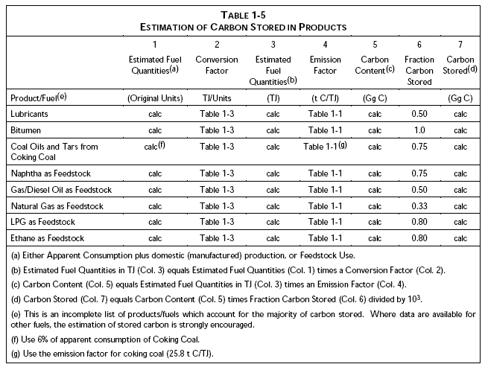
Source: Revised 1996 IPCC Guidelines, volume 3, page 1.28.

- Multiplication by an oxidation factor to account for the small amount of unoxidized carbon that is left in ash or soot. Parties should use oxidation factors that match their national circumstances.

Several countries have commented that the amount of carbon remaining unoxidized is highly variable, and in any case more variable than indicated by the general 1 per cent assumption across all oil-related fuels. For example, it has been noted that the amount of unburned carbon varies depending on several factors, including type of fuel consumed, type of combustion technology, age of the equipment, and operation and maintenance practices.

When national oxidation factors are not available, the ultimate option is to use the following IPCC default factors:

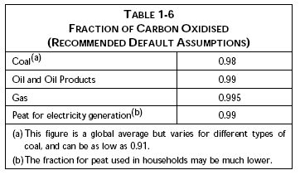
Source: Revised 1996 IPCC Guidelines, volume 3, page 1.29.

- Conversion of carbon to full molecular weight of CO₂ and summation across all fuels. To express the results as CO₂, the quantity of carbon oxidized should be multiplied by the molecular weight ratio of CO₂ to C (i.e. 44/12).

In addition to the six steps described above, emissions of CO₂ from international bunker fuels and biomass used as a fuel should be handled as follows:
- Bunker fuels: CO₂ emissions arising from fuels used in ships or aircraft for international transport should not be included in the national total. The quantities of fuels delivered to and consumed by international bunkers should be subtracted from the fuel supply to the country. The calculated bunker fuel emissions should be mentioned in a separate table as a memo item;
- Biomass fuels: Biomass fuels are included in the national energy and emissions accounts for completeness only. The resultant CO₂ emissions should not be included in national CO₂ emissions from fuel combustion. The release of carbon due to biomass used as energy should be accounted in the land use, land-use change and forestry (LULUCF) sector. Non-CO₂ emissions from biomass combustion, however, should be reported under the energy sector.

Because of the difficulties many countries have in allocating marine and aviation transport emissions between international and domestic, the IPCC provided a detailed decision tree and guidance for each in the IPCC good practice guidance. Both decision trees are provided below, along with a table describing how to distinguish individual travel segments between international and domestic. It is understood that many non-Annex I Parties will have difficulty strictly applying this guidance due to lack of detailed data.

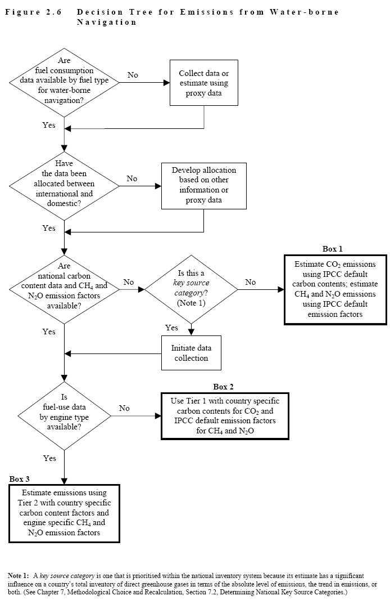
Source: IPCC good practice guidance, page 2.52.
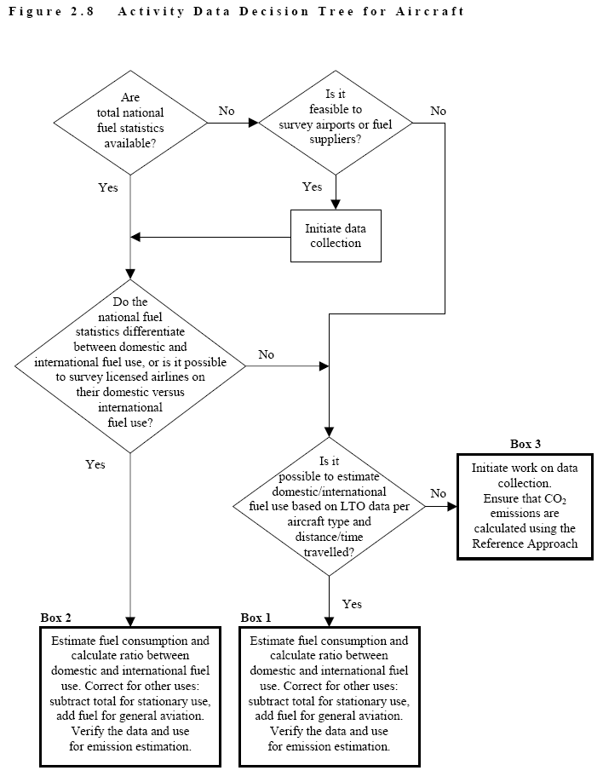
Source: IPCC good practice guidance, page 2.59.

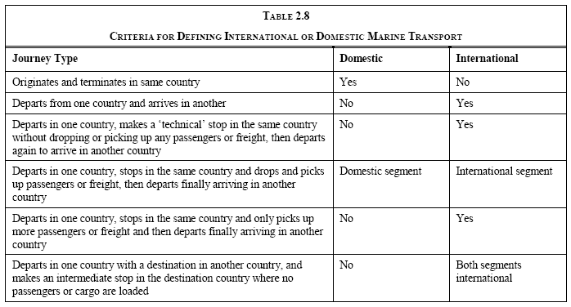
Source: IPCC good practice guidance, page 2.53.

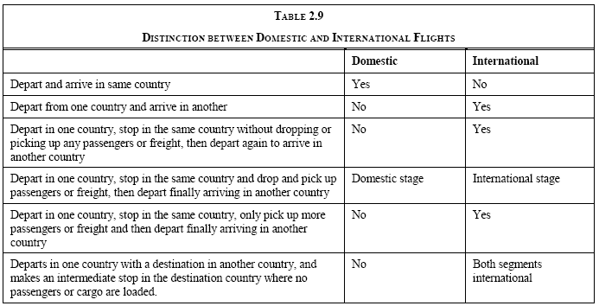
Source: IPCC good practice guidance, page 2.61.

  - Non-CO₂ emissions
The methods (i.e. tiers) for estimating non-CO₂ emissions require different levels of activity and technology detail.

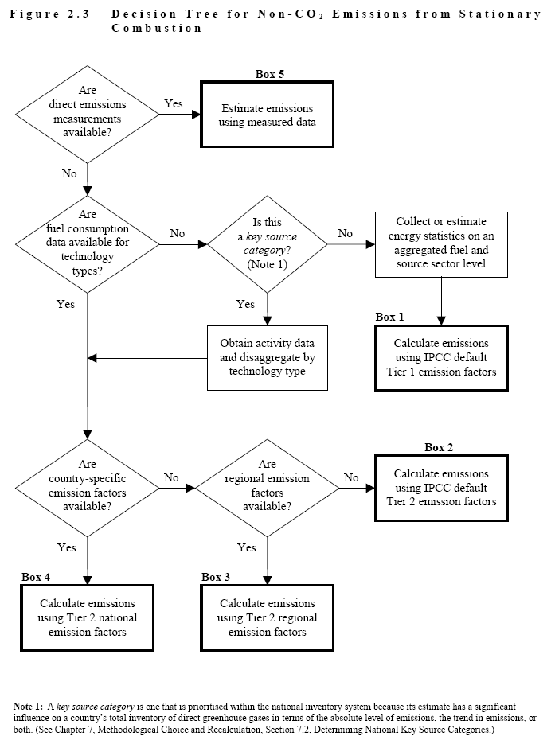
Source: IPCC good practice guidance, page 2.38.
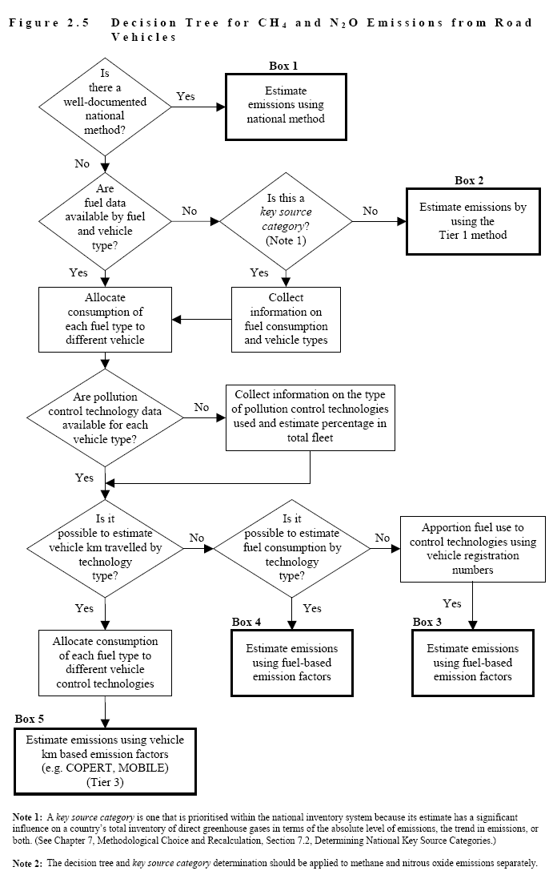
Source: IPCC good practice guidance, page 2.45.
Tier 1. Emissions from all sources of combustion are estimated by multiplying the quantity of fuel consumed by an average emission factor. Tier 1 methods do not require detailed activity data.

Tiers 2/3. Emissions are estimated by multiplying the quantity of fuel consumed by detailed fuel type and technology-specific emission factors.

Tier 1 methods rely on widely available fuel supply data that assume an average combustion technology is used. The difference between Tiers 2 and 3 is mainly an increase in the degree of detail required by the method. In general, Tier 2 methods use fuel consumption data that is disaggregated according to technology types that are sufficiently homogenous to permit the use of representative emission factors. Tier 3 methods generally estimate emissions according to activity types (km travelled or tonne-km carried) and specific fuel efficiency or fuel rates or an emission factor or factors expressed directly in terms of a unit of activity.

Both Tier 1 and Tier 2/3 methods rely on the same fundamental equation:

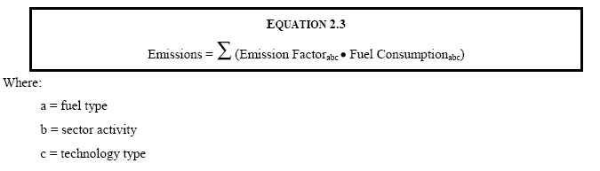
Source: IPCC good practice guidance, page 2.37.

Alternatively, countries may use national emission models or continuous emission measurement of CH₄ and N₂O, which is consistent with good practice, but in most cases continuous emission measurements are not justified because of the high cost of the measurements.

It is good practice to use the most disaggregated technology-specific and country-specific emission factors available, particularly those derived from direct measurements for stationary combustion sources. Using a Tier 2 approach, there are three possible types of emission factors:
- National emission factors;
- Regional emission factors;
- IPCC default emission factors, provided that a careful review of the applicability of these factors to the country’s conditions has been made. IPCC default factors may be used when no other information is available.

Stationary combustion. Default emission factors for CH₄, N₂O, NO_{x}, CO and NMVOCs by major technology and fuel types are presented in the Revised 1996 IPCC Guidelines, Reference Manual – Volume 3. Data are also presented on typical sulphur contents of fossil and biomass fuels. Alternative control technologies, with representative percentage reductions, are also shown. These data show the range and variation of sources and emission rates, as well as the impact of the control technologies.

Of particular importance for many countries are CH₄ emissions from various types of open burning and biomass combustion, because of the highly inefficient nature of the combustion process in many cases. In particular, charcoal production is likely to produce methane emissions at a rate that is several orders of magnitude greater than other combustion processes.

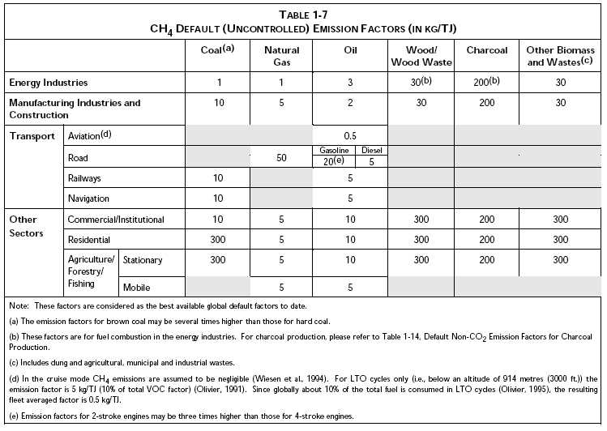
Source: Revised 1996 IPCC Guidelines, Reference Manual – Volume 3, p. 1.35.

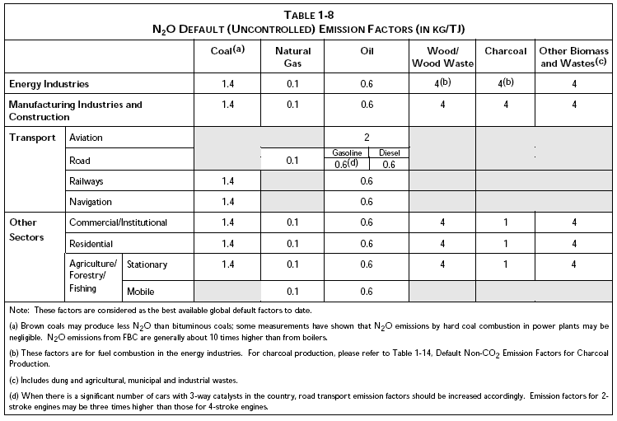
Source: Revised 1996 IPCC Guidelines, Reference Manual – Volume 3, p. 1.36.
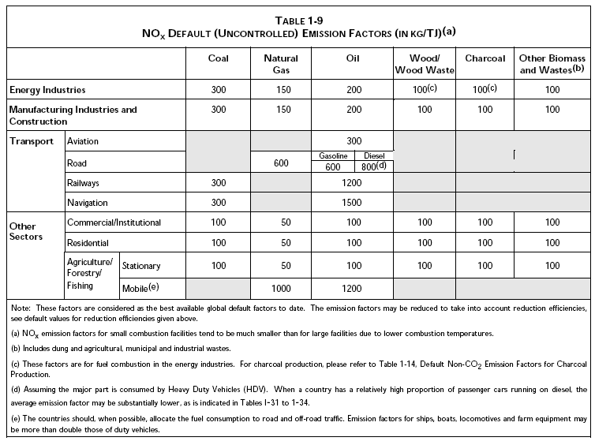
Source: Revised 1996 IPCC Guidelines, Reference Manual – Volume 3, p. 1.38.

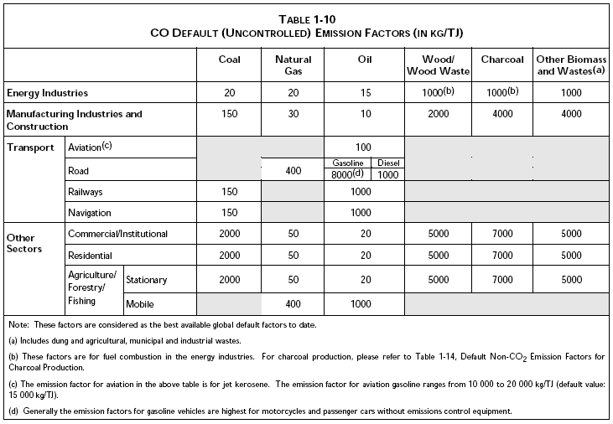
Source: Revised 1996 IPCC Guidelines, Reference Manual – Volume 3, p. 1.40.

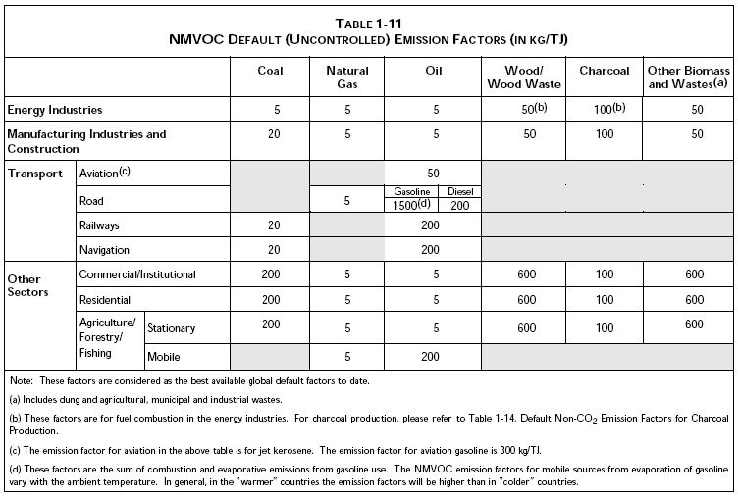
Source: Revised 1996 IPCC Guidelines, Reference Manual – Volume 3, p. 1.42.

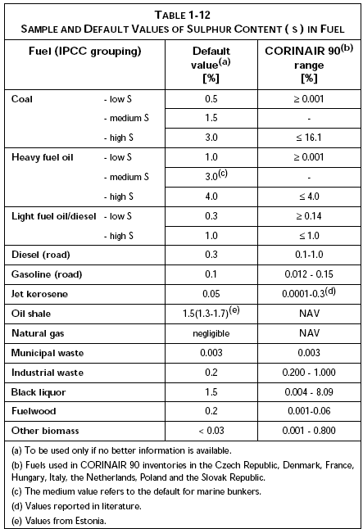
Source: Revised 1996 IPCC Guidelines, Reference Manual – Volume 3, p. 1.44.

Mobile combustion. Emissions of greenhouse gases from mobile sources can be estimated by major transport activity (road, air, rail and ships). However, as road transportation accounts for the majority of mobile-source fuel consumption, followed by air transport, greater priority has been attached to the development of emission models and inventories for road vehicles and aircraft. The diversity of mobile sources and the range of characteristics that affect emission factors are demonstrated and can be seen in the tables included in the Revised 1996 IPCC Guidelines.

Of particular importance for many countries are N₂O emissions from road transportation, which is considerably affected by the type of emission control technologies in use. Some catalyst-type control technologies can increase the rate of N₂O emissions relative to an uncontrolled vehicle. Non-Annex I Parties should focus their efforts on collecting data on the number of vehicles with catalytic emissions control devices that operate in their country. The type of catalytic control equipment can often be approximated by the age and make of the vehicle if it is not known. As shown in the table below, N₂O emission rates can vary dramatically (i.e. by an order of magnitude) due to the effect of different vehicle control technologies.

Table: Updated emission factors for USA gasoline vehicles.
Control technology | (g N₂O/kg fuel) | (g N₂O/MJ)
Low emission vehicle (low sulphur fuel) | 0.20 | 0.0045
Three-way catalyst (USA Tier 1) | 0.32 | 0.0073
Early three-way catalyst (USA Tier 0) | 0.54 | 0.012
Oxidation catalyst | 0.27 | 0.0061
Non-catalyst control | 0.062 | 0.0014
Uncontrolled | 0.065 | 0.0015
Source: IPCC good practice guidance, table 2.7, page 2.47.

- Relative importance of the energy sector – Fuel combustion
Carbon dioxide is the most common greenhouse gas produced by anthropogenic activities, accounting for about 60 per cent of the increase in radiative forcing since pre-industrial times. By far, the largest source of CO₂ emissions is due to combustion of fossil fuels for energy purposes.

Due to incomplete combustion, fuel combustion also results in the emission of relatively small amounts of CH₄. Thus, the contribution of fuel combustion to global emissions of CH₄ is minor (around 3 per cent). However, biomass combustion (e.g. fuelwood, charcoal, agricultural residues and wastes, and municipal wastes) is a potentially important source of methane and is by far the major contributor to CH₄ emissions within the fuel combustion category. In countries where substantial amounts of biomass-energy are used, fuel combustion is a more significant contributor to the CH₄ global picture.

The relative contribution of fuel combustion to global emissions of N₂O is more important than for the case of CH₄ (around 17 per cent). Due to more stringent NO_{x} emission controls and regulations for automobiles in many countries, N₂O emissions have increased.
- Relationships with other sources and sectors
There are several cases where double counting or miscounting of emissions from the energy sector is possible. To avoid these risks, the Revised 1996 IPCC Guidelines and the IPCC good practice guidance discuss ways to handle the interaction of sources and sectors with the energy sector.
  - Interaction with industrial processes sector
There are several cases of close interaction between fuel used as energy and fuel used in various industrial processes. In particular, you should carefully check to be sure countries are not double counting or omitting the fuel used in the iron and steel industry. The IPCC good practice guidance recommends allocating the carbon used as a reducing agent to the industrial processes sector; however, there are cases where the splitting of fuel use between the industrial processes and energy sectors is not possible. In such cases, countries typically allocate emissions to just one of these two sectors. This might lead to some irregularity in the sectoral emission trends if emissions are allocated differently across years or countries. Countries should provide explanations for their allocation decisions.

Some cases of double counting or omitting emissions can also occur in the accounting for non-energy uses of fossil fuels, in particular those that can lead to carbon storage. In theory, most CO₂ emissions resulting from the processing of non-energy fossil fuel feedstocks should be accounted for in the industrial processes sector (e.g. coal coke, petroleum coke anodes and cathodes, and ammonia feedstocks). In practice, however, some of the emissions from non-energy feedstocks will be accounted for under the energy sector using carbon storage factors (e.g. naphthas and LPG in the chemical industry and lubricants in transportation). These emissions often occur within the petrochemical industry where it is difficult to separate between energy and non-energy consumption.

The following table from the IPCC good practice guidance describes the accounting of fossil carbon emissions under the IPCC reporting framework.
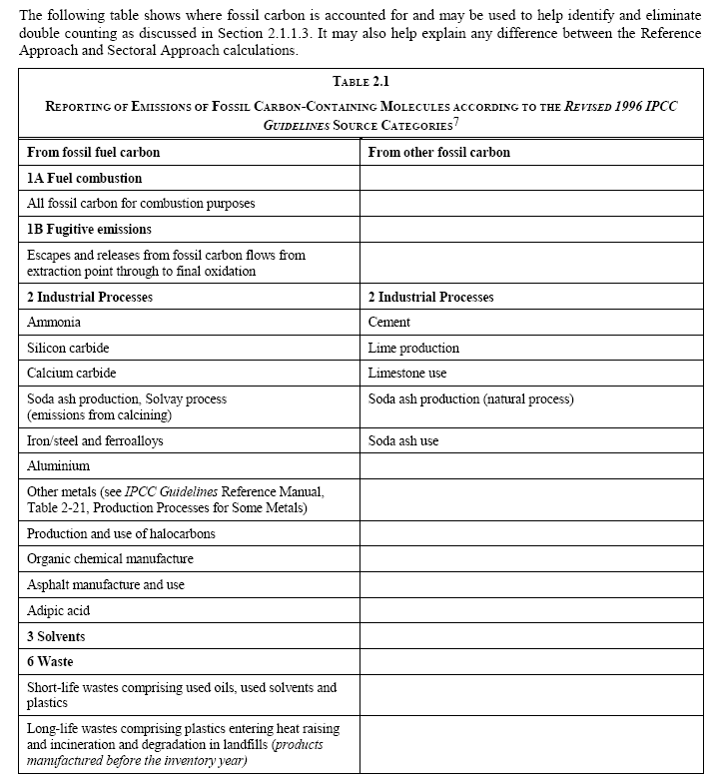
Source: IPCC good practice guidance, table 2.1, page 2.18.

  - Interaction with the waste and LULUCF sectors
Emissions relating to the combustion of wastes for energy purposes should be accounted for under the energy sector. Emissions from waste incineration that do not involve energy recovery should be accounted for under the waste sector. In either case, these wastes may originate from municipal solid waste collection, wastewater treatment facilities, food industries, or agricultural residues. Only the fraction of carbon in these wastes that is of fossil origin (e.g. plastics) is to be accounted for in the energy or waste sectors. Biogenic CO₂ is accounted for under the LULUCF sector. It is generally assumed that the same quantities of CO₂ from biogenic waste materials will be re-absorbed during the next growing season. It is especially important that the treatment of CO₂ emissions from waste combustion for energy and waste incineration is consistent with any carbon storage factors used in the estimating of CO₂ emissions from fossil fuel combustion.
  - Autoproduction of electricity
For various reasons, some companies choose to generate part or all of their own electricity and/or process heat, instead of purchasing it from an energy supplier (e.g. utility). In energy jargon these are called electricity autoproducers, autogenerators, self-generators, or self-producers. As recommended by the Revised 1996 IPCC Guidelines, autoproduced electricity should be assigned to the subsectors where it was generated (e.g. manufacturing industries). Care should be taken to ensure that no double counting or omission of emissions have occurred.
  - Fuel use for military purposes
Care should be taken to ensure that no double counting or omission of emissions due to military use of fossil fuels occurs. In particular, it is necessary to make sure that emissions from mobile sources operated by the country’s military are effectively included under the relevant transport categories or under the Other category. Confidentiality issues are frequently raised regarding data relating to military operations.
  - Mobile sources in agriculture
Care should also be taken to ensure that emissions from mobile sources used for on-site agricultural activities are accounted for under the agriculture/forestry/fisheries subsector and that emissions are not double counted in the transport subsector.
- Quality control and completeness
Countries should consider the following quality control and completeness issues before finalizing their inventory submission for fuel combustion:

- Have estimates for all gases (CO₂, CH₄ and N₂O), source categories, and subsource categories been provided?
- Have emissions from all of its territory, including territories and islands abroad been included?
- Have emissions from bunker fuels been reported under the memo items section of the summary tables and in the sectoral reporting table for the energy sector?
- Have all fossil-fuel-fired electricity power stations been included in the country’s emission estimates?
- Have emissions due to the combustion of fuels in the iron and steel industry been reported in the energy sector, as requested in the Revised 1996 IPCC Guidelines?
- Does the inventory avoid any double counting or omission of emissions from blast furnaces and coke production (i.e. if allocated to the industrial processes sector have emissions been excluded from energy sector)?
- Does the inventory report emissions from waste combustion with energy recovery under the energy sector? Do the CO₂ emission estimates from this waste combustion exclude the fraction of biogenic carbon in the wastes?
- Companies in the oil and natural gas industry often burn unprocessed or partially processed natural gas for fuel (i.e. non-marketable fuel). The consumption of these fuels may not be accounted for in sectoral consumption statistics. For instance, consumption of non-marketable gas is much less likely to be actually metered and may have substantially different carbon factors and calorific values than marketable gas due to greater concentrations of impurities and heavier-than-methane hydrocarbons.
- Compressor stations on gas transmission systems may not necessarily meter the fuel they draw from the pipeline. In these cases, the fuel consumption at the compressor stations is either estimated based on equipment duties or accounted as normal process shrinkage. Although not as common, similar situations can occur on oil transmission pipelines where product may sometimes be drawn from the pipeline to fuel the pumps. Theft, particularly from natural gas systems, may be a significant unaccounted source of fuel use in some countries.

In theory, a thorough comparison of the reference and sectoral approach calculations should identify many completeness issues. In practice, however, the energy statistics used for both approaches tend to come from similar government statistics, and therefore are likely to contain similar errors.
- Uncertainty
There are uncertainties associated with carbon content and calorific values for fuels. These are primarily related to the variability in fuel composition within the country and the frequency and scope of actual measurements. For most non-Annex I Parties, however, the uncertainty in activity data (i.e. fuel consumption data) will the dominant issue.

It is important to document the likely causes of uncertainty in national inventory reports and discuss steps being taken to reduce those uncertainties.
- UNFCCC software and reporting tables
The UNFCCC provides software to assist non-Annex I Parties in the preparation of their national greenhouse gas inventories. The worksheets included in this software are those referred to in decision 17/CP.8, and utilize IPCC default (i.e. Tier 1) methods in most cases, although national factors can also be used.

The software is available at:
<http://unfccc.int/resource/cd_roms/na1/ghg_inventories/index.htm>.

It is important to note that the Excel version of this software (version 1.3.2) will be replaced by a web-based tool to be available from June 2013.
- Reference materials
As an inventory expert, you should be familiar with the following technical materials, and stay informed on developments and updates to guidelines and relevant decisions of the UNFCCC Conference of the Parties (COP).

- UNFCCC Secretariat in Bonn for COP decisions, guidelines, reports, etc.
<http://unfccc.int>.

- The Institute for Global Environmental Strategies (IGES) in Japan for Revised 1996 IPCC Guidelines
<http://www.ipcc-nggip.iges.or.jp/public/gl/invs1.htm>.
- IGES for IPCC good practice guidance
<http://www.ipcc-nggip.iges.or.jp/public/gp/gpgaum.htm>.

- IGES for IPCC Emission Factor Database (EFDB)
<http://www.ipcc-nggip.iges.or.jp/EFDB/main.php>.

- International Energy Agency for national energy statistics
<http://www.iea.org>.

Closing
This handbook has introduced you to the skills and knowledge necessary to produce a high-quality greenhouse gas emissions inventory for the fuel combustion portion of the energy sector.

Any suggestions that you have to improve this handbook are welcome and should be sent to secretariat@unfccc.int.

Glossary

Activity data
Data on the magnitude of human activity resulting in emissions or removals taking place during a given period. For example, activity data in the energy sector can be the amount of fuel burned.

Alcohol
For the purpose of inventory preparation, alcohols include methyl alcohol (methanol), ethyl alcohol (ethanol) and tertiary butyl alcohol (TBA) (2-methyl propan-2-ol). Bio-alcohol used in fuels should be reported as a liquid biomass for information only.

Anthracite
A hard, black, lustrous coal containing a high percentage of fixed carbon and a low percentage of volatile matter. Often referred to as hard coal.

API gravity
American Petroleum Institute Gravity (API) is a measurement scale, relating to density, for crude oil or other liquid hydrocarbons, based on the formula:
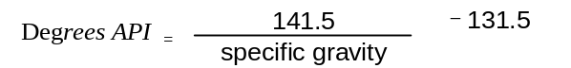

Apparent consumption
A concept used in the calculation of CO₂ emissions from fossil fuel consumption. This concept deals with apparent rather than actual consumption because it tracks the consumption of primary fuels to an economy with adjustments for net imports and stock changes in secondary fuels. While this procedure ensures that all of the carbon in fuels is accounted for, it is important to note that it does not produce actual consumption by specific fuel or fuel product. In cases where exports of secondary fuels exceed imports, it will produce negative numbers. This is clearly not an accurate estimate of the consumption of secondary fuel. It is merely an adjustment to the primary fuel supply calculated elsewhere in the worksheet.

Asphalt
(see Bitumen)

Biomass
Non-fossilized organic material both above ground and below ground, and both living and dead (e.g. trees, crops, grasses, tree litter and roots). When burned for energy purposes, these materials are referred to as biomass fuels. Biomass fuels also include gases recovered from the decomposition of organic matter (e.g. methane from manure digesters).

Bitumen
Solid, semi-solid or viscous hydrocarbon with a colloidal structure, brown to black in colour, obtained as a residue in the distillation of crude oil by vacuum distillation of oil residues from atmospheric distillation. It is soluble in carbon bisulphate, non-volatile thermoplastic (between 150° C and 200° C) with insulating and adhesive properties. Bitumen is used mainly in road construction and is also known as asphalt. The IPCC default net calorific value for bitumen is 40.19 TJ/Gg.

Bituminous coal
Includes anthracite, steam coal (other than anthracite) and coking coal. In the Revised 1996 IPCC Guidelines steam coal is referred to as ‘Other Bituminous Coal’. Bituminous coal has a gross calorific value greater than 23,865 kJ/kg (5,700 kcal/kg) on an ash-free but moist basis.

BKB
(See Patent Fuel and Brown Coal/Peat Briquettes (BKB).)

Black liquor
Also called sulphite lies. An alkaline spent liquor from digesters used in the production of sulphate or soda pulp during the manufacture of paper. Its energy content derives from the lignin removed from wood pulp.

Blast furnace gas (BFG)
BFG is obtained as a by-product in operating blast furnaces. It is recovered from furnaces and used partly within the plant and partly in other steel industry processes or in power stations equipped to burn it. Oxygen steel furnace gas is included under this category and is obtained as a by-product of the production of steel in an oxygen furnace. It is also known as converter gas or LD gas.

International bunker fuels
Fuels consumed for international marine and air transportation. International marine bunkers include fuels delivered to sea-going ships of all flags, including warships. Consumption by ships engaged in transport in inland and coastal waters is not included. International aviation bunkers include fuel use for international civil aviation. For the purpose of greenhouse gas emissions inventories, fuel used during landing and take-off for an international flight stage is considered to be part of international bunkers fuel use. Similar rules for determining international fuel use should be applied to military aviation activities.

Calorific value
The calorific value of a fuel is a measure of its heating value. It is expressed in terms of the heat released from a specified unit quantity under defined conditions of complete combustion. Two measures of calorific value are possible and are referred to as the net (NCV) and gross (GCV) calorific values. These measures may also be referred to as lower and higher heating values. The gross calorific value is the total quantity of heat released during combustion when all water formed by the combustion reaction is returned to the liquid state. The net calorific value is the total quantity of heat released during combustion when all water formed by the combustion reaction remains in the vapour state. The NCV is therefore lower than the GCV. As a general rule, for natural gas the NCV is 9 to 10 per cent lower than the GCV, while for oils and coals the NCV is 5 per cent lower than the GCV.

Charcoal
A black amorphous form of carbon made by carbonizing wood or other organic matter in the absence of air.

Coal
All coal, both primary (including hard coal, lignite and peat) and derived fuels (including patent fuel, coke-oven coke, gas coke, BKB, coke-oven gas and blast furnace gas).

Coke
Coke-oven coke is a solid product obtained from the carbonization of coal, principally coking coal (or lignite), at high temperature. It is low in moisture and volatile matter and used mainly in the iron and steel industry as energy source and reducing agent. Semi-coke, the solid product obtained from the carbonization of coal at a low temperature, should be included in the coke-oven category. Semi-coke is used as a domestic fuel or by the transformation plant itself. Gas coke is a by-product of hard coal used for the production of town gas in gas works. Gas coke is used for heating purposes.

Coke-oven gas
Obtained as a by-product of solid fuel carbonization and gasification operations carried out by coke producers and iron and steel plants that are not connected with gasworks and municipal gas plants.

Coking coal
Coal of calorific value greater than 23,865 kJ/kg (5,700 kcal/kg) on an ash-free but moist basis. Coking coal is a coal with a quality that allows the production of coke suitable to support a blast furnace charge.

Completeness
For the purpose of greenhouse gas emissions inventories, completeness means that an inventory covers all sources and sinks as well as all gases included in the Revised 1996 IPCC Guidelines for National Greenhouse Gas Inventories in addition to other existing relevant source/sink categories which are specific to individual countries (and therefore may not be included in the Revised 1996 IPCC Guidelines). Completeness also means full geographic coverage of sources and sinks of a Party.

Consistency
For the purpose of greenhouse gas emissions inventories, consistency means that an inventory should be internally consistent in all its elements over a period of years. An inventory is consistent if the same methodologies are used for the base and all subsequent years and if consistent data sets are used to estimate emissions or removals from sources or sinks. Under certain circumstances referred to in FCCC/CP/2002/8, an inventory using different methodologies for different years can be considered to be consistent if it has been recalculated in a transparent manner taking into account any good practices.

Crude oil
Crude oil is a mineral oil of natural origin comprising a mixture of hydrocarbons and associated impurities, such as sulphur. It exists in the liquid phase under normal surface temperature and pressure and its physical characteristics (density, viscosity, etc.) are highly variable. Inputs other than crude oil and natural gas liquids (NGL) should be included with crude oil and footnoted. These include hydrogen, synthetic crude oil, such as mineral oils extracted from shales and bituminous sand.

Conversion factor
The term conversion factor has multiple uses. For example, as net calorific value, to convert quantities expressed in natural units to energy units and as a scaling factor to convert one form of energy unit to another (e.g. Btu to GJ).

Decision tree
For the purpose of greenhouse gas emissions inventories, a decision tree is a flow chart describing the steps (choice of methods, choice of activity data and choice of emission factors) that need to be followed to develop an inventory or an inventory component in accordance with the principles of good practice in the IPCC good practice guidance.

Emission factor (EF)
A coefficient that relates activity data to the amount of chemical compound, which is the source of later emissions. Emission factors are often based on a sample of measurement data, averaged to develop a representative rate of emission for a given activity level under a given set of operating conditions.

Ethane
A naturally gaseous straight-chain hydrocarbon (C₂H₆) extracted from natural gas and refinery gas streams. Commonly used as a petrochemical feedstock in the manufacture of plastics and other products. The IPCC default net calorific value for ethane is 47.49 TJ/Gg.

Fossil fuel
Combustible fuels formed from organic matter within the earth’s crust over geological time scales and products manufactured from them. The fuels extracted from the earth and prepared for market are termed ‘primary fuels’ (e.g. coal, lignite, natural gas and crude oil) and fuel products manufactured from them are termed ‘secondary fuels’ (e.g. coke, blast furnace gas, gas/diesel oil, gasoline and LPG).

Gas/diesel oil
A medium distillate oil primarily distilling between 180° C and 380° C. The IPCC default net calorific value for gas/diesel oil is 43.33 TJ/Gg. Several grades are available:
- Diesel oil for diesel compression ignition (cars, trucks, marine, etc.);
- Light heating oil for industrial and commercial uses;
- Other gas oil, including heavy gas oils which distil between 380° C and 540° C, and which are used as petrochemical feedstocks.

Gas
Natural gas, including gas works gas (but excluding natural gas liquids) comprises gases at normal temperature and pressure occurring in underground deposits. In its marketed state it consists mainly of methane. It includes both ‘non-associated’ gas coming from fields producing hydrocarbons predominantly in gaseous form and ‘associated’ gas produced in association with crude oil. It also includes methane recovered from coal mines. Production is normally measured dry (i.e. after the removal of the NGLs and impurities present in the gas at the well head). It therefore excludes gas re-injected into the wells, gas flared and gas used at production and treatment plants.

Gas works gas
Includes substitute natural gas produced in public utility or private plants whose main purpose is manufacture, transport and distribution of gas. It also includes gas produced by carbonization (including gas produced by coke ovens and transferred to gas works gas) by total gasification with or without enrichment with oil products (LPG, residual fuel oil, etc.) by cracking of natural gas, and by reforming and simple mixing of gases and/or air.

Gasoline
Gasoline includes aviation gasoline, jet gasoline and motor gasoline. Aviation gasoline is motor spirit prepared especially for aviation piston engines with an octane number suited to the engine, a freezing point of –60° C and a distillation range usually within the limits of 30° C and 180° C. Jet gasoline is a light hydrocarbon oil distilling between 100° C and 250° C for use in aviation turbine power units. It is obtained by blending kerosene and gasoline or naphtha in such a way that the aromatic content does not exceed 25 per cent in volume and the vapour pressure is between 13.7 kPa and 20.6 kPa. Motor gasoline consists of a mixture of light hydrocarbons distilling between 35° C and 215° C. It is used as a fuel for land-based spark ignition engines. The IPCC default net calorific value for aviation and motor gasoline is 44.80 TJ/Gg.

Good practice
For the purpose of greenhouse gas emissions inventories, good practice is a set of procedures set out by the IPCC that are intended to ensure that greenhouse gas inventories are accurate in the sense that they are systematically neither overestimates nor underestimates, so far as can be judged, and that uncertainties are reduced as far as possible. Good practice covers choice of estimation methods appropriate to national circumstances, quality assurance and quality control at the national level, quantification of uncertainties and data archiving and reporting to promote transparency.

Hard coal
Includes coking coal, anthracite and other bituminous coal.

IEA
The International Energy Agency. An autonomous body specialized in energy and attached to the OECD.

Industry subsource category
Industrial consumption of fuels should be specified by subsectors that correspond to the International Standard Industrial Classification of All Economic Activities (ISIC). Energy used for transport by industry should not be reported here but under Transport. For each country, the emissions from the largest fuel-consuming industrial categories (ISIC) should be reported, as well as those from significant emitters of pollutants. The Revised 1996 IPCC Guidelines suggest the following list of categories:
- Iron and Steel Industry (ISIC Group 271 and Class 2731);
- Non-ferrous Metals (ISIC Group 272 and Class 2732);
- Chemicals (ISIC Division 24);
- Pulp, Paper and Print (ISIC Divisions 21 and 22);
- Food Processing, Beverages and Tobacco (ISIC Divisions 15 and 16);
- Other (construction branch, etc.).

Imports and exports
These comprise amounts of fuel having crossed the national territorial boundaries of the country, whether or not customs clearance has taken place.

Jet kerosene
A distillate used for aviation turbine power units. It has the same distillation characteristics between 150° C and 300° C (generally not above 250° C) and flash point as kerosene. In addition, it has particular specifications (such as freezing point) which are established by the International Air Transport Association (IATA). The IPCC default net calorific value for jet kerosene is 44.59 TJ/Gg.

Kerosene (other than jet kerosene)
Kerosene comprises refined petroleum distillate and is used for purposes other than aircraft transport (e.g. cooking and lighting). It distils between 150° C and 300° C. The IPCC default net calorific value for other kerosene is 44.75 TJ/Gg.

Key source category
For the purpose of greenhouse gas emissions inventories, a key source category is one that is prioritized within the national inventory system because its estimate has a significant influence on a country’s total inventory of direct greenhouse gases in terms of the absolute level of emissions, the trend in emissions, or both. (See Chapter 7 of the IPCC good practice guidance, Methodological Choice and Recalculation).

Lignite
Non-agglomerating coals with a gross calorific value less than 17,435 kJ/kg (4,165 kcal/kg) and greater than 31 per cent volatile matter on dry-mineral-matter-free basis.

Liquefied petroleum gas (LPG)
Light saturated paraffinic hydrocarbons derived from the refinery processes, crude oil stabilization and natural gas processing plants. They consist mainly of propane (C₃H₈) and butane (C₄H₁₀) or a combination of the two. They are normally liquefied under pressure for transportation and storage. The IPCC default net calorific value for LPG is 47.31 TJ/Gg.

Lubricants
Lubricants are hydrocarbons produced from distillate or residue, and they are mainly used to reduce friction between bearing surfaces. This category includes all finished grades of lubricating oil, from spindle oil to cylinder oil, and those used in greases, including motor oils and all grades of lubricating oil base stocks. The IPCC default net calorific value for lubricants is 40.19 TJ/Gg.

Methanol
Methanol (CH₃OH) is a colourless poisonous liquid with essentially no odour and little taste. It is the simplest alcohol, with a boiling point of 64.7° C. In transportation, methanol is used as a vehicle fuel by itself (M100), or blended with gasoline (M85).

Naphtha
A feedstock destined for either the petrochemical industry (e.g. ethylene manufacture or aromatics production) or for gasoline production by reforming or isomerization within the refinery. Naphtha comprises material in the 30° C and 210° C distillation range. The IPCC default net calorific value for naphtha is 45.01 TJ/Gg.

Natural gas liquids (NGL)
Liquid or liquefied hydrocarbons recovered from natural gas in separation facilities or gas processing plants. Natural gas liquids include ethane, propane, butane (normal and iso-), (iso) pentane and pentanes plus (sometimes referred to as natural gasoline or plant condensate).

Other subsectors
For the inventory purposes, ‘Other’ subsectors include the following combustion activities:
- Commercial/institutional includes fuel combustion in commercial and institutional buildings. (All activities included in ISIC categories 4103, 42, 6, 719, 72, 8 and 91-96);
- Residential includes fuel combustion in households;
- Agriculture/forestry/fisheries includes fuel combustion in agriculture, forestry, or domestic inland, coastal and deep-sea fishing. This includes traction vehicles, pump fuel use, grain drying, horticultural greenhouses and other agriculture, forestry or fishing-related fuel use. (Activities included in ISIC categories 05, 11, 12 and 1302). Highway agricultural transportation is excluded.

Patent fuel and brown coal/peat briquettes (BKB)
A composition fuel manufactured from coal fines by shaping with the addition of a binding agent (pitch). The amount of patent fuel produced can be slightly higher than the amount of coal consumed in the transformation process because of the addition of pitch. BKB are composition fuels manufactured from lignite/brown coal, produced by briquetting under high pressure. These figures include peat briquettes, dried lignite fines and dust.

Peat
Combustible, soft, porous or compressed sedimentary deposit of plant origin with a high water content (up to 90 per cent in its natural state), easily cut, of light to dark brown colour.

Petroleum coke
A black solid residue obtained mainly by cracking and carbonizing residue feedstock, tar and pitches in processes such as delayed coking or fluid coking. It consists mainly of carbon (90 to 95 per cent) and has low ash content. The IPCC default net calorific value for petroleum coke is 31.00 TJ/Gg.

Petroleum products
Includes refinery gas, ethane, LPG, gasoline (aviation and motor), jet fuels, kerosene, gas/diesel oil, heavy fuel oil, naphtha, white spirit, lubricants, bitumen, paraffin waxes, petroleum coke and other petroleum products.

Quality assurance and quality control
For the purpose of greenhouse gas emissions inventories, quality assurance (QA) includes a planned system of review procedures involving personnel not directly involved in the inventory compilation/development process to verify that data quality objectives were met, ensure that the inventory represents the best possible estimate of emissions and sinks given the current state of scientific knowledge and data available, and support the effectiveness of the quality control (QC) programme. For the purpose of greenhouse gas emissions inventories, QC is a system of routine technical activities, to measure and control the quality of the inventory as it is being developed. The QC system is designed:
- To provide routine and consistent checks to ensure data integrity, correctness and completeness;
- To identify and address errors and omissions;
- To document and archive inventory material and record all QC activities.

QC activities include general methods, such as accuracy checks on data acquisition and calculations and the use of approved standardized procedures for emission calculations, measurements, estimating uncertainties, archiving information and reporting. Higher tier QC activities include technical reviews of source categories, activity and emission factor data, and methods.

Reference approach
The IPCC reference approach is a simple, accurate and transparent approach for assessing CO₂ emissions due to combustion of energy, which is based on the usual energy balance sheet of a country. The reference approach calculations of CO₂ emissions can be performed quickly given that information on the quantities of fuels supplied to the whole economy is generally available.

Refinery gas
A mixture of non-condensable gases mainly consisting of hydrogen, methane, ethane and olefins obtained during distillation of crude oil or treatment of oil products (e.g. cracking) in refineries. This also includes gases, which are returned from the petrochemical industry. The IPCC default net calorific value for refinery gas is 48.15 TJ/Gg.

Residual fuel oil
All residual (heavy) fuel oils (including those obtained by blending). Kinematic viscosity is above 10 cSt at 80° C. The flash point is always above 50° C and density is always more than 0.90 kg/l. The IPCC default net calorific value for residual fuel oil is 40.19 TJ/Gg.

Sectoral approach
The sectoral approach assesses CO₂ and non-CO₂ emissions due to combustion of energy by estimating emissions split throughout the economy. Sectors to be considered are:
- Public electricity and heat production;
- Manufacturing industries and construction;
- Transport (including pipeline transport);
- Other sectors (commercial/institutional, residential, agriculture/forestry/fisheries);
- Other: all uses that are not included elsewhere, such as military uses.
The sectoral approach provides a valuable way for cross-checking emission estimates of CO₂, with the reference approach.

Stock changes
The difference between opening stock levels on the first day of the year and closing levels on the last day of the year of stocks on national territory held by producers, importers, energy transformation industries and large consumers. For the purpose of greenhouse gas emissions inventories, the formula of ‘apparent consumption’ considers the stock change with a negative algebraic sign (subtracted from the supply). Thus, when more fuel is added to the stock, it should be entered with a positive sign, thus withdrawing the quantity from consumption. A stock reduction is a negative stock change, and should receive a negative sign. By subtracting the negative quantities entered, the formula will cause an increase in the apparent consumption.

Stored carbon
Carbon retained for long periods of time within non-energy products manufactured from fuels (e.g. naphtha, lubricants and bitumen).

Sub-bituminous coal
Non-agglomerating coals with a gross calorific value between 17,435 kJ/kg (4165 kcal/kg) and 23,865 kJ/kg (5,700 cal/kg) containing more than 31 per cent volatile matter on dry-mineral-matter-free basis. See also lignite. The distinction between sub-bituminous coal and lignite is not normally made in Europe.

Sulphite lies
(see Black liquor)

Transparency
For the purpose of greenhouse gas emissions inventories, transparency means that the assumptions and methodologies used for an inventory should be clearly explained to facilitate replication and assessment of the inventory by users of the reported information. The transparency of inventories is fundamental to the success of the process for the communication and consideration of information.

Transport source category
Includes fuels consumed by all transport activities specified as follows:
- Civil aviation comprises international civil aviation and domestic air transport (commercial, private, agricultural, etc.), including take-offs and landings. It excludes use of fuel at airports for ground transport and fuel for stationary combustion at airports. For the purpose of greenhouse gas emissions inventories, civil aviation excludes international civil aviation, which should be accounted for under bunker fuels. Domestic civil aviation includes all civil domestic passenger and freight traffic inside a country (not used as international bunkers) and including take-offs and landings for these flight stages;
- Road transportation includes all combustion arising from fuel use in road vehicles, including the use of agricultural vehicles on highways;
- Railways includes fuel use for both freight and passenger traffic routes;
- Navigation includes fuels used for domestic navigation of all vessels not engaged in international transport, except fishing (which should be reported under other sectors (fisheries);
- Other transportation includes combustion of fuel from all remaining transport activities including pipeline transportation, ground activities in airports and harbours, and off-road activities not otherwise reported under agriculture or manufacturing industries and construction. Military transport should also be excluded, and be reported under 1.A.5 Other (Revised 1996 IPCC Guidelines – Vol. 1 – Reporting Instructions).

Trend
For the purpose of greenhouse gas emissions inventories, the trend of a quantity measures its change over a time period, with a positive trend value indicating growth in the quantity, and a negative value indicating a decrease. It is defined as the ratio of the change in the quantity over the time period, divided by the initial value of the quantity, and is usually expressed either as a percentage or a fraction.

White spirit and SBP
Refined distillate intermediates with a distillation in the naphtha/kerosene range. They are subdivided into:
- Industrial spirit (SBP): light oils distilling between 30° C and 200° C. There are seven or eight grades of industrial spirit, depending on the position of the cut in the distillation range. The grades are defined according to the temperature difference between the 5 and 90 per cent volume distillation points (which is not more than 60° C).
- White spirit: industrial spirit with a flash point above 30° C. The distillation range of white spirit is 135° C to 200° C.

Autoproduction refers to electricity, heat or steam produced by an industrial facility for its own consumption or sale to other consumers or to the electricity grid. Autoproduction is sometimes also called autogeneration, self-generation or self-production.
The fact that CH₄, CO and NMVOCs oxidize in the atmosphere to CO₂ is not clearly addressed in the Revised 1996 IPCC guidelines for other fossil carbon emission sources such as fugitive emissions from coal mines, oil and gas systems, and industrial processes. A fully consistent inventory should account for this oxidized CO₂ from non-combustion sources of fossil-based CH₄, CO and NMVOCs as well as from combustion sources.
It should be noted that most Parties included in Annex I to the Convention also have difficulty strictly applying the IPCC’s guidance on bunker fuels.

