Consultative Group of Experts on National Communications from Parties not included in Annex I to the Convention
(CGE)


Handbook on the Agriculture Sector
General Issues

CONTENTS

1 Principles and definition 4
2 Revised 1996 IPCC Guidelines for National Greenhouse Gas Inventories 4
2.1 Brief description of the Revised 1996 IPCC Guidelines for National Greenhouse Gas Inventories 5
2.2 General notes on the Revised 1996 IPCC Guidelines for the agricultural sector 5
2.2.1 Scope 5
2.2.2 Data quality and time frame 5
2.2.3 Default method 6
2.3 Basic principles underlying the Revised 1996 IPCC Guidelines 6
2.4 Methodologies and reporting 7
2.4.1 Activity data and emission factors 7
2.4.2 Worksheets 7
2.4.3 Notation key 8
2.4.4 Overview table 8
2.4.5 Data Completeness 8
2.4.6 Uncertainties 8
2.4.7 Documentation 8
2.5 Agriculture sector source categories 9
3 Good practice guidance and uncertainty management in natinal greenhouse gas inventories 11
3.1 Introduction 11
3.2 Activity data and national parameters 12
3.3 Key categories definition 13
3.4 Elaborating the inventory 14
3.4.1 Livestock characterization 14
3.4.2 Enteric fermentation and CH₄ emissions 16
3.4.3 Manure Management 16
3.4.3 Non-CO₂ Gas emissions from Biomass Burning 17
3.4.5 N₂O emissions from agricultural soils 23
4. UNFCCC Software and reporting tables 29
4.1 Structure 29
4.2 Operation 30
5. Emission factor database (EFDB) 31
5.1 General issues 31
5.2 Objectives 32
5.3 Criteria for inclusion of new data 32
5.4 Data contained and access to the EFDB 32
5.5 How to access to the web application 33

1. Principles and definitions

National greenhouse gas (GHG) inventories, referred to below as inventories, should fulfil some requisites to be precise and reliable. Thus, the inventories must be Transparent, Consistent, Comparable, Complete and Accurate (TCCCA).

In the context of these UNFCCC reporting guidelines on annual inventories:

- Transparency means that the assumptions and methodologies used for an inventory should be clearly explained to facilitate replication and assessment of the inventory by users of the reported information. The transparency of inventories is fundamental to the success of the process for the communication and consideration of information;

- Consistency means that an inventory should be internally consistent in all its elements with inventories of other years. An inventory is consistent if the same methodologies are used for the base and all subsequent years and if consistent data sets are used to estimate emissions or removals from sources or sinks. Under certain circumstances, an inventory using different methodologies for different years can be considered to be consistent if it has been recalculated in a transparent manner, in accordance with the Intergovernmental Panel on Climate Change (IPCC) Good Practice Guidance and Uncertainty Management in National Greenhouse Gas Inventories(hereinafter referred to as the IPCC good practice guidance);

- Comparability means that estimates of emissions and removals reported by Annex I Parties in inventories should be comparable among Annex I Parties. For this purpose, Annex I Parties should use the methodologies and formats agreed by the COP for estimating and reporting inventories. The allocation of different source/sink categories should follow the split of the Revised 1996 IPCC Guidelines for National Greenhouse Gas Inventories (hereinafter referred to as the Revised 1996 IPCC Guidelines), at the level of its summary and sectoral tables;

- Completeness means that an inventory covers all sources and sinks, as well as all gases, included in the IPCC Guidelines as well as other existing relevant source/sink categories which are specific to individual Annex I Parties and, therefore, may not be included in the IPCC Guidelines. Completeness also means full geographic coverage of sources and sinks of an Annex I Party;

- Accuracy is a relative measure of the exactness of an emission or removal estimate. Estimates should be accurate in the sense that they are systematically neither over nor under true emissions or removals, as far as can be judged, and that uncertainties are reduced as far as practicable. Appropriate methodologies should be used, in accordance with the IPCC good practice guidance, to promote accuracy in inventories.

It is understood that Annex-I Parties are obliged to fulfil all the requisites mentioned above, whilst non-Annex I Parties are encouraged to fulfil them as far as possible.

2. Revised 1996 IPCC Guidelines for National Greenhouse Gas Inventories

According to decision 17/CP.8, non-Annex I Parties should use the Revised 1996 IPCC Guidelines for estimating and reporting their national GHG inventories (available at <http://www.ipcc-nggip.iges.or.jp/public/gl/invs1.htm>). These guidelines comprise three volumes that together provide the range of information needed to plan, carry out and report results of a national inventory: Volumes I and III of the methodology are only available in English, but Volume II, which contains all the methodological tables and relevant explanations on how to calculate emissions, is also available in French, Russian and Spanish.

2.1 Brief Description of the Revised 1996 IPCC Guidelines

The GHG Inventory Reporting Instructions (Volume 1) provides step-by-step directions for assembling, documenting and transmitting completed national inventory data consistently, regardless of the method used to produce the estimates. These instructions are intended for all users of the Revised 1996 IPCC Guidelines and provide the primary means of ensuring that all reports are consistent and comparable.

The GHG Inventory Workbook (Volume 2) contains suggestions about planning and getting started on a national inventory for participants who do not have a national inventory available already and are not experienced in producing such inventories. It also contains step-by-step instructions for calculating emissions of carbon dioxide (CO₂) and methane (CH₄), as well as some other trace gases, from six major emission source categories. It is intended to help experts in as many countries as possible to start developing inventories.

The GHG Inventory Reference Manual (Volume 3) provides a compendium of information on methods for estimation of emissions for a broader range of greenhouse gases and a complete list of source types for each. It summarizes a range of possible methods for many source types. It also provides summaries of the scientific basis for the inventory methods recommended and gives extensive references to the technical literature.

The use of the Revised 1996 IPCC Guidelines is enhanced by the inventory software developed for use in calculating and estimating emissions (see Section 5 below). The Revised 1996 Guidelines are complemented by the IPCC good practice guidance inventories (see Section 3 below).

2.2 General Notes on the Revised 1996 Guidelines for the Agricultural Sector

2.2.1 Scope

The Revised 1996 IPCC Guidelines are designed to estimate and report on national inventories of anthropogenic GHG emissions and removals. In general terms, “anthropogenic” refers to GHG emissions and removals that are a direct result of human activities or are the result of natural processes that have been affected by human activities. National inventories should include GHG emissions and removals taking place within national (including administered) territories and offshore areas over which the country has jurisdiction.

2.2.2 Data Quality and Time Frame

The data available to estimate anthropogenic GHG emissions resulting from fuel combustion are generally of a better quality than the data available to estimate GHG emissions and removals in the areas of agriculture and land use change/forestry. Accordingly, while the Revised 1996 IPCC Guidelines request an emission figure for a single year in most source/sink sectors, three-year averages (with the base year in the middle) are preferred in the agriculture and land use, land-use change and forestry sectors.

2.2.3 Default Method

The Revised 1996 IPCC Guidelines contain “default” methodologies and a number of “default” assumptions and data for use in the estimation of GHG emissions and removals. This default information is included primarily to provide users with a starting point from which they can develop their own national assumptions and data. Indeed, national assumptions and data are always preferred because the default assumptions and data may not always be appropriate for specific national contexts. In general, therefore, default assumptions and data should be used only when national assumptions and data are not available. Section 2 of the Introduction to the IPCC Greenhouse Gas Inventory Workbook provides information on the quality of the default data available in different source/sink categories.

Many of the categories of emissions and removals can be estimated only with large ranges of uncertainty. Quite naturally, some national experts have developed methods that are designed to produce ranges of estimates rather than point estimates for highly uncertain categories. The Revised 1996 IPCC Guidelines, however, require that users provide a single point estimate for each gas and emissions/removal category. This is simply to make the task of compilation, comparison and evaluation of national reports manageable. Users are encouraged to provide uncertainty ranges or other statements of confidence or quality along with the point estimates. The procedures for reporting uncertainty information are discussed in the Greenhouse Gas Inventory Reporting Instructions.

2.3 Basic Principles Underlying the Revised 1996 IPCC Guidelines

There are basic principles underlying the Revised 1996 IPCC Guidelines:

Documentation standards: Documentation standards are necessary to ensure transparency of national inventories and hence to allow the inventory to be reviewed. By providing the necessary documentation, the comparability of national inventories can also be evaluated. Therefore, along with Sectoral and Summary Report Tables, countries should provide the worksheets used to develop the national inventory, containing at least all major assumptions activity data and emission factors. The IPCC also recommends that countries submit a description of the method used and any definitions, as well as other relevant assumptions that cannot be summarized in table form. Enough data should be provided to allow a third party to reconstruct the inventory from national activity data and assumptions (the working definition of transparency). To limit the volume of data to be provided, written documentation should focus on describing fully any differences in method and assumptions from the IPCC default methods.

Verification and uncertainty assessment: To improve the quality of inventory data and to help assess the uncertainty surrounding estimates, the Revised 1996 IPCC Guidelines Reporting Instructions recommend that inventories be verified through the use of a set of simple checks for completeness and accuracy of submissions. These checks can be performed centrally, although it is preferable for the countries to do as much as possible themselves. Finally, an uncertainty assessment should also be conducted as far as possible and summarized for each major part of the inventory. Conceptual guidance for the assessment of the uncertainty of emission estimates are provided in Annex I Managing Uncertainties. Other approaches to describing the uncertainty associated with point estimates of emissions and removals are also possible. Whether you use one of the approaches provided by the IPCC or another approach, you should include an uncertainty discussion in your inventory submission.

2.4 Methodologies and Reporting

The inventory has to be reported in the form of Sectoral, Summary and Overview Tables. Tables 1 to 6 correspond to each of the sectors. Agriculture is reported in Table 4 and its corresponding background sectoral tables (4A to 4G). Tables 7A and 7B correspond to Summary Report, and Tables 8A and 8B to Overview.

2.4.1 Activity Data and Emission Factors

Sectoral tables and their background worksheets must be filled in with activity data and emission factors. As described in the Glossary included in Volume 1:

Activity data means “data on the magnitude of human activity resulting in emissions or removals taking place during a given period of time. In the energy sector for example, the annual activity data for fuel combustion sources are the total amounts of fuel burned. Annual activity data for methane emissions from enteric fermentation are the total number of animals being raised, by species.”

Emission factor is “a coefficient that relates the activity data to the amount of chemical compound which is the source of later emissions. Emission factors are often based on a sample of measurement data, averaged to develop a representative rate of emission for a given activity level under a given set of operating conditions.”

The default methodology included in the Revised 1996 IPCC Guidelines includes default emission factors and, in some cases, default activity data. In spite of this, since the IPCC default methodology may not be appropriate for all countries, non-Annex I countries are encouraged to use country-specific and regional emission factors and activity data in order to reduce uncertainties of their estimates. In this sense, the use of the IPCC emission factor database (EFDB) (see Section 4 below) is also recommended.

The IPCC inventory methodology is based on various tiers, with Tier 1 being the default methodology. Tiers 2 and 3 involve more elaborate methods which could be either source category specific or technology based. In cases where a national methodology exists and is consistent with the Revised 1996 IPCC Guidelines, it is recommended to use the national methodology.

2.4.2 Worksheets

Worksheets provided in Volume 2 can be used for preparing the inventory. Worksheets are prepared so that the Party can describe the methodology used and fill in activity data and emission factors in a detailed and standardized way. With the aid of UNFCCC software (see Section 5), data from the worksheets is automatically converted into sectoral and summary tables. The use of these worksheets is highly recommended, unless the Party produces an inventory in a format different from the IPCC recommended format (in which case, the Party can fill in directly the sectoral tables). In general, the worksheets are essential for transparency and reconstruction of the inventory.

2.4.3 Notation Key

As far as possible, countries should use the Sectoral and Summary Report Tables to summarize final inventory results. A notation key (see box in p. 1.21, Volume 1) should be used: to show where countries believe the identified source is zero (0); where countries have opted not to estimate (NE) a particular source of a GHG; where, due to data limitations, an individual source is included elsewhere (IE); and where a particular category is reported as not occurring (NO) in a country.

2.4.4 Overview Table

The Overview Table (8A) should be used by countries to summarize their own assessment of completeness (e.g. partial, full estimate, not estimated) and quality (high, medium or low) of major source/sink inventory estimates. It gives a brief overview of the categories that have been taken into account in the emission inventory, as well as the level of documentation and disaggregation of the categories (see Notation Key, above, for a full explanation). The Disaggregation Key (8B) which follows the Overview Table gives a detailed explanation of the key used for the level of disaggregation for an inventory.

2.4.5 Data Completeness

In all tables used by countries to summarize their inventory data, footnotes should be added to indicate whether emission estimates are incomplete, or representative of only a part of the total activity, for any particular source or sink category. In this way countries are expected to report on the completeness of each individual emission estimate.

2.4.6 Uncertainties

Some considerations for managing uncertainties are explained in Annex 1 of Volume 1. It is recognized that there are several causes of uncertainty, including differing interpretations of source and sink category or other definitions, assumptions, units etc.; use of simplified representations with “averaged” values, especially emission factors and related assumptions to represent characteristics of a given population; uncertainty in the basic socio-economic activity data which drives the calculations; and inherent uncertainty in the scientific understanding of the basic processes leading to emissions and removals.

2.4.7 Documentation

Inventory reports should provide the minimum information required to enable the results to be reconstructed, and to justify the choice of methodology and data used. If worksheets are used to prepare the inventory, they should be part of the documentation included in the submission.

Documentation should contain enough information to explain the differences between national methods and data, and the IPCC default methods and assumptions. Reasons for the differences should be explained and sources of emission factors and other national data should also be clearly cited. Minimum requirements include: emission factors, activity data, and a list of references documenting any differences from IPCC recommendations.

The inventory report should also contain a written summary of the verification procedures that were used, as well as an overall assessment of the quality and completeness of each of the main source and sink estimates.

2.5 Agriculture Sector Source Categories

Module 4 in the Revised 1996 IPCC Guidelines includes all anthropogenic emissions from agriculture sector, except for fuel combustion emissions and sewage emissions, which are covered in the energy and waste modules, respectively.

The following categories are included in this module:

Enteric Fermentation (4A): Methane (CH₄) production from herbivores as a by-product of enteric fermentation, a digestive process by which carbohydrates are broken down by micro-organisms into simple molecules for absorption into the bloodstream. Both ruminant (e.g. cattle, sheep) and non-ruminant animals (e.g. pigs, horses) produce CH₄, although ruminants are the largest source (per unit of feed intake). Information to be reported under this category is organized by animal groups: Cattle (Diary and Non-diary), Buffalo, Sheep, Goats, Camels and Llamas, Horses, Mules and Asses, Swine, Poultry, and Other.

Tier 1 and Tier 2 methods are provided for this category. Tier 1 consists of determining the number of animals in each group and multiplying it by an emission factor. The Tier 2 method (for cattle only, although a Tier 2 method for sheep was also provided by IPCC good practice guidance) uses an enhanced characterization of livestock population, which results in an estimation of the average annual feed intake for every group of animals, which is in turn used for calculating the emission factor.

Manure Management (4B): CH₄ and nitrous oxide (N₂O) are produced from the decomposition of manure under low oxygen or anaerobic conditions. These conditions often occur when large numbers of animals are managed in a confined area (e.g. dairy farms, beef feedlots, and swine and poultry farms), where manure is typically stored in large piles or disposed of in lagoons and other types of manure management systems. This category includes the same subcategories as 4A, plus the following: Anaerobic, Liquid Systems, and Solid Storage and Drylot.

For CH₄ emissions the Revised 1996 IPCC Guidelines provides a Tier 1 and a Tier 2 method. Both tiers use an emission factor that is combined with the number of animals in each category to obtain the amount of emissions. Tier 1 requires livestock population data by climate region and uses default emission factors, whereas Tier 2 estimates the emission factor from manure characteristics (volatile solids excreted, maximum methane production capacity, and methane conversion factor). Tier 2 also requires detailed information on animal characteristics and the manner in which the manure is handled.

For N₂O only a Tier 1 method is provided, with five steps involved: a) livestock characterization; b) determination of total nitrogen (N) excretion rate per head for each livestock category; c) determination of the fraction of N excretion that is managed in each manure management system; d) determination of an emission factor for each manure management system; and e) calculation of emissions by multiplying activity data by emission factors.

Rice Cultivation (4C): The anaerobic decomposition of organic material in flooded rice fields produces CH₄, which escapes to the atmosphere by ebullition (bubbling up) through the water column, diffusion across the water/air interface, and transport through the rice plants. It is suggested that these CH₄ emissions be based on lowland rice ecosystems without organic amendments relating to water regime, where lowland refers to fields flooded for a significant period of time. Correction factors for soils with organic amendments should be applied as necessary. Any N₂O emissions from the use of nitrogen-based fertilizers in rice cultivation should be reported under 4D Agricultural Soils. This category encompasses the following sub-modules: Irrigated (both Continuously Flooded and Intermittently Flooded), Rain fed (Flood-Prone and Drought-Prone), Deepwater and Other.

The Revised 1996 IPCC Guidelines provide only one method for CH₄ from rice production. It uses annual harvested data (broken down by rice ecosystem or water management type) and use of organic amendments and soil types as activity data. The emission factor is calculated by first estimating a basic factor for continuously flooded fields without organic amendments, which is then scaled to account for several production characteristics (i.e., cropping practices, use of multiple crops, ecosystem type, water management regime, addition of organic amendments, and soil type).

Agricultural Soils (4D): Emissions and removals of CH₄ and N₂O from agricultural soil/land and non-methane volatile organic compounds (NMVOCs) from crops. These are influenced by irrigation practices, climatic variables, soil temperature and humidity. Carbon dioxide (CO₂) emissions from, and removals by, agricultural soils are reported under the land-use, land use change and forestry sector. Any N₂O emissions from the use of nitrogen-based fertilizers in rice cultivation should be reported here. N₂O emissions may be related to the use of both organic and inorganic fertilizers, biological N fixation, and return of crop residues to the field or to animal production. Non-CO₂ GHG emissions associated with the use of compost and human waste as fertilizers should also be recorded in this category. Emissions of N₂O from sewage are to be reported under waste (6B) and N₂O emissions from animal waste management systems other than grazing, under manure management (4B). Emissions of N₂O from manure used for fuel are reported under the energy module (1A).

The Revised 1996 IPCC Guidelines provide one method for each direct and indirect N₂O emission from agricultural soils. No methods are provided for CH₄ emissions or removals, or for N₂O removals by agricultural soils.

For direct N₂O emissions due to N inputs to soils (synthetic fertilizers, animal manure, use of N-fixing crops, incorporation of crop residues into soil and N mineralization in organic soils), the Revised 1996 IPCC Guidelines provide a Tier 1 method (later classified into Tier 1a and Tier 1b by the IPCC good practice guidance). Two emission factors are required for this method, one to account for emissions from N inputs, and another to account for N mineralized from organic soil cultivation. Regarding activity data, several parameters need to be estimated: annual use of synthetic fertilizers, annual use of manure, amount of N fixed by crops, amount of crop residues returned to soil, and area of organic soils cultivated annually.

For indirect N₂O emissions, the Revised 1996 IPCC Guidelines describe how to estimate emissions from three sources: a) volatilization of applied synthetic fertilizer and animal manure N, and its subsequent atmospheric deposition as nitrogen oxides (NO_{X}) and ammonia (NH₄); b) leaching and runoff of applied fertilizer and manure N; and c) discharge of human sewage N into rivers or estuaries. A Tier 1 method (later classified into Tier 1a and Tier 1b by the IPCC good practice guidance) is provided for each of these sources.

Prescribed Burning of Savannas (4E): Emissions of CH₄, carbon monoxide (CO), N₂O, and NO_{X} from the burning of savannas (tropical and subtropical formations with continuous grass cover, occasionally interrupted by trees and shrubs). Savannas are burned to control the growth of vegetation, remove pests and weeds, promote the nutrient cycle and to encourage the growth of new grass for animal grazing. CO₂ from prescribed savannas burning is noted for information but is not included in the inventory total since it is assumed that an equivalent amount of CO₂ is removed by re-growing vegetation in the following year.

A simple method is provided in the Revised 1996 IPCC Guidelines, based on estimation of activity data (basically area burned annually and biomass burned) and emission ratios for CH₄, CO, N₂O and NO_{X}.

Field Burning of Agricultural Residues (4F): Emissions of non-CO₂ GHGs from burning (in the field) of crop residue and other agricultural wastes on site. These include woody crop residues (e.g. coconut shells, jute sticks, etc.); cereal residues (e.g. rice and wheat straw, maize stalks, etc.); green crop residues (e.g. groundnut straw, soybean tops, etc.). The burning of agricultural waste for energy is excluded here but included under fuel combustion activities in Section 1A. CO₂ from vegetal or biomass burning is noted for information but is not included in the inventory total, since it is assumed that a roughly equivalent amount of CO₂ is removed by re-growth of the next crop. The following sub-modules are included in this category: Cereals, Pulse, Tuber and Root, Sugar Cane, and Other.

The IPCC method for non-CO₂ gases from burning of agricultural residues is similar to that for burning of savannas, consisting in multiplication of activity data by emission ratios.

Other (4G): This includes other sources in the agriculture sector not covered by any of the other categories, and that may be relevant in certain countries.

3. Good Practice Guidance and Uncertainty Management in National Greenhouse Gas Inventories

3.1. Introduction

The Good Practice Guidance and Uncertainty Management in National Greenhouse Gas Inventories (referred to below the IPCC good practice guidance) contains the following chapters:

- Chapter 1, Introduction
- Chapter 2, Energy
- Chapter 3, Industrial Processes
- Chapter 4, Agriculture
- Chapter 5, Waste
- Chapter 6, Uncertainty
- Chapter 7, Methodology
- Chapter 8, QA/QC

It also includes annexes and other general information.

This document complements the Revised 1996 IPCC Guidelines, in order to include cross-cutting issues which ensure the fulfilment of the quality requisites, mentioned under chapter 1.1. The fulfilment of the good practice guidance is compulsory for Annex I Parties whereas it is only recommended to be followed by the non-Annex I (NIA) Parties on a voluntary basis.

This improvement is mainly related to the following issues:

- Application of source-specific decision trees, to define the most accurate methodological issues (method, emission factor sources and activity data origin) in order to produce the best emission/removal estimates (meaning complete, transparent, accurate, reliable);
- Time-series development;
- Uncertainty measurements at the source category level;
- Reporting and documentation;
- Quality assurance/quality control (QA/QC) procedures, which may be general or at the sectoral level.

This document will mainly discuss matters related to the methodological guidance for agriculture, taking always into account that the cross-cutting issues (completeness, transparency, uncertainty assessment, QA/QC procedures) are always present when the inventory of a source category is under development. So, when the inventory team is producing the inventory, some general questions are always present at the category level, for example:

- Is the source covered completely (meaning all the sub-sources)?
- Are the emission estimates transparent?
- Is the uncertainty assessed properly?
- Are the QA/QC procedures described?

3.2 Activity data and national parameters

In many cases, the main barrier to elaborating an accurate inventory is the availability of activity data. Many non-Annex I (NAI) Parties –and also some Annex I Parties – do not have institutional arrangements to systematically collect and regularly publish the activity data that the IPCC good practice guidelines ask for. In this case, perhaps it is a key moment for the Party to improve its institutional framework, provided that the capacity of data collection and reporting is important not only for the inventory elaboration but for the national decision-making process in all the sectors of the national life.

However, if there is no time and/or the Party lacks the financial resources to overcome this deficiency in its institutional framework, the FAO database (accessing through <http://faostat.fao.org/?alias=faostatclassic>) may provide alternate activity data (such as animal populations, crop surface/yield, animal population, national consumption of nitrogen fertilizers), which allow the Party to build up its inventory.

When dealing with partitioning parameters (such as amount of manure produced per animal species, nitrogen content of manure, manure by animal waste management system, crop/residue ratio, carbon content in crop residues, fraction of surface burned, etc.), there are two ways to produce the values:

- The use of the IPCC default values (included in the guidelines and the EFDB);
- National expertise.

Certainly, the availability of activity data is the first driving factor to condition the accuracy and reliability of the inventory produced.

3.3 Key categories definition

The first step in producing an accurate national GHG inventory, is the definition of the key categories, either by level or by trend. This will condition the level of detail to be applied at the source category level. It is good practice that emissions from a key source are estimated following the most detailed procedure, meaning country-specific is better than Tier 2 is better than Tier 1, and country-specific (ideally reflecting internal differences in environmental and production conditions) emission factors are better than default emission factors. Certainly, the ideal condition should be fulfilled provided that:

- The Party owns the activity data needed for the most detailed approach; or
- The Party can collect activity data without jeopardizing the financial resources for the whole inventory system.

If not, the level of detail must be going down until a balance with the available activity data is reached.

According to the table shown below:

- Enteric fermentation (CH₄ emissions) was a key category for all the inventories submitted in 2001 and 2002, by Annex I Parties;
- Agricultural soils (direct N₂O emissions) was almost always a key category (94%);
- Agricultural soils (indirect N₂O emissions) was a frequent key category (60%);
- Manure management (CH₄ and N₂O emissions) and Animal production (N₂O emissions) were very rarely key categories (40, 28 and 38%, respectively).

Frequency of agriculture sector key sources categories (in per cent)

Source category | Gas emitted | 2001 | 2002 | Overall
Major key sources:
- Enteric fermentation | CH₄ | 100% | 100% | 100%
- Agricultural soils | Direct N₂O | 91.7% | 96.2% | 94.0%
- Agricultural soils | Indirect N₂O | 54.2% | 65.4% | 60.0%
Important key sources:
- Manure management | CH₄ | 41.7% | 38.5% | 40.0%
- Animal production | N₂O | 37.5% | 38.5% | 38.0%
- Manure management | N₂O | 20.8% | 34.6% | 28.0%
Minor key sources:
- Agricultural soils | CH₄ | 12.5% | 3.8% | 8.0%
- Agricultural soils | CO₂ | 4.2% | 3.8% | 4.0%
- Agricultural soils, others | N₂O | 4.2% | 0.0% | 2.0%
- Savannas burning | CH₄ | 4.2% | 0.0% | 2.0%
- Savannas burning | N₂O | 4.2% | 0.0% | 2.0%
Negligible key sources:
- Rice production | CH₄ | 0.0% | 0.0% | 0.0%
- Crop residue field burning | CH₄ | 0.0% | 0.0% | 0.0%
- Crop residue field burning | N₂O | 0.0% | 0.0% | 0.0%
Total submissions |  | 24 | 26 | 50

Therefore, if no previous information is available, the inventory team should assume that enteric fermentation and direct N₂O emissions from agricultural soils will be key sources and the best efforts must be devoted (meaning the most detailed methodologies) to these categories. However, each Party may present significantly different key category profiles, so it is the responsibility of the inventory team to be familiar with the national characteristics of the agriculture sector in order to better target always scarce financial resources. If there is no previous information, the opinion of national experts may be of a great help in order to better focus efforts.

3.4 Elaborating the inventory

3.4.1 Livestock characterization

Livestock activity data are needed for several source categories; in fact, this information is needed for the follow categories:

- CH₄ emissions from enteric fermentation;
- CH₄ and N₂O emissions from manure management;
- N₂O emissions from agricultural soils.

For those Parties with an important livestock activity, it is good practice to produce a single characterization (either enhanced or basic per animal species), to ensure consistency among the source categories involved. It is also good practice to take into consideration the following two issues:

- The inclusion of all the animal species existing in the Party (completeness);
- The assessment of the contribution of each animal species to the total emission of the individual source category (enteric fermentation and manure management).

The decision tree for this issue is included (Figure 4-1 in the IPCC good practice guidance). It is good practice to apply higher tier methods and more specific emission factors for those animal species with a significant contribution to the source emissions (25% or more). In summary, it is ideal that significant animal species for enteric fermentation and manure management are treated in the following way: enhanced (detailed) characterization; country-specific or higher tier; and country-specific and regionally disaggregated emission factors (provided the Party owns the activity data that allows the application of this detailed methodology). The non-significant animal species may receive a basic (not detailed) characterization along with default tiers and emission factors.

Cattle is always the most important animal species contributing to GHG emissions; swine is the most important contributor to N₂O emissions from manure management. So, it is recommended that Parties always apply enhanced characterization for cattle and swine. Buffalo and sheep populations may be included in this level, depending on the national circumstances.

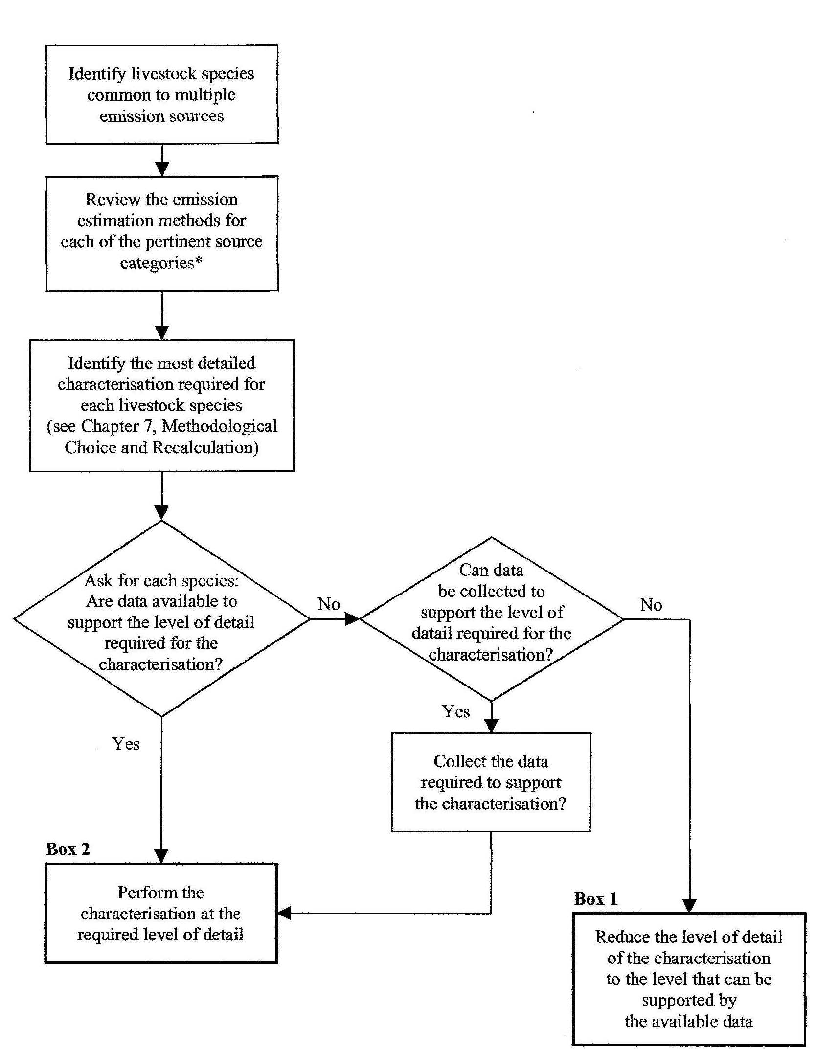
Cattle, (buffalo),
swine, (sheep),
species without
tier/EF
Goats, horses, mules/asses,
poultry, (sheep)
Recommended for species with
enhanced characterization,
when key source
Required for species
with high individual
contribution, when key source
DECISION TREES: Livestock characterization

A. Basic Characterization

The basis characterization is included in the Revised 1996 IPCC Guidelines and the following data should be collected:

- List of livestock species and categories;
- Annual population data, for each species and category;
- Average annual milk production for dairy cows;
- Percentage of animals per climate regions existing in the country.

B. Enhanced Characterization

The enhanced livestock characterization needs the following activity data:

- Segregation of livestock into subcategories to reflect country-specific variations in age structure and animal performance;
- Livestock population data by subcategory;
- Feed intake estimates for a typical animal in each subcategory (used in the Tier 2 enteric fermentation emissions estimate for cattle, buffalo, and sheep). Additionally, these estimates should be used to harmonize the estimated manure and N excretion rates for CH₄ and N₂O emissions from manure management and direct and indirect N₂O agricultural soil emissions.

It is good practice to classify cattle and buffalo populations into a minimum of three main subcategories for each species:

- Cattle: Mature Dairy Cows, Mature Non-Dairy Cattle, and Young Cattle.
- Buffalo: Mature Dairy Buffalo (females only), Mature Non-Dairy Buffalo, and Young Buffalo.

Animal performance data is used to estimate gross energy (GE) intake, which is the amount of energy (MJ/day) an animal needs to perform activities such as growth, lactation and pregnancy. It is good practice to estimate GE intake based on animal performance data. Parties should use the corrected equation presented as Equation 4.11 in the IPCC good practice guidance.

If activity data at regional level are not available, the Party should consult its own experts regarding regional livestock production patterns and land distribution to estimate the regional animal distributions. If the resources are not available to conduct a detailed survey, assumptions may be based upon the opinions of such experts.

C. Characterization of animal species without emission estimation method

Some countries may have domesticated animals for which there are no Tier 1 or Tier 2 methods (e.g. llamas, alpacas, wapiti, emus, ostriches, deer). The IPCC good practice guidance recommends that emissions from these animals should be based on country-specific emission factors when they are likely to be significant emission sources.

3.4.2. Enteric fermentation and CH₄ emissions

The decision tree for estimating methane emissions from enteric fermentation defines the route Parties should follow to produce accurate estimates (Figure 4.2 in IPCC good practice guidance). The main features of this decision tree are:

- If there is no domestic animal production, the Party should report “NO”;
- If enteric fermentation occurs but is not a key category (impossible, as mentioned before), a basic livestock characterization and Tier 1 method may be applied to all the animal species; however, it is recommended that the Party apply enhanced characterization and Tier 2 for the significant animal species (cattle, basically), provided the Party has the necessary data;
- If enteric fermentation occurs and is a key category, then an enhanced livestock characterization and Tier 2 method should be used for the significant animal species (cattle, mainly) accepting a basic characterization and Tier 1 method for the rest of the species.

The Revised 1996 IPCC Guidelines describe two general methods for estimating emissions from enteric fermentation:

- Tier 1, a simplified approach that relies on default emission factors drawn from previous studies. The Tier 1 approach is likely to be sufficient for many countries and can be used to estimate emissions for all the animal species when the category is not key source;
- Tier 2, is a more complex approach that requires detailed country-specific data on nutrient requirements, feed intake and CH₄ conversion rates for specific feed types, to develop country-specific emission factors for country-defined livestock categories. The Tier 2 approach should be used if enteric fermentation is key category and only for the significant animal species.

When applying Tier 2 methods, Parties should use the data from their enhanced livestock characterization to develop their emission factors. The IPCC good practice guidance provides information to develop emission factors for cattle and sheep. In the absence of data for buffalo, the approach described for cattle can be applied, given the similarities between these species.

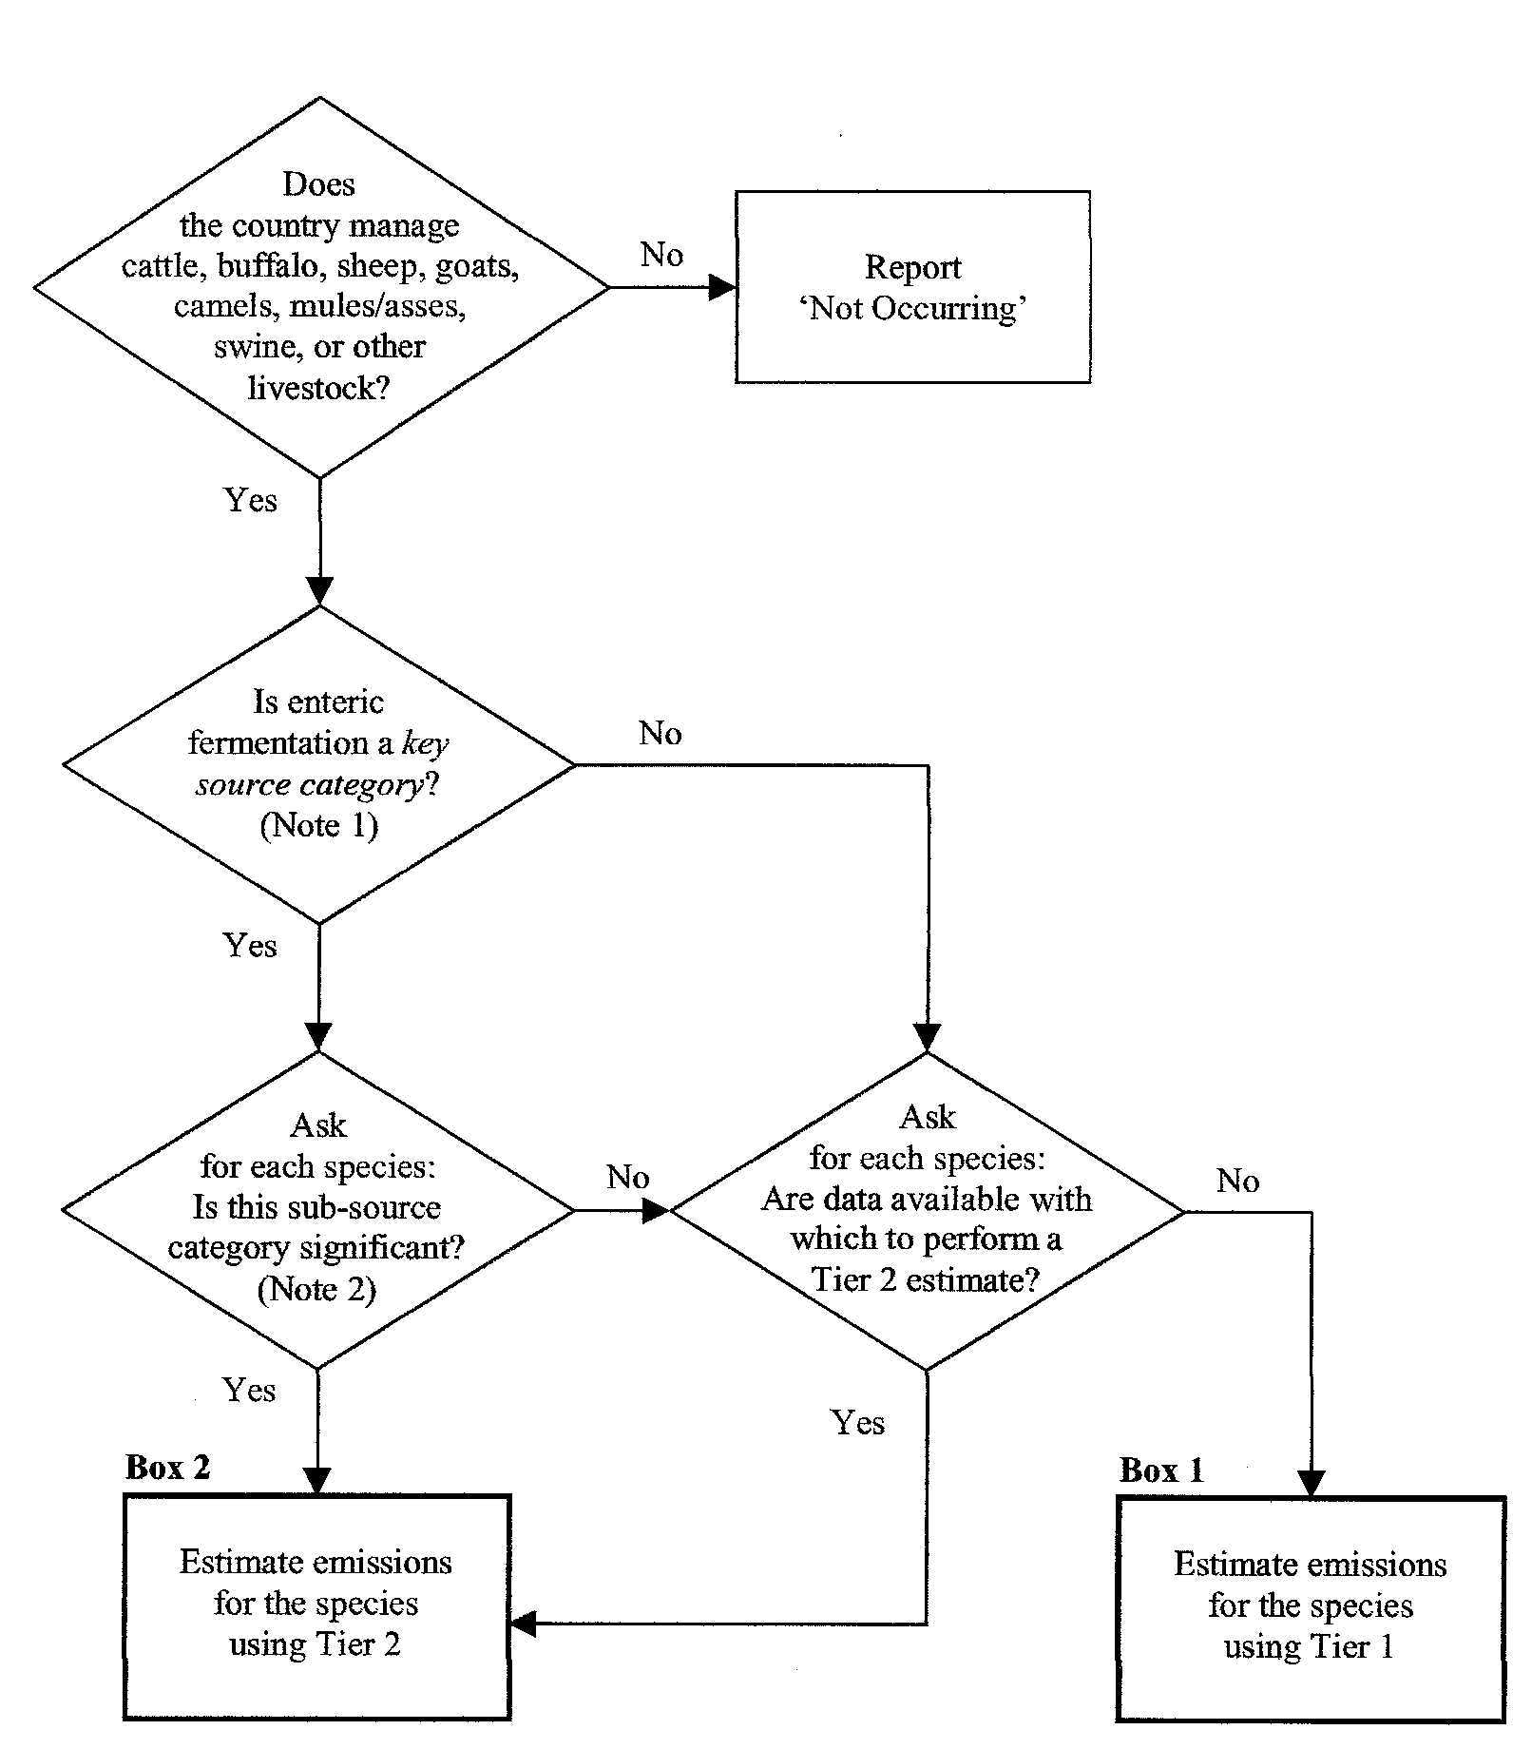
DECISION TREE: CH₄ emissions from Enteric Fermentation
Cattle and species with
significant individual
contribution to a
key source
Buffalo, sheep, goats, horses, mules/asses,
poultry
Event impossible
Species with no
significant
contribution to
a key source
If not enough
activity data
Accuracy of
estimates:

Box 2
>
Box 1

3.4.3. Manure management

A. CH₄ emissions

To estimate CH₄ emissions from manure management, the Party must extract the livestock data from the single livestock characterization; the use of default or country-specific emission factors (developed based on manure characteristics B_{O}, VS, MCF and manure management systems) will depend on the significance of the animal species on the total emissions of the category.

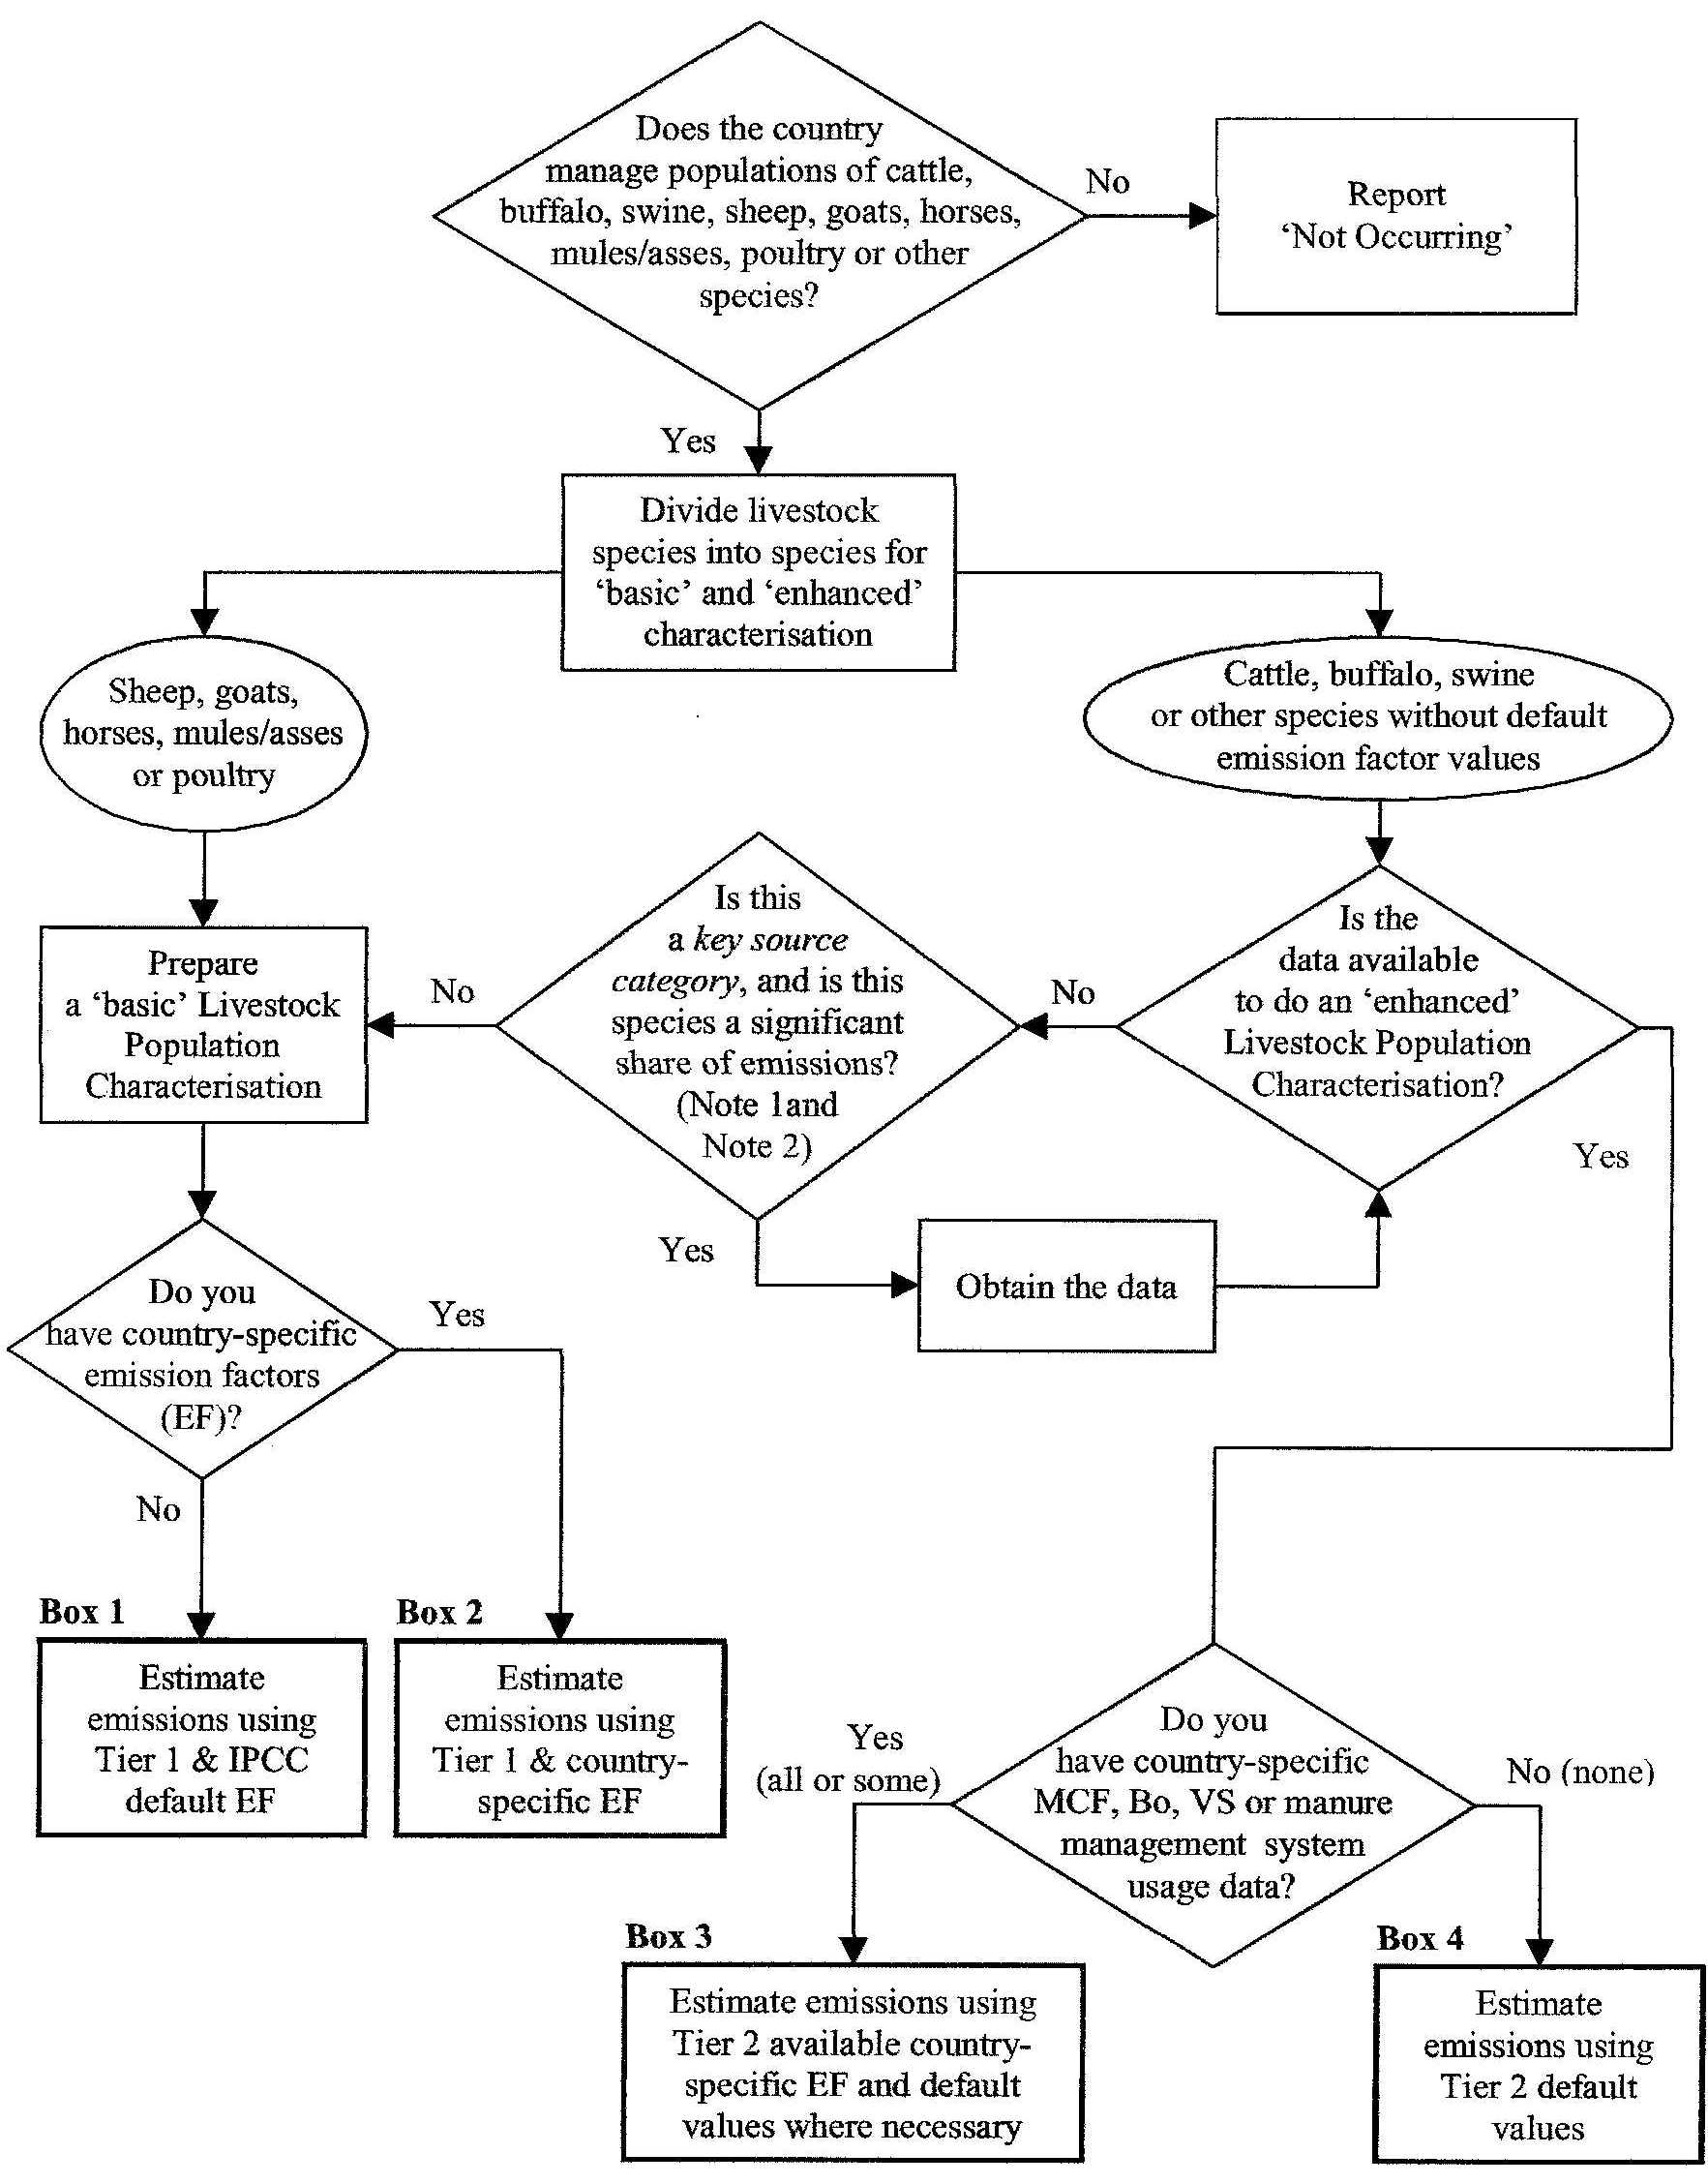
DECISION TREE: CH₄ emissions from Manure Management
Goats, horses, mules/asses,
poultry, sheep
Cattle, buffalo,
swine, (sheep),
species without
Tier/EF
If key source and high individual
contribution
Accuracy of
estimates:

Box 3
>
Box 4
>
Box 2
>
Box 1

The decision tree for estimating CH₄ emissions from manure management defines the route the Party should follow to produce accurate estimates (Figure 4.3 in the IPCC good practice guidance). The main features of this decision tree are:

- If there is no domestic animal production, the Party should report “NO”;
- If CH₄ from manure management occurs but is not a key category, the Party may estimate emissions following a basic livestock characterization and Tier 1 for all the animal species;
- If CH₄ from manure management occurs and is a key category, the Party should elaborate an enhanced livestock characterization and apply Tier 2 for the significant species (normally cattle, sheep, swine), provided the Party has the necessary data;
- If CH₄ from manure management occurs and is a key category, the Party may elaborate a basic livestock characterization and apply Tier 1 for the non-significant species (normally goats, camels, asses, mules, poultry).

The Tier 1 method requires livestock population data by animal species, category and climate region (i.e., cool, temperate, warm). The Tier 2 method requires detailed information on animal characteristics and the manner in which the manure is managed. The required activity data are:

- Volatile solid (VS) excretion rates. Country-specific VS values are based on estimated daily average feed intake, digestible energy of the feed and ash content of the manure;
- Maximum CH₄ producing capacity of the manure (B_{o});
- CH₄ conversion factor (MCF).

The method chosen will depend on data availability and natural circumstances. Parties should make efforts to use the Tier 2 method, including emission factors derived from country-specific factors.

B. N₂O emissions

To estimate N₂O emissions from manure management, the Party must extract the livestock data from the single livestock characterization, to determine:

- The annual average nitrogen excretion rate per head (N_{ex}) for each animal species/category (T);
- The fraction of the total annual excretion for each livestock species/category that is managed with each manure management system type;
- N₂O emission factors for each manure management system type.

The decision tree for estimating N₂O emissions from manure management defines the route Parties should follow to produce accurate estimates (Figure 4.4 in the IPCC good practice guidance). The main features of this decision tree are:

- If there is no domestic animal production, the Party should report “NO”;
- If N₂O from manure management occurs and is not a key category, the Party may use a basic livestock characterization for all the animal and default emission factors;
- If N₂O from manure management occurs and is a key category, the Party should use an enhanced livestock characterization and country-specific emission factors for those significant animal species (normally cattle, sheep, swine), using the combination of basic characterization and default emission factors for the non-significant animal species (normally goats, horses, camels, mules, asses, poultry).

The required activity data, in addition to those necessary for the livestock characterization, are:

- Annual average nitrogen (N) excretion per head of species/category;
- Fraction of total annual excretion for each livestock species/category that is managed in a manure management system.

If national statistics on the distribution of manure management systems are not available, the Party should conduct a survey, but if that is not possible, the values may be derived from national expert opinion. Parties are also encouraged to disaggregate the activity data for each major climatic zone.
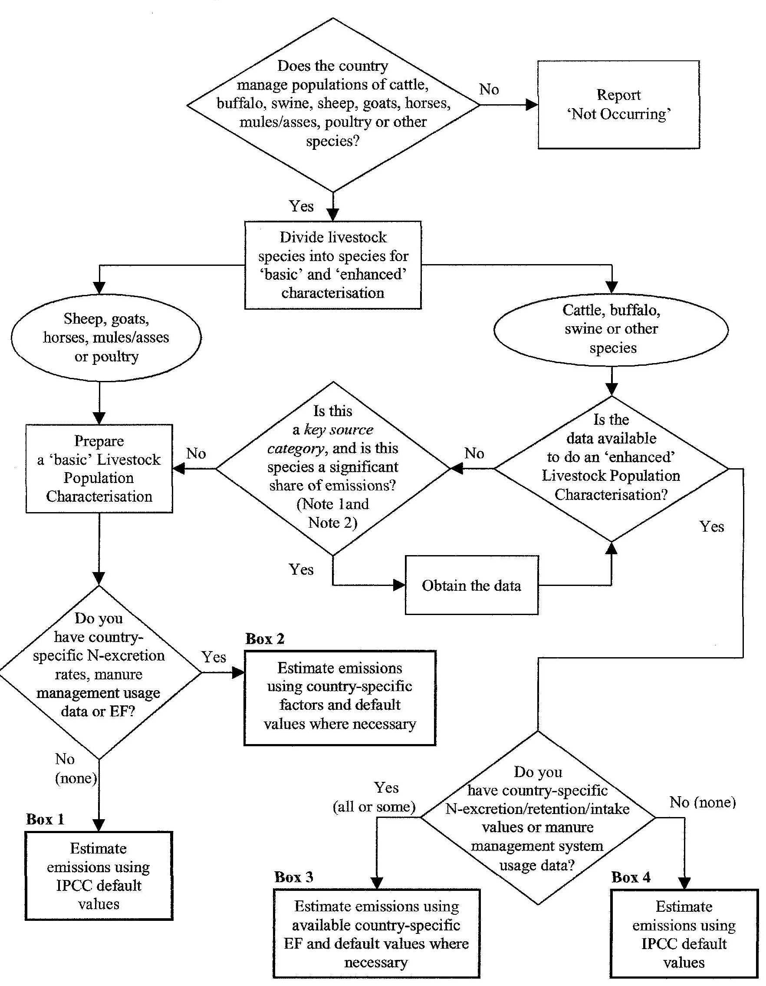
DECISION TREE: N₂O emissions from Manure Management
Accuracy of
estimates:

Box 3
>
Box 4
>
Box 2
>
Box 1

3.4.4. Non-CO₂ gas emissions from Biomass Burning

A. Prescribed Burning of Savannas

The IPCC good practice guidance describes only one method to estimate non-CO₂ gas emissions from savanna burning. This method is based on activity data (fraction of area burned) and emission factors (detailed below). Default activity data and emission factors are available in the Revised 1996 IPCC Guidelines and also in the EFDB.

Among the Annex I Parties, it is key category for Australia only but, among the NAI Parties, it is very likely that this condition is reached in many African and Latin American Parties. The decision tree for estimating emissions from savanna burning defines the route the Party should follow to produce accurate estimates (Figure 4.5 in the IPCC good practice guidance). The main features of this decision tree are:

- If savanna burning does not occur, the Party should report “NO”;
- If savanna burning occurs but is not a key category, emissions can be estimated using IPCC default values;
- If savanna burning occurs and is a key category, the Party should use country-specific factors, provided the available activity data allows it.

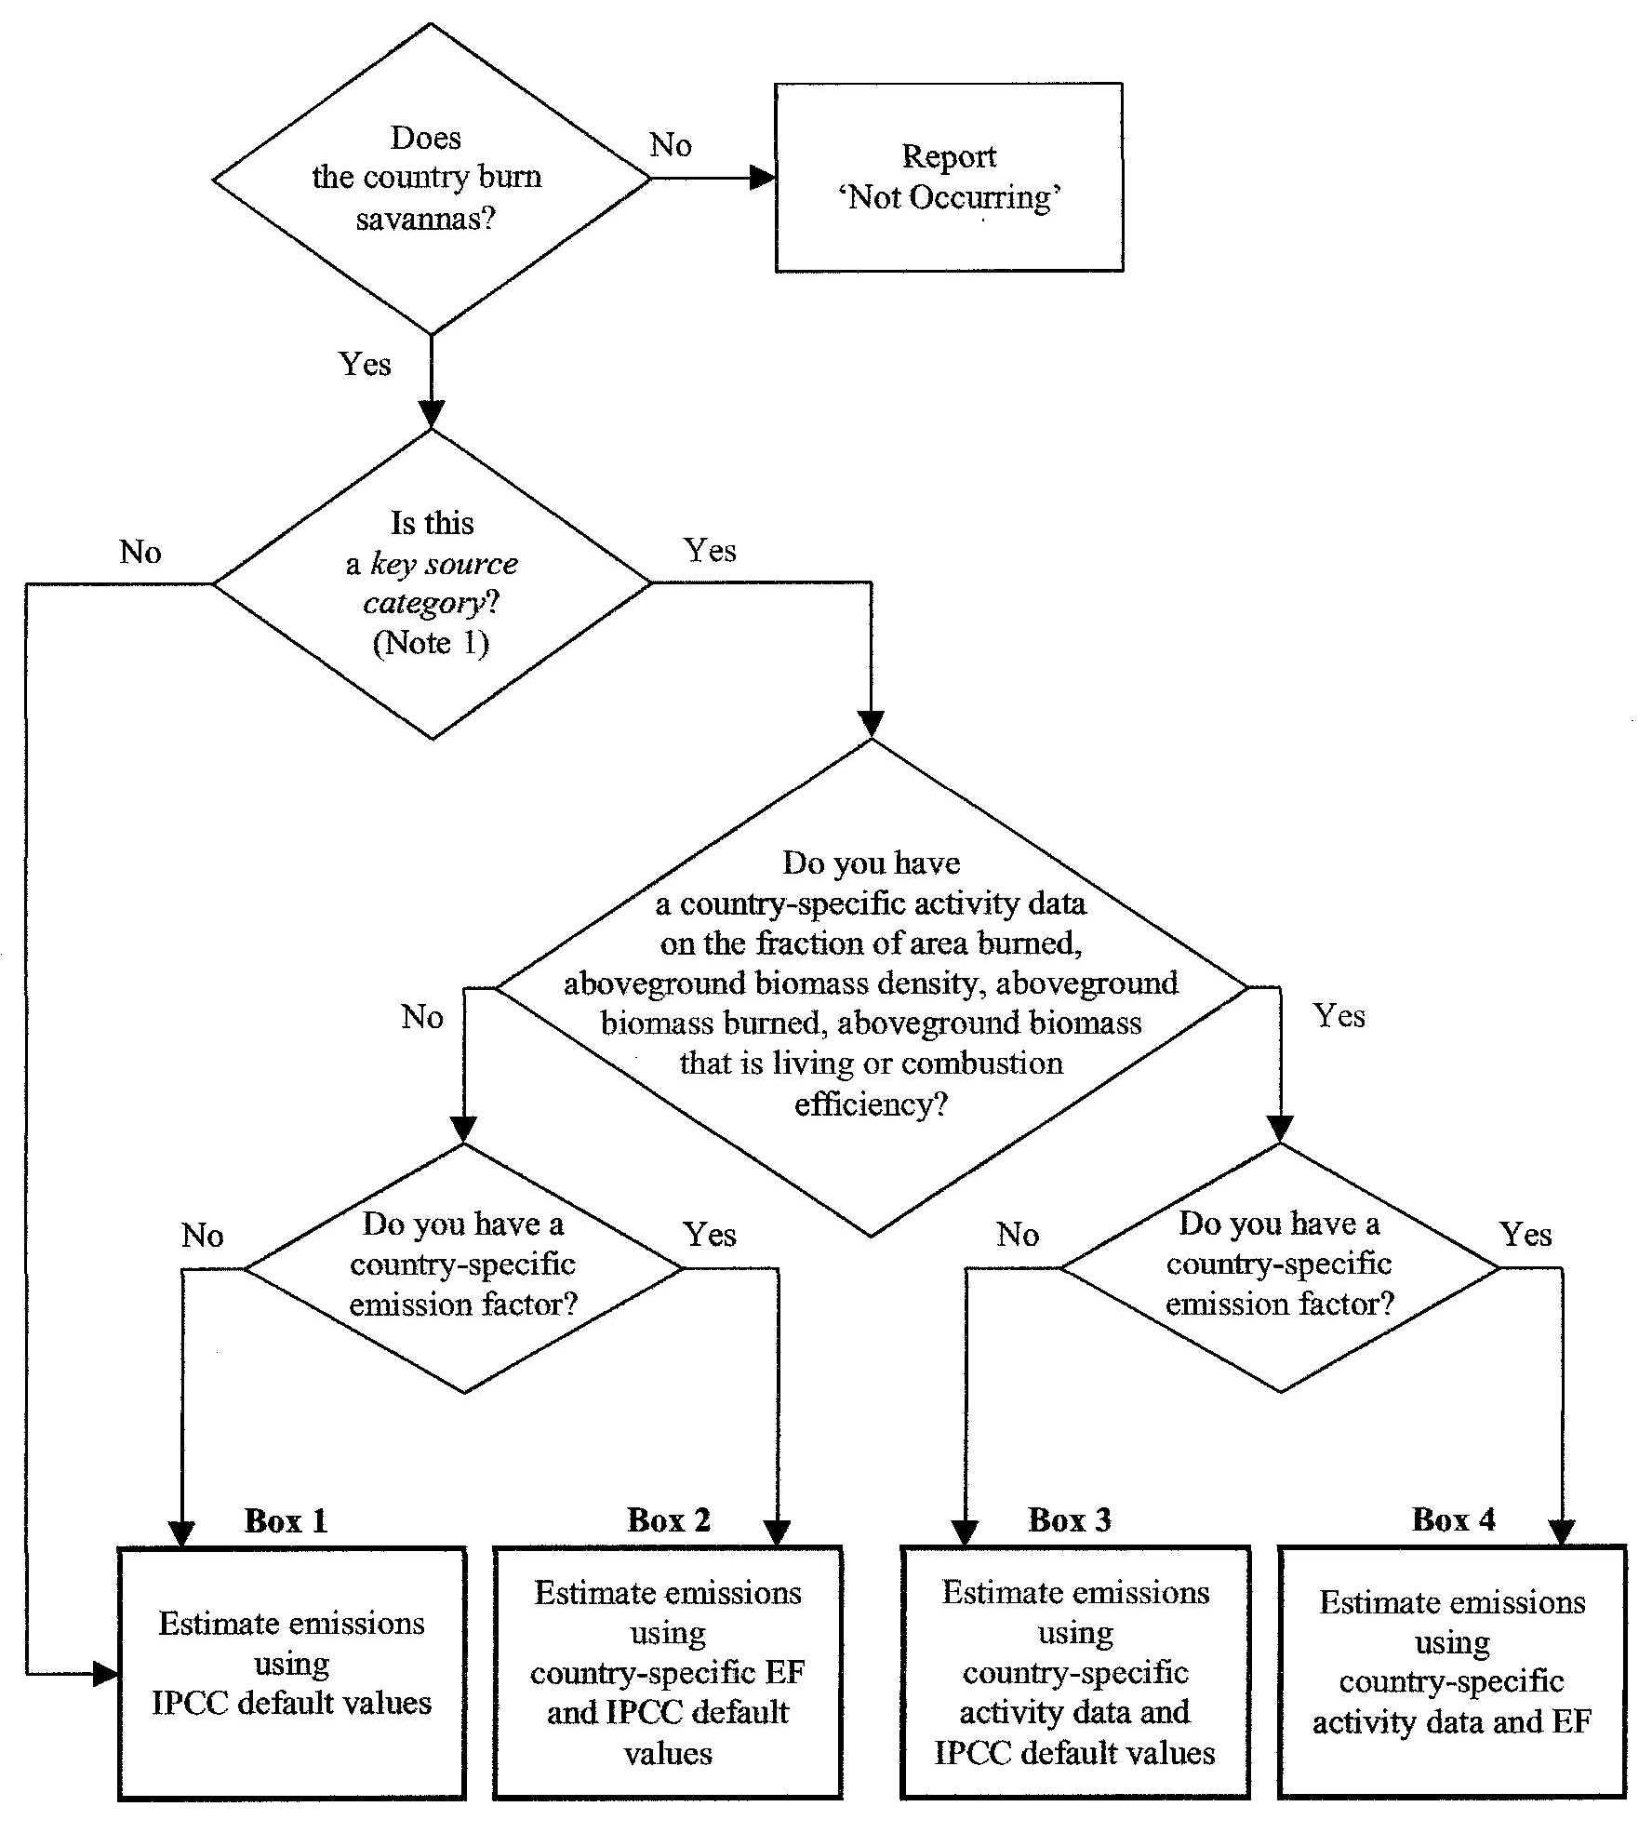
DECISION TREE: GHG emissions from Savanna Prescribed Burning
Accuracy of
estimates:

Box 4
>
Box 3
>
Box 2
>
Box 1

The IPCC method requires:

- A value for the living fraction of aboveground biomass;
- Values for the oxidized fraction after burning;
- Carbon fraction of living and dead biomass, used to calculate the amount of carbon and nitrogen released from savanna burning.

These parameters are difficult to measure in the field, and they are not usually included in the statistics collection systems, so national expert judgment is often necessary. A combustion efficiency factor can be used to approximate the vegetation and combustion conditions, which ultimately determine the emission factors of CH₄ and N₂O. Combustion efficiency is defined as the molar ratio of emitted CO₂ concentrations to the sum of emitted CO and CO₂ concentrations from savanna fires.

The IPCC good practice guidance refers to the Revised 1996 IPCC Guidelines for this source category. Additional information is provided in Appendix 4A.1 of the IPCC good practice guidance, which describes some of the details of a possible future revision of the methodology.

B. Field Burning of Crop Residues

Only one IPCC method is available to estimate non-CO₂ gas emissions from agricultural residue burning. When available, country-specific activity data and emission factors should be used. Default activity data and emission factors are available in the Revised 1996 IPCC Guidelines; in addition, the FAO database (see above) may help with data on surface of crops. The primary uncertainty in estimating emissions of CH₄ and N₂O from agricultural residue burning is the fraction of agricultural residue burned in the field. To avoid under/over estimation and/or double counting, a mass balance must be performed to account for all the uses of the crop residues.

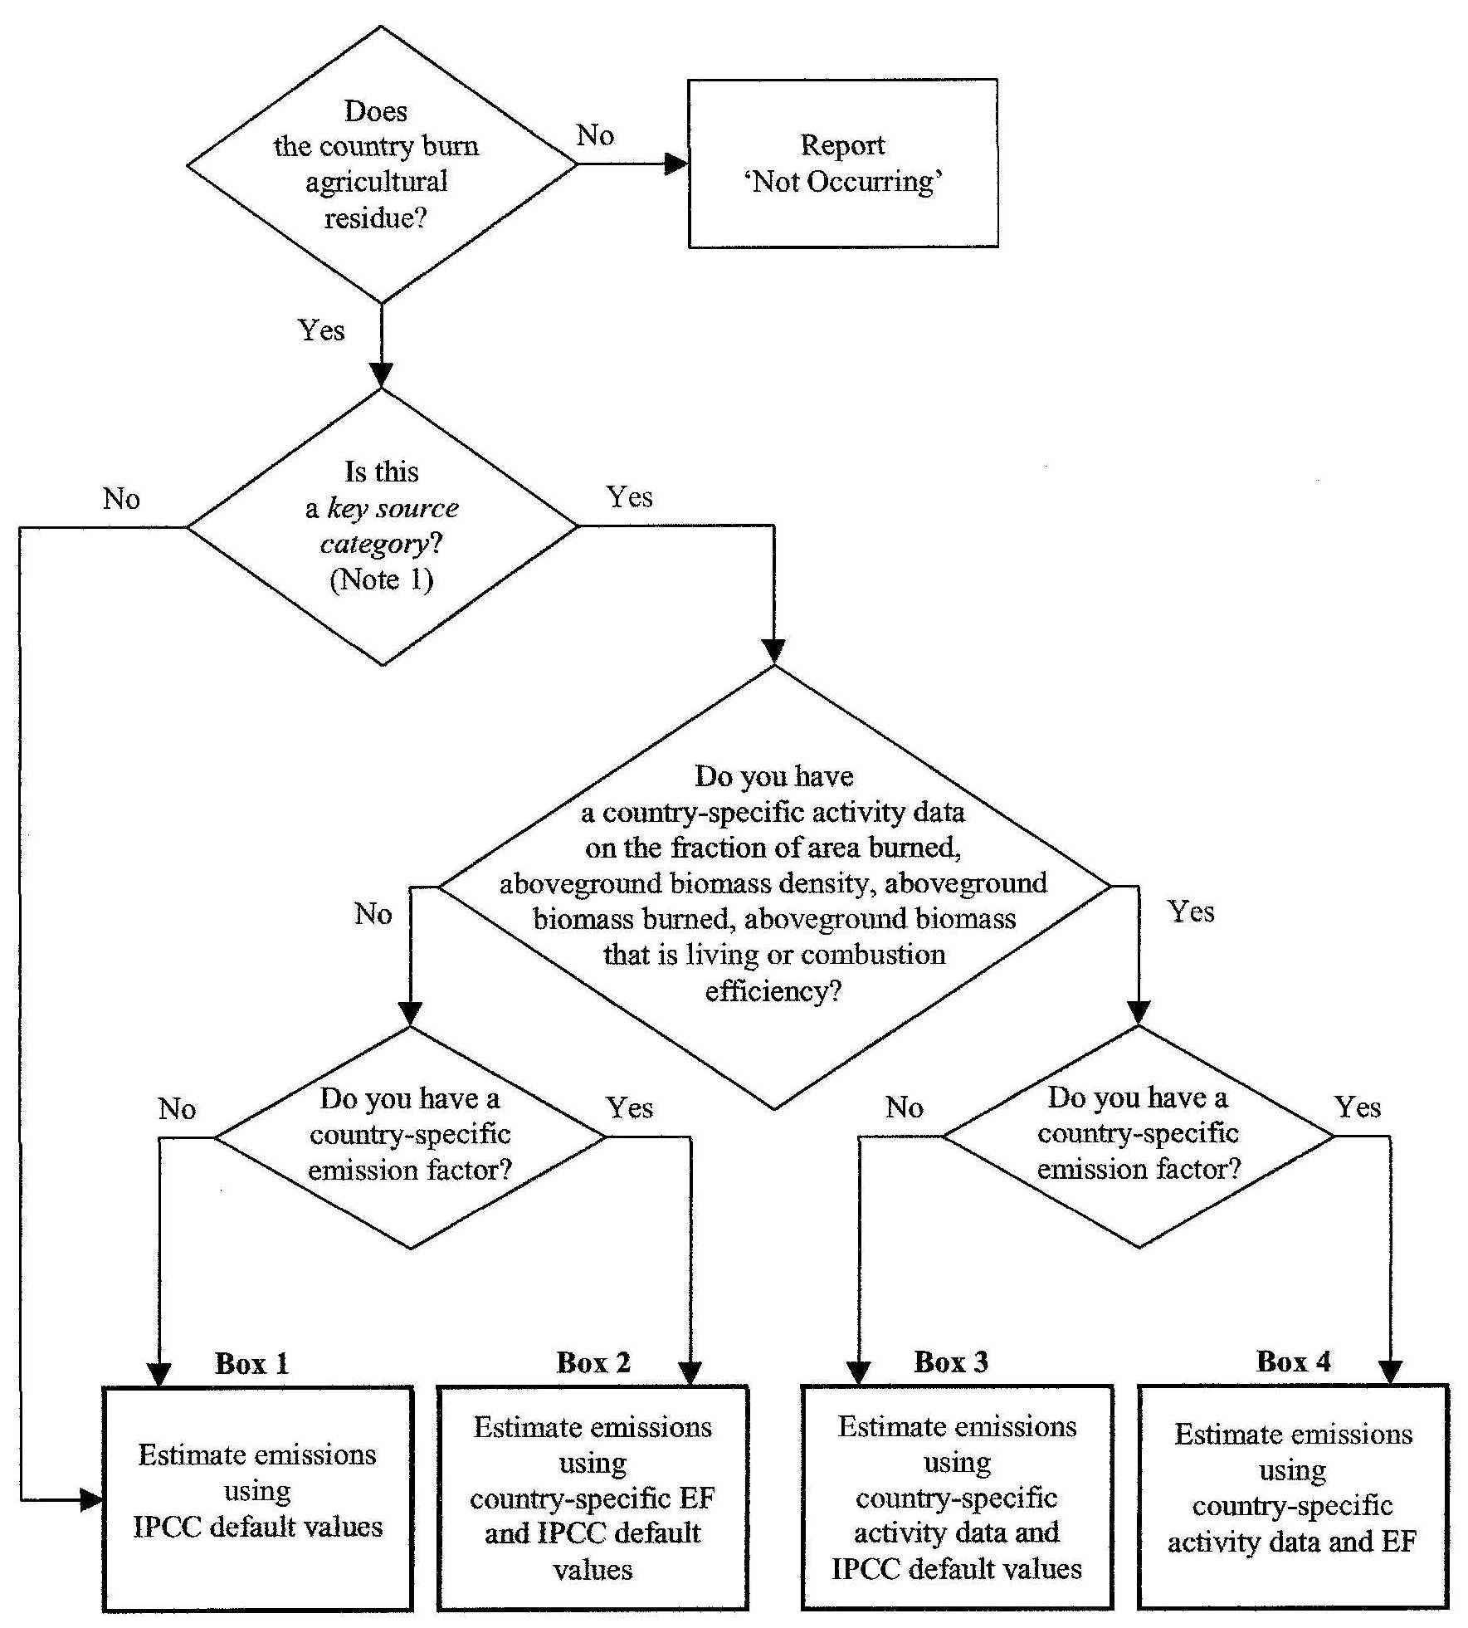
DECISION TREE: GHG emissions from Crop Residue Burning
Accuracy of
estimates:

Box 4
>
Box 3
>
Box 2
>
Box 1

The IPCC method requires a group of activity data which are difficult to measure in the field and are not usually included in the statistics collection systems, so expert opinion is highly relevant. The activity data required are:

- Area of crops producing straw residues for each regional units;
- Cropping season for each crop type;
- Residue produced per crop and season;
- Mass balance of crop residues produced: burned on site [total residue - off the field and burned elsewhere (e.g., energy) – reduced in the field (e.g., consumed by animals, decayed in the field) – off the field for non-energy uses (e.g., biofuel, confined domestic livestock feed, building materials, etc.)];
- Combustion efficiency.

The decision tree for estimating emissions from field burning of crop residues defines the route the Party should follow to produce accurate estimates (Figure 4.6 in the IPCC good practice guidance). The IPCC good practice guidance then refers to the Revised 1996 IPCC Guidelines for this source category. Additional information is provided in Appendix 4A.2 of the IPCC good practice guidance. This appendix describes some of the details of a possible future revision of the methodology.

3.4.5 N₂O emissions from agricultural soils

A. Direct N₂O emissions

The following sources of anthropogenic nitrogen inputs result in direct N₂O emissions from agricultural soils:

- Application of synthetic fertilizers (FSN);
- Application of animal manure (FAM);
- Cultivation of nitrogen-fixing crops (FBN);
- Incorporation of crop residues into soils (FCR);
- Soil nitrogen mineralization due to cultivation of organic soils (FOS);
- Others sources such as sewage sludge, which should be included if sufficient information is available.

Because the IPCC good practice guidance requires that indirect and direct emissions be estimated separately, the inventory team should ensure that double counting emissions from synthetic fertilizer, animal manure and other sources, are avoided. As an example, the amount of manure applied to soils must be a fraction of the total manure produced by confined livestock.

The decision tree for estimating direct N₂O emissions from agricultural soils defines the route the Party should follow to produce accurate estimates (Figure 4.7 in the IPCC good practice guidance). The main features of this decision tree are:

- If there is no N input to soils, no N-fixing crops produced, and no histosols cultivated, the Party should report “NO”;
- If direct emissions from agricultural soils occur but is not a key category, emissions can be estimated using FAO activity data and default emission factors and partition fractions;
- If direct emissions from agricultural soils occur and is a key category, Parties should assess the individual contribution of each nitrogen source and collect country-specific activity data, partition fractions and emission factors for the significant N sources (if possible);
- If no country-specific partition fractions and/or emission factors are available, default partition fractions and/or emission factors are acceptable.

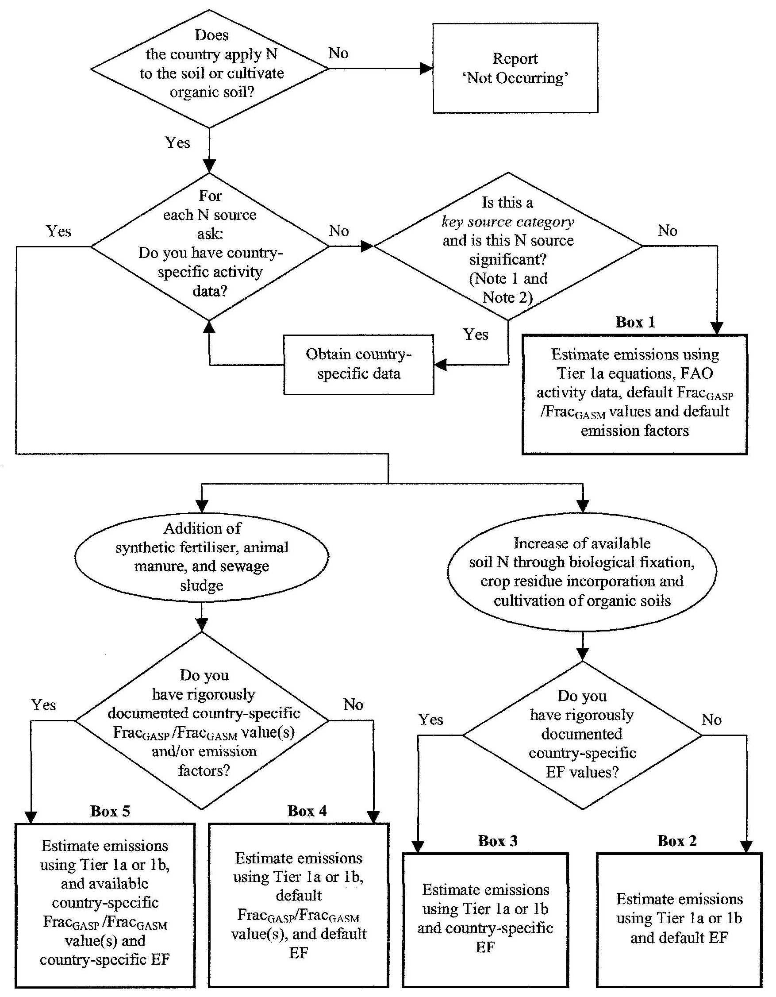
DECISION TREE: Direct N₂O emissions from Agricultural Soils
Accuracy of
estimates:
FAMSS NFCCR
Box 5 Box 3
> >
Box 4 Box 2
> >
Box 1
Preferential route

There is only one Tier for this source category, but having two variations: Tier 1a and Tier 1b (described in the IPCC good practice guidance), which includes updated equations. The selection of a Tier 1a or Tier 1b method is not related to the key source condition but to the availability of activity data. Preference should be given to the Tier 1b equations, which expand the number of terms in the equations. For Parties without the necessary data for Tier 1b, the simpler Tier 1a equations are acceptable. Estimating emissions combining Tier 1a and Tier 1b equations for different sub categories, depending on the availability of activity data, is also acceptable. For some subcategories there are no Tier 1b equations because no refinement was considered.

Several types of activity data are required for this source category and it is highly unlikely that the Party will be able to fulfil all the requirements because many of the data types are beyond the scope of the national statistics collection system. Due to the importance of this source, it is desirable that the Parties make their best efforts to have country-specific activity data. The IPCC method requires the following data:

- Synthetic fertilizers: amount of N applied as fertilizer;
- Animal manure:
  - Total amount produced under confinement and direct grazing;
  - Destination: 1) treated in animal waste management systems (i.e., N₂O emissions from manure management), 2) manure from grazing animals (i.e., N₂O emissions from animal production), 3) manure used as fuel, 4) manure used as animal food, 5) manure applied to soils;
  - N content of manure;
- N-fixing crops:
  - Area of N-fixing crops (pulses) and nitrogen fixing forage crops;
  - Fraction of the N-fixing plants in the established prairies;
  - N content in aboveground part;
  - Residue/crop ratios;
- Crop residues:
  - Area of residue-producing crops;
  - Residue/crop ratios;
  - Residues fractions according end-up destination, specially that which is applied to soils;
  - N content in crop residues;
- Histosols:
  - Area of cultivated histosols;
  - Sewage sludge:
  - Amount of sewage sludge applied to soils;
  - N content in sewage sludge;
  - Partition coefficients: FRACGASF, FRACGASM, FRACPRP, FRACSEWSLUDGE, FRACFUEL-AM, FRAC_{FEED-AM}, FRAC_{CONST-AM}, FRAC_{NCRBF}, FRAC_{DM}, FRAC_{NCRO}, FRAC_{BURN}, FRAC_{FUEL-CR}.

It is important to remember that the activity data concerning animal manure should come from the Party’s single livestock characterization. The inventory team must ensure that emissions from animal manure produced by from grazing animals are not included in the emissions from animal manure applied to soils nor from manure management.

B. Indirect N₂O emissions

The IPCC method for estimating indirect N₂O emissions includes the following pathways by which anthropogenic inputs of nitrogen become available for formation of N₂O:

- Atmospheric deposition on soils of NO_{X} and NH₄ with the sources of N including volatilization of N inputs to soils as well as combustion and industrial process sources;
- Leaching and runoff of N that is applied to soils;
- Disposal of sewage N;
- Formation of N₂O in the atmosphere from NH₃ emissions originating from anthropogenic activities (no IPCC method available);
- Disposal of effluents from food processing and other operations (no IPCC method available).

From these five pathways, the Revised 1996 IPCC Guidelines provides methods for estimating emissions for the following:

- The portion of the atmospheric deposition of NO_{X} and NH₄ associated with N from synthetic fertilizers and animal manure that have been applied to soils;
- The portion of N from applied synthetic fertilizers and animal manure lost as leaching and runoff;
- The discharge of sewage N into rivers or estuaries.

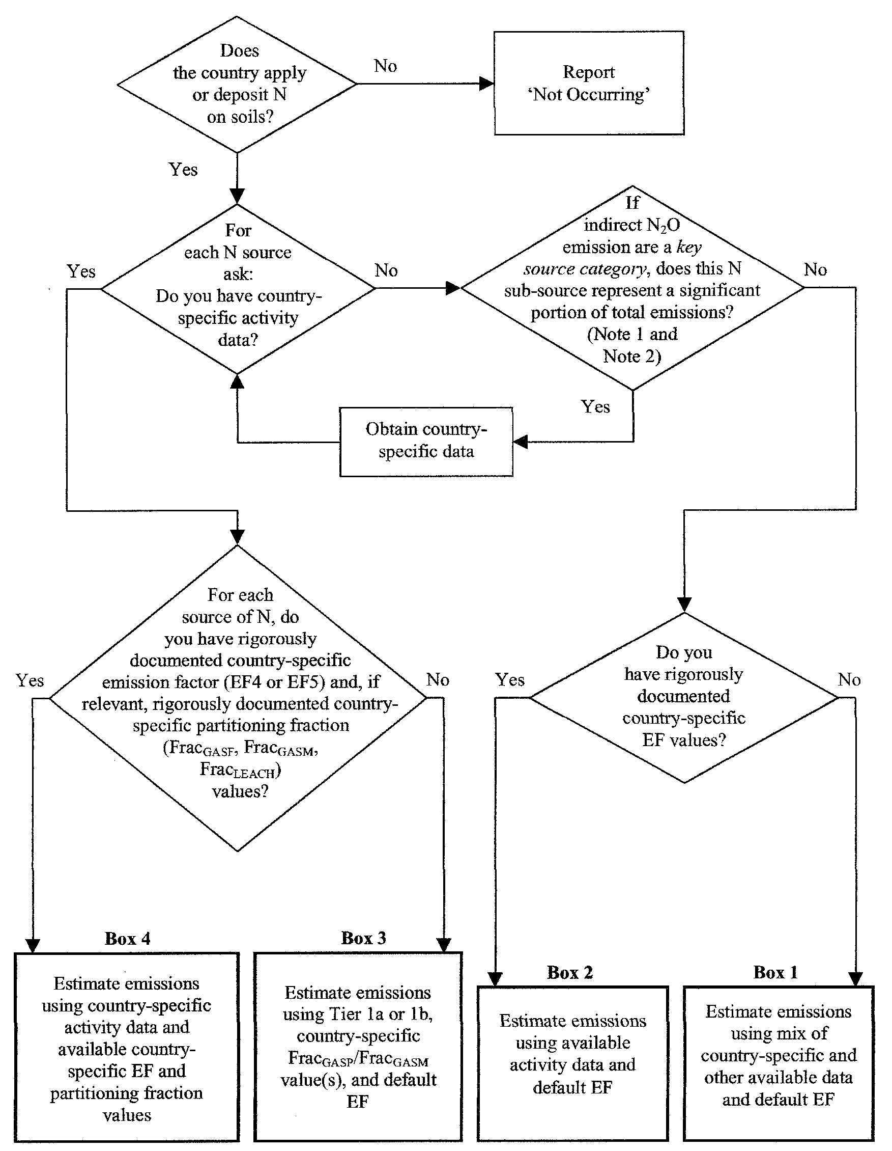
DECISION TREE: Indirect N₂O emissions from Agricultural Soils
Accuracy of
estimates:

Box 4
>
Box 3
>
Box 2
>
Box 1
Preferential route

The decision tree for estimating indirect N₂O emissions from agricultural soils defines the route Parties should follow to produce accurate estimates (Figure 4.8 in the IPCC good practice guidance). The main features of this decision tree are:

- If there is no N input to soils, no N-fixing crops produced, and no histosols cultivated, the Party should report “NO”;
- If indirect emissions from agricultural soils occur but is not a key category, emissions from each nitrogen source can be estimated using the default emission factors. If indirect emissions from agricultural soils occur and is a key category, the Party should assess the individual contribution of each nitrogen source and collect country-specific activity data, partition fractions and emission factors for the significant subsources;
- If no country-specific partition fractions and/or emission factors are available, default partition fractions and/or emission factors are acceptable, even if the subsources are significant.

The activity data used for this source category is the same as that collected for the direct N₂O emissions:

- Synthetic fertilizers:
  - Amount of N applied as fertilizers;
  - Animal manure:
  - Total amount of animal manure produced;
  - Amount of animal manure that is devoted to other uses: 1) treated in animal waste management systems, which are accounted under manure management; 2) manure from grazing animals, which are accounted for under animal production; 3) manure used as fuel; and 4) manure used as animal food;
  - N content in manure,
  - Sewage sludge:
  - Amount applied to soils;
  - N content in sewage sludge;
  - Partition coefficients: FRAC_{GASF}, FRAC_{GASM}, and FRAC_{LEACH}.

C. N₂O emissions from animal production (pasture, range, and paddock)

There are three potential sources of N₂O emissions related to animal production:

- Animals themselves (not accounted as assumed negligible);
- Animal wastes during storage and treatment (accounted under manure management);
- Dung and urine deposited by free-range grazing animals (accounted here).

This source category deals only with the last of these three sources: dung and urine deposited by grazing animals (pasture range and paddock).

The activity data for N₂O emissions from animal production can be taken from other source categories, such as direct emissions and manure management. The required activity data are:

- The data required to estimate N₂O emissions from each relevant animal waste management system used by the Party;
- The fraction of animal populations managed as direct grazing, per animal species;
- N excretion rates per animal species.

The methodology for N₂O emissions from animal production is addressed in the IPCC good practice guidance under manure management, although emissions are accounted for under N₂O emissions from agricultural soils in the Revised 1996 IPCC Guidelines and UNFCCC software. It is also important that activity data be based on a single livestock characterization.

3.4. CH₄ emissions from rice production

The IPCC good practice guidance provides one method for estimating methane emissions from rice production. This method uses annual harvested areas and area-based seasonally integrated emission factors. In its simplest form, the IPCC method can be implemented using national activity data (i.e. national total area harvested) and a single emission factor.

However, conditions to grow rice (e.g., water management practices, organic fertilizer use, soil type) may be highly variable and may significantly affect CH₄ emissions. The IPCC method can be modified to account for this variability in growing conditions by disaggregating national total harvested area into subunits (e.g. harvested areas under different water management regimes) and multiplying the harvested area for each subunit by an emission factor that is representative of the conditions that define the subunit.

The decision tree for estimating methane emissions from rice production defines the route Parties should follow to produce accurate estimates (Figure 4.9 in the IPCC good practice guidance). The main features of this decision tree are:

- If there is no rice cultivation, the Party should report “NO”;
- If emissions from rice production occur but is not a key category, emissions can be estimated using default emission factors and, where possible, scaling factors for other factors including organic amendments;
- If emissions from rice production occur and is a key category, emission estimates should be based on data from each cropping region, country-specific emission factors and scaling factors for water management, organic amendments and soil type.

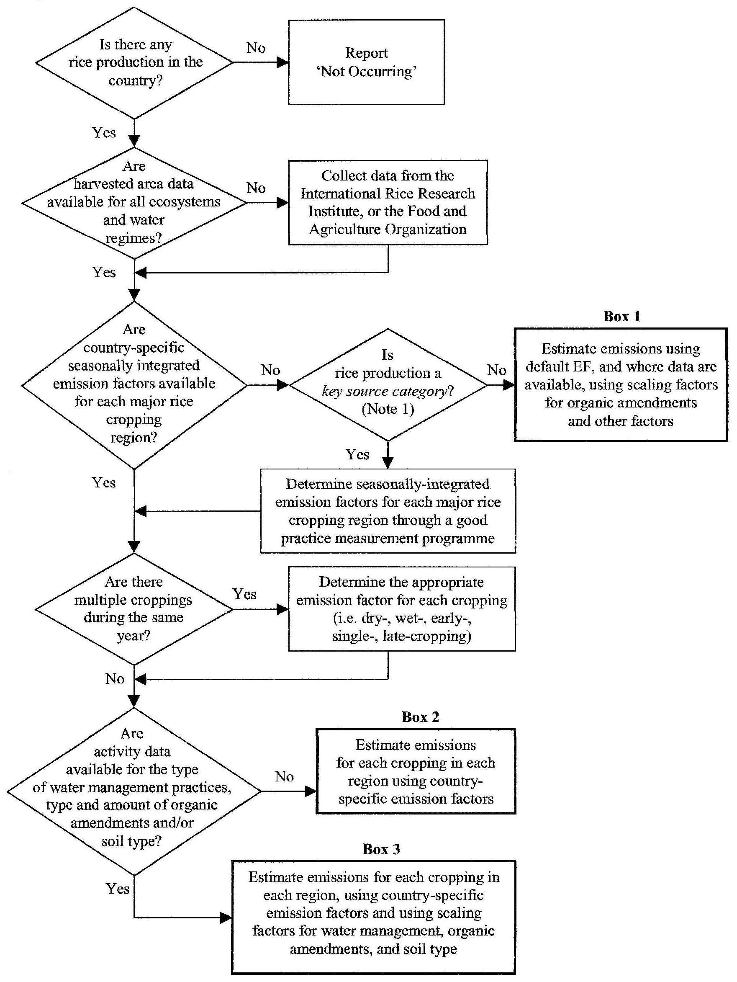
DECISION-TREE: CH₄ emissions from Rice Cultivation
Accuracy of
estimates:

Box 3
>
Box 2
>
Box 1

Data on rice production and harvested area should be available in most Parties’ national statistics, preferably by ecosystem or water management type. If these data are not available, they can be downloaded from the FAO website: <http://www.fao.org/ag/agp/agpc/doc> or from IRRI’s World Rice Statistics (e.g. IRRI, 1995). For various reasons cultivation area statistics may be biased; therefore Parties are encouraged to verify their harvested area statistics with remote sensing data. It may also be necessary for Parties to complete a survey of cropping practices to obtain data on the type and amount of organic amendments applied.

4. UNFCCC Software and reporting tables

The UNFCCC provides software to assist non-Annex I Parties in the preparation of their national greenhouse gas inventories. The worksheets included in this software are those referred to in decision 17/CP.8, and utilize IPCC default (i.e. Tier 1) methods in most cases, although national factors can also be used.
The software is available at:
<http://unfccc.int/resource/cd_roms/na1/ghg_inventories/index.htm>.
It is important to note that the Excel version of this software (version 1.3.2) will be replaced by a web-based tool to be available from June 2013.

4.1. Structure

The program is organized in several workbooks, corresponding to ‘Overview’ and to each of six sectoral modules. Each of these workbooks has a specific custom menu.

The ‘Overview’ workbook consists of 18 sheets. These sheets can either be filled in manually, or automatically updated with information introduced into the sectoral worksheets. The 18 sheets are as follows:

- Sheet 1 (‘Head’): contains basic data on inventory (country, inventory year, contact person, etc.). This information is automatically included in the headings of all other tables;
- Sheets 2–4: contain sheets 1 to 3 of Table 1 (sectoral report for energy sector).;
- Sheets 5–6: contain sheets 1 and 2 of Table 2 (sectoral report for industrial processes sector);
- Sheet 7: contains Table 3 (sectoral report for solvent and other product use sector);
- Sheets 8–9: contain sheets 1 and 2 of Table 4 (sectoral report for agriculture sector);
- Sheet 10: contains Table 5 (sectoral report for land use, land-use change and forestry sector);
- Sheet 11: contains Table 6 (sectoral report for waste sector);
- Sheets 12–14: contain sheets 1 to 3 of Table 7A (Summary Report);
- Sheet 15: contains Table 7B (Short Summary Report);
- Sheets 16–18: contain sheets 1 to 3 of Table 8A (Overview Table).

There is a workbook for every inventory sector. The agriculture workbook has 22 sheets, corresponding to the different worksheets included in Revised 1996 IPCC Guidelines (Vol. 2, p 4.49–4.63):

- Sheet 1: contains sheet 1 of Worksheet 4-1 (‘Methane emissions from domestic livestock enteric fermentation and manure management’);
- Sheets 2-7: contain various sheets of Worksheet 4-1 supplemental (‘Nitrogen excretion for animal waste management system’);
- Sheet 8: contains sheet 2 of Worksheet 4-1 (‘Nitrous oxide emissions from animal production and emissions from animal waste management systems’);
- Sheet 9: contains Worksheet 4-2 (‘Methane emissions from flooded rice fields’);
- Sheets 10-12: contain sheets 1-3 of Worksheet 4-3 (‘Prescribed burning of savannas’);
- Sheets 13-15: contain sheets 1-3 of Worksheet 4-4 (‘Field burning of agricultural residues’);
- Sheet 16: contains sheet 1 of Worksheet 4-5, Sub-Module ‘Agricultural Soils’ (‘Direct nitrous oxide emissions from agricultural fields, excluding cultivation of Histosols’);
- Sheets 17-18: contain Worksheets 4-5A supplemental (‘Manure nitrogen used’) and 4-5B supplemental (‘Nitrogen input from crop residues’);
- Sheet 19: contains sheet 2 of Worksheet 4-5, Sub-Module ‘Agricultural Soils’ (‘Direct nitrous oxide emissions from cultivation of Histosols’);
- Sheet 20: contains sheet 3 of Worksheet 4-5, Sub-Module ‘Agricultural Soils’ (‘Nitrous oxide emissions from grazing animals – pasture range and paddock’);
- Sheet 21: contains sheet 4 of Worksheet 4-5, Sub-Module ‘Agricultural Soils’ (‘Indirect nitrous oxide emissions from atmospheric deposition of NH₃ and NOX’);
- Sheet 22: contains sheet 5 of Worksheet 4-5, Sub-Module ‘Agricultural Soils’ (‘Indirect nitrous oxide emissions from leaching’).

4.2 Operation

After choosing a template, the software will open. Excel will load a file called Overview.xls. This file contains the reporting tables from the Reporting Instructions (Volume 1, Revised 1996 IPCC Guidelines) and will be open at all times when you are running the software. This is to make sure that all the calculations are updated as you work.

You will see that the standard Excel menu system is replaced by a special menu system which you can use to move around the tables and make all your inventory calculations.

The Sectors menu option will allow you to open other files to perform the Workbook calculations for the ‘Energy’, ‘Industrial Processes’, ‘Agriculture’, ‘Land-use Change/Forestry’ and ‘Waste’ sectors. These files are called ‘Module1.xls’, ‘Module2.xls’, ‘Module4.xls’, ‘Module5.xls’ and ‘Module6.xls’, respectively. There are no calculations to be made for the ‘Solvents and Other Product Use’ sector, since there is no Workbook methodology for this sector.

The File, Edit, Insert, Window and Help menus are standard Excel menus that can be used to open and close files, modify the worksheets, change from one worksheet to another and obtain help within the Excel program. There are currently no Help items for the UNFCCC software itself contained within the online Help system.

You will find that each worksheet in the software has its own custom menu system, which will help you move through the various areas requiring data input. You can also click on the tabs at the bottom of the window to move from one worksheet to another. The tabs are labeled using the same format as the Workbook and Reporting Instructions. For all the Sector worksheets (Energy, Industrial Processes, Agriculture, Land-use Change and Forestry, Waste) the Tabs are labeled with the number of the worksheet and the number of the sheet within that worksheet. At the end of each set of Tabs there is a Tab labeled Module 1. This Tab contains the programming code for creating the custom menu system and should not be modified in any way.

To start constructing your inventory, click on ‘Sectors’ at the top and select ‘Agriculture’. A new file will be opened that contains the worksheets from the Workbook for the sector. Use the instructions in the Workbook to fill in the required information for making the emission estimates.
The Workbook contains detailed explanations on how the calculations should be made.

While you are completing the sector worksheets, the sectoral and summary tables in Overview.xls will be filled in automatically. However, if you have calculations for a sector or source which is not included in the Workbook, you will have to enter this value manually into Overview.xls. Also, if you have made a calculation using your own method, you will have to enter the results into Overview.xls. Finally, Tables 8A1, 2 and 3 will have to be filled in manually.

5. Emission factor database (EFDB)

5.1. General issues

As stated in the Acknowledgements of the EFDB Manual for Web application: “the quality of national inventories of anthropogenic emissions by sources and removals by sinks of greenhouse gases not controlled by the Montreal Protocol (GHG inventories) depends substantially on reliable emission factors and activity data. Although it is preferable to use emission factors that reflect national circumstances, emission factor development is expensive, time consuming and necessitates a wide degree of expertise (and exceeds the possibilities of the majority of the non-Annex I Parties). The Revised 1996 IPCC Guidelines for National Greenhouse Gas Inventories (IPCC Guidelines) and the report on Good Practice Guidance and Uncertainty Management in National Greenhouse Gas Inventories (GPG2000) provide default emission factors for the majority of source and sink categories. Some of these default emission factors are region or country specific, but in general not all regions or countries are covered.

“Sharing of research information would enable countries (specially non-Annex I Parties) to use or develop emission factors that are more applicable to the circumstances in question than the IPCC default emission factors without having to bear the associated research costs. For this reason, many countries have indicated that an easily accessible public database on GHG emission factors with supporting scientific information would help improve the quality of GHG inventories in a cost-effective way. A database on GHG emission factors with supporting scientific information would also support the future review and update of the Revised 1996 IPCC Guidelines.

“With this background, a project to establish a database on GHG emission factors (EFDB project) was initiated with a scoping meeting in New Delhi, India, on 24-25 July 2000. Subsequently, the functional design was agreed upon at the first expert meeting in Paris, France, on 2–4 July 2001, and a prototype database was constructed in January 2002 based on the agreement at the Paris meeting. It was subject to pilot testing by a number of inventory experts from different countries for eight weeks, from 11 February to 8 April 2002. At the second expert meeting in Bratislava, Slovakia, on 23–24 April 2002, participants considered the comments obtained through the pilot testing and discussed how to improve the prototype database. The EFDB was improved in accordance with the conclusion of the Bratislava meeting, and finally released to the public at the 8th session of the Conference of the Parties to the UNFCCC (COP8) in October 2002.”

5.2. Objectives

The main objectives of the EFDB are:

- To be a recognized library of GHG emission factors and other parameters;
- To contain background documentation or technical references of emission factors and other parameters;
- To serve as a communications platform for distribution and commenting on new data from research and measurement.

It means that researchers and members of the scientific community may incorporate their own findings, as far as emission factors and other parameters development are concerned. But new data provided by the global scientific and inventory society will be evaluated for acceptance by the EFDB Editorial Board according to some predefined criteria. Ultimately, however, the responsibility for using this information appropriately will always remain with the users themselves.

5.3. Criteria for Inclusion of New Data

The main criteria for acceptance of the inclusion of new data are:

- Robustness: the value is unlikely to change, within the accepted uncertainty, if there was repetition of the original measurement programme or modeling activity;
- Applicability: an emission factor can only be applicable if the source and its mix of technology, operating and environmental conditions and abatement and control technologies under which the emission factor was measured or modeled are clear and allow the user to see how it can be applied;
- Documentation: access information to the original technical reference are provided to evaluate the robustness and applicability as described above.

The EFDB Editorial Committee is composed by two Co-chairs, two Editorial Coordinators per sector and three or four Sector Experts per sector. Originally, and according to the traditional criteria of IPCC for the selection of the members of this Editorial Committee, all the world regions recognized by the WMO are represented; also, there must be a balance between Annex I and non-Annex I Parties representatives.

To propose new data, the scientists can submit their data on line. For that, they have to contact the Technical Support Unit (TSU) of the Task Force Bureau (TFB) by <ipcc-efdb@iges.or.jp>, which will register the data provider and will give them an ID, password and other technical support. The provider must input the data following the guidance given in the EFDB User Manual for Web Application.

5.4. Data contained and access to the EFDB

At present, EFDB contains only the IPCC default data and the data from CORINAIR94; for Agriculture, data come mainly from the IPCC because from 1,387 inputs, 1,303 come from IPCC, being 87.2% devoted to CH₄ and N₂O, which are the main gases emitted from this sector. New data are being provided by the global scientific and inventory society, and will be evaluated for acceptance by EFDB Editorial Board.

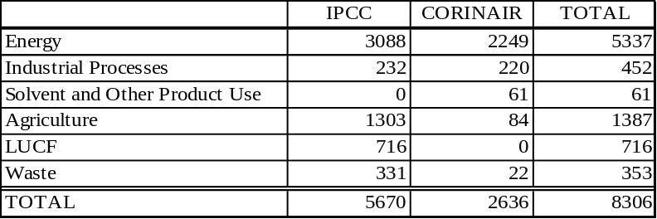
Number of data records by Sector

The EFDB should assist countries in producing inventories that are neither over- nor underestimates so far as can be judged and in which uncertainties are reduced as far as practicable.

There are two different applications:

- Web application: http://www.ipcc-nggip.iges.or.jp/EFDB/main.php

- For all users to carry out online search;
- For data providers to submit new emission factors or other parameters;

- CD-ROM application: for all users, in particular for those who have difficulty with Internet connection, to carry out off-line search.

The web application is the core of this system and new data will be made available in the web application first. In both cases, emission factors can be easily found with the supporting information (as given in the user guides).

5.5. How to access to the web application

Connect to <http://www.ipcc-nggip.iges.or.jp/EFDB/main.php>. Once open, click on the “Finf EF” option and a page having three options will be displayed:

- Step-by-step search using the IPCC Source/Sink Category and Gas;
- FULL-TEXT search using keywords;
- Find EF using unique ID.

If you are entering by the first time, you should click on the first option (step-by-step search). If so, a new page will be displayed showing all the sources recognized by the agriculture sector:

- Enteric fermentation;
- Manure management;
- Rice cultivation;
- Prescribed savanna burning;
- Field burning of crop residues;
- Agricultural soils;
- Others.

Entering specific sector, a red mark (button) will appear when the lowest hierarchy level is reached:

- It will appear for “Agricultural soils”, “Prescribed burning of savannas” and “Other” at the first page of agriculture;
- It will appear for all the animal species – except for Cattle – at the first page of enteric fermentation;
- It will appear for “Diary” and “Non-diary” for the second page of enteric fermentation;
- And so on with the rest of the agricultural sources.

You have to choose the source you need to get the emission factors. Here is an example: suppose we need emission factors for enteric fermentation of some animal species. Click on “enteric fermentation” and a second level will be displayed, showing you all the animal species recognized by the IPCC guidelines:

- Cattle;
- Buffalo;
- Sheep;
- Goats;
- Camels and llamas;
- Horses;
- Mules and asses,;
- Swine;
- Poultry;
- Others.

Assume you need emission factors for goats. Clicking on “goats”, a new window is displayed with the same detail than the previous one but with the word “goats” in bold and in cursive; at the back of the page, click on “Proceed to Step 2”.

At the next window, you will see the initial page for Step 2 opened. Select the gas(es) you are working with (e.g. for enteric fermentation, CH₄ is the gas to look for); then, click on “Apply” and then on “Search” and the window showing all the emission factors related to “goats”. Key points to note:

- Each emission factor has its own unique identification number, by which is it possible to look again for the same emission factor when opening the web application again;
- In the right-hand column, there is the option of “details”; if clicked, you will see the details of the emission factor provider.

