CGE TRAINING MATERIALS FOR VULNERABILITY AND ADAPTATION ASSESSMENT
Chapter 5: Coastal Resources

Contents
5.1 introduction 1
5.2 Drivers of change 3
5.2.1 Sea level 3
5.2.2 Sea level scenarios 4
5.2.3 Changes in storminess and extreme water levels 6
5.2.4 Other oceanic drivers (e.g. wave climate, currents, ocean acidification, sea surface temperature) 8
5.2.5 The El Niño/La Niña-Southern Oscillation (ENSO) 9
5.2.6 Non-climate drivers 11
5.3 Potential Impacts 12
5.3.1 Biophysical impacts 13
5.3.2 Socio-economic impacts 14
5.4 Situation Summary 16
5.5 Methods, Tools and Data Requirements 17
5.5.1 General considerations 17
5.5.2 Screening assessment 18
5.5.3 The Bruun Rule 19
5.5.4 Vulnerability assessment 21
5.5.5 Planning assessment 22
5.5.6 Coastal zone integrated assessment models 24
5.5.7 Risk based assessments: a blended approach 24
5.6 Tools 27
5.7 Data 31
5.8 Adaptation 34
5.8.1 Adaptation 34
5.8.2 Planning 38
5.8.3 Integration 40
5.8.4 Mainstreaming 40
5.8.5 Monitoring and evaluation 41
5.9 References 42
5.10 Further Reading 46

introduction
Global sea level rise due to climate change will have a wide range of physical and ecological effects on coastal systems. These include inundation, flood and storm damage, loss of wetlands, erosion, saltwater intrusion and rising water tables. Other effects of climate change, such as higher sea water temperatures, changes in precipitation patterns, and changes in storm tracks, frequency and intensity, will also affect coastal systems, both directly and through interactions with sea level rise. Rising sea surface temperatures are likely to cause the migration of coastal species toward higher latitudes (especially when linked to increased ocean acidification) and increased coral bleaching. Changes in precipitation and storm patterns will alter the risks of flooding and storm damage.
Error: Reference source not found summarizes some of the main bio-geophysical and socio-economic impacts of climate change and sea level rise, and their interactions. These bio-geophysical effects in turn will have direct and indirect socio-economic impacts on human settlements, agriculture, freshwater supply and quality, fisheries, tourism, financial services and human health in the coastal zone (Nicholls et al., 2007). Widespread changes in marketed goods and services, such as land, infrastructure and agricultural and industrial productivity are also likely

Figure 5-: Climate change and the coastal system showing the major climate change drivers (Source: Nicholls et al., 2007)
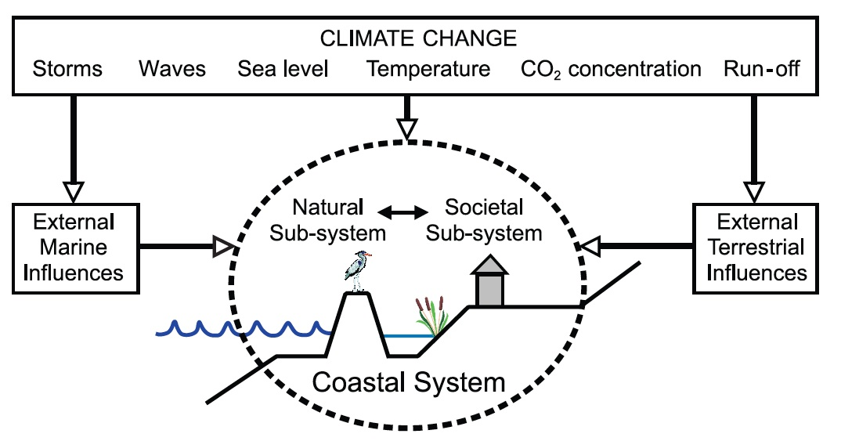
Table 5-: Primary drivers of coastal climate change impacts, secondary drivers and processes (adapted from NCCOE, 2004)
Primary driver | Secondary or process variable
- Mean sea level  - Ocean currents, sea surface temperature (SST), and acidification  - Wind climate  - Wave climate  - Rainfall/run-off  - Air temperature | - Local sea level  - Local currents  - Local winds  - Local waves  - Effects on structures  - Groundwater  - Coastal flooding  - Beach response  - Foreshore stability  - Sediment transport  - Hydraulics of estuaries  - Quality of coastal waters  - Ecology

Assessments of the vulnerability of coastal resources to the impacts of climate change should distinguish between ‘natural system vulnerability’ and ‘socio-economic system vulnerability’. While both are dependent on sensitivity, exposure and adaptive capacity (see Smit et al., 2001) and are clearly related and interdependent, analysis of socio-economic vulnerability to sea level rise, however, requires a prior understanding of how the natural system will be affected. Hence, analysis of coastal vulnerability most often starts with the natural system response. In addition, other climatic and non-climatic stresses should be acknowledged in a vulnerability analysis, because sea level rise cannot easily be isolated from other coastal processes and coastal systems evolve because of factors other than sea level rise.
Adaptation to sea level rise will be essential in the 21st century and beyond, through responding to both mean and extreme sea levels and other climate drivers. Given the already large and rapidly growing population within the coastal zone, autonomous adaptation alone will not be able to cope with regional sea level rise (Nicholls, 2010). Therefore all levels of government have a fundamental role in developing and facilitating appropriate adaptation responses (Tribbia and Moser, 2008).

Drivers of change
The coastal system is a dynamic environment with complex interactions between climate and non-climate drivers of change, summarized in Error: Reference source not found. A useful approach to considering the key drivers of change and their impact on secondary coastal processes is presented by the Engineers Australia National Committee on Coastal and Ocean Engineering (NCCOE) Guidelines for Responding to the Effects of Climate Change in Coastal and Ocean Engineering. The NCCOE approach considers six primary climate drivers and their respective impact on 13 secondary or process variables. The approach is useful in that it allows a user to establish an assessment matrix for a range of impact assessments. Error: Reference source not found outlines the primary drivers along with the secondary process variables.

Sea level
Changes in the level of the sea occur as a result of large-scale, basin-wide and global-scale changes in sea levels and land movement, as well as regional and local changes (Church et al., 2010). The sea level at any moment is the sum of the mean sea level, plus the state of the tides, wave set-up, responses to air pressure and near shore winds. Additionally, sea level may be affected by flows of water from on-shore through rivers and groundwater flows. The sea surface temperature (SST) is also an important factor for sea level rise.
As a result of climate change it is likely that both mean conditions and extremes in sea level conditions will change over a range of time scales (Figure 5-).
Figure 5-: Main contributions of net extreme event hazard and regional mean sea level rise (Source: Jones et al., 2009)
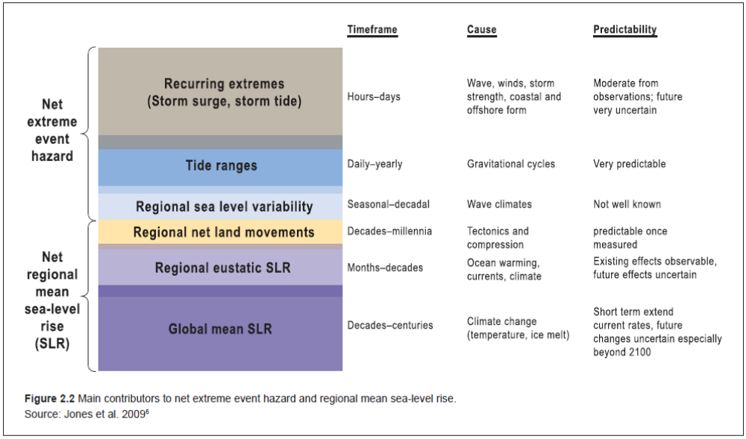
Relative sea level rise (i.e. the rise of the sea relative to the land, which itself may be rising or falling) has a wide range of effects on coastal processes. In addition to raising the ocean level, rising sea level also affects the coastal processes that operate around mean sea level (e.g. tides, waves – refer to Error: Reference source not found). The immediate effects of a rise in sea level therefore include inundation and increased frequency and depth of flooding of coastal land. Longer-term effects include changes to landforms, particularly beach erosion and salt marsh decline, as the coast adjusts to the new environmental conditions.
Importantly, coastal waters will continue to be affected by extreme tides, storm surges and storm tides, which may become increasingly severe in many places as a result of climate change. These factors will interact with sediments in coastal systems. The combined effect of rising sea levels and changes in extremes will likely produce much greater risks in the coastal zone than any single factor.

Sea level scenarios
The Intergovernmental Panel on Climate Change (IPCC) Third Assessment Report (TAR) projections of sea level rise were expressed in the form of globally averaged levels for the year 2100 compared with 1990 levels, while the IPCC Fourth Assessment Report (AR4) were expressed for the 2090–2100 decade compared with 1980–2000 averages.
The average of the TAR model projections for the full range of emissions scenarios is approximately 30–50 cm (dark shading Figure 5-3). The range of all model projections over all emissions scenarios is approximately 20–50 cm (light shading in Figure 5-3). The full range of projections, including an allowance for the uncertainty in estimates of contributions from land-based ice, was for a sea level rise of approximately 9–88 cm (outer black lines Figure 5-3).
The AR4 sea level rise projections consist of two components. The first component includes the estimated sea level rise from ocean thermal expansion, glaciers and ice caps and modelled ice-sheet contributions and is for a sea level rise of approximately 18–59 cm in 2095 (magenta bar Figure 5-). The second component consists of a possible rapid dynamic response of the Greenland and West Antarctic Ice Sheets, which could result in an accelerating contribution to sea level rise (Church at al., 2010). AR4 assumed an allowance of between 10 and 20 cm for the response of these ice sheets (red bar Figure 5-).
Figure 5-: Projected range of sea level rise for the 21st century: The TAR projections are indicated by the shaded regions and the curved lines are the upper and lower limits. The AR4 projections are the bars plotted at 2095. The inset shows sea level observed with satellite altimeters from 1993 to 2006 (orange) and observed with coastal sea level measurements from 1990 to 2001 (blue) (Source: Church et al., 2008)
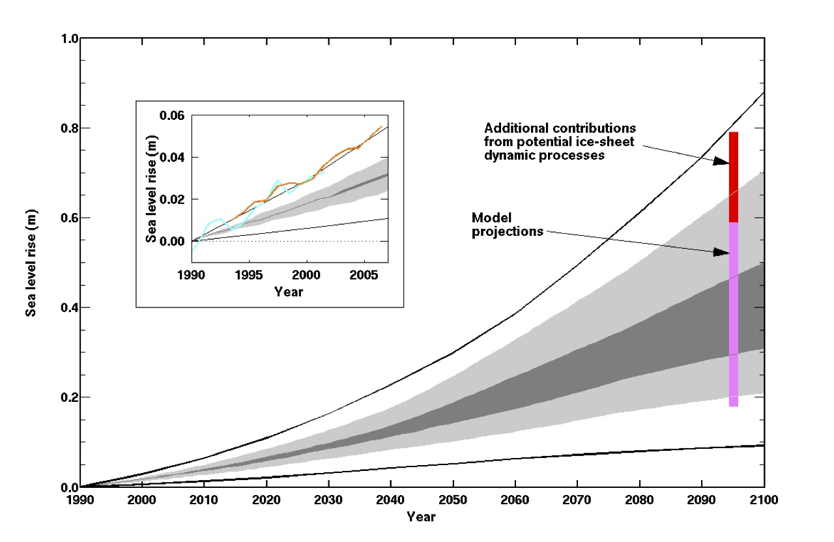
It is important to note that the AR4 estimates of sea level rise are generally seen as underestimates in the context of recently published peer reviewed studies. Recent studies using semi-empirical models have estimated sea level rise values of generally more than 1 metre for the 21st century (Figure 5-). Further information on these particular studies can be found in the further reading section of this chapter.
Figure 5-: Range of most recent estimates for 21st century sea level rise from semi-empirical models compared with the IPCC AR4 (Source: Rahmstorf, 2010)
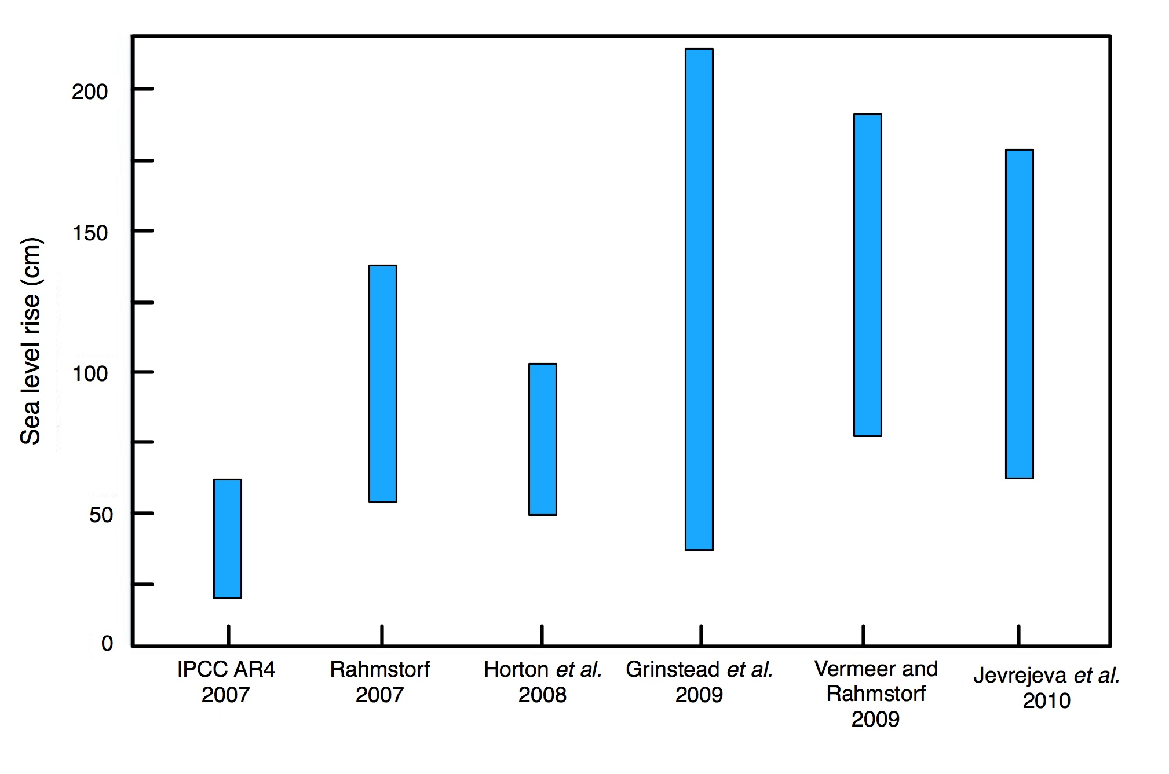

Changes in storminess and extreme water levels
The intensity and frequency of storm systems are key drivers of extreme water levels and wave heights, episodic erosion, inundation of low-lying areas and flooding among others (Nicholls et al., 2007). AR4 suggests an increase in the intensity of storm systems and, more recently, the study “Tropical cyclones and climate change” (Knutson et al., 2010), which has been adopted by the World Meteorological Organization (WMO) consensus statement on tropical cyclones, suggests that there will be a shift towards stronger storms, with intensity increases of 2–11 per cent by 2100, decreases in the globally averaged frequency of tropical cyclones, by 6–34 per cent and increases of the order of 20 per cent in the precipitation rate within 100 km of the storm centre. Changes in storm tracks and duration remain uncertain.
However, according to a special report by Working Groups I and II of the IPCC (IPCC, 2012), it is likely that there has been a pole-ward shift in the main northern and southern storm tracks during the past 50 years. There is strong agreement with respect to this change between several reanalysis products for a wide selection of cyclone parameters and cyclone identification methods, and European and Australian pressure-based storminess proxies are consistent with a pole-ward shift over the past 50 years, which indicates that the evidence is robust. Advances have been made in documenting the observed decadal and multi-decadal variability of extratropical cyclones using proxies for storminess. So the recent pole-ward shift should be seen in light of new studies with longer time spans that indicate that the last 50 years coincide with relatively low cyclonic activity in northern coastal Europe in the beginning of the period. Several studies using reanalyses suggest an intensification of high-latitude cyclones, but there is still insufficient knowledge of how changes in the observational systems are influencing the cyclone intensification in reanalyses, so even in cases of high agreement among the studies the evidence cannot be considered to be robust, thus we have only low confidence in these changes.
Other regional changes in intensity and the number of cyclones have been reported. However, the level of agreement between different studies using different tracking algorithms, different reanalyses, or different cyclone parameters is still low. Thus, we have low confidence in the amplitude, and in some regions in the sign, of the regional changes.
As for storminess, according to IPCC (2012), post-AR4 studies provide additional evidence that trends in extreme coastal high water across the globe reflect the increases in mean sea level, suggesting that mean sea level rise rather than changes in storminess are largely contributing to this increase (although data are sparse in many regions and this lowers the confidence in this assessment). It is therefore considered likely that sea level rise has led to a change in extreme coastal high water levels. It is likely that there has been an anthropogenic influence on increasing extreme coastal high water levels via mean sea level contributions. Although changes in storminess may contribute to changes in sea level extremes (e.g. Guam; see Figure 5-5), the limited geographical coverage of studies to date and the uncertainties associated with storminess changes overall mean that a general assessment of the effects of storminess changes on storm surge is not possible at this time. On the basis of studies of observed trends in extreme coastal high water levels it is very likely that mean sea level rise will contribute to upward trends in the future.

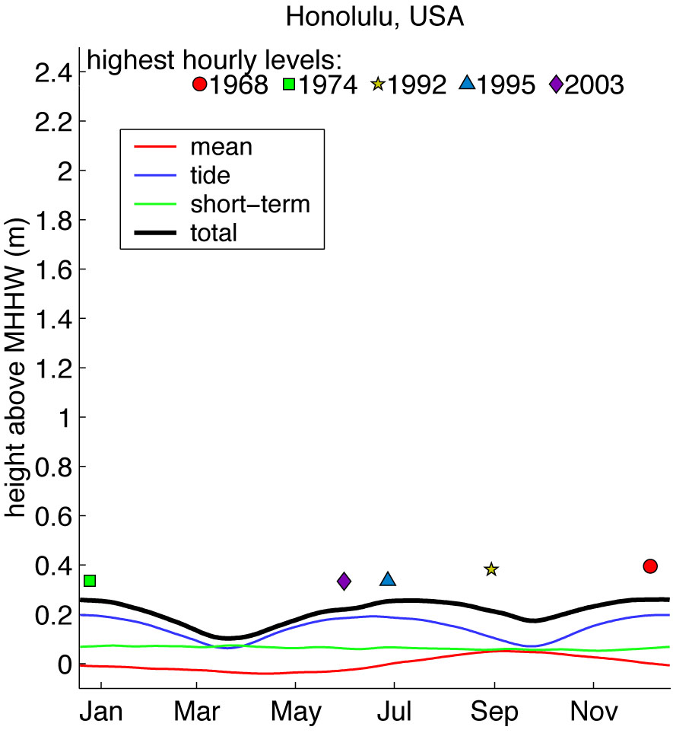
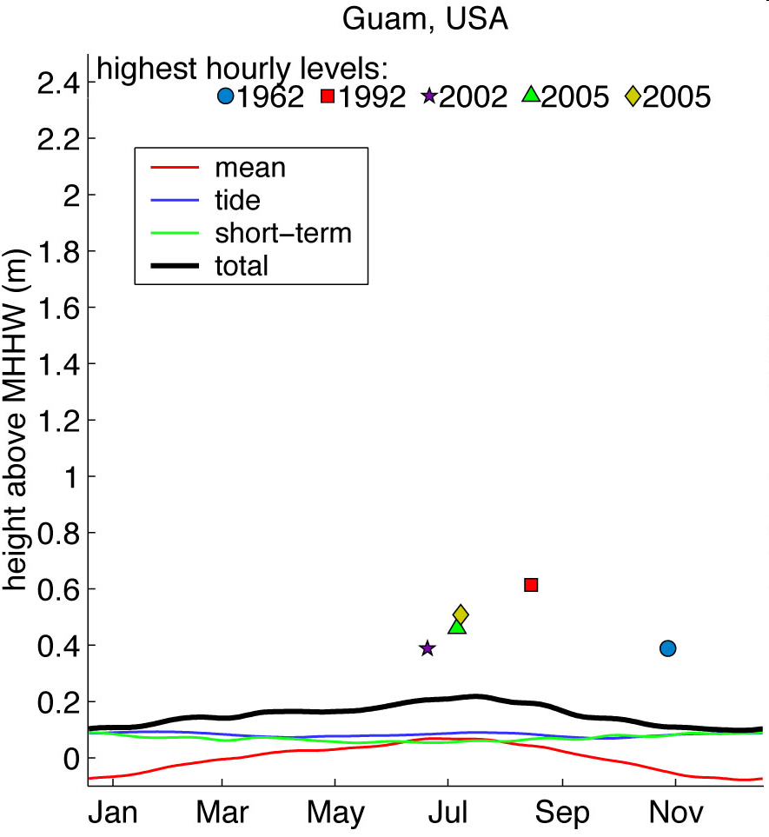
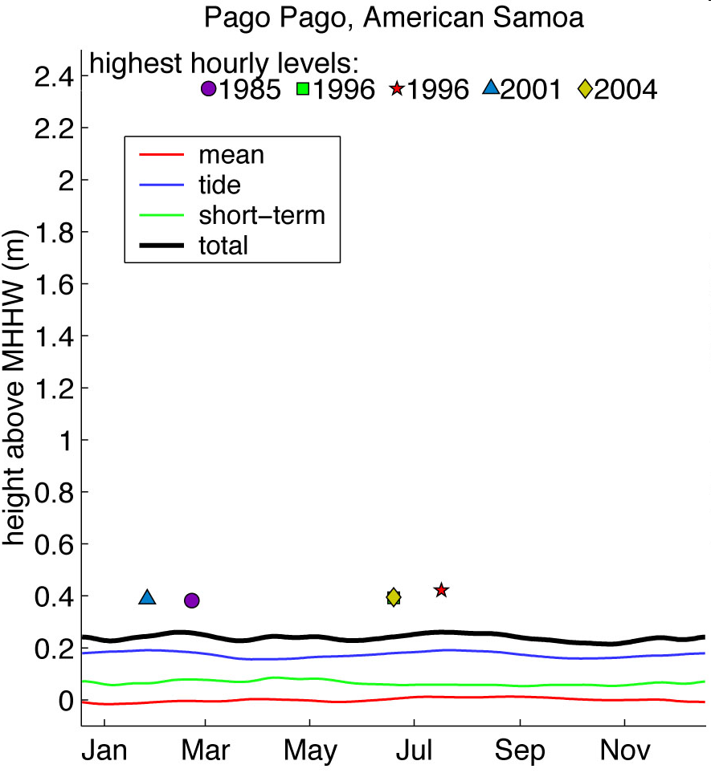
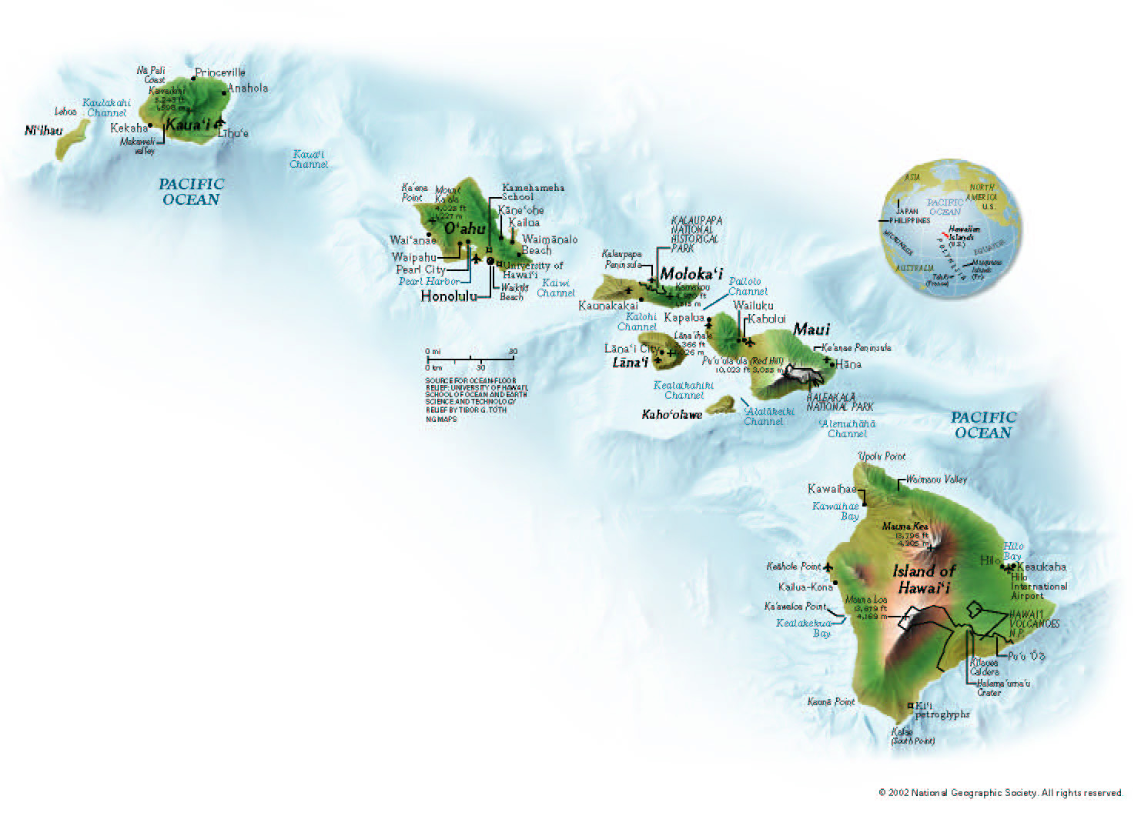
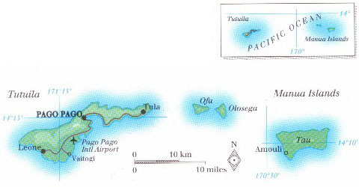
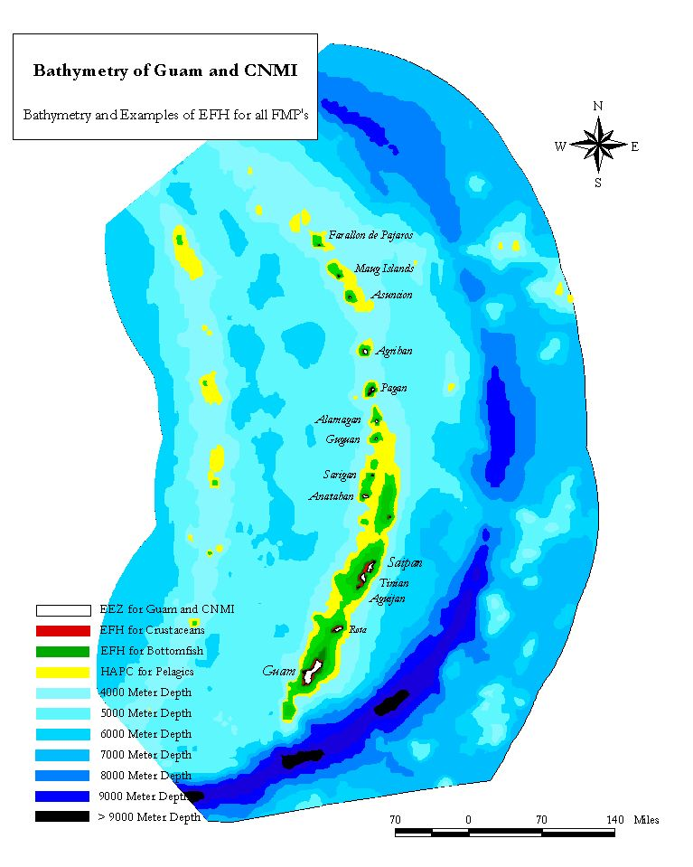
Figure 5-5: Daily water level time series in Guam, Pago Pago, and Honolulu. These plots show the daily extreme event (95th percentile) of the observed water level, the extreme event (95th percentile) of the daily non-tidal residual, the 95th percentile of the daily predicted tide, and the daily average water level. The five highest hourly values measured are included for comparison with the climatology. Guam is all storms, Samoa is all tide, and Hawaii is mixed
(Source: <http://www.pacificstormsclimatology.org/>; John Marra, Personal communication).
(all storm..)
(all tide..)
(storm, tide..)

Other oceanic drivers (e.g. wave climate, currents, ocean acidification, sea surface temperature)
The magnitude, frequency and approach direction of waves impacting the coast are significant drivers of shoreline change. Significant regional variability will exist in potential future changes (Nicholls et al., 2007).
Increased atmospheric carbon dioxide (CO₂) dissolving in the oceans has lowered ocean surface pH by 0.1 unit since 1750 (Nicholls et al., 2007). An increase in ocean acidification will likely have significant spatially and temporally variable impacts on marine biodiversity.
Projected changes in SST will likely drive changes in stratification/circulation; reduced incidence of sea ice at higher latitudes; increased coral bleaching and mortality; pole-ward species migration and increased algal blooms (Nicholls et al., 2007). Changes of global and local SST particularly influence the El Niño/La Niña Southern Oscillation (ENSO) climate cycle, which in turn causes regional sea level variability and change on seasonal time scales. The global climate model experiment indicates that much of the atmospheric response to ENSO is associated with changes in SSTs in the Pacific Ocean (Lau, 1985).

THE EL Nino /LA NINA SOUTHERN OSCILLATION (ENSO)
El Niño is caused by major warming of the equatorial waters in the Pacific Ocean. In this case, the anomaly of the SSTs in the tropical Pacific increases (+0.5 to +1.5°C in the NINO 3.4 area ) from its long-term average (Figure 5-6). On the other hand, La Niña is caused by major cooling of the same equatorial waters, in which case the anomaly of the SSTs in the tropical Pacific decreases (–0.5 to –1.5°C in the NINO 3.4 area) from its long-term average (Figure 5 - 6).
Figure 5-6: SST in the typical El Niño (left panel) and La Niña (right panel) events. (Source: <http://iri.columbia.edu/climate/ENSO/background/basics.html>)
El Niño La Niña
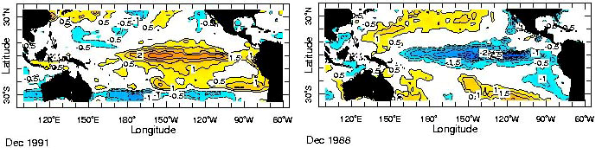
The Southern Oscillation represents the atmospheric component of the cycle in which lower (higher) than normal sea level pressure occurs near Tahiti and higher (lower) sea level pressure occurs in Australia during El Niño (La Niña) conditions. El Niño events (event and year is synonymously used in this paper) occur every three to seven years and may last for many months, causing significant economic and atmospheric consequences worldwide. During the past forty years, ten of these major El Niño (La Niña) events have been recorded, the worst of which occurred in 1997–1998 (1998–99). Previous to this, the El Niño event in 1982–1983 was the strongest. Some of the El Niño events have persisted for more than one year. These El Niño/La Niña events are associated with consistent climate anomalies (i.e. shifts in temperature, precipitation and sea level patterns) across the globe. These events are therefore treated as an important component of the climate system as they impact weather on a global scale (see Clarke, 2008 and references therein for the dynamics of ENSO). This is also a fast growing science and there is abundant literature available on this issue in various print and web formats.
The tropical climate variability has been found to be heavily influenced by the ENSO climate cycle (Bjerknes, 1966; Ropelewski and Halpert, 1987; Chu, 1995). Low sea level during the El Niño events and high sea level during the La Niña events are the results of this influence (Chowdhury et al., 2007a). Rainfall and tropical cyclone activities in the Pacific and Caribbean are also influenced by ENSO. Therefore, knowing the ENSO conditions ahead of time would provide substantial opportunities to provide early warnings on climate extremes for the Pacific, Caribbean and parts of South American region. This advanced information would have far-reaching economic ramifications for these countries.
To summarize, the ENSO impacts on Caribbean Island and South America:
- The Caribbean response to ENSO depends very much on which part of the Caribbean is being discussed. r example, like southern Florida, Cuba is expected to have below average precipitation during La Niña winters;
- Haiti and Dominican Republic are often also included in that response, but less reliably;
- Puerto Rico also does, but to a still lesser degree;
- The Lesser Antilles are in a transition zone, where the northern ones have a slightly greater chance of being dry during La Niña (and wet during El Niño), while the southern ones (e.g. Grenada) share the effect of northern South America, which is the opposite (wet tendency during La Niña);
- So the place where the dryness can be most confidently attributed to the La Niña is Cuba, and the opposite effect is expected in the islands just north of South America.

Non-climate drivers
“Few of the world’s coastlines are now beyond the influence of human pressures, although not all coasts are inhabited (Buddemeier et al., 2002). Utilization of the coast increased dramatically during the 20th century, a trend that seems certain continue through the 21st century.” (IPCC AR4, p. 319)
There has been extensive human modification of coastal systems that have served to significantly influence the exposure and sensitivity of the coast to climate change. These modifications include changes to sediment supply and sediment pathways through a range of mechanisms – including port/harbour construction, coastal protection works and up-stream damming for freshwater supply/hydroelectric power and deforestation. Coastal subsidence due to ground water abstraction is also locally significant, particularly in delta coasts. These influences must be carefully considered in the assessment of future coastal impacts (outlined in section 5.3, below). In addition, careful consideration of future socio-economic scenarios of changes in coastal regions, through for example urbanization, should also be considered in impact assessments (see chapter 3).
In addition, the impacts of geological natural hazards, in particular earthquakes that can both substantially change relative sea level in a matter of minutes and trigger devastating tsunamis, should also be considered.

Potential Impacts
The impacts of climate change on coastal zones are well documented in the contribution of Working Group II to the AR4 chapter on Coastal Systems and Low-lying Areas. The impacts can be broadly grouped into two main categories: bio-geophysical impacts such as erosion and inundation, and socio-economic impacts associated with bio-geophysical impacts such as the loss of land and impacts on livelihoods. Table 5- summarizes both the links between both types of climate change impacts and their effects on the coastal environment.
Figure 5-7: Climate change drivers and impacts on the coast (Source: Short and Woodroffe, 2009)
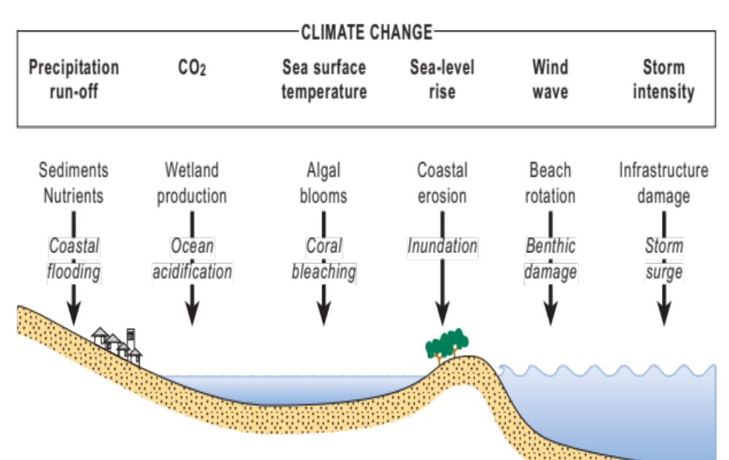
Table 5-: Example effects of climate change on the coastal zone (adapted from Abuodha and Woodroffe, 2007)
Effect category | Example effects on the coastal environment
Bio-geophysical | - Displacement of coastal lowlands and wetlands  - Increased coastal erosion  - Increased flooding  - Salinization of surface and groundwater
Socio-economic | - Loss of property and land  - Increased flood risk/loss of life  - Damage to coastal protection works and other infrastructure  - Loss of renewable and subsistence resources  - Loss of tourism, recreation and coastal habitats  - Impacts on agriculture and aquaculture through decline in soil and water quality
Secondary impacts of accelerated sea level rise | - Impact on livelihoods and human health  - Decline in health/living standards as a result of decline in drinking water quality  - Threat to housing quality
Infrastructure and economic activity | - Diversion of resources to adaptation responses to sea level rise impacts  - Increasing protection costs  - Increasing insurance premiums  - Political and institutional instability, and social unrest  - Threats to particular cultures and ways of life

Biophysical impacts
The key future impacts and vulnerabilities on coastal ecosystems are well documented (Nicholls et al., 2007). Table 5- outlines the main climate drivers for coastal ecosystems, their trends due to climate change and their main physical and ecosystem effects. Further detail on the impacts can be found in Nicholls et al. (2007), section 6.4.1.
Table 5-: Main climate drivers for coastal systems, their trends due to climate change, and their main physical and ecosystem effects (Nicholls et al., 2007)
Climate driver (trend) | Main physical and ecosystem effects on coastal ecosystems
CO₂ concentration (I) | Increased CO₂ fertilization; decreases seawater pH (or ‘ocean acidification’) negatively impacting coral reefs and other pH-sensitive organisms
Sea surface temperature (I, R) | Increased stratification/changes circulation; reduced incidence of sea ice at higher latitudes; increased coral bleaching and mortality; pole-ward species migration; increased algal blooms
Sea level (I, R) | Inundation, flood and storm damage; erosion; saltwater intrusion; rising water tables/impeded drainage; wetland loss (and change)
Storm intensity (I, R) | Increased extreme water levels and wave heights; increased episodic erosion, storm damage, risk of flooding and defence failure
Storm frequency (?, R); Storm track (?, R) | Altered surges and storm waves and hence risk of storm damage and flooding
Wave climate (?, R) | Altered wave conditions, including swell; altered patterns of erosion and accretion; re-orientation of beach plan form
Run-off (R) | Altered flood risk in coastal lowlands; altered water quality/salinity; altered fluvial sediment supply; altered circulation and nutrient supply
Key: (I) = Increasing; (?) = uncertain; (R) = regional variability

Socio-economic impacts
The socio-economic impacts of climate change are generally built on the physical changes summarized in Table 5-. The socio-economic impacts of climate change will be cross cutting in nature, the key climate-related impacts on the various socio-economic sectors within the coastal zone are presented in Table 5 - . Additional detail on the impacts on each individual sector can be found in Nicholls et al. (2007), section 6.4.2.
Table 5 - : Summary of climate-related impacts on socio-economic sectors in coastal zones (Nicholls et al., 2007)
Coastal socio-economic sector | Temperature rise (air and seawater) | Extreme events (storms, waves) | Floods (sea level, run-off) | Rising water tables (sea level) | Erosion (sea level, storms, waves) | Salt water intrusion (sea level, run-off) | Biological effects (all climate drivers)
Freshwater resources | X | X | X | X | – | X | x
Agriculture and forestry | X | X | X | X | – | X | x
Fisheries and aquaculture | X | X | x | – | x | X | X
Health | X | X | X | x | – | X | X
Recreation and tourism | X | X | x | – | X | – | X
Biodiversity | X | X | X | X | X | X | X
Settlements/  infrastruc  ture | X | X | X | X | X | X | –
Gender | X | X | X | X | X | X | -
Key: X = strong; x = weak; – = negligible or not established.

Situation Summary
In summary, the key biophysical effects of climate change on coastal systems from a societal perspective include:
- Increased flood-frequency probabilities;
- Erosion;
- Inundation;
- Rising water tables;
- Saltwater intrusion;
- Biological effects.
The potential socio-economic effects of climate change are:
- Direct loss of economic, ecological, cultural and subsistence values through loss of land, infrastructure and coastal habitats;
- Increased flood risk to people, land and infrastructure and the values stated above;
- Other effects relating to changes in water management, salinity and biological activity, such as loss of tourism, loss of coastal habitats and effects on agriculture and aquaculture.
Global climate change already impacts and will continue to impact coastal communities, ecosystems, and livelihoods in the coastal zone where over 40 per cent of the world’s population reside. Irrespective of climate change, coastal areas face a wide range of issues associated with population growth, water pollution, and changes in freshwater flows, resource exploitation and degradation and widespread habitat change. These existing stresses will likely be exacerbated by climate change, creating an imperative to include coastal adaptation as part of effective coastal management and a priority for immediate action for coastal areas (USAID, 2009).

Methods, Tools and Data Requirements

General considerations
The various approaches to model the movement of coastlines due to climate change are summarized by Abuodha and Woodroffe (2007). Most methods for assessing impacts on beaches and sandy coasts are underpinned by the basic premise of the Bruun ‘rule’, with methods becoming increasingly sophisticated to include responses of different kinds of coasts.
Three levels of assessment are commonly applied (see also Table 5 - ):
- Strategic level (screening assessment);
- Vulnerability assessments (various scales);
- Site-specific level (planning assessment).
Table 5 - : Overall levels of assessment for coastal vulnerability assessments (adapted from Hoozemans and Pennekamp, 1993; WCC’93, 1994)
Level of assessment | Timescale required | Precision | Prior knowledge | Other scenarios considered  (in addition to sea level rise)
Strategic level  (screening assessment) | 2–3 months | Lowest | Low | Directions of change
Vulnerability assessments  (various scales) | 1–2 years | Medium | Medium | Likely socio-economic scenarios and scenarios of key climate change drivers
Site-specific level  (planning assessment) | Ongoing | Highest | High | All climate change drivers (often with multiple scenarios)
The aim of screening assessments and vulnerability assessments is to focus attention on critical issues concerning the coastal zone to assist with broad scale prioritization of concern and to target future studies, rather than to provide detailed predictions. Assessments at the site-specific level (planning assessments) seek to develop very detailed assessments of responses to sea level rise and climate change. Such assessments can be embedded within environmental impact assessment (EIA) requirements, or be undertaken due to other statutory land-use planning requirements, such as those required for the development of new coastal urban land. In addition,
planning assessments can be embedded within broader integrated coastal zone management (ICZM) frameworks (Kay and Alder, 2005) which seek to integrate responses to all existing and potential problems of the coastal zone, including minimizing vulnerability to long-term effects of climate change.
In determining the appropriate approach to assess the likely impacts of climate change on the coastal zone, a number of questions should be considered (Lu, 2006).
- Who are the targeted end-users of the results of the assessment? (Answering this question will inform the level of technical detail required; methods for the treatment of uncertainties; and format for presenting results);
- What kind of output/information is expected from the assessment? (i.e. public awareness materials such as climate scenarios and their potential impacts; key vulnerabilities such as risk/vulnerability maps; a national/sectored adaptation strategy; or a combination of the above);
- What resources are available to conduct the study (human and financial)?
- How much time is there to conduct the study?
These questions set the basis for determining the type of assessment and consequently the tools and data requirements to perform the assessment. The availability or ease of access to data and models must not define the type of assessment used; rather an assessment approach that meets stakeholder’s needs should inform the selection of methods and models.

Screening assessment
A screening assessment can initially be qualitative, and can be followed up by semi-quantitative assessment. Screening-level analysis is generally of the four major impacts of sea level rise on the coastal zone: inundation, erosion, flooding and salinization. Impacts on the socio-economics of the area can be assessed using the matrix shown in Table 5-, and it should be possible to factor in any major contemporary problems, such as beach mining and development on the coast such as ports/harbours. Either qualitative scores can be assigned to each cell in Table 5- (such as on a scale from 1–10) or simple descriptions, such as high/medium/low impact.
Table 5-: Screening assessment impact matrix
Biophysical impacts | Socio-economic impacts
Biophysical impacts | Tourism | Human settlements | Agriculture | Water supply | Fisheries | Financial services | Human health | Gender
Inundation
Erosion
Flooding
Salinization
Others?

The Bruun Rule
A commonly applied rule to approximate erosion of sandy shorelines in response to sea level rise is the Bruun ‘Rule’ (Bruun, 1962). The ‘rule’ is based on the cross-shore exchange of sediments relative to sea level rise. Bruun states that within the closure zone of the beach (typically defined as the limit of significant wave-driven sediment transport), the beach will adjust to maintain its equilibrium profile relative to the still water level. This is achieved by translating the profile landwards and upwards, with eroded sediments at the shoreline end of the profile being deposited in the offshore end of the profile maintaining a net balance of sediment. The shoreline translation is given by geometry (as illustrated in Figure 5-8) and is expressed by the equation below.
The general equation is:
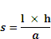
Where s = recession of shoreline (m)
l = length of active zone (m)
a = sea level rise (m)
h = height of closure zone (m)

Figure 5-8: The Bruun Rule (adapted from Bruun, 1990)
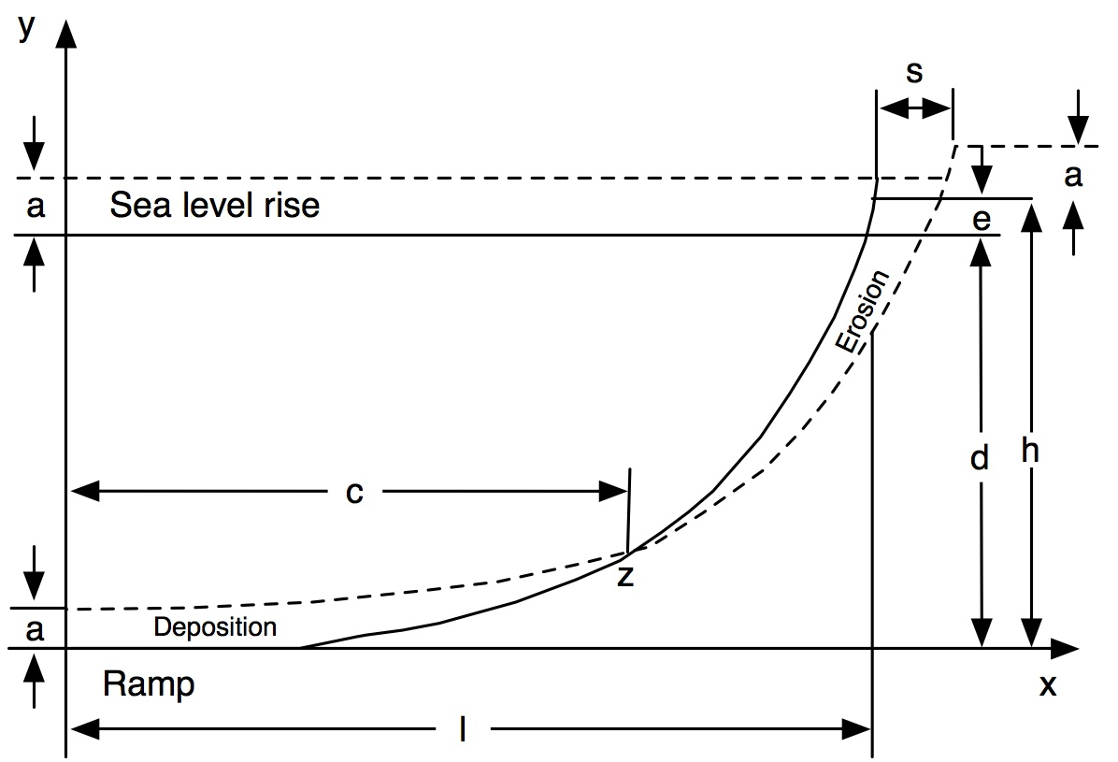

The Bruun ‘rule’ can be used to provide an approximate ‘rule of thumb’ for potential coastal erosion due to sea level rise. As a result, it is often used in strategic-level assessments, particularly at the screening level. However, there is considerable scientific debate as to the usefulness of applying the Bruun rule in any coastal setting for predicting future shoreline change, including open coast settings for which it was originally developed. For example Cooper and Pilkey (2004) note that several assumptions behind the Bruun Rule are known to be false and nowhere has the Bruun Rule been adequately proven. In addition, the coastal chapter of AR4 (Nicholls et al., 2007) concluded that there is not a simple relationship between sea level rise and horizontal movement of the shoreline, and sediment budget approaches are most useful to assess beach response to climate change.

Vulnerability assessment
The United States Agency for International Development (USAID) report Adapting to Coastal Climate Change: A Guidebook for Development Planners (USAID, 2009) outlines the following steps in a coastal vulnerability assessment
- Assess climate change projections;
- Assess exposure to climate change;
- Assess sensitivity to climate change;
- Assess health of coastal habitats and ecosystems;
- Assess adaptive capacity.
Assessing a coastal areas’ vulnerability to the impacts of climate change involves understanding: 1) the climate projections for a given region or locale; 2) what is at risk (climate change exposure and sensitivity); and 3) the capacity of society to cope with the expected or actual climate changes (adaptive capacity). Combined, these three factors define the vulnerability of people in a place to climate change (see Figure 5 -)
Figure 5 - 9: USAID coastal vulnerability assessment framework (Source: USAID (2009), adapted from Allison, 2007)
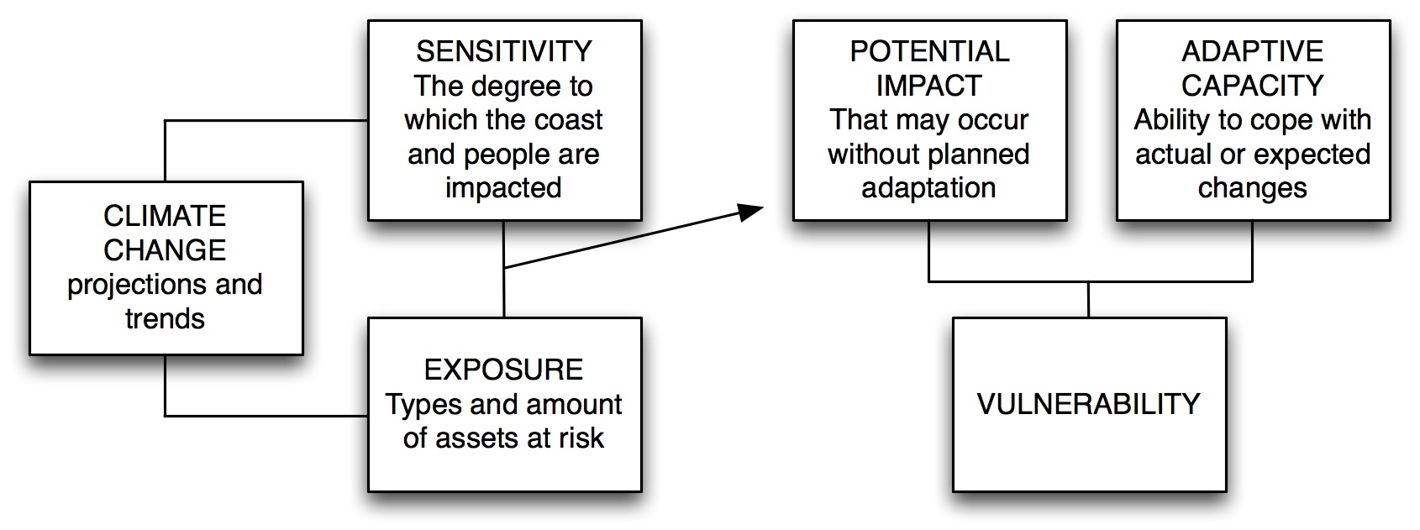
Error: Reference source not found shows an example framework of how vulnerability assessment can be put into action. First, vulnerability assessment distinguishes between the natural system vulnerability and the socio-economic system vulnerability to climate change, even though they are clearly related and interdependent. Second, analysis of socio-economic vulnerability to sea level rise requires a prior understanding of how the natural system will be affected. Hence, analysis of coastal vulnerability always starts with the natural system response. Last, other climatic and non-climatic stresses are acknowledged, indicating that sea level rise is not occurring independent from other
processes and that the coastal system will evolve due to factors other than sea level rise.
Figure 5-10: Example of a framework for vulnerability assessment (Kay et al, 2006)
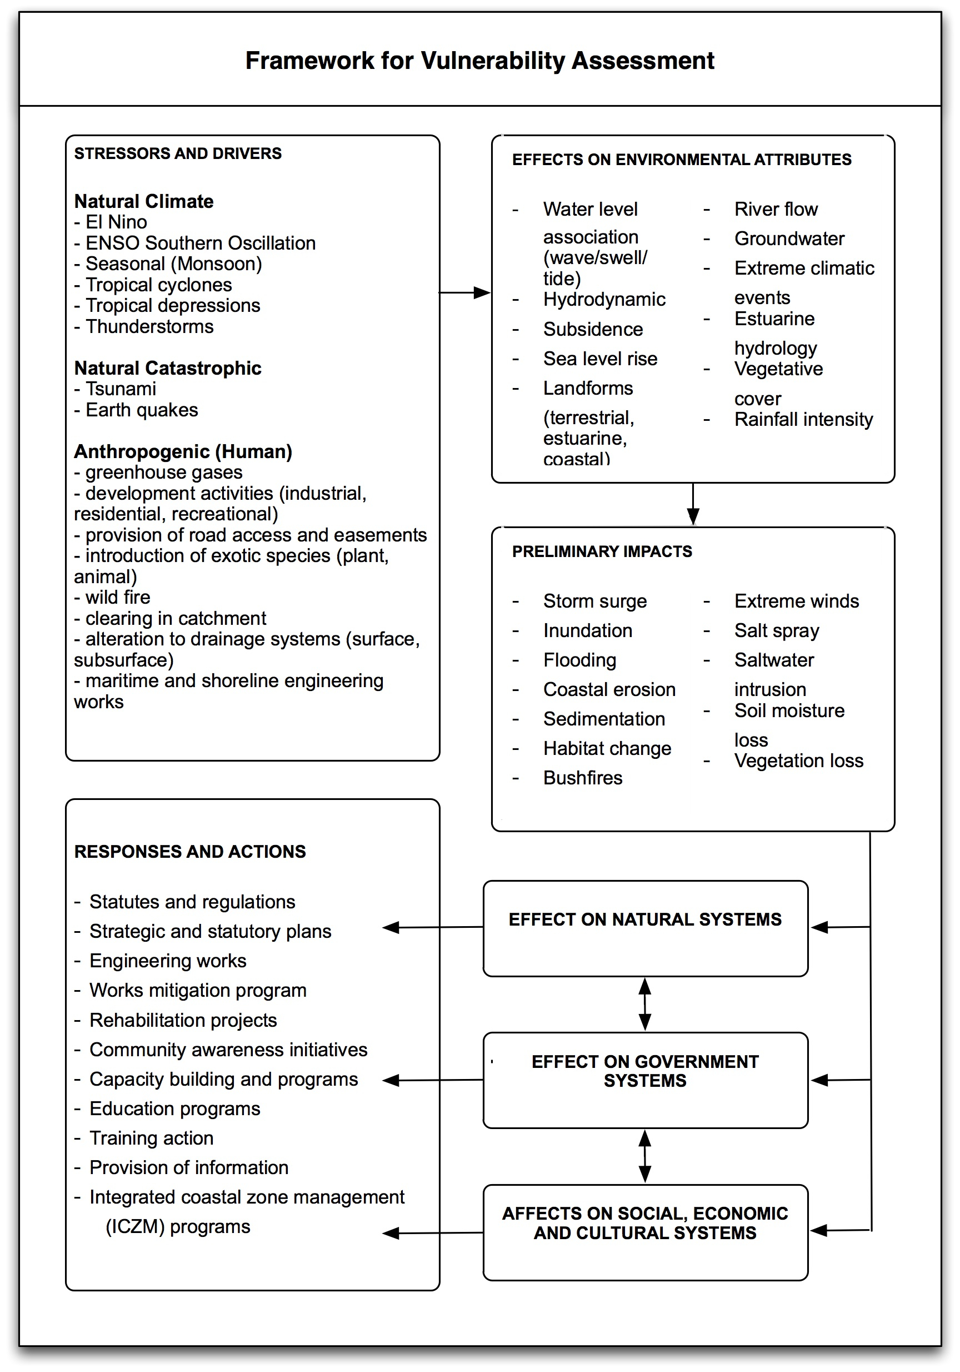

Planning assessment
For an area where a more in-depth assessment is required, the next step after the vulnerability assessment is a planning assessment. The aim is to integrate all possible responses to sea level rise and other climate change drivers in the coastal zone to minimize future vulnerability and often to aid in formulating future policy or in determining detailed land use. A planning assessment is an ongoing investigation of a specific area. Assessing the future impacts of sea level rise on the coastal zone requires information on the major processes in the sediment budget of the area concerned. The assessment must also consider other climate change impacts, such as changing storm frequency, intensity and direction.
The goal of a planning assessment must be specific to the area, focusing on the issues that are pertinent to that area. An example is an integrated flood and erosion assessment undertaken on the United Kingdom coast (Evans et al., 2004a, 2004b). It is considering future socio-economic scenarios of population, development and legislation, as well as sea level rise and climate change scenarios, beach evolution modelling and varying coastal protection options. The aim is to quantify the future impacts of projected cliff recession on long-shore sediment supply and, therefore, beach volume and flood risk in low-lying areas of the coastal zone. This level of assessment is data and time intensive and often on-going; however, the results, while site-specific, should be appropriate to influence future policy and to feed into more local management plans.

Coastal zone integrated assessment models
The aim of the EU-funded project DINAS-COAST (Dynamic and interactive assessment of national, regional and global vulnerability of coastal zones to climate change and sea level rise) was to develop a CD-ROM-based tool that would enable its users to produce quantitative information on a range of coastal vulnerability indicators, for user-selected climatic and socio-economic scenarios and adaptation policies, on national, regional and global scales, covering all coastal nations. This tool is called DIVA – Dynamic and Interactive Vulnerability Assessment (Vafeidis et al., 2003; McFadden et al., 2007).
The DIVA methodology used a database of features, both physical and socio-economic, based on segments of the coastline, within integrated modules to assess adaptation options under future climate change scenarios. The modules were flooding, relative sea level rise, erosion, wetland change, wetland evaluation and river effects. Generalized example outputs of the model are numbers of people flooded, wetlands lost, adaptation costs (including those relating to flood protection and beach protection) and the amount of land lost under the specified relative sea level rise scenario.
However, the DIVA tool is currently not available for download due to a lack of resources for maintaining and supporting the software. The release of new versions of the DIVA tool with a graphical user interface is contingent on the availability of future funding.

Risk-based assessments: a blended approach
Risk management commonly follows a standardized procedure including the identification, analysis, evaluation and treatment of the considered risks (ISO Standard 31000). On the other hand, the concept of vulnerability proposed by the IPCC combines the assessment of exposure (e.g. climate change projections), sensitivity (e.g. population growth) and adaptive capacity (e.g. technological options for coastal defence) (IPCC, 2007).
Risk-based approaches to vulnerability assessment have an explicit management-oriented approach that assesses risk to management organizations (which can be governments, communities, NGOs or the private sector) due to climate change (see chapter 2).
Importantly, the application of risk-based approaches in Australia has evolved into a multi-scaled coastal risk assessment typically following an approach of ‘model scaling’ whereby up-scaling (considering larger areas of assessment) is facilitated by progressively reducing the number of processes considered. This is essentially the same approach as the sequence of screening assessments, vulnerability assessments and detailed site-specific assessments outlined above.
A ‘first-pass’ (screening) assessment approach, fundamentally using the Bruun Rule, but incorporating factors for low-level topography and the presence of erosion-resistant features can be applied at a broad national scale. This can provide initial ‘broad brush’ estimates of potential impacts.

Box 5-:Vulnerability assessment using a line mapping approach
Coastal geomorphology datasets can be compiled in a line format with each of the different landform attribute fields displayed or analysed, individually or as specific combinations of attributes. A line map is able to segment the coast at every point where any of the landform attributes change, as illustrated in the figure below.
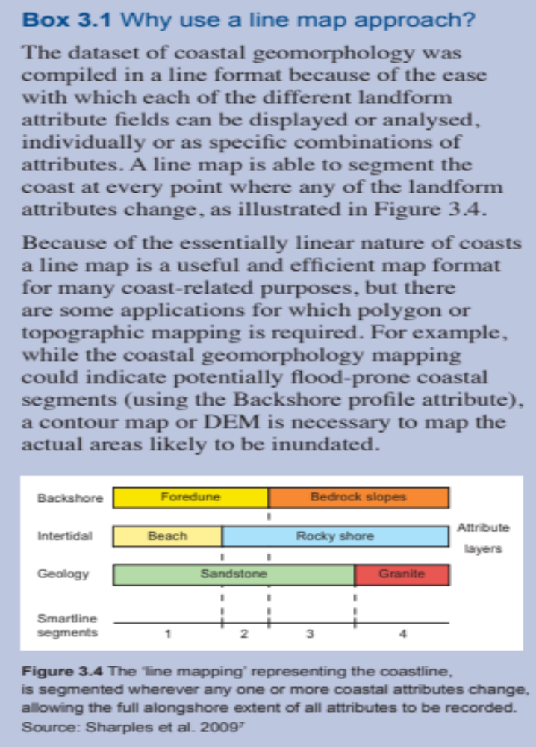
Because of the essentially linear nature of coasts, a line map is a useful and efficient map format for many coast-related purposes, but there are some applications for which polygon or topographic mapping is required. For example, while the coastal geomorphology mapping could indicate potentially flood-prone coastal segments, a contour map or digital elevation model (DEM) is necessary to map the actual areas likely to be inundated
The multi-scaled approach using a landform hierarchy is already applied to coastal management in Great Britain (Whitehouse et al., 2009). The availability of detailed aerial imagery, light detecting and ranging (LiDAR) and geomorphic knowledge bases has allowed development of refined approaches for this type of assessment in a number of instances around Australia (Gozzard, 2010; Eliot et al., 2011).
The fundamental benefit of the approach towards climate change impact assessment is improved consistency between models at different scales: the dominant land units when considered at lower scales determine the model type applied at each level. Although this does not prevent the application of invalid models to different landform types (see section 5.5), it facilitates clear identification of the zones in which the selected model has reduced validity. The approach of multi-scaled landform assessment is in common use for land use and hydrological studies (Schoknecht et al., 2004; van Gool et al., 2005).
Although it is acknowledged that data constraints may prohibit the full application of this type of approach to coastal vulnerability assessment in non-Annex I countries without additional technical assistance, the core principles of a multi-scaled approach are
extremely useful to provide a pathway for long-term application in subsequent studies with a view to augmenting data sets as appropriate funding becomes available. Importantly, ‘scale thinking’ also provides a framework for considering the application of specific impact assessment tools outlined in the next section.

Tools
There are a range of tools commonly used in the various approaches to coastal vulnerability and adaptation (V&A) assessment including tools for: decision support; modelling and analysis; data collection, processing and management; stakeholder engagement and outreach; conceptual modelling; visualization; project management; and monitoring and assessment.
A range of tools and methods (15 in total) applied globally to support V&A assessment of coastal resources is described in the UNFCCC Compendium. A brief analysis of a selection of these tools is shown in Figure 5 -. The methods and tools are generally used to establish the current physical condition of the coast, to consider the variability of each condition in the face of on-going natural environmental factors, and to evaluate the likely response.
In coastal V&A, there has also been an increasing trend towards assessing the practical options for climate change adaptation by applying broad V&A frameworks (as discussed in chapter 2), complemented with specific tools. This enhances the ability to mainstream the results of coastal V&A assessments into existing government systems aimed at managing coastal zones (see chapter 9).

Table 5-: Strengths and limitations of selected tools for vulnerability and adaptation assessment of coastal resources (adapted from UNFCCC Resource Guide; Kay and Travers, 2008)
Method | Strengths | Limitations
Shoreline planning method | Widespread application around the world’s coasts in coastal management | Requires customization to individual coastal zone management administrative systems
Coastal vulnerability indices (CVI) | Generally easily calculated and employed for rapid vulnerability assessment | Requires customization of variables for case-by-case use
Dynamic interactive vulnerability analysis (DIVA) | Provides a reasonable overview of climatic and socio-economic scenarios and adaptation policies on regional and global scales | Provides course-scale resolution of potential coastal impacts at a national scale, some but limited perspectives on vulnerability of the coast to climate change  (Not currently available for download)
CoastClim and SimClim | Commercial decision-making aid for changed climate conditions | Requires purchase
Smartline | Cost effective and rapid geomorphic mapping of coastal sensitivity, able to be considered at multiple scales | Adaptation to local and site-specific scale will require testing and validation
The evolution of assessment techniques is marked by:
- Improved consideration of uncertainties involved in climate and impact projections;
- Increased integration of climatic and non-climatic stressors;
- More realistic recognition of the potential for and limitations to societal responses;
- Increased importance of stakeholder involvement; and
- A purposeful shift form science driven vulnerability assessment to policy driven vulnerability reduction (Abuodah and Woodroffe, 2007).
Many of the tools are heavily dependent on the availability of input datasets. While it is likely that several of these tools and techniques could be adapted and updated for use by non-Annex I countries, this will require further focused investigation with specific attention to data availability and in-country capacity.

Table 5-: Tools categorized according to function
Tool category | Description | Example links
Process tools | Helps design and conduct a planning process that incorporates the unique elements that address the vulnerabilities, risks and uncertainties inherent in climate-related planning | National Oceanic and Atmospheric Administration (NOAA) CSC Roadmap:  <http://www.csc.noaa.gov/digitalcoast/training/coastalrisk.html>  (See also chapter 2 for community-based V&A tools)  European Union/IMCORE coastal adaptation guidance:  <http://www.coastaladaptation.eu/index.php/en/>  Georgetown Climate Center Adaptation Tool Kit: Sea Level Rise and Coastal Land Use:  <http://www.georgetownclimate.org/sites/default/files/Adaptation_Tool_Kit_SLR.pdf>
Visualization tools | Allow users to build unique tools and simulations that enable stakeholder engagement though the use of pictures or web-based tools. The tools in this group are generally simple to use, but can include web-based geographic information system (GIS) visualization tools that require special software, hardware and expertise | CanVis:  <http://www.csc.noaa.gov/digitalcoast/tools/canvis/>  Sea level rise explorer:  <http://www.globalwarmingart.com/wiki/Special:SeaLevel>  Google Mashups:  <http://clear.uconn.edu/training/maps/mashup.htm>  <http://www.google.com/earth/>
Socio-economic tools | Provide community level socio-economic data that allows planners and stakeholders to visualize, explore and understand the social impacts that could result from future hazards and climate change | SoVi (Social Vulnerability Index) (USA data only)  <http://webra.cac.sc.edu/hvri/products/sovi.aspx>
Analytical tools | Allow planners to investigate current conditions and ecosystem processes, determine the effects of potential future conditions, and explore scenarios to determine potential effects of planning decisions | Sea Level Rise Affecting Marshes Model (SLAMM-Viewer) (USA locations only)  <http://www.slammview.org>
ENSO tools | Basics of El Niño and La Niña; how are specific “ENSO” events defined? | <http://iri.columbia.edu/climate/ENSO/background/pastevent.html>  <http://www.cdc.noaa.gov/cgi-bin/data/composites/printpage.pl>
Tide trend tools | Tide predictions | <http://tidesandcurrents.noaa.gov/station_retrieve.shtml?type=Tide+Predictions>

When choosing a tool to use in an assessment the following factors should be considered:
- Make sure you understand the time, funding and expertise needed to collect the data needed to use the tool (or tools); run the tool; and interpret and communicate tool results. One of the best ways to gather this information is by talking to previous tool users and the tool developer;
- Allow enough time for an iterative process. Tool use is most effective when stakeholders can explore a range of alternatives and make improvements to scenarios (and possibly the tools themselves) as they learn about the process, the trade-offs involved in meeting diverse objectives, and the possible results of different decisions;
- Make sure you are using tools that provide the types of results that you need. Some tools provide general indices rather than quantitative results, while others provide highly quantitative results, which may need to be generalized for management and communication purposes. In addition, some tools may not provide results at the temporal or spatial scales appropriate for the management decisions that you need to make.
- Do not expect tools to provide all the answers. Tools are generally best used to make strategic-level decisions with respect to climate change impacts rather than tactical decisions.

Data
Estimating possible future impacts of climate change on coastal zones must be based on an understanding of the current sensitivity and exposure of coastal areas to present day natural hazards (e.g. storms, extreme waves) through the use of data on areas prone to coastal erosion or inundation and local observational data on biophysical conditions.
In most countries, departments of environment, planning or ports/harbours and similar sources can provide data needed for analysis. In addition, global-level data sets can be obtained online. The key sources of online data are summarized in Error: Reference source not found.
Table 5-: Data sources for coastal vulnerability and adaptation assessment
Category | Title | Description | Link
Sea level data | Permanent Service for Mean Sea Level (PSMSL) | The PSMSL is the global data bank for long-term sea level change information from tide gauges and bottom pressure recorders around the globe | <http://www.psmsl.org/>  <http://ilikai.soest.hawaii.edu/uhslc/data.html/>
Sea level data | Global Sea Level Observing System (GLOSS) | The GLOSS provides data from 289 sea level stations around the world for long-term climate change and oceanographic sea level monitoring | <http://www.gloss-sealevel.org/>
Remotely sensed topography data | Land Process Distributed Active Archive Centre (LP DAAC) | The LP DAAC is a component of NASAs Earth Observing System Data and Information System (EOSDIS) that processes, archives and distributed lands data and products derived from EOS sensors | <https://lpdaac.usgs.gov/lpdaac/get_data/>
Remotely sensed topography data | Shuttle Radar Topography Mission (SRTM) | The SRTM is a NASA project designed to obtain digital elevation data on a near-global scale to generate high-resolution digital topographic database of Earth | <http://www2.jpl.nasa.gov/srtm/>
Oceanography | NOAA National Oceanographic Data Center (NODC) | The NODC provides global and regional data on a range of oceanic drivers and parameters | <http://www.nodc.noaa.gov/>
Oceanography | Global Oceanographic Data Center (GODAC) | Online data center of the Japan Agency for Marine-Earth Science and Technology (JAMSTEC) | <http://www.godac.jp/top/en/index.html>
Coastal processes | Digital Coast Coastal Inundation Toolkit | Toolkit designed to walk communities through an approach for understanding and addressing coastal inundation issues | <http://www.ebmtools.org/?q=digital-coast-coastal-inundation-toolkit.html>
Storminess | Pacific Storms Climatology Products (PSCP) | Pacific Storms (formerly PRICIP) is focused on improving our understanding of patterns and trends of storm frequency and intensity – ‘storminess’ – within the Pacific region | <http://www.pacificstormsclimatology.org/>
Finally, it is important to consider a number of factors in the use of data in coastal vulnerability assessments:
- Invest in the data management and documentation process up front by accounting for data management and documentation in project design and budget. Well-managed and documented data are much more useful to a project because they can be used by multiple collaborators over a long time period;
- Recognize that poor input into tools or models will result in poor output. There is no clear threshold for when data or analyses are too limited or flawed to be valid, but projects should always be alert to this possibility. Less data precision is needed for regional and/or long-term decisions than local decisions for immediate needs or site-specific impact assessments;
- Recognize that even though data and tools are incomplete and imperfect, decisions will be made on incomplete data whether tools are used or not;
- Be open and honest about data gaps and the uncertainty of existing data. Identifying and presenting data gaps up front will lend credibility to the process and help focus resources on gathering needed data. The data collection process can be a beneficial to a project if it is used as a time to build partnerships and a common body of information;
- Incorporate human knowledge into the decision-making process. Subject matter experts can fill in gaps in existing data sets, and local resource users are often one of the best sources of information about historical and current resource use and condition. Collection of human knowledge should use rigorous social science data collection techniques;
- Plan for a long-term data acquisition process to ensure a steady stream of current and accurate information.

Adaptation
Given that sea level rise is very likely to occur for centuries (see section 5.2.1), the need for adaptation in coastal areas will also continue for centuries. Against this backdrop, a ‘commitment to coastal adaptation’ needs to be built into long-term coastal management policy. Natural systems have a capacity to respond autonomously to external pressures such as climate change, and this can be described as the natural ability of coastal systems to respond. For example, a healthy, unobstructed wetland would respond by depositing more sediment and growing vertically, keeping pace with sea level rise, and this would be an example of autonomous adaptation. In many places, however, human activities, such as development or pollution in the coastal zone, have reduced the natural system’s ability to adapt. Planned adaptation to sea level rise should therefore include consideration of options to reverse these trends of ‘maladaptation’ so as to increase the natural resilience of the coast and increase the capacity for autonomous adaptation.
Socio-economic systems in coastal zones also have the capacity to respond autonomously to climate change. Farmers may switch to more salt-tolerant crops, and people may move out of areas increasingly susceptible to flooding. This is likely to become more important as sea level rise increases.
Because impacts are likely to be great, even taking into account autonomous adaptation, there is a further need for planned adaptation. Examples of initiatives that embrace planned adaptation for climate change are the adoption of strengthened and improved physical planning and development control regulations, and include those relating to ICZM and shoreline management planning (see Box 5 - 2). They could also include implementation of an EIA process and coastal disaster management.

Box 5-: Shoreline management planning for adaptation
The most recent shoreline management guidelines used in England and Wales are applied at a national level (Defra, 2004) and can be adapted for use elsewhere. They are a set of proactive strategies for shoreline management that will be implemented within shoreline management plans. The coast is divided into a number of coastal cells and sub-cells, and further divided into management units, reflecting land use. For each management unit, strategic responses are selected, such as protect (termed ‘hold the line’), for developed areas, or allow natural processes to occur (termed ‘do nothing’), where human impacts might be minor. Although these approaches have not been applied in developing countries, strategic shoreline management plans are expected to be developed widely in the coming few decades.
Planned and therefore proactive adaptation is aimed at reducing a system’s vulnerability by either minimizing risk or maximizing adaptive capacity. Five generic objectives of proactive adaptation relevant to coastal zones can be identified:
- Increasing robustness of infrastructural designs and long-term investments. Infrastructure would be designed to withstand more intense and frequent extreme events;
- Increasing flexibility of vulnerable managed systems. Systems would be designed and operated to cope with a wide variety of climate conditions. Flexibility can include improving a system’s resilience, that is, its capacity to recover from extreme events;
- Enhancing adaptability of vulnerable natural systems. Natural systems can be made more adaptable by reducing stresses they currently face, such as degradation of habitat, and enabling them to adapt through such means as removing barriers to migration (e.g. removing hard coastal structures that can block inland migration of wetlands);
- Reversing maladaptive trends. Many current trends increase vulnerability to climate change. For example, subsidizing development in flood plains can increase the number of people and amount of property in low-lying coastal areas vulnerable to sea level rise and increased coastal storms;
- Improving societal awareness, preparedness and warnings. Education about risks from climate change and how to reduce or respond to them can help reduce vulnerability.
For coastal zones, another classification of three basic adaptation strategies is often used (e.g. IPCC, 1992):
- Protect: to reduce the risk of an event by decreasing the probability of its occurrence;
- Accommodate: to increase society’s ability to cope with the effects of the event;
- Retreat; to reduce the risk of the event by limiting its potential effects.
Each of these strategies is designed to protect human use of the coastal zone and, if applied appropriately, each has different consequences for coastal ecosystems. Retreat involves giving up land to the sea by strategic retreat from or prevention of future major developments in coastal areas that may be affected by future sea level rise.
Accommodation involves altered use of the land, including adaptive responses, such as elevating buildings above flood levels and modifying drainage systems. Retreat and accommodation help to maintain the dynamic nature of the coastline and allow coastal ecosystems to migrate inland unhindered, and therefore to adapt naturally. In contrast,
protection can often lead to ‘coastal squeeze’ and loss of habitats, although this can be minimized using soft approaches to defence, such as beach nourishment. This strategy involves defending areas of the coast, by building or maintaining defensive structures or by artificially maintaining beaches and dunes. It is generally used to protect settlements and productive agricultural land, but often involves the loss of the natural functions of the coast. Retreat and accommodation are best implemented proactively, whereas protection can be either reactive or proactive.
Options for adaptation to saltwater intrusion in groundwater are not explicitly covered by the three generic options of retreat, accommodation and protection. There are, however, a number of options:
- Reclaiming land in front of the coast to allow new freshwater lenses to develop;
- Extracting saline groundwater to reduce inflow and seepage;
- Infiltrating fresh surface water;
- Inundating low-lying areas;
- Widening existing dune areas where natural groundwater recharge occurs;
- Creating physical barriers.
Box 5-: Mapping of inundation prone areas in the coastal zone of Mauritius under the Africa Adaptation Programme
The Republic of Mauritius (ROM) comprises the mainland Mauritius, small islands such as Rodrigues, St Brandon, Agalega, and other outer islands. The mainland Mauritius is a small tropical island in the Indian Ocean and is located near latitude 20º South and longitude 57º East. It has a total land area of 2,040 km², with a coastal zone mostly surrounded by fringing reef that encloses a lagoon area of 243 km². The topography of the coast comprises mostly of low lying areas, flat plains in the north and minor cliffs in the western and southern part of the island, where coral reef is absent. In 2010 population of the ROM was estimated at 1.3 million inhabitants.
The impacts of climate variability and extreme weather events, inter alia, sea level rise, torrential rains causing flash floods, landslides and water logging in low lying areas are becoming a major national concern. This situation is exacerbated by accelerated sea level rise which is likely to provoke serious coastal inundation and erosion.
As part of the Africa Adaptation Programme (AAP) funded by the Government of Japan under its Cool Earth Partnership for Africa, the ROM will shortly be hiring the services of an appropriate consultancy firm to undertake the mapping of inundation prone areas on the coastal zone, using GIS.
The consultancy firm working on the project will have to use high resolution satellite imagery or LIDAR, to produce contour lines from 0.5 m interval up to 10 m above mean sea level, in order to identify the inundation prone areas. The project will also comprise an inventory of the multi-sectoral exposures to the impact of sea level rise. The infrastructural and socio-economic data gathered will be included in the database of the GIS.
The GIS data outputs from the project will be integrated/overlaid with other existing national GIS data, in order to identify and assess the exposure of risks to people, property loss, critical facilities, infrastructure and economic activities as well as the potential losses (human, economic and financial) related to/sea level rise. The outcome of the disaster risk management project will be eventually integrated into urban planning and development of the ROM.
Box 5-4: ENSO-based seasonal sea level forecasts for the US-Affiliated Pacific Islands
The Pacific ENSO Applications Climate Center (PEAC) developed an operational canonical correlation analysis (CCA) statistical model for sea level forecasts in the US-Affiliated Pacific Islands (USAPI) with lead times of several months or longer. The ENSO climate cycle and the SSTs in the tropical Pacific Ocean were taken as the primary factors in modulating sea level variability on the seasonal time scales. Based on this operational CCA model, the real-time forecasts for seasonal sea level variations (i.e. anomalies with respect to the climatology) are published at the official PEAC website (<http://lumahai.soest.hawaii.edu/Enso/peu/update.html>) for planning and decision options regarding hazard management in the USAPI region. The enhancement of current forecasting and warning capabilities with seasonal sea level information and forecasts offers the potential for better adaptation strategies regarding hazard management in the USAPI. (See also Chowdhury et al., 2007b.)

Planning
In selecting adaptation measures, it is important to acknowledge differences among countries. Different country contexts drive the need to tailor adaptation measures to local conditions. Adaptation measures need to be commensurate with the realities of time, funding, personnel, and institutional capacity. Capacity to respond to climate change issues will grow with time, experience and the positive reinforcement that comes with success. Early successes of adaptation may begin with establishing setbacks and buffer areas, for example, in undeveloped areas or areas proposed for future development that are exposed to flooding and erosion. More complex adaptation measures might include those that involve infrastructure development and maintenance.
Population density and infrastructure are other key considerations in selecting measures. For example, in developed areas facing potential increases in erosion, sea level rise, or flooding, the favoured adaptation option would be structural shore protection (to stabilize the shoreline) versus retreat. In underdeveloped areas, the opposite would be likely – that is, a strategy of retreat would be favoured. Retreat refers to a series of measures that would remove the population and development by ‘retreating’ landward (i.e. away from the potential risk).
Coastal managers, stakeholders and decision-makers can use a range of criteria in deciding the best adaptation option within a given local context. Criteria include:
- Technical effectiveness: How effective will the adaptation option be in solving problems arising from climate change (i.e. might some measures be more beneficial than others)?
- Costs: What is the cost to implement the adaptation option and what are the benefits? Is one approach both cheaper and more effective? Is the measure a ‘no regrets’ measure, that is, would it be worthwhile regardless of climate change (e.g. protecting/restoring coastal ecosystems that are already vulnerable or of urgent concern for other reasons)?
- Benefits: What are the direct climate change-related benefits? Does taking action avoid damage to human health, property or livelihoods? Or, does it reduce insurance premiums? Are there any greenhouse gas reduction advantages that could be valued according to the market price for carbon credits? Other benefits include increased ecosystem goods and services and positive contributions to economic value chains.
- Implementation considerations: How easy is it to design and implement the option in terms of level of skill required, information needed, scale of implementation, and other barriers?
Most adaptation measures can help in achieving multiple objectives and benefits. ‘No regrets’ measures should be the priority. For example, wetlands protection and living shoreline strategies would be beneficial even in the absence of climate change. Living shorelines protect from erosion and at the same time can enhance vegetated shoreline habitats today and in the future as wetlands migrate landward. This, in turn, can benefit natural resources-dependent livelihoods and increase community resilience. Compare this to the option of constructing a seawall – a strategy that also could protect against erosion in a specific location, but at the same time cause problems in the future (e.g. erosion of adjacent shoreline or preventing wetland migration), and bring little benefit to the larger community and natural ecosystem. Measures that provide few benefits other than protection require a high degree of certainty about the impact from climate change at a particular site.
Each sector has implementation challenges and strategies for adaptation. The list below is sourced from the USAID guidebook for coastal development planners (USAID, 2009) and, although developed specifically for the coastal sector, it is applicable across all sectors:
- Ensure adequate governance capacity;
- Strengthen legal frameworks;
- Strengthen personnel capabilities;
- Highlight costs of ‘doing nothing’;
- Develop sustainable funding;
- Plan for externalities;
- Maintain a scientific basis for policy;
- Maintain and inclusive and participatory process;
- Select technically appropriate and effective measures.

Integration
When assessing the impact of climate change of the coastal sector, it is important to consider how changes in other sectors may also contribute to impacts in the coastal sector. For example, water stress (reduced rainfall) could impact on the coastal sector, destabilizing natural coastal barriers such as a dunes or mangroves.
While impact and adaptation planning are discussed at the sector-specific level, it is important to consider the interrelationships between sectors and how these may influence overall risk prioritization and adaptation planning. Such a cross-sector assessment is referred to as ‘integration’. The aim of integration is to understand the interrelationships between sector-specific risks to set impact and adaptation priorities. This may be important for policy makers and other stakeholders to understand how a sector, community, region or nation could be affected in total by climate change, and what the total economic impact may be. It may also be important to know how different sectors, regions or populations compare in terms of relative vulnerability to help set priorities for adaptation.
Chapter 9 in these training materials provides further details about integrating impact assessment and adaptation outcomes.

Mainstreaming
Mainstreaming is defined as the process of incorporating climate concerns and adaptation responses into relevant policies, plans, programmes, and projects at the national, sub-national and local scales is called mainstreaming (USAID, 2009). Adaptation measures are rarely implemented solely in response to climate change, rather they also commonly achieve other development benefits. When completing national communications, it is important to consider how the outcomes will be mainstreamed in country, to allow for meaningful change to occur.
In the coastal sector, an example of mainstreaming would be incorporating climate change scenarios into coastal plans and setback policies.
The UNDP mainstreaming framework outlines three components to effective climate change mainstreaming:
- Finding the entry points and making the case;
- Mainstreaming adaptation into policy processes;
- Meeting the implementation challenge.
Further information about mainstreaming is provided in chapter 9 of this resource.

Monitoring and evaluation
A key question when implementing adaptation options is how will adaptation effectiveness by monitored and evaluated? Fortunately, a number of organizations, including UNDP and the World Bank, are working to develop practical approaches to monitor and evaluate climate change adaptation applying ‘results-based frameworks’ embedded within the broader context of aid effectiveness.
Some issues to be considered in the design of adaptation monitoring and evaluation include (Kay et al., forthcoming):
- Results orientation: what exactly does the adaptive action aim to achieve?
- Decision context: Why was the adaptive action chosen – perhaps to focus on immediate health priorities to reduce vulnerability or longer-term climate change impacts – and what are the barriers, constraints and opportunities that will influence the success of its implementation?
- Spatial considerations: Over what scale will the impact of the adaptive action be?
- Temporal considerations: When will the impact of an adaptive action become known?
These are important considerations that can also help in the overall planning of adaptive actions with respect to coastal zones and also provide a focus to ensure that specific actions chosen through the planning process are most effective.
There are four key steps to monitoring and evaluation for the specific purpose of reporting on the implementation of adaptation priorities identified in national communications:
- Establish monitoring and evaluation framework;
- Developing an evaluation plan;
- Conducting evaluation;
- Communicate results.
Further guidance on adaptation monitoring and evaluation is provided in chapter 9.

ReferenceS
Abuodha PA and Woodroffe CD. 2007. International Assessments of the Coastal Zone to Climate Change, Including an Australian Perspective. Australian Greenhouse Office (AGO), Department of the Environment and Heritage.
Allison E. 2007. Fisheries and Aquaculture Can Provide Solution to Cope with Climate Change, Issues Brief 1707, WorldFish Center: Malaysia. Available at <http://www.iclarm.org/v2/files/CC-ThreatToFisheries1701.pdf>.
AGO (Australian Greenhouse Office). 2007. Climate Change Impacts and Risk Management. A Guide for Business and Government. AGO, Department of the Environment and Water Resources.
Bjerknes J. 1966. A possible response of the atmospheric Hadley circulation to equatorial anomalies of ocean temperature. Tellus, 18: 820–829.
Bruun P. 1962. Sea level rise as a cause of shore erosion. Journal Waterways and Harbours Division. 88(1–3): 117–130.
Bruun P. 1990. Port Engineering Volume 2. Houston, Texas: Gulf Publishing Company.
Buddemeier RW, Smith SV, Swaaney DP and Crossland CJ. 2002. The Role of the Coastal Ocean in the Disturbed and Undisturbed Nutrient and Carbon Cycles. LOICZ Reports and Studies Series No. 24. 84 pp.
Chapman DM, Geary M, Roy PS and Thom BG. 1982. Coastal Evolution and Coastal Erosion in New South Wales. A report prepared for the Coastal Council of New South Wales. Government Printer, New South Wales.
Chu P-S. 1995. Hawaii rainfall anomalies and El Nino. J. Climate, 8: 1697–1703.
Chowdhury MR, Chu P-S and Schroeder T. 2007a. ENSO and seasonal sea-level variability – A diagnostic discussion for the U.S-Affiliated Pacific Islands. Theor. Appl. Climatol. 88: 213–224.
Chowdhury MR, Chu P-S, Schroeder T, and Colasacco N. 2007b. Seasonal sea-level forecasts by Canonical Correlation Analysis – An operational scheme for the U.S-Affiliated Pacific Islands (USAPI). Int. J. Climatol. 27: 1389–1402.
Church, JA, White NJ, Aarup T, Wilson WS, Woodworth PL, Domingues CM, Hunter JR, and Lambeck K. 2008. Understanding global sea levels: past, present and future. Sustainability Science. 3: 9–22.
Church JA, Woodworth PL, Aarup T, and Wilson WS. 2010. Understanding Sea-level Rise and Variability. Oxford: Wiley-Blackwell.
Clarke, A., (2008): An Introduction to the Dynamics of El Nino & the Southern Oscillation. Academic Press. pp 324
Cooper JAG and Pilkey OH. 2004. Sea-level rise and shoreline retreat: time to abandon the Bruun Rule. Global Planetary Change. 43: 157–171.
Defra (Department for Environment, Food and Rural Affairs). 2004. Making Space for Water: Developing a New Government Strategy for Flood and Coastal Erosion Risk Management in England: A Consultation Exercise. London: Department for the Environment, Food and Rural Affairs. 154 pp.
Eliot I, Nutt C, Gozzard B, Higgins M, Buckley E and Bowyer J. 2011. Coastal Compartments of Western Australia: A Physical Framework for Marine and Coastal Planning. Report to the Departments of Environment & Conservation, Planning and Transport.
Evans EP, Ashley RM, Hall J, Penning-Rowsell E, Saul A, Sayers P, Thorne C and Watkinson A. 2004a. Foresight; Future Flooding. Scientific Summary. Volume I: Future risks and their drivers. London: Office of Science and Technology.
Evans EP, Ashley RM, Hall J, Penning-Rowsell E, Saul A, Sayers P, Thorne C and Watkinson A. 2004b. Foresight; Future Flooding. Scientific Summary. Volume II: Managing future risks. London: Office of Science and Technology.
Gozzard JR. 2010. WACoast – a New Information Resource about the Western Australian Coastline. Paper presented at the City to Cape – 2100 sea level rise seminar, hosted by the Academy of Technological Sciences & Engineering, Engineers Australia and the Australian Sustainable Development Institute, at Curtin University of Technology.
Hoozemans FMJ, Marchand M and Pennekamp HA. 1993. Sea Level Rise: A Global Vulnerability Assessment — Vulnerability Assessments for Population, Coastal Wetlands and Rice Production on a Global Scale. Second revised edition. Delft and The Hague, The Netherlands: Delft Hydraulics and Rijkswaterstaat. xxiii+184 pp.
Hunter J. 2010. Estimating sea-level extremes under conditions of uncertain sea-level rise. Climatic Change. 99: 331–350.
IPCC (Intergovernmental Panel on Climate Change). 1992. Climate Change 1992: The Supplementary Report to the IPCC Impacts Assessment. JT Houghton, BA Callander and SK Varney (eds.). Cambridge and New York: Cambridge University Press.
IPCC. 2007. Working Group II Group ‘Impacts, Adaptation and Vulnerability’ IPCC Fourth Assessment Report <http://www.ipcc.ch/ipccreports/ar4-wg2.htm>.
IPCC. 2012. Managing the Risks of Extreme Events and Disasters to Advance Climate Change Adaptation. A Special Report of Working Groups I and II of the Intergovernmental Panel on Climate Change. CB Field, V Barros, TF Stocker, D Qin, DJ Dokken, KL Ebi, MD Mastrandrea, KJ Mach, G-K Plattner, SK Allen, M Tignor and PM Midgley (eds.). Cambridge and New York: Cambridge University Press. 582 pp. Available at <http://ipcc-wg2.gov/SREX/images/uploads/SREX-All_FINAL.pdf>.
Jones R, Stafford-Smith M, Church J, McInnes K, Symonds G, Abbs D, Wang X, Gorddard R, McAllister R and Tilbrook B. 2009. Climatic Change in the Coastal Zone. Technical report prepared for the Australian Department of Climate Change.
Kay RC and Alder J. 2005. Coastal Planning and Management. London and New York: Taylor and Francis.
Kay R and Travers A. 2008. Assessment of Coastal Vulnerability Tools, in assistance of the UNFCCC Compendium redrafting. (Drawing on Abuodha PA and Woodroffe CD. 2006.) International Assessments of the Vulnerability of the Coastal Zone to Climate Change, including an Australian perspective. Report submission to Australian Greenhouse Office in response to RFQ 116/2005DEH. Coastal Zone Management White Paper. Available at <http://www.coastalmanagement.com>.
Key RC, Crossland CJ, Gardner S, Waterman P and Woodroffe CD. 2006. The Australian Coast: Assessing and Communicating Vulnerability to Climate Change. Background Reference Paper for the Australian Greenhouse Office, Canberra, Australia.
Kay RC, Haines A, Rosenzweig C, Steffen W and Thom B. Forthcoming. Perspectives on Adaptation Effectiveness. In: J Palutokof, M Parry and S Boulter (eds.). Climate Adaptation Futures.
Knutson TR, McBride JL, Chan J, Emanuel K, Holland G, Landsea C, Held I, Kossin JP, Srivastava AK and Sugi M. 2010. Tropical cyclones and climate change. Nature Geoscience. 3: 157–163.
Lamhauge N, Lanzi E and Shardul A. 2011. Monitoring and Evaluation for Adaptation: Lessons from Development Co-operation Agencies. Paris: Organisation for Economic Co-Operation and Development (OECD).
Lau, K. M. .1985: Elements of a stochastic dynamical theory of the long-term variability of the El Niño–Southern Oscillation. J. Atmospheric Science 42: 1552–1558.
Lu X. 2006. Guidance on the Development of Regional Climate Scenarios for Application in Climate Change Vulnerability and Adaptation Assessments, within the Framework of National Communications from Parties not Included in Annex I to the United Nations Framework Convention on Climate Change. New York: National Communications Support Programme, UNDP/UNEP/GEF. 42 pp.
McFadden L, Nicholls RJ, Tol RSJ and Vafeidis AT. 2007. A methodology for modelling coastal space for global assessments. Journal of Coastal Research. 23(4): 911–920.
NCCOE (National Committee on Coastal and Ocean Engineering). 2004. Guidelines for Responding to the Effects of Climate Change in Coastal and Ocean Engineering. Canberra: The National Committee on Coastal and Ocean Engineering. Engineers Australia.
Nicholls RJ. 2010. Impacts of and Responses to Sea-Level Rise. In: Understanding Sea-level Rise and Variability. Oxford: Wiley-Blackwell. pp. 17–43.
Nicholls RJ, Wong PP, Burkett VR, Codignotto JO, Hay JE, McLean RF, Ragoonaden S and Woodroffe CD. 2007. Coastal systems and low-lying areas. Climate Change 2007: Impacts, Adaptation and Vulnerability. Contribution of Working Group II to the Fourth Assessment Report of the Intergovernmental Panel on Climate Change. ML Parry, OF Canziani, JP Palutikof, PJ van der Linden and CE Hanson (eds.). Cambridge: Cambridge University Press. pp. 315–356.
Rahmstorf R. 2010. A new view on sea level rise. Nature. 4: 44–45.
Ropelewski CF and Halpert MS. 1987. Global and regional scale precipitation patterns associated with the El Niño–Southern Oscillation. Mon. Wea. Rev. 115: 1606–1626.
Schoknecht N, Tille PJ and Purdie B. 2004. Soil-landscape Mapping in South Western Australia – Overview of Methodology and Outputs. Technical Report 280. Department of Agriculture Resource Management.
Searle DJ and Semeniuk V. 1986. Detailed documentation of a Holocene sea-level record in the Perth region, southern Western Australia. Quaternary Research. 26: 299–308.
Short A and Woodroffe C. 2009. The Coast of Australia. Cambridge: Cambridge University Press.
Smit B, Pilifosova O, Burton I, Challenger B, Huq S, Klein RJT and Yohe G. 2001. Adaptation to climate change in the context of sustainable development and equity. Climate Change 2001: Impacts, Adaptation and Vulnerability. Contribution of the Working Group II to the Third Assessment Report of the Intergovernmental Panel on Climate Change. JJ McCarthy, O Canziani, NA Leary, DJ Dokken and KS White, (eds.). Cambridge: Cambridge University Press. pp. 877–912.
Tribbia J and Moser SC. 2008. More than information: what coastal managers need to plan for climate change. Environmental Science & Policy. 11: 315–328.
USAID (United States Agency for International Development). 2009. Adapting to Coastal Climate Change: A Guidebook for Development Planners. Available at <http://www.crc.uri.edu/download/CoastalAdaptationGuide.pdf>.
Vafeidis A, Nicholls RJ, and McFadden L. 2003. Developing a database for global vulnerability analysis of coastal zones: The DINAS-COAST project and the DIVA tool. In: Proceedings of EARSL 2003. Ghent, Belgium, June 2003.
van Gool D, Tille PJ and Moore G. 2005. Land Evaluation Standards for Land Resource Mapping – Assessing Land Qualities and Determining Land Capability in South-Western Western Australia. Technical Report 298. Department of Agriculture Resource Management.
WCC’93, 1993: World Coast 2000: Preparing to Meet the Coastal Challenges of the 21st Century. Statement of the World Coast Conference, Noordwijk, 1-5 November 1993.
WCC’93, 1994: Preparing to Meet the Coastal Challenges of the 21st Century. Report of the World Coast Conference, Noordwijk, 1-5 November 1993, Ministry of Transport, Public Works and Water Management, The Hague, The Netherlands.
Whitehouse R, Balson P, Beech N, Brampton A, Blott S, Burningham H, Cooper N, French J, Guthrie G, Hanson S, Nicholls R, Pearson S, Pye K, Rossington K, Sutherland J and Walkden M. 2009. Characterisation and Prediction of Large-scale Long-term Change of Coastal Geomorphological Behaviour: Final Science report. Joint Environment Agency/Defra Flood and Coastal Erosion Risk Management Research and Development Programme. Science Report SC060074/SR1. Bristol: Environment Agency.

Further Reading
Nellemann C, Hain S and Alder J. 2008. In Dead Water: Merging of Climate Change with Pollution, Over-harvest and Infestations in the World’s Fishing Grounds. United Nations Environment Programme (UNEP). Available at <http://www.unep.org/pdf/InDeadWater LR.pdf>.
Schroeder TA, Chowdhury MR, Lander MA, Guard C, Felkley C, and Gifford D 2012. The role of the Pacific ENSO Applications Climate Center in reducing vulnerability to climate hazards: Experience from the U.S.-Affiliated Pacific Islands. Bull. Amer. Meteor. Soc. 93: 1003–1015. Available at <http://journals.ametsoc.org/doi/pdf/10.1175/BAMS-D-11-00109.1>.
SPREP (South Pacific Regional Environment Programme). 2006. CV&A: A Guide to Community Vulnerability and Adaptation Assessment and Action. South Pacific Regional Environment Programme. Available at
<http://www.pacificrisa.org/cms/images/Nakalevu%202006%20CVA%20A%20Guide%20to%20community%20vulnerability%20and%20adpatation%20assessment%20and%20action%20(3).pdf>.
Tompkins EL S. A. Nicholson-Cole, L. Hurlston, E. Boyd, G. Brooks Hodge, J Clarke, G. Gray, N. Trotz, and L. Varlack. 2005. Surviving Climate Change in Small Islands: A Guidebook. Norwich, UK: Tyndall Centre for Climate Change Research. Available at <http://www.tyndall.ac.uk/publications/surviving.pdf>.
USAID (United States Agency for International Development). 2009. Adapting to Coastal Climate Change: A Guidebook for Development Planners.
USAID. 2008. Adapting to Climate Variability and Change: A Guidance Manual for Development Planning. Available at
<http://www.usaid.gov/our_work/environment/climate/docs/reports/cc_vamanual.pdf>.
USAID. 2007. How Resilient is your Coastal Community? A Guide for Evaluating Coastal Community Resilience to Tsunamis and other Hazards. Bangkok, Thailand: U.S. Indian Ocean Tsunami Warning System Program. Available at <http://www.crc.uri.edu/download/CCRGuide_lowres.pdf>.
Woman’s Environment & Development Organization (WEDO) and International Union for Conservation of Nature (IUCN). 2007. Gender Equality and Adaptation. Fact Sheet. Available at <http://www.genderandenvironment.org/admin/admin/biblioteca/documentos/Factsheet%20Adaptation.pdf>.
Websites: Computer-based Decision Tools
Adaptation Wizard: Risk-based analysis and decision-making, UK Climate Impacts Programme. Available at <www.ukcip.org.uk>.
Assessment and Design for Adaptation to Climate Change (ADAPT): A Tool to Screen for Climate Risk. World Bank. Available at <http://go.worldbank.org/AWJKT60300>.
Community-based Risk Screening Tool – Adaptation and Livelihoods (CRISTAL), International Institute for Sustainable Development. Available at <www.iisd.org/security/es/resilience/climate_phase2.asp>.
Mapping and Modeling Providing Regional Climates for Impact Studies (PRECIS) Regional Climate Modeling System. UK Met Office. <http://precis.metoffice.com>.
SERVIR Regional Modeling and Visualization System. Available at <http://www.iagt.org/downloads.aspx#sv>.
Vulnerability Assessment Tutorial. U.S. National Oceanic and Atmospheric Administration. Available at <http://www.csc.noaa.gov/digitalcoast/training/roadmap/resources.html>.
Tide Predictions. Available at <http://tidesandcurrents.noaa.gov/station_retrieve.shtml?type=Tide+Predictions>.
ENSO Basics. Available at <http://iri.columbia.edu/climate/ENSO/background/pastevent.html>.
SST and Wind Composite Analysis. Available at <http://www.cdc.noaa.gov/cgi-bin/data/composites/printpage.pl>.

<http://www.engineersaustralia.org.au/coastal-ocean-engineering/publications>
The NINO 3.4 Region is bounded by 120°W–170°W and 5°S–5°N.
See <http://www.cpc.ncep.noaa.gov/products/analysis_monitoring/ensocycle/enso_cycle.shtml>
See the following links and references therein: <http://www.cpc.ncep.noaa.gov/products/precip/CWlink/MJO/enso.shtml>; <http://portal.iri.columbia.edu/portal/server.pt?open=512&objID=491&mode=2&cached=true>; <http://www.elnino.noaa.gov/index.html>.

